UNITED STATES
SECURITIES AND EXCHANGE COMMISSION
WASHINGTON, D.C. 20549
___________________
FORM 8-K
___________________
CURRENT REPORT
Pursuant to Section 13 or 15(d) of the Securities Exchange Act of 1934
Date of Report (Date of earliest event reported): March 2, 2026
___________________
MONGODB, INC.
(Exact Name of Registrant as Specified in its Charter)
___________________
Delaware |  |  |  |  |  | 001-38240 |  |  | 26-1463205
(State or Other Jurisdiction  of Incorporation) |  |  |  |  |  | (Commission File Number) |  |  | (IRS Employer  Identification No.)
1633 Broadway, |  |  | 38th Floor
New York, |  |  | NY |  |  |  |  |  | 10019
(Address of Principal Executive Offices) |  |  |  |  |  |  |  |  | (Zip Code)
646-727-4092
(Registrant’s Telephone Number, Including Area Code)
Not Applicable
(Former Name or Former Address, if Changed Since Last Report)
___________________
Securities registered pursuant to Section 12(b) of the Exchange Act:
Title of each class |  |  |  |  |  | Trading Symbol(s) |  |  |  |  |  | Name of each exchange on which registered
Common Stock, par value $0.001 per share |  |  |  |  |  | MDB |  |  |  |  |  | The Nasdaq Stock Market LLC
 |  |  |  |  |  |  |  |  |  |  |  | (Nasdaq Global Market)
Check the appropriate box below if the Form 8-K filing is intended to simultaneously satisfy the filing obligation of the registrant under any of the following provisions (see General Instructions A.2. below):
☐ Written communications pursuant to Rule 425 under the Securities Act (17 CFR 230.425)
☐ Soliciting material pursuant to Rule 14a-12 under the Exchange Act (17 CFR 240.14a-12)
☐ Pre-commencement communications pursuant to Rule 14d-2(b) under the Exchange Act (17 CFR 240.14d-2(b))
☐ Pre-commencement communications pursuant to Rule 13e-4(c) under the Exchange Act (17 CFR 240.13e-4(c))
Indicate by check mark whether the registrant is an emerging growth company as defined in Rule 405 of the Securities Act of 1933 (§230.405 of this chapter) or Rule 12b-2 of the Securities Exchange Act of 1934 (§240.12b-2 of this chapter).
Emerging growth company ☐
If an emerging growth company, indicate by check mark if the registrant has elected not to use the extended transition period for complying with any new or revised financial accounting standards provided pursuant to Section 13(a) of the Exchange Act. ☐

Item 2.02 Results of Operations and Financial Condition.
On March 2, 2026, MongoDB, Inc. (the “Company”) issued a press release announcing its financial results for the three months ended January 31, 2026. A copy of the press release is furnished as Exhibit 99.1 to this Current Report on Form 8-K and is incorporated herein by reference.

The information furnished under this Item 2.02, including Exhibit 99.1, shall not be deemed “filed” for purposes of Section 18 of the Securities Exchange Act of 1934, as amended, or subject to the liabilities of that section. The information shall not be deemed incorporated by reference into any other filing with the Securities and Exchange Commission made by the Company, regardless of any general incorporation language in such filing.

Item 5.02 Departure of Directors or Certain Officers; Election of Directors; Appointment of Certain Officers; Compensatory Arrangements of Certain Officers.
Departure of President, Field Operations

On February 27, 2026, Cedric Pech, the Company’s President, Field Operations, notified the Company of his intent to resign, effective April 15, 2026 (the “Separation Date”).

In connection with Mr. Pech’s resignation, the Company has entered into a separation agreement (the “Separation Agreement”) with Mr. Pech effective February 27, 2026 with a term ended April 15, 2026 (the “Term”). During the Term, Mr. Pech will remain an employee of the Company through the Separation Date and will provide advisory services and continue to receive his base salary in effect as of the date hereof and other employee benefits through the Separation Date. Mr. Pech remains eligible to receive his fiscal year 2026 bonus, which shall be payable on or around April 1, 2026.

Mr. Pech’s outstanding unvested equity awards under the Company’s 2016 Equity Incentive Plan will continue to vest until April 1, 2026, provided he continues to provide services under the Separation Agreement until such date. Any outstanding awards scheduled to vest after April 1, 2026 will be forfeited.

The Separation Agreement provides for a general release and waiver of claims against the Company in exchange for the payments and benefits described above.

A copy of the Separation Agreement will be filed with the Company’s Quarterly Report on Form 10-Q for the quarter ended April 30, 2026. The above summary of the Separation Agreement does not purport to be complete and is subject to and qualified in its entirety by reference to the Separation Agreement.

Appointment of Interim Principal Accounting Officer

Effective February 26, 2026 and until March 13, 2026, Michael J. Berry, the Company’s Chief Financial Officer and principal financial officer, was designated by the Company’s board of directors as the Company’s interim principal accounting officer. Mr. Berry’s biographical information can be found in the Company’s Form 8-K, filed on April 28, 2025.

Appointment of Principal Accounting Officer

On February 26, 2026, the Company’s board of directors appointed Kong Phan as the Company’s Chief Accounting Officer and designated him as the Company’s principal accounting officer, effective April 14, 2026 (the “Effective Date”). Mr. Phan will assume the designation of principal accounting officer from Mr. Berry, who is serving as the Company’s principal financial officer in his capacity as Chief Financial Officer.

Prior to his appointment with the Company, Mr. Phan, age 43, served as Chief Accounting Officer and principal accounting officer of Confluent, Inc. from September 2024 and, from April 2017 to September 2024, as its Corporate Controller. Prior to Confluent, Mr. Phan held various accounting roles at Yahoo! Inc., Electronic Arts, Gap Inc., and Ernst and Young, LLP. Mr. Phan holds a B.S. from Sonoma State University and is a Certified Public Accountant in California.

In connection with his appointment as Chief Accounting Officer, Mr. Phan signed an offer letter on February 24, 2026 that entitles him to receive (i) a starting annual base salary of $400,000 and (ii) annual incentive compensation with a target cash bonus opportunity of 40% of his annual base salary. The Company will grant a service-vested award of restricted stock units (“RSUs”) under the Company’s 2016 Equity Incentive Plan with a grant date value of approximately $2,000,000. The

RSU award will vest over three years, with 40% of the RSUs vesting after 12 months of continuous service from the vesting start date, the next 40% of the RSUs vesting in the subsequent 12 months of continuous service in equal quarterly installments and the remaining 20% of the RSUs vesting in the remaining 12 months of continuous service in equal quarterly installments. Mr. Phan will also receive a sign-on bonus of $300,000 in cash, payable on the Company’s first payroll cycle, and subject to reimbursement if Mr. Phan voluntarily resigns or is terminated for cause within 12 months of the Effective Date.

Mr. Phan will also be eligible to participate in the compensation and benefit programs generally available to the Company’s executive officers.

In connection with this appointment, the Company and Mr. Phan entered into the Company’s standard form of indemnification agreement, a copy of which was filed as Exhibit 10.5 to Form S-1 filed with the SEC on September 21, 2017.

Mr. Phan does not have a family relationship with any of the officers or directors of the Company. Mr. Phan was not appointed pursuant to any arrangement or understanding between such individual and any other person.

There are no related party transactions reportable under Item 404(a) of Regulation S-K.

Item 5.03. Amendments to Articles of Incorporation or Bylaws; Change in Fiscal Year
On February 26, 2026, the Board of Directors (the “Board”) of the Company, upon the recommendation of the Nominating and Corporate Governance Committee of the Board, approved and adopted the Amended and Restated Bylaws of the Company (the “Amended and Restated Bylaws”), effective as of such date.

The Amended and Restated Bylaws implement “proxy access” by permitting a stockholder, or group of up to 20 stockholders, to nominate up to two director candidates or, if greater, up to 20% of the number of directors then serving on the Board, if the stockholder or group has owned at least three percent of the Company’s common stock continuously for at least three years and satisfies certain eligibility, procedural and disclosure requirements set forth in the Amended and Restated Bylaws.

The foregoing description is qualified in its entirety by reference to the text of the Amended and Restated Bylaws, which are attached hereto as Exhibit 3.1 and incorporated by reference herein.

Item 9.01 Financial Statements and Exhibits.
(d) Exhibits
Exhibit No. |  |  |  |  |  | Description
3.1 |  |  |  |  |  | Amended and Restated Bylaws
99.1 |  |  |  |  |  | Press Release, dated March 2, 2026.
104 |  |  |  |  |  | Cover Page Interactive Data File (embedded within the Inline XBRL document)

SIGNATURES
Pursuant to the requirements of the Securities Exchange Act of 1934, as amended, the Registrant has duly caused this report to be signed on its behalf by the undersigned hereunto duly authorized.
 |  |  | MONGODB, INC.
Dated: March 2, 2026 |  |  | By: |  |  |  |  |  | /s/ Chirantan J. Desai
Name: Chirantan J. Desai
Title: President and Chief Executive Officer



Exhibit 3.1 AMENDED AND RESTATED BYLAWS OF MONGODB, INC.​ (A DELAWARE CORPORATION)

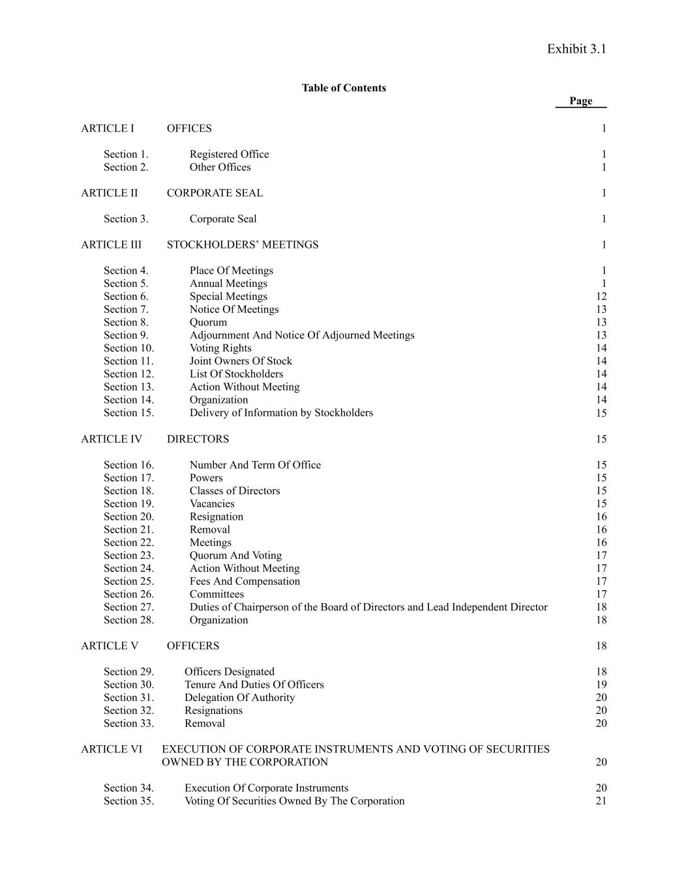
Exhibit 3.1 Table of Contents Page ARTICLE I OFFICES 1 Section 1. Registered Office 1 Section 2. Other Offices 1 ARTICLE II CORPORATE SEAL 1 Section 3. Corporate Seal 1 ARTICLE III STOCKHOLDERS’ MEETINGS 1 Section 4. Place Of Meetings 1 Section 5. Annual Meetings 1 Section 6. Special Meetings 12 Section 7. Notice Of Meetings 13 Section 8. Quorum 13 Section 9. Adjournment And Notice Of Adjourned Meetings 13 Section 10. Voting Rights 14 Section 11. Joint Owners Of Stock 14 Section 12. List Of Stockholders 14 Section 13. Action Without Meeting 14 Section 14. Organization 14 Section 15. Delivery of Information by Stockholders 15 ARTICLE IV DIRECTORS 15 Section 16. Number And Term Of Office 15 Section 17. Powers 15 Section 18. Classes of Directors 15 Section 19. Vacancies 15 Section 20. Resignation 16 Section 21. Removal 16 Section 22. Meetings 16 Section 23. Quorum And Voting 17 Section 24. Action Without Meeting 17 Section 25. Fees And Compensation 17 Section 26. Committees 17 Section 27. Duties of Chairperson of the Board of Directors and Lead Independent Director 18 Section 28. Organization 18 ARTICLE V OFFICERS 18 Section 29. Officers Designated 18 Section 30. Tenure And Duties Of Officers 19 Section 31. Delegation Of Authority 20 Section 32. Resignations 20 Section 33. Removal 20 ARTICLE VI EXECUTION OF CORPORATE INSTRUMENTS AND VOTING OF SECURITIES OWNED BY THE CORPORATION 20 Section 34. Execution Of Corporate Instruments 20 Section 35. Voting Of Securities Owned By The Corporation 21

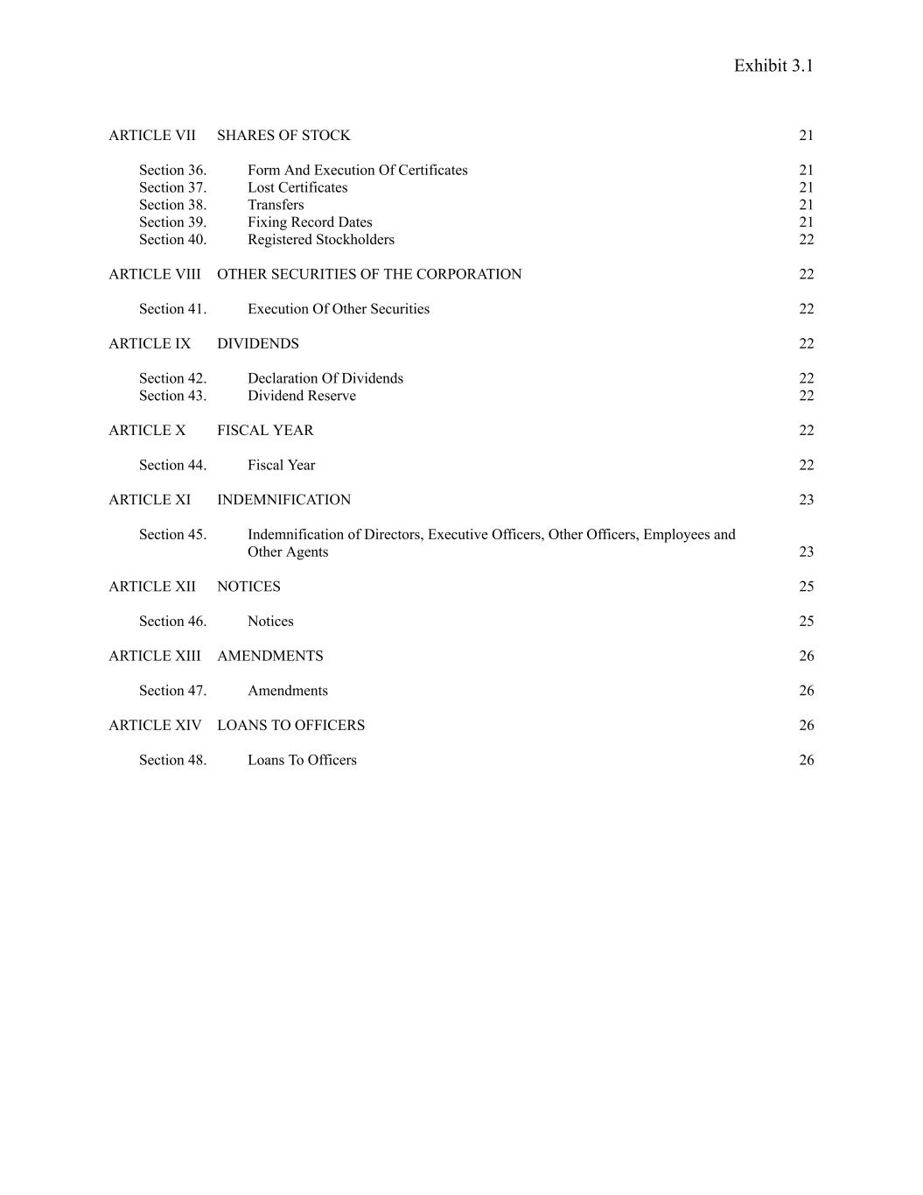
Exhibit 3.1 ARTICLE VII SHARES OF STOCK 21 Section 36. Form And Execution Of Certificates 21 Section 37. Lost Certificates 21 Section 38. Transfers 21 Section 39. Fixing Record Dates 21 Section 40. Registered Stockholders 22 ARTICLE VIII OTHER SECURITIES OF THE CORPORATION 22 Section 41. Execution Of Other Securities 22 ARTICLE IX DIVIDENDS 22 Section 42. Declaration Of Dividends 22 Section 43. Dividend Reserve 22 ARTICLE X FISCAL YEAR 22 Section 44. Fiscal Year 22 ARTICLE XI INDEMNIFICATION 23 Section 45. Indemnification of Directors, Executive Officers, Other Officers, Employees and Other Agents 23 ARTICLE XII NOTICES 25 Section 46. Notices 25 ARTICLE XIII AMENDMENTS 26 Section 47. Amendments 26 ARTICLE XIV LOANS TO OFFICERS 26 Section 48. Loans To Officers 26

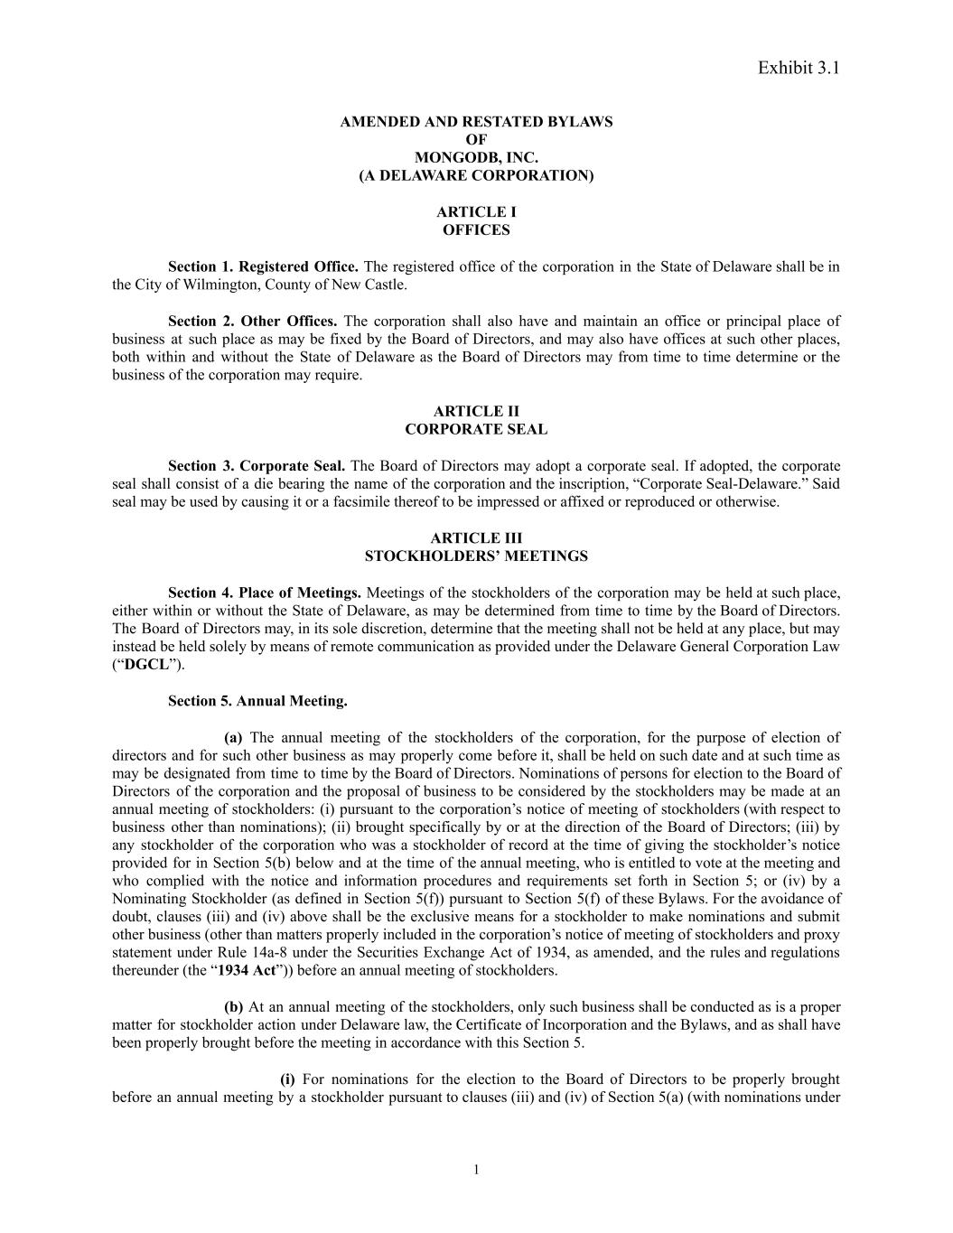
Exhibit 3.1 AMENDED AND RESTATED BYLAWS OF MONGODB, INC.​ (A DELAWARE CORPORATION) ARTICLE I OFFICES Section 1. Registered Office. The registered office of the corporation in the State of Delaware shall be in the City of Wilmington, County of New Castle. Section 2. Other Offices. The corporation shall also have and maintain an office or principal place of business at such place as may be fixed by the Board of Directors, and may also have offices at such other places, both within and without the State of Delaware as the Board of Directors may from time to time determine or the business of the corporation may require. ARTICLE II CORPORATE SEAL Section 3. Corporate Seal. The Board of Directors may adopt a corporate seal. If adopted, the corporate seal shall consist of a die bearing the name of the corporation and the inscription, “Corporate Seal-Delaware.” Said seal may be used by causing it or a facsimile thereof to be impressed or affixed or reproduced or otherwise. ARTICLE III STOCKHOLDERS’ MEETINGS Section 4. Place of Meetings. Meetings of the stockholders of the corporation may be held at such place, either within or without the State of Delaware, as may be determined from time to time by the Board of Directors. The Board of Directors may, in its sole discretion, determine that the meeting shall not be held at any place, but may instead be held solely by means of remote communication as provided under the Delaware General Corporation Law (“DGCL”). Section 5. Annual Meeting. (a) The annual meeting of the stockholders of the corporation, for the purpose of election of directors and for such other business as may properly come before it, shall be held on such date and at such time as may be designated from time to time by the Board of Directors. Nominations of persons for election to the Board of Directors of the corporation and the proposal of business to be considered by the stockholders may be made at an annual meeting of stockholders: (i) pursuant to the corporation’s notice of meeting of stockholders (with respect to business other than nominations); (ii) brought specifically by or at the direction of the Board of Directors; (iii) by any stockholder of the corporation who was a stockholder of record at the time of giving the stockholder’s notice provided for in Section 5(b) below and at the time of the annual meeting, who is entitled to vote at the meeting and who complied with the notice and information procedures and requirements set forth in Section 5; or (iv) by a Nominating Stockholder (as defined in Section 5(f)) pursuant to Section 5(f) of these Bylaws. For the avoidance of doubt, clauses (iii) and (iv) above shall be the exclusive means for a stockholder to make nominations and submit other business (other than matters properly included in the corporation’s notice of meeting of stockholders and proxy statement under Rule 14a-8 under the Securities Exchange Act of 1934, as amended, and the rules and regulations thereunder (the “1934 Act”)) before an annual meeting of stockholders. (b) At an annual meeting of the stockholders, only such business shall be conducted as is a proper matter for stockholder action under Delaware law, the Certificate of Incorporation and the Bylaws, and as shall have been properly brought before the meeting in accordance with this Section 5. (i) For nominations for the election to the Board of Directors to be properly brought before an annual meeting by a stockholder pursuant to clauses (iii) and (iv) of Section 5(a) (with nominations under 1

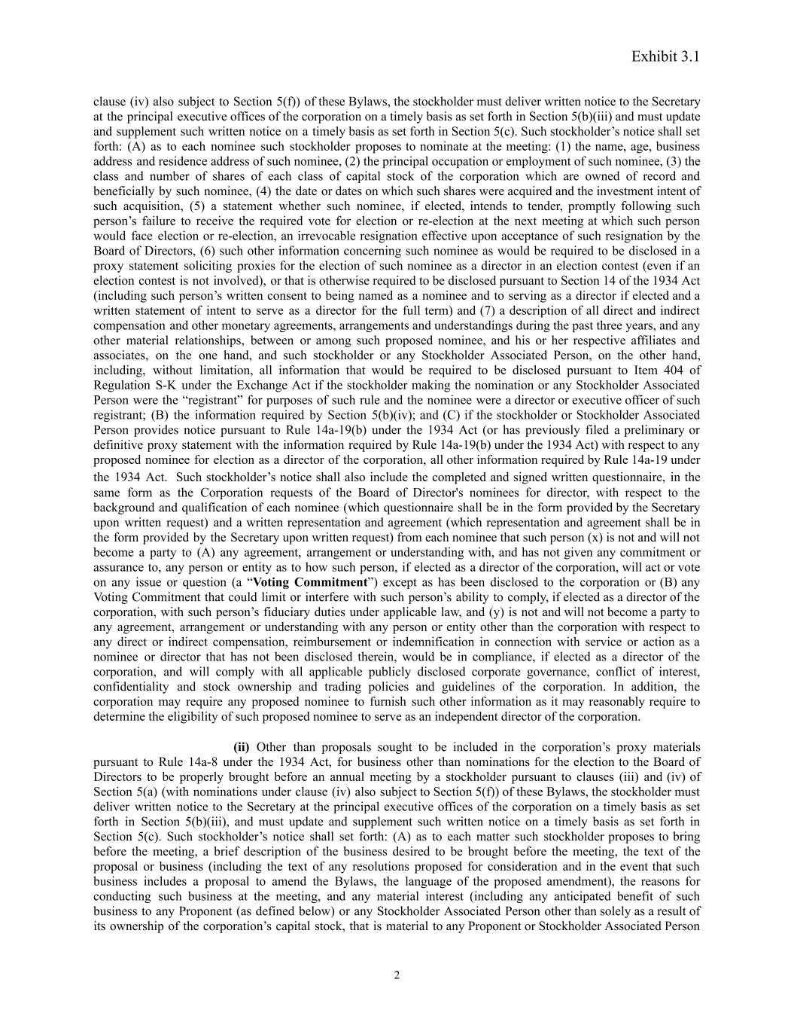
Exhibit 3.1 clause (iv) also subject to Section 5(f)) of these Bylaws, the stockholder must deliver written notice to the Secretary at the principal executive offices of the corporation on a timely basis as set forth in Section 5(b)(iii) and must update and supplement such written notice on a timely basis as set forth in Section 5(c). Such stockholder’s notice shall set forth: (A) as to each nominee such stockholder proposes to nominate at the meeting: (1) the name, age, business address and residence address of such nominee, (2) the principal occupation or employment of such nominee, (3) the class and number of shares of each class of capital stock of the corporation which are owned of record and beneficially by such nominee, (4) the date or dates on which such shares were acquired and the investment intent of such acquisition, (5) a statement whether such nominee, if elected, intends to tender, promptly following such person’s failure to receive the required vote for election or re-election at the next meeting at which such person would face election or re-election, an irrevocable resignation effective upon acceptance of such resignation by the Board of Directors, (6) such other information concerning such nominee as would be required to be disclosed in a proxy statement soliciting proxies for the election of such nominee as a director in an election contest (even if an election contest is not involved), or that is otherwise required to be disclosed pursuant to Section 14 of the 1934 Act (including such person’s written consent to being named as a nominee and to serving as a director if elected and a written statement of intent to serve as a director for the full term) and (7) a description of all direct and indirect compensation and other monetary agreements, arrangements and understandings during the past three years, and any other material relationships, between or among such proposed nominee, and his or her respective affiliates and associates, on the one hand, and such stockholder or any Stockholder Associated Person, on the other hand, including, without limitation, all information that would be required to be disclosed pursuant to Item 404 of Regulation S-K under the Exchange Act if the stockholder making the nomination or any Stockholder Associated Person were the “registrant” for purposes of such rule and the nominee were a director or executive officer of such registrant; (B) the information required by Section 5(b)(iv); and (C) if the stockholder or Stockholder Associated Person provides notice pursuant to Rule 14a-19(b) under the 1934 Act (or has previously filed a preliminary or definitive proxy statement with the information required by Rule 14a-19(b) under the 1934 Act) with respect to any proposed nominee for election as a director of the corporation, all other information required by Rule 14a-19 under the 1934 Act. Such stockholder’s notice shall also include the completed and signed written questionnaire, in the same form as the Corporation requests of the Board of Director's nominees for director, with respect to the background and qualification of each nominee (which questionnaire shall be in the form provided by the Secretary upon written request) and a written representation and agreement (which representation and agreement shall be in the form provided by the Secretary upon written request) from each nominee that such person (x) is not and will not become a party to (A) any agreement, arrangement or understanding with, and has not given any commitment or assurance to, any person or entity as to how such person, if elected as a director of the corporation, will act or vote on any issue or question (a “Voting Commitment”) except as has been disclosed to the corporation or (B) any Voting Commitment that could limit or interfere with such person’s ability to comply, if elected as a director of the corporation, with such person’s fiduciary duties under applicable law, and (y) is not and will not become a party to any agreement, arrangement or understanding with any person or entity other than the corporation with respect to any direct or indirect compensation, reimbursement or indemnification in connection with service or action as a nominee or director that has not been disclosed therein, would be in compliance, if elected as a director of the corporation, and will comply with all applicable publicly disclosed corporate governance, conflict of interest, confidentiality and stock ownership and trading policies and guidelines of the corporation. In addition, the corporation may require any proposed nominee to furnish such other information as it may reasonably require to determine the eligibility of such proposed nominee to serve as an independent director of the corporation. (ii) Other than proposals sought to be included in the corporation’s proxy materials pursuant to Rule 14a-8 under the 1934 Act, for business other than nominations for the election to the Board of Directors to be properly brought before an annual meeting by a stockholder pursuant to clauses (iii) and (iv) of Section 5(a) (with nominations under clause (iv) also subject to Section 5(f)) of these Bylaws, the stockholder must deliver written notice to the Secretary at the principal executive offices of the corporation on a timely basis as set forth in Section 5(b)(iii), and must update and supplement such written notice on a timely basis as set forth in Section 5(c). Such stockholder’s notice shall set forth: (A) as to each matter such stockholder proposes to bring before the meeting, a brief description of the business desired to be brought before the meeting, the text of the proposal or business (including the text of any resolutions proposed for consideration and in the event that such business includes a proposal to amend the Bylaws, the language of the proposed amendment), the reasons for conducting such business at the meeting, and any material interest (including any anticipated benefit of such business to any Proponent (as defined below) or any Stockholder Associated Person other than solely as a result of its ownership of the corporation’s capital stock, that is material to any Proponent or Stockholder Associated Person 2

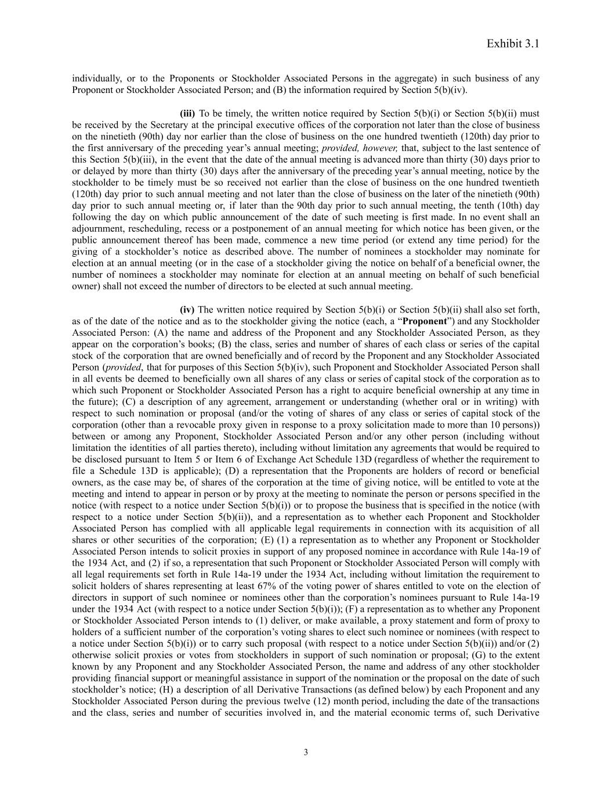
Exhibit 3.1 individually, or to the Proponents or Stockholder Associated Persons in the aggregate) in such business of any Proponent or Stockholder Associated Person; and (B) the information required by Section 5(b)(iv). (iii) To be timely, the written notice required by Section 5(b)(i) or Section 5(b)(ii) must be received by the Secretary at the principal executive offices of the corporation not later than the close of business on the ninetieth (90th) day nor earlier than the close of business on the one hundred twentieth (120th) day prior to the first anniversary of the preceding year’s annual meeting; provided, however, that, subject to the last sentence of this Section 5(b)(iii), in the event that the date of the annual meeting is advanced more than thirty (30) days prior to or delayed by more than thirty (30) days after the anniversary of the preceding year’s annual meeting, notice by the stockholder to be timely must be so received not earlier than the close of business on the one hundred twentieth (120th) day prior to such annual meeting and not later than the close of business on the later of the ninetieth (90th) day prior to such annual meeting or, if later than the 90th day prior to such annual meeting, the tenth (10th) day following the day on which public announcement of the date of such meeting is first made. In no event shall an adjournment, rescheduling, recess or a postponement of an annual meeting for which notice has been given, or the public announcement thereof has been made, commence a new time period (or extend any time period) for the giving of a stockholder’s notice as described above. The number of nominees a stockholder may nominate for election at an annual meeting (or in the case of a stockholder giving the notice on behalf of a beneficial owner, the number of nominees a stockholder may nominate for election at an annual meeting on behalf of such beneficial owner) shall not exceed the number of directors to be elected at such annual meeting. (iv) The written notice required by Section 5(b)(i) or Section 5(b)(ii) shall also set forth, as of the date of the notice and as to the stockholder giving the notice (each, a “Proponent”) and any Stockholder Associated Person: (A) the name and address of the Proponent and any Stockholder Associated Person, as they appear on the corporation’s books; (B) the class, series and number of shares of each class or series of the capital stock of the corporation that are owned beneficially and of record by the Proponent and any Stockholder Associated Person (provided, that for purposes of this Section 5(b)(iv), such Proponent and Stockholder Associated Person shall in all events be deemed to beneficially own all shares of any class or series of capital stock of the corporation as to which such Proponent or Stockholder Associated Person has a right to acquire beneficial ownership at any time in the future); (C) a description of any agreement, arrangement or understanding (whether oral or in writing) with respect to such nomination or proposal (and/or the voting of shares of any class or series of capital stock of the corporation (other than a revocable proxy given in response to a proxy solicitation made to more than 10 persons)) between or among any Proponent, Stockholder Associated Person and/or any other person (including without limitation the identities of all parties thereto), including without limitation any agreements that would be required to be disclosed pursuant to Item 5 or Item 6 of Exchange Act Schedule 13D (regardless of whether the requirement to file a Schedule 13D is applicable); (D) a representation that the Proponents are holders of record or beneficial owners, as the case may be, of shares of the corporation at the time of giving notice, will be entitled to vote at the meeting and intend to appear in person or by proxy at the meeting to nominate the person or persons specified in the notice (with respect to a notice under Section 5(b)(i)) or to propose the business that is specified in the notice (with respect to a notice under Section 5(b)(ii)), and a representation as to whether each Proponent and Stockholder Associated Person has complied with all applicable legal requirements in connection with its acquisition of all shares or other securities of the corporation; (E) (1) a representation as to whether any Proponent or Stockholder Associated Person intends to solicit proxies in support of any proposed nominee in accordance with Rule 14a-19 of the 1934 Act, and (2) if so, a representation that such Proponent or Stockholder Associated Person will comply with all legal requirements set forth in Rule 14a-19 under the 1934 Act, including without limitation the requirement to solicit holders of shares representing at least 67% of the voting power of shares entitled to vote on the election of directors in support of such nominee or nominees other than the corporation’s nominees pursuant to Rule 14a-19 under the 1934 Act (with respect to a notice under Section 5(b)(i)); (F) a representation as to whether any Proponent or Stockholder Associated Person intends to (1) deliver, or make available, a proxy statement and form of proxy to holders of a sufficient number of the corporation’s voting shares to elect such nominee or nominees (with respect to a notice under Section 5(b)(i)) or to carry such proposal (with respect to a notice under Section 5(b)(ii)) and/or (2) otherwise solicit proxies or votes from stockholders in support of such nomination or proposal; (G) to the extent known by any Proponent and any Stockholder Associated Person, the name and address of any other stockholder providing financial support or meaningful assistance in support of the nomination or the proposal on the date of such stockholder’s notice; (H) a description of all Derivative Transactions (as defined below) by each Proponent and any Stockholder Associated Person during the previous twelve (12) month period, including the date of the transactions and the class, series and number of securities involved in, and the material economic terms of, such Derivative 3

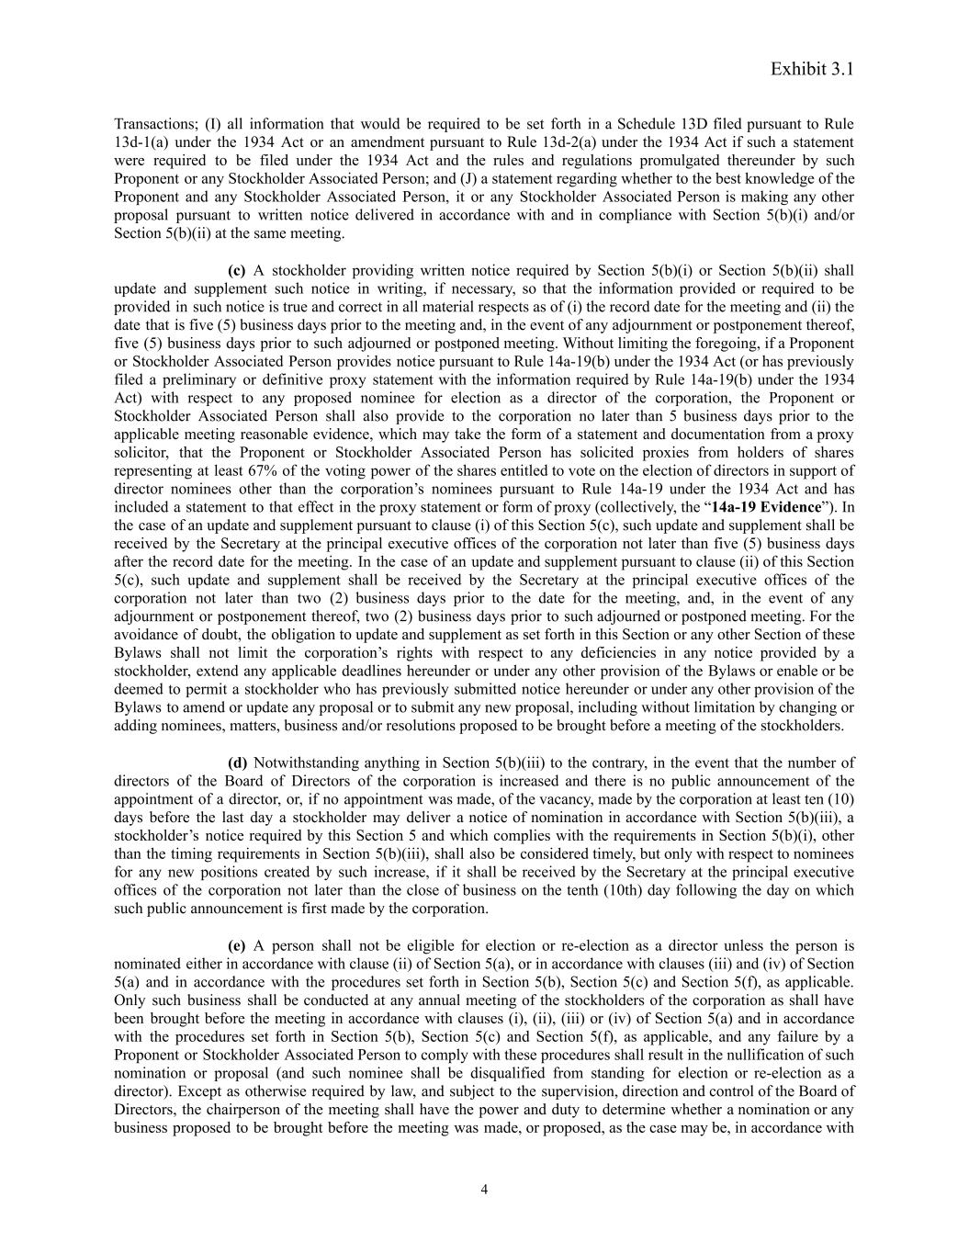
Exhibit 3.1 Transactions; (I) all information that would be required to be set forth in a Schedule 13D filed pursuant to Rule 13d-1(a) under the 1934 Act or an amendment pursuant to Rule 13d-2(a) under the 1934 Act if such a statement were required to be filed under the 1934 Act and the rules and regulations promulgated thereunder by such Proponent or any Stockholder Associated Person; and (J) a statement regarding whether to the best knowledge of the Proponent and any Stockholder Associated Person, it or any Stockholder Associated Person is making any other proposal pursuant to written notice delivered in accordance with and in compliance with Section 5(b)(i) and/or Section 5(b)(ii) at the same meeting. (c) A stockholder providing written notice required by Section 5(b)(i) or Section 5(b)(ii) shall update and supplement such notice in writing, if necessary, so that the information provided or required to be provided in such notice is true and correct in all material respects as of (i) the record date for the meeting and (ii) the date that is five (5) business days prior to the meeting and, in the event of any adjournment or postponement thereof, five (5) business days prior to such adjourned or postponed meeting. Without limiting the foregoing, if a Proponent or Stockholder Associated Person provides notice pursuant to Rule 14a-19(b) under the 1934 Act (or has previously filed a preliminary or definitive proxy statement with the information required by Rule 14a-19(b) under the 1934 Act) with respect to any proposed nominee for election as a director of the corporation, the Proponent or Stockholder Associated Person shall also provide to the corporation no later than 5 business days prior to the applicable meeting reasonable evidence, which may take the form of a statement and documentation from a proxy solicitor, that the Proponent or Stockholder Associated Person has solicited proxies from holders of shares representing at least 67% of the voting power of the shares entitled to vote on the election of directors in support of director nominees other than the corporation’s nominees pursuant to Rule 14a-19 under the 1934 Act and has included a statement to that effect in the proxy statement or form of proxy (collectively, the “14a-19 Evidence”). In the case of an update and supplement pursuant to clause (i) of this Section 5(c), such update and supplement shall be received by the Secretary at the principal executive offices of the corporation not later than five (5) business days after the record date for the meeting. In the case of an update and supplement pursuant to clause (ii) of this Section 5(c), such update and supplement shall be received by the Secretary at the principal executive offices of the corporation not later than two (2) business days prior to the date for the meeting, and, in the event of any adjournment or postponement thereof, two (2) business days prior to such adjourned or postponed meeting. For the avoidance of doubt, the obligation to update and supplement as set forth in this Section or any other Section of these Bylaws shall not limit the corporation’s rights with respect to any deficiencies in any notice provided by a stockholder, extend any applicable deadlines hereunder or under any other provision of the Bylaws or enable or be deemed to permit a stockholder who has previously submitted notice hereunder or under any other provision of the Bylaws to amend or update any proposal or to submit any new proposal, including without limitation by changing or adding nominees, matters, business and/or resolutions proposed to be brought before a meeting of the stockholders. (d) Notwithstanding anything in Section 5(b)(iii) to the contrary, in the event that the number of directors of the Board of Directors of the corporation is increased and there is no public announcement of the appointment of a director, or, if no appointment was made, of the vacancy, made by the corporation at least ten (10) days before the last day a stockholder may deliver a notice of nomination in accordance with Section 5(b)(iii), a stockholder’s notice required by this Section 5 and which complies with the requirements in Section 5(b)(i), other than the timing requirements in Section 5(b)(iii), shall also be considered timely, but only with respect to nominees for any new positions created by such increase, if it shall be received by the Secretary at the principal executive offices of the corporation not later than the close of business on the tenth (10th) day following the day on which such public announcement is first made by the corporation. (e) A person shall not be eligible for election or re-election as a director unless the person is nominated either in accordance with clause (ii) of Section 5(a), or in accordance with clauses (iii) and (iv) of Section 5(a) and in accordance with the procedures set forth in Section 5(b), Section 5(c) and Section 5(f), as applicable. Only such business shall be conducted at any annual meeting of the stockholders of the corporation as shall have been brought before the meeting in accordance with clauses (i), (ii), (iii) or (iv) of Section 5(a) and in accordance with the procedures set forth in Section 5(b), Section 5(c) and Section 5(f), as applicable, and any failure by a Proponent or Stockholder Associated Person to comply with these procedures shall result in the nullification of such nomination or proposal (and such nominee shall be disqualified from standing for election or re-election as a director). Except as otherwise required by law, and subject to the supervision, direction and control of the Board of Directors, the chairperson of the meeting shall have the power and duty to determine whether a nomination or any business proposed to be brought before the meeting was made, or proposed, as the case may be, in accordance with 4

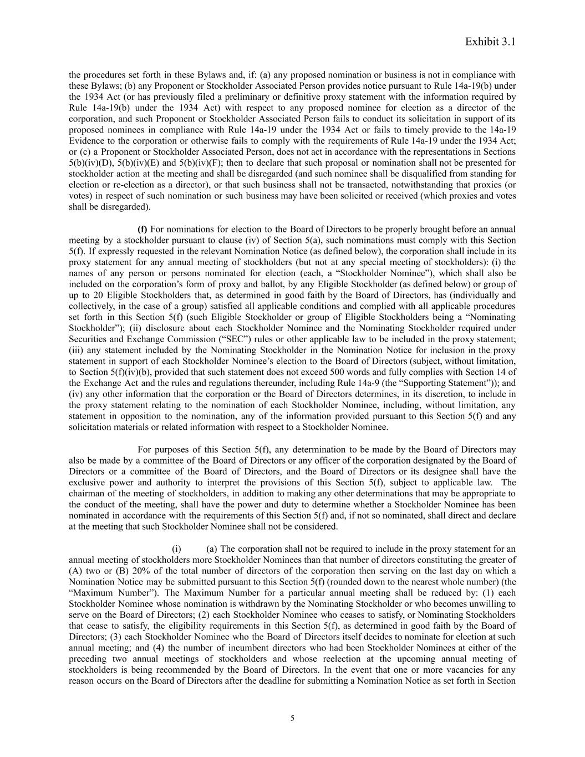
Exhibit 3.1 the procedures set forth in these Bylaws and, if: (a) any proposed nomination or business is not in compliance with these Bylaws; (b) any Proponent or Stockholder Associated Person provides notice pursuant to Rule 14a-19(b) under the 1934 Act (or has previously filed a preliminary or definitive proxy statement with the information required by Rule 14a-19(b) under the 1934 Act) with respect to any proposed nominee for election as a director of the corporation, and such Proponent or Stockholder Associated Person fails to conduct its solicitation in support of its proposed nominees in compliance with Rule 14a-19 under the 1934 Act or fails to timely provide to the 14a-19 Evidence to the corporation or otherwise fails to comply with the requirements of Rule 14a-19 under the 1934 Act; or (c) a Proponent or Stockholder Associated Person, does not act in accordance with the representations in Sections 5(b)(iv)(D), 5(b)(iv)(E) and 5(b)(iv)(F); then to declare that such proposal or nomination shall not be presented for stockholder action at the meeting and shall be disregarded (and such nominee shall be disqualified from standing for election or re-election as a director), or that such business shall not be transacted, notwithstanding that proxies (or votes) in respect of such nomination or such business may have been solicited or received (which proxies and votes shall be disregarded). (f) For nominations for election to the Board of Directors to be properly brought before an annual meeting by a stockholder pursuant to clause (iv) of Section 5(a), such nominations must comply with this Section 5(f). If expressly requested in the relevant Nomination Notice (as defined below), the corporation shall include in its proxy statement for any annual meeting of stockholders (but not at any special meeting of stockholders): (i) the names of any person or persons nominated for election (each, a “Stockholder Nominee”), which shall also be included on the corporation’s form of proxy and ballot, by any Eligible Stockholder (as defined below) or group of up to 20 Eligible Stockholders that, as determined in good faith by the Board of Directors, has (individually and collectively, in the case of a group) satisfied all applicable conditions and complied with all applicable procedures set forth in this Section 5(f) (such Eligible Stockholder or group of Eligible Stockholders being a “Nominating Stockholder”); (ii) disclosure about each Stockholder Nominee and the Nominating Stockholder required under Securities and Exchange Commission (“SEC”) rules or other applicable law to be included in the proxy statement; (iii) any statement included by the Nominating Stockholder in the Nomination Notice for inclusion in the proxy statement in support of each Stockholder Nominee’s election to the Board of Directors (subject, without limitation, to Section 5(f)(iv)(b), provided that such statement does not exceed 500 words and fully complies with Section 14 of the Exchange Act and the rules and regulations thereunder, including Rule 14a-9 (the “Supporting Statement”)); and (iv) any other information that the corporation or the Board of Directors determines, in its discretion, to include in the proxy statement relating to the nomination of each Stockholder Nominee, including, without limitation, any statement in opposition to the nomination, any of the information provided pursuant to this Section 5(f) and any solicitation materials or related information with respect to a Stockholder Nominee. For purposes of this Section 5(f), any determination to be made by the Board of Directors may also be made by a committee of the Board of Directors or any officer of the corporation designated by the Board of Directors or a committee of the Board of Directors, and the Board of Directors or its designee shall have the exclusive power and authority to interpret the provisions of this Section 5(f), subject to applicable law. The chairman of the meeting of stockholders, in addition to making any other determinations that may be appropriate to the conduct of the meeting, shall have the power and duty to determine whether a Stockholder Nominee has been nominated in accordance with the requirements of this Section 5(f) and, if not so nominated, shall direct and declare at the meeting that such Stockholder Nominee shall not be considered. (i)​ (a) The corporation shall not be required to include in the proxy statement for an annual meeting of stockholders more Stockholder Nominees than that number of directors constituting the greater of (A) two or (B) 20% of the total number of directors of the corporation then serving on the last day on which a Nomination Notice may be submitted pursuant to this Section 5(f) (rounded down to the nearest whole number) (the “Maximum Number”). The Maximum Number for a particular annual meeting shall be reduced by: (1) each Stockholder Nominee whose nomination is withdrawn by the Nominating Stockholder or who becomes unwilling to serve on the Board of Directors; (2) each Stockholder Nominee who ceases to satisfy, or Nominating Stockholders that cease to satisfy, the eligibility requirements in this Section 5(f), as determined in good faith by the Board of Directors; (3) each Stockholder Nominee who the Board of Directors itself decides to nominate for election at such annual meeting; and (4) the number of incumbent directors who had been Stockholder Nominees at either of the preceding two annual meetings of stockholders and whose reelection at the upcoming annual meeting of stockholders is being recommended by the Board of Directors. In the event that one or more vacancies for any reason occurs on the Board of Directors after the deadline for submitting a Nomination Notice as set forth in Section 5

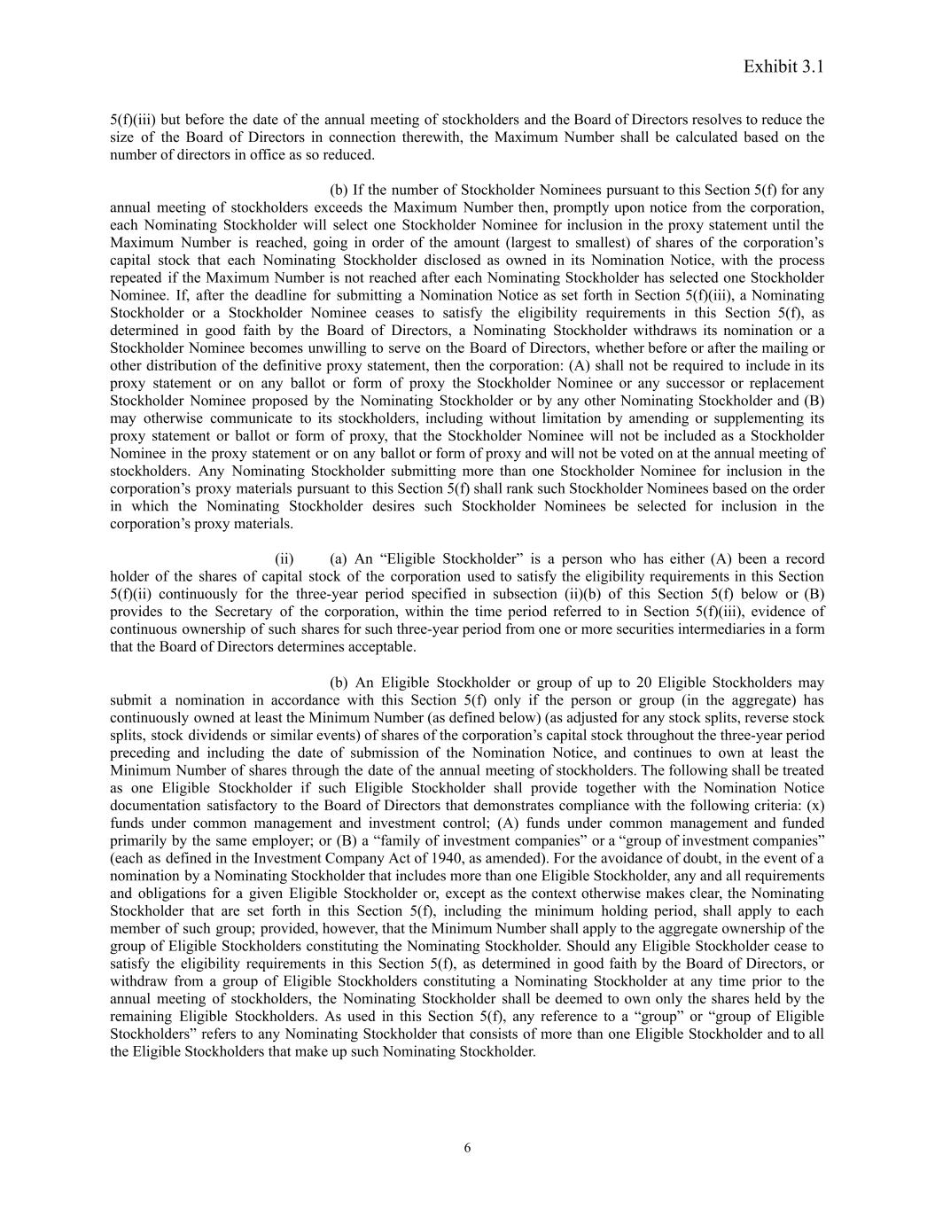
Exhibit 3.1 5(f)(iii) but before the date of the annual meeting of stockholders and the Board of Directors resolves to reduce the size of the Board of Directors in connection therewith, the Maximum Number shall be calculated based on the number of directors in office as so reduced. (b) If the number of Stockholder Nominees pursuant to this Section 5(f) for any annual meeting of stockholders exceeds the Maximum Number then, promptly upon notice from the corporation, each Nominating Stockholder will select one Stockholder Nominee for inclusion in the proxy statement until the Maximum Number is reached, going in order of the amount (largest to smallest) of shares of the corporation’s capital stock that each Nominating Stockholder disclosed as owned in its Nomination Notice, with the process repeated if the Maximum Number is not reached after each Nominating Stockholder has selected one Stockholder Nominee. If, after the deadline for submitting a Nomination Notice as set forth in Section 5(f)(iii), a Nominating Stockholder or a Stockholder Nominee ceases to satisfy the eligibility requirements in this Section 5(f), as determined in good faith by the Board of Directors, a Nominating Stockholder withdraws its nomination or a Stockholder Nominee becomes unwilling to serve on the Board of Directors, whether before or after the mailing or other distribution of the definitive proxy statement, then the corporation: (A) shall not be required to include in its proxy statement or on any ballot or form of proxy the Stockholder Nominee or any successor or replacement Stockholder Nominee proposed by the Nominating Stockholder or by any other Nominating Stockholder and (B) may otherwise communicate to its stockholders, including without limitation by amending or supplementing its proxy statement or ballot or form of proxy, that the Stockholder Nominee will not be included as a Stockholder Nominee in the proxy statement or on any ballot or form of proxy and will not be voted on at the annual meeting of stockholders. Any Nominating Stockholder submitting more than one Stockholder Nominee for inclusion in the corporation’s proxy materials pursuant to this Section 5(f) shall rank such Stockholder Nominees based on the order in which the Nominating Stockholder desires such Stockholder Nominees be selected for inclusion in the corporation’s proxy materials. (ii)​ (a) An “Eligible Stockholder” is a person who has either (A) been a record holder of the shares of capital stock of the corporation used to satisfy the eligibility requirements in this Section 5(f)(ii) continuously for the three-year period specified in subsection (ii)(b) of this Section 5(f) below or (B) provides to the Secretary of the corporation, within the time period referred to in Section 5(f)(iii), evidence of continuous ownership of such shares for such three-year period from one or more securities intermediaries in a form that the Board of Directors determines acceptable. (b) An Eligible Stockholder or group of up to 20 Eligible Stockholders may submit a nomination in accordance with this Section 5(f) only if the person or group (in the aggregate) has continuously owned at least the Minimum Number (as defined below) (as adjusted for any stock splits, reverse stock splits, stock dividends or similar events) of shares of the corporation’s capital stock throughout the three-year period preceding and including the date of submission of the Nomination Notice, and continues to own at least the Minimum Number of shares through the date of the annual meeting of stockholders. The following shall be treated as one Eligible Stockholder if such Eligible Stockholder shall provide together with the Nomination Notice documentation satisfactory to the Board of Directors that demonstrates compliance with the following criteria: (x) funds under common management and investment control; (A) funds under common management and funded primarily by the same employer; or (B) a “family of investment companies” or a “group of investment companies” (each as defined in the Investment Company Act of 1940, as amended). For the avoidance of doubt, in the event of a nomination by a Nominating Stockholder that includes more than one Eligible Stockholder, any and all requirements and obligations for a given Eligible Stockholder or, except as the context otherwise makes clear, the Nominating Stockholder that are set forth in this Section 5(f), including the minimum holding period, shall apply to each member of such group; provided, however, that the Minimum Number shall apply to the aggregate ownership of the group of Eligible Stockholders constituting the Nominating Stockholder. Should any Eligible Stockholder cease to satisfy the eligibility requirements in this Section 5(f), as determined in good faith by the Board of Directors, or withdraw from a group of Eligible Stockholders constituting a Nominating Stockholder at any time prior to the annual meeting of stockholders, the Nominating Stockholder shall be deemed to own only the shares held by the remaining Eligible Stockholders. As used in this Section 5(f), any reference to a “group” or “group of Eligible Stockholders” refers to any Nominating Stockholder that consists of more than one Eligible Stockholder and to all the Eligible Stockholders that make up such Nominating Stockholder. 6

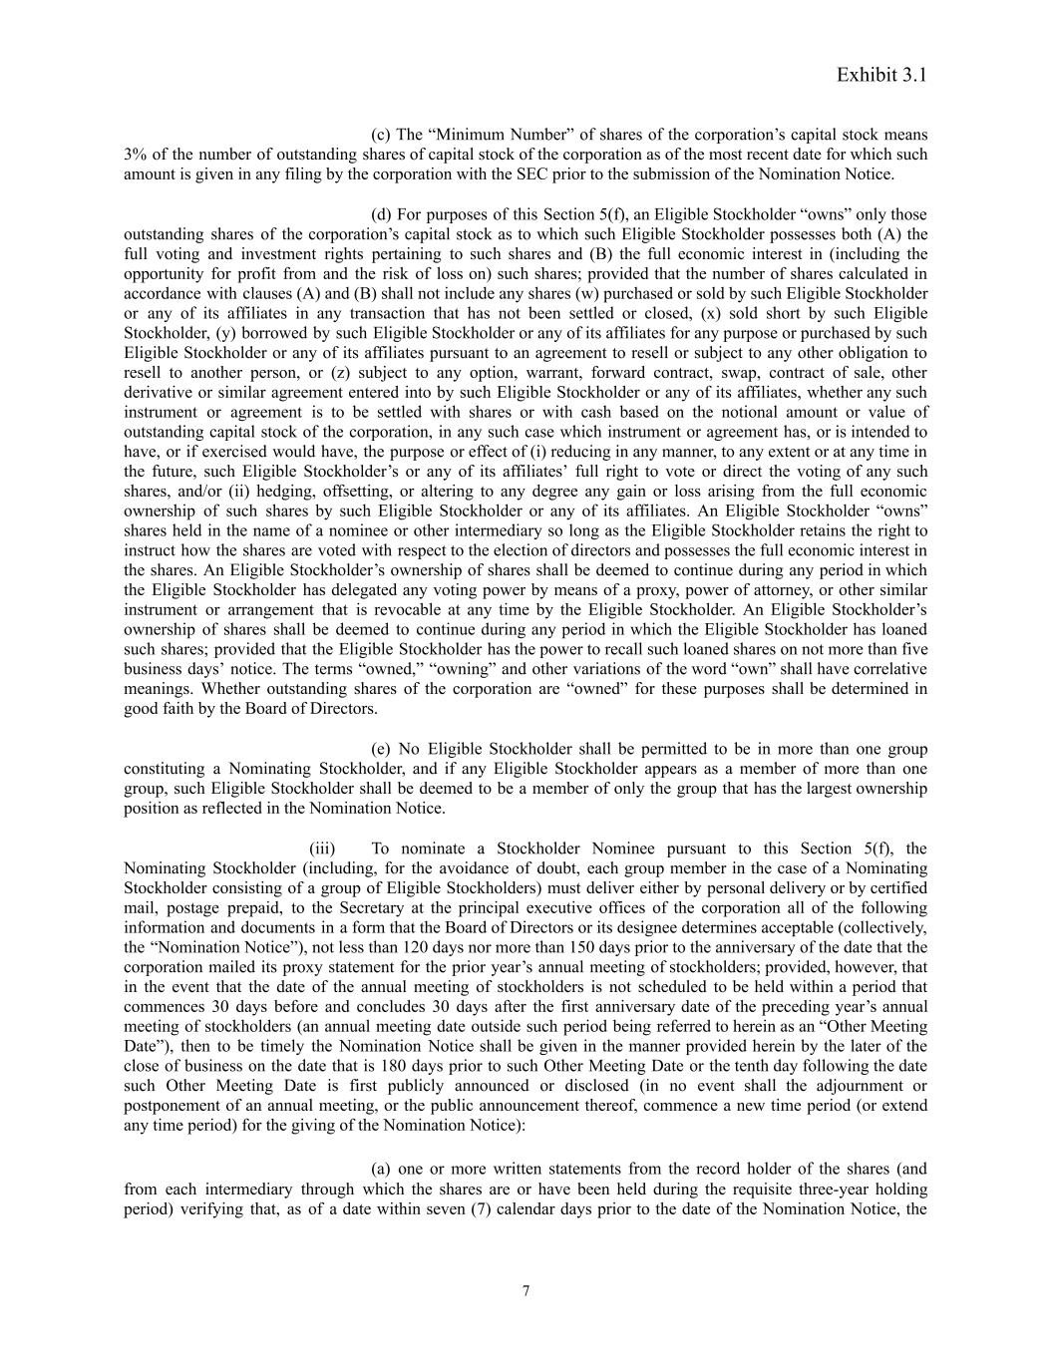
Exhibit 3.1 (c) The “Minimum Number” of shares of the corporation’s capital stock means 3% of the number of outstanding shares of capital stock of the corporation as of the most recent date for which such amount is given in any filing by the corporation with the SEC prior to the submission of the Nomination Notice. (d) For purposes of this Section 5(f), an Eligible Stockholder “owns” only those outstanding shares of the corporation’s capital stock as to which such Eligible Stockholder possesses both (A) the full voting and investment rights pertaining to such shares and (B) the full economic interest in (including the opportunity for profit from and the risk of loss on) such shares; provided that the number of shares calculated in accordance with clauses (A) and (B) shall not include any shares (w) purchased or sold by such Eligible Stockholder or any of its affiliates in any transaction that has not been settled or closed, (x) sold short by such Eligible Stockholder, (y) borrowed by such Eligible Stockholder or any of its affiliates for any purpose or purchased by such Eligible Stockholder or any of its affiliates pursuant to an agreement to resell or subject to any other obligation to resell to another person, or (z) subject to any option, warrant, forward contract, swap, contract of sale, other derivative or similar agreement entered into by such Eligible Stockholder or any of its affiliates, whether any such instrument or agreement is to be settled with shares or with cash based on the notional amount or value of outstanding capital stock of the corporation, in any such case which instrument or agreement has, or is intended to have, or if exercised would have, the purpose or effect of (i) reducing in any manner, to any extent or at any time in the future, such Eligible Stockholder’s or any of its affiliates’ full right to vote or direct the voting of any such shares, and/or (ii) hedging, offsetting, or altering to any degree any gain or loss arising from the full economic ownership of such shares by such Eligible Stockholder or any of its affiliates. An Eligible Stockholder “owns” shares held in the name of a nominee or other intermediary so long as the Eligible Stockholder retains the right to instruct how the shares are voted with respect to the election of directors and possesses the full economic interest in the shares. An Eligible Stockholder’s ownership of shares shall be deemed to continue during any period in which the Eligible Stockholder has delegated any voting power by means of a proxy, power of attorney, or other similar instrument or arrangement that is revocable at any time by the Eligible Stockholder. An Eligible Stockholder’s ownership of shares shall be deemed to continue during any period in which the Eligible Stockholder has loaned such shares; provided that the Eligible Stockholder has the power to recall such loaned shares on not more than five business days’ notice. The terms “owned,” “owning” and other variations of the word “own” shall have correlative meanings. Whether outstanding shares of the corporation are “owned” for these purposes shall be determined in good faith by the Board of Directors. (e) No Eligible Stockholder shall be permitted to be in more than one group constituting a Nominating Stockholder, and if any Eligible Stockholder appears as a member of more than one group, such Eligible Stockholder shall be deemed to be a member of only the group that has the largest ownership position as reflected in the Nomination Notice. (iii)​ To nominate a Stockholder Nominee pursuant to this Section 5(f), the Nominating Stockholder (including, for the avoidance of doubt, each group member in the case of a Nominating Stockholder consisting of a group of Eligible Stockholders) must deliver either by personal delivery or by certified mail, postage prepaid, to the Secretary at the principal executive offices of the corporation all of the following information and documents in a form that the Board of Directors or its designee determines acceptable (collectively, the “Nomination Notice”), not less than 120 days nor more than 150 days prior to the anniversary of the date that the corporation mailed its proxy statement for the prior year’s annual meeting of stockholders; provided, however, that in the event that the date of the annual meeting of stockholders is not scheduled to be held within a period that commences 30 days before and concludes 30 days after the first anniversary date of the preceding year’s annual meeting of stockholders (an annual meeting date outside such period being referred to herein as an “Other Meeting Date”), then to be timely the Nomination Notice shall be given in the manner provided herein by the later of the close of business on the date that is 180 days prior to such Other Meeting Date or the tenth day following the date such Other Meeting Date is first publicly announced or disclosed (in no event shall the adjournment or postponement of an annual meeting, or the public announcement thereof, commence a new time period (or extend any time period) for the giving of the Nomination Notice): (a) one or more written statements from the record holder of the shares (and from each intermediary through which the shares are or have been held during the requisite three-year holding period) verifying that, as of a date within seven (7) calendar days prior to the date of the Nomination Notice, the 7

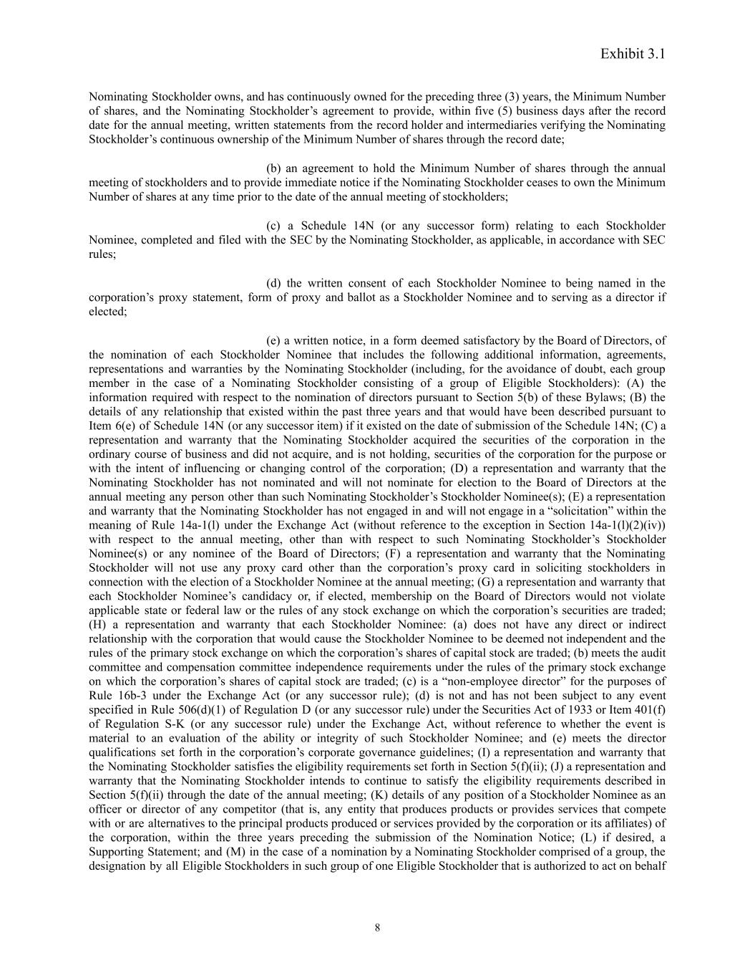
Exhibit 3.1 Nominating Stockholder owns, and has continuously owned for the preceding three (3) years, the Minimum Number of shares, and the Nominating Stockholder’s agreement to provide, within five (5) business days after the record date for the annual meeting, written statements from the record holder and intermediaries verifying the Nominating Stockholder’s continuous ownership of the Minimum Number of shares through the record date; (b) an agreement to hold the Minimum Number of shares through the annual meeting of stockholders and to provide immediate notice if the Nominating Stockholder ceases to own the Minimum Number of shares at any time prior to the date of the annual meeting of stockholders; (c) a Schedule 14N (or any successor form) relating to each Stockholder Nominee, completed and filed with the SEC by the Nominating Stockholder, as applicable, in accordance with SEC rules; (d) the written consent of each Stockholder Nominee to being named in the corporation’s proxy statement, form of proxy and ballot as a Stockholder Nominee and to serving as a director if elected; (e) a written notice, in a form deemed satisfactory by the Board of Directors, of the nomination of each Stockholder Nominee that includes the following additional information, agreements, representations and warranties by the Nominating Stockholder (including, for the avoidance of doubt, each group member in the case of a Nominating Stockholder consisting of a group of Eligible Stockholders): (A) the information required with respect to the nomination of directors pursuant to Section 5(b) of these Bylaws; (B) the details of any relationship that existed within the past three years and that would have been described pursuant to Item 6(e) of Schedule 14N (or any successor item) if it existed on the date of submission of the Schedule 14N; (C) a representation and warranty that the Nominating Stockholder acquired the securities of the corporation in the ordinary course of business and did not acquire, and is not holding, securities of the corporation for the purpose or with the intent of influencing or changing control of the corporation; (D) a representation and warranty that the Nominating Stockholder has not nominated and will not nominate for election to the Board of Directors at the annual meeting any person other than such Nominating Stockholder’s Stockholder Nominee(s); (E) a representation and warranty that the Nominating Stockholder has not engaged in and will not engage in a “solicitation” within the meaning of Rule 14a-1(l) under the Exchange Act (without reference to the exception in Section 14a-1(l)(2)(iv)) with respect to the annual meeting, other than with respect to such Nominating Stockholder’s Stockholder Nominee(s) or any nominee of the Board of Directors; (F) a representation and warranty that the Nominating Stockholder will not use any proxy card other than the corporation’s proxy card in soliciting stockholders in connection with the election of a Stockholder Nominee at the annual meeting; (G) a representation and warranty that each Stockholder Nominee’s candidacy or, if elected, membership on the Board of Directors would not violate applicable state or federal law or the rules of any stock exchange on which the corporation’s securities are traded; (H) a representation and warranty that each Stockholder Nominee: (a) does not have any direct or indirect relationship with the corporation that would cause the Stockholder Nominee to be deemed not independent and the rules of the primary stock exchange on which the corporation’s shares of capital stock are traded; (b) meets the audit committee and compensation committee independence requirements under the rules of the primary stock exchange on which the corporation’s shares of capital stock are traded; (c) is a “non-employee director” for the purposes of Rule 16b-3 under the Exchange Act (or any successor rule); (d) is not and has not been subject to any event specified in Rule 506(d)(1) of Regulation D (or any successor rule) under the Securities Act of 1933 or Item 401(f) of Regulation S-K (or any successor rule) under the Exchange Act, without reference to whether the event is material to an evaluation of the ability or integrity of such Stockholder Nominee; and (e) meets the director qualifications set forth in the corporation’s corporate governance guidelines; (I) a representation and warranty that the Nominating Stockholder satisfies the eligibility requirements set forth in Section 5(f)(ii); (J) a representation and warranty that the Nominating Stockholder intends to continue to satisfy the eligibility requirements described in Section 5(f)(ii) through the date of the annual meeting; (K) details of any position of a Stockholder Nominee as an officer or director of any competitor (that is, any entity that produces products or provides services that compete with or are alternatives to the principal products produced or services provided by the corporation or its affiliates) of the corporation, within the three years preceding the submission of the Nomination Notice; (L) if desired, a Supporting Statement; and (M) in the case of a nomination by a Nominating Stockholder comprised of a group, the designation by all Eligible Stockholders in such group of one Eligible Stockholder that is authorized to act on behalf 8

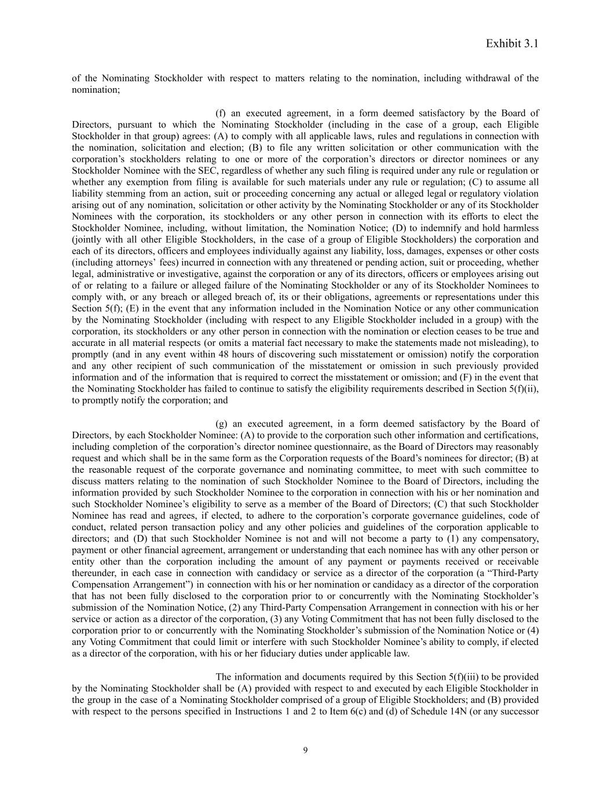
Exhibit 3.1 of the Nominating Stockholder with respect to matters relating to the nomination, including withdrawal of the nomination; (f) an executed agreement, in a form deemed satisfactory by the Board of Directors, pursuant to which the Nominating Stockholder (including in the case of a group, each Eligible Stockholder in that group) agrees: (A) to comply with all applicable laws, rules and regulations in connection with the nomination, solicitation and election; (B) to file any written solicitation or other communication with the corporation’s stockholders relating to one or more of the corporation’s directors or director nominees or any Stockholder Nominee with the SEC, regardless of whether any such filing is required under any rule or regulation or whether any exemption from filing is available for such materials under any rule or regulation; (C) to assume all liability stemming from an action, suit or proceeding concerning any actual or alleged legal or regulatory violation arising out of any nomination, solicitation or other activity by the Nominating Stockholder or any of its Stockholder Nominees with the corporation, its stockholders or any other person in connection with its efforts to elect the Stockholder Nominee, including, without limitation, the Nomination Notice; (D) to indemnify and hold harmless (jointly with all other Eligible Stockholders, in the case of a group of Eligible Stockholders) the corporation and each of its directors, officers and employees individually against any liability, loss, damages, expenses or other costs (including attorneys’ fees) incurred in connection with any threatened or pending action, suit or proceeding, whether legal, administrative or investigative, against the corporation or any of its directors, officers or employees arising out of or relating to a failure or alleged failure of the Nominating Stockholder or any of its Stockholder Nominees to comply with, or any breach or alleged breach of, its or their obligations, agreements or representations under this Section 5(f); (E) in the event that any information included in the Nomination Notice or any other communication by the Nominating Stockholder (including with respect to any Eligible Stockholder included in a group) with the corporation, its stockholders or any other person in connection with the nomination or election ceases to be true and accurate in all material respects (or omits a material fact necessary to make the statements made not misleading), to promptly (and in any event within 48 hours of discovering such misstatement or omission) notify the corporation and any other recipient of such communication of the misstatement or omission in such previously provided information and of the information that is required to correct the misstatement or omission; and (F) in the event that the Nominating Stockholder has failed to continue to satisfy the eligibility requirements described in Section 5(f)(ii), to promptly notify the corporation; and (g) an executed agreement, in a form deemed satisfactory by the Board of Directors, by each Stockholder Nominee: (A) to provide to the corporation such other information and certifications, including completion of the corporation’s director nominee questionnaire, as the Board of Directors may reasonably request and which shall be in the same form as the Corporation requests of the Board’s nominees for director; (B) at the reasonable request of the corporate governance and nominating committee, to meet with such committee to discuss matters relating to the nomination of such Stockholder Nominee to the Board of Directors, including the information provided by such Stockholder Nominee to the corporation in connection with his or her nomination and such Stockholder Nominee’s eligibility to serve as a member of the Board of Directors; (C) that such Stockholder Nominee has read and agrees, if elected, to adhere to the corporation’s corporate governance guidelines, code of conduct, related person transaction policy and any other policies and guidelines of the corporation applicable to directors; and (D) that such Stockholder Nominee is not and will not become a party to (1) any compensatory, payment or other financial agreement, arrangement or understanding that each nominee has with any other person or entity other than the corporation including the amount of any payment or payments received or receivable thereunder, in each case in connection with candidacy or service as a director of the corporation (a “Third-Party Compensation Arrangement”) in connection with his or her nomination or candidacy as a director of the corporation that has not been fully disclosed to the corporation prior to or concurrently with the Nominating Stockholder’s submission of the Nomination Notice, (2) any Third-Party Compensation Arrangement in connection with his or her service or action as a director of the corporation, (3) any Voting Commitment that has not been fully disclosed to the corporation prior to or concurrently with the Nominating Stockholder’s submission of the Nomination Notice or (4) any Voting Commitment that could limit or interfere with such Stockholder Nominee’s ability to comply, if elected as a director of the corporation, with his or her fiduciary duties under applicable law. The information and documents required by this Section 5(f)(iii) to be provided by the Nominating Stockholder shall be (A) provided with respect to and executed by each Eligible Stockholder in the group in the case of a Nominating Stockholder comprised of a group of Eligible Stockholders; and (B) provided with respect to the persons specified in Instructions 1 and 2 to Item 6(c) and (d) of Schedule 14N (or any successor 9

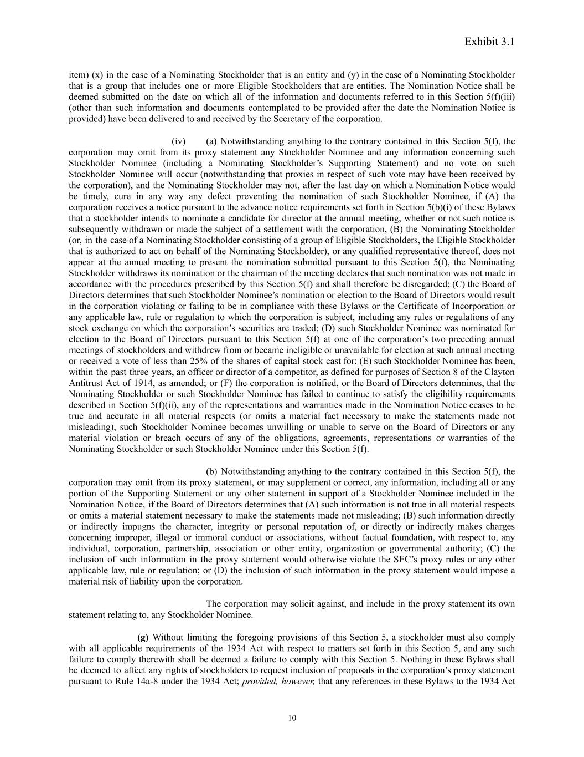
Exhibit 3.1 item) (x) in the case of a Nominating Stockholder that is an entity and (y) in the case of a Nominating Stockholder that is a group that includes one or more Eligible Stockholders that are entities. The Nomination Notice shall be deemed submitted on the date on which all of the information and documents referred to in this Section 5(f)(iii) (other than such information and documents contemplated to be provided after the date the Nomination Notice is provided) have been delivered to and received by the Secretary of the corporation. (iv)​ (a) Notwithstanding anything to the contrary contained in this Section 5(f), the corporation may omit from its proxy statement any Stockholder Nominee and any information concerning such Stockholder Nominee (including a Nominating Stockholder’s Supporting Statement) and no vote on such Stockholder Nominee will occur (notwithstanding that proxies in respect of such vote may have been received by the corporation), and the Nominating Stockholder may not, after the last day on which a Nomination Notice would be timely, cure in any way any defect preventing the nomination of such Stockholder Nominee, if (A) the corporation receives a notice pursuant to the advance notice requirements set forth in Section 5(b)(i) of these Bylaws that a stockholder intends to nominate a candidate for director at the annual meeting, whether or not such notice is subsequently withdrawn or made the subject of a settlement with the corporation, (B) the Nominating Stockholder (or, in the case of a Nominating Stockholder consisting of a group of Eligible Stockholders, the Eligible Stockholder that is authorized to act on behalf of the Nominating Stockholder), or any qualified representative thereof, does not appear at the annual meeting to present the nomination submitted pursuant to this Section 5(f), the Nominating Stockholder withdraws its nomination or the chairman of the meeting declares that such nomination was not made in accordance with the procedures prescribed by this Section 5(f) and shall therefore be disregarded; (C) the Board of Directors determines that such Stockholder Nominee’s nomination or election to the Board of Directors would result in the corporation violating or failing to be in compliance with these Bylaws or the Certificate of Incorporation or any applicable law, rule or regulation to which the corporation is subject, including any rules or regulations of any stock exchange on which the corporation’s securities are traded; (D) such Stockholder Nominee was nominated for election to the Board of Directors pursuant to this Section 5(f) at one of the corporation’s two preceding annual meetings of stockholders and withdrew from or became ineligible or unavailable for election at such annual meeting or received a vote of less than 25% of the shares of capital stock cast for; (E) such Stockholder Nominee has been, within the past three years, an officer or director of a competitor, as defined for purposes of Section 8 of the Clayton Antitrust Act of 1914, as amended; or (F) the corporation is notified, or the Board of Directors determines, that the Nominating Stockholder or such Stockholder Nominee has failed to continue to satisfy the eligibility requirements described in Section 5(f)(ii), any of the representations and warranties made in the Nomination Notice ceases to be true and accurate in all material respects (or omits a material fact necessary to make the statements made not misleading), such Stockholder Nominee becomes unwilling or unable to serve on the Board of Directors or any material violation or breach occurs of any of the obligations, agreements, representations or warranties of the Nominating Stockholder or such Stockholder Nominee under this Section 5(f). (b) Notwithstanding anything to the contrary contained in this Section 5(f), the corporation may omit from its proxy statement, or may supplement or correct, any information, including all or any portion of the Supporting Statement or any other statement in support of a Stockholder Nominee included in the Nomination Notice, if the Board of Directors determines that (A) such information is not true in all material respects or omits a material statement necessary to make the statements made not misleading; (B) such information directly or indirectly impugns the character, integrity or personal reputation of, or directly or indirectly makes charges concerning improper, illegal or immoral conduct or associations, without factual foundation, with respect to, any individual, corporation, partnership, association or other entity, organization or governmental authority; (C) the inclusion of such information in the proxy statement would otherwise violate the SEC’s proxy rules or any other applicable law, rule or regulation; or (D) the inclusion of such information in the proxy statement would impose a material risk of liability upon the corporation. The corporation may solicit against, and include in the proxy statement its own statement relating to, any Stockholder Nominee. (g) Without limiting the foregoing provisions of this Section 5, a stockholder must also comply with all applicable requirements of the 1934 Act with respect to matters set forth in this Section 5, and any such failure to comply therewith shall be deemed a failure to comply with this Section 5. Nothing in these Bylaws shall be deemed to affect any rights of stockholders to request inclusion of proposals in the corporation’s proxy statement pursuant to Rule 14a-8 under the 1934 Act; provided, however, that any references in these Bylaws to the 1934 Act 10

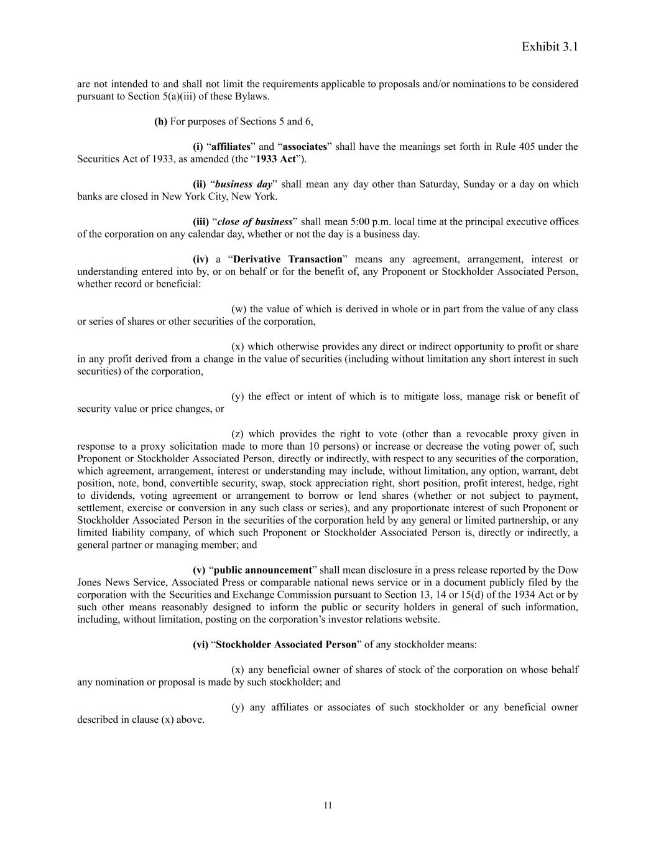
Exhibit 3.1 are not intended to and shall not limit the requirements applicable to proposals and/or nominations to be considered pursuant to Section 5(a)(iii) of these Bylaws. (h) For purposes of Sections 5 and 6, (i) “affiliates” and “associates” shall have the meanings set forth in Rule 405 under the Securities Act of 1933, as amended (the “1933 Act”). (ii) “business day” shall mean any day other than Saturday, Sunday or a day on which banks are closed in New York City, New ‎York. (iii) “close of business” shall mean 5:00 p.m. local time at the principal executive offices of the corporation on any calendar ‎day, whether or not the day is a business day. (iv) a “Derivative Transaction” means any agreement, arrangement, interest or understanding entered into by, or on behalf or for the benefit of, any Proponent or Stockholder Associated Person, whether record or beneficial: (w) the value of which is derived in whole or in part from the value of any class or series of shares or other securities of the corporation, (x) which otherwise provides any direct or indirect opportunity to profit or share in any profit derived from a change in the value of securities (including without limitation any short interest in such securities) of the corporation, (y) the effect or intent of which is to mitigate loss, manage risk or benefit of security value or price changes, or (z) which provides the right to vote (other than a revocable proxy given in response to a proxy solicitation made to more than 10 persons) or increase or decrease the voting power of, such Proponent or Stockholder Associated Person, directly or indirectly, with respect to any securities of the corporation, which agreement, arrangement, interest or understanding may include, without limitation, any option, warrant, debt position, note, bond, convertible security, swap, stock appreciation right, short position, profit interest, hedge, right to dividends, voting agreement or arrangement to borrow or lend shares (whether or not subject to payment, settlement, exercise or conversion in any such class or series), and any proportionate interest of such Proponent or Stockholder Associated Person in the securities of the corporation held by any general or limited partnership, or any limited liability company, of which such Proponent or Stockholder Associated Person is, directly or indirectly, a general partner or managing member; and (v) “public announcement” shall mean disclosure in a press release reported by the Dow Jones News Service, Associated Press or comparable national news service or in a document publicly filed by the corporation with the Securities and Exchange Commission pursuant to Section 13, 14 or 15(d) of the 1934 Act or by such other means reasonably designed to inform the public or security holders in ‎general of such information, including, without limitation, posting on the corporation’s investor relations website. (vi) “Stockholder Associated Person” of any stockholder means: (x) any beneficial owner of shares of stock of the corporation on whose behalf any nomination or proposal is made by such stockholder; and (y) any affiliates or associates of such stockholder or any beneficial owner described in clause (x) above. 11

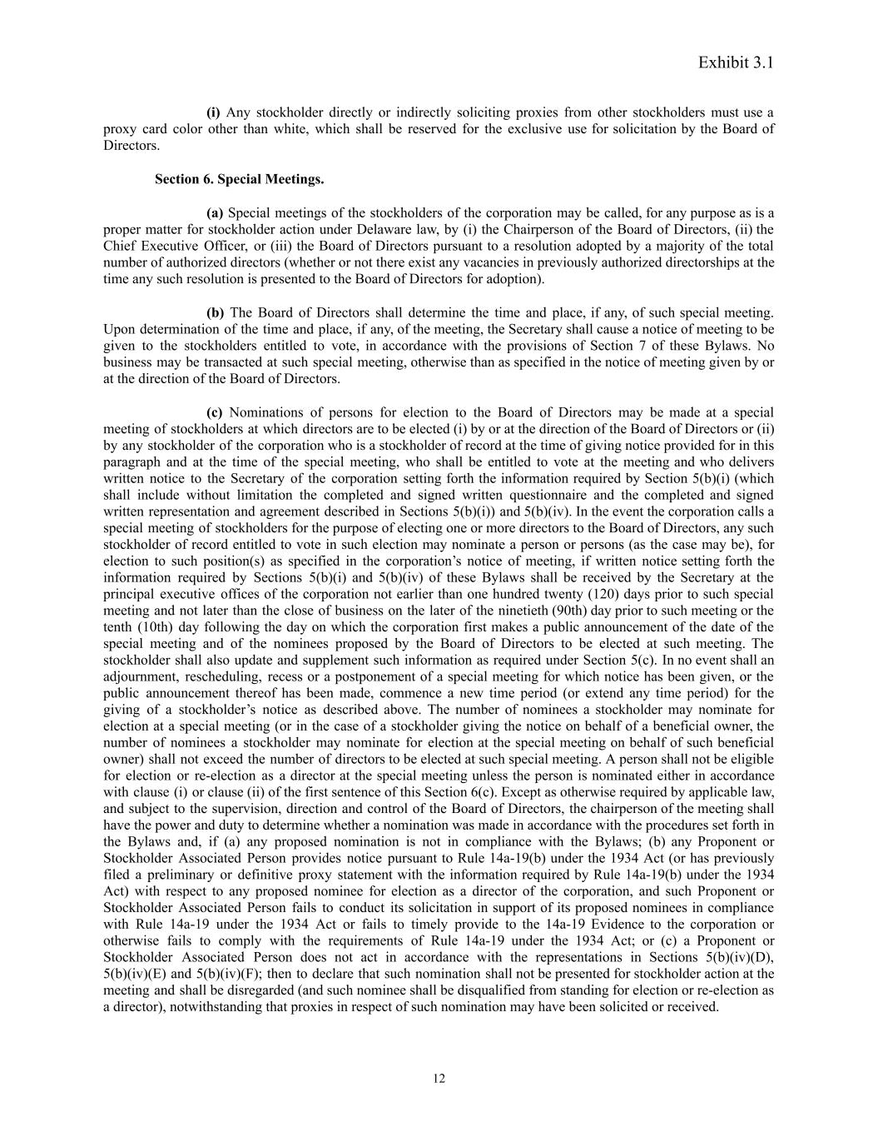
Exhibit 3.1 (i) Any stockholder directly or indirectly soliciting proxies from other stockholders must use a proxy card color other than white, which shall be reserved for the exclusive use for solicitation by the Board of Directors. Section 6. Special Meetings. (a) Special meetings of the stockholders of the corporation may be called, for any purpose as is a proper matter for stockholder action under Delaware law, by (i) the Chairperson of the Board of Directors, (ii) the Chief Executive Officer, or (iii) the Board of Directors pursuant to a resolution adopted by a majority of the total number of authorized directors (whether or not there exist any vacancies in previously authorized directorships at the time any such resolution is presented to the Board of Directors for adoption). (b) The Board of Directors shall determine the time and place, if any, of such special meeting. Upon determination of the time and place, if any, of the meeting, the Secretary shall cause a notice of meeting to be given to the stockholders entitled to vote, in accordance with the provisions of Section 7 of these Bylaws. No business may be transacted at such special meeting, otherwise than as specified in the notice of meeting given by or at the direction of the Board of Directors. (c) Nominations of persons for election to the Board of Directors may be made at a special meeting of stockholders at which directors are to be elected (i) by or at the direction of the Board of Directors or (ii) by any stockholder of the corporation who is a stockholder of record at the time of giving notice provided for in this paragraph and at the time of the special meeting, who shall be entitled to vote at the meeting and who delivers written notice to the Secretary of the corporation setting forth the information required by Section 5(b)(i) (which shall include without limitation the completed and signed written questionnaire and the completed and signed written representation and agreement described in Sections 5(b)(i)) and 5(b)(iv). In the event the corporation calls a special meeting of stockholders for the purpose of electing one or more directors to the Board of Directors, any such stockholder of record entitled to vote in such election may nominate a person or persons (as the case may be), for election to such position(s) as specified in the corporation’s notice of meeting, if written notice setting forth the information required by Sections 5(b)(i) and 5(b)(iv) of these Bylaws shall be received by the Secretary at the principal executive offices of the corporation not earlier than one hundred twenty (120) days prior to such special meeting and not later than the close of business on the later of the ninetieth (90th) day prior to such meeting or the tenth (10th) day following the day on which the corporation first makes a public announcement of the date of the special meeting and of the nominees proposed by the Board of Directors to be elected at such meeting. The stockholder shall also update and supplement such information as required under Section 5(c). In no event shall an adjournment, rescheduling, recess or a postponement of a special meeting for which notice has been given, or the public announcement thereof has been made, commence a new time period (or extend any time period) for the giving of a stockholder’s notice as described above. The number of nominees a stockholder may nominate for election at a special meeting (or in the case of a stockholder giving the notice on behalf of a beneficial owner, the number of nominees a stockholder may nominate for election at the special meeting on behalf of such beneficial owner) shall not exceed the number of directors to be elected at such special meeting. A person shall not be eligible for election or re-election as a director at the special meeting unless the person is nominated either in accordance with clause (i) or clause (ii) of the first sentence of this Section 6(c). Except as otherwise required by applicable law, and subject to the supervision, direction and control of the Board of Directors, the chairperson of the meeting shall have the power and duty to determine whether a nomination was made in accordance with the procedures set forth in the Bylaws and, if (a) any proposed nomination is not in compliance with the Bylaws; (b) any Proponent or Stockholder Associated Person provides notice pursuant to Rule 14a-19(b) under the 1934 Act (or has previously filed a preliminary or definitive proxy statement with the information required by Rule 14a-19(b) under the 1934 Act) with respect to any proposed nominee for election as a director of the corporation, and such Proponent or Stockholder Associated Person fails to conduct its solicitation in support of its proposed nominees in compliance with Rule 14a-19 under the 1934 Act or fails to timely provide to the 14a-19 Evidence to the corporation or otherwise fails to comply with the requirements of Rule 14a-19 under the 1934 Act; or (c) a Proponent or Stockholder Associated Person does not act in accordance with the representations in Sections 5(b)(iv)(D), 5(b)(iv)(E) and 5(b)(iv)(F); then to declare that such nomination shall not be presented for stockholder action at the meeting and shall be disregarded (and such nominee shall be disqualified from standing for election or re-election as a director), notwithstanding that proxies in respect of such nomination may have been solicited or received. 12

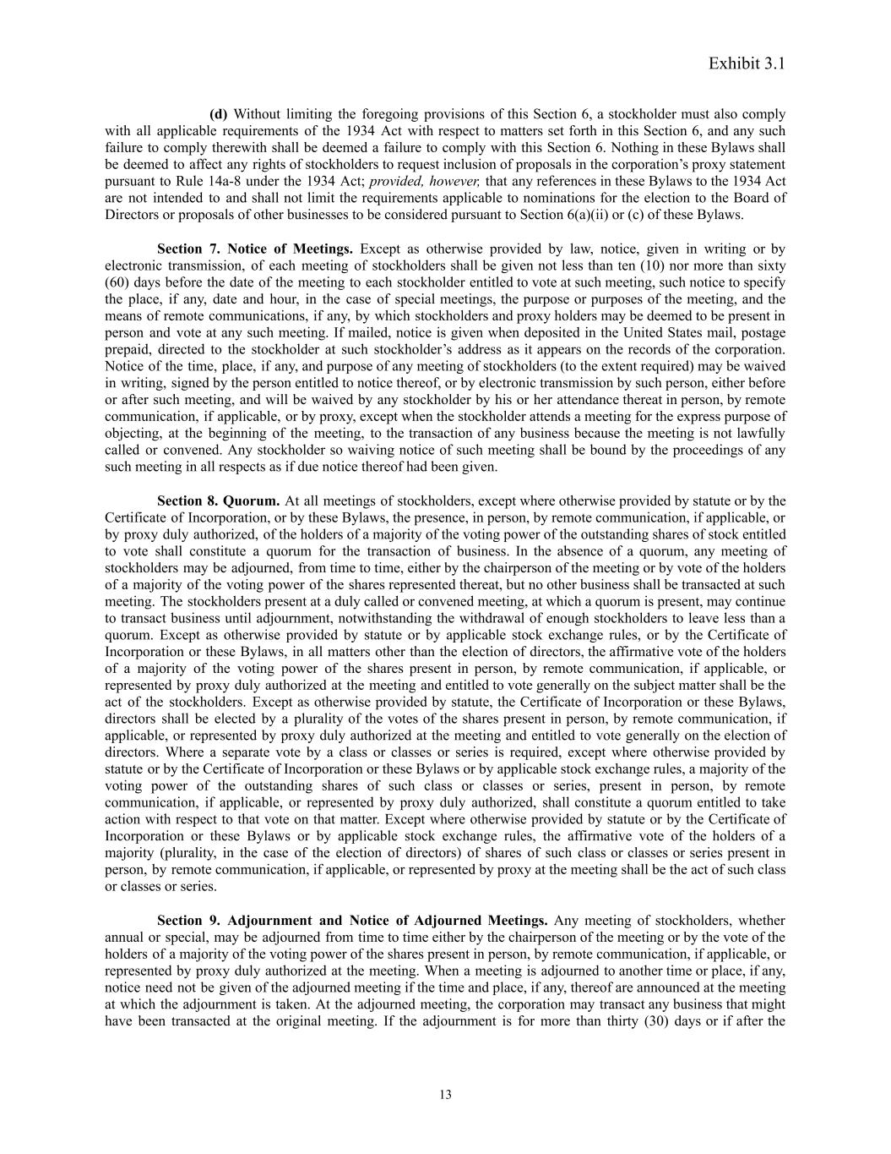
Exhibit 3.1 (d) Without limiting the foregoing provisions of this Section 6, a stockholder must also comply with all applicable requirements of the 1934 Act with respect to matters set forth in this Section 6, and any such failure to comply therewith shall be deemed a failure to comply with this Section 6. Nothing in these Bylaws shall be deemed to affect any rights of stockholders to request inclusion of proposals in the corporation’s proxy statement pursuant to Rule 14a-8 under the 1934 Act; provided, however, that any references in these Bylaws to the 1934 Act are not intended to and shall not limit the requirements applicable to nominations for the election to the Board of Directors or proposals of other businesses to be considered pursuant to Section 6(a)(ii) or (c) of these Bylaws. Section 7. Notice of Meetings. Except as otherwise provided by law, notice, given in writing or by electronic transmission, of each meeting of stockholders shall be given not less than ten (10) nor more than sixty (60) days before the date of the meeting to each stockholder entitled to vote at such meeting, such notice to specify the place, if any, date and hour, in the case of special meetings, the purpose or purposes of the meeting, and the means of remote communications, if any, by which stockholders and proxy holders may be deemed to be present in person and vote at any such meeting. If mailed, notice is given when deposited in the United States mail, postage prepaid, directed to the stockholder at such stockholder’s address as it appears on the records of the corporation. Notice of the time, place, if any, and purpose of any meeting of stockholders (to the extent required) may be waived in writing, signed by the person entitled to notice thereof, or by electronic transmission by such person, either before or after such meeting, and will be waived by any stockholder by his or her attendance thereat in person, by remote communication, if applicable, or by proxy, except when the stockholder attends a meeting for the express purpose of objecting, at the beginning of the meeting, to the transaction of any business because the meeting is not lawfully called or convened. Any stockholder so waiving notice of such meeting shall be bound by the proceedings of any such meeting in all respects as if due notice thereof had been given. Section 8. Quorum. At all meetings of stockholders, except where otherwise provided by statute or by the Certificate of Incorporation, or by these Bylaws, the presence, in person, by remote communication, if applicable, or by proxy duly authorized, of the holders of a majority of the voting power of the outstanding shares of stock entitled to vote shall constitute a quorum for the transaction of business. In the absence of a quorum, any meeting of stockholders may be adjourned, from time to time, either by the chairperson of the meeting or by vote of the holders of a majority of the voting power of the shares represented thereat, but no other business shall be transacted at such meeting. The stockholders present at a duly called or convened meeting, at which a quorum is present, may continue to transact business until adjournment, notwithstanding the withdrawal of enough stockholders to leave less than a quorum. Except as otherwise provided by statute or by applicable stock exchange rules, or by the Certificate of Incorporation or these Bylaws, in all matters other than the election of directors, the affirmative vote of the holders of a majority of the voting power of the shares present in person, by remote communication, if applicable, or represented by proxy duly authorized at the meeting and entitled to vote generally on the subject matter shall be the act of the stockholders. Except as otherwise provided by statute, the Certificate of Incorporation or these Bylaws, directors shall be elected by a plurality of the votes of the shares present in person, by remote communication, if applicable, or represented by proxy duly authorized at the meeting and entitled to vote generally on the election of directors. Where a separate vote by a class or classes or series is required, except where otherwise provided by statute or by the Certificate of Incorporation or these Bylaws or by applicable stock exchange rules, a majority of the voting power of the outstanding shares of such class or classes or series, present in person, by remote communication, if applicable, or represented by proxy duly authorized, shall constitute a quorum entitled to take action with respect to that vote on that matter. Except where otherwise provided by statute or by the Certificate of Incorporation or these Bylaws or by applicable stock exchange rules, the affirmative vote of the holders of a majority (plurality, in the case of the election of directors) of shares of such class or classes or series present in person, by remote communication, if applicable, or represented by proxy at the meeting shall be the act of such class or classes or series. Section 9. Adjournment and Notice of Adjourned Meetings. Any meeting of stockholders, whether annual or special, may be adjourned from time to time either by the chairperson of the meeting or by the vote of the holders of a majority of the voting power of the shares present in person, by remote communication, if applicable, or represented by proxy duly authorized at the meeting. When a meeting is adjourned to another time or place, if any, notice need not be given of the adjourned meeting if the time and place, if any, thereof are announced at the meeting at which the adjournment is taken. At the adjourned meeting, the corporation may transact any business that might have been transacted at the original meeting. If the adjournment is for more than thirty (30) days or if after the 13

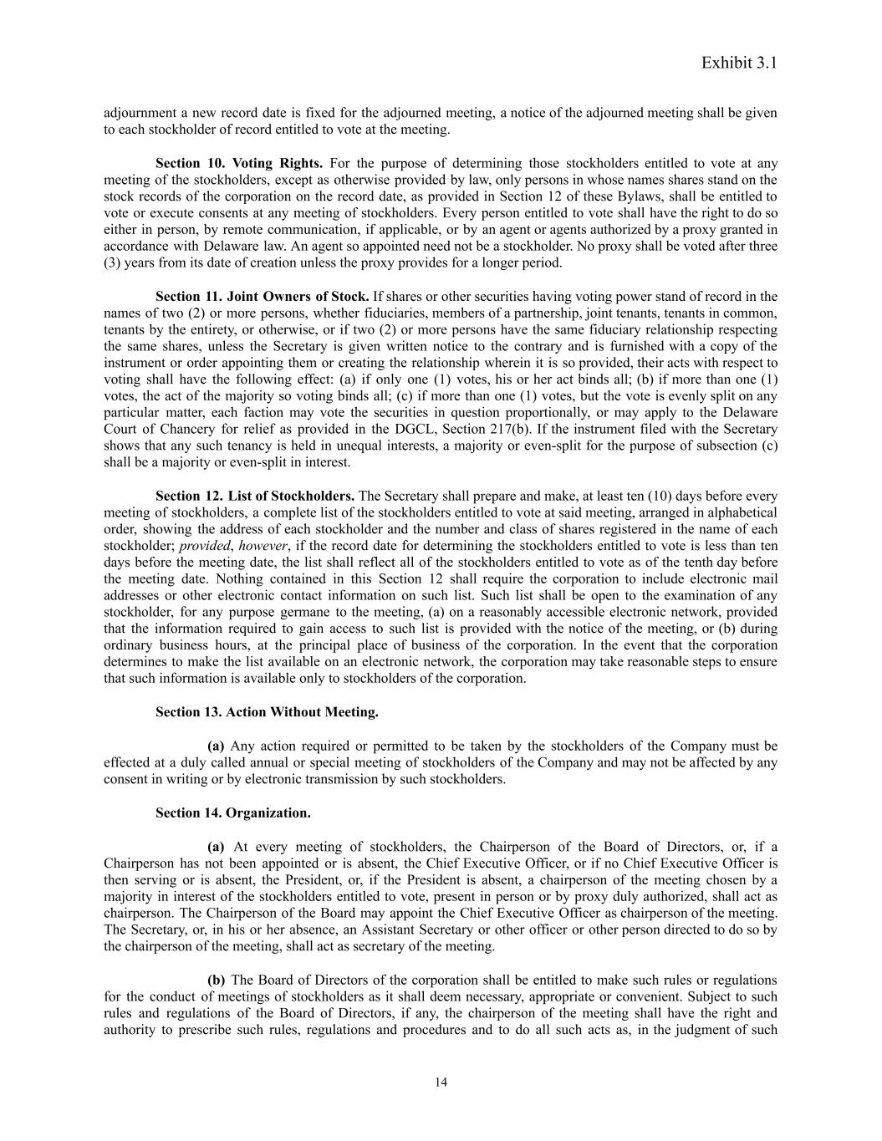
Exhibit 3.1 adjournment a new record date is fixed for the adjourned meeting, a notice of the adjourned meeting shall be given to each stockholder of record entitled to vote at the meeting. Section 10. Voting Rights. For the purpose of determining those stockholders entitled to vote at any meeting of the stockholders, except as otherwise provided by law, only persons in whose names shares stand on the stock records of the corporation on the record date, as provided in Section 12 of these Bylaws, shall be entitled to vote or execute consents at any meeting of stockholders. Every person entitled to vote shall have the right to do so either in person, by remote communication, if applicable, or by an agent or agents authorized by a proxy granted in accordance with Delaware law. An agent so appointed need not be a stockholder. No proxy shall be voted after three (3) years from its date of creation unless the proxy provides for a longer period. Section 11. Joint Owners of Stock. If shares or other securities having voting power stand of record in the names of two (2) or more persons, whether fiduciaries, members of a partnership, joint tenants, tenants in common, tenants by the entirety, or otherwise, or if two (2) or more persons have the same fiduciary relationship respecting the same shares, unless the Secretary is given written notice to the contrary and is furnished with a copy of the instrument or order appointing them or creating the relationship wherein it is so provided, their acts with respect to voting shall have the following effect: (a) if only one (1) votes, his or her act binds all; (b) if more than one (1) votes, the act of the majority so voting binds all; (c) if more than one (1) votes, but the vote is evenly split on any particular matter, each faction may vote the securities in question proportionally, or may apply to the Delaware Court of Chancery for relief as provided in the DGCL, Section 217(b). If the instrument filed with the Secretary shows that any such tenancy is held in unequal interests, a majority or even-split for the purpose of subsection (c) shall be a majority or even-split in interest. Section 12. List of Stockholders. The Secretary shall prepare and make, at least ten (10) days before every meeting of stockholders, a complete list of the stockholders entitled to vote at said meeting, arranged in alphabetical order, showing the address of each stockholder and the number and class of shares registered in the name of each stockholder; provided, however, if the record date for determining the stockholders entitled to vote is less than ten days before the meeting date, the list shall reflect all of the stockholders entitled to vote as of the tenth day before the meeting date. Nothing contained in this Section 12 shall require the corporation to include electronic mail addresses or other electronic contact information on such list. Such list shall be open to the examination of any stockholder, for any purpose germane to the meeting, (a) on a reasonably accessible electronic network, provided that the information required to gain access to such list is provided with the notice of the meeting, or (b) during ordinary business hours, at the principal place of business of the corporation. In the event that the corporation determines to make the list available on an electronic network, the corporation may take reasonable steps to ensure that such information is available only to stockholders of the corporation. Section 13. Action Without Meeting. (a) Any action required or permitted to be taken by the stockholders of the Company must be effected at a duly called annual or special meeting of stockholders of the Company and may not be affected by any consent in writing or by electronic transmission by such stockholders. Section 14. Organization. (a) At every meeting of stockholders, the Chairperson of the Board of Directors, or, if a Chairperson has not been appointed or is absent, the Chief Executive Officer, or if no Chief Executive Officer is then serving or is absent, the President, or, if the President is absent, a chairperson of the meeting chosen by a majority in interest of the stockholders entitled to vote, present in person or by proxy duly authorized, shall act as chairperson. The Chairperson of the Board may appoint the Chief Executive Officer as chairperson of the meeting. The Secretary, or, in his or her absence, an Assistant Secretary or other officer or other person directed to do so by the chairperson of the meeting, shall act as secretary of the meeting. (b) The Board of Directors of the corporation shall be entitled to make such rules or regulations for the conduct of meetings of stockholders as it shall deem necessary, appropriate or convenient. Subject to such rules and regulations of the Board of Directors, if any, the chairperson of the meeting shall have the right and authority to prescribe such rules, regulations and procedures and to do all such acts as, in the judgment of such 14

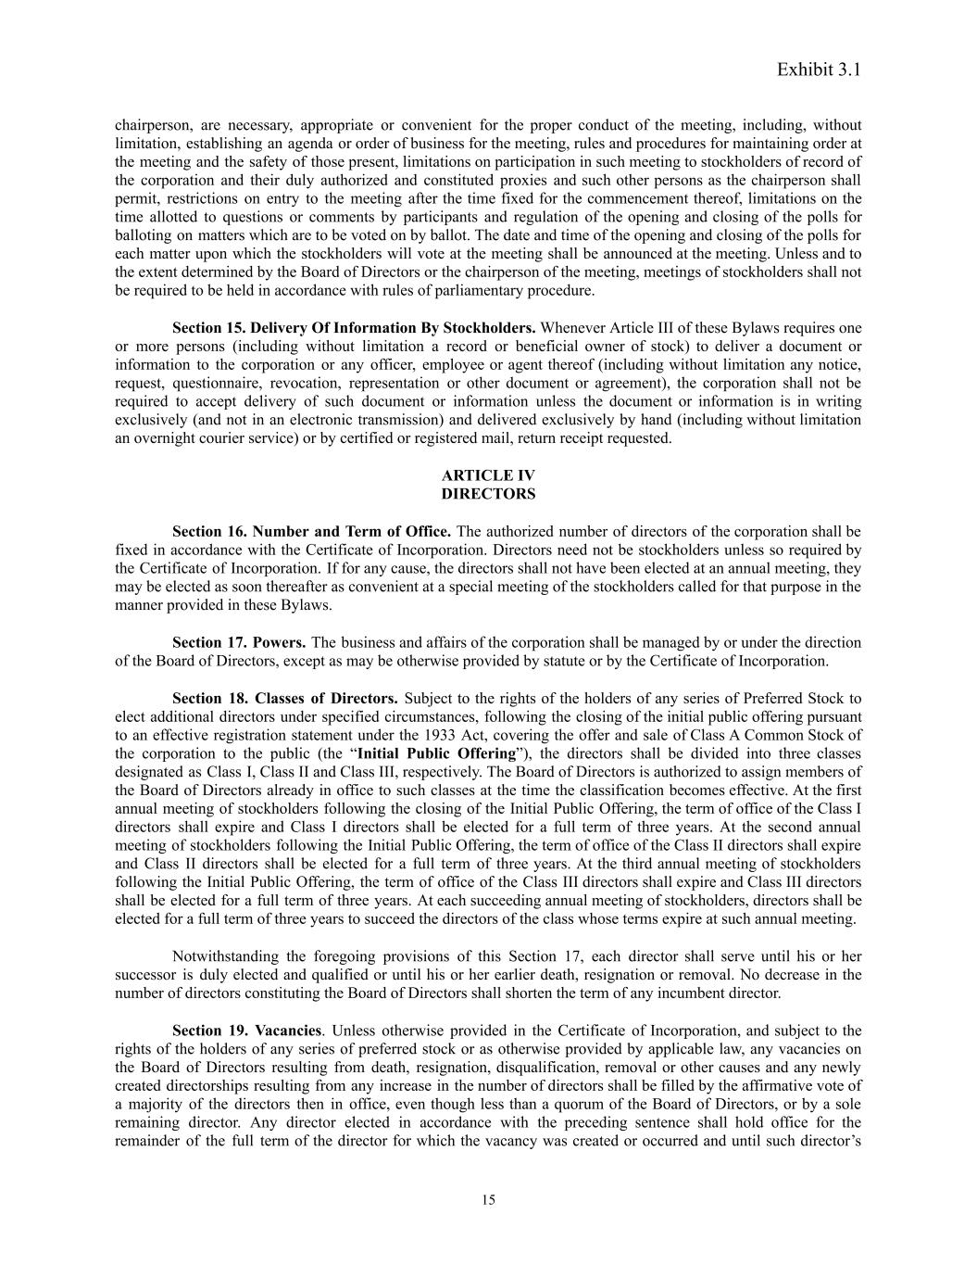
Exhibit 3.1 chairperson, are necessary, appropriate or convenient for the proper conduct of the meeting, including, without limitation, establishing an agenda or order of business for the meeting, rules and procedures for maintaining order at the meeting and the safety of those present, limitations on participation in such meeting to stockholders of record of the corporation and their duly authorized and constituted proxies and such other persons as the chairperson shall permit, restrictions on entry to the meeting after the time fixed for the commencement thereof, limitations on the time allotted to questions or comments by participants and regulation of the opening and closing of the polls for balloting on matters which are to be voted on by ballot. The date and time of the opening and closing of the polls for each matter upon which the stockholders will vote at the meeting shall be announced at the meeting. Unless and to the extent determined by the Board of Directors or the chairperson of the meeting, meetings of stockholders shall not be required to be held in accordance with rules of parliamentary procedure. Section 15. Delivery Of Information By Stockholders. Whenever Article III of these Bylaws requires one or more persons (including without limitation a record or beneficial owner of stock) to deliver a document or information to the corporation or any officer, employee or agent thereof (including without limitation any notice, request, questionnaire, revocation, representation or other document or agreement), the corporation shall not be required to accept delivery of such document or information unless the document or information is in writing exclusively (and not in an electronic transmission) and delivered exclusively by hand (including without limitation an overnight courier service) or by certified or registered mail, return receipt requested. ARTICLE IV DIRECTORS Section 16. Number and Term of Office. The authorized number of directors of the corporation shall be fixed in accordance with the Certificate of Incorporation. Directors need not be stockholders unless so required by the Certificate of Incorporation. If for any cause, the directors shall not have been elected at an annual meeting, they may be elected as soon thereafter as convenient at a special meeting of the stockholders called for that purpose in the manner provided in these Bylaws. Section 17. Powers. The business and affairs of the corporation shall be managed by or under the direction of the Board of Directors, except as may be otherwise provided by statute or by the Certificate of Incorporation. Section 18. Classes of Directors. Subject to the rights of the holders of any series of Preferred Stock to elect additional directors under specified circumstances, following the closing of the initial public offering pursuant to an effective registration statement under the 1933 Act, covering the offer and sale of Class A Common Stock of the corporation to the public (the “Initial Public Offering”), the directors shall be divided into three classes designated as Class I, Class II and Class III, respectively. The Board of Directors is authorized to assign members of the Board of Directors already in office to such classes at the time the classification becomes effective. At the first annual meeting of stockholders following the closing of the Initial Public Offering, the term of office of the Class I directors shall expire and Class I directors shall be elected for a full term of three years. At the second annual meeting of stockholders following the Initial Public Offering, the term of office of the Class II directors shall expire and Class II directors shall be elected for a full term of three years. At the third annual meeting of stockholders following the Initial Public Offering, the term of office of the Class III directors shall expire and Class III directors shall be elected for a full term of three years. At each succeeding annual meeting of stockholders, directors shall be elected for a full term of three years to succeed the directors of the class whose terms expire at such annual meeting. Notwithstanding the foregoing provisions of this Section 17, each director shall serve until his or her successor is duly elected and qualified or until his or her earlier death, resignation or removal. No decrease in the number of directors constituting the Board of Directors shall shorten the term of any incumbent director. Section 19. Vacancies. Unless otherwise provided in the Certificate of Incorporation, and subject to the rights of the holders of any series of preferred stock or as otherwise provided by applicable law, any vacancies on the Board of Directors resulting from death, resignation, disqualification, removal or other causes and any newly created directorships resulting from any increase in the number of directors shall be filled by the affirmative vote of a majority of the directors then in office, even though less than a quorum of the Board of Directors, or by a sole remaining director. Any director elected in accordance with the preceding sentence shall hold office for the remainder of the full term of the director for which the vacancy was created or occurred and until such director’s 15

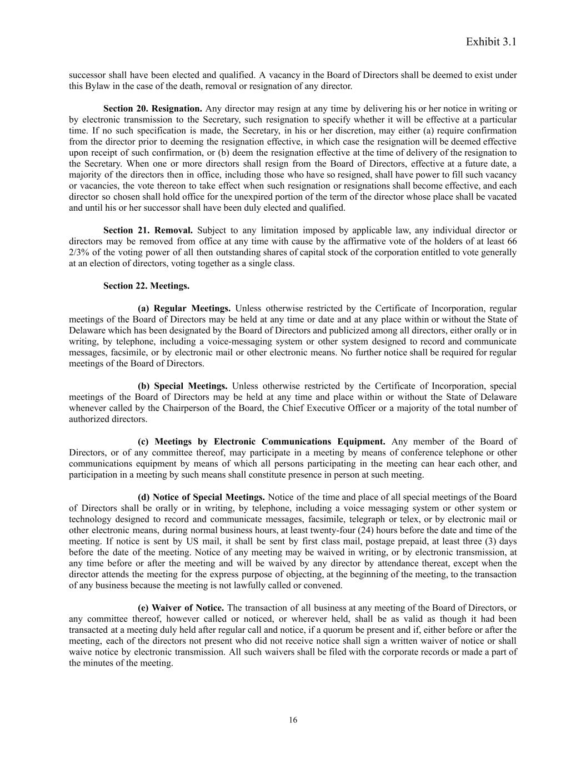
Exhibit 3.1 successor shall have been elected and qualified. A vacancy in the Board of Directors shall be deemed to exist under this Bylaw in the case of the death, removal or resignation of any director. Section 20. Resignation. Any director may resign at any time by delivering his or her notice in writing or by electronic transmission to the Secretary, such resignation to specify whether it will be effective at a particular time. If no such specification is made, the Secretary, in his or her discretion, may either (a) require confirmation from the director prior to deeming the resignation effective, in which case the resignation will be deemed effective upon receipt of such confirmation, or (b) deem the resignation effective at the time of delivery of the resignation to the Secretary. When one or more directors shall resign from the Board of Directors, effective at a future date, a majority of the directors then in office, including those who have so resigned, shall have power to fill such vacancy or vacancies, the vote thereon to take effect when such resignation or resignations shall become effective, and each director so chosen shall hold office for the unexpired portion of the term of the director whose place shall be vacated and until his or her successor shall have been duly elected and qualified. Section 21. Removal. Subject to any limitation imposed by applicable law, any individual director or directors may be removed from office at any time with cause by the affirmative vote of the holders of at least 66 2/3% of the voting power of all then outstanding shares of capital stock of the corporation entitled to vote generally at an election of directors, voting together as a single class. Section 22. Meetings. (a) Regular Meetings. Unless otherwise restricted by the Certificate of Incorporation, regular meetings of the Board of Directors may be held at any time or date and at any place within or without the State of Delaware which has been designated by the Board of Directors and publicized among all directors, either orally or in writing, by telephone, including a voice-messaging system or other system designed to record and communicate messages, facsimile, or by electronic mail or other electronic means. No further notice shall be required for regular meetings of the Board of Directors. (b) Special Meetings. Unless otherwise restricted by the Certificate of Incorporation, special meetings of the Board of Directors may be held at any time and place within or without the State of Delaware whenever called by the Chairperson of the Board, the Chief Executive Officer or a majority of the total number of authorized directors. (c) Meetings by Electronic Communications Equipment. Any member of the Board of Directors, or of any committee thereof, may participate in a meeting by means of conference telephone or other communications equipment by means of which all persons participating in the meeting can hear each other, and participation in a meeting by such means shall constitute presence in person at such meeting. (d) Notice of Special Meetings. Notice of the time and place of all special meetings of the Board of Directors shall be orally or in writing, by telephone, including a voice messaging system or other system or technology designed to record and communicate messages, facsimile, telegraph or telex, or by electronic mail or other electronic means, during normal business hours, at least twenty-four (24) hours before the date and time of the meeting. If notice is sent by US mail, it shall be sent by first class mail, postage prepaid, at least three (3) days before the date of the meeting. Notice of any meeting may be waived in writing, or by electronic transmission, at any time before or after the meeting and will be waived by any director by attendance thereat, except when the director attends the meeting for the express purpose of objecting, at the beginning of the meeting, to the transaction of any business because the meeting is not lawfully called or convened. (e) Waiver of Notice. The transaction of all business at any meeting of the Board of Directors, or any committee thereof, however called or noticed, or wherever held, shall be as valid as though it had been transacted at a meeting duly held after regular call and notice, if a quorum be present and if, either before or after the meeting, each of the directors not present who did not receive notice shall sign a written waiver of notice or shall waive notice by electronic transmission. All such waivers shall be filed with the corporate records or made a part of the minutes of the meeting. 16

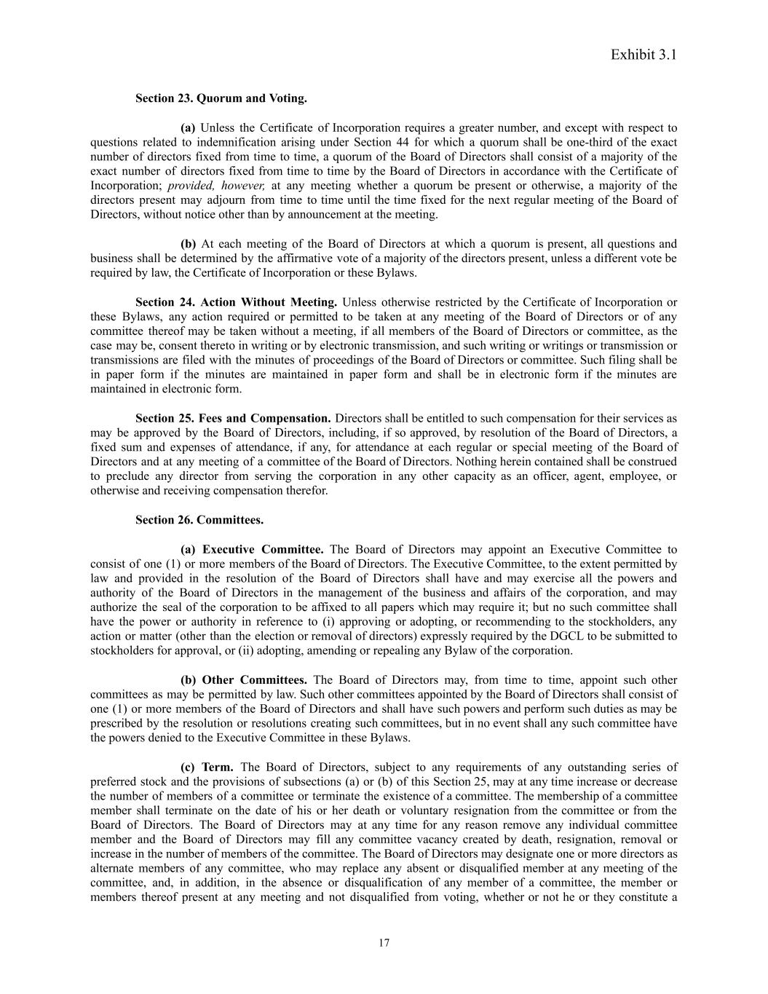
Exhibit 3.1 Section 23. Quorum and Voting. (a) Unless the Certificate of Incorporation requires a greater number, and except with respect to questions related to indemnification arising under Section 44 for which a quorum shall be one-third of the exact number of directors fixed from time to time, a quorum of the Board of Directors shall consist of a majority of the exact number of directors fixed from time to time by the Board of Directors in accordance with the Certificate of Incorporation; provided, however, at any meeting whether a quorum be present or otherwise, a majority of the directors present may adjourn from time to time until the time fixed for the next regular meeting of the Board of Directors, without notice other than by announcement at the meeting. (b) At each meeting of the Board of Directors at which a quorum is present, all questions and business shall be determined by the affirmative vote of a majority of the directors present, unless a different vote be required by law, the Certificate of Incorporation or these Bylaws. Section 24. Action Without Meeting. Unless otherwise restricted by the Certificate of Incorporation or these Bylaws, any action required or permitted to be taken at any meeting of the Board of Directors or of any committee thereof may be taken without a meeting, if all members of the Board of Directors or committee, as the case may be, consent thereto in writing or by electronic transmission, and such writing or writings or transmission or transmissions are filed with the minutes of proceedings of the Board of Directors or committee. Such filing shall be in paper form if the minutes are maintained in paper form and shall be in electronic form if the minutes are maintained in electronic form. Section 25. Fees and Compensation. Directors shall be entitled to such compensation for their services as may be approved by the Board of Directors, including, if so approved, by resolution of the Board of Directors, a fixed sum and expenses of attendance, if any, for attendance at each regular or special meeting of the Board of Directors and at any meeting of a committee of the Board of Directors. Nothing herein contained shall be construed to preclude any director from serving the corporation in any other capacity as an officer, agent, employee, or otherwise and receiving compensation therefor. Section 26. Committees. (a) Executive Committee. The Board of Directors may appoint an Executive Committee to consist of one (1) or more members of the Board of Directors. The Executive Committee, to the extent permitted by law and provided in the resolution of the Board of Directors shall have and may exercise all the powers and authority of the Board of Directors in the management of the business and affairs of the corporation, and may authorize the seal of the corporation to be affixed to all papers which may require it; but no such committee shall have the power or authority in reference to (i) approving or adopting, or recommending to the stockholders, any action or matter (other than the election or removal of directors) expressly required by the DGCL to be submitted to stockholders for approval, or (ii) adopting, amending or repealing any Bylaw of the corporation. (b) Other Committees. The Board of Directors may, from time to time, appoint such other committees as may be permitted by law. Such other committees appointed by the Board of Directors shall consist of one (1) or more members of the Board of Directors and shall have such powers and perform such duties as may be prescribed by the resolution or resolutions creating such committees, but in no event shall any such committee have the powers denied to the Executive Committee in these Bylaws. (c) Term. The Board of Directors, subject to any requirements of any outstanding series of preferred stock and the provisions of subsections (a) or (b) of this Section 25, may at any time increase or decrease the number of members of a committee or terminate the existence of a committee. The membership of a committee member shall terminate on the date of his or her death or voluntary resignation from the committee or from the Board of Directors. The Board of Directors may at any time for any reason remove any individual committee member and the Board of Directors may fill any committee vacancy created by death, resignation, removal or increase in the number of members of the committee. The Board of Directors may designate one or more directors as alternate members of any committee, who may replace any absent or disqualified member at any meeting of the committee, and, in addition, in the absence or disqualification of any member of a committee, the member or members thereof present at any meeting and not disqualified from voting, whether or not he or they constitute a 17

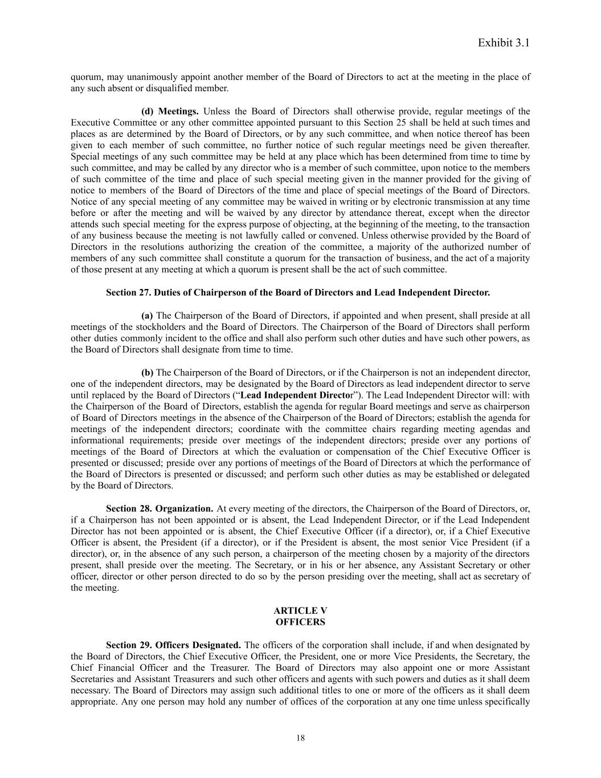
Exhibit 3.1 quorum, may unanimously appoint another member of the Board of Directors to act at the meeting in the place of any such absent or disqualified member. (d) Meetings. Unless the Board of Directors shall otherwise provide, regular meetings of the Executive Committee or any other committee appointed pursuant to this Section 25 shall be held at such times and places as are determined by the Board of Directors, or by any such committee, and when notice thereof has been given to each member of such committee, no further notice of such regular meetings need be given thereafter. Special meetings of any such committee may be held at any place which has been determined from time to time by such committee, and may be called by any director who is a member of such committee, upon notice to the members of such committee of the time and place of such special meeting given in the manner provided for the giving of notice to members of the Board of Directors of the time and place of special meetings of the Board of Directors. Notice of any special meeting of any committee may be waived in writing or by electronic transmission at any time before or after the meeting and will be waived by any director by attendance thereat, except when the director attends such special meeting for the express purpose of objecting, at the beginning of the meeting, to the transaction of any business because the meeting is not lawfully called or convened. Unless otherwise provided by the Board of Directors in the resolutions authorizing the creation of the committee, a majority of the authorized number of members of any such committee shall constitute a quorum for the transaction of business, and the act of a majority of those present at any meeting at which a quorum is present shall be the act of such committee. Section 27. Duties of Chairperson of the Board of Directors and Lead Independent Director. (a) The Chairperson of the Board of Directors, if appointed and when present, shall preside at all meetings of the stockholders and the Board of Directors. The Chairperson of the Board of Directors shall perform other duties commonly incident to the office and shall also perform such other duties and have such other powers, as the Board of Directors shall designate from time to time. (b) The Chairperson of the Board of Directors, or if the Chairperson is not an independent director, one of the independent directors, may be designated by the Board of Directors as lead independent director to serve until replaced by the Board of Directors (“Lead Independent Director”). The Lead Independent Director will: with the Chairperson of the Board of Directors, establish the agenda for regular Board meetings and serve as chairperson of Board of Directors meetings in the absence of the Chairperson of the Board of Directors; establish the agenda for meetings of the independent directors; coordinate with the committee chairs regarding meeting agendas and informational requirements; preside over meetings of the independent directors; preside over any portions of meetings of the Board of Directors at which the evaluation or compensation of the Chief Executive Officer is presented or discussed; preside over any portions of meetings of the Board of Directors at which the performance of the Board of Directors is presented or discussed; and perform such other duties as may be established or delegated by the Board of Directors. Section 28. Organization. At every meeting of the directors, the Chairperson of the Board of Directors, or, if a Chairperson has not been appointed or is absent, the Lead Independent Director, or if the Lead Independent Director has not been appointed or is absent, the Chief Executive Officer (if a director), or, if a Chief Executive Officer is absent, the President (if a director), or if the President is absent, the most senior Vice President (if a director), or, in the absence of any such person, a chairperson of the meeting chosen by a majority of the directors present, shall preside over the meeting. The Secretary, or in his or her absence, any Assistant Secretary or other officer, director or other person directed to do so by the person presiding over the meeting, shall act as secretary of the meeting. ARTICLE V OFFICERS Section 29. Officers Designated. The officers of the corporation shall include, if and when designated by the Board of Directors, the Chief Executive Officer, the President, one or more Vice Presidents, the Secretary, the Chief Financial Officer and the Treasurer. The Board of Directors may also appoint one or more Assistant Secretaries and Assistant Treasurers and such other officers and agents with such powers and duties as it shall deem necessary. The Board of Directors may assign such additional titles to one or more of the officers as it shall deem appropriate. Any one person may hold any number of offices of the corporation at any one time unless specifically 18

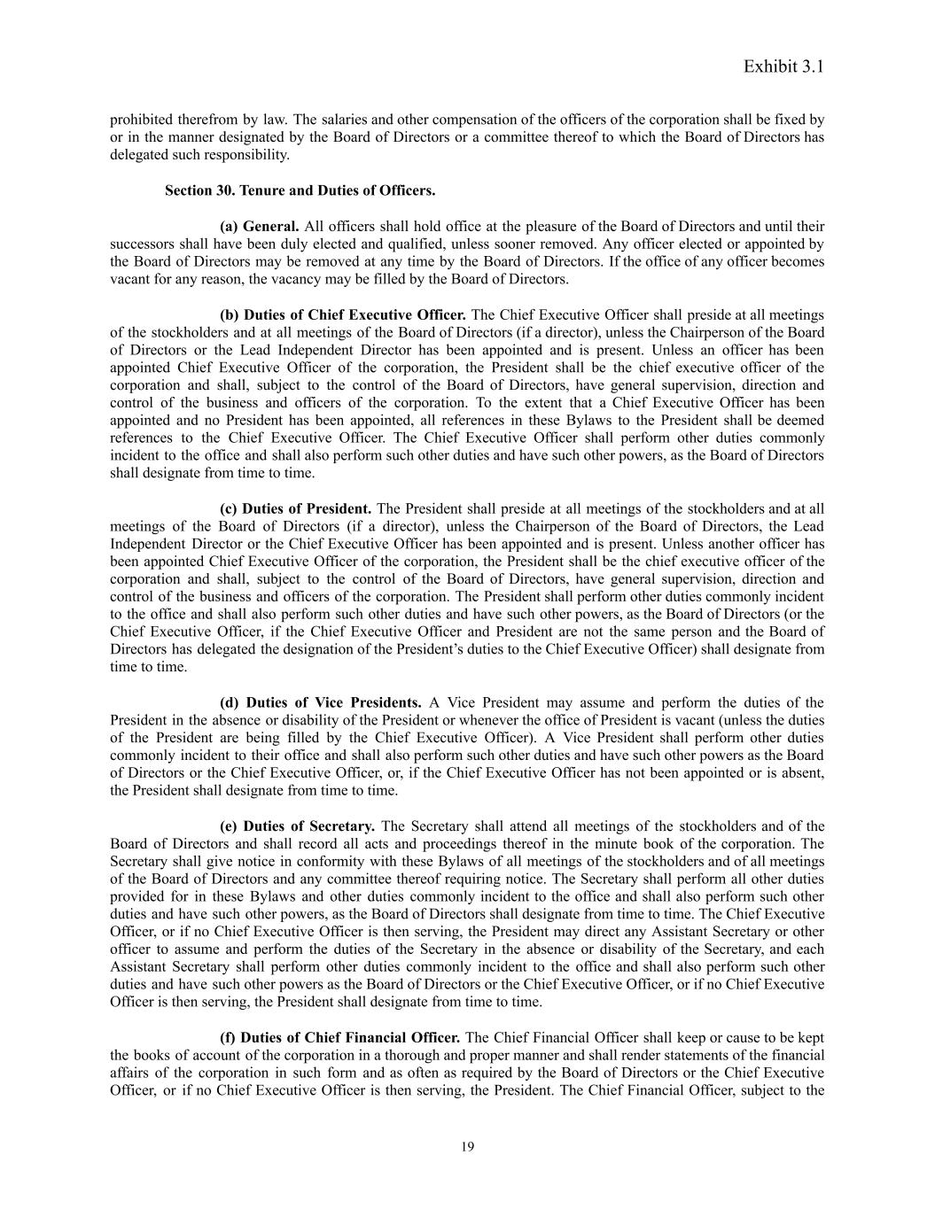
Exhibit 3.1 prohibited therefrom by law. The salaries and other compensation of the officers of the corporation shall be fixed by or in the manner designated by the Board of Directors or a committee thereof to which the Board of Directors has delegated such responsibility. Section 30. Tenure and Duties of Officers. (a) General. All officers shall hold office at the pleasure of the Board of Directors and until their successors shall have been duly elected and qualified, unless sooner removed. Any officer elected or appointed by the Board of Directors may be removed at any time by the Board of Directors. If the office of any officer becomes vacant for any reason, the vacancy may be filled by the Board of Directors. (b) Duties of Chief Executive Officer. The Chief Executive Officer shall preside at all meetings of the stockholders and at all meetings of the Board of Directors (if a director), unless the Chairperson of the Board of Directors or the Lead Independent Director has been appointed and is present. Unless an officer has been appointed Chief Executive Officer of the corporation, the President shall be the chief executive officer of the corporation and shall, subject to the control of the Board of Directors, have general supervision, direction and control of the business and officers of the corporation. To the extent that a Chief Executive Officer has been appointed and no President has been appointed, all references in these Bylaws to the President shall be deemed references to the Chief Executive Officer. The Chief Executive Officer shall perform other duties commonly incident to the office and shall also perform such other duties and have such other powers, as the Board of Directors shall designate from time to time. (c) Duties of President. The President shall preside at all meetings of the stockholders and at all meetings of the Board of Directors (if a director), unless the Chairperson of the Board of Directors, the Lead Independent Director or the Chief Executive Officer has been appointed and is present. Unless another officer has been appointed Chief Executive Officer of the corporation, the President shall be the chief executive officer of the corporation and shall, subject to the control of the Board of Directors, have general supervision, direction and control of the business and officers of the corporation. The President shall perform other duties commonly incident to the office and shall also perform such other duties and have such other powers, as the Board of Directors (or the Chief Executive Officer, if the Chief Executive Officer and President are not the same person and the Board of Directors has delegated the designation of the President’s duties to the Chief Executive Officer) shall designate from time to time. (d) Duties of Vice Presidents. A Vice President may assume and perform the duties of the President in the absence or disability of the President or whenever the office of President is vacant (unless the duties of the President are being filled by the Chief Executive Officer). A Vice President shall perform other duties commonly incident to their office and shall also perform such other duties and have such other powers as the Board of Directors or the Chief Executive Officer, or, if the Chief Executive Officer has not been appointed or is absent, the President shall designate from time to time. (e) Duties of Secretary. The Secretary shall attend all meetings of the stockholders and of the Board of Directors and shall record all acts and proceedings thereof in the minute book of the corporation. The Secretary shall give notice in conformity with these Bylaws of all meetings of the stockholders and of all meetings of the Board of Directors and any committee thereof requiring notice. The Secretary shall perform all other duties provided for in these Bylaws and other duties commonly incident to the office and shall also perform such other duties and have such other powers, as the Board of Directors shall designate from time to time. The Chief Executive Officer, or if no Chief Executive Officer is then serving, the President may direct any Assistant Secretary or other officer to assume and perform the duties of the Secretary in the absence or disability of the Secretary, and each Assistant Secretary shall perform other duties commonly incident to the office and shall also perform such other duties and have such other powers as the Board of Directors or the Chief Executive Officer, or if no Chief Executive Officer is then serving, the President shall designate from time to time. (f) Duties of Chief Financial Officer. The Chief Financial Officer shall keep or cause to be kept the books of account of the corporation in a thorough and proper manner and shall render statements of the financial affairs of the corporation in such form and as often as required by the Board of Directors or the Chief Executive Officer, or if no Chief Executive Officer is then serving, the President. The Chief Financial Officer, subject to the 19

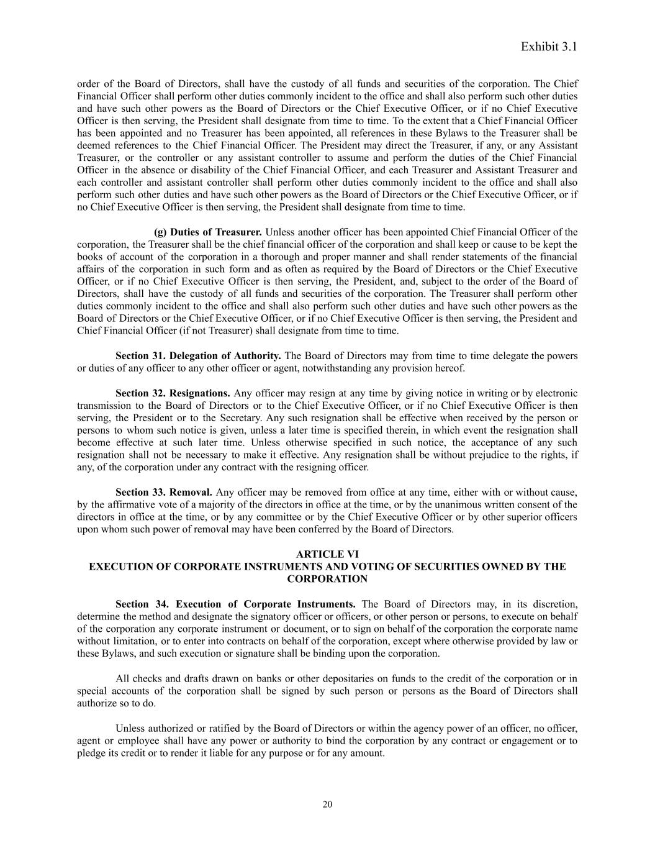
Exhibit 3.1 order of the Board of Directors, shall have the custody of all funds and securities of the corporation. The Chief Financial Officer shall perform other duties commonly incident to the office and shall also perform such other duties and have such other powers as the Board of Directors or the Chief Executive Officer, or if no Chief Executive Officer is then serving, the President shall designate from time to time. To the extent that a Chief Financial Officer has been appointed and no Treasurer has been appointed, all references in these Bylaws to the Treasurer shall be deemed references to the Chief Financial Officer. The President may direct the Treasurer, if any, or any Assistant Treasurer, or the controller or any assistant controller to assume and perform the duties of the Chief Financial Officer in the absence or disability of the Chief Financial Officer, and each Treasurer and Assistant Treasurer and each controller and assistant controller shall perform other duties commonly incident to the office and shall also perform such other duties and have such other powers as the Board of Directors or the Chief Executive Officer, or if no Chief Executive Officer is then serving, the President shall designate from time to time. (g) Duties of Treasurer. Unless another officer has been appointed Chief Financial Officer of the corporation, the Treasurer shall be the chief financial officer of the corporation and shall keep or cause to be kept the books of account of the corporation in a thorough and proper manner and shall render statements of the financial affairs of the corporation in such form and as often as required by the Board of Directors or the Chief Executive Officer, or if no Chief Executive Officer is then serving, the President, and, subject to the order of the Board of Directors, shall have the custody of all funds and securities of the corporation. The Treasurer shall perform other duties commonly incident to the office and shall also perform such other duties and have such other powers as the Board of Directors or the Chief Executive Officer, or if no Chief Executive Officer is then serving, the President and Chief Financial Officer (if not Treasurer) shall designate from time to time. Section 31. Delegation of Authority. The Board of Directors may from time to time delegate the powers or duties of any officer to any other officer or agent, notwithstanding any provision hereof. Section 32. Resignations. Any officer may resign at any time by giving notice in writing or by electronic transmission to the Board of Directors or to the Chief Executive Officer, or if no Chief Executive Officer is then serving, the President or to the Secretary. Any such resignation shall be effective when received by the person or persons to whom such notice is given, unless a later time is specified therein, in which event the resignation shall become effective at such later time. Unless otherwise specified in such notice, the acceptance of any such resignation shall not be necessary to make it effective. Any resignation shall be without prejudice to the rights, if any, of the corporation under any contract with the resigning officer. Section 33. Removal. Any officer may be removed from office at any time, either with or without cause, by the affirmative vote of a majority of the directors in office at the time, or by the unanimous written consent of the directors in office at the time, or by any committee or by the Chief Executive Officer or by other superior officers upon whom such power of removal may have been conferred by the Board of Directors. ARTICLE VI EXECUTION OF CORPORATE INSTRUMENTS AND VOTING OF SECURITIES OWNED BY THE CORPORATION Section 34. Execution of Corporate Instruments. The Board of Directors may, in its discretion, determine the method and designate the signatory officer or officers, or other person or persons, to execute on behalf of the corporation any corporate instrument or document, or to sign on behalf of the corporation the corporate name without limitation, or to enter into contracts on behalf of the corporation, except where otherwise provided by law or these Bylaws, and such execution or signature shall be binding upon the corporation. All checks and drafts drawn on banks or other depositaries on funds to the credit of the corporation or in special accounts of the corporation shall be signed by such person or persons as the Board of Directors shall authorize so to do. Unless authorized or ratified by the Board of Directors or within the agency power of an officer, no officer, agent or employee shall have any power or authority to bind the corporation by any contract or engagement or to pledge its credit or to render it liable for any purpose or for any amount. 20

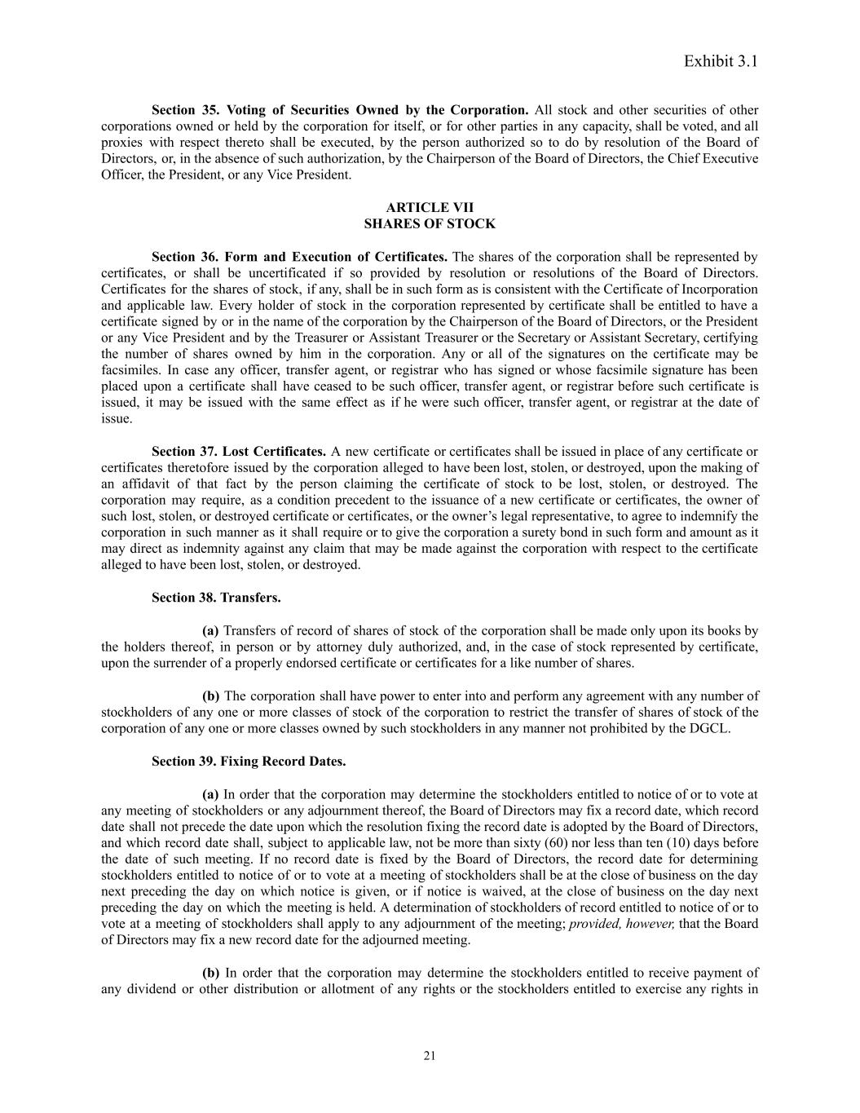
Exhibit 3.1 Section 35. Voting of Securities Owned by the Corporation. All stock and other securities of other corporations owned or held by the corporation for itself, or for other parties in any capacity, shall be voted, and all proxies with respect thereto shall be executed, by the person authorized so to do by resolution of the Board of Directors, or, in the absence of such authorization, by the Chairperson of the Board of Directors, the Chief Executive Officer, the President, or any Vice President. ARTICLE VII SHARES OF STOCK Section 36. Form and Execution of Certificates. The shares of the corporation shall be represented by certificates, or shall be uncertificated if so provided by resolution or resolutions of the Board of Directors. Certificates for the shares of stock, if any, shall be in such form as is consistent with the Certificate of Incorporation and applicable law. Every holder of stock in the corporation represented by certificate shall be entitled to have a certificate signed by or in the name of the corporation by the Chairperson of the Board of Directors, or the President or any Vice President and by the Treasurer or Assistant Treasurer or the Secretary or Assistant Secretary, certifying the number of shares owned by him in the corporation. Any or all of the signatures on the certificate may be facsimiles. In case any officer, transfer agent, or registrar who has signed or whose facsimile signature has been placed upon a certificate shall have ceased to be such officer, transfer agent, or registrar before such certificate is issued, it may be issued with the same effect as if he were such officer, transfer agent, or registrar at the date of issue. Section 37. Lost Certificates. A new certificate or certificates shall be issued in place of any certificate or certificates theretofore issued by the corporation alleged to have been lost, stolen, or destroyed, upon the making of an affidavit of that fact by the person claiming the certificate of stock to be lost, stolen, or destroyed. The corporation may require, as a condition precedent to the issuance of a new certificate or certificates, the owner of such lost, stolen, or destroyed certificate or certificates, or the owner’s legal representative, to agree to indemnify the corporation in such manner as it shall require or to give the corporation a surety bond in such form and amount as it may direct as indemnity against any claim that may be made against the corporation with respect to the certificate alleged to have been lost, stolen, or destroyed. Section 38. Transfers. (a) Transfers of record of shares of stock of the corporation shall be made only upon its books by the holders thereof, in person or by attorney duly authorized, and, in the case of stock represented by certificate, upon the surrender of a properly endorsed certificate or certificates for a like number of shares. (b) The corporation shall have power to enter into and perform any agreement with any number of stockholders of any one or more classes of stock of the corporation to restrict the transfer of shares of stock of the corporation of any one or more classes owned by such stockholders in any manner not prohibited by the DGCL. Section 39. Fixing Record Dates. (a) In order that the corporation may determine the stockholders entitled to notice of or to vote at any meeting of stockholders or any adjournment thereof, the Board of Directors may fix a record date, which record date shall not precede the date upon which the resolution fixing the record date is adopted by the Board of Directors, and which record date shall, subject to applicable law, not be more than sixty (60) nor less than ten (10) days before the date of such meeting. If no record date is fixed by the Board of Directors, the record date for determining stockholders entitled to notice of or to vote at a meeting of stockholders shall be at the close of business on the day next preceding the day on which notice is given, or if notice is waived, at the close of business on the day next preceding the day on which the meeting is held. A determination of stockholders of record entitled to notice of or to vote at a meeting of stockholders shall apply to any adjournment of the meeting; provided, however, that the Board of Directors may fix a new record date for the adjourned meeting. (b) In order that the corporation may determine the stockholders entitled to receive payment of any dividend or other distribution or allotment of any rights or the stockholders entitled to exercise any rights in 21

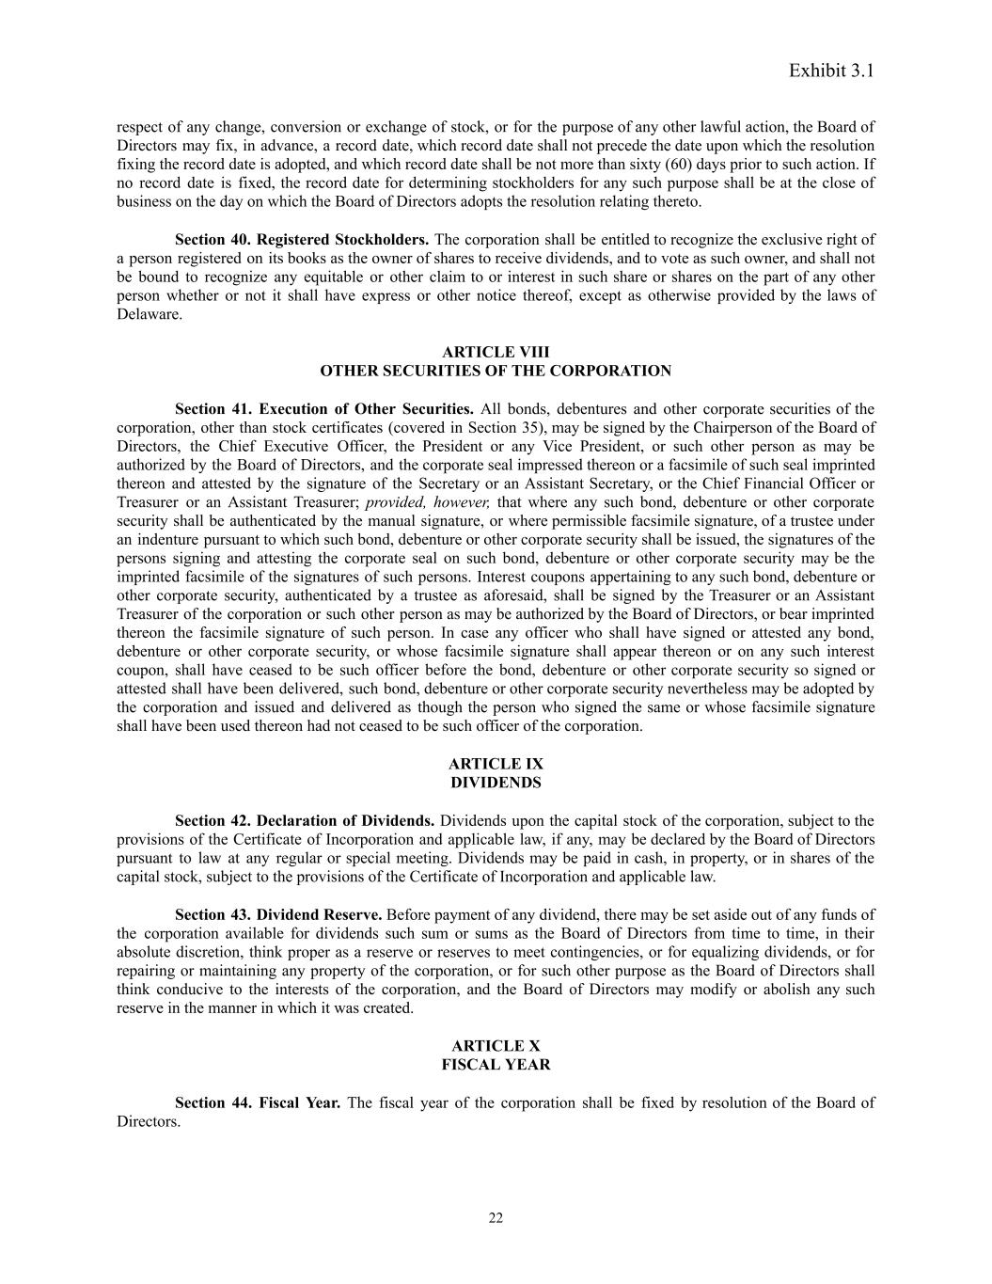
Exhibit 3.1 respect of any change, conversion or exchange of stock, or for the purpose of any other lawful action, the Board of Directors may fix, in advance, a record date, which record date shall not precede the date upon which the resolution fixing the record date is adopted, and which record date shall be not more than sixty (60) days prior to such action. If no record date is fixed, the record date for determining stockholders for any such purpose shall be at the close of business on the day on which the Board of Directors adopts the resolution relating thereto. Section 40. Registered Stockholders. The corporation shall be entitled to recognize the exclusive right of a person registered on its books as the owner of shares to receive dividends, and to vote as such owner, and shall not be bound to recognize any equitable or other claim to or interest in such share or shares on the part of any other person whether or not it shall have express or other notice thereof, except as otherwise provided by the laws of Delaware. ARTICLE VIII OTHER SECURITIES OF THE CORPORATION Section 41. Execution of Other Securities. All bonds, debentures and other corporate securities of the corporation, other than stock certificates (covered in Section 35), may be signed by the Chairperson of the Board of Directors, the Chief Executive Officer, the President or any Vice President, or such other person as may be authorized by the Board of Directors, and the corporate seal impressed thereon or a facsimile of such seal imprinted thereon and attested by the signature of the Secretary or an Assistant Secretary, or the Chief Financial Officer or Treasurer or an Assistant Treasurer; provided, however, that where any such bond, debenture or other corporate security shall be authenticated by the manual signature, or where permissible facsimile signature, of a trustee under an indenture pursuant to which such bond, debenture or other corporate security shall be issued, the signatures of the persons signing and attesting the corporate seal on such bond, debenture or other corporate security may be the imprinted facsimile of the signatures of such persons. Interest coupons appertaining to any such bond, debenture or other corporate security, authenticated by a trustee as aforesaid, shall be signed by the Treasurer or an Assistant Treasurer of the corporation or such other person as may be authorized by the Board of Directors, or bear imprinted thereon the facsimile signature of such person. In case any officer who shall have signed or attested any bond, debenture or other corporate security, or whose facsimile signature shall appear thereon or on any such interest coupon, shall have ceased to be such officer before the bond, debenture or other corporate security so signed or attested shall have been delivered, such bond, debenture or other corporate security nevertheless may be adopted by the corporation and issued and delivered as though the person who signed the same or whose facsimile signature shall have been used thereon had not ceased to be such officer of the corporation. ARTICLE IX DIVIDENDS Section 42. Declaration of Dividends. Dividends upon the capital stock of the corporation, subject to the provisions of the Certificate of Incorporation and applicable law, if any, may be declared by the Board of Directors pursuant to law at any regular or special meeting. Dividends may be paid in cash, in property, or in shares of the capital stock, subject to the provisions of the Certificate of Incorporation and applicable law. Section 43. Dividend Reserve. Before payment of any dividend, there may be set aside out of any funds of the corporation available for dividends such sum or sums as the Board of Directors from time to time, in their absolute discretion, think proper as a reserve or reserves to meet contingencies, or for equalizing dividends, or for repairing or maintaining any property of the corporation, or for such other purpose as the Board of Directors shall think conducive to the interests of the corporation, and the Board of Directors may modify or abolish any such reserve in the manner in which it was created. ARTICLE X FISCAL YEAR Section 44. Fiscal Year. The fiscal year of the corporation shall be fixed by resolution of the Board of Directors. 22

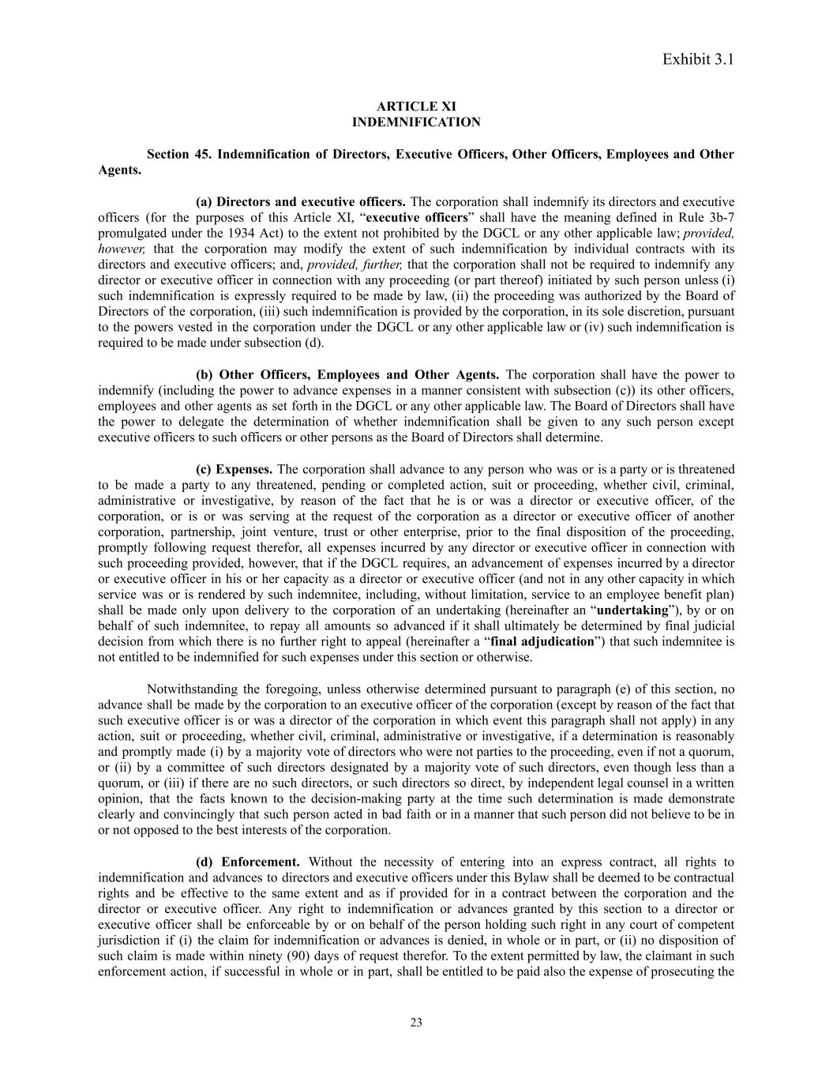
Exhibit 3.1 ARTICLE XI INDEMNIFICATION Section 45. Indemnification of Directors, Executive Officers, Other Officers, Employees and Other Agents. (a) Directors and executive officers. The corporation shall indemnify its directors and executive officers (for the purposes of this Article XI, “executive officers” shall have the meaning defined in Rule 3b-7 promulgated under the 1934 Act) to the extent not prohibited by the DGCL or any other applicable law; provided, however, that the corporation may modify the extent of such indemnification by individual contracts with its directors and executive officers; and, provided, further, that the corporation shall not be required to indemnify any director or executive officer in connection with any proceeding (or part thereof) initiated by such person unless (i) such indemnification is expressly required to be made by law, (ii) the proceeding was authorized by the Board of Directors of the corporation, (iii) such indemnification is provided by the corporation, in its sole discretion, pursuant to the powers vested in the corporation under the DGCL or any other applicable law or (iv) such indemnification is required to be made under subsection (d). (b) Other Officers, Employees and Other Agents. The corporation shall have the power to indemnify (including the power to advance expenses in a manner consistent with subsection (c)) its other officers, employees and other agents as set forth in the DGCL or any other applicable law. The Board of Directors shall have the power to delegate the determination of whether indemnification shall be given to any such person except executive officers to such officers or other persons as the Board of Directors shall determine. (c) Expenses. The corporation shall advance to any person who was or is a party or is threatened to be made a party to any threatened, pending or completed action, suit or proceeding, whether civil, criminal, administrative or investigative, by reason of the fact that he is or was a director or executive officer, of the corporation, or is or was serving at the request of the corporation as a director or executive officer of another corporation, partnership, joint venture, trust or other enterprise, prior to the final disposition of the proceeding, promptly following request therefor, all expenses incurred by any director or executive officer in connection with such proceeding provided, however, that if the DGCL requires, an advancement of expenses incurred by a director or executive officer in his or her capacity as a director or executive officer (and not in any other capacity in which service was or is rendered by such indemnitee, including, without limitation, service to an employee benefit plan) shall be made only upon delivery to the corporation of an undertaking (hereinafter an “undertaking”), by or on behalf of such indemnitee, to repay all amounts so advanced if it shall ultimately be determined by final judicial decision from which there is no further right to appeal (hereinafter a “final adjudication”) that such indemnitee is not entitled to be indemnified for such expenses under this section or otherwise. Notwithstanding the foregoing, unless otherwise determined pursuant to paragraph (e) of this section, no advance shall be made by the corporation to an executive officer of the corporation (except by reason of the fact that such executive officer is or was a director of the corporation in which event this paragraph shall not apply) in any action, suit or proceeding, whether civil, criminal, administrative or investigative, if a determination is reasonably and promptly made (i) by a majority vote of directors who were not parties to the proceeding, even if not a quorum, or (ii) by a committee of such directors designated by a majority vote of such directors, even though less than a quorum, or (iii) if there are no such directors, or such directors so direct, by independent legal counsel in a written opinion, that the facts known to the decision-making party at the time such determination is made demonstrate clearly and convincingly that such person acted in bad faith or in a manner that such person did not believe to be in or not opposed to the best interests of the corporation. (d) Enforcement. Without the necessity of entering into an express contract, all rights to indemnification and advances to directors and executive officers under this Bylaw shall be deemed to be contractual rights and be effective to the same extent and as if provided for in a contract between the corporation and the director or executive officer. Any right to indemnification or advances granted by this section to a director or executive officer shall be enforceable by or on behalf of the person holding such right in any court of competent jurisdiction if (i) the claim for indemnification or advances is denied, in whole or in part, or (ii) no disposition of such claim is made within ninety (90) days of request therefor. To the extent permitted by law, the claimant in such enforcement action, if successful in whole or in part, shall be entitled to be paid also the expense of prosecuting the 23

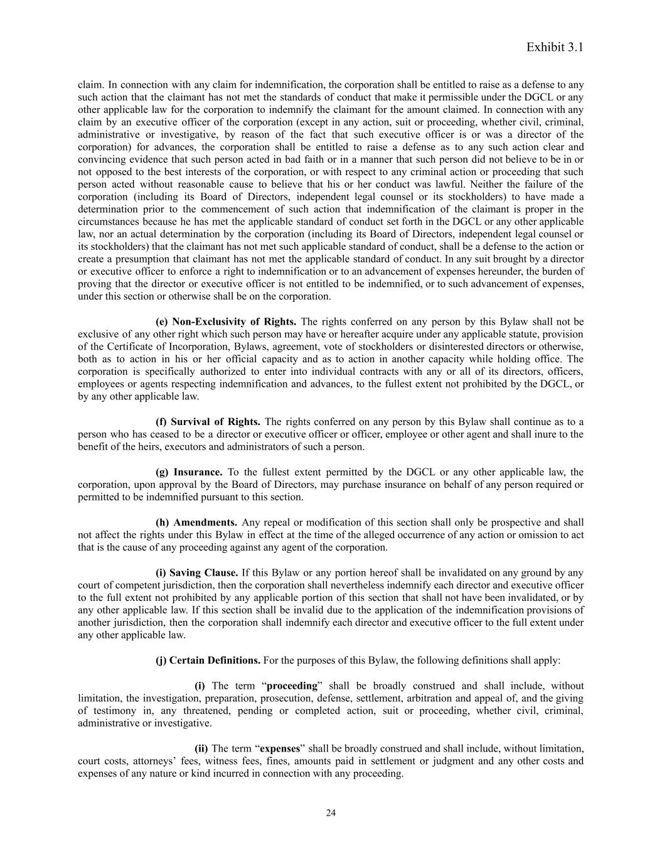
Exhibit 3.1 claim. In connection with any claim for indemnification, the corporation shall be entitled to raise as a defense to any such action that the claimant has not met the standards of conduct that make it permissible under the DGCL or any other applicable law for the corporation to indemnify the claimant for the amount claimed. In connection with any claim by an executive officer of the corporation (except in any action, suit or proceeding, whether civil, criminal, administrative or investigative, by reason of the fact that such executive officer is or was a director of the corporation) for advances, the corporation shall be entitled to raise a defense as to any such action clear and convincing evidence that such person acted in bad faith or in a manner that such person did not believe to be in or not opposed to the best interests of the corporation, or with respect to any criminal action or proceeding that such person acted without reasonable cause to believe that his or her conduct was lawful. Neither the failure of the corporation (including its Board of Directors, independent legal counsel or its stockholders) to have made a determination prior to the commencement of such action that indemnification of the claimant is proper in the circumstances because he has met the applicable standard of conduct set forth in the DGCL or any other applicable law, nor an actual determination by the corporation (including its Board of Directors, independent legal counsel or its stockholders) that the claimant has not met such applicable standard of conduct, shall be a defense to the action or create a presumption that claimant has not met the applicable standard of conduct. In any suit brought by a director or executive officer to enforce a right to indemnification or to an advancement of expenses hereunder, the burden of proving that the director or executive officer is not entitled to be indemnified, or to such advancement of expenses, under this section or otherwise shall be on the corporation. (e) Non-Exclusivity of Rights. The rights conferred on any person by this Bylaw shall not be exclusive of any other right which such person may have or hereafter acquire under any applicable statute, provision of the Certificate of Incorporation, Bylaws, agreement, vote of stockholders or disinterested directors or otherwise, both as to action in his or her official capacity and as to action in another capacity while holding office. The corporation is specifically authorized to enter into individual contracts with any or all of its directors, officers, employees or agents respecting indemnification and advances, to the fullest extent not prohibited by the DGCL, or by any other applicable law. (f) Survival of Rights. The rights conferred on any person by this Bylaw shall continue as to a person who has ceased to be a director or executive officer or officer, employee or other agent and shall inure to the benefit of the heirs, executors and administrators of such a person. (g) Insurance. To the fullest extent permitted by the DGCL or any other applicable law, the corporation, upon approval by the Board of Directors, may purchase insurance on behalf of any person required or permitted to be indemnified pursuant to this section. (h) Amendments. Any repeal or modification of this section shall only be prospective and shall not affect the rights under this Bylaw in effect at the time of the alleged occurrence of any action or omission to act that is the cause of any proceeding against any agent of the corporation. (i) Saving Clause. If this Bylaw or any portion hereof shall be invalidated on any ground by any court of competent jurisdiction, then the corporation shall nevertheless indemnify each director and executive officer to the full extent not prohibited by any applicable portion of this section that shall not have been invalidated, or by any other applicable law. If this section shall be invalid due to the application of the indemnification provisions of another jurisdiction, then the corporation shall indemnify each director and executive officer to the full extent under any other applicable law. (j) Certain Definitions. For the purposes of this Bylaw, the following definitions shall apply: (i) The term “proceeding” shall be broadly construed and shall include, without limitation, the investigation, preparation, prosecution, defense, settlement, arbitration and appeal of, and the giving of testimony in, any threatened, pending or completed action, suit or proceeding, whether civil, criminal, administrative or investigative. (ii) The term “expenses” shall be broadly construed and shall include, without limitation, court costs, attorneys’ fees, witness fees, fines, amounts paid in settlement or judgment and any other costs and expenses of any nature or kind incurred in connection with any proceeding. 24

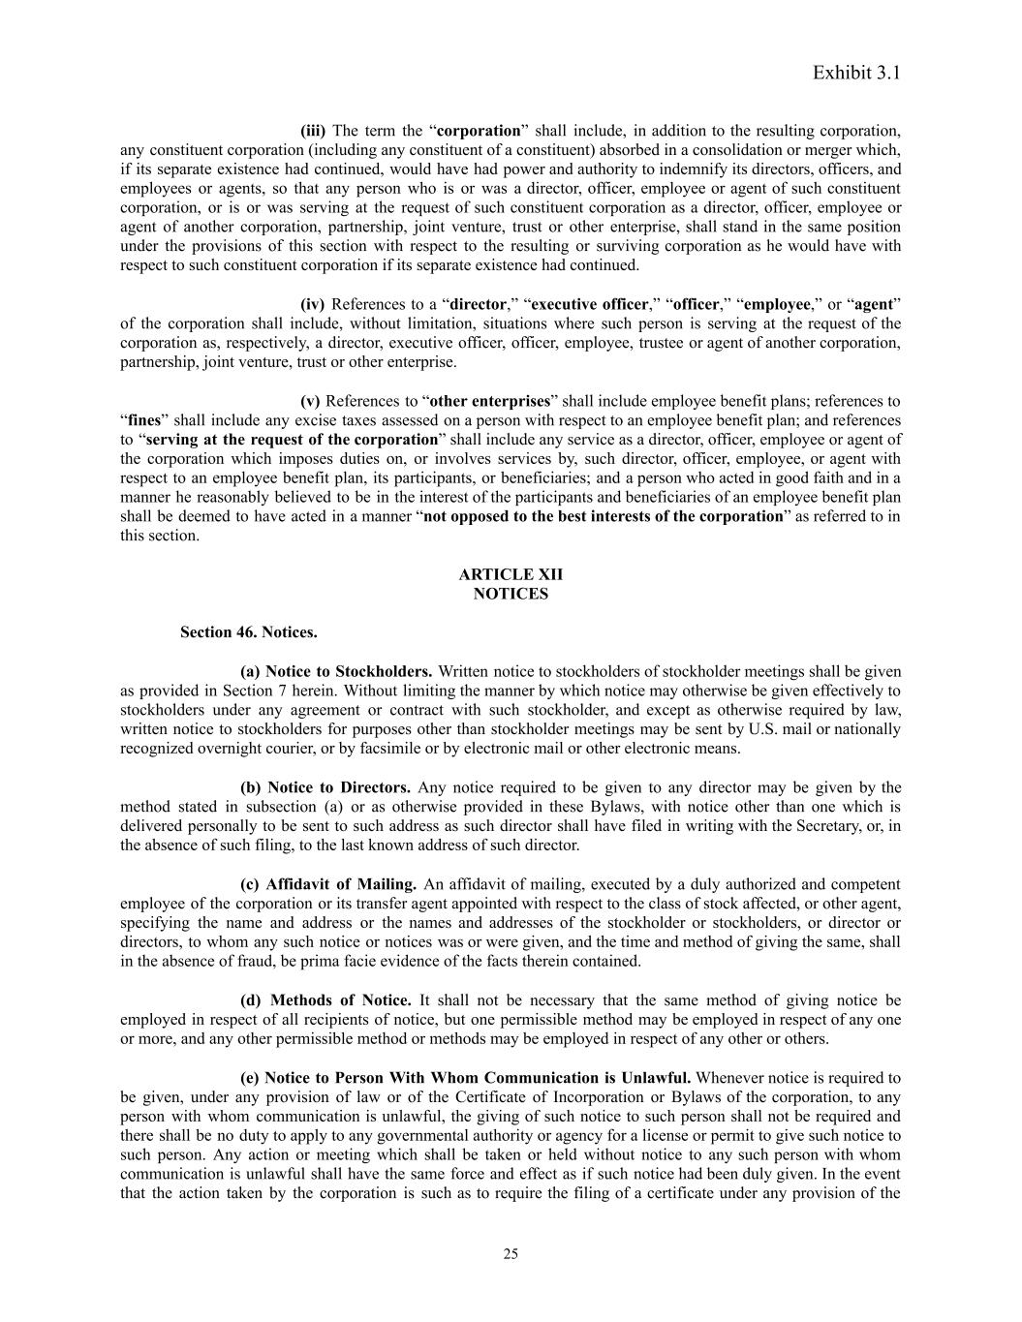
Exhibit 3.1 (iii) The term the “corporation” shall include, in addition to the resulting corporation, any constituent corporation (including any constituent of a constituent) absorbed in a consolidation or merger which, if its separate existence had continued, would have had power and authority to indemnify its directors, officers, and employees or agents, so that any person who is or was a director, officer, employee or agent of such constituent corporation, or is or was serving at the request of such constituent corporation as a director, officer, employee or agent of another corporation, partnership, joint venture, trust or other enterprise, shall stand in the same position under the provisions of this section with respect to the resulting or surviving corporation as he would have with respect to such constituent corporation if its separate existence had continued. (iv) References to a “director,” “executive officer,” “officer,” “employee,” or “agent” of the corporation shall include, without limitation, situations where such person is serving at the request of the corporation as, respectively, a director, executive officer, officer, employee, trustee or agent of another corporation, partnership, joint venture, trust or other enterprise. (v) References to “other enterprises” shall include employee benefit plans; references to “fines” shall include any excise taxes assessed on a person with respect to an employee benefit plan; and references to “serving at the request of the corporation” shall include any service as a director, officer, employee or agent of the corporation which imposes duties on, or involves services by, such director, officer, employee, or agent with respect to an employee benefit plan, its participants, or beneficiaries; and a person who acted in good faith and in a manner he reasonably believed to be in the interest of the participants and beneficiaries of an employee benefit plan shall be deemed to have acted in a manner “not opposed to the best interests of the corporation” as referred to in this section. ARTICLE XII NOTICES Section 46. Notices. (a) Notice to Stockholders. Written notice to stockholders of stockholder meetings shall be given as provided in Section 7 herein. Without limiting the manner by which notice may otherwise be given effectively to stockholders under any agreement or contract with such stockholder, and except as otherwise required by law, written notice to stockholders for purposes other than stockholder meetings may be sent by U.S. mail or nationally recognized overnight courier, or by facsimile or by electronic mail or other electronic means. (b) Notice to Directors. Any notice required to be given to any director may be given by the method stated in subsection (a) or as otherwise provided in these Bylaws, with notice other than one which is delivered personally to be sent to such address as such director shall have filed in writing with the Secretary, or, in the absence of such filing, to the last known address of such director. (c) Affidavit of Mailing. An affidavit of mailing, executed by a duly authorized and competent employee of the corporation or its transfer agent appointed with respect to the class of stock affected, or other agent, specifying the name and address or the names and addresses of the stockholder or stockholders, or director or directors, to whom any such notice or notices was or were given, and the time and method of giving the same, shall in the absence of fraud, be prima facie evidence of the facts therein contained. (d) Methods of Notice. It shall not be necessary that the same method of giving notice be employed in respect of all recipients of notice, but one permissible method may be employed in respect of any one or more, and any other permissible method or methods may be employed in respect of any other or others. (e) Notice to Person With Whom Communication is Unlawful. Whenever notice is required to be given, under any provision of law or of the Certificate of Incorporation or Bylaws of the corporation, to any person with whom communication is unlawful, the giving of such notice to such person shall not be required and there shall be no duty to apply to any governmental authority or agency for a license or permit to give such notice to such person. Any action or meeting which shall be taken or held without notice to any such person with whom communication is unlawful shall have the same force and effect as if such notice had been duly given. In the event that the action taken by the corporation is such as to require the filing of a certificate under any provision of the 25

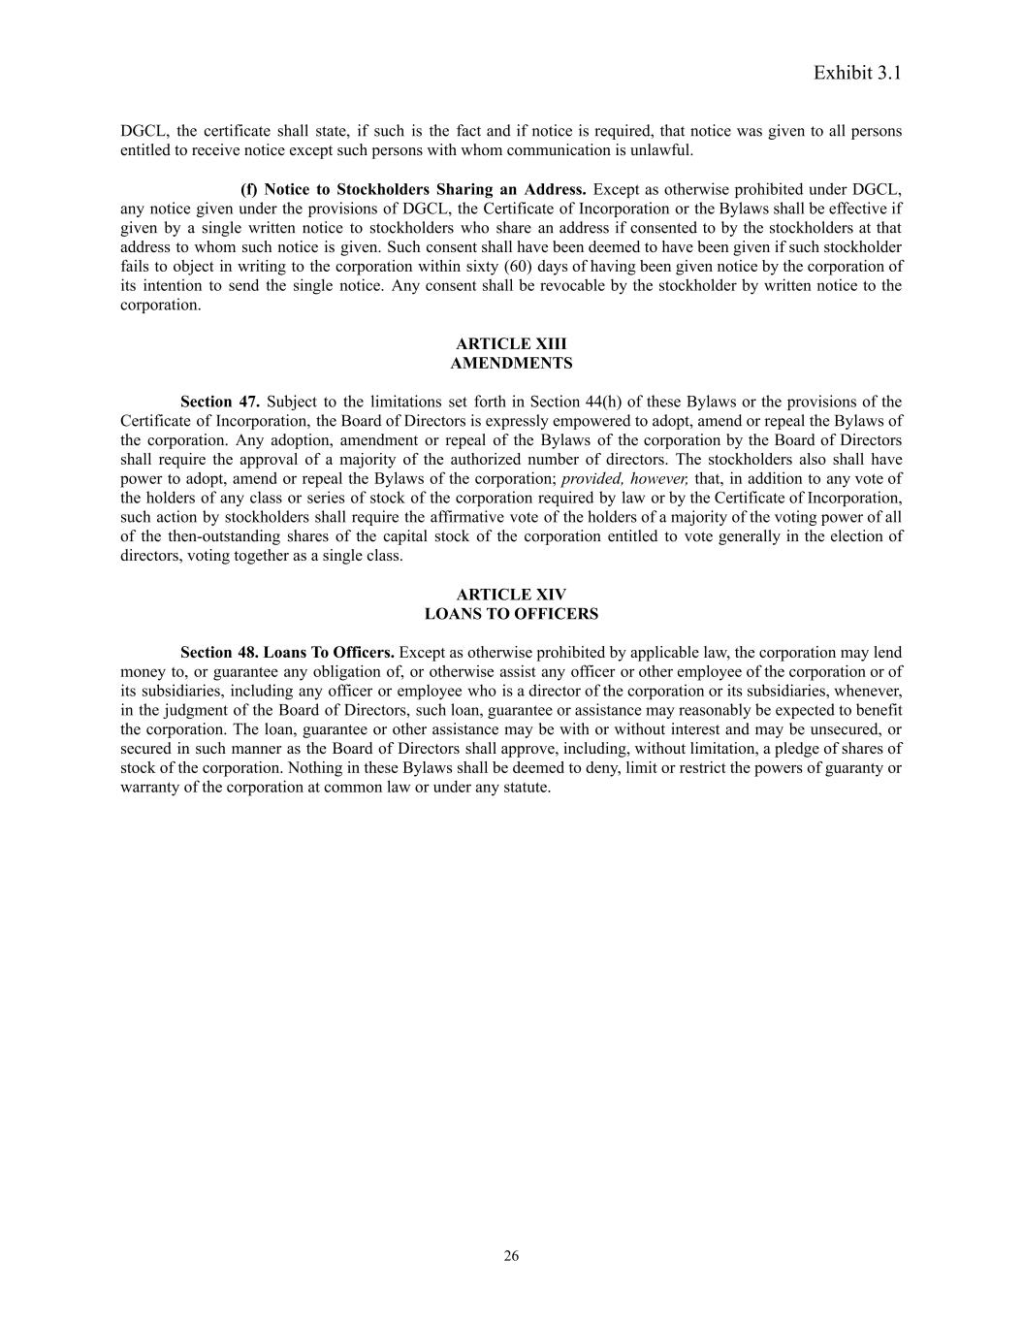
Exhibit 3.1 DGCL, the certificate shall state, if such is the fact and if notice is required, that notice was given to all persons entitled to receive notice except such persons with whom communication is unlawful. (f) Notice to Stockholders Sharing an Address. Except as otherwise prohibited under DGCL, any notice given under the provisions of DGCL, the Certificate of Incorporation or the Bylaws shall be effective if given by a single written notice to stockholders who share an address if consented to by the stockholders at that address to whom such notice is given. Such consent shall have been deemed to have been given if such stockholder fails to object in writing to the corporation within sixty (60) days of having been given notice by the corporation of its intention to send the single notice. Any consent shall be revocable by the stockholder by written notice to the corporation. ARTICLE XIII AMENDMENTS Section 47. Subject to the limitations set forth in Section 44(h) of these Bylaws or the provisions of the Certificate of Incorporation, the Board of Directors is expressly empowered to adopt, amend or repeal the Bylaws of the corporation. Any adoption, amendment or repeal of the Bylaws of the corporation by the Board of Directors shall require the approval of a majority of the authorized number of directors. The stockholders also shall have power to adopt, amend or repeal the Bylaws of the corporation; provided, however, that, in addition to any vote of the holders of any class or series of stock of the corporation required by law or by the Certificate of Incorporation, such action by stockholders shall require the affirmative vote of the holders of a majority of the voting power of all of the then-outstanding shares of the capital stock of the corporation entitled to vote generally in the election of directors, voting together as a single class. ARTICLE XIV LOANS TO OFFICERS Section 48. Loans To Officers. Except as otherwise prohibited by applicable law, the corporation may lend money to, or guarantee any obligation of, or otherwise assist any officer or other employee of the corporation or of its subsidiaries, including any officer or employee who is a director of the corporation or its subsidiaries, whenever, in the judgment of the Board of Directors, such loan, guarantee or assistance may reasonably be expected to benefit the corporation. The loan, guarantee or other assistance may be with or without interest and may be unsecured, or secured in such manner as the Board of Directors shall approve, including, without limitation, a pledge of shares of stock of the corporation. Nothing in these Bylaws shall be deemed to deny, limit or restrict the powers of guaranty or warranty of the corporation at common law or under any statute. 26

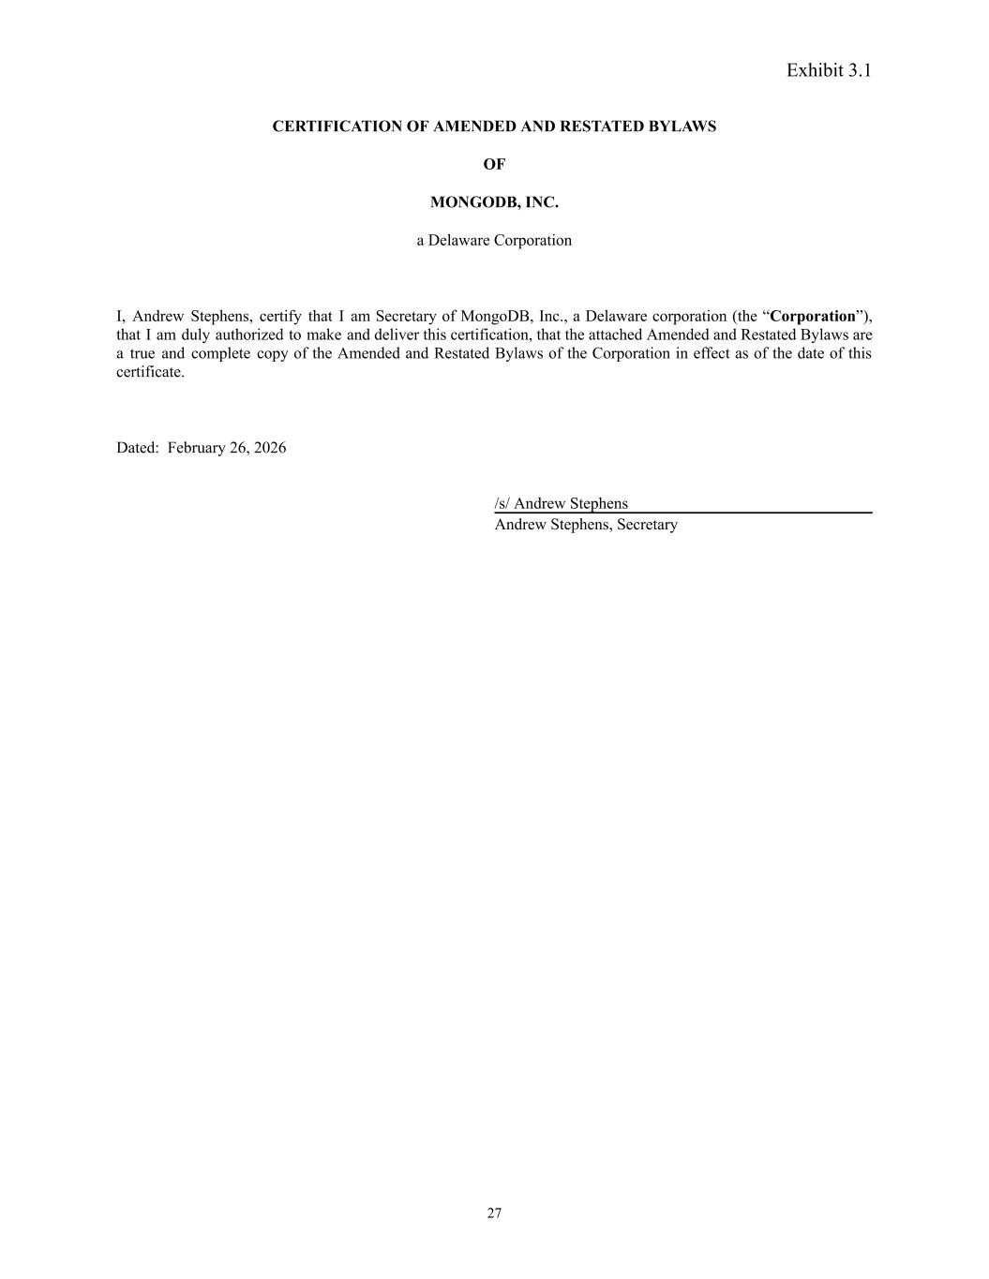
Exhibit 3.1 CERTIFICATION OF AMENDED AND RESTATED BYLAWS OF MONGODB, INC. a Delaware Corporation I, Andrew Stephens, certify that I am Secretary of MongoDB, Inc., a Delaware corporation (the “Corporation”), that I am duly authorized to make and deliver this certification, that the attached Amended and Restated Bylaws are a true and complete copy of the Amended and Restated Bylaws of the Corporation in effect as of the date of this certificate. Dated: February 26, 2026 /s/ Andrew Stephens Andrew Stephens, Secretary 27

Exhibit 99.1

MongoDB, Inc. Announces Fourth Quarter Fiscal 2026 Financial Results
Fourth Quarter Fiscal 2026 Total Revenue of $695.1 million, up 27% year-over-year
Full Year Fiscal 2026 Total Revenue of $2.46 billion, up 23% year-over-year
Atlas Revenue up 29% year-over-year in the Fourth Quarter and Full Year Fiscal 2026
Added 2,700 Customers, with Over 65,200 Total Customers as of January 31, 2026
NEW YORK - March 2, 2026 - MongoDB, Inc. (NASDAQ: MDB) today announced its financial results for the fourth quarter ended January 31, 2026.
"We delivered strong fourth quarter results driven by our continued go-to-market execution and the broad-based demand we are seeing across our product lines, as customers deploy additional elements of the MongoDB platform. At the same time, we significantly outperformed on operating margin, achieving a rule of 40 performance and demonstrating we can drive durable revenue growth while simultaneously expanding margin," said CJ Desai, President and Chief Executive Officer of MongoDB.

"Whether it's AI & digital natives looking for a highly performant solution that dynamically scales, a large enterprise looking for multi-cloud resiliency for their mission critical applications, or a customer seeking an integrated offering for AI agents with features such as search, vector search and embeddings in a single intelligent data layer, customers are excited about the strength of the MongoDB platform, the innovations we have been bringing to market, and plan to deliver in the years to come."

Fourth Quarter Fiscal 2026 Financial Highlights
•Revenue: Total revenue was $695.1 million for the fourth quarter of fiscal 2026, an increase of 27% year-over-year. Subscription revenue was $673.1 million, an increase of 27% year-over-year, and services revenue was $22.0 million, an increase of 26% year-over-year.
•Gross Profit: Gross profit was $507.7 million for the fourth quarter of fiscal 2026, representing a 73% gross margin compared to 73% in the year-ago period. Non-GAAP gross profit was $524.7 million, representing a 75% non-GAAP gross margin, compared to a non-GAAP gross margin of 75% in the year-ago period.
•Income (Loss) from Operations: Income from operations was $0.3 million for the fourth quarter of fiscal 2026, compared to a loss from operations of $18.6 million in the year-ago period. Non-GAAP income from operations was $158.8 million, compared to non-GAAP income from operations of $112.5 million in the year-ago period.
•Net Income: Net income was $15.5 million, or $0.18 per share, based on 86.5 million diluted weighted-average shares outstanding, for the fourth quarter of fiscal 2026. This compares to a net income of $15.8 million, or $0.19 per share, in the year-ago period. Non-GAAP net income was $142.7 million, or $1.65 per share, based on 86.5 million fully diluted weighted-average shares outstanding. This compares to a non-GAAP net income of $108.4 million, or $1.28, per share in the year-ago period.
•Cash Flow: As of January 31, 2026, MongoDB had $2.4 billion in cash, cash equivalents, short-term investments and restricted cash. During the three months ended January 31, 2026, MongoDB generated $179.6 million of cash from operations, compared to $50.5 million of cash from operations in the year-ago period. MongoDB used $1.1 million of cash in capital expenditures and used $1.7 million of cash in principal payments of finance leases, leading to free cash flow of $176.7 million, compared to free cash flow of $22.9 million in the year-ago period.
A reconciliation of each non-GAAP measure to the most directly comparable GAAP measure has been provided in the financial statement tables included at the end of this press release. An explanation of these measures is also included below under the heading “Non-GAAP Financial Measures.”

Fourth Quarter Fiscal 2026 and Recent Business Highlights
•At its flagship MongoDB.local San Francisco event, MongoDB announced the integration of its core database with industry-leading embedding and reranking models from Voyage AI by MongoDB. This integration creates a unified data intelligence layer for production AI, allowing developers to build sophisticated applications at scale with reduced hallucination risk and no requirement to move or duplicate data.
•MongoDB introduced a set of new AI capabilities designed to simplify how intelligent applications are built and operated. The launch included five new embedding models from Voyage AI by MongoDB (including the Voyage 4 series), Automated Embedding for MongoDB Community Vector Search, and new embedding and reranking AI model APIs for Atlas. Additionally, MongoDB launched an AI-powered data operations assistant for MongoDB Compass and Atlas Data Explorer.
•MongoDB announced an expansion to its MongoDB for Startups program; a reciprocal partner ecosystem that gives AI-first startups a production-ready data foundation and integrated stack from day one. MongoDB for Startups members now represent more than $200 billion in aggregate valuation, and MongoDB is increasing its Bay Area investment to deepen engagement with high-growth AI founders and drive long-term AI workloads on MongoDB.
•MongoDB was recognized as the Amazon Web Services (AWS) Global Technology Partner of the Year, reflecting the deep integration between MongoDB Atlas and AWS’s leading AI services—including Amazon Bedrock, Amazon SageMaker, and Amazon Q—and our shared focus on helping customers modernize applications and ship production generative AI workloads faster and more efficiently.
Leadership Update
Effective March 3rd, 2026, Erica Volini joins MongoDB as Chief Customer Officer to accelerate the company's next phase of growth. Erica brings a rare blend of experience serving large enterprise customers and scaling partner led growth – from leading a multi-billion dollar practice at Deloitte to most recently scaling ServiceNow's partner ecosystem and broader GTM strategy, as the company exceeded $10 billion in annual revenue.
MongoDB is also announcing that Cedric Pech, President of Field Operations, and Paul Capombassis, Chief Revenue Officer (CRO), are leaving MongoDB. This transition has been planned for some time, and the management team believes now is the right moment for this change. MongoDB extends the company's sincere gratitude for their contributions over the last decade, where they have been instrumental in building the foundation of the GTM engine. MongoDB has a deep bench of go-to-market talent, and the team is well-positioned to execute against its objectives without disruption. MongoDB is also in the latter stages of an executive search for a new CRO. To ensure operational continuity, Mr. Capombassis will remain as CRO through the end of the first quarter. He will serve as an advisor in the second quarter to ensure a seamless transition to the new CRO.

2
First Quarter Fiscal Year 2027 Guidance
Based on information available to management as of today, March 2, 2026, MongoDB is issuing the following financial guidance for the first quarter fiscal 2027.
Revenues are expected to be in the range of: |  |  | $659 million to $664 million
 |  |  | GAAP |  |  |  |  |  | Non-GAAP
Income (Loss) from Operations are expected to be in the range of: |  |  | $(48.0) million to $(44.0) million |  |  |  |  |  | $105.0 million to $109.0 million
Net Income (Loss) per Share is expected to be in the range of: |  |  | $(0.34) to $(0.29) |  |  |  |  |  | $1.15 to $1.19
Full Year Fiscal 2027 Guidance
Based on information available to management as of today, March 2, 2026, MongoDB is issuing the following financial guidance for the full year fiscal 2027.
Revenues are expected to be in the range of: |  |  | $2.860 billion to $2.900 billion
 |  |  | GAAP |  |  |  |  |  | Non-GAAP
Income (Loss) from Operations are expected to be in the range of: |  |  | $(117.0) million to $(97.0) million |  |  |  |  |  | $545.0 million to $565.0 million
Net Income (Loss) per Share is expected to be in the range of: |  |  | $(0.73) to $(0.49) |  |  |  |  |  | $5.75 to $5.93
Conference Call Information
MongoDB will host a conference call today, March 2, 2026, at 5:00 p.m. (Eastern Time) to discuss its financial results and business outlook. A live webcast of the call will be available on the “Investor Relations” page of MongoDB’s website at https://investors.mongodb.com. To access the call by phone, please go to this link (registration link), and you will be provided with dial in details. To avoid delays, we encourage participants to dial into the conference call fifteen minutes ahead of the scheduled start time. A replay of the webcast will also be available for a limited time at http://investors.mongodb.com.
3
Forward-Looking Statements
This press release includes certain “forward-looking statements” within the meaning of Section 27A of the Securities Act of 1933, as amended, or the Securities Act, and Section 21E of the Securities Exchange Act of 1934, as amended, including statements concerning MongoDB’s financial guidance for the fourth fiscal quarter and full year fiscal 2027. These forward-looking statements include, but are not limited to, plans, objectives, expectations and intentions and other statements contained in this press release that are not historical facts and statements identified by words such as “anticipate,” “believe,” “continue,” “could,” “estimate,” “expect,” “intend,” “may,” “plan,” “project,” “will,” “would” or the negative or plural of these words or similar expressions or variations. These forward-looking statements reflect our current views about our plans, intentions, expectations, strategies and prospects, which are based on the information currently available to us and on assumptions we have made. Although we believe that our plans, intentions, expectations, strategies and prospects as reflected in or suggested by those forward-looking statements are reasonable, we can give no assurance that the plans, intentions, expectations or strategies will be attained or achieved. Furthermore, actual results may differ materially from those described in the forward-looking statements and are subject to a variety of assumptions, uncertainties, risks and factors that are beyond our control including, without limitation: our customers renewing their subscriptions with us and expanding their usage of software and related services; global political changes; the effects of the ongoing military conflicts between Russia and Ukraine and Israel and Hamas and recent events in Venezuela on our business and future operating results; economic downturns and/or the effects of rising interest rates, inflation and volatility in the global economy and financial markets on our business and future operating results; our potential failure to meet publicly announced guidance or other expectations about our business and future operating results; reputational harm or other adverse consequences resulting from use of AI and ML in our product offerings and internal operations if they don't produce the desired benefits; our limited operating history; our history of losses; our potential failure to repurchase shares of our common stock at favorable prices, if at all; failure of our platform to satisfy customer demands; the effects of increased competition; our investments in new products and our ability to introduce new features, services or enhancements, including AI and ML; social, ethical and security issues relating to the use of new and evolving technologies, such as artificial intelligence, in our offerings or partnerships; our ability to effectively expand our sales and marketing organization; our ability to continue to build and maintain credibility with the developer community; our ability to add new customers or increase sales to our existing customers; our ability to maintain, protect, enforce and enhance our intellectual property; our ability to continue to increase revenue from our Atlas platform; the effects of social, ethical and regulatory issues relating to the use of new and evolving technologies, such as AI and ML, in our offerings or partnerships; the growth and expansion of the market for database products and our ability to penetrate that market; our ability to maintain the security of our software and adequately address privacy concerns; our ability to manage our growth effectively and successfully recruit and retain additional highly-qualified personnel; our ability to integrate acquisitions and work with our strategic partners effectively; and the price volatility of our common stock. These and other risks and uncertainties are more fully described in our filings with the Securities and Exchange Commission (“SEC”), including under the caption “Risk Factors” in our Quarterly Report on Form 10-Q for the fiscal quarter ended October 31, 2025, filed with the SEC on December 2, 2025. Additional information will be made available in our Annual Report on Form 10-K for the fiscal year ended January 31, 2026, and other filings and reports that we may file from time to time with the SEC. Except as required by law, we undertake no duty or obligation to update any forward-looking statements contained in this release as a result of new information, future events, changes in expectations or otherwise.
Non-GAAP Financial Measures
This press release includes the following financial measures defined as non-GAAP financial measures by the SEC: non-GAAP gross profit, non-GAAP gross margin, non-GAAP operating expenses, non-GAAP income from operations, non-GAAP operating margin, non-GAAP net income, non-GAAP net income per share and free cash flow. Non-GAAP gross profit and non-GAAP gross margin exclude expenses associated with stock-based compensation. Non-GAAP operating expenses, non-GAAP income from operations, non-GAAP operating margin, non-GAAP net income and non-GAAP net income per share exclude:
•expenses associated with stock-based compensation including employer payroll taxes upon the vesting and exercising of stock-based awards and expenses related to stock appreciation rights previously issued to our employees in China;
4
•amortization of intangible assets for the acquired technology and acquired customer relationships associated with prior acquisitions;
•certain acquisition-related costs and other, including due diligence costs, professional fees in connection with an acquisition and certain integration-related expenses. These expenses are unpredictable, and dependent on factors that may be outside of our control and unrelated to the continuing operations of the acquired business or our Company. In addition, the size and complexity of an acquisition, which often drives the magnitude of acquisition-related costs, may not be indicative of such future costs;
•restructuring costs associated with a formal restructuring plan that are primarily related to workforce reductions. The Company excludes these expenses because they are not reflective of ordinary course ongoing business and operating results; and
•in the case of non-GAAP net income and non-GAAP net income per share, amortization of the debt issuance costs associated with our convertible senior notes and gains or losses on our financial instruments;
•additionally, non-GAAP net income and non-GAAP net income per share are adjusted for an assumed provision for income taxes based on an estimated long-term non-GAAP tax rate as well as the tax charges or benefits resulting from the integration of intellectual property from acquisitions. The non-GAAP tax rate was calculated utilizing a three-year financial projection that excludes the direct impact of the GAAP to non-GAAP adjustments and considers other factors such as operating structure and existing tax positions in various jurisdictions. We intend to periodically reevaluate the projected long-term tax rate, as necessary, for significant events and our ongoing analysis of relevant tax law changes.
MongoDB uses these non-GAAP financial measures internally in analyzing its financial results and believes they are useful to investors, as a supplement to GAAP measures, in evaluating MongoDB’s ongoing operational performance. MongoDB believes that the use of these non-GAAP financial measures provides an additional tool for investors to use in evaluating ongoing operating results and trends and in comparing its financial results with other companies in MongoDB’s industry, many of which may present similar non-GAAP financial measures to investors.
Free cash flow represents net cash from/used in operating activities, less capital expenditures, principal payments of finance lease liabilities and capitalized software development costs, if any. MongoDB uses free cash flow to understand and evaluate its liquidity and to generate future operating plans. The exclusion of capital expenditures, principal payments of finance lease liabilities and amounts capitalized for software development facilitates comparisons of MongoDB’s liquidity on a period-to-period basis and excludes items that it does not consider to be indicative of its liquidity. MongoDB believes that free cash flow is a measure of liquidity that provides useful information to investors in understanding and evaluating the strength of its liquidity and future ability to generate cash that can be used for strategic opportunities or investing in its business in the same manner as MongoDB’s management and board of directors.
Non-GAAP financial measures have limitations as an analytical tool and should not be considered in isolation from, or as a substitute for, financial information prepared in accordance with GAAP. In particular, other companies may report non-GAAP gross profit, non-GAAP gross margin, non-GAAP operating expenses, non-GAAP income from operations, non-GAAP net income, non-GAAP net income per share, free cash flow or similarly titled measures but calculate them differently, which reduces their usefulness as comparative measures. Investors are encouraged to review the reconciliation of these non-GAAP financial measures to their most directly comparable GAAP financial measures, as presented below. This earnings press release and any future releases containing such non-GAAP reconciliations can also be found on the Investor Relations page of MongoDB’s website at https://investors.mongodb.com.
About MongoDB
Headquartered in New York, MongoDB’s mission is to empower innovators to create, transform, and disrupt industries with software and data. MongoDB's unified, intelligent data platform was built to power the next generation of applications, and MongoDB is the most widely available, globally distributed database on the market. With integrated capabilities for operational data, search, real-time analytics, and AI-powered retrieval, MongoDB helps organizations everywhere move faster, innovate more efficiently, and simplify complex architectures.
5
Millions of developers and more than 60,000 customers across almost every industry—including approximately 75% of the Fortune 100—rely on MongoDB for their most important applications. To learn more, visit mongodb.com.
Investor Relations
Jess Lubert
jess.lubert@mongodb.com

Media Relations
MongoDB
press@mongodb.com

6
MONGODB, INC.
CONDENSED CONSOLIDATED BALANCE SHEETS
(in thousands of U.S. dollars, except share and per share data)
(unaudited)

 |  |  | January 31, 2026 |  |  |  |  |  | January 31, 2025
Assets
Current assets:
Cash and cash equivalents |  |  | $ | 1,083,540 |  |  |  |  | $ | 490,133
Short-term investments |  |  | 1,303,701 |  |  |  |  |  | 1,846,444
Accounts receivable, net of allowance for doubtful accounts of $12,979 and $8,888 as of January 31, 2026 and January 31, 2025, respectively |  |  | 499,002 |  |  |  |  |  | 393,099
Deferred commissions |  |  | 131,442 |  |  |  |  |  | 112,632
Prepaid expenses and other current assets |  |  | 97,170 |  |  |  |  |  | 81,214
Total current assets |  |  | 3,114,855 |  |  |  |  |  | 2,923,522
Property and equipment, net |  |  | 39,773 |  |  |  |  |  | 46,377
Operating lease right-of-use assets |  |  | 28,978 |  |  |  |  |  | 34,607
Goodwill |  |  | 191,397 |  |  |  |  |  | 69,679
Intangible assets, net |  |  | 34,502 |  |  |  |  |  | 24,597
Deferred tax assets |  |  | 26,021 |  |  |  |  |  | 20,810
Other assets |  |  | 323,322 |  |  |  |  |  | 310,701
Total assets |  |  | $ | 3,758,848 |  |  |  |  | $ | 3,430,293
Liabilities and Stockholders’ Equity
Current liabilities:
Accounts payable |  |  | $ | 20,269 |  |  |  |  | $ | 10,467
Accrued compensation and benefits |  |  | 143,046 |  |  |  |  |  | 120,354
Operating lease liabilities |  |  | 9,259 |  |  |  |  |  | 9,126
Other accrued liabilities |  |  | 109,803 |  |  |  |  |  | 87,659
Deferred revenue |  |  | 387,119 |  |  |  |  |  | 334,381
Total current liabilities |  |  | 669,496 |  |  |  |  |  | 561,987
Deferred tax liability |  |  | 352 |  |  |  |  |  | 262
Operating lease liabilities |  |  | 23,600 |  |  |  |  |  | 27,374
Deferred revenue |  |  | 83,588 |  |  |  |  |  | 25,404
Other liabilities |  |  | 29,454 |  |  |  |  |  | 33,042
Total liabilities |  |  | 806,490 |  |  |  |  |  | 648,069
Stockholders’ equity:
Common stock, par value of $0.001 per share; 1,000,000,000 shares authorized as of January 31, 2026 and January 31, 2025; 83,370,769 shares issued and 80,492,774 shares outstanding as of January 31, 2026; 80,558,847 shares issued and 80,467,811 shares outstanding as of January 31, 2025 |  |  | 81 |  |  |  |  |  | 78
Additional paid-in capital |  |  | 5,345,494 |  |  |  |  |  | 4,625,093
Treasury stock, 2,877,995 shares (repurchased at an average of $171.84 per share) as of January 31, 2026 and 99,371 shares (repurchased at an average of $13.27 per share) as of January 31, 2025 |  |  | (494,569) |  |  |  |  |  | (1,319)
Accumulated other comprehensive income (loss) |  |  | 13,207 |  |  |  |  |  | (924)
Accumulated deficit |  |  | (1,911,855) |  |  |  |  |  | (1,840,704)
Total stockholders’ equity |  |  | 2,952,358 |  |  |  |  |  | 2,782,224
Total liabilities and stockholders’ equity |  |  | $ | 3,758,848 |  |  |  |  | $ | 3,430,293

7
MONGODB, INC.
CONDENSED CONSOLIDATED STATEMENTS OF OPERATIONS
(in thousands of U.S. dollars, except share and per share data)
(unaudited)

 |  |  | Three Months Ended January 31, |  |  |  |  |  |  |  |  |  |  |  | Years Ended January 31,
 |  |  | 2026 |  |  |  |  |  | 2025 |  |  |  |  |  | 2026 |  |  |  |  |  | 2025
Revenue:
Subscription |  |  | $ | 673,100 |  |  |  |  | $ | 530,958 |  |  |  |  | $ | 2,385,977 |  |  |  |  | $ | 1,943,864
Services |  |  | 21,972 |  |  |  |  |  | 17,440 |  |  |  |  |  | 77,820 |  |  |  |  |  | 62,579
Total revenue |  |  | 695,072 |  |  |  |  |  | 548,398 |  |  |  |  |  | 2,463,797 |  |  |  |  |  | 2,006,443
Cost of revenue:
Subscription(1) |  |  | 155,076 |  |  |  |  |  | 122,676 |  |  |  |  |  | 571,531 |  |  |  |  |  | 441,404
Services(1) |  |  | 32,336 |  |  |  |  |  | 26,339 |  |  |  |  |  | 124,527 |  |  |  |  |  | 93,892
Total cost of revenue |  |  | 187,412 |  |  |  |  |  | 149,015 |  |  |  |  |  | 696,058 |  |  |  |  |  | 535,296
Gross profit |  |  | 507,660 |  |  |  |  |  | 399,383 |  |  |  |  |  | 1,767,739 |  |  |  |  |  | 1,471,147
Operating expenses:
Sales and marketing(1) |  |  | 248,537 |  |  |  |  |  | 212,211 |  |  |  |  |  | 944,389 |  |  |  |  |  | 871,148
Research and development(1) |  |  | 189,125 |  |  |  |  |  | 150,400 |  |  |  |  |  | 716,303 |  |  |  |  |  | 596,837
General and administrative(1) |  |  | 69,694 |  |  |  |  |  | 55,334 |  |  |  |  |  | 244,015 |  |  |  |  |  | 219,226
Total operating expenses |  |  | 507,356 |  |  |  |  |  | 417,945 |  |  |  |  |  | 1,904,707 |  |  |  |  |  | 1,687,211
Income (loss) from operations |  |  | 304 |  |  |  |  |  | (18,562) |  |  |  |  |  | (136,968) |  |  |  |  |  | (216,064)
Other income, net |  |  | 19,099 |  |  |  |  |  | 22,716 |  |  |  |  |  | 81,277 |  |  |  |  |  | 84,465
Income (loss) before provision for (benefit from) income taxes |  |  | 19,403 |  |  |  |  |  | 4,154 |  |  |  |  |  | (55,691) |  |  |  |  |  | (131,599)
Provision for (benefit from) income taxes |  |  | 3,873 |  |  |  |  |  | (11,672) |  |  |  |  |  | 15,460 |  |  |  |  |  | (2,527)
Net income (loss) |  |  | $ | 15,530 |  |  |  |  | $ | 15,826 |  |  |  |  | $ | (71,151) |  |  |  |  | $ | (129,072)
Net income (loss) per share:
Basic |  |  | $ | 0.19 |  |  |  |  | $ | 0.20 |  |  |  |  | $ | (0.88) |  |  |  |  | $ | (1.73)
Diluted |  |  | $ | 0.18 |  |  |  |  | $ | 0.19 |  |  |  |  | $ | (0.88) |  |  |  |  | $ | (1.73)
Weighted-average shares used to compute net income (loss) per share:
Basic |  |  | 81,281,748 |  |  |  |  |  | 77,631,824 |  |  |  |  |  | 81,246,520 |  |  |  |  |  | 74,555,001
Diluted |  |  | 86,457,703 |  |  |  |  |  | 84,594,079 |  |  |  |  |  | 81,246,520 |  |  |  |  |  | 74,555,001
(1) Includes stock-based compensation expense as follows:
 |  |  | Three Months Ended January 31, |  |  |  |  |  |  |  |  |  |  |  | Years Ended January 31,
 |  |  | 2026 |  |  |  |  |  | 2025 |  |  |  |  |  | 2026 |  |  |  |  |  | 2025
Cost of revenue—subscription |  |  | $ | 8,444 |  |  |  |  | $ | 7,982 |  |  |  |  | $ | 34,660 |  |  |  |  | $ | 29,548
Cost of revenue—services |  |  | 4,444 |  |  |  |  |  | 3,766 |  |  |  |  |  | 17,183 |  |  |  |  |  | 13,917
Sales and marketing |  |  | 37,454 |  |  |  |  |  | 40,124 |  |  |  |  |  | 149,786 |  |  |  |  |  | 161,317
Research and development |  |  | 70,808 |  |  |  |  |  | 58,156 |  |  |  |  |  | 279,581 |  |  |  |  |  | 226,367
General and administrative |  |  | 22,843 |  |  |  |  |  | 15,014 |  |  |  |  |  | 69,244 |  |  |  |  |  | 62,791
Total stock-based compensation expense |  |  | $ | 143,993 |  |  |  |  | $ | 125,042 |  |  |  |  | $ | 550,454 |  |  |  |  | $ | 493,940

8
MONGODB, INC.
CONDENSED CONSOLIDATED STATEMENTS OF CASH FLOWS
(in thousands of U.S. dollars)
(unaudited)

 |  |  | Three Months Ended January 31, |  |  |  |  |  |  |  |  |  |  |  | Years Ended January 31,
 |  |  | 2026 |  |  |  |  |  | 2025 |  |  |  |  |  | 2026 |  |  |  |  |  | 2025
Cash flows from operating activities
Net income (loss) |  |  | $ | 15,530 |  |  |  |  | $ | 15,826 |  |  |  |  | $ | (71,151) |  |  |  |  | $ | (129,072)
Adjustments to reconcile net loss to net cash provided by operating activities:
Depreciation and amortization |  |  | 5,740 |  |  |  |  |  | 2,171 |  |  |  |  |  | 22,394 |  |  |  |  |  | 11,751
Stock-based compensation |  |  | 143,993 |  |  |  |  |  | 125,042 |  |  |  |  |  | 550,454 |  |  |  |  |  | 493,940
Amortization of debt discount and issuance costs |  |  | — |  |  |  |  |  | — |  |  |  |  |  | — |  |  |  |  |  | 2,419
Amortization of finance right-of-use assets |  |  | 993 |  |  |  |  |  | 993 |  |  |  |  |  | 3,974 |  |  |  |  |  | 3,974
Amortization of operating right-of-use assets |  |  | 2,546 |  |  |  |  |  | 2,948 |  |  |  |  |  | 11,044 |  |  |  |  |  | 11,248
Deferred income taxes |  |  | (2,471) |  |  |  |  |  | (15,995) |  |  |  |  |  | (3,158) |  |  |  |  |  | (16,794)
Amortization of premium and accretion of discount on short-term investments, net |  |  | (2,094) |  |  |  |  |  | (5,942) |  |  |  |  |  | (10,843) |  |  |  |  |  | (25,059)
Realized and unrealized loss (gain) on financial instruments, net |  |  | 500 |  |  |  |  |  | 253 |  |  |  |  |  | 1,063 |  |  |  |  |  | (937)
Unrealized foreign exchange loss (gain) |  |  | 1,078 |  |  |  |  |  | (2,956) |  |  |  |  |  | 2,118 |  |  |  |  |  | (964)
Change in operating assets and liabilities, net of effects of business combinations:
Accounts receivable, net |  |  | (81,222) |  |  |  |  |  | (57,978) |  |  |  |  |  | (106,410) |  |  |  |  |  | (69,236)
Prepaid expenses and other current assets |  |  | (9,173) |  |  |  |  |  | (24,231) |  |  |  |  |  | (11,056) |  |  |  |  |  | (24,813)
Deferred commissions |  |  | (20,743) |  |  |  |  |  | (30,333) |  |  |  |  |  | (9,791) |  |  |  |  |  | (69,127)
Other long-term assets |  |  | 992 |  |  |  |  |  | (12,973) |  |  |  |  |  | (13,007) |  |  |  |  |  | (30,677)
Accounts payable |  |  | 5,361 |  |  |  |  |  | (1,028) |  |  |  |  |  | 8,916 |  |  |  |  |  | 541
Accrued liabilities |  |  | 16,907 |  |  |  |  |  | 2,760 |  |  |  |  |  | 27,830 |  |  |  |  |  | 25,254
Operating lease liabilities |  |  | (2,784) |  |  |  |  |  | (2,931) |  |  |  |  |  | (11,105) |  |  |  |  |  | (12,076)
Deferred revenue |  |  | 102,907 |  |  |  |  |  | 54,990 |  |  |  |  |  | 112,366 |  |  |  |  |  | (16,362)
Other liabilities, non-current |  |  | 1,544 |  |  |  |  |  | (78) |  |  |  |  |  | 1,510 |  |  |  |  |  | (3,819)
Net cash provided by operating activities |  |  | 179,604 |  |  |  |  |  | 50,538 |  |  |  |  |  | 505,148 |  |  |  |  |  | 150,191
Cash flows from investing activities
Purchases of property, equipment and other assets |  |  | (1,134) |  |  |  |  |  | (25,979) |  |  |  |  |  | (4,960) |  |  |  |  |  | (29,550)
Business combination, net of cash acquired |  |  | — |  |  |  |  |  | — |  |  |  |  |  | (2,032) |  |  |  |  |  | —
Investments in non-marketable securities |  |  | (866) |  |  |  |  |  | (5,500) |  |  |  |  |  | (9,188) |  |  |  |  |  | (11,250)
Proceeds from the sales of marketable securities |  |  | — |  |  |  |  |  | 44,984 |  |  |  |  |  | 127,660 |  |  |  |  |  | 44,984
Proceeds from maturities of marketable securities |  |  | 249,000 |  |  |  |  |  | 182,600 |  |  |  |  |  | 844,970 |  |  |  |  |  | 752,600
Purchases of marketable securities |  |  | (80,343) |  |  |  |  |  | (442,421) |  |  |  |  |  | (417,635) |  |  |  |  |  | (1,414,224)
Net cash provided by (used in) investing activities |  |  | 166,657 |  |  |  |  |  | (246,316) |  |  |  |  |  | 538,815 |  |  |  |  |  | (657,440)
Cash flows from financing activities
Repurchases of common stock |  |  | (57,254) |  |  |  |  |  | — |  |  |  |  |  | (400,333) |  |  |  |  |  | —
Proceeds from settlement of capped calls |  |  | — |  |  |  |  |  | (366) |  |  |  |  |  | — |  |  |  |  |  | 170,223
Proceeds from the issuance of common stock under the Employee Stock Purchase Plan |  |  | 17,907 |  |  |  |  |  | 34,427 |  |  |  |  |  | 40,824 |  |  |  |  |  | 36,048
Proceeds from exercise of stock options |  |  | 861 |  |  |  |  |  | (16,672) |  |  |  |  |  | 3,183 |  |  |  |  |  | 1,968
Taxes paid related to net share settlement of equity awards |  |  | (60,078) |  |  |  |  |  | — |  |  |  |  |  | (98,574) |  |  |  |  |  | —
Principal payments of finance leases |  |  | (1,739) |  |  |  |  |  | (1,645) |  |  |  |  |  | (7,539) |  |  |  |  |  | (6,179)
Net cash (used in) provided by financing activities |  |  | (100,303) |  |  |  |  |  | 15,744 |  |  |  |  |  | (462,439) |  |  |  |  |  | 202,060
Effect of exchange rate changes on cash, cash equivalents and restricted cash |  |  | 3,497 |  |  |  |  |  | (2,876) |  |  |  |  |  | 12,348 |  |  |  |  |  | (5,701)
Net increase (decrease) in cash, cash equivalents and restricted cash |  |  | 249,455 |  |  |  |  |  | (182,910) |  |  |  |  |  | 593,872 |  |  |  |  |  | (310,890)
Cash, cash equivalents and restricted cash, beginning of period |  |  | 837,170 |  |  |  |  |  | 675,663 |  |  |  |  |  | 492,753 |  |  |  |  |  | 803,643
Cash, cash equivalents and restricted cash, end of period |  |  | $ | 1,086,625 |  |  |  |  | $ | 492,753 |  |  |  |  | $ | 1,086,625 |  |  |  |  | $ | 492,753

9
MONGODB, INC.
RECONCILIATION OF GAAP MEASURES TO NON-GAAP MEASURES
(in thousands of U.S. dollars, except share and per share data)
(unaudited)

 |  |  | Three Months Ended January 31, |  |  |  |  |  |  |  |  |  |  |  | Years Ended January 31,
 |  |  | 2026 |  |  |  |  |  | 2025 |  |  |  |  |  | 2026 |  |  |  |  |  | 2025
Reconciliation of GAAP gross profit to non-GAAP gross profit:
Gross profit on a GAAP basis |  |  | $ | 507,660 |  |  |  |  | $ | 399,383 |  |  |  |  | $ | 1,767,739 |  |  |  |  | $ | 1,471,147
Gross margin (Gross profit/Total revenue) on a GAAP basis |  |  | 73 |  | % |  |  |  | 73 |  | % |  |  |  | 72 |  | % |  |  |  | 73 |  | %
Add back:
Expenses associated with stock-based compensation: Cost of Revenue—Subscription |  |  | 9,080 |  |  |  |  |  | 8,220 |  |  |  |  |  | 35,832 |  |  |  |  |  | 30,365
Expenses associated with stock-based compensation: Cost of Revenue—Services |  |  | 4,939 |  |  |  |  |  | 4,114 |  |  |  |  |  | 18,748 |  |  |  |  |  | 14,507
Restructuring |  |  | — |  |  |  |  |  | — |  |  |  |  |  | 88 |  |  |  |  |  | —
Amortization of intangible assets |  |  | 3,023 |  |  |  |  |  | — |  |  |  |  |  | 11,441 |  |  |  |  |  | —
Non-GAAP gross profit |  |  | $ | 524,702 |  |  |  |  | $ | 411,717 |  |  |  |  | $ | 1,833,848 |  |  |  |  | $ | 1,516,019
Non-GAAP gross margin (Non-GAAP gross profit/Total revenue) |  |  | 75 |  | % |  |  |  | 75 |  | % |  |  |  | 74 |  | % |  |  |  | 76 |  | %
Reconciliation of GAAP operating expenses to non-GAAP operating expenses:
Sales and marketing operating expense on a GAAP basis |  |  | $ | 248,537 |  |  |  |  | $ | 212,211 |  |  |  |  | $ | 944,389 |  |  |  |  | $ | 871,148
Less:
Expenses associated with stock-based compensation |  |  | 40,734 |  |  |  |  |  | 41,725 |  |  |  |  |  | 156,906 |  |  |  |  |  | 166,854
Restructuring |  |  | (254) |  |  |  |  |  | — |  |  |  |  |  | 4,521 |  |  |  |  |  | —
Amortization of intangible assets |  |  | — |  |  |  |  |  | — |  |  |  |  |  | — |  |  |  |  |  | 85
Non-GAAP sales and marketing operating expense |  |  | $ | 208,057 |  |  |  |  | $ | 170,486 |  |  |  |  | $ | 782,962 |  |  |  |  | $ | 704,209
Research and development operating expense on a GAAP basis |  |  | $ | 189,125 |  |  |  |  | $ | 150,400 |  |  |  |  | $ | 716,303 |  |  |  |  | $ | 596,837
Less:
Expenses associated with stock-based compensation |  |  | 76,848 |  |  |  |  |  | 61,091 |  |  |  |  |  | 290,415 |  |  |  |  |  | 234,257
Restructuring |  |  | — |  |  |  |  |  | — |  |  |  |  |  | 159 |  |  |  |  |  | —
Amortization of intangible assets |  |  | 170 |  |  |  |  |  | 170 |  |  |  |  |  | 680 |  |  |  |  |  | 3,078
Certain acquisition-related costs and other |  |  | — |  |  |  |  |  | — |  |  |  |  |  | 40 |  |  |  |  |  | —
Non-GAAP research and development operating expense |  |  | $ | 112,107 |  |  |  |  | $ | 89,139 |  |  |  |  | $ | 425,009 |  |  |  |  | $ | 359,502
General and administrative operating expense on a GAAP basis |  |  | $ | 69,694 |  |  |  |  | $ | 55,334 |  |  |  |  | $ | 244,015 |  |  |  |  | $ | 219,226
Less:
Expenses associated with stock-based compensation |  |  | 24,020 |  |  |  |  |  | 15,725 |  |  |  |  |  | 72,472 |  |  |  |  |  | 66,194
Restructuring |  |  | (55) |  |  |  |  |  | — |  |  |  |  |  | (55) |  |  |  |  |  | —
Certain acquisition-related costs and other |  |  | — |  |  |  |  |  | — |  |  |  |  |  | 1,894 |  |  |  |  |  | —
Non-GAAP general and administrative operating expense |  |  | $ | 45,729 |  |  |  |  | $ | 39,609 |  |  |  |  | $ | 169,704 |  |  |  |  | $ | 153,032
Reconciliation of GAAP loss from operations to non-GAAP income from operations:
10
 |  |  | Three Months Ended January 31, |  |  |  |  |  |  |  |  |  |  |  | Years Ended January 31,
 |  |  | 2026 |  |  |  |  |  | 2025 |  |  |  |  |  | 2026 |  |  |  |  |  | 2025
Income (loss) from operations on a GAAP basis |  |  | $ | 304 |  |  |  |  | $ | (18,562) |  |  |  |  | $ | (136,968) |  |  |  |  | $ | (216,064)
GAAP operating margin (Loss from operations/Total revenue) |  |  | — |  | % |  |  |  | (3) |  | % |  |  |  | (6) |  | % |  |  |  | (11) |  | %
Add back:
Expenses associated with stock-based compensation |  |  | 155,621 |  |  |  |  |  | 130,874 |  |  |  |  |  | 574,373 |  |  |  |  |  | 512,177
Restructuring |  |  | (309) |  |  |  |  |  | — |  |  |  |  |  | 4,713 |  |  |  |  |  | —
Amortization of intangible assets |  |  | 3,193 |  |  |  |  |  | 170 |  |  |  |  |  | 12,121 |  |  |  |  |  | 3,163
Certain acquisition-related costs and other |  |  | — |  |  |  |  |  | — |  |  |  |  |  | 1,934 |  |  |  |  |  | —
Non-GAAP income from operations |  |  | $ | 158,809 |  |  |  |  | $ | 112,482 |  |  |  |  | $ | 456,173 |  |  |  |  | $ | 299,276
Non-GAAP operating margin (Non-GAAP income from operations/Total revenue) |  |  | 23 |  | % |  |  |  | 21 |  | % |  |  |  | 19 |  | % |  |  |  | 15 |  | %
Reconciliation of GAAP net loss to non-GAAP net income:
Net income (loss) on a GAAP basis |  |  | $ | 15,530 |  |  |  |  | $ | 15,826 |  |  |  |  | $ | (71,151) |  |  |  |  | $ | (129,072)
Add back:
Expenses associated with stock-based compensation |  |  | 155,621 |  |  |  |  |  | 130,874 |  |  |  |  |  | 574,373 |  |  |  |  |  | 512,177
Restructuring |  |  | (309) |  |  |  |  |  | — |  |  |  |  |  | 4,713 |  |  |  |  |  | —
Amortization of intangible assets |  |  | 3,193 |  |  |  |  |  | 170 |  |  |  |  |  | 12,121 |  |  |  |  |  | 3,163
Certain acquisition-related costs and other |  |  | — |  |  |  |  |  | — |  |  |  |  |  | 1,934 |  |  |  |  |  | —
Amortization of debt issuance costs related to convertible senior notes |  |  | — |  |  |  |  |  | — |  |  |  |  |  | — |  |  |  |  |  | 2,419
Less:
Gain (loss) on financial instruments, net |  |  | (500) |  |  |  |  |  | (253) |  |  |  |  |  | (1,063) |  |  |  |  |  | 937
Income tax effects and adjustments * |  |  | 31,809 |  |  |  |  |  | 38,762 |  |  |  |  |  | 92,243 |  |  |  |  |  | 79,572
Non-GAAP net income |  |  | $ | 142,726 |  |  |  |  | $ | 108,361 |  |  |  |  | $ | 430,810 |  |  |  |  | $ | 308,178
Reconciliation of GAAP net loss per share, diluted, to non-GAAP net income per share, fully diluted:
Net income (loss) per share, diluted, on a GAAP basis |  |  | $ | 0.18 |  |  |  |  | $ | 0.19 |  |  |  |  | $ | (0.88) |  |  |  |  | $ | (1.73)
Add back:
Expenses associated with stock-based compensation |  |  | 1.80 |  |  |  |  |  | 1.55 |  |  |  |  |  | 7.07 |  |  |  |  |  | 6.87
Restructuring |  |  | — |  |  |  |  |  | — |  |  |  |  |  | 0.06 |  |  |  |  |  | —
Amortization of intangible assets |  |  | 0.04 |  |  |  |  |  | — |  |  |  |  |  | 0.15 |  |  |  |  |  | 0.04
Certain acquisition-related costs and other |  |  | — |  |  |  |  |  | — |  |  |  |  |  | 0.02 |  |  |  |  |  | —
Amortization of debt issuance costs related to convertible senior notes |  |  | — |  |  |  |  |  | — |  |  |  |  |  | — |  |  |  |  |  | 0.03
Less:
Gain (loss) on financial instruments, net |  |  | (0.01) |  |  |  |  |  | — |  |  |  |  |  | (0.01) |  |  |  |  |  | 0.01
Income tax effects and adjustments * |  |  | 0.38 |  |  |  |  |  | 0.46 |  |  |  |  |  | 1.14 |  |  |  |  |  | 1.07
Non-GAAP net income per share, diluted |  |  | $ | 1.65 |  |  |  |  | $ | 1.28 |  |  |  |  | $ | 5.29 |  |  |  |  | $ | 4.13
Adjustment for fully diluted earnings per share |  |  | — |  |  |  |  |  | — |  |  |  |  |  | (0.32) |  |  |  |  |  | (0.47)
Non-GAAP net income per share, fully diluted ** |  |  | $ | 1.65 |  |  |  |  | $ | 1.28 |  |  |  |  | $ | 4.97 |  |  |  |  | $ | 3.66
* Non-GAAP financial information is adjusted for an assumed benefit (provision) for income taxes based on our long-term projected tax rate of 20%. Due to the differences in the tax treatment of items excluded from non-GAAP earnings, our estimated tax rate on non-GAAP income may differ from our GAAP tax rate and from our actual tax liabilities.
** Fully diluted non-GAAP net income per share is calculated based upon 86.5 million and 86.7 million of fully diluted weighted-average shares of outstanding common stock for the three and twelve months ended January 31, 2026, respectively, and 84.6 million and 84.1 million of fully diluted weighted-average shares of outstanding common stock for the three and twelve months ended January 31, 2025, respectively.
11

The following table presents a reconciliation of free cash flow to net cash provided by operating activities, the most directly comparable GAAP measure, for each of the periods indicated (unaudited, in thousands):
 |  |  | Three Months Ended January 31, |  |  |  |  |  |  |  |  |  |  |  | Years Ended January 31,
 |  |  | 2026 |  |  |  |  |  | 2025 |  |  |  |  |  | 2026 |  |  |  |  |  | 2025
Net cash provided by operating activities |  |  | $ | 179,604 |  |  |  |  | $ | 50,538 |  |  |  |  | $ | 505,148 |  |  |  |  | $ | 150,191
Capital expenditures |  |  | (1,134) |  |  |  |  |  | (25,979) |  |  |  |  |  | (4,960) |  |  |  |  |  | (29,550)
Principal payments of finance leases |  |  | (1,739) |  |  |  |  |  | (1,645) |  |  |  |  |  | (7,539) |  |  |  |  |  | (6,179)
Free cash flow |  |  | $ | 176,731 |  |  |  |  | $ | 22,914 |  |  |  |  | $ | 492,649 |  |  |  |  | $ | 114,462

12
MONGODB, INC.
RECONCILIATION OF GAAP GUIDANCE TO NON-GAAP GUIDANCE
FIRST QUARTER & FULL YEAR FISCAL 2027
(in millions of U.S. dollars, except share and per share data)
(unaudited)

 |  |  | First Quarter  Fiscal 2027 |  |  |  |  |  | Full Year  Fiscal 2027
Income (loss) from operations - GAAP Guidance |  |  | $(48.0) to $(44.0) |  |  |  |  |  | $(117.0) to $(97.0)
Add back:
Expenses associated with stock-based compensation |  |  | 150.0 |  |  |  |  |  | 650.0
Amortization of intangible assets |  |  | 3.0 |  |  |  |  |  | 12.0
Income (loss) from operations- Non-GAAP Guidance |  |  | $105.0 to $109.0 |  |  |  |  |  | $545.0 to $565.0

 |  |  | First Quarter  Fiscal 2027 |  |  |  |  |  | Full Year  Fiscal 2027
Net income (loss) per share - GAAP Guidance |  |  | $(0.34) to $(0.29) |  |  |  |  |  | $(0.73) to $(0.49)
Add back:
Expenses associated with stock-based compensation |  |  | 1.85 |  |  |  |  |  | 7.95
Amortization of intangible assets |  |  | 0.04 |  |  |  |  |  | 0.15
Less:
Income tax effects and adjustments* |  |  | 0.33 to 0.44 |  |  |  |  |  | 1.27 to 1.32
Adjustment for fully diluted earnings per share |  |  | (0.07) |  |  |  |  |  | (0.35) to (0.36)
Net income (loss) per share - Non-GAAP Guidance |  |  | $1.15 to $1.19 |  |  |  |  |  | $5.75 to $5.93

* Non-GAAP financial information is adjusted for an assumed provision for income taxes based on our long-term projected tax rate of 20%. Due to the differences in the tax treatment of items excluded from non-GAAP earnings, our estimated tax rate on non-GAAP income may differ from our GAAP tax rate and from our actual tax liabilities.

13
MONGODB, INC.
CUSTOMER COUNT METRICS
The following table presents certain customer count information as of the periods indicated:
 |  |  | 1/31/2024 |  |  |  |  |  | 4/30/2024 |  |  |  |  |  | 7/31/2024 |  |  |  |  |  | 10/31/2024 |  |  |  |  |  | 1/31/2025 |  |  |  |  |  | 4/30/2025 |  |  |  |  |  | 7/31/2025 |  |  |  |  |  | 10/31/2025 |  |  |  |  |  | 1/31/2026
Total Customers(a) |  |  | 47,800+ |  |  |  |  |  | 49,200+ |  |  |  |  |  | 50,700+ |  |  |  |  |  | 52,600+ |  |  |  |  |  | 54,500+ |  |  |  |  |  | 57,100+ |  |  |  |  |  | 59,900+ |  |  |  |  |  | 62,500+ |  |  |  |  |  | 65,200+
Atlas Customers(b) |  |  | 46,300+ |  |  |  |  |  | 47,700+ |  |  |  |  |  | 49,200+ |  |  |  |  |  | 51,100+ |  |  |  |  |  | 53,100+ |  |  |  |  |  | 55,800+ |  |  |  |  |  | 58,500+ |  |  |  |  |  | 61,200+ |  |  |  |  |  | 63,900+
Customers over $100K(c) |  |  | 2,052 |  |  |  |  |  | 2,137 |  |  |  |  |  | 2,189 |  |  |  |  |  | 2,314 |  |  |  |  |  | 2,396 |  |  |  |  |  | 2,506 |  |  |  |  |  | 2,564 |  |  |  |  |  | 2,694 |  |  |  |  |  | 2,799
(a) Our definition of “customer” excludes users of our free offerings and all affiliated entities are counted as a single customer.
(b) For the fourth quarter ended January 31, 2026, our Atlas customer count includes Voyage customers, consistent with their inclusion in Atlas (cloud) revenue. Prior-period amounts for the Atlas customer count have been adjusted to conform to the current presentation where applicable and total customer count remains unchanged.
(c) Represents the number of customers with $100,000 or greater in annualized recurring revenue (“ARR”). ARR includes the revenue we expect to receive from our customers over the following 12 months based on contractual commitments and, in the case of Direct Sales Customers of Atlas, by annualizing the prior 90 days of their actual consumption of Atlas, assuming no increases or reductions in their subscriptions or usage. For all other customers of our self-serve products, we calculate ARR by annualizing the prior 30 days of their actual consumption of such products, assuming no increases or reductions in usage. ARR excludes professional services.

14
MONGODB, INC.
SUPPLEMENTAL REVENUE INFORMATION
The following table presents certain supplemental revenue information as of the periods indicated:
 |  |  | 1/31/2024 |  |  |  |  |  | 4/30/2024 |  |  |  |  |  | 7/31/2024 |  |  |  |  |  | 10/31/2024 |  |  |  |  |  | 1/31/2025 |  |  |  |  |  | 4/30/2025 |  |  |  |  |  | 7/31/2025 |  |  |  |  |  | 10/31/2025 |  |  |  |  |  | 1/31/2026
MongoDB Enterprise Advanced: % of Subscription Revenue |  |  | 26 |  | % |  |  |  | 25 |  | % |  |  |  | 24 |  | % |  |  |  | 25 |  | % |  |  |  | 23 |  | % |  |  |  | 22 |  | % |  |  |  | 21 |  | % |  |  |  | 20 |  | % |  |  |  | 21 |  | %

The following table presents the Company’s revenues disaggregated by subscription product categories and services (in thousands):

 |  |  | Three Months Ended January 31, |  |  |  |  |  |  |  |  |  |  |  | Years Ended January 31,
Subscription product categories and services: |  |  | 2026 |  |  |  |  |  | 2025 |  |  |  |  |  | 2026 |  |  |  |  |  | 2025
Atlas-related |  |  | $ | 502,604 |  |  |  |  | $ | 389,042 |  |  |  |  | $ | 1,807,866 |  |  |  |  | $ | 1,405,184
Other subscription |  |  | 170,496 |  |  |  |  |  | 141,916 |  |  |  |  |  | 578,111 |  |  |  |  |  | 538,680
Services |  |  | 21,972 |  |  |  |  |  | 17,440 |  |  |  |  |  | 77,820 |  |  |  |  |  | 62,579
Total |  |  | $ | 695,072 |  |  |  |  | $ | 548,398 |  |  |  |  | $ | 2,463,797 |  |  |  |  | $ | 2,006,443
15

