UNITED STATES
SECURITIES AND EXCHANGE COMMISSION
WASHINGTON, DC 20549
_____________________
FORM 10-K
_____________________
(Mark One)
☑ ANNUAL REPORT PURSUANT TO SECTION 13 OR 15(d) OF THE SECURITIES EXCHANGE ACT OF 1934
For the fiscal year ended January 31, 2026
OR
☐ TRANSITION REPORT PURSUANT TO SECTION 13 OR 15(d) OF THE SECURITIES EXCHANGE ACT OF 1934
For the transition period from to
Commission File Number: 001-38240
_____________________
MONGODB, INC.
(Exact name of registrant as specified in its charter)
_____________________
Delaware |  |  |  |  |  |  |  |  | 26-1463205
(State or other jurisdiction of  incorporation or organization) |  |  |  |  |  |  |  |  | (I.R.S. Employer  Identification No.)
1633 Broadway |  |  | 38th Floor
New York |  |  | NY |  |  |  |  |  | 10019
(Address of principal executive offices) |  |  |  |  |  |  |  |  | (Zip Code)
Registrant’s telephone number, including area code: 646-727-4092
_____________________
Securities registered pursuant to Section 12(b) of the Act:
Title of each class |  |  |  |  |  | Trading Symbol(s) |  |  |  |  |  | Name of each exchange on which registered
Common Stock, par value $0.001 per share |  |  |  |  |  | MDB |  |  |  |  |  | The Nasdaq Stock Market LLC
 |  |  |  |  |  |  |  |  |  |  |  | (Nasdaq Global Market)

Securities registered pursuant to Section 12(g) of the Act:
None
(Title of class)
_____________________
Indicate by check mark if the registrant is a well-known seasoned issuer, as defined in Rule 405 of the Securities Act. Yes ☑ No ☐
Indicate by check mark if the registrant is not required to file reports pursuant to Section 13 or Section 15(d) of the Act. Yes ☐ No ☑
Indicate by check mark whether the registrant (1) has filed all reports required to be filed by Section 13 or 15(d) of the Securities Exchange Act of 1934 during the preceding 12 months (or for such shorter period that the registrant was required to file such reports), and (2) has been subject to such filing requirements for the past 90 days. Yes ☑ No ☐
Indicate by check mark whether the registrant has submitted electronically every Interactive Data File required to be submitted pursuant to Rule 405 of Regulation S-T (§ 232.405 of this chapter) during the preceding 12 months (or for such shorter period that the registrant was required to submit such files). Yes ☑ No ☐

Indicate by check mark whether the registrant is a large accelerated filer, an accelerated filer, a non-accelerated filer, a smaller reporting company or an emerging growth company. See the definitions of “large accelerated filer,” “accelerated filer,” “smaller reporting company” and “emerging growth company” in Rule 12b-2 of the Exchange Act.
Large Accelerated Filer |  |  | ☑ |  |  | Accelerated Filer |  |  | ☐
Non-Accelerated Filer |  |  | ☐ (Do not check if a small reporting company) |  |  | Small Reporting Company |  |  | ☐
Emerging Growth Company |  |  | ☐
If an emerging growth company, indicate by check mark if the registrant has elected not to use the extended transition period for complying with any new or revised financial accounting standards provided pursuant to Section 13(a) of the Exchange Act. ☐
Indicate by check mark whether the registrant has filed a report on and attestation to its management’s assessment of the effectiveness of its internal control over financial reporting under Section 404(b) of the Sarbanes-Oxley Act (15 U.S.C. 7262(b)) by the registered public accounting firm that prepared or issued its audit report. ☑
If securities are registered pursuant to Section 12(b) of the Act, indicate by check mark whether the financial statements of the registrant included in the filing reflect the correction of an error to previously issued financial statements. ☐
Indicate by check mark whether any of those error corrections are restatements that required a recovery analysis of incentive-based compensation received by any of the registrant’s executive officers during the relevant recovery period pursuant to §240.10D-1(b).☐
Indicate by check mark whether the registrant is a shell company (as defined in Rule 12b-2 of the Exchange Act). Yes ☐ No ☑
The aggregate market value of the voting and non-voting common equity held by non-affiliates of the registrant, based on the closing price of the registrant’s shares of common stock as reported by The Nasdaq Global Market on July 31, 2025 (the last business day of the registrant’s second fiscal quarter), was approximately $19.1 billion.
As of March 9, 2026, there were 80,369,527 shares of the registrant’s common stock, par value $0.001 per share, outstanding.
DOCUMENTS INCORPORATED BY REFERENCE
Portions of the registrant’s definitive proxy statement relating to its 2026 annual meeting of shareholders (the “2026 Proxy Statement”) are incorporated by reference into Part III of this Annual Report on Form 10-K where indicated. The 2026 Proxy Statement will be filed with the U.S. Securities and Exchange Commission within 120 days after the end of the registrant’s fiscal year ended January 31, 2026.

MongoDB, Inc.
Form 10-K
For the Fiscal Year Ended January 31, 2026
TABLE OF CONTENTS
 |  |  |  |  |  | Page
PART I
Item 1. |  |  | Business |  |  | 2
Item 1A. |  |  | Risk Factors |  |  | 14
Item 1B. |  |  | Unresolved Staff Comments |  |  | 49
Item 1C. |  |  | Cybersecurity |  |  | 50
Item 2. |  |  | Properties |  |  | 50
Item 3. |  |  | Legal Proceedings |  |  | 51
Item 4. |  |  | Mine Safety Disclosures |  |  | 51
PART II
Item 5. |  |  | Market for Registrant’s Common Equity, Related Stockholder Matters and Issuer Purchases of Equity Securities |  |  | 52
Item 6. |  |  | Reserved |  |  | 53
Item 7. |  |  | Management’s Discussion and Analysis of Financial Condition and Results of Operations |  |  | 54
Item 7A. |  |  | Quantitative and Qualitative Disclosures About Market Risk |  |  | 65
Item 8. |  |  | Financial Statements and Supplementary Data |  |  | 66
Item 9. |  |  | Changes in and Disagreements with Accountants on Accounting and Financial Disclosure |  |  | 104
Item 9A. |  |  | Controls and Procedures |  |  | 104
Item 9B. |  |  | Other Information |  |  | 105
Item 9C. |  |  | Disclosure Regarding Foreign Jurisdictions that Prevent Inspections |  |  | 105
PART III
Item 10. |  |  | Directors, Executive Officers and Corporate Governance |  |  | 106
Item 11. |  |  | Executive Compensation |  |  | 106
Item 12. |  |  | Security Ownership of Certain Beneficial Owners and Management and Related Stockholder Matters |  |  | 106
Item 13. |  |  | Certain Relationships and Related Transactions and Director Independence |  |  | 106
Item 14. |  |  | Principal Accountant Fees and Services |  |  | 106
PART IV
Item 15. |  |  | Exhibits and Financial Statement Schedules |  |  | 107
Item 16. |  |  | Form 10-K Summary |  |  | 110

Table of Contents
General
Unless the context otherwise indicates, references in this report to the terms “MongoDB,” the “Company,” “we,” “our” and “us” refer to MongoDB, Inc., its divisions and its subsidiaries. All information presented herein is based on our fiscal calendar. Unless otherwise stated, references to particular years, quarters, months or periods refer to the Company’s fiscal years ended January 31 and the associated quarters, months and periods of those fiscal years.
Trademarks
“MongoDB” and the MongoDB leaf logo and other trademarks or service marks of MongoDB, Inc. appearing in this Annual Report on Form 10-K (this “Form 10-K”) are the property of MongoDB, Inc. This Form 10-K contains additional trade names, trademarks and service marks of others, which are the property of their respective owners. Solely for convenience, trademarks and trade names referred to in this Form 10-K may appear without the ® or ™ symbols.
Special Note Regarding Forward-Looking Statements
This Form 10-K contains forward-looking statements within the meaning of Section 27A of the Securities Act of 1933, as amended (the “Securities Act”) and Section 21E of the Securities Exchange Act of 1934, as amended (the “Exchange Act”), that are based on our management’s beliefs and assumptions and on information currently available to our management. Forward-looking statements are inherently subject to risks and uncertainties, some of which cannot be predicted or quantified. All statements other than present and historical facts and conditions contained in this Form 10-K, including statements regarding our future results of operations and financial position, business strategy, plans and our objectives for future operations, are forward-looking statements. In some cases, you can identify forward-looking statements by terminology such as “anticipate,” “believe,” “can,” “continue,” “could,” “estimate,” “expect,” “intend,” “may,” “might,” “objective,” “ongoing,” “plan,” “potential,” “predict,” “project,” “should,” “will,” or “would,” or the negative or plural of these terms or other comparable terminology. Actual events or results may differ from those expressed in these forward-looking statements and these differences may be material and adverse. Forward-looking statements include, but are not limited to, statements about:
•our future operating and financial performance, ability to generate positive cash flow and ability to achieve and sustain profitability;
•our ability to successfully anticipate and satisfy customer demands, including through the introduction of new features, products or services and the provision of professional services;
•the effects of increased competition in our market;
•our ability to expand our sales and marketing organization and to scale our business, including entering into new markets and managing our international expansion;
•negative economic, business and political conditions, including as a result of the interest rate environment and inflationary pressures that adversely affect the general economy, imposition of trade tariffs, the job market, consumer confidence and spending habits;
•the effects of geopolitical instability, including as a result of the conflict in Iran, the unrest in Mexico, the Israel-Hamas conflict, recent events in Venezuela and Russia’s invasion of Ukraine and the imposition of sanctions on Russia and other actions in response, on economic and market conditions, and heightened cybersecurity risks;
•the future trading prices of our common stock and the impact of securities analysts’ reports and macroeconomic trends on these prices;
•our ability to continue to build and maintain credibility with the developer community;
•our ability to attract and retain customers to use our products;
•our ability to maintain, protect, enforce and enhance our intellectual property;
•the effects of social, ethical and regulatory issues relating to the use of new and evolving technologies, such as artificial intelligence, in our offerings or partnerships;
•the growth and expansion of the market for database products and our ability to penetrate such market;
1

Table of Contents
•our ability to maintain the security of our software and adequately address privacy concerns;
•our ability to identify security threats and vulnerabilities, to effectively distribute security patches and remediation information to our customers and to implement security measures designed to protect against security breaches and other security incidents involving us or our third-party service providers;
•our ability to accurately forecast our sales cycle and make changes to our pricing model;
•our ability to form new and expand existing strategic partnerships;
•the attraction and retention of highly skilled and key personnel;
•our ability to enhance our brand;
•our ability to integrate acquired businesses;
•our ability to effectively manage our growth and future expenses and maintain our corporate culture; and
•our ability to comply with modified or new laws and regulations applying to our business.
We have based the forward-looking statements contained in this Form 10-K primarily on our current expectations and projections about future events and trends that we believe may affect our business, financial condition, results of operations, prospects, business strategy and financial needs. The outcome of the events described in these forward-looking statements is subject to risks, uncertainties, assumptions and other factors described in the section titled “Risk Factors” and elsewhere in this Form 10-K. These risks are not exhaustive. Other sections of this Form 10-K include additional factors that could adversely affect our business and financial performance. Moreover, we operate in a very competitive and rapidly changing environment. New risks and uncertainties emerge from time to time and it is not possible for us to predict all risks and uncertainties that could have an impact on the forward-looking statements contained in this Form 10-K. We cannot assure you that the results, events and circumstances reflected in the forward-looking statements will be achieved or occur, and actual results, events or circumstances could differ materially from those described in the forward-looking statements. In light of the significant uncertainties in these forward-looking statements, you should not regard these statements as a representation or warranty by us or any other person that we will achieve our objectives and plans in any specified time frame or at all.
In addition, statements that “we believe” and similar statements reflect our beliefs and opinions on the relevant subject. These statements are based upon information available to us as of the date of this Form 10-K and while we believe such information forms a reasonable basis for such statements, such information may be limited or incomplete and our statements should not be read to indicate that we have conducted an exhaustive inquiry into, or review of, all potentially available relevant information. These statements are inherently uncertain and investors are cautioned not to unduly rely upon these statements.
The forward-looking statements made in this Form 10-K relate only to events as of the date on which such statements are made. We undertake no obligation to update any forward-looking statements after the date of this Form 10-K or to conform such statements to actual results or revised expectations, except as required by law.
This Form 10-K contains market data and industry forecasts that were obtained from industry publications. These data and forecasts involve a number of assumptions and limitations and you are cautioned not to give undue weight to such information. We have not independently verified any third-party information. While we believe the market position, market opportunity and market size information included in this Form 10-K is generally reliable, such information is inherently imprecise.
PART I

Item 1. Business
Overview
MongoDB is the developer data platform company whose mission is to empower developers to create, transform, and disrupt industries by unleashing the power of software and data. Our developer data platform is a globally distributed operational database integrated with a set of data services that allow development teams to address the growing variety of application requirements, all in a unified and consistent user experience.
2

Table of Contents
The foundation of our platform is the world’s leading, modern general purpose database. Built on our unique document-based architecture, our database is designed to handle unstructured data and meet the needs of organizations for performance, scalability, flexibility and reliability while maintaining the strengths of relational databases.Every software application requires a database to store, organize and process data. Large organizations can have tens of thousands of applications and associated databases. A database directly impacts an application's performance, scalability, flexibility and reliability. As a result, selecting a database is a highly strategic decision that directly affects developer productivity, application performance and organizational competitiveness.
The global database market is dominated by legacy relational databases, which were first developed in the 1970s. Their underlying architecture remains largely unchanged even though the nature of applications, how they are deployed and their role in business has evolved dramatically. Modern software development is highly iterative and requires flexibility. Relational databases were not built to support the volume, variety and speed of data being generated today, hindering application performance and developer productivity. In a relational database environment, developers are often required to spend significant time fixing and maintaining the linkages between modern applications and the rigid database structures that are inherent in relational offerings. Further, relational databases were built before cloud computing and were not designed for “always-on” globally distributed deployments. These factors have left developers and their organizations in need of more agile and effective database alternatives. A number of non-relational database alternatives have attempted to address the limitations of relational databases, but they have not achieved widespread developer mindshare and marketplace adoption due to technical trade-offs in their product architectures and the resulting compromises developers are required to make in application development.
Our database combines the best of both relational and non-relational databases. We believe our core platform differentiation is driven by our ability to address the needs of organizations for performance, scalability, flexibility and reliability while maintaining the strengths of relational databases. Our document-based architecture enables developers to manage data more naturally, making it easy and intuitive for developers to rapidly and cost-effectively build, modernize, deploy and maintain applications, thereby increasing the pace of innovation within an organization. Customers can run our database in any environment, depending on their operational requirements: fully managed as a service or self-managed in the cloud, on-premises or in a hybrid environment.
In 2023, generative artificial intelligence (“AI”) emerged as a significant technology trend. Generative AI is the process of generating original content by using foundation models (“FMs”), which are trained on large amounts of generally available data. Organizations of all sizes are looking at how to use their proprietary data in concert with FMs to drive better, AI-powered experiences for their customers. Organizations need a modern database to securely build, deploy, and scale generative AI applications. AI-driven workloads require the underlying database to be capable of processing queries against rich and complex data structures quickly and efficiently. Our flexible document model is uniquely positioned to help customers build sophisticated AI applications because it is designed to handle different data types (source data, vector data, metadata and generated data) right alongside live operational data, negating the need for multiple database systems and complex back-end architectures.
In addition to the database offering, our developer data platform includes additional capabilities that allow developers to address a broader range of application requirements. Our platform’s integrated capabilities allow organizations to reduce the need for disparate, single-purpose data technologies, thereby lowering the cost and complexity of their application infrastructure. These complementary capabilities of our platform include:
•Search. Extends the developer interface for working with the database to seamlessly implement relevance-based search operations, simplifying the development of rich search experiences in applications. It also eliminates the need to run a separate search engine alongside the database and maintains the sync between the two systems.
•Vector search. Enables customers to easily and securely use pre-trained foundation models to leverage their own proprietary, up-to-date data for more accurate and trustworthy AI applications. Atlas Vector Search allows the integration of an operational database and vector search in a unified, fully managed platform.
•Time series. Supports the entire end-to-end cycle of applications that leverage time series data, from ingestion, storage and querying to native data visualization and automated data archival in a single platform, which removes the need for complex integration, thereby increasing efficiency and reducing cost.
•Data lifecycle. Includes capabilities that help users more effectively manage the lifecycle of their application data. For example, Atlas Online Archive helps users automatically tier aged data out of the database while keeping the data fully accessible.
3

Table of Contents
•Application-driven analytics. Includes a wide range of capabilities to help development teams build richer application experiences that rely on automatic, low-latency analytical processing of live data. This includes rich aggregations and indexing strategies, as well as dedicated analytics nodes for workload isolation.
•Stream processing. Simplifies processing high-volume, high-velocity streams of data, transforming how developers build responsive, real-time applications. Use cases include personalization, anomaly detection, and predictive maintenance.
•Queryable encryption. Allows a database to search and filter data while it remains fully encrypted. This technology increases security and compliance by ensuring sensitive information is never visible to database administrators, cloud providers, or potential hackers.
In February 2025, we acquired all outstanding shares of Voyage AI Innovations, Inc. (“Voyage AI”). Voyage AI was a pioneer in state-of-the-art embedding and reranking models that power next-generation AI applications. These models improve the accuracy of data retrieval and reduce the risk of AI hallucinations, which has been a primary factor limiting generative AI adoption. Integrating Voyage AI’s technology with MongoDB’s data platform capabilities will enable organizations to confidently, cost effectively, and securely build trustworthy, AI powered applications that deliver more accurate and reliable results at scale.
We compete in the database management software market, which is one of the largest in the software industry. We believe the market for our offerings is large and growing. According to the International Data Corporation (IDC)’s Worldwide Database Management Systems Software Forecast, 2025-2029, the worldwide Database Management Software market was $93 billion in 2024, growing to approximately $169 billion in 2029. This represents a 13% five-year compound annual growth rate. Over the last two years, a number of companies launched code assistant tools, which leverage generative AI to help developers write and test their code faster, thereby accelerating application development. We believe this acceleration in application development will further benefit the data management software market, by increasing the volume of new software and demand for scalable, flexible data platforms to manage the resulting growth of data.
The MongoDB Advantage
The key differentiating features and capabilities of our developer data platform include:
We Built Our Platform for Developers.
MongoDB was built by developers for developers. We architected our platform with robust functionality and made it easy and intuitive for developers to build, modernize, deploy and maintain applications rapidly and cost-effectively, thereby increasing developer productivity. Our document-based architecture enables developers to manage and interact with data in a more natural way than legacy alternatives. Consequently, developers can focus on the application and end-user experience, because they do not have to spend time fixing and maintaining the linkages between the application and a rigid relational database structure, resulting in faster pace of innovation for organizations. We also develop and maintain drivers in all leading programming languages, allowing developers to interact with our platform using the programming language of their choice, further increasing developer productivity. MongoDB has been named as one of the most desired database technologies for developers since Stack Overflow introduced databases as a category in their Annual Developer Survey in 2017.
We Built a Platform for Modern Applications.
Our founders were frustrated by the challenges and limitations of working with legacy database offerings. Our platform was built to address these challenges and limits while maintaining the best aspects of relational databases, allowing developers both to build new, modern applications that could not be built on relational databases and to more quickly and easily modernize existing applications.
Core features and benefits of our platform include:
•Versatility. Our developer data platform supports a broad range of workloads and offers our customers a host of features and services that complement our database offering. Our platform provides an integrated solution that precludes the need for single-purpose technologies and allows our customers to reduce the cost and back-end complexity of their application infrastructure, as well as increase the speed of innovation.
4

Table of Contents
•Performance. We deliver the extreme throughput and predictable low-latency required by the most demanding applications, delivering millions of operations per second.
•Scalability. Our architecture scales horizontally across thousands of servers, supporting petabytes of data and millions of users in a globally distributed environment. It is easy to add capacity to our platform in a modular, predictable and cost-efficient manner. Applications can be run anywhere with our global multi-cloud reach.
•Flexibility and control. MongoDB's intelligent distributed systems architecture enables users to easily place data where their applications and users need it. MongoDB can be run within and across geographically distributed data centers and cloud regions, providing levels of scalability, workload isolation and data locality to meet today's modern application requirements.
•Reliability. Our platform includes the critical, advanced security features and fault-tolerance that enterprises demand. It was built to operate in a globally distributed environment for “always-on” applications. Our multi-cloud and global reach empowers applications to withstand regional outages while addressing the most demanding data security and privacy requirements.
We Allow Customers to Run Any Application Anywhere.
Our platform supports applications across a wide range of use cases and is easily configurable, allowing customers to adjust settings and parameters to optimize performance for a specific application and use case. Customers can run our platform in any environment, depending on their operational requirements: fully managed as a service or self-managed in the cloud, on-premises or in a hybrid environment. Customers can deploy our platform in any of the major public clouds, providing them with increased flexibility and cost-optimization opportunities by enabling public cloud vendor optionality. Our customers have a consistent experience regardless of infrastructure, providing optionality, flexibility, application and data portability.
Customers of Atlas, our multi-cloud offering, enjoy the benefits of using MongoDB as a service in the public cloud, further enabling developers to focus on their application performance and end-user experience, rather than the back-end infrastructure lifecycle management. With Atlas, organizations only have to manage how their applications use the database and are freed from the tasks of infrastructure provisioning, configuring operating systems, upgrading software and more.

Key Customer Benefits
Our platform delivers the following key business benefits for our customers:
•Maximize competitive advantage through software and data. Our platform is built to support modern applications, allowing organizations to harness the full power of software and data to drive competitive advantage. Developers use our platform to build new, operational and customer-facing applications, including applications that cannot be built on legacy databases. As a result, our platform can help drive our customers’ ability to compete, improve end-user satisfaction, increase their revenue and gain market share.
•Increase developer productivity. By empowering developers to build and modernize applications quickly and cost-efficiently, we enable developers’ agility and accelerate their time-to-revenue for new products. Our platform’s document-based architecture and intuitive drivers make developing new applications and iterating on existing applications very efficient, increasing developer productivity. Atlas allows developers to focus on application performance and end-user experience, rather than the database infrastructure management including provisioning, operating system configuration, upgrades, monitoring and backups.
•Deliver high reliability for mission-critical deployments. Our platform is designed to support mission-critical applications by being fault-tolerant and always-on, reducing downtime for our customers and minimizing the risk of lost revenue.
•Reduce complexity. Our platform’s integrated capabilities allow customers to reduce the need for disparate, single-purpose solutions, thereby reducing the cost and complexity of the application infrastructure required to support a wide variety of application requirements.
•Reduce total cost of ownership. The speed and efficiency of application development using our platform, coupled with decreased developer resources required for application maintenance, can result in a significant reduction in the total cost of ownership for enterprises. In addition, our platform runs on commodity hardware, which requires less
5

Table of Contents
oversight and management from operations personnel and can operate in the cloud provider of choice or other low-cost environments, leading to reduced application-related overhead costs for our customers and lower total cost of ownership.
Our Products
Our customers can implement our developer data platform as a managed service offering, or they can choose a self-managed option. Atlas is our managed multi-cloud database-as-a-service (“DBaaS”) offering that includes an integrated set of database and related services. MongoDB Enterprise Advanced is our proprietary self-managed commercial offering for enterprise customers that can run in the cloud, on-premises or in a hybrid environment.
Atlas
In June 2016, we introduced Atlas, our hosted multi-cloud DBaaS offering that includes comprehensive infrastructure and management, which we run and manage in the public cloud. Atlas provides customers with a highly flexible, managed offering that includes automated provisioning and healing, comprehensive system monitoring, managed backup and restore, default security and other features that reduce operational complexity and increase application resiliency. Atlas allows customers to remove themselves from the complexity of managing the database and related underlying infrastructure, so they can instead focus on the application and end-user experience and innovate more rapidly to better serve their own customers and capitalize on new business opportunities.
Built for resilience, scale, and security, Atlas is available in more than 130 regions worldwide across all three major cloud providers (Amazon Web Services (“AWS”), Google Cloud Platform (“GCP”) and Microsoft Azure), enabling our customers to leverage the benefits of different cloud platforms for different use cases with broader geographic reach and helping them avoid infrastructure vendor lock-in. The availability of multi-cloud clusters on Atlas allows organizations to deploy a fully managed, distributed database across multiple cloud providers simultaneously without the added operational complexity of managing data replication and migration across clouds.
Over the years, we have introduced additional features and functionality, which have increased the capabilities of Atlas and accelerated and expanded its adoption including Atlas Search, Atlas Vector Search, Atlas Data Federation, Atlas Charts, and Atlas Stream Processing.
Most recently, we have introduced an application programming interface (“API”) within Atlas that natively provides access to Voyage AI’s embedding and reranking models. These capabilities, when combined with the core functionality of Atlas, enable organizations to build, deploy and scale AI-powered applications with higher accuracy, lower latency and reduced architectural complexity.
Together, these new features and capabilities for Atlas enable businesses to improve operational efficiency and speed up their pace of innovation by standardizing many types of workloads on a single developer data platform across the enterprise.
We frequently analyze customer feedback to inform what areas of our product strategy we should prioritize and continue investing in. Based on customer feedback and the availability of our partner offerings, MongoDB reprioritized its product roadmap and discontinued support for mongomirror in July 2025. Mongomirror has been replaced by mongosync, which provides significant enhancements in features, performance, and reliability to mongomirror.
Atlas represented 73%, 70% and 66% of our total revenue for the fiscal years ended January 31, 2026, 2025 and 2024, respectively.
MongoDB Enterprise Advanced
MongoDB Enterprise Advanced is our proprietary self-managed commercial database offering for enterprise customers that can run in the cloud, on-premises or in a hybrid environment. MongoDB Enterprise Advanced is a subscription package that includes a commercial license to our platform and the following:
•MongoDB Enterprise Database Server. The MongoDB enterprise database server is our proprietary commercial database. It stores, organizes and processes data and facilitates access and changes to the data. It includes advanced security features, auditing functionality and enterprise-standard authentication and authorization, as well as encrypted and in-memory storage engines to enable a wide range of workloads.
6

Table of Contents
•Enterprise Management Capabilities. MongoDB Enterprise Advanced customers can choose either our Cloud Manager Premium product (for customers who want to manage our platform via the cloud) or Ops Manager (generally for those with on-premises deployments), our sophisticated suite of management tools that allow operations teams to run, manage and configure MongoDB according to their needs.
•Analytics Integrations. We provide integrations to allow data and business analysts to analyze data in applications running on our platform using their existing business intelligence and analytics tools. Our analytics integrations ensure enterprises can efficiently extract significant value from applications built on our platform.
MongoDB Enterprise Advanced represented 20%, 23% and 26% of our total revenue for the fiscal years ended January 31, 2026, 2025 and 2024, respectively.
Professional Services
We provide professional services to our customers, including consulting and training, to make customer deployments of our platform successful, thereby increasing customer retention and driving customer revenue expansion. Given that we have designed our platform to be easily deployed, our services typically do not involve implementation and are designed to facilitate a more rapid and successful deployment of MongoDB by our customers. Professional services are an important part of our customer retention and expansion strategy. Customers who purchase professional services have typically increased their subscription usage with our platform and have done so more quickly than customers who have not engaged with our professional services.
Professional services represented 3% of our total revenue for each of the fiscal years ended January 31, 2026, 2025, and 2024.
Free Offerings
To encourage developer usage, familiarity and adoption of our platform, we offer Community Server and a free tier of Atlas as “freemium” offerings. Community Server is a free-to-download version of our database that includes the core functionality that developers need to get started with MongoDB but not all of the features of our commercial platform. Community Server is available under a license that protects our intellectual property and supports our business model. Our goal is to convert Community Server users to paying customers of our commercial offerings (Atlas or MongoDB Enterprise Advanced). Our Community Server has been downloaded over 700 million times from our website alone since February 2009. Our free tier of Atlas provides access to our hosted database solution with limited processing power and storage, as well as certain operational limitations.
Unlike software companies built around third-party open source projects, we own the intellectual property of our offerings since we are the creators of the software, enabling our proprietary software subscription business model. Owning the intellectual property of our offering also allows us to retain control over our future product roadmap, including the determination of which features are included in our free or paid offerings.
Our Growth Strategy
We are pursuing our large market opportunity with growth strategies that include:
•Expanding sales within our customer base. We seek to grow our sales with our customers in several ways. As an application grows and requires additional capacity, our customers increase their spending on our platform. Our customers may expand their subscriptions to our platform as they migrate additional existing applications or build new applications, either within the same department or in other lines of business or geographies. As customers modernize their information technology (“IT”) infrastructure and move to the cloud, they may migrate applications from legacy databases. Even within our largest customers, we believe we typically represent a small percentage of their overall spend on databases, reflecting our small market penetration. Our goal is to increase the number of customers that standardize on our database platform within their organization, which may include offering centralized internal support for developers within the organization or the deployment of an internal MongoDB-as-a-service offering. Our ability to expand within existing customers is demonstrated by our net annualized recurring revenue (“ARR”) expansion rate, which in the fourth quarter was 121%. See Part II, Item 7, Management’s Discussion and Analysis of Financial Condition and Results of Operations of this Form 10-K for a description of ARR and a discussion of our net ARR expansion rate.
7

Table of Contents
•Acquiring new customers. We believe there is a substantial opportunity to continue to grow our customer base. We benefit from word-of-mouth awareness and frictionless experimentation by the developer community through our free offerings. We also drive awareness through targeted marketing programs, such as our Reclaim the Bay initiative, our .Local user conferences, and other efforts to educate developers regarding the capabilities of our products. Many of these programs are targeted at AI-native customers and driving awareness of AI-product capabilities such as Vector Search and Voyage Embeddings. As a result of these efforts, our self-serve and direct sales prospects are often familiar with our platform and may have already built applications using our technology. While we market to organizations of all sizes across a broad range of industries, our key sales focus is on enterprises that invest more heavily in software application development and deployment. These organizations have a greater need for databases and, in the largest enterprises, can have tens of thousands of applications and associated databases. We plan to continue to invest in our direct sales force to grow our larger enterprise subscription base, both domestically and internationally.
•Extending product leadership and introducing new products. We remain committed to investing in our platform to expand its functionality and drive broader adoption. Our core innovation principle is to empower developers to solve complex data challenges within a unified ecosystem. In 2025, we strengthened our AI capabilities through the acquisition of Voyage AI, a pioneer in high-performance embedding and reranking models. By integrating these models, we improve data retrieval accuracy and mitigate the risk of AI "hallucinations"—a critical barrier to enterprise generative AI adoption. Furthermore, we have democratized access to our advanced search technology by expanding Vector Search to self-managed environments, including MongoDB Community Edition and Enterprise Server. Most recently, we introduced Automated Embedding in public preview, which natively generates vector embeddings within the database. This eliminates the need for external scripts and significantly streamlines the development of next-generation, AI-driven applications.
•Fostering the MongoDB developer community. We have attracted a large and growing community of highly engaged developers, who have downloaded our Community Server offering over 700 million times from our website since February 2009. We believe that the engagement of developers increases our brand awareness. Many of these developers become proponents of MongoDB within their organizations, which may result in new customers selecting our platform, as well as expansion opportunities within existing customers. Historically, we have invested in our community through active sponsorship of user groups, our user conferences, MongoDB University and other community-centered events. As of January 31, 2026, there were over 3.0 million MongoDB University registrations. We intend to continue to invest in the MongoDB developer community.
•Growing and cultivating our partner ecosystem. We have built a partner ecosystem of independent software vendors, systems integrators, value added resellers, cloud and technology partners. For example, we have expanded our business partnerships with all three major cloud providers (AWS, GCP and Microsoft Azure) to enhance our joint marketing initiatives, deliver technology integrations that benefit customers and align with our sales strategy. We have expanded our global partner ecosystem with Alibaba Cloud and Tencent Cloud to offer an authorized MongoDB-as-a-Service solution in China, allowing their customers to easily adopt and consume our hosted solution. We have also expanded our existing partnerships with independent software vendors and global systems integrators including IBM, Accenture, Infosys, Capgemini, Confluent, HCL, Wipro, Cognizant, Deloitte and Tata Consultancy Services. Our system integrator partners have also been valuable in working with organizations to migrate and modernize applications to our platform, including leveraging the cloud with Atlas. During 2024, we announced MongoDB AI Applications Program (MAAP), a first-of-its-kind collaboration to help customers build and deploy AI applications, while reducing integration risk. MAAP brings together industry-leading consultancies and foundation model providers, all major cloud providers, and AI innovators all in one place. The MAAP ecosystem includes Accenture, Anthropic, AWS, Capgemini, Cohere, Confluent, Fireworks.ai, Google Cloud, IBM, LangChain, LlamaIndex, Nomic, Microsoft Azure and Unstructured. We intend to continue to expand and enhance our partner relationships to benefit our global customers, grow our market presence and drive greater sales efficiency.
•Expanding internationally. We believe there is a significant opportunity to continue to expand the use of our platform outside the United States. During the fiscal years ended January 31, 2026, 2025, and 2024, revenue generated outside of the United States was 46%, 46%, and 46% of our total revenue. We intend to continue to expand our sales and drive the adoption of our platform globally.
8

Table of Contents
Human Capital Management
We believe that our employees and the culture we have established are critically important to our success. To continue to compete and succeed in our highly competitive and rapidly evolving market, it is imperative that we attract, develop and retain top talent. To support these objectives, we strive to be an employer of choice in our industry by continuing to invest in our company culture as defined by our Leadership Commitment, offer competitive compensation and benefits, support the health and well-being of our employees, and create an environment that supports high performance and growth for all our employees.
As of January 31, 2026, we had a total of 5,636 employees, including 2,927 employees located outside the United States. We are subject to laws and regulations relating to our relationship with our employees. Generally, these laws and regulations are specific to the location of our business and we engage with legally recognized employee representative bodies in these locations as required. We have not experienced any work stoppages and we consider our relations with our employees to be good.
Our Culture
We believe our culture is critical to our success and has delivered tangible financial and operational benefits for our customers, our employees and our stockholders. Our culture is grounded in the MongoDB Leadership Commitment framework and states that all employees at MongoDB are keepers of our culture and expected to do three things to be successful: deliver the right outcomes for our customers (what we do), live our values in everything we do (why we do it), and engage with each other as leaders (how we do it).
Company Values
•Think big, go far. We are big dreamers with a passion for creativity. We eagerly pursue new opportunities and markets through innovation and disruption. We have a pioneering spirit - always ready to forge new paths and take smart risks.
•Build together. We achieve amazing things by connecting and leveraging the diversity of perspectives, skills, experiences and backgrounds of our entire organization. We place the success of the company over any individual or team. We discuss things thoroughly, but prioritize commitment over consensus.
•Embrace the power of differences. We commit to creating a culture of belonging, where people of different origins, backgrounds and experiences feel valued and heard. This is cultivated by learning from and respecting each other’s similarities and differences. We approach conversations with positive intent and believe that others value the perspective we bring to the table. We recognize that a diverse workforce is the best way to broaden our perspectives, foster innovation and enable a sustainable competitive advantage.
•Make it matter. We are relentless in our pursuit of meaningful impact. We think strategically and are clear on what we are and are not trying to do. We accomplish an amazing amount of important work and we are obsessed with delivering on our commitments.
•Be intellectually honest. We embrace reality. We apply high-quality thinking and rigor and operate with transparency. We have courage in our convictions but work hard to ensure biases or personal beliefs do not get in the way of finding the best solution.
•Own what you do. We take ownership and are accountable for everything that we do. We empower and we are empowered to make things happen and balance independence with interdependence. We demand excellence from ourselves. We each play our own part in making MongoDB a great place to work.
We are continuing to embed the MongoDB Leadership Commitment, and therefore our Values, into all aspects of the employee lifecycle from recruiting to performance management to leadership development and more to build a high performance and inclusive culture.
Talent & Leadership Development
Promoting the professional growth and development of our talent is a priority for us to ensure retention, engagement and ultimately better business outcomes, especially as we navigate the challenges of scaling in a competitive business environment. Development at MongoDB happens largely on the job - as a growing company, we add and expand roles
9

Table of Contents
frequently, offering employees the opportunity to take on new challenges and the ability to learn and grow. In addition to our ongoing delivery of professional and technical skill growth, we focus on two key levers for developing our talent. First, we are committed to developing talent using our performance and growth framework, which equips managers and employees to deliver great results through continuous feedback and semi-annual employee performance and growth conversations, that include employee self-reflections and development plans. Second, we are focused on leadership development at all levels at MongoDB through both structured and customized programming for managers at all levels. This includes training programs and coaching services. All our leadership development content is anchored in the MongoDB Leadership Principles, which describe what good leadership at MongoDB looks like.
Compensation and Benefits
We provide competitive compensation and benefits for our employees globally. We continue to evolve our compensation programs to maintain competitive alignment with market practices while ensuring all pay decisions are driven by performance. Our compensation package may include base salary, commission or semi-annual bonuses and long-term equity awards. Where the market indicates, equity compensation continues to be an important tool to attract and retain talent. Employees in equity-eligible roles receive a new hire award at the time of hire and an annual performance-related refresh thereafter. To foster a strong sense of ownership and align our employees’ interests with our long-term success, we offer all full-time employees globally the opportunity to participate in an employee stock purchase plan.
In addition to cash and equity compensation, we offer employees a wide array of benefits designed to be aligned with local reward practices and to be competitive with those offered by companies that we compete with for talent. In the United States, these include health (medical, dental and vision) insurance, paid time off, retirement benefits and additional resources to support employees' overall well-being. While the philosophy around our benefits is the same worldwide, specific benefits may vary by country due to local regulations and preferences.
Finally, we are committed to pay equity, regardless of gender, ethnicity or other personal characteristics. To deliver on that commitment, we benchmark and set pay ranges based on market data and consider factors such as an employee’s role and experience, job location and performance. In addition, to reduce the risk of bias and help ensure consistent pay practices, we use a third-party tool to conduct annual pay parity checks.
Health, Safety and Well-Being
We believe the health, safety and well-being of our employees are vital to our success. We have introduced guidelines, regular reviews and training, which reflect our commitment to both the physical and psychological health and well-being of our employees. As part of this commitment, we recognize our responsibility to provide a safe and healthy work environment for all employees, contractors, customers and visitors.
We have a hybrid approach to working which we introduced in 2021 during the Covid-19 pandemic. Our four working models - in office, flexible, remote and customer-facing remote - help ensure that we are meeting business needs while also offering employees flexibility. We gather feedback regularly from employees, assessing workplace safety and operational effectiveness, and seek opportunities to enhance the overall experience for our hybrid workforce globally. We offer training for our people managers and employees on how to thrive in a global, hybrid work environment, and how to ensure collaboration and social interaction. We have several hub offices and a network of satellite offices in locations around the world and continue to introduce new workplace initiatives to enhance the employee experience.
As it relates to employee well-being, we offer a range of benefits under our four pillars of well-being:
•Physical well-being. We offer our employees access to comprehensive and competitive medical coverage in local markets, often covering the employee and dependent premiums. Our plans often include dental, optical, maternity, hospitalization and outpatient care, among other coverages, as well as comprehensive travel medical coverage while they travel for work assignments. To promote healthy lifestyles, we also offer employees access to highly subsidized or discounted monthly gym and exercise class memberships.
•Financial well-being. We believe that financial security is an enabler of creativity and productivity, which is why we offer retirement saving options for our employees, as well as benefits such as life insurance, disability insurance, critical illness and accident coverage.
•Emotional well-being. Our employees and their families have 24-hour access to our Employee Assistance Program (“EAP”). Our EAP offers confidential guidance on matters such as family support, mental health and legal
10

Table of Contents
assistance. Through local partners, employees have access to free counseling and coaching sessions. Globally we also have a team of mental Health First Aiders, who are trained to be a point of contact for any of our employees experiencing emotional distress. In addition, all employees receive a complimentary subscription to a meditation app, which provides hundreds of themed meditation sessions on everything from sleep to focus to reducing stress.
•Family well-being. We provide global fertility benefits to our employees and their partners, including fertility care, adoption and surrogacy assistance and unlimited access to 1:1 guidance with certified practitioners. In the United States and some of our bigger geographies, we also offer backup childcare support. We feel strongly that parents should be able to share the responsibilities of caregiving and our parental leave policy gives all new parents at least 20 weeks of paid leave. Globally, our employees have access to personalized guidance to parents and caregivers, offering a full spectrum of family support for those with children of all ages.
Employee Engagement
We conduct anonymous engagement surveys regularly to help us understand the employee experience, identify areas of strength and development opportunities among teams, measure the effectiveness of our people and culture initiatives and understand employees’ sentiments on management. These surveys are managed by a third-party vendor to encourage candor. The results are reviewed by senior management, who analyze areas of progress or opportunity and work with their teams to determine actionable steps based on survey results. The results also drive organization-wide focus areas and commitments focused on leadership, culture and inclusion.
Our Customers
As of January 31, 2026, we had over 65,200 customers spanning a wide range of industries in more than 100 countries around the world. All affiliated entities are counted as a single customer. No single customer represented more than 10% of our revenue in fiscal year 2026. All affiliated entities are counted as a single customer and our definition of “customer” excludes users of our free offerings.
Sales and Marketing
Our sales and marketing teams work together closely to drive awareness and adoption of our platform, accelerate customer acquisition and generate and increase revenue from customers. While we sell to organizations of all sizes across a broad range of industries, our key sales focus is on enterprises that invest more heavily in software application development and deployment. These organizations have a greater need for databases and, in the largest enterprises, can have tens of thousands of applications and associated databases. We plan to continue to invest in our direct sales force to grow our larger enterprise subscription base, both domestically and internationally.
Our go-to-market model is primarily focused on driving awareness and usage of our platform among software developers with the goal of converting that usage into paid consumption of our platform. We are a pioneer of developer evangelism and education and have cultivated a large, highly engaged global developer community. We foster developer engagement through community events and conferences to demonstrate how developers can create or modernize applications quickly and intuitively using our platform. We intend to continue to cultivate our relationships with developers through continued investment in and growth of our MongoDB Advocacy Hub, User Groups and MongoDB University.
To drive developer awareness of, engagement with, and adoption of our platform, we created our Community Server and Atlas free tier offerings. These let developers use, experiment and evaluate our platform frictionlessly, which we believe has contributed to our platform’s popularity. We believe that developers are often advocates for us because of our developer-focused approach. As a result, our self-serve and direct sales prospects are often familiar with our platform and may have already built applications using our technology. To assess the most likely commercial prospects, we employ a process-oriented and data-driven approach to customer acquisition. We utilize advanced marketing technologies and processes to drive awareness and engagement, educate and convert prospects into customers. We also analyze usage patterns of our self-serve and free tier users to identify those accounts that might benefit from engagement with our sales teams. As customers expand their usage of our platform, our relationships with them often evolve to include technology and business leaders within their organizations and our goal is to get organizations to standardize on our platform. Once our customers reach a certain spending level with us, we support them with customer success advocates to ensure their satisfaction and expand their usage of our platform. We also have a partner ecosystem of global system integrators, value-added resellers and independent software vendors, which we collectively refer to as strategic partners.
11

Table of Contents
Our sales and marketing organization includes sales development, inside sales, field sales, sales engineering and marketing personnel.
Research and Development
Our research and development efforts are focused on enhancing our existing products and developing new products to extend our product leadership, increase our market penetration and deepen our relationships with our customers. Our research and development organization is built around small development teams. Our small development teams foster greater agility, which enables us to develop new, innovative products and make rapid changes to our infrastructure that increase resiliency and operational efficiency.We intend to continue to invest in our research and development capabilities to extend our platform.
Competition
The worldwide database software market is rapidly evolving and highly competitive. We believe that the principal competitive factors in our market are:
•mindshare with software developers and IT executives;
•product capabilities, including flexibility, scalability, performance, security and reliability;
•flexible deployment options, including fully managed as a service or self-managed in the cloud, on-premises or in a hybrid environment;
•ease of deployment;
•breadth of use cases supported;
•generative AI capabilities;
•ability to support structured, unstructured and semi-structured data;
•ease of integration with existing IT infrastructure;
•robustness of professional services and customer support;
•price and total cost of ownership;
•adherence to industry standards and certifications, including cybersecurity standards and certifications;
•size of customer base and level of user adoption;
•strength of sales and marketing efforts; and
•brand awareness and reputation.
We believe that we compete favorably on the basis of the factors listed above.
We primarily compete with established legacy database software providers such as IBM, Microsoft, Oracle and other similar companies. We also compete with public cloud providers that offer database functionality, such as AWS, GCP and Microsoft Azure as well as other database software providers.
Some of our actual and potential competitors, in particular the legacy database providers and large cloud providers, have advantages over us, such as longer operating histories, more established relationships with current or potential customers and commercial partners, significantly greater financial, technical, marketing or other resources, stronger brand recognition, larger intellectual property portfolios and broader global distribution and presence. Such competitors may make their products available at a low cost or no cost basis to enhance their overall relationships with current or potential customers. Our competitors may also be able to respond more quickly and effectively than we can to new or changing opportunities, technologies, standards or customer requirements. In addition, some of our larger competitors have substantially broader offerings and can bundle competing products with hardware or other software offerings, including their cloud computing and customer relationship management platforms. Other large software and internet companies may also
12

Table of Contents
seek to enter our market. As we introduce new technologies, such as the ones we announced during fiscal year 2025, and as our existing markets see more market entry, we expect competition to intensify.
Seasonality
We have experienced seasonal fluctuations in our revenue and operating results and this trend may continue in the future. We may experience variability and reduced comparability of our quarterly revenue and operating results with respect to the timing and nature of certain contracts, particularly multi-year contracts that contain a term license. We may also experience fluctuations as Atlas revenue is recorded on a consumption basis and varies with usage, inclusive of seasonal variability. As Atlas revenue continues to increase as a percentage of total revenue, these fluctuations may have a greater impact on our results of operations.
Intellectual Property
We rely on a combination of patent, copyright, trademark and trade secret laws in the United States and other jurisdictions, as well as license agreements and other contractual protections, to protect our proprietary technology. We also rely on a number of registered and unregistered trademarks to protect our brand.
As of January 31, 2026, in the United States, we had been issued 101 patents, which expire between 2030 and 2044 and had 44 patent applications pending, of which 8 are provisional applications. In addition, as of January 31, 2026, we had 10 registered trademarks in the United States and 2 pending trademark applications in the United States.
Unlike software companies built around open source projects, we own the intellectual property of our core offerings, allowing us to retain control over our future product roadmap, including the determination of which features are included in our free or paid offerings. All versions of Community Server released after October 16, 2018 are offered under the SSPL. Versions of Community Server released prior to October 16, 2018 are offered under the AGPL. Both the SSPL and the AGPL permit users to run the database without charge but subject to certain terms and conditions. The SSPL explicitly requires Community Server users that offer MongoDB as a third-party service to make publicly available the source code for all the programs used to offer such service. The AGPL requires users to make publicly available the source code for any modified version of the database that they distribute, run as a service or otherwise make available to end users. By contrast, we offer our Enterprise Server database under a commercial license that does not have this requirement and this is one of the reasons some organizations elect to buy a subscription including a commercial license to our platform. In addition, by offering Community Server under the SSPL and AGPL, we limit the appeal to other parties, including public cloud vendors, of monetizing our software without licensing it from us, further supporting our software subscription business model.
In addition, we seek to protect our intellectual property rights by implementing a policy that requires our employees and independent contractors involved in development of intellectual property on our behalf to enter into agreements acknowledging that all works or other intellectual property generated or conceived by them on our behalf are our property and assigning to us any rights, including intellectual property rights, that they may claim or otherwise have in those works or property, to the extent allowable under applicable law.
Corporate Information
MongoDB, Inc. was incorporated under the laws of the State of Delaware in November 2007 under the name 10Gen, Inc. We changed our name to MongoDB, Inc. on August 27, 2013. In October 2017, we completed our initial public offering and our common stock is listed on The Nasdaq Global Market (“Nasdaq”) under the symbol “MDB.” Our principal executive offices are located at 1633 Broadway, 38th Floor, New York, New York 10019 and our telephone number is (646) 727-4092.
Available Information
Our Annual Report on Form 10-K, Quarterly Reports on Form 10-Q, Current Reports on Form 8-K and amendments to reports filed pursuant to Sections 13(a) and 15(d) of the Exchange Act, proxy statements and other information are filed with the U.S. Securities and Exchange Commission (“SEC”). We are subject to the informational requirements of the Exchange Act and file or furnish reports, proxy statements and other information with the SEC. Such reports and other information filed by us with the SEC are available free of charge on our website at investors.mongodb.com when such reports are available on the SEC’s website. The SEC maintains a website that contains reports, proxy and information statements and other information regarding issuers that file electronically with the SEC at www.sec.gov. The information contained on the websites referenced in this Form 10-K is not incorporated by reference into this filing. Further, our references to website URLs are intended to be inactive textual references only.
13

Table of Contents

Item 1A. Risk Factors
Our operations and financial results are subject to various risks and uncertainties including those described below. You should consider carefully the risks and uncertainties described below, in addition to other information contained in this Form 10-K, including our consolidated financial statements and related notes. The risks and uncertainties described below are not the only ones we face. Additional risks and uncertainties that we are unaware of, or that we currently believe are not material, may also become important factors that adversely affect our business. If any of the following risks or others not specified below materialize, our business, financial condition and results of operations could be materially and adversely affected. In that case, the trading price of our common stock could decline.
Risk Factors Summary
Investing in our common stock involves a high degree of risk because we are subject to numerous risks and uncertainties that could negatively impact our business, financial condition and results of operations, as more fully described below. These risks and uncertainties include, but are not limited to, the following:
•Unfavorable conditions in our industry or the global economy or reductions in information technology spending could limit our ability to grow our business and materially and adversely affect our results of operations.
•Our business and results of operations depend substantially on our customers renewing their subscriptions with us and expanding their usage of software and related services. Any decline in our customer renewals or failure to convince our customers to broaden their usage of subscription offerings and related services could materially and adversely harm our business, results of operations and financial condition.
•We may fail to meet our publicly announced guidance or other expectations about our business and future operating results, which would cause our stock price to decline.
•We have a limited operating history at our current scale, which makes it difficult to predict our future results of operations.
•We have a history of losses and as our costs increase, we may not be able to generate sufficient revenue to achieve or sustain profitability.
•Because we derive more than the majority of our revenue from Atlas, failure of Atlas to satisfy customer demands could adversely affect our business, results of operations, financial condition and growth prospects and our future revenue may be more difficult to predict.
•We currently face significant competition and expect that intense competition will continue.
•If we do not effectively expand our sales and marketing organization, we may be unable to add new customers or increase sales to our existing customers.
•Our decision to offer Community Server under the Server Side Public License (“SSPL”) may harm the adoption of Community Server.
•We could be negatively impacted if the GNU Affero General Public License Version 3 (the “AGPL”), the SSPL and other open source licenses under which some of our software is licensed are not enforceable.
•Our licensing model for Community Server could negatively affect our ability to monetize and protect our intellectual property rights.
•We could incur substantial costs in obtaining, maintaining, protecting, defending or enforcing our intellectual property rights and any failure to obtain, maintain, protect, defend or enforce our intellectual property rights could reduce the value of our software and brand.
•If we are not able to introduce new features or services successfully and to make enhancements to our software or services, our business and results of operations could be adversely affected.
14

Table of Contents
•We have experienced rapid growth in recent periods. If we fail to continue to grow and to manage our growth effectively, we may be unable to execute our business plan, increase our revenue, improve our results of operations, maintain high levels of service, or adequately address competitive challenges.
•If we or our third-party service providers, experience a security breach or other security incident, or unauthorized access to personal, proprietary, confidential or other sensitive data is otherwise obtained, our software may be perceived as not being secure, customers may reduce or terminate their use of our software, and we may face litigation, regulatory investigations, significant liability and reputational damage.
•We rely on the performance of highly skilled personnel, including senior management and our engineering, professional services, sales and technology professionals; if we are unable to retain or motivate key personnel or hire, retain and motivate qualified personnel, our business would be harmed.
•If we are not able to maintain and enhance our brand, especially among developers, our business and results of operations may be adversely affected.
Risks Related to Our Business and Industry
Unfavorable conditions in our industry or the global economy or reductions in information technology spending could limit our ability to grow our business and materially and adversely affect our results of operations.
Our overall performance depends in part on worldwide economic conditions and our results of operations may vary based on the impact of changes in our industry or the global economy on us or our customers. The revenue growth and potential profitability of our business depend on demand for database software and services generally and for our subscription offering and related services in particular. Current or future economic uncertainties or downturns could materially and adversely affect our business and results of operations. Negative conditions in the general economy both in the United States and abroad, including conditions resulting from changes in gross domestic product growth, labor shortages, supply chain disruptions, inflationary pressures, rising interest rates, financial and credit market fluctuations, changes in trade policies, such as trade wars, tariffs or other trade restrictions or the threat of such actions, international trade relations, political turmoil, natural catastrophes, regional or global outbreaks of contagious diseases, such as the COVID-19 pandemic, volatility in the banking sector, warfare and terrorist attacks on the United States, Europe, the Asia Pacific region or elsewhere, such as the conflict in the Middle East, could cause a decrease in business investments, including spending on information technology, disrupt the timing and cadence of key industry and marketing events and otherwise could materially and adversely affect the growth of our business and results of operations. Geopolitical risks, including those arising from trade tension and/or the imposition of trade tariffs, terrorist activity or acts of civil or international hostility, are increasing. In particular, there is currently significant uncertainty about trade policies, treaties, tariffs and taxes, which may lead to continuing volatility in U.S. and global financial and economic conditions and commodity markets, declining consumer confidence, significant inflation and diminished expectations for the economy, and which may ultimately lead to reduced usage or demand for our products. Similarly, the ongoing military conflict between Russia and Ukraine has had negative impacts on the global economy, including by contributing to rapidly rising costs of living (driven largely by higher energy prices) in Europe and creating uncertainty in the global capital markets and is expected to have further global economic consequences, including disruptions of the global supply chain and energy markets. The geopolitical instability resulting from the conflict in Iran, the unrest in Mexico, the conflict between Israel and Hamas and recent events in Venezuela, and any resulting conflicts in the respective regions, may have similar negative impacts. Further, other events outside of our control, including natural disasters, climate change-related events, pandemics (such as the COVID-19 pandemic) or health crises may arise from time to time and be accompanied by governmental actions that may increase international tension. Any such events and responses, including regulatory developments, may cause significant volatility and declines in the global markets, disproportionate impacts to certain industries or sectors, disruptions to commerce (including to economic activity, travel and supply chains), loss of life and property damage, and may materially and adversely affect the global economy or capital markets, as well as our business and results of operations.

Additionally, the global economy, including credit and financial markets, has experienced extreme volatility and disruptions and may continue to experience such disruptions in the future, including severely diminished liquidity and credit availability, declines in consumer confidence, declines in economic growth, increases in unemployment rates, increases in inflation rates, higher interest rates and uncertainty about economic stability. As a result of these factors, our revenues may be affected by both decreased customer acquisition and lower than anticipated revenue growth from existing customers. For example, the COVID-19 pandemic resulted in widespread unemployment, economic slowdown and extreme volatility. Similarly, the ongoing military conflict between Russia and Ukraine has created extreme volatility in the global capital markets and has caused and could continue to cause disruptions of the global supply chain and energy markets. The geopolitical instability resulting from the conflict in Iran, the unrest in Mexico, the conflict between Israel and Hamas and
15

Table of Contents
recent events in Venezuela, and any resulting conflicts in the respective regions, has caused and may continue to cause similar negative impacts. Any such volatility and disruptions may have material and adverse consequences on us, the third parties on whom we rely or our customers. Increased inflation and/or interest rates can adversely affect us by increasing our costs, including labor and employee benefit costs. Any significant increases in inflation and related increase in interest rates could have a material and adverse effect on our business, financial condition or results of operations.

Further, to the extent there is a sustained general economic downturn and our database software is perceived by customers and potential customers as costly, or too difficult to deploy or migrate to, our revenue may be disproportionately affected by delays or reductions in general information technology spending. This could also result in an extension of our sales cycle with potential customers, thus increasing the time and cost associated with our sales process. Further, if our customers experience reductions in their technology spending, even if they choose to use our products, they may not purchase additional products and services in the future due to budget limitations.

In addition, the banking sector has previously experienced increased volatility as a result of several distressed or closed banks and financial institutions. While we have not suffered any material effects as a result of the increased financial market volatility, we do regularly maintain cash balances at third-party financial institutions in excess of government- insured limits, and if financial institutions used by us or our customers face insolvency or illiquidity challenges due to events affecting the banking system and / or financial markets, our and our customers' ability to access existing cash, cash equivalents, and investments may be threatened. To the extent that the resulting receivership or insolvency causes customers to be unable to, or causes delays, in accessing bank deposits, our customers may not be able to pay us on time or at all for the products and services that we provide them and they may not renew their subscriptions with us. The failure of banks or financial institutions and the measures taken by governments, businesses and other organizations in response to such events could adversely impact our business, financial condition and results of operations.

Also, competitors, many of whom are larger and more established than we are, may respond to market conditions by lowering prices and attempting to lure away our customers. In addition, the increased pace of consolidation in certain industries may result in reduced overall spending on our subscription offerings and related services. We cannot predict the timing, strength or duration of any economic slowdown, instability or recovery, generally or within any particular industry. If the economic conditions of the general economy or markets in which we operate worsen from present levels, our business, results of operations and financial condition could be materially and adversely affected.
We have a limited operating history at our current scale, which makes it difficult to predict our future results of operations.
As a result of our limited operating history at our current scale, our ability to forecast our future results of operations is limited and subject to a number of uncertainties, including our ability to accurately predict future growth. Our historical revenue growth has been inconsistent and should not be considered indicative of our future performance. Further, in future periods, our revenue growth could slow or our revenue could decline for a number of reasons, including slowing adoption or usage of MongoDB or demand for our subscription offerings and related services, reduced conversion of users of our free offerings to paying customers, increasing competition, changes to technology or our intellectual property or our failure, for any reason, to continue to capitalize on growth opportunities. We have also encountered and will encounter risks and uncertainties frequently experienced by growing companies in rapidly changing industries, such as the risks and uncertainties described herein. If our assumptions regarding these risks and uncertainties and our future revenue growth are incorrect or change, or if we do not address these risks successfully, our operating and financial results could differ materially from our expectations and our business could suffer.
We have a history of losses and as our costs increase, we may not be able to generate sufficient revenue to achieve or sustain profitability.
We have incurred net losses in each period since our inception, including net losses of $71.2 million,$129.1 million and $176.6 million for the fiscal years ended January 31, 2026, 2025 and 2024, respectively. We had an accumulated deficit of $1.9 billion as of January 31, 2026. We expect our operating expenses to increase significantly as we increase our sales and marketing efforts, continue to invest in research and development and expand our operations and infrastructure, both domestically and internationally. In particular, we have entered into non-cancelable multi-year capacity commitments with respect to cloud infrastructure services with certain third-party cloud providers, which require us to pay for such capacity irrespective of actual usage. In addition, we have incurred and expect to continue to incur significant additional legal, accounting and other expenses related to being a public company. While our revenue has grown in recent years, if our revenue declines or fails to grow at a rate faster than these increases in our operating expenses, we will not be able to achieve
16

Table of Contents
and maintain profitability in future periods. As a result, we expect to continue to generate losses. We cannot assure you that we will achieve profitability in the future or that, if we do become profitable, we will be able to sustain profitability.
Because we derive more than the majority of our revenue from Atlas, failure of MongoDB Atlas to satisfy customer demands could adversely affect our business, results of operations, financial condition and growth prospects and our future revenue may be more difficult to predict.
We derive and expect to continue to derive more than the majority of our revenue from Atlas, our database-as-a-service offering, which is primarily recognized on a usage-basis. As such, market adoption and usage of Atlas is critical to our continued success. Although Atlas has seen rapid adoption since its commercial launch in June 2016, and though we intend to continue to direct a significant portion of our financial and operating resources to develop and grow Atlas, including offering a free tier of Atlas to generate developer usage and awareness, we cannot guarantee that rate of adoption will continue at the same pace or at all. Demand for Atlas is affected by a number of factors, many of which are beyond our control, including economic downturns, continued market acceptance by developers, the availability of our Community Server offering, the continued volume, variety and velocity of data that is generated, timing of development and release of new offerings by our competitors, technological change and the rate of growth in our market. If we are unable to continue to meet the demands of our customers and the developer community, our business operations, financial results and growth prospects will be materially and adversely affected. In addition, because our customers’ usage of Atlas may vary for a number of reasons, our visibility into the timing of revenue recognition is limited. There is a risk that customers will consume our Atlas offering more slowly than we expect, and our actual results may differ from our forecasts and our future revenue may be less predictable going forward due to, among other things, fluctuations in the rate of customer renewals and expansions and seasonality of, or fluctuations in, usage of Atlas.
Our business and results of operations depend substantially on our customers renewing their subscriptions with us and expanding their usage of software and related services. Any decline in our customer renewals or failure to convince our customers to broaden their usage of subscription offerings and related services could materially and adversely harm our business, results of operations and financial condition.
Our subscription offerings are term-based and a majority of our subscription contracts are one year in duration. In order for us to maintain or improve our results of operations, it is important that our customers renew their subscriptions with us when the existing subscription term expires and renew on the same or more favorable quantity and terms. Our customers have no obligation to renew their subscriptions and we may not be able to accurately predict customer renewal rates. In addition, the growth of our business depends in part on our customers expanding their use of subscription offerings and related services, including increasing their usage and workloads with us. Historically, some of our customers have elected not to renew their subscriptions with us or have not expanded their usage of our services over time for a variety of reasons, including as a result of changes in their strategic IT priorities, budgets, costs and, in some instances, due to competing solutions. Our retention rate and our net ARR expansion rate may also decline or fluctuate as a result of a number of other factors, including our customers’ satisfaction or dissatisfaction with our software, the increase in the contract value of subscription and support contracts from new customers, the effectiveness of our customer support services, our pricing, the prices of competing products or services, mergers and acquisitions affecting our customer base, global economic conditions and the other risk factors described herein. As a result, we cannot assure you that customers will renew subscriptions or increase their usage of our software and related services. If our customers do not renew their subscriptions or renew on less favorable terms, or if we are unable to expand our customers’ usage of our software, our business, results of operations and financial condition could be materially and adversely affected.
Further, to the extent there is a sustained general economic downturn and our database software is perceived by customers and potential customers as costly, or too difficult to deploy or migrate to, our revenue may be disproportionately affected by delays or reductions in general information technology spending. See “—Unfavorable conditions in our industry or the global economy or reductions in information technology spending could limit our ability to grow our business and materially and adversely affect our results of operations.”

We currently face significant competition and expect that intense competition will continue.
The database software market, for both relational and non-relational database products, is highly competitive and rapidly evolving, and others may put out competing databases or sell services in connection with existing open source or source available databases, including ours. The principal competitive factors in our market include: mindshare with software developers and information technology (“IT”) executives; product capabilities, including flexibility, scalability, performance, security and reliability; flexible deployment options, including fully managed as a service or self-managed in the cloud, on-
17

Table of Contents
premises or in a hybrid environment and ease of deployment; breadth of use cases supported; ease of integration with existing IT infrastructure; robustness of professional services and customer support; price and total cost of ownership; adherence to industry standards and certifications, including cybersecurity standards and certifications; size of customer base and level of user adoption; strength of sales and marketing efforts; and brand awareness and reputation. If we fail to compete effectively with respect to any of these competitive factors, we may fail to attract new customers or lose or fail to renew existing customers, which would cause our business and results of operations to suffer.
We primarily compete with established legacy database software providers such as IBM, Microsoft, Oracle and other similar companies. We also compete with public cloud providers such as Amazon Web Services (“AWS”), Google Cloud Platform (“GCP”) and Microsoft Azure that offer database functionality and with smaller, emerging database software providers. In addition, other large software and internet companies may seek to enter our market.
Some of our actual and potential competitors, in particular the legacy relational database providers and large cloud providers, have advantages over us, such as longer operating histories, more established relationships with current or potential customers and commercial partners, significantly greater financial, technical, marketing or other resources, stronger brand recognition, larger intellectual property portfolios and broader global distribution and presence. Such competitors may make their products available at a low cost or no cost basis in order to enhance their overall relationships with current or potential customers. Our competitors may also be able to respond more quickly and effectively than we can to new or changing opportunities, technologies, standards or customer requirements, or may be able to devote greater resources than we can to the development, promotion, and sale of their products and services. As we introduce new technologies and product enhancements, and as our existing markets see more market entry, we expect competition to intensify in the future. In addition, some of our larger competitors have substantially broader offerings and can bundle competing products with hardware or other software offerings, including their cloud computing and customer relationship management platforms. As a result, customers may choose a bundled offering from our competitors, even if individual products have more limited functionality compared to our software. These larger competitors are also often in a better position to withstand any significant reduction in technology spending and will therefore not be as susceptible to competition or economic downturns. In addition, some competitors may offer products or services that address one or a limited number of functions at lower prices, with greater depth than our products or in geographies where we do not operate.

Furthermore, our actual and potential competitors may establish cooperative relationships among themselves or with third parties that may further enhance their resources and offerings in the markets we address. In addition, third parties with greater available resources may acquire current or potential competitors. As a result of such relationships and acquisitions, our actual or potential competitors might be able to adapt more quickly to new technologies and customer needs, devote greater resources to the promotion or sale of their products, initiate or withstand substantial price competition, take advantage of other opportunities more readily or develop and expand their offerings more quickly than we do. For all of these reasons, we may not be able to compete successfully against our current or future competitors.
If we do not effectively expand our sales and marketing organization, we may be unable to add new customers or increase sales to our existing customers.
Increasing our customer base and achieving broader market acceptance of our subscription offerings and related services will depend, to a significant extent, on our ability to timely and effectively expand our sales and marketing operations and activities. We are substantially dependent on our direct sales force and our marketing efforts to obtain new customers. We believe that there is significant competition for experienced sales professionals with the sales skills and technical knowledge that we require, particularly as we continue to target larger enterprises. Our ability to achieve significant revenue growth in the future will depend, in part, on our success in recruiting, training and retaining a sufficient number of experienced sales professionals, especially in highly competitive markets. New hires require significant training and time before they achieve full productivity, particularly in new or developing sales territories. Our recent hires and planned hires may not become as productive as quickly as we expect, and we may be unable to hire or retain sufficient numbers of qualified individuals in the future in the markets where we do business. Because of our limited operating history, we cannot predict whether, or to what extent, our sales will increase as we expand our sales and marketing organization or how long it will take for sales personnel to become productive. Our business and results of operations could be harmed if the expansion of our sales and marketing organization does not generate a significant increase in revenue.
Our adoption strategies include offering Community Server and a free tier of Atlas and we may not be able to realize the intended benefits of these strategies.
To encourage developer usage, familiarity and adoption of our platform, we offer Community Server as a “freemium” offering. Community Server is a free-to-download version of our database that does not include all of the features of our
18

Table of Contents
commercial platform. We also offer a free tier of Atlas in order to accelerate adoption, promote usage and drive brand and product awareness. We do not know if we will be able to convert these users to paying customers of our platform. Our marketing strategy also depends in part on persuading users who use one of these free versions to convince others within their organization to purchase and deploy our platform. To the extent that users of Community Server or our free tier of Atlas do not become, or lead others to become, paying customers, we will not realize the intended benefits of these strategies and our ability to grow our business or achieve profitability may be harmed.
Our decision to offer Community Server under the SSPL, may harm the adoption of Community Server.
On October 16, 2018, we announced that we were changing the license for Community Server from the AGPL to a new software license, the SSPL. The SSPL builds on the spirit of the AGPL, but includes an explicit condition that any organization attempting to exploit MongoDB as a service must open source the software that it uses to offer such service. Since the SSPL is a new license and has not been interpreted by any court, developers and the companies they work for may be hesitant to adopt Community Server because of uncertainty around the provisions of the SSPL and how it will be interpreted and enforced. In addition, the SSPL has not been approved by the Open Source Initiative, nor has it been included in the Free Software Foundation’s list of free software licenses. This may negatively impact the adoption of Community Server, which in turn could lead to reduced brand and product awareness, ultimately leading to a decline in paying customers and our ability to grow our business or achieve profitability may be harmed.
We track certain operational metrics with internal systems and tools and do not independently verify such metrics. Certain of our operational metrics are subject to inherent challenges in measurement, and any real or perceived inaccuracies in such metrics may adversely affect our business and reputation.

We track certain operational metrics, including annualized recurring revenue (“ARR”), annualized monthly recurring revenue (“MRR”), ARR expansion rate, total customers, direct sales customers, Atlas customers, customers over 100K and downloads of our platform and non-GAAP metrics such as non-GAAP gross profit, non-GAAP gross margin, non-GAAP operating expenses, non-GAAP income (loss) from operations, non-GAAP net income (loss), non-GAAP net income (loss) per share and free cash flow. These operational metrics are tracked with internal systems and tools that are not independently verified by any third party and which may differ from estimates or similar metrics published by third parties due to differences in sources, methodologies, or the assumptions on which we rely. Our internal systems and tools have a number of limitations, and our methodologies for tracking these metrics may change over time, which could result in unexpected changes to our metrics, including the metrics we publicly disclose. If the internal systems and tools we use to track these metrics undercount or overcount performance or contain algorithmic or other technical errors, the data we report may not be accurate. While these numbers are based on what we believe to be reasonable estimates of our metrics for the applicable period of measurement, there are inherent challenges in measuring how our platform is used across large populations. In addition, limitations or errors with respect to how we measure data or with respect to the data that we measure may affect our understanding of certain details of our business, which could affect our long-term strategies. If our operating metrics are not accurate representations of our business, if investors do not perceive our operating metrics to be accurate, or if we discover material inaccuracies with respect to these figures, we expect that our business, reputation, financial condition, and results of operations would be adversely affected.

We could be negatively impacted if the AGPL, the SSPL and other open source licenses under which some of our software is licensed are not enforceable.

The versions of Community Server released prior to October 16, 2018 are licensed under the AGPL. This license states that any program licensed under it may be copied, modified and distributed provided certain conditions are met. On October 16, 2018, we issued a new software license, the SSPL, for all versions of Community Server released on or after that date. The SSPL builds on the spirit of the AGPL, but includes an explicit condition that any organization using Community Server to offer MongoDB as a third-party service must open source the software that it uses to offer such service. It is possible that a court could hold the SSPL or AGPL to be unenforceable. If a court held either license or certain aspects of this license to be unenforceable, others may be able to use our software to compete with us in the marketplace in a manner not subject to the restrictions set forth in the SSPL or AGPL.
Our licensing model for Community Server could negatively affect our ability to monetize and protect our intellectual property rights.
We make our Community Server offering available under either the SSPL (for versions released on or after October 16, 2018) or the AGPL (for versions released prior to October 16, 2018). Community Server is a free-to-download version of
19

Table of Contents
our database that includes the core functionality developers need to get started with MongoDB but not all of the features of our commercial platform. Both the SSPL and the AGPL grant licensees broad freedom to view, use, copy, modify and redistribute the source code of Community Server provided certain conditions are met. Some commercial enterprises consider SSPL- or AGPL-licensed software to be unsuitable for commercial use because of the “copyleft” requirements of those licenses. However, some of those same commercial enterprises do not have the same concerns regarding using the software under the SSPL or AGPL for internal purposes. As a result, these commercial enterprises may never convert to paying customers of our platform. Anyone can obtain a free copy of Community Server from the internet and we do not know who all of our SSPL or AGPL licensees are. Competitors could develop modifications of our software to compete with us in the marketplace. We do not have visibility into how our software is being used by licensees, so our ability to detect violations of the SSPL or AGPL is extremely limited.
In addition to Community Server, we contribute other source code to open source projects under open source licenses and release internal software projects under open source licenses and anticipate doing so in the future. Because the source code for Community Server and any other software we contribute to open source projects or distribute under open source licenses is publicly available, our ability to monetize and protect our intellectual property rights with respect to such source code may be limited or, in some cases, lost entirely.
Our software incorporates third-party open source software, which could negatively affect our ability to sell our products and subject us to possible litigation.
Our software includes third-party open source software and we intend to continue to incorporate third-party open source software in our products in the future. There is a risk that the use of third-party open source software in our software could impose conditions or restrictions on our ability to monetize our software. Although we monitor the incorporation of open source software into our products to avoid such restrictions, we cannot be certain that we have not incorporated open source software in our products or platform in a manner that is inconsistent with our licensing model or that we have not breached the terms of an applicable open source license agreement, in part because open source license terms are often ambiguous. Certain open source projects also include other open source software and there is a risk that those dependent open source libraries may be subject to inconsistent licensing terms. This could create further uncertainties as to the governing terms for the open source software we incorporate.
In addition, the terms of certain open source licenses to which we are subject have not been interpreted by U.S. or foreign courts and there is a risk that open source software licenses could be construed in a manner that imposes unanticipated restrictions or conditions on our use of such software. Additionally, we may from time to time face claims from third parties claiming ownership of, or demanding release of, the software or derivative works that we developed using such open source software, which could include proprietary portions of our source code, or otherwise seeking to enforce the terms of the applicable open source licenses. These claims could result in litigation and could require us to make those proprietary portions of our source code freely available, purchase a costly license or cease offering the implicated software or services unless and until we can re-engineer them to avoid infringement. This re-engineering process could require significant additional research and development resources and we may not be able to complete it successfully.
In addition to risks related to license requirements, the use of third-party open source software can lead to greater risks than the use of third-party commercial software, as open source licensors generally do not provide warranties, indemnities or other contractual protections with respect to the software (for example, non-infringement or functionality). There is typically no support available for open source software, and we cannot ensure that the authors of such open source software will implement or push updates to address security risks or will not abandon further development and maintenance. Our use of open source software may also present additional security risks because the source code for open source software is publicly available, which may make it easier for hackers and other third parties to determine how to breach our systems and networks that rely on open source software. In addition, licensors of open source software included in our offerings may, from time to time, modify the terms of their license agreements in such a manner that those license terms may become incompatible with our licensing model and thus could, among other consequences, prevent us from incorporating the software subject to the modified license.
Any of these risks could be difficult to eliminate or manage and if not addressed, could have a negative effect on our business, results of operations and financial condition.
20

Table of Contents
If we are not able to introduce new features or services successfully and to make enhancements to our software or services, our business and results of operations could be adversely affected.
Our ability to attract new customers and increase revenue from existing customers depends in part on our ability to enhance and improve our software and to introduce new features and services. To grow our business and remain competitive, we must continue to enhance our software and develop features that reflect the constantly evolving nature of technology and our customers’ needs. For instance, with the development of next-generation solutions that utilize new and advanced features, including artificial intelligence (“AI”) and machine learning (“ML”), we may be required to commit significant resources to developing new products, enhancements and developments. The success of new products, enhancements and developments depends on several factors: our anticipation of market changes and demands for product features, including timely product introduction and conclusion, sufficient customer demand, cost effectiveness in our product development efforts and the proliferation of new technologies that are able to deliver competitive products and services at lower prices, more efficiently, more conveniently or more securely. In addition, because our software is designed to operate with a variety of systems, applications, data and devices, we will need to continuously modify and enhance our software to keep pace with changes in such systems. We may not be successful in developing these modifications and enhancements. Furthermore, the addition of features and solutions to our software will increase our research and development expenses. Any new features that we develop may not be introduced in a timely or cost-effective manner or may not achieve the market acceptance necessary to generate sufficient revenue to justify the related expenses. It is difficult to predict customer adoption of new features. Such uncertainty limits our ability to forecast our future results of operations and subjects us to a number of challenges, including our ability to plan for and model future growth. If we cannot address such uncertainties and successfully develop new features, enhance our software or otherwise overcome technological challenges and competing technologies, our business and results of operations could be adversely affected.
We also offer professional services including consulting and training and must continually adapt to assist our customers in deploying our software in accordance with their specific IT strategies. If we cannot introduce new services or enhance our existing services to keep pace with changes in our customers’ deployment strategies, we may not be able to attract new customers, retain existing customers and expand their use of our software or secure renewal contracts, which are important for the future of our business.
Our success is highly dependent on our ability to penetrate the existing market for database products, as well as the growth and expansion of the market for database products.
Our future success will depend in large part on our ability to service existing demand, as well as the continued growth and expansion of the database market. It is difficult to predict demand for our offerings, the conversion from one to the other and related services and the size, growth rate and expansion of these markets, the entry of competitive products or the success of existing competitive products. Our ability to penetrate the existing database market and any expansion of the market depends on a number of factors, including cost, performance and perceived value associated with our subscription offerings, as well as our customers’ willingness to adopt an alternative approach to relational and other database products available in the market. Furthermore, many of our potential customers have made significant investments in relational databases, such as offerings from Oracle, and may be unwilling to invest in new products. If the market for databases fails to grow at the rate that we anticipate or decreases in size or we are not successful in penetrating the existing market, our business would be harmed.
Our future quarterly results may fluctuate significantly and if we fail to meet the expectations of analysts or investors, our stock price could decline substantially.
Our results of operations, including our revenue, operating expenses and cash flows may vary significantly in the future as a result of a variety of factors, many of which are outside of our control, may be difficult to predict and may or may not fully reflect the underlying performance of our business and period-to-period comparisons of our operating results may not be meaningful. Some of the factors that may cause our results of operations to fluctuate from quarter to quarter include:
•changes in actual and anticipated growth rates of our revenue, customers and other key operating metrics;
•new product announcements, pricing changes and other actions by competitors;
•the mix of revenue and associated costs attributable to subscriptions for our Atlas and MongoDB Enterprise Advanced offerings (such as our non-cancelable multi-year cloud infrastructure capacity commitments, which require us to pay for such capacity irrespective of actual usage) and professional services, as such relative mix may impact our gross margins and operating income;
21

Table of Contents
•the mix of revenue and associated costs attributable to sales where subscriptions are bundled with services versus sold on a standalone basis and sales by us and our partners;
•our ability to attract new customers;
•our ability to timely and effectively expand our sales and marketing capabilities and teams;
•our ability to retain customers and expand their usage of our software, particularly for our largest customers;
•our inability to enforce the AGPL or SSPL;
•delays in closing sales, including the timing of renewals, which may result in revenue being pushed into the next quarter, particularly because a large portion of our sales occur toward the end of each quarter;
•the timing of revenue recognition;
•the mix of revenue attributable to larger transactions as opposed to smaller transactions;
•changes in customers’ budgets and in the timing of their budgeting cycles and purchasing decisions;
•changes in customers’ consumption of our platform;
•customers and potential customers opting for alternative products, including developing their own in-house solutions, or opting to use only the free version of our products;
•fluctuations in currency exchange rates;
•our ability to control costs, including our operating expenses;
•the timing and success of new products, features and services offered by us and our competitors or any other change in the competitive dynamics of our industry, including consolidation among competitors, customers or strategic partners;
•significant security breaches or other security vulnerabilities, incidents, technical difficulties, or interruptions with respect to the delivery and use of our software;
•our failure to maintain the level of service uptime and performance required by our customers;
•the collectability of receivables from customers and resellers, which may be hindered or delayed if these customers or resellers experience financial distress;
•changes in political and economic conditions, in domestic or international markets;
•general economic conditions, both domestically and internationally, including warfare and terrorist attacks on the United States and other regions in which we or our customers operate, such as the conflict in Iran, the unrest in Mexico, the Russia-Ukraine conflict, the Israel-Hamas conflict and recent events in Venezuela, as well as economic conditions specifically affecting industries in which our customers participate;
•sales tax and other tax determinations by authorities in the jurisdictions in which we conduct business;
•timing, amount, and cost of our investments to expand the capacity of our public cloud providers;
•the amount and timing of legal expenses, including settlements, judgments, fines, legal fees, and other charges associated with litigation, governmental investigations or inquiries, regulatory investigations or inquiries, or other legal proceedings;
•the amount and timing of costs associated with hiring, training, and integrating new employees and retaining and motivating existing employees;
•the effects and timing of acquisitions and their integration;
•changes in regulatory or legal environments, including the interpretation or enforcement of regulatory or legal requirements, that may cause us to incur, among other things, expenses associated with compliance;
22

Table of Contents
•the impact of new accounting pronouncements; and
•fluctuations in stock-based compensation expense.
The occurrence of one or more of the foregoing and other factors may cause our results of operations to vary significantly and be materially and adversely affected. For example, fluctuations in our quarterly operating results and the price of our common stock may be particularly pronounced in the current economic environment due to the ongoing geopolitical instability resulting from the conflict in Iran, the unrest in Mexico, the conflicts between Russia and Ukraine, Israel and Hamas and recent events in Venezuela, continued restrictive monetary policy in certain markets in which we operate, declines in consumer confidence, declines in economic growth, persistent inflation and uncertainty about economic stability. It is especially difficult to predict the impact of such events on the global economic markets, which have been and will continue to be highly dependent upon the actions of governments, businesses, and other enterprises in response to macroeconomic events, and the effectiveness of those actions. Any of these factors or any combination thereof could materially and adversely affect our business, results of operations and financial condition. We also intend to continue to invest to grow our business and to take advantage of our market opportunity. Accordingly, historical patterns and our results of operations in any one quarter may not be meaningful and should not be relied upon as indicative of future performance. Additionally, if our quarterly results of operations fall below the expectations of investors or securities analysts who follow our stock, the price of our common stock could decline substantially and we could face costly lawsuits, including securities class action suits. See the section titled “Legal Proceedings” included in Part I, Item 3 of this Annual Report on Form 10-K.

We have experienced rapid growth in recent periods. If we fail to continue to grow and to manage our growth effectively, we may be unable to execute our business plan, increase our revenue, improve our results of operations, maintain high levels of service, or adequately address competitive challenges.
We have experienced rapid growth in our business, operations and employee headcount. For fiscal years 2026, 2025 and 2024, our total revenue was $2,463.8 million, $2,006.4 million and $1,683.0 million, respectively, representing a 23%, 19%, and 31% growth rate, respectively. We have also significantly increased the size of our customer base from over 3,200 customers as of January 31, 2017 to over 65,200 customers as of January 31, 2026, and we grew from 713 employees as of January 31, 2017 to 5,636 employees as of January 31, 2026. Our success will depend in part on our ability to continue to grow and to manage this growth, domestically and internationally, effectively.
Our current and anticipated growth is expected to place a significant strain on our management, administrative, operational and financial infrastructure. We will need to continue to improve our operational, financial and management processes and controls and our reporting procedures to manage the expected growth of our operations and personnel, which will require significant expenditures and allocation of valuable management and employee resources. If we fail to implement these infrastructure improvements effectively, our ability to ensure the uninterrupted operation of key business systems and comply with the rules and regulations that are applicable to public reporting companies will be impaired. Further, if we do not effectively manage the growth of our business and operations, the quality of our products and services could suffer, the preservation of our culture, values and entrepreneurial environment may change and we may not be able to adequately address competitive challenges. This could impair our ability to attract new customers, retain existing customers and expand their use of our products and services, all of which would adversely affect our brand, overall business, results of operations and financial condition.
If we or our third-party service providers experience a security breach or other security incident, or unauthorized access to personal, proprietary, confidential or other sensitive data is otherwise obtained, our software may be perceived as not being secure, customers may reduce or terminate their use of our software, and we may face litigation, regulatory investigations, significant liability and reputational damage.
Cyberattacks, malicious internet-based activity, and online and offline fraud, and other similar activities threaten the confidentiality, integrity and availability of our personal, proprietary, confidential and other sensitive data and our information technology systems and networks, and those of the third parties upon which we rely to help deliver services to our customers. Such threats are prevalent, increasing in frequency, evolving in nature and becoming increasingly difficult to detect and their frequency may be increased, and effectiveness enhanced, by the use of AI. These threats come from a variety of sources, including traditional computer “hackers,” threat actors (including organized criminal threat actors), “hacktivists,” personnel (such as through theft or misuse), sophisticated nation-states, and nation-state-supported actors. In addition, some actors, such as sophisticated nation-states and nation-state supported actors now engage and are expected to continue to engage in cyberattacks, including without limitation for geopolitical reasons and in conjunction with military conflicts and defense activities. During times of war and other major conflicts, we and the third parties upon whom we rely may be
23

Table of Contents
vulnerable to a heightened risk of these attacks, including retaliatory cyberattacks, that could materially disrupt our systems and networks, operations and supply chain. We and the third parties upon which we rely may be subject to a variety of evolving threats, including but not limited to social-engineering attacks (including through phishing attacks), malicious code (such as viruses and worms), malware (including as a result of advanced persistent threat intrusions), denial-of-service attacks (such as credential stuffing), credential harvesting, account takeovers, personnel misconduct or error, fraud, ransomware attacks, supply-chain attacks, software bugs, server malfunctions, software or hardware failures, loss or theft of data or other information technology assets, adware, telecommunications failures, pandemics, earthquakes, fires, floods, and other similar threats.
Ransomware attacks, including by organized criminal threat actors, nation-states, and nation-state-supported actors, are becoming increasingly prevalent and severe and can lead to significant interruptions in our operations, loss of data and income, reputational harm, and diversion of funds. Extortion payments may alleviate the negative impact of a ransomware attack, but we may be unwilling or unable to make such payments due to, for example, applicable laws or regulations prohibiting such payments. Similarly, supply-chain attacks have increased in frequency and severity, and we cannot guarantee that third parties and infrastructure in our supply chain or our third-party partners’ supply chains have not been compromised or that they do not contain exploitable defects or bugs that could result in a breach of or disruption to our information technology systems (including our products) or the third-party information technology systems that support us and our services. Our software may also contain security flaws or vulnerabilities that expose us and our customers to an increased risk of cyberattack or exploitation.
The COVID-19 pandemic increased our remote workforce, which increased risks to our information technology systems and data, as more of our employees work from home, utilizing network connections, computers and devices outside our premises or network, including while at home, in transit and in public locations. Additionally, cybersecurity risks may be heightened as a result of the ongoing global conflicts such as the military conflict between Russia and Ukraine and the related sanctions imposed by the United States and other countries or the geopolitical instability resulting from the conflict in Iran, the unrest in Mexico, the conflict between Israel and Hamas and recent events in Venezuela. Furthermore, future or past business transactions (such as acquisitions or integrations) could expose us to additional data security risks and vulnerabilities, as our systems could be negatively affected by vulnerabilities present in acquired or integrated entities’ systems and technologies. Risks related to data security will increase as we continue to grow the scale and functionality of our business and collect, store, transmit and otherwise process increasingly large amounts of our and our customers’ information and data, which may include personal, proprietary, confidential or other sensitive data.
Any of the above identified or similar threats could cause a security breach or other security incident that could result in unauthorized, unlawful, or accidental acquisition, modification, destruction, loss, alteration, encryption, disclosure, transfer, use or other processing of, or access to our information technology systems and networks or personal, proprietary, confidential or other sensitive information, or those of the third parties upon whom we rely. For example, in December 2023 we discovered that a previously unknown flaw in a third-party application used by MongoDB enabled an unauthorized third party to successfully phish and to gain access to certain corporate applications, including applications that we use to provide support services to MongoDB customers, which include customer contact information and related account metadata. In an effort to contain the impact of this security incident, we immediately activated our incident response process, promptly published an alert on our website and emailed customers notifying them of the situation and reminding them to stay vigilant. The investigation led by MongoDB into this incident uncovered no evidence of unauthorized access to Atlas clusters, a finding that has been verified by our third-party forensic experts. To date, we have not experienced a cybersecurity event that had a material impact on our financial performance or operations, but it is possible that we might experience such an attack in the future. A security breach or other security incident could disrupt our ability (and that of third parties upon whom we rely) to provide our platform, products, and services.

We may expend significant resources or modify our business activities to try to protect against, mitigate or remediate actual or perceived security breaches and other security incidents. Certain data privacy and security obligations may require us to implement and maintain specific security measures, industry-standard or reasonable security measures to protect our information technology systems and networks and personal, proprietary, confidential or other sensitive information.
While we have implemented security measures designed to protect against security breaches and other security incidents, there can be no assurance that these measures will be effective. We have not always been able in the past and may be unable in the future to detect vulnerabilities in our information technology systems and networks (including our products) because such threats and techniques change frequently, are often sophisticated in nature, and may not be detected until after a security breach or other security incident has occurred. For example, industry publications have reported ransomware attacks on MongoDB instances, some of which we believe were successful due to the failure by users of our Community Server offering to properly turn on the recommended security settings when running these instances. Despite our efforts to identify
24

Table of Contents
and remediate vulnerabilities, if any, in our information technology systems and networks (including our products), our efforts may not be successful. As new technology, particularly AI, makes it easier to detect and understand vulnerabilities in our code, it may become easier for third parties to exploit such vulnerabilities before we can remediate them, which may require us to dedicate greater time and resources to vulnerability detection and remediation than in the past. Further, we may experience delays in developing and deploying remedial measures designed to address any such identified vulnerabilities.
We use third-party service providers and subprocessors to help us deliver services to our customers. These third-party service providers and subprocessors may collect, store, transmit or otherwise process personal data or other confidential information of our employees and our customers. Our ability to monitor these third parties’ information security practices is limited, and these third parties may not have adequate information security measures in place. Due to applicable laws, regulations, rules, standards, contractual obligations, policies and other obligations, we may be held responsible for security breaches or other security incidents attributed to our third-party service providers as they relate to the information we share with them.
Applicable data privacy and security obligations may require us to notify relevant stakeholders of security breaches and other security incidents. Such disclosures are costly, and the disclosures or the failure to comply with such requirements could lead to adverse consequences.
If we (or a third party upon whom we rely) experience or are perceived to have experienced a security breach or other security incident, or fail to make adequate or timely disclosures to the public, regulators, law enforcement agencies or affected individuals, as applicable, following any such event, we previously have, and may in the future, experience adverse consequences. These consequences may include: liability under applicable data privacy and security laws, regulations, rules, standards, contractual obligations, policies and other obligations; obligations to notify regulators and affected individuals; government enforcement actions (for example, investigations, fines, penalties, audits, and inspections); additional reporting requirements and/or oversight; restrictions on processing personal and other sensitive information; litigation (including class claims); indemnification and other contractual obligations; damages; negative publicity; reputational harm; monetary fund diversions; interruptions in our operations (including availability of data); financial loss; and other similar harms. Security breaches and other security incidents and attendant consequences may cause customers to stop using our platform, products, and services, deter new customers from using our platform, products, and services, and negatively impact our ability to grow and operate our business.
Our contracts may not contain limitations of liability, and even where they do, there can be no assurance that limitations of liability in our contracts are sufficient to protect us from liabilities, damages, or claims related to our data privacy and security obligations.
While we maintain general liability insurance coverage and coverage for errors or omissions, we cannot assure you that such coverage will be adequate or otherwise protect us from liabilities or damages with respect to claims alleging compromises of personal, proprietary, confidential or other sensitive data or otherwise relating to data privacy and security matters. The successful assertion of one or more large claims against us that exceeds our available insurance coverage, or results in changes to our insurance policies (including premium increases or the imposition of large deductible or co-insurance requirements), could have an adverse effect on our business. In addition, we cannot be sure that our existing insurance coverage and coverage for errors and omissions will continue to be available on acceptable terms or at all, or that our insurers will not deny coverage as to any future claim.
Our sales cycle may be long and is unpredictable and our sales efforts require considerable time and expense.
The timing of our sales and related revenue recognition is difficult to predict because of the length and unpredictability of the sales cycle for our offerings. We are often required to spend significant time and resources to better educate and familiarize potential customers with the value proposition of paying for our products and services. The length of our sales cycle, from initial evaluation to payment for our offerings is generally three to nine months, but can vary substantially from customer to customer or from application to application within a given customer. As the purchase and deployment of our products can be dependent upon customer initiatives, our sales cycle can extend to more than a year for some customers. Customers often view a subscription to our products and services as a strategic decision and significant investment and, as a result, frequently require considerable time to evaluate, test and qualify our product offering prior to entering into or expanding a subscription. During the sales cycle, we expend significant time and money on sales and marketing and contract negotiation activities, which may not result in a sale. Additional factors that may influence the length and variability of our sales cycle include:
•the effectiveness of our sales force, in particular new sales people as we increase the size of our sales force;
25

Table of Contents
•the discretionary nature of purchasing and budget cycles and decisions;
•the obstacles placed by a customer’s procurement process;
•our ability to convert users of our free offerings to paying customers;
•economic conditions and other factors impacting customer budgets;
•customer evaluation of competing products during the purchasing process; and
•evolving customer demands.
Given these factors, it is difficult to predict whether and when a sale will be completed and when revenue from a sale will be recognized, particularly the timing of revenue recognition related to the term license portion of our subscription revenue. In addition, as a result of rising inflation and interest rates, and global economic uncertainty, potential customers may consider reducing or delaying, technology or other discretionary spending, which could also result in an extension of our sales cycle. This could impact the variability and comparability of our quarterly revenue results and may have an adverse effect on our business, results of operations and financial condition.
We may be forced to reduce prices for our subscription offerings and as a result our revenue and results of operations will be harmed.
As the market for databases evolves, or as new competitors introduce new products or services that compete with ours, we may be unable to attract new customers or convert users of our free offerings to paying customers on terms or based on pricing models that we have used historically. In the past, we have been able to increase our prices for our subscription offerings, but we may choose not to introduce or be unsuccessful in implementing future price increases. As a result of these and other factors, in the future we may be required to reduce our prices or be unable to increase our prices, or it may be necessary for us to increase our services or product offerings without additional revenue to remain competitive, all of which could harm our results of operations and financial condition.
If we are unable to attract new customers in a manner that is cost-effective and assures customer success, we will not be able to grow our business, which would adversely affect our results of operations and financial condition.
In order to grow our business, we must continue to attract new customers in a cost-effective manner and enable these customers to realize the benefits associated with our products and services. We may not be able to attract new customers for a variety of reasons, including as a result of their use of traditional relational and/or other database products and their internal timing, budget or other constraints that hinder their ability to migrate to or adopt our products or services.
Even if we do attract new customers, the cost of new customer acquisition, product implementation and ongoing customer support may prove so high as to prevent us from achieving or sustaining profitability. For example, in fiscal years 2026, 2025 and 2024, total sales and marketing expense represented 38%, 43% and 47% of revenue, respectively. We intend to continue to hire additional sales personnel, increase our marketing activities to help educate the market about the benefits of our platform and services, grow our domestic and international operations and build brand awareness. We also intend to continue to cultivate our relationships with developers through continued investment in our MongoDB.local events, MongoDB Advocacy Hub, User Groups, MongoDB University and our partner ecosystem of global system integrators, value-added resellers and independent software vendors. If the costs of these sales and marketing efforts increase dramatically, if we do not experience a substantial increase in leverage from our partner ecosystem, or if our sales and marketing efforts do not result in substantial increases in revenue, our business, results of operations and financial condition may be adversely affected. In addition, while we expect to continue to invest in our professional services organization to accelerate our customers’ ability to adopt our products and ultimately create and expand their use of our products over time, we cannot assure you that any of these investments will lead to the cost-effective acquisition of additional customers.
If we fail to offer high quality support, our business and reputation could suffer.
Our customers rely on our personnel for support of our software and services included in our subscription packages. High-quality support is important for the renewal and expansion of our agreements with existing customers. The importance of high-quality support will increase as we expand our business and pursue new customers. If we do not help our customers quickly resolve issues and provide effective ongoing support, our ability to sell new software to existing and new customers could suffer and our reputation and relationships with existing or potential customers could be harmed.
26

Table of Contents
Real or perceived errors, failures or bugs in our software could adversely affect our business, results of operations, financial condition and growth prospects.
Our software is complex and therefore, undetected errors, failures or bugs have occurred in the past and may occur in the future. Our software is used in IT environments with different operating systems, system management software, applications, devices, databases, servers, storage, middleware, custom and third-party applications and equipment and networking configurations, which may cause errors or failures in the IT environment into which our software is deployed. This diversity increases the likelihood of errors or failures in those IT environments. Despite testing by us, real or perceived errors, failures or bugs may not be found until our customers use our software. Real or perceived errors, failures or bugs in our products could result in negative publicity, security breaches or other security incidents, loss of or delay in market acceptance of our software, regulatory investigations and enforcement actions, harm to our brand, weakening of our competitive position, or claims by customers for losses sustained by them or failure to meet the stated service level commitments in our customer agreements. In such an event, we may be required, or may choose, for customer relations or other reasons, to expend significant additional resources in order to help correct the problem. Any real or perceived errors, failures or bugs in our software could also impair our ability to attract new customers, retain existing customers or expand their use of our software, which would adversely affect our business, results of operations and financial condition.
We are subject to stringent and evolving U.S. and foreign laws, regulations, rules, standards, contractual obligations, policies and other obligations particularly related to data privacy and security. Our actual or perceived failure to comply with such obligations could lead to regulatory investigations or actions; litigation; fines and penalties; a disruption of our business operations; reputational harm; loss of revenue or profits; and other adverse business consequences.
Data privacy and security is a significant issue in the United States, Europe and in many other countries and jurisdictions where we offer our software and services. In the ordinary course of business, we collect, receive, store, generate, use, transfer, disclose, make accessible, protect, secure, dispose of, transmit, share and otherwise process personal data and other sensitive information, including proprietary and confidential business data, trade secrets, and intellectual property. We collect personal information from individuals located both in the United States and abroad and may store or otherwise process such information outside of the country in which it was collected. Our data processing activities subject us to numerous data privacy and security obligations, such as various laws, regulations, rules, guidance, industry standards, external and internal privacy and security policies, contracts, and other obligations that govern the processing of personal data by us and on our behalf.
In the United States, federal, state, and local governments have enacted numerous data privacy and security laws, including data breach notification laws, personal data privacy laws, and consumer protection laws. For example, at the federal level, Section 5 of the Federal Trade Commission Act prohibits unfair or deceptive acts or practices in or affecting commerce (which extends to data privacy and security practices), and the Health Insurance Portability and Accountability Act of 1996 (“HIPAA”), as amended by the Health Information Technology for Economic and Clinical Health Act (“HITECH”), imposes specific requirements relating to the privacy, security, and transmission of individually identifiable health information. At the state level, the California Consumer Privacy Act, as modified by the California Privacy Rights Act (collectively, the “CCPA”) gives California residents the right to, among other things, request disclosure of personal information collected about them and whether that information has been sold to others, request deletion of personal information (subject to certain exceptions), opt out of sales of their personal information, and not be discriminated against for exercising these rights. The CCPA also authorizes private lawsuits to recover statutory damages for certain data breaches. The effects of the CCPA are potentially significant and may require us to modify our data collection or processing practices and policies and increase our compliance costs and potential liability with respect to personal information we collect about California residents.
A number of other U.S. states have also enacted, or are considering enacting, comprehensive data privacy laws that share similarities with the CCPA. Certain state laws and regulations may be more stringent, broader in scope, or offer greater individual rights, with respect to personal data than federal or other state laws and regulations, and such laws and regulations may differ from each other, which may complicate compliance efforts and increase legal risk and compliance costs for us and the third parties upon whom we rely. In addition, laws in all 50 U.S. states generally require businesses to provide notice under certain circumstances to consumers whose personal data has been disclosed as a result of a data breach. These laws are not consistent, and compliance in the event of a widespread data breach is difficult and may be costly.

Furthermore, from time to time, U.S. presidential administrations have issued, and may in the future issue, Executive Orders related to cybersecurity practices that may affect our business.For example, while the Biden administration’s Executive Order 14208 (2021) established a framework for federal cybersecurity, the current administration has shifted toward a more decentralized, risk-based approach. In June 2025, the Trump administration issued Executive Order 14306,
27

Table of Contents
which amended prior orders and increased private-sector flexibility. The transition to this decentralized model may lead to inconsistent or fragmented cybersecurity requirements across various federal agencies, complicating our compliance efforts,
Internationally, virtually every jurisdiction in which we operate has established its own data privacy and security legal framework with which we or our customers must comply, including, but not limited to, the European Economic Area (“E.E.A.”), Switzerland, the United Kingdom (“U.K.”), Canada, Brazil and other countries. The collection, use, disclosure, transfer, or other processing of personal data regarding individuals in the E.E.A. is subject to the General Data Protection Regulation (the “GDPR”), and other European laws governing the processing of personal data. Data protection authorities in the E.E.A. have the power to impose administrative fines for violations of the GDPR of up to a maximum of €20 million or 4% of the entity’s total worldwide global turnover for the preceding financial year, whichever is higher. Further, the GDPR provides for private litigation related to the processing of personal data that can be brought by classes of data subjects or consumer protection organizations authorized at law to represent the data subjects’ interests. Since we act as a data processor for our Atlas customers, we have taken steps to cause our processes to be compliant with applicable portions of the GDPR, but because of the ambiguities in the GDPR and the evolving interpretation of the GDPR by data protection authorities, we cannot assure you that such steps are complete or effective.
Following the exit of the U.K. from the European Union (“E.U.”), the GDPR was transposed into U.K. law (the “U.K. GDPR”) as supplemented by the U.K. Data Protection Act 2018, which currently imposes the same obligations as the GDPR in most material respects. Failure to comply with the U.K. GDPR can result in fines up to a maximum of £17.5 million or 4% of the entity’s total worldwide global turnover for the preceding financial year, whichever is higher. However, the U.K. GDPR will not automatically incorporate changes made to the GDPR going forward (which would need to be specifically incorporated by the U.K. government). Moreover, the U.K. government has adopted reforms to its data privacy and cybersecurity legal framework in its Data (Use and Access) Act 2025, which became law on June 19, 2025 (phasing in between June 2025 and June 2026) and which will introduce significant changes from the GDPR, all of which creates a risk of divergent parallel regimes and related uncertainty, along with the potential for increased compliance costs and risks for affected businesses.
The European Commission also revised its Cybersecurity Directive (“NIS2”), which came into force in January 2023 and applies extraterritorially similar to the GDPR. Among other things, NIS2 requires companies providing essential and digital services across key sectors in the EU economy, including cloud services providers, to adopt or update policies and procedures on issues such as incident handling and supply chain security. However, EU Member States have flexibility in identifying the types of entities considered “essential,” and many EU Member States have not yet fully transposed NIS2 into national law, creating ongoing uncertainty around how NIS2 will impact our business. Moreover, in January 2026, the European Commission proposed amendments to NIS2, which are still being finalized. In addition, the EU’s Digital Operational Resiliency Act (“DORA”) for the financial sector took effect in January 2025. DORA standardizes how financial entities report cybersecurity incidents, test their digital operational resilience, and manage ICT third-party risk across the financial services sector and EU member states. We have taken steps to ensure our contracts with EU financial sector customers are DORA-compliant, however we cannot assure you that such steps are complete or effective.
Countries outside Europe are implementing significant limitations on the processing of personal data, similar to those in the GDPR. For example, Brazil has enacted the General Data Protection Law (Lei Geral de Proteção de Dados Pessoais, or “LGPD”) (Law No. 13,709/2018). In addition, on June 5, 2020, Japan passed amendments to its Act on the Protection of Personal data, or APPI, which entered into force on April 1, 2022. Both of these laws broadly regulate the processing of personal data in a manner comparable to the GDPR, and violators of the LGPD and APPI face substantial penalties.
Some foreign data privacy and security laws, including, without limitation, the GDPR, the U.K. GDPR, and the Swiss Federal Act on Data Protection may restrict the cross-border transfer of personal data, such as transfers of data to the United States from the E.E.A., Switzerland or U.K. These laws may require data exporters and data importers - as a condition of cross-border data transfers - to implement specific safeguards to protect the transferred personal data. Existing mechanisms that facilitate cross-border personal data transfers may change or be invalidated. For example, the GDPR generally restricts the transfer of personal data to countries outside of the E.E.A. that the European Commission does not consider to provide an adequate level of data privacy and security, such as the United States, unless the parties to the transfer have implemented specific safeguards to protect the transferred personal data, such as, most commonly, the “Standard Contractual Clauses” (“SCCs”) released by the European Commission. Use of the SCCs imposes additional compliance burdens, such as conducting transfer impact assessments to determine whether additional security measures are necessary to protect the at-issue personal data. Although the U.K. currently has an adequacy decision from the European Commission, such that SCCs are not required for the transfer of personal data from the E.E.A. to the U.K., that decision will sunset in December 2031 and it may be revoked in the future by the European Commission if the U.K. data protection regime is reformed in ways that deviate substantially from the GDPR. Adding further complexity for international data transfers, in March 2022, the U.K.
28

Table of Contents
adopted its own International Data Transfer Agreement for transfers of personal data out of the U.K. to so-called third countries, as well as an international data transfer addendum that can be used with the SCCs for the same purpose. Moreover, on July 10, 2023 the European Commission adopted an adequacy decision concluding that the United States ensures an adequate level of protection for personal data transferred from the E.U. to the U.S. under the EU-U.S. Data Privacy Framework.

We are currently self-certified under the EU-U.S. Data Privacy Framework, however such adequacy decision is likely to face challenge at the Court of Justice of the European Union. While the EU-U.S. Data Privacy Framework does not apply to the U.K., on October 12, 2023, the U.K. government adopted an adequacy decision concluding that the United States ensures an adequate level of protection transferred from the U.K. to the United States under the U.K. Extension to the EU-U.S. Data Privacy Framework (“U.K. Data Privacy Framework”). We are currently self-certified under the U.K. Data Privacy Framework, and have also self-certified under the Swiss Data Privacy Framework. Both the U.K. and Swiss Data Privacy Frameworks could also be contested or otherwise affected by any challenges to the EU-U.S. Data Privacy Framework. Certain countries outside Europe (including Russia, China and Brazil) have also passed or are considering laws requiring local data residency or otherwise impeding the transfer of personal data across borders, any of which could increase the cost and complexity of doing business. If we cannot implement a valid compliance mechanism for cross-border data transfers, we may face increased exposure to regulatory actions, substantial fines, and injunctions against processing or transferring personal data from Europe or other foreign jurisdictions. The inability to import personal data to the United States could significantly and negatively impact our business operations; limit our ability to collaborate with parties that are subject to such cross-border data transfer or localization laws; or require us to increase our personal data processing capabilities and infrastructure in foreign jurisdictions at significant expense.

In addition to the GDPR, other European legislative proposals and present laws and regulations apply to cookies and similar tracking technologies, electronic communications, and marketing. In the E.E.A. and the U.K., regulators are increasingly focusing on compliance with requirements related to the online behavioral advertising ecosystem. Although the European Commission officially withdrew the long-stalled ePrivacy Regulation in February 2025, they immediately replaced that effort with a new reform package in late 2025 called the “Digital Omnibus”. Compliance with these laws and regulations may require us to make significant operational changes, limit the effectiveness of our marketing activities, divert the attention of our technology personnel, adversely affect our margins, and subject us to liabilities.
In addition to government regulation, we may be contractually subject to industry standards adopted by privacy advocates and industry groups and may become subject to such obligations in the future. We may also be bound by other contractual obligations related to data privacy and security, and our efforts to comply with such obligations may not be successful.
Further, because data privacy and security are critical competitive factors in our industry, we publish privacy policies and other documentation regarding our collection, use, disclosure and other processing of personal data and other confidential information. Although we endeavor to comply with our published policies, certifications and documentation, we may at times fail to do so, may be perceived to have failed to do so, or be alleged to have failed to do so. Moreover, despite our efforts, we may not be successful in achieving compliance if our employees or vendors fail to comply with our published policies, certifications and documentation. The publication of our privacy policies and other documentation that provide promises and assurances about data privacy and security can subject us to potential government or legal action if they are found to be deceptive, unfair or misrepresentative of our actual practices. Should any of these statements prove to be untrue or be perceived as untrue, even if because of circumstances beyond our reasonable control, we may face litigation, disputes, claims, investigations, inquiries or other proceedings by the U.S. Federal Trade Commission, federal, state and foreign regulators, our customers and private litigants, which could adversely affect our business, reputation, results of operations and financial condition.
Because the interpretation and application of data privacy and security laws, regulations, rules, standards and other obligations are still uncertain and likely to remain uncertain for the foreseeable future, it is possible that these laws, regulations, rules, standards and other actual or alleged obligations, including contractual or self-regulatory obligations, may be interpreted and applied in a manner that is inconsistent with our data management practices or the features of our software. If so, in addition to the possibility of fines, lawsuits and other claims, we could be required to fundamentally change our business activities and practices or modify our software, which we may be unable to do in a commercially reasonable manner or at all and which could have an adverse effect on our business. Any inability to adequately address data privacy and security concerns, even if unfounded, or the failure, or perceived failure, to comply with applicable data privacy and security laws, regulations, rules, standards, contractual obligations, policies and other actual or alleged obligations, could result in additional cost and liability to us, damage our reputation, inhibit sales and adversely affect our business.
29

Table of Contents
Furthermore, the costs of compliance with and other burdens imposed by, the laws, regulations, rules, standards, contractual obligations, policies and other obligations related to data privacy and security that are applicable to the businesses of our customers may limit the use and adoption of, and reduce the overall demand for, our software. Privacy concerns, whether valid or not valid, may inhibit market adoption of our software particularly in certain industries and foreign countries.
Our estimates of market opportunity and forecasts of market growth may prove to be inaccurate and even if the market in which we compete achieves the forecasted growth, our business could fail to grow at similar rates, if at all.
Our market opportunity estimates and growth forecasts are subject to significant uncertainty and are based on third-party assumptions and estimates that may not prove to be accurate. The market in which we compete may not meet these size estimates and may not achieve these growth forecasts. Even if the market in which we compete meets such size estimates and the growth forecasts, our business could fail to grow at similar rates, if at all, for a variety of reasons, which would adversely affect our results of operations.
We could incur substantial costs in obtaining, maintaining, protecting, defending or enforcing our intellectual property rights and any failure to obtain, maintain, protect, defend or enforce our intellectual property rights could reduce the value of our software and brand.
Our success and ability to compete depend in part upon our intellectual property rights. As of January 31, 2026, we had 101 issued patents and 44 pending patent applications in the United States. Patent applications may not result in issued patents and even if a patent issues, we cannot assure you that such patent will be adequate to protect our business. In addition to patent protection, we primarily rely on copyright and trademark laws, trade secret protection and confidentiality or other contractual arrangements with our employees, customers, partners and others to protect our intellectual property rights. However, the steps we take to protect our intellectual property rights may not be adequate and we may be unable to detect the unauthorized use of, or prevent third parties from infringing, misappropriating or otherwise violating, our intellectual property rights. In order to protect our intellectual property rights, we may be required to spend significant resources to establish, monitor and enforce such rights. Litigation brought to enforce our intellectual property rights could be costly, time-consuming and distracting to management and could be met with defenses, counterclaims and countersuits attacking the validity and enforceability of our intellectual property rights. Additionally, because of the substantial amount of discovery required in connection with intellectual property litigation, there is a risk that some of our confidential information could be compromised by disclosure during this type of litigation. An adverse determination of any litigation proceedings could put our intellectual property at risk of being invalidated, interpreted narrowly or held unenforceable and could put our related intellectual property at risk of not issuing or being canceled. The local laws of some foreign countries do not protect our intellectual property rights to the same extent as the laws of the United States and effective intellectual property protection and mechanisms may not be available in those jurisdictions. We may need to expend additional resources to defend our intellectual property in these countries and our inability to do so could impair our business or adversely affect our international expansion. Our patent applications and patents arising from any patent applications we may file in the future may never be granted and, even if we are successful in obtaining effective protection, it is expensive to maintain these rights, both in terms of application and maintenance costs, and the time and cost required to defend our rights could be substantial. Additionally, the process of obtaining patent protection is expensive and time-consuming, and we may be unable to prosecute all necessary or desirable patent applications at a reasonable cost or in a timely manner. Even if we are able to secure our intellectual property rights, there can be no assurances that such rights will provide us with competitive advantages or distinguish our products and services from those of our competitors or that our competitors will not independently develop similar technology.
In addition, we regularly contribute source code under open source licenses and have made some of our own software available under open source or source available licenses and we include third-party open source software in our products. Because the source code for any software we contribute to open source projects or distribute under open source or source available licenses is publicly available, our ability to protect our intellectual property rights with respect to such source code may be limited or lost entirely. In addition, from time to time, we may face claims from third parties claiming ownership of, or demanding release of, the software or derivative works that we have developed using third-party open source software, which could include our proprietary source code, or otherwise seeking to enforce the terms of the applicable open-source license. See “—Our software incorporates third-party open source software, which could negatively affect our ability to sell our products and subject us to possible litigation.”
30

Table of Contents
We have been, and may in the future be, subject to intellectual property rights claims by third parties, which may be costly to defend, could require us to pay significant damages and could limit our ability to use certain technologies.
Companies in the software and technology industries, including some of our current and potential competitors, own large numbers of patents, copyrights, trademarks and trade secrets and frequently enter into litigation based on allegations of infringement, misappropriation or other violations of intellectual property rights. We have in the past and may in the future be subject to claims that we have misappropriated, misused, infringed or otherwise violated the intellectual property rights of our competitors, non-practicing entities or other third parties. This risk is exacerbated by the fact that our software incorporates third-party open source software.
Any intellectual property claims, with or without merit, could be very time-consuming and expensive and could divert our management’s attention and other resources. These claims could also subject us to significant liability for damages, potentially including treble damages if we are found to have willfully infringed patents or copyrights. These claims could also result in our having to stop using technology found to be in violation of a third party’s rights, some of which we have invested considerable effort and time to bring to market. We might be required to seek a license for the intellectual property, which may not be available on reasonable terms or at all. Even if a license is available, we could be required to pay significant royalties, which would increase our operating expenses. As a result, we may be required to develop alternative non-infringing technology, which could require significant effort and expense. If we cannot license or develop technology for any aspect of our business that may ultimately be determined to infringe, misappropriate or otherwise violate the intellectual property rights of another party, we could be forced to limit or stop sales of subscriptions to our software and may be unable to compete effectively. In addition, to the extent we hire personnel from competitors, we may be subject to allegations that such personnel have divulged proprietary or other confidential information to us. Further, we may be unaware of the intellectual property rights of others that may cover some or all of our products, and our insurance may not cover intellectual property rights infringement claims that may be made. Any of these results would adversely affect our business, results of operations and financial condition.
If we are unable to maintain successful relationships with our partners, our business, results of operations and financial condition could be harmed.
In addition to our direct sales force and our website, we use strategic partners, such as global system integrators, value-added resellers and independent software vendors to sell our subscription offerings and related services. Our agreements with our partners are generally nonexclusive, meaning our partners may offer their customers products and services of several different companies, including products and services that compete with ours, or may themselves be or become competitors. If our partners do not effectively market and sell our subscription offerings and related services, choose to use greater efforts to market and sell their own products and services or those of our competitors, or fail to meet the needs of our customers, our ability to grow our business and sell our subscription offerings and related services may be harmed. Our partners may cease marketing our subscription offerings or related services with limited or no notice and with little or no penalty. The loss of a substantial number of our partners, our possible inability to replace them, or the failure to recruit additional partners could harm our growth objectives and results of operations.
We rely upon third-party cloud providers to host our cloud offering; any disruption of or interference with our use of third-party cloud providers would adversely affect our business, results of operations and financial condition.
We outsource substantially all of the infrastructure relating to Atlas across AWS, Microsoft Azure and GCP to host our cloud offering. If the hosting of Atlas is disrupted or interfered with for any reason, our business would be negatively impacted. Customers of Atlas need to be able to access our platform at any time, without interruption or degradation of performance and we provide them with service level commitments with respect to uptime. Third-party cloud providers run their own platforms that we access and we are, therefore, vulnerable to their service interruptions. We may experience interruptions, delays and outages in service and availability from time to time as a result of problems with our third-party cloud providers’ infrastructure. Lack of availability of this infrastructure could be due to a number of potential causes including technical failures, natural disasters, fraud, cyberattacks, or security breaches or other security incidents that we cannot predict or prevent. Such interruptions, delays or outages could lead to the triggering of our service level agreements and the issuance of credits to our cloud offering customers, which may impact our business, results of operations and financial condition. In addition, if we or any of these third-party cloud providers, experience a security breach or other security incident, our software is unavailable or our customers are unable to use our software within a reasonable amount of time or at all, then our business, results of operations and financial condition could be adversely affected. In some instances, we may not be able to identify the cause or causes of these performance problems within a period of time acceptable to our customers. It is possible that our customers and potential customers would hold us accountable for any breach of security
31

Table of Contents
affecting a third-party cloud provider’s infrastructure and we may incur significant liability from those customers and from third parties with respect to any breach affecting these systems. We may not be able to recover a material portion of our liabilities to our customers and third parties from a third-party cloud provider. It may also become increasingly difficult to maintain and improve our performance, especially during peak usage times, as our software becomes more complex and the usage of our software increases. Any of the above circumstances or events may harm our business, results of operations and financial condition.
Interruptions or performance problems associated with our technology and infrastructure may adversely affect our business, results of operations and financial condition.
Our continued growth depends in part on the ability of our existing customers and new customers to access our software at any time and within an acceptable amount of time. We may experience service disruptions, outages and other performance problems due to a variety of factors, including infrastructure changes or failures, human or software errors, malicious acts, terrorism, security breaches or other security incidents, or capacity constraints. Capacity constraints could be due to a number of potential causes including technical failures, natural disasters, fraud, cyberattacks, data breaches or other security incidents. In some instances, we may not be able to identify and/or remedy the cause or causes of these performance problems within an acceptable period of time. It may become increasingly difficult to maintain and improve our performance as our software offerings and customer implementations become more complex. If our software is unavailable or if our customers are unable to access features of our software within a reasonable amount of time or at all, or if other performance problems occur, our business, results of operations and financial conditions may be adversely affected.
Incorrect or improper implementation or use of our software could result in customer dissatisfaction and harm our business, results of operations, financial condition and growth prospects.
Our database software and related services are designed to be deployed in a wide variety of technology environments, including in large-scale, complex technology environments and we believe our future success will depend at least, in part, on our ability to support such deployments. Implementations of our software may be technically complicated and it may not be easy to maximize the value of our software without proper implementation and training. For example, industry publications have reported ransomware attacks on MongoDB instances. We believe these attacks were successful due to the failure by users of our Community Server offering to properly turn on the recommended security settings when running these instances. If our customers are unable to implement our software successfully, or in a timely manner, customer perceptions of our company and our software may be impaired, our reputation and brand may suffer and customers may choose not to renew their subscriptions or increase their purchases of our related services.
Our customers and partners need regular training in the proper use of and the variety of benefits that can be derived from our software to maximize its potential. We often work with our customers to achieve successful implementations, particularly for large, complex deployments. Our failure to train customers on how to efficiently and effectively deploy and use our software, or our failure to provide effective support or professional services to our customers, whether actual or perceived, may result in negative publicity or legal actions against us. Also, as we continue to expand our customer base, any actual or perceived failure by us to properly provide these services will likely result in lost opportunities for follow-on sales of our related services.
If we fail to meet our service level commitments, our business, results of operations and financial condition could be adversely affected.
Our agreements with customers typically provide for service level commitments. Our MongoDB Enterprise Advanced customers typically get service level commitments with certain guaranteed response times and comprehensive 24x365 coverage. Our Atlas customers typically get monthly uptime service level commitments, where we are required to provide a service credit for any extended periods of downtime. The complexity and quality of our customer’s implementation and the performance and availability of cloud services and cloud infrastructure are outside our control and, therefore, we are not in full control of whether we can meet these service level commitments. Our business, results of operations and financial condition could be adversely affected if we fail to meet our service level commitments for any reason. Any extended service outages could adversely affect our business, reputation and brand.
32

Table of Contents
We rely on the performance of highly skilled personnel, including senior management and our engineering, professional services, sales and technology professionals; if we are unable to retain or motivate key personnel or hire, retain and motivate qualified personnel, our business would be harmed.
We believe our success has depended, and continues to depend, on the efforts and talents of our senior management team, particularly our Chief Executive Officer, and our highly skilled team members, including our sales personnel, customer-facing technical personnel, software engineers, and AI-researchers or AI-skilled personnel.
We do not maintain key man insurance on any of our executive officers or key employees. From time to time, there may be changes in our senior management team resulting from the termination or departure of our executive officers and key employees. The majority of our senior management and key employees are employed on an at-will basis, which means that they could terminate their employment with us at any time. The loss of any of our senior management or key employees could adversely affect our ability to build on the efforts they have undertaken to execute our business plan and to execute against our market opportunity. We may not be able to find adequate replacements. We cannot ensure that we will be able to retain the services of any members of our senior management or other key employees.
Further, if members of our management and other key personnel in critical functions across our organization are unable to perform their duties or have limited availability, we may not be able to execute on our business strategy and/or our operations may be negatively impacted.
Our ability to successfully pursue our growth strategy and compete effectively also depends on our ability to attract, motivate and retain our personnel. Competition for well-qualified employees in all aspects of our business, including sales personnel, customer-facing technical personnel, software engineers, and AI-researchers or AI-skilled personnel, is intense, and it may be even more challenging to retain qualified personnel as many companies have moved to offer a remote or hybrid work environment. Our recruiting efforts focus on elite organizations and our primary recruiting competition are well-known, high-paying technology companies. In response to competition, rising inflation rates and labor shortages, we may need to adjust employee compensation, which could affect our operating costs and margins, as well as potentially cause dilution to existing stockholders. We may also lose new employees to our competitors or other technology companies before we realize the benefit of our investment in recruiting and training them. If we do not succeed in attracting well-qualified employees or retaining and motivating existing employees, our business would be adversely affected.
If we are not able to maintain and enhance our brand, especially among developers, our business and results of operations may be adversely affected.
We believe that developing and maintaining widespread awareness of our brand, especially with developers, in a cost-effective manner is critical to achieving widespread acceptance of our software and attracting new customers. Brand promotion activities may not generate customer awareness or increase revenue and even if they do, any increase in revenue may not offset the expenses we incur in building our brand. For instance, our continued focus and investment in MongoDB.local events, MongoDB University and similar investments in our brand and customer engagement and education may not generate a sufficient financial return. If we fail to successfully promote and maintain our brand, or continue to incur substantial expenses, we may fail to attract or retain customers necessary to realize a sufficient return on our brand-building efforts, or to achieve the widespread brand awareness that is critical for broad customer adoption of our platform.
Our corporate culture has contributed to our success and if we cannot continue to maintain and develop this culture as we grow and evolve, we may be unable to execute effectively and could lose the innovation, creativity and entrepreneurial spirit we have worked hard to foster, which could harm our business.
We believe that our culture has been and will continue to be a key contributor to our success. Our workforce has increased significantly since our initial public offering in 2017 and we expect to continue to hire as we expand, especially among research and development and sales and marketing personnel. Such headcount growth may result in a change to our corporate culture.
Our leadership team also plays a key role in our corporate culture. We may recruit and hire other senior executives in the future. Such management changes subject us to a number of risks, such as risks pertaining to coordination of responsibilities and tasks, creation of new management systems and processes, differences in management style, any of which could adversely impact our corporate culture. In addition, we may need to adapt our corporate culture and work environments to changing circumstances, such as during times of a natural disaster or pandemic.
33

Table of Contents
If we do not continue to maintain and develop our corporate culture, we may be unable to execute effectively and foster the innovation, creativity and entrepreneurial spirit we believe we need to support our growth, which could harm our business.
We depend and rely upon SaaS technologies from third parties to operate our business and interruptions or performance problems with these technologies may adversely affect our business and results of operations.
We rely on hosted SaaS applications from third parties in order to operate critical functions of our business, including enterprise resource planning, order management, contract management billing, project management and accounting and other operational activities. If these services become unavailable due to extended outages, interruptions or because they are no longer available on commercially reasonable terms, our expenses could increase, our ability to manage finances could be interrupted and our processes for managing sales of our platform and supporting our customers could be impaired until equivalent services, if available, are identified, obtained and implemented, all of which could adversely affect our business.
Indemnity provisions in various agreements could expose us to substantial liability for data breaches, intellectual property infringement and other losses.
Our agreements with customers and other third parties may include indemnification provisions under which we agree to indemnify them for losses suffered or incurred as a result of claims of intellectual property infringement, damages caused by us to property or persons, security breaches or other security incidents, or other liabilities relating to or arising from our software, services or other contractual obligations. Large indemnity payments could harm our business, results of operations and financial condition. Although we normally contractually limit our liability with respect to such indemnity obligations, we may still incur substantial liability related to them. Any dispute with a customer with respect to such obligations could have adverse effects on our relationship with that customer and other existing customers and new customers and harm our business and results of operations.
Because our long-term growth strategy involves sales to customers outside the United States, our business is susceptible to risks associated with international operations.
A significant portion of our revenue is derived internationally and we are susceptible to risks related to our international operations. In the fiscal years ended January 31, 2026, 2025 and 2024, total revenue generated from customers outside the United States was 46%, 46% and 46%, respectively, of our total revenue. We currently have international offices outside of North America in Europe, the Middle East and Africa (“EMEA”), the Asia-Pacific region and South America, focusing primarily on selling our products and services in those regions. In addition, we expanded our reach in China in February 2021 when we announced a global partnership with Tencent Cloud that allows customers to easily adopt and use MongoDB-as-a-Service across Tencent’s global cloud infrastructure. In the future, we may continue to expand our presence in these regions or expand into other international locations. Our current international operations and future initiatives involve a variety of risks, including risks associated with:
•changes in a specific country’s or region’s political or economic conditions;
•the need to adapt and localize our products for specific countries;
•greater difficulty collecting accounts receivable and longer payment cycles;
•unexpected changes in laws, regulatory requirements, taxes or trade laws;
•shelter-in-place, occupancy limitations or similar orders, private travel limitation, or business disruption in regions affecting our operations, stemming from actual, imminent or perceived outbreak of contagious disease;
•more stringent regulations relating to data privacy and security and the unauthorized use of, or access to, commercial and personal data, particularly in EMEA;
•differing labor regulations, especially in EMEA, where labor laws are generally more advantageous to employees as compared to the United States, including deemed hourly wage and overtime regulations in these locations;
•challenges inherent in efficiently managing an increased number of employees over large geographic distances, including the need to implement appropriate systems, policies, benefits and compliance programs;
34

Table of Contents
•difficulties in managing a business in new markets with diverse cultures, languages, customs, legal systems, alternative dispute systems and regulatory systems;
•increased costs associated with international operations, including travel, real estate, infrastructure and legal compliance costs;
•currency exchange rate fluctuations and the resulting effect on our revenue and expenses and the cost and risk of entering into hedging transactions if we chose to do so in the future;
•the effect of other economic factors, including inflation, pricing and currency devaluation;
•limitations on our ability to reinvest earnings from operations in one country to fund the capital needs of our operations in other countries;
•laws and business practices favoring local competitors or general preferences for local vendors;
•operating in new, developing or other markets in which there are significant uncertainties regarding the interpretation, application and enforceability of laws and regulations, including relating to contract and intellectual property rights;
•limited or insufficient intellectual property protection or difficulties enforcing our intellectual property;
•political instability, including any escalation in the geopolitical tensions between China and Taiwan, social unrest, terrorist activities, acts of civil or international hostility, such as the conflict in Iran, the unrest in Mexico, the Russia-Ukraine conflict, the Israel-Hamas conflict and recent events in Venezuela, natural disasters or regional or global outbreaks of contagious diseases, such as the COVID-19 pandemic;
•exposure to liabilities under anti-corruption and anti-money laundering laws, including the U.S. Foreign Corrupt Practices Act, U.K. Bribery Act and similar laws and regulations in other jurisdictions; and
•adverse tax burdens and foreign exchange controls that could make it difficult to repatriate earnings and cash.
Our limited experience in operating our business internationally increases the risk that any potential future expansion efforts that we may undertake will not be successful. If we invest substantial time and resources to expand our international operations and are unable to do so successfully and in a timely manner, our business and results of operations will suffer.
Changes in government trade policies, including the imposition of tariffs and other trade barriers, could limit our ability to sell our products to certain customers and certain markets, which could adversely affect our business, financial condition and results of operations.
The United States or foreign governments may take administrative, legislative or regulatory action that could materially interfere with our ability to sell our offerings in certain countries. For instance, there is currently significant uncertainty about the future relationship between the United States and China with respect to trade policies, treaties, tariffs and taxes. If tariffs or other trade barriers are placed on offerings such as ours, this could have a direct or indirect adverse effect on our business. Even in the absence of tariffs or other trade barriers, the related uncertainty and the market's fears relating to international trade may lead to continuing volatility in U.S. and global financial and economic conditions and commodity markets, declining consumer confidence, significant inflation and diminished expectations for the economy, and may ultimately result in lower demand for our offerings, which could adversely affect our business, financial condition and results of operations.

If currency exchange rates fluctuate substantially in the future, our financial results, which are reported in U.S. dollars, could be adversely affected.
As we continue to expand our international operations, we become more exposed to the effects of fluctuations in currency exchange rates. Often, contracts executed by our foreign operations are denominated in the currency of that country or region and a portion of our revenue is therefore subject to foreign currency risks. However, a strengthening of the U.S. dollar could increase the real cost of our subscription offerings and related services to our customers outside of the United States, adversely affecting our business, results of operations and financial condition. We incur expenses for employee compensation and other operating expenses at our non-U.S. locations in the local currency. Fluctuations in the exchange rates between the U.S. dollar and other currencies could result in the dollar equivalent of such expenses being higher. This could have a negative impact on our reported results of operations. To date, we have not engaged in any hedging strategies and any
35

Table of Contents
such strategies, such as forward contracts, options and foreign exchange swaps related to transaction exposures that we may implement in the future to mitigate this risk may not eliminate our exposure to foreign exchange fluctuations. Moreover, the use of hedging instruments may introduce additional risks if we are unable to structure effective hedges with such instruments.
Changes in laws and regulations related to the internet or changes in the internet infrastructure itself may diminish the demand for our software and could have a negative impact on our business.
The future success of our business and particularly our cloud offerings, such as Atlas, depends upon the continued use of the internet as a primary medium for commerce, communication and business applications. Federal, state or foreign government bodies or agencies have in the past adopted, and may in the future adopt, laws or regulations affecting the use of the internet as a commercial medium. Changes in these laws or regulations could require us to modify our software in order to comply with these changes. In addition, government agencies or private organizations may begin to impose taxes, fees or other charges for accessing the internet or commerce conducted via the internet. These laws or charges could limit the growth of internet-related commerce or communications generally, resulting in reductions in the demand for internet-based solutions such as ours.
In addition, the use of the internet as a business tool could be adversely affected due to delays in the development or adoption of new standards and protocols to handle increased demands of internet activity, security, reliability, cost, ease of use, accessibility and quality of service. The performance of the internet and its acceptance as a business tool have been adversely affected by a variety of evolving data security threats and the internet has experienced a variety of outages and other delays as a result of damage to portions of its infrastructure. If the use of the internet is adversely affected by these issues, demand for our subscription offerings and related services could suffer.
Our corporate structure and intercompany arrangements are subject to the tax laws of various jurisdictions and we could be obligated to pay additional taxes, which would harm our results of operations.
Based on our current corporate structure, we may be subject to taxation in several jurisdictions around the world with increasingly complex tax laws, the application of which can be uncertain. The amount of taxes we pay in these jurisdictions could increase substantially as a result of changes in the applicable tax principles, including increased tax rates, new tax laws or revised interpretations of existing tax laws and precedents. The authorities in these jurisdictions could review our tax returns or require us to file tax returns in jurisdictions in which we are not currently filing and could impose additional tax, interest and penalties. In addition, the authorities could claim that various withholding requirements apply to us or our subsidiaries, assert that benefits of tax treaties are not available to us or our subsidiaries, or challenge our methodologies for valuing developed technology or intercompany arrangements, including our transfer pricing. The relevant taxing authorities may determine that the manner in which we operate our business does not achieve the intended tax consequences. If such a disagreement was to occur and our position was not sustained, we could be required to pay additional taxes and interest and penalties. Any increase in the amount of taxes we pay or that are imposed on us could increase our worldwide effective tax rate and harm our business and results of operations.
We have completed acquisitions in the past and may in the future expand through acquisitions or investments in strategic partnerships, each of which may divert our management’s attention, result in additional dilution to our stockholders, increase expenses, disrupt our operations, and harm our results of operations.

Our success will depend, in part, on our ability to grow our business in response to changing technologies, customer demands and competitive pressures. We have in the past acquired, and we may in the future expand through, acquisitions or investments in products or technologies that we believe could complement or expand our platform, enhance our technical capabilities or otherwise offer growth opportunities. The identification of suitable acquisition candidates can be difficult, time-consuming and costly and we may not be able to successfully complete identified acquisitions.

The risks we face in connection with any acquisitions or strategic investments include:
•the potential of incurring charges or assuming substantial debt or other liabilities, which may cause adverse tax consequences or unfavorable accounting treatment, and which may expose us to claims and disputes by stockholders and third parties, including intellectual property claims and disputes, or which may not generate sufficient financial return to offset additional costs and expenses related to the acquisition or strategic investment;
•we may encounter difficulties or unforeseen expenditures in integrating the business, technologies, products, personnel or operations of any company that we acquire or invest in, particularly if key personnel of the acquired company decide not to work for us;
36

Table of Contents
•we may not be able to realize anticipated synergies;
•an acquisition or strategic investment may disrupt our ongoing business, divert resources, increase our expenses and distract our management;
•an acquisition may result in a delay or reduction of customer purchases for both us and the company acquired due to customer uncertainty about continuity and effectiveness of service from either company and we may experience increased customer churn with respect to the company acquired;
•we may encounter challenges integrating the employees of the acquired company into our company culture;
•for international transactions, we may face additional challenges related to the integration of operations across different cultures and languages and the economic, political and regulatory risks associated with specific countries;
•we may be unable to successfully sell any acquired products or increase adoption or usage of acquired products, or increase spend by acquired customers;
•our use of cash to pay for acquisitions or strategic investment would limit other potential uses for our cash;
•if we incur debt to fund any acquisitions, such debt may subject us to material restrictions on our ability to conduct our business, including financial maintenance covenants;
•if we issue a significant amount of equity securities in connection with future acquisitions, existing stockholders may be diluted and earnings per share may decrease; and
•unforeseen legal liability arising from prior or ongoing acts or omissions by the acquired businesses which are not discovered by due diligence during the acquisition process or that prove to have a greater than anticipated adverse impact. There is no assurance that acquired businesses will have invested sufficient efforts in their own regulatory compliance, and we may need to invest in and seek to improve the regulatory compliance controls and systems of such businesses. Generally, if an acquired business fails to meet our expectations, or if we are unable to establish effective regulatory compliance controls with respect to an acquired business, our operating results, business, and financial condition may suffer.
The occurrence of any of these risks could have an adverse effect on our business, results of operations and financial condition.
We are subject to risks associated with our non-marketable securities, including partial or complete loss of invested capital. Significant changes in the fair value of our private investment portfolio could negatively impact our financial results.
We have non-marketable equity securities in privately-held companies. The financial success of our investments in any privately-held company is typically dependent on a liquidity event, such as a public offering, acquisition or other favorable market event reflecting appreciation to the cost of our initial investment. In addition, valuations of privately-held companies are inherently complex due to the lack of readily available market data.
We record all fair value adjustments of our non-marketable securities through the consolidated statements of operations. As a result, we may experience additional volatility to our statements of operations due to the valuation and timing of observable price changes or impairments of our non-marketable securities. Our ability to mitigate this volatility in any given period may be impacted by our contractual obligations to hold securities for a set period of time. All of our investments, especially our non-marketable securities, are subject to a risk of a partial or total loss of investment capital. Changes in the fair value or partial or total loss of investment capital of these individual companies could be material to our financial statements and negatively impact our business and financial results.
Failure to comply with anti-bribery, anti-corruption and anti-money laundering laws could subject us to penalties and other adverse consequences.
We are subject to the U.S. Foreign Corrupt Practices Act of 1977, as amended (the “FCPA”), the U.S. Travel Act, the U.K. Bribery Act (the “Bribery Act”) and other anti-corruption, anti-bribery and anti-money laundering laws in various jurisdictions around the world. The FCPA, Bribery Act and similar applicable laws generally prohibit companies, their officers, directors, employees and third-party intermediaries, business partners and agents from making improper payments or providing other improper things of value to government officials or other persons. We and our third-party intermediaries may have direct or indirect interactions with officials and employees of government agencies or state-owned or affiliated entities
37

Table of Contents
and other third parties where we may be held liable for the corrupt or other illegal activities of these third-party business partners and intermediaries, our employees, representatives, contractors, resellers and agents, even if we do not explicitly authorize such activities. While we have policies and procedures and internal controls to address compliance with such laws, we cannot assure you that all of our employees and agents will not take actions in violation of our policies and applicable law, for which we may be ultimately held responsible. To the extent that we learn that any of our employees, third-party intermediaries, agents, or business partners do not adhere to our policies, procedures, or internal controls, we are committed to taking appropriate remedial action. In the event that we believe or have reason to believe that our directors, officers, employees, third-party intermediaries, agents, or business partners have or may have violated such laws, we may be required to investigate or have outside counsel investigate the relevant facts and circumstances. Detecting, investigating and resolving actual or alleged violations can be extensive and require a significant diversion of time, resources and attention from senior management. Any violation of the FCPA, Bribery Act, or other applicable anti-bribery, anti-corruption laws and anti-money laundering laws could result in whistleblower complaints, adverse media coverage, investigations, loss of export privileges, severe criminal or civil sanctions, fines and penalties or suspension or debarment from U.S. government contracts, all of which may have a material adverse effect on our reputation, business, operating results and prospects and financial condition.
Our reported financial results may be adversely affected by changes in accounting principles generally accepted in the United States.
Generally accepted accounting principles in the United States (“GAAP”), are subject to interpretation by the FASB, the SEC and various bodies formed to promulgate and interpret appropriate accounting principles. A change in these principles or interpretations could have a significant effect on our reported financial results and could affect the reporting of transactions completed before the announcement of a change. New accounting pronouncements and varying interpretations of accounting pronouncements have occurred and may occur in the future. Changes to existing rules or the questioning of current practices may adversely affect our reported financial results or the way we conduct our business. For example, SEC proposals on climate-related disclosures may require us to update our accounting or operational policies, processes, or systems to reflect new or amended financial reporting standards. Such changes may adversely affect our business, financial condition and operating results.
If our estimates or judgments relating to our critical accounting policies prove to be incorrect, our results of operations could be adversely affected.
The preparation of financial statements in conformity with GAAP requires management to make estimates and assumptions that affect the amounts reported in the consolidated financial statements and accompanying notes. We base our estimates on historical experience and on various other assumptions that we believe to be reasonable under the circumstances, as described in Note 2 Summary of Significant Accounting Policies, in the Notes to Consolidated Financial Statements included in Part II, Item 8, Financial Statements, of this Form 10-K. The results of these estimates form the basis for making judgments about the carrying values of assets, liabilities and equity and the amount of revenue and expenses that are not readily apparent from other sources. Significant assumptions and estimates used in preparing our Consolidated Financial Statements include those related to revenue recognition, allowances for doubtful accounts, the period of benefit for deferred contract acquisition costs, the incremental borrowing rate related to the Company’s lease liabilities, stock-based compensation, legal contingencies, fair value of acquired intangible assets and goodwill, useful lives and carrying values of intangible assets and property and equipment, fair value of non-marketable securities and accounting for income taxes. Our results of operations may be adversely affected if our assumptions change or if actual circumstances differ from those in our assumptions, which could cause our results of operations to fall below the expectations of securities analysts and investors, resulting in a decline in the trading price of our common stock.
If we fail to maintain an effective system of disclosure controls and internal control over financial reporting, our ability to produce timely and accurate financial statements or comply with applicable regulations could be impaired.
As a public company, we are subject to the reporting requirements of the Exchange Act, the Sarbanes-Oxley Act and the rules and regulations of the applicable listing standards of the Nasdaq. We expect that the requirements of these rules and regulations will continue to increase our legal, accounting and financial compliance costs, make some activities more difficult, time-consuming and costly and place significant strain on our personnel, systems and resources.
The Sarbanes-Oxley Act requires, among other things, that we maintain effective disclosure controls and procedures and internal control over financial reporting. We have developed and are continuing to refine our disclosure controls and other procedures that are designed to ensure that information required to be disclosed by us in the reports that we will file with the SEC is recorded, processed, summarized and reported within the time periods specified in SEC rules and forms and
38

Table of Contents
that information required to be disclosed in reports under the Exchange Act is accumulated and communicated to our principal executive and financial officers. We are also continuing to improve our internal control over financial reporting. In order to maintain and improve the effectiveness of our disclosure controls and procedures and internal control over financial reporting, we have expended and anticipate that we will continue to expend, significant resources, including accounting-related costs and significant management oversight.
Our current controls and any new controls that we develop may become inadequate because of changes in conditions in our business. Further, weaknesses in our disclosure controls and internal control over financial reporting may be discovered in the future. Any failure to develop or maintain effective controls or any difficulties encountered in their implementation or improvement could harm our results of operations or cause us to fail to meet our reporting obligations and may result in a restatement of our financial statements for prior periods. Any failure to implement and maintain effective internal control over financial reporting also could adversely affect the results of periodic management evaluations and annual independent registered public accounting firm attestation reports regarding the effectiveness of our internal control over financial reporting that we are required to include in our periodic reports filed with the SEC. Ineffective disclosure controls and procedures and internal control over financial reporting could also cause investors to lose confidence in our reported financial and other information, which would likely have a negative effect on the trading price of our common stock. In addition, if we are unable to continue to meet these requirements, we may not be able to remain listed on the Nasdaq.
We are required, pursuant to SEC rules that implement Section 404 of the Sarbanes-Oxley Act, to furnish a report by management on, among other things, the effectiveness of our internal control over financial reporting on an annual basis. This assessment includes disclosure of any material weaknesses identified by our management in our internal control over financial reporting. In addition, we are required to have our independent registered public accounting firm issue an opinion on the effectiveness of our internal control over financial reporting on an annual basis. During the evaluation and testing process, if we identify one or more material weaknesses in our internal control over financial reporting, we will be unable to assert that our internal control over financial reporting is effective. If we are unable to assert that our internal control over financial reporting is effective, or if our independent registered public accounting firm is unable to express an opinion on the effectiveness of our internal control over financial reporting, we could lose investor confidence in the accuracy and completeness of our financial reports, which could have an adverse effect on our business and results of operations and could cause a decline in the price of our common stock and we may be subject to investigation or sanctions by the SEC.
We may require additional capital to support our operations or the growth of our business and we cannot be certain that this capital will be available on reasonable terms when required, or at all.
We intend to continue to make investments to support our business growth and may require additional funds to respond to business challenges, including the need to develop new features or otherwise enhance our database software, improve our operating infrastructure or acquire businesses and technologies. Accordingly, we may need to secure additional capital through equity or debt financings. If we raise additional capital, our existing stockholders could suffer significant dilution and any new equity securities we issue could have rights, preferences and privileges superior to those of holders of our common stock. Any debt financing that we may secure in the future could involve restrictive covenants relating to our capital raising activities and other financial and operational matters, which may make it more difficult for us to obtain additional capital and to pursue business opportunities, including potential acquisitions. We may not be able to obtain additional financing on terms that are favorable to us, if at all. If we are unable to obtain adequate financing or financing on terms that are satisfactory to us when we require it, our ability to continue to support our business growth and to respond to business challenges could be significantly impaired and our business may be harmed.
We are a multinational organization with a distributed workforce facing increasingly complex tax issues in many jurisdictions and we could be obligated to pay additional taxes in various jurisdictions.
As a multinational organization, we may be subject to taxation in several jurisdictions around the world with increasingly new and complex tax laws, the amount of taxes we pay in these jurisdictions could increase substantially as a result of changes in the applicable tax principles, including increased tax rates, new tax laws or revised interpretations of existing tax laws and precedents, which could have a material adverse effect on our liquidity and operating results. Additionally, the rise of flexible work policies resulting from the COVID-19 pandemic is likely to continue to increase the complexity of our payroll tax practices and may lead to challenges with our payments to tax authorities. Furthermore, authorities in the many jurisdictions in which we operate or have employees could review our tax returns and impose additional tax, interest and penalties and the authorities could claim that various withholding requirements apply to us or our subsidiaries or assert that benefits of certain tax treaties are not available to us or our subsidiaries, any of which could have a material impact on us and the results of our operations.
39

Table of Contents
The enactment of legislation implementing changes in U.S. taxation of international business activities or the adoption of other tax reform policies could materially impact our financial position and results of operations.
Changes to U.S. tax laws, including limitations on the ability of taxpayers to claim and utilize foreign tax credits and the deferral of certain tax deductions until earnings outside of the United States are repatriated to the United States, as well as changes to U.S. tax laws that may be enacted in the future, could impact the tax treatment of our foreign earnings. Due to the expansion of our international business activities, any changes in the U.S. taxation of such activities may impact our evidence supporting a full valuation allowance or increase our worldwide effective tax rate and adversely affect our financial position and results of operations.
Potential tax reform globally and in the United States may result in significant changes to U.S. federal income tax law, including changes to the U.S. federal income taxation of corporations (including ours) and/or changes to the U.S. federal income taxation of stockholders in U.S. corporations, including investors in our common stock. For example, the U.S. Tax Cuts and Jobs Act of 2017 (the “Act”) was enacted on December 22, 2017 and significantly revised the U.S. corporate income tax law. Additional significant changes to U.S. federal corporate tax law were made by the Coronavirus Aid, Relief, and Economic Security Act, and the Inflation Reduction Act (“IRA”). The Company has determined that it is not currently subject to the tax effects of the IRA, which includes a corporate alternative minimum tax and an excise tax on stock buybacks. In addition, many jurisdictions have enacted legislation and adopted policies resulting from the Organization for Economic Cooperation and Development’s (“OECD”) Anti-Base Erosion and Profit Shifting Pillar Two Model Rules (“Pillar Two”). Rules adopted in response to the initiative establish a global per-country minimum tax of 15%. Many countries have enacted legislation, or have indicated their intent to adopt legislation, to implement these rules. The OECD and implementing countries are expected to continue to make further revisions to their legislation and release additional guidance. Pillar Two became effective for the Company in the first quarter of its fiscal year ending January 31, 2025. While the Company does not anticipate that Pillar Two will have a material impact on its tax provision or effective tax rate in the short-term, the Company continues to monitor evolving tax legislation in the jurisdictions in which it operates.
On July 4, 2025, the One Big Beautiful Bill ("OBBBA") was signed into law. The OBBBA includes a broad range of U.S. tax reform measures, including, among other provisions, the immediate expensing of U.S. research and development expenditures. In accordance with ASC 740, we have recognized the effects of the new tax law in the period of enactment. As we maintain a full valuation allowance on its U.S. deferred tax assets, the legislation does not have a material impact on its consolidated financial statements.

We continue to monitor the progression of new global and U.S. legislation impact on our effective tax rate. We are currently unable to predict whether any future changes will occur and, if so, the impact of such changes, including on the U.S. federal income tax considerations relating to the purchase, ownership and disposition of our common stock.
Our ability to use our net operating losses to offset future taxable income may be subject to certain limitations.
As of January 31, 2026, we had net operating loss (“NOL”) carryforwards for U.S. federal and state, Irish and U.K. income tax purposes. A lack of future taxable income would adversely affect our ability to utilize these NOLs before they expire. In general, under Section 382 of the Code, a corporation that undergoes an “ownership change” (as defined under Section 382 of the Code and applicable Treasury Regulations) is subject to limitations on its ability to utilize its pre-change NOLs to offset future taxable income. We may experience a future ownership change under Section 382 of the Code that could affect our ability to utilize the NOLs to offset our income. Furthermore, our ability to utilize NOLs of companies that we have acquired or may acquire in the future may be subject to limitations. There is also a risk that due to regulatory changes, such as suspensions on the use of NOLs or other unforeseen reasons, our existing NOLs could expire or otherwise be unavailable to reduce future income tax liabilities, including for state tax purposes.
For these reasons, we may not be able to utilize a material portion of the NOLs reflected on our balance sheet, even if we attain profitability, which could potentially result in increased future tax liability to us and could adversely affect our results of operations and financial condition.
Taxing authorities may successfully assert that we should have collected or in the future should collect sales and use, value added or similar taxes and we could be subject to liability with respect to past or future sales, which could adversely affect our results of operations.
We do not collect sales and use, value added or similar taxes in all jurisdictions in which we have sales and we believe that such taxes are not applicable to our products and services in certain jurisdictions. Sales and use, value added and similar tax laws and rates vary greatly by jurisdiction. Certain jurisdictions in which we do not collect such taxes may assert that such
40

Table of Contents
taxes are applicable, which could result in tax assessments, penalties and interest, to us or our end-customers for the past amounts and we may be required to collect such taxes in the future. If we are unsuccessful in collecting such taxes from our end-customers, we could be held liable for such costs. Such tax assessments, penalties and interest, or future requirements may adversely affect our results of operations.
We are subject to governmental export and import controls that could impair our ability to compete in international markets or subject us to liability if we violate the controls.
Our offerings are subject to U.S. export controls and we incorporate encryption technology into certain of our offerings. These encryption offerings and the underlying technology may be exported outside of the United States only with the required export authorizations, including by license.
Furthermore, our activities are subject to the economic sanctions laws and regulations by the U.S. and other jurisdictions that prohibit the shipment of certain products and services without the required export authorizations or export to countries, governments and persons targeted by the sanctions. While we take precautions to prevent our offerings from being exported in violation of these laws, including obtaining authorizations for our encryption offerings, implementing IP address blocking and screenings against U.S. Government and international lists of restricted and prohibited persons, we cannot guarantee that the precautions we take will prevent violations of export control and sanctions laws.
We also note that if our channel partners fail to obtain appropriate import, export or re-export licenses or permits, we may also be adversely affected, through reputational harm as well as other negative consequences including government investigations and penalties. We presently incorporate export control compliance requirements in our channel partner agreements. Complying with export control and sanctions regulations for a particular sale may be time-consuming and may result in the delay or loss of sales opportunities.
If we fail to comply with U.S. and other sanctions and export control laws and regulations, we and certain of our employees could be subject to substantial civil or criminal penalties, including the possible loss of export or import privileges, fines, which may be imposed on us and responsible employees or managers and, in extreme cases, the incarceration of responsible employees or managers.
Also, various countries, in addition to the United States, regulate the import, export and sale of certain encryption and other technology, including permitting and licensing requirements and have enacted laws that could limit our ability to distribute our offerings or could limit our customers’ ability to implement our offerings in those countries. Changes in our offerings or future changes in export and import regulations may create delays in the introduction of our offerings in international markets, prevent our customers with international operations from deploying our offerings globally or, in some cases, prevent the export or import of our offerings to certain countries, governments, or persons altogether. Any change in export or import regulations, economic sanctions or related legislation, or change in the countries, governments, persons or technologies targeted by such regulations, could result in decreased use of our offerings by, or in our decreased ability to export or sell our offerings to, existing or potential customers with international operations. Any decreased use of our offerings or limitation on our ability to export or sell our offerings would likely adversely affect our business operations and financial results.
Our business is subject to the risks of earthquakes, fire, floods, pandemics and public health emergencies and other natural catastrophic events and to interruption by man-made problems such as power disruptions, security breaches or other security incidents, or terrorism.
As of January 31, 2026, we have customers in over 100 countries and employees in over 25 countries. A significant natural disaster or man-made problem, such as an earthquake, fire, flood, an act of terrorism, the regional or global outbreak of a contagious disease, such as the COVID-19 pandemic, or other catastrophic event occurring in any of these locations, could adversely affect our business, results of operations and financial condition. Further, if a natural disaster or man-made problem were to affect data centers used by our cloud infrastructure service providers this could adversely affect the ability of our customers to use our products. In addition, natural disasters, regional or global outbreaks of contagious diseases and acts of terrorism could cause disruptions in our or our customers’ businesses, national economies or the world economy as a whole. Moreover, these types of events could negatively impact consumer and business spending in the impacted regions or depending upon the severity, globally, which could adversely impact our operating results. For example, the COVID-19 pandemic and/or the precautionary measures that we, our customers, and the governmental authorities adopted resulted in operational challenges, including, among other things, adapting to new work-from-home arrangements. More generally, a catastrophic event could adversely affect economies and financial markets globally and lead to an economic downturn, which could decrease technology spending and adversely affect demand for our products and services. Any prolonged economic
41

Table of Contents
downturn or a recession could materially harm our business and operating results and those of our customers, could result in business closures, layoffs, or furloughs of, or reductions in the number of hours worked by, our and our customer's employees, and a significant increase in unemployment in the United States and elsewhere. Such events may also lead to a reduction in the capital and operating budgets that we or our customers have available, which could harm our business, financial condition, and operating results. As we experienced during the COVID-19 pandemic, the trading prices for our and other technology companies' common stock may be highly volatile as a result of a catastrophic event, which may reduce our ability to access capital on favorable terms or at all. In the event of a major disruption caused by a natural disaster or man-made problem, we may be unable to continue our operations and may endure system interruptions, reputational harm, delays in our development activities, lengthy interruptions in service, data breaches or other security incidents and loss of critical data, any of which could adversely affect our business, results of operations and financial condition.
In addition, data security threats have become more prevalent, we face increased risk from these activities to maintain the performance, reliability, security and availability of our subscription offerings and related services and technical infrastructure to the satisfaction of our customers, which may harm our reputation and our ability to retain existing customers and attract new customers.
To the extent any of the above or similar events occur and adversely affect our business and results of operations, such event may also have the effect of heightening many of the other risks and uncertainties described in this “Risk Factors” section which may materially and adversely affect our business and results of operations.
We are subject to risks related to our environmental, social, and governance activities and disclosures.
We communicate certain environmental, social and governance (“ESG”) related initiatives and goals regarding environmental matters, diversity and other matters in our ESG Report (formerly known as the Corporate Sustainability Report), on our website and elsewhere. The implementation of any of our current or future initiatives, goals and commitments may be difficult to achieve and may require considerable investment. Additionally, if these initiatives are not perceived to be adequate, or if the positions we take (or choose not to take) on social and ethical issues are unpopular with some of our employees, partners, or with our customers or potential customers, our reputation could be harmed, which could negatively impact our ability to attract or retain employees, partners or customers. If we fail to satisfy the expectations of investors, regulators, customers and other stakeholders, if our initiatives are not executed as planned, or if we fail to implement sufficient oversight or accurately capture and disclose ESG matters, our reputation and business, operating results and financial condition could be adversely impacted.

In addition, there is an increasing focus from regulators, certain investors, customers and other stakeholders concerning ESG matters, both in the United States and internationally. Some investors may use these non-financial performance factors to guide their investment strategies and, in some cases, may choose not to invest in us if they believe our ESG-related policies and actions are inadequate. The growing investor demand for measurement of non-financial performance is addressed by third-party providers of sustainability assessment and ESG ratings on companies. The criteria by which our ESG practices are assessed may change due to the constant evolution of the sustainability landscape, which could result in greater expectations of us and cause us to undertake costly initiatives to satisfy such new criteria. If we elect not to or are unable to satisfy such new criteria, investors and other stakeholders may conclude that our ESG-related policies and/or actions with respect to corporate social responsibility are inadequate. There have also been increasing allegations of greenwashing against companies making significant ESG claims due to a variety of perceived deficiencies in performance. As stakeholder perceptions of sustainability continue to evolve, we may face reputational damage and potential stakeholder engagement and/or litigation in the event that we do not meet the ESG standards set by various constituencies. In addition, there exists certain “anti-ESG” sentiment among some individuals and government institutions, and we may also face scrutiny, reputational risk, lawsuits, or market access restrictions from these parties regarding our ESG initiatives.

Standards for tracking and reporting ESG matters continue to evolve. Accordingly, there can be no assurance that our reporting frameworks and principles will be in compliance with any new environmental and social laws and regulations that may be promulgated in the United States and elsewhere, and the costs of changing any of our current practices to comply with any new legal and regulatory requirements, and to keep up with market trends and stay competitive among our peers, in the United States and elsewhere may be substantial. Our selection of voluntary disclosure frameworks and standards, and the interpretation or application of those frameworks and standards, may change from time to time or differ from those of others. Our processes and controls for reporting ESG matters across our operations and supply chain are evolving along with multiple disparate standards for identifying, measuring, and reporting metrics, including ESG -related disclosures pursuant to voluntary disclosure standards and those that are or may be required by the SEC and other regulators, and such standards, or interpretation and guidance thereof, may change over time, which could result in significant revisions to our current goals, reported progress in achieving such goals, or ability to achieve such goals in the future.

42

Table of Contents
Social, ethical, security and regulatory issues relating to the use of new and evolving technologies, such as AI and ML, in our offerings or partnerships may result in reputational harm and liability.

Social, ethical, security and regulatory issues relating to the use of new and evolving technologies such as AI and ML, including generative AI and AI models, in our offerings, internal operations or partnerships, may result in reputational harm and liability, and may cause us to incur additional research and development costs to resolve such issues. The use of generative and agentic AI, relatively new and emerging technologies in the early stages of commercial use, exposes us to additional risks, such as damage to our reputation, competitive position, and business, legal and regulatory risks and additional costs. For example, generative AI has been known to produce false or “hallucinatory” inferences or output, and certain generative AI uses machine learning and predictive analytics, which can create inaccurate, incomplete, or misleading content, unintended biases, and other discriminatory or unexpected results, errors or inadequacies, any of which may not be easily detectable by us or any of our related service providers. As with many innovations, AI and ML presents risks and challenges that could affect its adoption, and therefore our business. Our offerings based on AI and ML may expose us to additional claims, demands and proceedings by private parties and regulatory authorities and subject us to legal liability as well as brand and reputational harm.

If we enable or offer solutions that draw controversy due to their perceived or actual impact on society or if the content, analyses or recommendations that AI and ML-powered solutions assist in producing in our products and services are, or are perceived to be, deficient, insufficient, inaccurate, biased, unethical or otherwise flawed, we may experience brand or reputational harm, competitive harm or legal liability. Potential government regulation related to AI and ML use and ethics may also increase the burden and cost of research and development in this area, and failure to properly remediate AI and ML usage or ethics issues may cause public confidence in AI and ML to be undermined. The rapid evolution of AI and ML will require the application of resources to develop, test and maintain any potential offerings or partnerships to help ensure that AI and ML are implemented ethically in order to minimize unintended, harmful impact.
In addition, the use of AI and ML may enhance intellectual property, cybersecurity, operational and technological risks. Examples of heightened cybersecurity threats emerging from the rise of generative AI include the use of deepfake technologies in phishing and social engineering attacks, and more sophisticated malware that can evade conventional detection tools. AI and ML also make it cheaper for attackers to create malware, phishing, code reviews, or other tools at a high volume. AI and ML may change the way our industry identifies and responds to cybersecurity threats, and businesses that are slow to adopt or fail to adopt such new technologies may face a competitive disadvantage. The use of AI also has resulted in, and may in the future result in, security breaches or other security incidents that implicate the personal data of users of AI-powered applications. If we experience security breaches or incidents in connection with our use of AI and ML, it could adversely affect our reputation and expose us to legal liability or regulatory risk.
As the regulatory framework for AI, ML and related technologies evolves, it is possible that new laws and regulations will be adopted, or that existing laws and regulations, including intellectual property, privacy, data protection and cybersecurity, consumer protection, competition and equal opportunity laws and regulations, may be interpreted in ways that would affect our business and the ways in which we or our partners use AI, ML or related technologies, our financial condition and our results of operations, including as a result of the cost to comply with such laws or regulations.
For example, if we or our third-party AI providers do not have sufficient rights to use the data or other material or content on which AI tools rely, or the output generated by our use of such AI tools, we may incur liability through the violation of such laws, third-party intellectual property, privacy or other rights, or contracts to which we are a party. Moreover, use of generative AI in our code development process, while offering various potential benefits, could also pose certain ownership and security risks with respect to our codebase, given the current legal uncertainties relating to ownership of AI- or ML-generated works and the potential for security flaws in output code. If any of our employees, contractors, vendors or service providers use any third-party AI-powered software in connection with our business or the services they provide to us, it may lead to the inadvertent disclosure of our confidential information, including inadvertent disclosure of our confidential information into publicly available third-party training sets, which may impact our ability to realize the benefit of, or adequately maintain, protect and enforce our intellectual property or confidential information, harming our competitive position and business. Our ability to mitigate risks associated with disclosure of our confidential information, including in connection with AI and ML-powered software, will depend on our implementation, maintenance, monitoring and enforcement of appropriate technical and administrative safeguards, policies and procedures governing the use of AI and ML in our business.
Moreover, any content created by us using generative AI tools may not be subject to copyright protection which may adversely affect our intellectual property rights in, or ability to commercialize or use, any such content. In the United States, a number of civil lawsuits have been initiated related to the foregoing and other concerns, the outcome of any one of which
43

Table of Contents
may, amongst other things, require us to limit the ways in which we use AI in our business. For example, the output produced by generative AI tools may include information subject to certain rights of publicity or privacy laws or constitute an unauthorized derivative work of the copyrighted material used in training the underlying AI model, any of which could also create a risk of liability for us, or adversely affect our business or operations. Our business, financial condition and results of operations may be adversely affected if content, recommendations, solutions or features or their development or deployment (including the collection, use, or other processing of data used to train or create such AI and ML solutions or features) are found to have or alleged to have infringed upon or misappropriated third-party intellectual property rights or violate applicable laws, regulations, or other actual or asserted legal obligations to which we are or may become subject.
Further, potential government regulation related to AI and ML use and ethics may also increase the burden and cost of research and development in this area, and failure to properly remediate AI and ML usage or ethics issues may cause public confidence in AI and ML to be undermined, which could slow adoption of AI and ML in our products and services. For example, the European Union’s Artificial Intelligence Act (the “EU AI Act”) entered into force on August 1, 2024, with the first set of provisions taking effect on February 2, 2025. The EU AI Act establishes, among other things, a risk-based governance framework for regulating AI systems operating in the EU. This framework categorizes AI systems, based on the risks associated with such AI systems’ intended purposes, as creating unacceptable or high risks, with all other AI systems being considered low risk. The EU AI Act prohibits certain uses of AI systems and places numerous obligations on providers and deployers of permitted AI systems, with heightened requirements based on AI systems that are general purpose, which we currently have, or considered high risk. In addition, a patchwork of state-level AI-related legislation continues to emerge in the United States. We may not be able to anticipate how to respond to these rapidly evolving frameworks, and we may need to expend resources to adjust our operations or offerings in certain jurisdictions if the legal frameworks are inconsistent across jurisdictions. Furthermore, because AI and ML technology itself is highly complex and rapidly developing, it is not possible to predict all of the legal, operational or technological risks that may arise relating to the use of AI and ML. These and other developments may require us to make significant changes to our use of AI and ML, including by limiting or restricting our use of AI and ML, which may require us to make significant changes to our policies and practices. The cost to comply with such laws or regulations could be significant and would increase our operating expenses, which could adversely affect our business, financial condition and results of operations.
As the utilization of AI and ML becomes more prevalent, we anticipate that it will continue to present new or unanticipated ethical, reputational, technical, operational, legal, competitive and regulatory issues, among others. We expect that our incorporation of AI and ML in our business will require additional resources, including the incurrence of additional costs, to develop and maintain our products and solutions and features to minimize potentially harmful or unintended consequences, to comply with applicable and emerging laws and regulations, to maintain or extend our competitive position, and to address any ethical, reputational, technical, operational, legal, competitive or regulatory issues which may arise as a result of any of the foregoing. As a result, the challenges presented with our use of AI and ML could adversely affect our business, financial condition and results of operations.

The broader adoption, use and commercialization of AI and ML technologies, and the continued rapid pace of developments in the AI and ML field, are inherently uncertain. The use of AI and ML technologies in our product offerings and internal operations may not produce the desired benefits, and may result in increased reputational harm, or other adverse consequences.

We are increasingly utilizing and building AI and ML capabilities into our business, as well as incorporating AI and ML into our internal operations. We expect AI and ML solutions and features to help drive future growth in our business, but there can be no assurance that we will realize the desired or anticipated benefits from AI and ML. If we are unable to keep up with the changing AI landscape or in developing services to meet our customers’ evolving AI needs, or if the AI landscape does not develop to the extent we or our customers expect, our business, operating results, financial condition and future prospects may be adversely impacted.

In addition, the rapid adoption of generative and agentic AI tools may change how software developers design, build and deploy applications, including through increased automation of coding, infrastructure configuration and application architecture. Because a significant portion of our strategy is focused on being the database platform of choice for developers, changes in developer workflows, tooling or decision-making processes resulting from the adoption of AI-enabled development tools could affect how developers select databases or other data platforms. If these evolving development patterns reduce developer engagement with, or preference for, our platform or favor alternative technologies or architectures, it could adversely affect demand for our products and services.

44

Table of Contents
We may fail to properly implement or market our AI and ML solutions and features. Our competitors or other third parties may incorporate AI and ML into their products, offerings, and solutions more quickly or more successfully than us, which could impair our ability to compete effectively and adversely affect our results of operations. Our ability to effectively implement and market our AI and ML solutions and features will depend, in part, on our ability to attract and retain employees with AI and ML expertise, and we expect significant competition for professionals with the skills and technical knowledge that we will require.

In addition, we may incur significant costs and experience significant delays in developing new solutions and services or supporting or enhancing our product offerings to adapt to the changing AI and ML landscape, and we may not achieve a return on investment or capitalize on the opportunities presented by demand for AI and ML solutions. Moreover, while adoption of AI and ML is likely to continue and may accelerate, the long-term trajectory of this technological trend is uncertain. Further, market acceptance, understanding and valuation of solutions and services that incorporate AI and ML technologies is uncertain, and the perceived value of AI and ML technologies used and provided by our customers could be inaccurate. If AI and ML is not broadly adopted by enterprises to the extent we expect, or if new use cases do not arise, then our opportunity may be smaller than we expect. Such risks and challenges could undermine public confidence in AI and ML, which could slow or even halt their adoption and negatively affect our business. See “—Social, ethical, security and regulatory issues relating to the use of new and evolving technologies, such as AI and ML, in our offerings or partnerships may result in reputational harm and liability.”

Risks Related to Ownership of Our Common Stock
The trading price of our common stock has been and is likely to continue to be volatile, which could cause the value of our common stock to decline.
Technology stocks have historically experienced high levels of volatility. The trading price of our common has been and is likely to continue to be volatile. Factors that could cause fluctuations in the trading price of our common stock include the following:
•actual or anticipated changes or fluctuations in our results of operations;
•whether our results of operations meet the expectations of securities analysts or investors;
•announcements of new products or technologies, commercial relationships, acquisitions or other events by us or our competitors;
•changes in how customers perceive the benefits of our product and future product offerings and releases;
•departures of key personnel;
•price and volume fluctuations in the overall stock market from time to time;
•fluctuations in the trading volume of our shares or the size of our public float;
•sales of large blocks of our common stock;
•changes in actual or future expectations of investors or securities analysts;
•significant data breach or other security incident involving our software;
•litigation involving us, our industry, or both;
•regulatory developments or changes in government trade policy in the United States, foreign countries or both;
•general economic conditions and trends;
•major catastrophic events in our domestic and foreign markets; and
•“flash crashes,” “freeze flashes” or other glitches that disrupt trading on the securities exchange on which we are listed.
In addition, if the market for technology stocks or the stock market in general experiences a loss of investor confidence, the trading price of our common stock could decline for reasons unrelated to our business, results of operations or
45

Table of Contents
financial condition. The trading price of our common stock might also decline in reaction to events that affect other companies in our industry even if these events do not directly affect us. In the past, following periods of volatility in the trading price of a company’s securities, securities class action litigation has often been brought against that company. If our stock price is volatile, we may become the target of securities litigation. Securities litigation could result in substantial costs and divert our management’s attention and resources from our business. This could have an adverse effect on our business, results of operations and financial condition.
We may fail to meet our publicly announced guidance or other expectations about our business and future operating results, which would cause our stock price to decline.
We release earnings guidance in our quarterly and annual earnings conference calls, quarterly and annual earnings releases, or otherwise, regarding our future performance that represents our management’s estimates as of the date of release. This guidance includes forward-looking statements based on projections prepared by our management. Projections are based upon a number of assumptions and estimates that, while presented with numerical specificity, are inherently subject to significant business, economic and competitive uncertainties and contingencies on our business, many of which are beyond our control and are based upon specific assumptions with respect to future business decisions, some of which will change. Some of those key assumptions relate to the macroeconomic environment, including inflation and interest rates, which are inherently difficult to predict. We intend to state possible outcomes as high and low ranges which are intended to provide a sensitivity analysis as variables are changed but are not intended to imply that actual results could not fall outside of the suggested ranges. The principal reason that we release guidance is to provide a basis for our management to discuss our business outlook with analysts and investors. Furthermore, analysts and investors may develop and publish their own projections of our business, which may form a consensus about our future performance. Our actual business results may vary significantly from such guidance or that consensus due to a number of factors, many of which are outside of our control, including due to the global economic uncertainty and financial market volatility, instability in the banking sector, the ongoing geopolitical instability resulting from the conflict in Iran, the unrest in Mexico, the conflicts between Russia and Ukraine and Israel and Hamas and recent events in Venezuela, severely diminished liquidity and credit availability, declines in consumer confidence, declines in economic growth, increases in unemployment rates, increases in inflation rates, higher interest rates and uncertainty about economic stability, any of which or combination thereof could materially and adversely affect our business and future operating results. Furthermore, if we make downward revisions of our previously announced guidance, if we withdraw our previously announced guidance, or if our publicly announced guidance of future operating results fails to meet expectations of securities analysts, investors or other interested parties, the price of our common stock would decline.

Guidance is necessarily speculative in nature, and it can be expected that some or all of the assumptions underlying the guidance furnished by us will not materialize or will vary significantly from actual results. Accordingly, our guidance is only an estimate of what management believes is realizable as of the date of release. Actual results may vary from our guidance and the variations may be material. In light of the foregoing, investors are urged not to rely upon our guidance in making an investment decision regarding our common stock.
Any failure to successfully implement our operating strategy or the occurrence of any of the events or circumstances set forth in this “Risk Factors” section in this report could result in the actual operating results being different from our guidance, and the differences may be adverse and material.
Our issuance of additional capital stock in connection with financings, acquisitions, investments, our equity incentive plans or otherwise will dilute all other stockholders.
We expect to issue additional capital stock in the future that will result in dilution to all other stockholders. We expect to grant equity awards to employees, directors and consultants under our equity incentive plans. We may also raise capital through equity financings in the future. As part of our business strategy, we may acquire or make investments in companies, products or technologies and issue equity securities to pay for any such acquisition or investment. Any such issuances of additional capital stock may cause stockholders to experience significant dilution of their ownership interests and the per share value of our common stock to decline.
We do not intend to pay dividends on our common stock for the foreseeable future.
We have never declared or paid any dividends on our capital stock. We intend to retain any earnings to finance the operation and expansion of our business and we do not anticipate paying any dividends in the foreseeable future. As a result, investors in our common stock may only receive a return if the market price of our common stock increases.
The requirements of being a public company may strain our resources, divert management's attention and affect our ability to attract and retain additional executive management and qualified board members.
46

Table of Contents
As a public company, we are subject to the reporting requirements of the Exchange Act, the Sarbanes-Oxley Act, the Dodd-Frank Wall Street Reform and Consumer Protection Act, the listing requirements of the Nasdaq and other applicable securities rules and regulations. Our management and other personnel devote a substantial amount of time to compliance with these requirements. Moreover, these laws, regulations and standards are subject to varying interpretations and their application in practice may evolve over time as regulatory and governing bodies issue revisions to, or new interpretations of, these public company requirements. Such changes could result in continuing uncertainty regarding compliance matters and higher legal and financial costs necessitated by ongoing revisions to disclosure and governance practices. We will continue to invest resources to comply with evolving laws, regulations and standards and this investment may result in increased general and administrative expenses and a diversion of management's time and attention from revenue-generating activities to compliance activities. If our efforts to comply with new laws, regulations and standards differ from the activities intended by regulatory or governing bodies due to ambiguities related to their application and practice, regulatory authorities may initiate legal proceedings against us and our business may be adversely affected.
Being a public company under these rules and regulations has made it more expensive for us to obtain director and officer liability insurance and in the future, we may be required to accept reduced coverage or incur substantially higher costs to obtain coverage. These factors could also make it more difficult for us to attract and retain qualified executive officers or members of our Board of Directors, particularly to serve on our audit and compensation committees.
As a result of the disclosures within our filings with the SEC, information about our business and our financial condition is available to competitors and other third parties, which may result in threatened or actual litigation, including by competitors and other third parties. If such claims are successful, our business and results of operations could be adversely affected. Even if the claims do not result in litigation or are resolved in our favor, these claims and the time and resources necessary to resolve them, could divert the resources of our management and adversely affect our business and results of operations.
Our amended and restated certificate of incorporation provides that the Court of Chancery of the State of Delaware and the federal district courts of the United States of America will be the exclusive forums for substantially all disputes between us and our stockholders, which could limit our stockholders’ ability to obtain a favorable judicial forum for disputes with us or our directors, officers, or employees.
Our amended and restated certificate of incorporation provides that the Court of Chancery of the State of Delaware is the exclusive forum for the following types of actions or proceedings under Delaware statutory or common law:
•any derivative action or proceeding brought on our behalf;
•any action asserting a breach of fiduciary duty;
•any action asserting a claim against us arising under the Delaware General Corporation Law, our amended and restated certificate of incorporation, or our amended and restated bylaws; and
•any action asserting a claim against us that is governed by the internal-affairs doctrine.
This provision would not apply to suits brought to enforce a duty or liability created by the Exchange Act. Furthermore, Section 22 of the Securities Act creates concurrent jurisdiction for federal and state courts over all such Securities Act actions. Accordingly, both state and federal courts have jurisdiction to entertain such claims. To prevent having to litigate claims in multiple jurisdictions and the threat of inconsistent or contrary rulings by different courts, among other considerations, our amended and restated certificate of incorporation further provides that the federal district courts of the United States of America will be the exclusive forum for resolving any complaint asserting a cause of action arising under the Securities Act. These exclusive forum provisions may limit a stockholder’s ability to bring a claim in a judicial forum that it finds favorable for disputes with us or our directors, officers, or other employees, which may discourage lawsuits against us and our directors, officers and other employees. While the Delaware courts have determined that such choice of forum provisions are facially valid, a stockholder may nevertheless seek to bring a claim in a venue other than those designated in the exclusive forum provisions. In such instance, we would expect to vigorously assert the validity and enforceability of the exclusive forum provisions of our amended and restated certificate of incorporation. This may require significant additional costs, and there can be no assurance that the provisions will be enforced by a court in those other jurisdictions. If a court were to find either exclusive-forum provision in our amended and restated certificate of incorporation to be inapplicable or unenforceable in an action, we may incur further significant additional costs associated with resolving the dispute in other jurisdictions.
47

Table of Contents
Delaware law and our corporate charter and bylaws contain anti-takeover provisions that could delay or discourage takeover attempts that stockholders may consider favorable.
Our amended and restated certificate of incorporation and amended and restated bylaws contain provisions that could delay or prevent a change in control of our company. These provisions could also make it difficult for stockholders to elect directors who are not nominated by the current members of our Board of Directors or take other corporate actions, including effecting changes in our management. These provisions include:
•a classified Board of Directors with three-year staggered terms, which could delay the ability of stockholders to change the membership of a majority of our Board of Directors;
•the ability of our Board of Directors to issue shares of preferred stock and to determine the price and other terms of those shares, including preferences and voting rights, without stockholder approval, which could be used to significantly dilute the ownership of a hostile acquirer;
•the exclusive right of our Board of Directors to elect a director to fill a vacancy created by the expansion of our Board of Directors or the resignation, death or removal of a director, which prevents stockholders from being able to fill vacancies on our Board of Directors;
•a prohibition on stockholder action by written consent, which forces stockholder action to be taken at an annual or special meeting of our stockholders;
•the requirement that a special meeting of stockholders may be called only by our Board of Directors, the chairperson of our Board of Directors or our chief executive officer, which limitations could delay the ability of our stockholders to force consideration of a proposal or to take action, including the removal of directors;
•the requirement for the affirmative vote of holders of a majority of the voting power of all of the then outstanding shares of the voting stock to amend the provisions of our amended and restated certificate of incorporation relating to the management of our business (including our classified board structure) or certain provisions of our amended and restated bylaws, which may inhibit the ability of an acquirer to effect such amendments to facilitate an unsolicited takeover attempt;
•the ability of our Board of Directors to amend our bylaws, which may allow our Board of Directors to take additional actions to prevent an unsolicited takeover and inhibit the ability of an acquirer to amend our bylaws to facilitate an unsolicited takeover attempt; and
•advance notice procedures with which stockholders must comply to nominate candidates to our Board of Directors or to propose matters to be acted upon at a stockholders’ meeting, which may discourage or deter a potential acquirer from conducting a solicitation of proxies to elect the acquirer’s own slate of directors or otherwise attempting to obtain control of us.
In addition, as a Delaware corporation, we are subject to Section 203 of the Delaware General Corporation Law, which may prohibit large stockholders, in particular those owning 15% or more of our outstanding voting stock, from merging or combining with us for a specified period of time.
Sales of substantial amounts of our common stock in the public markets, or the perception that they might occur, could cause the market price of our common stock to decline.
Sales of a substantial number of shares of our common stock into the public market, particularly sales by our directors, executive officers, and principal stockholders, or the perception that these sales might occur, could cause the market price of our common stock to decline.
In addition, we have options outstanding that, if fully exercised, would result in the issuance of shares of our common stock. We also have restricted stock units (“RSUs”) outstanding that, if vested and settled, would result in the issuance of shares of common stock. All of the shares of common stock issuable upon the exercise of stock options and vesting of RSUs and the shares reserved for future issuance under our equity incentive plans, are registered for public resale under the Securities Act. Accordingly, these shares will be able to be freely sold in the public market upon issuance, subject to applicable vesting requirements.
48

Table of Contents
There can be no assurance that we will repurchase shares of our common stock or that we will repurchase shares at favorable prices.

We have a share repurchase program (the “Share Repurchase Program”) pursuant to which we are authorized to repurchase up to $1,000,000,000 of our common stock from time to time through open market transactions. The amount and timing of our share repurchases, if any, are subject to the availability of capital and our determination that the share repurchases are in the best interest of the Company and our stockholders. Our Share Repurchase Program does not obligate us to repurchase any specific number of shares and may be suspended at any time at our discretion.
Our ability to make share repurchases, if any, will depend upon market conditions, cash balances and future capital requirements, results of operations, financial condition, compliance with applicable legal requirements and other factors that we may deem relevant and which may be beyond our control. In addition, we can provide no assurance that we will repurchase stock at favorable prices, if at all. As a result, there can be no guarantee around the timing of our share repurchases. Any failure to repurchase stock after we have announced our intention to do so, a reduction in the frequency of repurchases, or the completion of our Share Repurchase Program could have a negative effect on our reputation, investor confidence in us and our stock price.
The existence of our Share Repurchase Program could cause our stock price to be higher than it otherwise would be and could potentially reduce the market liquidity for our stock. Although our Share Repurchase Program is intended to enhance long-term stockholder value, there is no assurance that it will do so because the market price of our common stock may decline below the levels at which we repurchase shares, and short-term stock price fluctuations could reduce the effectiveness of the program.
Repurchasing our common stock will reduce the amount of cash we have available to fund working capital, repayment of debt, capital expenditures, strategic acquisitions or business opportunities, and other general corporate purposes, and we may fail to realize the anticipated long-term stockholder value of our share repurchase programs.
Risks Related to our Indebtedness
In the past, we incurred significant amounts of debt and may in the future incur additional indebtedness. We may not have sufficient cash flow from our business to make payments on such debt when due.
We and our subsidiaries may incur substantial additional debt in the future, subject to the restrictions contained in our future debt agreements, some of which may be secured debt. In addition to any future indebtedness, we have entered into long-term contractual commitments, including non-cancelable multi-year capacity commitments with respect to cloud infrastructure services with certain third-party cloud providers, which require us to pay for such capacity irrespective of actual usage, as well as non-cancelable operating and finance lease agreements, principally for office space globally, with lease terms generally ranging from one to twelve years. We may be required to use a substantial portion of our cash flows from operations to pay interest and principal on our indebtedness. Our ability to make scheduled payments of the principal of, to pay interest on or to refinance our indebtedness, depends on our future performance, which is subject to economic, financial, competitive and other factors beyond our control. Such payments will reduce the funds available to us for working capital, capital expenditures and other corporate purposes and limit our ability to obtain additional financing for working capital, capital expenditures, expansion plans and other investments, which may in turn limit our ability to implement our business strategy, heighten our vulnerability to downturns in our business, the industry, or in the general economy, limit our flexibility in planning for, or reacting to, changes in our business and the industry and prevent us from taking advantage of business opportunities as they arise. Our business may not be able to generate cash flow from operations in the future sufficient to service our debt and make necessary capital expenditures. If we are unable to generate such cash flow, we may be required to adopt one or more alternatives, such as selling assets, restructuring debt or obtaining additional equity capital on terms that may be onerous or highly dilutive. We may not be able to engage in any of these activities or engage in these activities on desirable terms, which could result in a default on our debt obligations. Additionally, weakness and volatility in capital markets and the economy, in general or as a result of macroeconomic conditions such as rising inflation, could limit our access to capital markets and increase our costs of borrowing.

Item 1B. Unresolved Staff Comments
None.

49

Table of Contents
Item 1C. Cybersecurity
Cybersecurity Risk Management
At MongoDB, cybersecurity risk management is an integral part of our overall information security program, which we review and update at least annually to reflect changes to our organization, business practices, technology and services, and applicable legislation and regulations. Our information security program is designed to align with the National Institute of Standards and Technology Cyber Security Framework and provides a framework for handling cybersecurity threats and incidents, including threats and incidents associated with the use of services provided by third parties. This framework includes steps for assessing the severity of a cybersecurity threat or incident, identifying the source of a cybersecurity threat or incident including whether the cybersecurity threat or incident is associated with a third-party service provider, implementing cybersecurity countermeasures and mitigation strategies and informing management and our board of directors of material cybersecurity threats and incidents. In addition, our information security team provides ongoing education to and requires mandatory training at least once annually of all employees. To bolster the security of our products and services, we have appropriate technical and organizational measures in place to protect data that our customers upload to Atlas, which is certified against ISO 27001:2022, ISO 27017:2015, ISO 27018:2019, ISO 9001:2015, SOC 2 Type II, Payment Card Industry Data Security Standard v.4.0.1, and Cloud Security Alliance (“CSA”) Security, Trust, Assurance, Information Security Registered Assessors Program and Risk (“STAR”) Level 2 and are working to complete similar certifications for Voyage AI. We also engage third parties to perform annual audits of our standards-based certifications and we have undergone a Health Insurance Portability and Accountability Act examination validated by a qualified third-party assessor.
Governance
Our board of directors has overall oversight responsibility for our enterprise risk management, and delegates cybersecurity risk management oversight to its Security Committee, which was established in May 2024. The Security Committee is responsible for ensuring that management has processes in place designed to identify and assess cybersecurity risks to which the Company is exposed and implement processes and programs designed to manage cybersecurity risks, including mitigation and remediation of cybersecurity threats and incidents. Under the Security Committee charter, the Security Committee meets with our Chief Technology Officer, (“CTO”), and other senior executives on a quarterly basis to perform more in-depth reviews of the Company’s cybersecurity programs, as well as relevant cybersecurity risks and mitigation strategies. Ahead of each such quarterly meeting, management, including the CTO and our information security team, prepares and provides cybersecurity reports that cover, among other topics, developments in cybersecurity and updates to the company’s cybersecurity programs and mitigation strategies, legislative developments affecting MongoDB's information security program, and notable security incidents and investigations. The Security Committee subsequently reports material cybersecurity matters to our full board of directors. In addition, our management follows a risk-based escalation process to notify the Security Committee outside of the regular reporting cycle when they identify an emerging cybersecurity risk.
Our cybersecurity programs are under the direction of our CTO, who receives reports from our security teams and monitors the prevention, detection, mitigation, and remediation of cybersecurity incidents. Our CTO and key security leaders are certified and experienced information systems security professionals, security engineers, and information security managers each with well over a decade of experience. Our CTO and security teams, along with our management, are responsible for identifying, considering and assessing material cybersecurity risks on an ongoing basis, establishing processes to ensure that such potential cybersecurity risk exposures are monitored, putting in place appropriate mitigation measures and maintaining our cybersecurity programs.
Despite our efforts, we cannot eliminate all risks from cybersecurity threats, or provide assurances that we have not experienced an undetected cybersecurity incident. For more information about these risks, please see “Risk Factors – Risks Related to our Business and Industry” in this annual report on Form 10-K.

Item 2. Properties
Our current principal executive office is located in New York, New York and, as of January 31, 2026, consists of approximately 106,230 square feet of space under a lease that expires in December 2029.
We lease over 60 other offices of varying sizes around the world for our employees, with the largest located in Dublin, Palo Alto, Singapore, Gurgaon, and London.
50

Table of Contents
We lease all of our facilities and do not own any real property. We may procure additional space in the future as we continue to add employees and expand geographically. We believe our facilities are adequate and suitable for our current needs and that, should it be needed, suitable additional or alternative space will be available to accommodate our operations.

Item 3. Legal Proceedings
The information required to be set forth under this Item 3 is incorporated by reference to Note 9, Commitments and Contingencies of the Notes to Consolidated Financial Statements included in this Annual Report on Form 10-K.

Item 4. Mine Safety Disclosures
Not applicable.

51

Table of Contents
PART II

Item 5. Market for Registrant's Common Equity, Related Stockholder Matters and Issuer Purchases of Equity Securities
Market Information for Common Stock
Our common stock is traded on The Nasdaq Global Market (the “Nasdaq”) under the symbol “MDB.”
Holders of Record
As of March 9, 2026, there were 44 stockholders of record of our common stock and the closing price of our common stock was $271.74 per share as reported on the Nasdaq. Because many of our shares of common stock are held by brokers and other institutions on behalf of stockholders, we are unable to estimate the total number of stockholders represented by these record holders.
Dividend Policy
We have never declared or paid any dividends on our common stock. We currently intend to retain all available funds and any future earnings for the operation and expansion of our business. Accordingly, we do not anticipate declaring or paying dividends in the foreseeable future. The payment of any future dividends will be at the discretion of our Board of Directors and will depend on our results of operations, capital requirements, financial condition, prospects, contractual arrangements, any limitations on payment of dividends present in any debt agreements and other factors that our Board of Directors may deem relevant.
Recent Sales of Unregistered Securities
None.
Purchases of Equity Securities by the Issuer and Affiliated Purchasers
Share repurchases of our common stock for the three months ended January 31, 2026 were as follows:
Period |  |  |  |  |  | Total Number of Shares Purchased (1) |  |  |  |  |  | Average Price Paid Per Share (2) |  |  |  |  |  | Total Number of Shares Purchased as Part of Publicly Announced Program |  |  |  |  |  | Approximate Dollar Value of Shares that May Yet Be Purchased Under the Program  (in thousands)
November 1 - November 30, 2025 |  |  |  |  |  | — |  |  |  |  |  | — |  |  |  |  |  | — |  |  |  |  |  | $ | 654,665
December 1 - December 31, 2025 |  |  |  |  |  | 65,004 |  |  |  |  |  | 422.75 |  |  |  |  |  | 65,004 |  |  |  |  |  | 627,200
January 1 - January 31, 2026 |  |  |  |  |  | 67,811 |  |  |  |  |  | 406.73 |  |  |  |  |  | 67,811 |  |  |  |  |  | $ | 599,663
Total |  |  |  |  |  | 132,815 |  |  |  |  |  | $ | 414.74 |  |  |  |  | 132,815
(1) On June 3, 2025, the Company’s Board of Directors authorized an additional $800.0 million in repurchases under the Company’s existing share repurchase program, bringing the aggregate authorized repurchase amount to $1.0 billion. Repurchases of the Company's common stock may be made from time to time, either through open market transactions or in privately negotiated transactions. The timing of the repurchases will depend on certain factors, including but not limited to, market conditions and prices and management’s discretion. The repurchases may be suspended, terminated or modified at any time for any reason, including market conditions, the cost of repurchasing shares, the availability of alternative investment opportunities, liquidity, and other factors deemed appropriate. These factors may also affect the timing and amount of share repurchases. The Company is not obligated to purchase any dollar amount or particular number of shares.
(2) Average price paid includes costs associated with the repurchases, excluding the 1% excise tax as a result of the Inflation Reduction Act (“IRA”).

52

Table of Contents
Stock Performance Graph
The graph below shows a comparison, from January 31, 2021 through January 31, 2026, of the cumulative total return to stockholders of our common stock relative to the Nasdaq Composite Index (“Nasdaq Composite”) and the Nasdaq Computer Index (“Nasdaq Computer”).
The graph assumes that $100 was invested in each of our common stock, the Nasdaq Composite and the Nasdaq Computer at their respective closing prices on January 31, 2021 and assumes reinvestment of gross dividends. The stock price performance shown in the graph represents past performance and should not be considered an indication of future stock price performance.
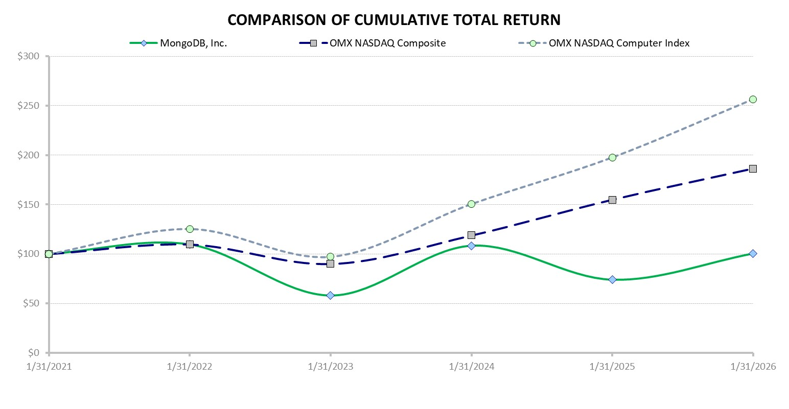
This performance graph shall not be deemed “soliciting material” or to be “filed” with the SEC for purposes of Section 18 of the Exchange Act, or otherwise subject to the liabilities under that Section and shall not be deemed to be incorporated by reference into any filing of MongoDB, Inc. under the Securities Act or the Exchange Act.

Item 6. Reserved

53

Table of Contents
Item 7. Management’s Discussion and Analysis of Financial Condition and Results of Operations
The following discussion should be read in conjunction with the consolidated financial statements and notes thereto included in Part II, Item 8, Financial Statements and Supplementary Data, of this Form 10-K. All information presented herein is based on our fiscal calendar. Unless otherwise stated, references to particular years, quarters, months or periods refer to our fiscal years ended January 31 and the associated quarters, months and periods of those fiscal years.

Overview
MongoDB is the developer data platform company whose mission is to empower developers to create, transform, and disrupt industries by unleashing the power of software and data. The foundation of our offering is the world’s leading, modern general purpose database. Organizations can deploy our database at scale in the cloud, on-premises, or in a hybrid environment. Built on our unique document-based architecture, our database is designed to meet the needs of organizations for performance, scalability, flexibility and reliability while maintaining the strengths of relational databases. In addition to the database, our developer data platform includes a set of, tightly integrated, capabilities such as search, time series, data lifecycle, application-driven analytics and stream processing that allow developers to address a broader range of application requirements. Our business model combines the developer mindshare and adoption benefits of open source with the economic benefits of a proprietary software subscription business model.
We generate revenue primarily from sales of subscriptions, which accounted for 97% of our total revenue for the year ended January 31, 2026 and 97% for the years ended January 31, 2025 and 2024.
Atlas is our hosted multi-cloud database-as-a-service (“DBaaS”) offering, which we run and manage in the cloud, and includes comprehensive infrastructure and management, as well as a host of additional features, such as Atlas Search, Vector Search, time series, data lifecycle, application-driven analytics, and stream processing. During the year ended January 31, 2026, Atlas revenue represented 73% of our total revenue, as compared to 70% in the prior year, reflecting the continued growth of Atlas since its introduction in June 2016. We have experienced strong growth in self-serve customers of Atlas, which are charged monthly in arrears based on their usage. We have also seen growth in Atlas customers sold by our sales force, which typically sign annual contracts and pay in advance or are invoiced monthly in arrears based on usage. Customers sold by our sales force may also sign contracts that remain in effect until terminated and are invoiced monthly in arrears based on usage. We expect to continue to see a higher portion of our Atlas contracts to be billed monthly in arrears based on usage without requiring upfront commitments.
MongoDB Enterprise Advanced is our proprietary commercial database server offering for enterprise customers that can run in the cloud, on-premises or in a hybrid environment. MongoDB Enterprise Advanced revenue represented 21%, 24% and 26% of our subscription revenue for the years ended January 31, 2026, 2025 and 2024, respectively. We sell subscriptions directly through our field and inside sales teams, as well as indirectly through channel partners. The majority of our subscription contracts are one year in duration and are invoiced upfront. When we enter into multi-year subscriptions, the customer is typically invoiced on an annual basis or pays upfront.
Many of our enterprise customers initially get to know our software by using Community Server, which is our free-to-download version of our database that includes the core functionality developers need to get started with MongoDB without all the features of our commercial platform. Our platform has been downloaded from our website more than 700 million times since February 2009. We also offer a free tier of Atlas, which provides access to our hosted database solution with limited processing power and storage, as well as certain operational limitations. As a result, with the availability of both Community Server and Atlas free tier offerings, our direct sales prospects are often familiar with our platform and may have already built applications using our technology. A core component of our growth strategy for Atlas and MongoDB Enterprise Advanced is to convert developers and their organizations who are already using Community Server or the free tier of Atlas to become customers of our commercial products and enjoy the benefits of either a self-managed or hosted offering.
We also generate revenue from services, which consist primarily of fees associated with consulting and training services. Revenue from services accounted for 3% of our total revenue for the year ended January 31, 2026 and 3% for the year ended January 31, 2025 and 2024. We expect to continue to invest in our services organization as we believe it plays an important role in accelerating our customers’ realization of the benefits of our platform, which helps drive customer retention and expansion.
We believe the market for our offerings is large and growing. We have experienced rapid growth and have made substantial investments in developing our platform and expanding our sales and marketing footprint. We intend to continue to invest to grow our business to take advantage of our market opportunity.
54

Table of Contents
Macroeconomic and Other Factors
Our operational and financial performance is subject to risks including those caused by the adverse macroeconomic environment and the geopolitical landscape.
Adverse macroeconomic conditions include slower or negative economic growth and higher inflation. While the impact of these macroeconomic conditions on our business, results of operations and financial position remain uncertain over the long term, we expect to experience macroeconomic headwinds on growth rate for our existing Atlas applications in the short term.

We continue to monitor the developments of the macroeconomic environment and the geopolitical landscape. As these factors develop and we evaluate their impact on our business, we may adjust our business practices accordingly. For further discussion of the potential impacts of these factors on our business, operating results, and financial condition, see the section titled “Risk Factors” included in Part I, Item 1A of this Form 10-K. Other factors affecting our performance are discussed below.
Share Repurchase Program
In February 2025, the Company’s Board of Directors authorized a program to repurchase up to $200.0 million of the Company’s common stock. In June 2025, the Company’s Board of Directors authorized an additional $800.0 million in repurchases under the Share Repurchase Program, bringing the aggregate authorized repurchase amount to $1.0 billion. During the year ended January 31, 2026, the Company repurchased 1,576,109 shares of common stock for $400.3 million. The average price per share for the year ended January 31, 2026 was $306.87. All repurchases were made in open market transactions and recorded in treasury stock. As of January 31, 2026, our total remaining authorization under our stock repurchase plan is $599.7 million.
The timing and amount of any repurchases will be determined by management based on an evaluation of market conditions and other factors. The program does not obligate us to acquire any particular amount of common stock, and the repurchase program may be suspended or discontinued at any time at our discretion.
Business Acquisition
On February 17, 2025, we acquired all of the outstanding shares of Voyage AI Innovations, Inc. (“Voyage AI”), an AI-powered software company that specializes in embedding and reranking models. The acquisition date fair value of the purchase consideration was $160.9 million, which was comprised of 484,169 shares of our common stock valued at $141.4 million as of the acquisition date and $19.5 million in cash. In addition, we also issued to certain of Voyage AI’s employees a total of 213,023 shares of restricted stock awards and 35,152 shares of restricted stock units in exchange for a portion of their Voyage AI stock. These shares are subject to vesting agreements contingent upon each of these employees’ continued employment with us or our affiliates, pursuant to which the shares will vest over the weighted-average requisite service period of 2.7 years. The $62.2 million fair value of these restricted stock awards and $10.3 million fair value of these restricted stock units are accounted for as post-combination stock-based compensation expense over the weighted-average requisite service period.
The results of operations of this business combination have been included in our consolidated financial statements from the date of acquisition. See Note 5, Business Combinations, in our Notes to Consolidated Financial Statements included in Part II, Item 8 of this Form 10-K, for details regarding this business combination.

Factors Affecting Our Performance
Extending Product Leadership and Maintaining Developer Mindshare
We are committed to delivering market-leading products to continue to build and maintain credibility with the global software developer community. We believe we must maintain our product leadership position and the strength of our brand to drive further revenue growth. We intend to continue to invest in our product offerings with the goal of expanding the functionality and adoption of our developer data platform. During 2024, we introduced MongoDB version 8.0 enhancing enterprise-grade security, resilience and availability for a wide variety of applications. We added additional features to Queryable Encryption, an encrypted search scheme, to support equality and range searches. Over the years, we have introduced additional features and functionality to Atlas, including Atlas Search, Atlas Vector Search, Atlas Data Federation, Atlas Charts, and Atlas Stream Processing, which now provide dedicated infrastructure for search use cases so customers can scale independently of their database to manage their workloads with greater flexibility and operational efficiency. Recently,
55

Table of Contents
we have introduced an application programming interface (API) within Atlas that natively provides access to Voyage AI’s embedding and reranking models. These capabilities, when combined with the core functionality of Atlas, enable organizations to build, deploy and scale AI-powered applications with higher accuracy, lower latency and reduced architectural complexity.
We intend to continue to invest in our engineering capabilities and marketing activities to maintain our strong position in the developer community. We have spent $3.2 billion on research and development since our inception. Our results of operations may fluctuate as we make these investments to drive increased customer adoption and usage.
Growing Our Customer Base and Expanding Our Global Reach
We are intensely focused on continuing to grow our customer base. We have invested, and expect to continue to invest, in our sales and marketing efforts and developer community outreach, which are critical to driving customer acquisition. As of January 31, 2026, we had over 65,200 customers across a wide range of industries and in over 100 countries, compared to over 54,500 customers and over 47,800 customers as of January 31, 2025 and 2024, respectively. All affiliated entities are counted as a single customer and our definition of “customer” excludes users of our free offerings.
We are also focused on increasing the number of overall Atlas customers as we emphasize the on-demand scalability of Atlas by allowing our customers to consume the product with minimal commitment. We had over 63,900 Atlas customers as of January 31, 2026. The growth in Atlas customers included new customers to MongoDB and existing MongoDB Enterprise Advanced customers adding incremental Atlas workloads.
Retaining and Expanding Revenue from Existing Customers
The economic attractiveness of our subscription-based model is demonstrated by customer renewals and increasing existing customer subscriptions over time, referred to as land-and-expand. We believe that there is a significant opportunity to drive additional sales to existing customers, and expect to invest in sales and marketing and customer success personnel and activities to achieve additional revenue growth from existing customers. If an application grows and requires additional capacity, our customers increase their usage of our platform. Our customers add incremental workloads or expand their subscriptions to our platform as they migrate additional existing applications or build new applications, either within the same department or in other lines of business or geographies. Also, as customers modernize their information technology infrastructure and move to the cloud, they may migrate applications from legacy databases. Our goal is to increase the number of customers that standardize on our platform within their organization, as well as add new workloads with new and existing customers. Over time, the subscription amount for our typical direct sales customer has increased.
We calculate annualized recurring revenue (“ARR”) to help us measure our subscription revenue performance. ARR includes the revenue we expect to receive from our customers over the following 12 months based on contractual commitments and, in the case of direct sales customers of Atlas, by annualizing the prior 90 days of their actual usage of Atlas, assuming no increases or reductions in their subscriptions or usage. For all other customers of our self-serve products, we calculate ARR by annualizing the prior 30 days of their actual usage of such products, assuming no increases or reductions in usage. ARR excludes professional services. The number of customers with $100,000 or greater in ARR was 2,799, 2,396 and 2,052 as of January 31, 2026, 2025 and 2024, respectively. Our ability to increase sales to existing customers will depend on a number of factors, including customers’ satisfaction or dissatisfaction with our products and services, competition, pricing, economic conditions or overall changes in our customers’ spending levels.
We also examine the rate at which our customers increase their spend with us, which we call net ARR expansion rate. We calculate net ARR expansion rate by dividing the ARR at the close of a given period (the “measurement period”), from customers who were also customers at the close of the same period in the prior year (the “base period”), by the ARR from all customers at the close of the base period, including those who churned or reduced their subscriptions. As of January 31, 2026, our net ARR expansion rate was approximately 121%. Our net ARR expansion rate may fluctuate in future periods due to a variety of factors, including the volume and type of workloads that we onboard, growth rate of historical workloads on our platform and changes in the macroeconomic environment.
Our ability to increase sales to existing customers will depend on a number of factors, including customers’ satisfaction or dissatisfaction with our products and services, competition, pricing, economic conditions or overall changes in our customers’ spending levels.
56

Table of Contents
Investing in Growth and Scaling Our Business
We are focused on our long-term revenue potential. We believe that our market opportunity is large and we will continue to invest in scaling across all organizational functions in order to grow our operations both domestically and internationally. Any investments we make in our sales and marketing organization will occur in advance of experiencing the benefits from such investments, so it may be difficult for us to determine if we are efficiently allocating resources in those areas.

Components of Results of Operations
Revenue
Subscription Revenue. Our subscription revenue is comprised of term licenses and database-as-a-service solutions. Revenue from our Atlas database-as-a-service offering is primarily generated on a usage basis and is billed either monthly in arrears or paid upfront. Subscriptions to term licenses include technical support and access to new software versions on a when-and-if available basis. Revenue from our term licenses is recognized upfront for the license component and ratably for the technical support and when-and-if available update components. Associated contracts are typically billed annually in advance. The majority of our subscription contracts are one year in duration. When we enter into multi-year subscriptions, the customer is typically invoiced on an annual basis or pays upfront. Our subscription contracts are generally non-cancelable and non-refundable.
Services Revenue. Services revenue is comprised of consulting and training services and is recognized over the period of delivery of the applicable services.
We expect our revenue may vary from period to period based on, among other things, the timing and size of new subscriptions, customer usage patterns, the proportion of term license contracts that commence within the period, the rate of customer renewals and expansions, delivery of professional services, the impact of significant transactions and seasonality of or fluctuations in usage from our Atlas customers.
Cost of Revenue
Cost of Subscription Revenue. Cost of subscription revenue primarily includes third-party cloud infrastructure expenses for our database-as-a-service solutions. We expect our cost of subscription revenue to increase in absolute dollars as our subscription revenue increases and, depending on the results of Atlas, our cost of subscription revenue may increase as a percentage of subscription revenue as well. Cost of subscription revenue also includes personnel costs, including salaries, bonuses and benefits and stock-based compensation, for employees associated with our subscription arrangements principally related to technical support and allocated shared costs, as well as depreciation and amortization.
Cost of Services Revenue. Cost of services revenue primarily includes personnel costs, including salaries, bonuses and benefits and stock-based compensation, for employees associated with our professional service contracts, as well as, travel costs, allocated shared costs and depreciation and amortization. We expect our cost of services revenue to increase in absolute dollars as our services revenue increases.
Gross Profit and Gross Margin
Gross Profit. Gross profit represents revenue less cost of revenue.
Gross Margin. Gross margin, or gross profit as a percentage of revenue, has been and will continue to be affected by a variety of factors, including the average sales price of our products and services, the mix of products sold, transaction volume growth and the mix of revenue between subscriptions and services. We expect our gross margin to fluctuate over time depending on the factors described above and, to the extent Atlas revenue increases as a percentage of total revenue, our gross margin may decline as a result of the associated hosting costs of Atlas.
Operating Expenses
Our operating expenses consist of sales and marketing, research and development and general and administrative expenses. Personnel costs are the most significant component of each category of operating expenses. Operating expenses also include travel and related costs and allocated overhead costs for facilities, information technology and employee benefit costs.
57

Table of Contents
Sales and Marketing. Sales and marketing expense consists primarily of personnel costs, including salaries, sales commission and benefits, bonuses and stock-based compensation. These expenses also include costs related to marketing programs, travel-related expenses and allocated overhead. Marketing programs consist of advertising, events, corporate communications, and brand-building and developer-community activities. We expect our sales and marketing expense to increase in absolute dollars over time as we expand our sales force and increase our marketing resources, expand into new markets and further develop our self-serve and partner channels.
Research and Development. Research and development expense consists primarily of personnel costs, including salaries, bonuses and benefits, and stock-based compensation. It also includes amortization associated with intangible acquired assets and allocated overhead. We expect our research and development expenses to continue to increase in absolute dollars, as we continue to invest in our developer data platform and develop new products.
General and Administrative. General and administrative expense consists primarily of personnel costs, including salaries, bonuses and benefits, and stock-based compensation for administrative functions including finance, legal, human resources and external legal and accounting fees, as well as allocated overhead. We expect general and administrative expense to increase in absolute dollars over time as we continue to invest in the growth of our business, as well as incur the ongoing costs of compliance associated with being a publicly traded company.
Other Income (Expense), Net
Other income (expense), net consists primarily of interest income, interest expense, gains and losses on financial instruments, net and gains and losses from foreign currency transactions.
Provision for Income Taxes
Provision for income taxes consists primarily of state income taxes in the United States and income taxes in certain foreign jurisdictions in which we conduct business. As of January 31, 2026, we had net operating loss (“NOL”) carryforwards for U.S. federal and state, Irish and U.K. income tax purposes of approximately $2.2 billion, $2.0 billion, $857.2 million and $64.5 million, respectively, which begin to expire in the year ending January 31, 2028 for U.S. federal purposes and January 31, 2027 for state purposes. Operating losses in the United States, for years after January 31, 2019, in Ireland and the U.K. may be carried forward indefinitely. The deferred tax assets associated with the NOL carryforwards in each of these jurisdictions are subject to a full valuation allowance. Under Section 382 of the U.S. Internal Revenue Code of 1986 (the “Code”), a corporation that experiences an “ownership change” is subject to a limitation on its ability to utilize its pre-change NOLs to offset future taxable income. We also have U.S. federal and state research credit carryforwards of $207.2 million and $19.6 million, respectively, which begin to expire in the year ending January 31, 2029 for federal purposes and January 31, 2027 for state purposes.
On July 4, 2025, the One Big Beautiful Bill ("OBBBA") was signed into law. The OBBBA includes a broad range of U.S. tax reform measures, including, among other provisions, the immediate expensing of U.S. research and development expenditures. In accordance with ASC 740, we have recognized the effects of the new tax law in the period of enactment. As we maintain a full valuation allowance on its U.S. deferred tax assets, the legislation does not have a material impact on its consolidated financial statements.

Highlights for the Years Ended January 31, 2026, 2025 and 2024
For the years ended January 31, 2026, 2025 and 2024, our total revenue was $2,463.8 million, $2,006.4 million and $1,683.0 million, respectively. The increase in total revenue was primarily driven by our net ARR expansion rate of 121% as of January 31, 2026. Our net loss was $71.2 million, $129.1 million and $176.6 million for the years ended January 31, 2026, 2025 and 2024, respectively, driven primarily by higher sales and marketing spend and research and development costs. Our operating cash flow was $505.1 million, $150.2 million and $121.5 million for the years ended January 31, 2026, 2025 and 2024, respectively.
58

Table of Contents
Results of Operations
The following tables set forth our results of operations for the periods presented in U.S. dollars (in thousands) and as a percentage of our total revenue. Percentage of revenue figures are rounded and therefore may not subtotal exactly.
 |  |  | Years Ended January 31,
 |  |  | 2026 |  |  |  |  |  |  |  |  |  |  |  | 2025 |  |  |  |  |  |  |  |  |  |  |  | 2024
 |  |  | $ |  |  |  |  |  | % of Revenue |  |  |  |  |  | $ |  |  |  |  |  | % of Revenue |  |  |  |  |  | $ |  |  |  |  |  | % of Revenue
Consolidated Statements of Operations Data:
Revenue:
Subscription |  |  | $ | 2,385,977 |  |  |  |  | 97 |  | % |  |  |  | $ | 1,943,864 |  |  |  |  | 97 |  | % |  |  |  | $ | 1,627,326 |  |  |  |  | 97 |  | %
Services |  |  | 77,820 |  |  |  |  |  | 3 |  |  |  |  |  | 62,579 |  |  |  |  |  | 3 |  |  |  |  |  | 55,685 |  |  |  |  |  | 3
Total revenue |  |  | 2,463,797 |  |  |  |  |  | 100 |  |  |  |  |  | 2,006,443 |  |  |  |  |  | 100 |  |  |  |  |  | 1,683,011 |  |  |  |  |  | 100
Cost of revenue:
Subscription(1) |  |  | 571,531 |  |  |  |  |  | 23 |  |  |  |  |  | 441,404 |  |  |  |  |  | 22 |  |  |  |  |  | 345,233 |  |  |  |  |  | 20
Services(1) |  |  | 124,527 |  |  |  |  |  | 5 |  |  |  |  |  | 93,892 |  |  |  |  |  | 5 |  |  |  |  |  | 79,252 |  |  |  |  |  | 5
Total cost of revenue |  |  | 696,058 |  |  |  |  |  | 28 |  |  |  |  |  | 535,296 |  |  |  |  |  | 27 |  |  |  |  |  | 424,485 |  |  |  |  |  | 25
Gross profit |  |  | 1,767,739 |  |  |  |  |  | 72 |  |  |  |  |  | 1,471,147 |  |  |  |  |  | 73 |  |  |  |  |  | 1,258,526 |  |  |  |  |  | 75
Operating expenses:
Sales and marketing(1) |  |  | 944,389 |  |  |  |  |  | 38 |  |  |  |  |  | 871,148 |  |  |  |  |  | 43 |  |  |  |  |  | 782,760 |  |  |  |  |  | 47
Research and development(1) |  |  | 716,303 |  |  |  |  |  | 29 |  |  |  |  |  | 596,837 |  |  |  |  |  | 30 |  |  |  |  |  | 515,940 |  |  |  |  |  | 31
General and administrative(1) |  |  | 244,015 |  |  |  |  |  | 10 |  |  |  |  |  | 219,226 |  |  |  |  |  | 11 |  |  |  |  |  | 193,558 |  |  |  |  |  | 11
Total operating expenses |  |  | 1,904,707 |  |  |  |  |  | 77 |  |  |  |  |  | 1,687,211 |  |  |  |  |  | 84 |  |  |  |  |  | 1,492,258 |  |  |  |  |  | 89
Loss from operations |  |  | (136,968) |  |  |  |  |  | (6) |  |  |  |  |  | (216,064) |  |  |  |  |  | (11) |  |  |  |  |  | (233,732) |  |  |  |  |  | (14)
Other income, net |  |  | 81,277 |  |  |  |  |  | 3 |  |  |  |  |  | 84,465 |  |  |  |  |  | 4 |  |  |  |  |  | 70,216 |  |  |  |  |  | 5
Loss before provision for (benefit from) income taxes |  |  | (55,691) |  |  |  |  |  | (2) |  |  |  |  |  | (131,599) |  |  |  |  |  | (7) |  |  |  |  |  | (163,516) |  |  |  |  |  | (9)
Provision for (benefit from) income taxes |  |  | 15,460 |  |  |  |  |  | 1 |  |  |  |  |  | (2,527) |  |  |  |  |  | (1) |  |  |  |  |  | 13,084 |  |  |  |  |  | 1
Net loss |  |  | $ | (71,151) |  |  |  |  | (3) |  | % |  |  |  | $ | (129,072) |  |  |  |  | (6) |  | % |  |  |  | $ | (176,600) |  |  |  |  | (10) |  | %
(1) Includes stock-based compensation expense as follows (in thousands):
 |  |  | Years Ended January 31,
 |  |  | 2026 |  |  |  |  |  | 2025 |  |  |  |  |  | 2024
Cost of revenue—subscription |  |  | $ | 34,660 |  |  |  |  | $ | 29,548 |  |  |  |  | $ | 23,677
Cost of revenue—services |  |  | 17,183 |  |  |  |  |  | 13,917 |  |  |  |  |  | 12,733
Sales and marketing |  |  | 149,786 |  |  |  |  |  | 161,317 |  |  |  |  |  | 159,907
Research and development |  |  | 279,581 |  |  |  |  |  | 226,367 |  |  |  |  |  | 198,927
General and administrative |  |  | 69,244 |  |  |  |  |  | 62,791 |  |  |  |  |  | 61,663
Total stock-based compensation expense |  |  | $ | 550,454 |  |  |  |  | $ | 493,940 |  |  |  |  | $ | 456,907

Comparison of the Years Ended January 31, 2026 and 2025
Revenue
 |  |  | Years Ended January 31, |  |  |  |  |  |  |  |  |  |  |  | Change
(in thousands) |  |  | 2026 |  |  |  |  |  | 2025 |  |  |  |  |  | $ |  |  |  |  |  | %
Subscription |  |  | $ | 2,385,977 |  |  |  |  | $ | 1,943,864 |  |  |  |  | $ | 442,113 |  |  |  |  | 23 |  | %
Services |  |  | 77,820 |  |  |  |  |  | 62,579 |  |  |  |  |  | 15,241 |  |  |  |  |  | 24 |  | %
Total revenue |  |  | $ | 2,463,797 |  |  |  |  | $ | 2,006,443 |  |  |  |  | $ | 457,354 |  |  |  |  | 23 |  | %
59

Table of Contents
Total revenue growth reflects increased demand for our platform and related services. Subscription revenue increased by $442.1 million primarily due to an increase in consumption of Atlas by our large existing customers as evidenced by our net ARR expansion rate of 121% as of January 31, 2026.
Cost of Revenue, Gross Profit and Gross Margin Percentage
 |  |  | Years Ended January 31, |  |  |  |  |  |  |  |  |  |  |  | Change
(in thousands) |  |  | 2026 |  |  |  |  |  | 2025 |  |  |  |  |  | $ |  |  |  |  |  | %
Subscription cost of revenue |  |  | $ | 571,531 |  |  |  |  | $ | 441,404 |  |  |  |  | $ | 130,127 |  |  |  |  | 29 |  | %
Services cost of revenue |  |  | 124,527 |  |  |  |  |  | 93,892 |  |  |  |  |  | 30,635 |  |  |  |  |  | 33 |  | %
Total cost of revenue |  |  | 696,058 |  |  |  |  |  | 535,296 |  |  |  |  |  | 160,762 |  |  |  |  |  | 30 |  | %
Gross profit |  |  | $ | 1,767,739 |  |  |  |  | $ | 1,471,147 |  |  |  |  | $ | 296,592 |  |  |  |  | 20 |  | %
Gross margin |  |  | 72 |  | % |  |  |  | 73 |  | %
Subscription |  |  | 76 |  | % |  |  |  | 77 |  | %
Services |  |  | (60) |  | % |  |  |  | (50) |  | %
The increase in subscription cost of revenue was primarily due to a $93.6 million increase in third-party cloud infrastructure costs, including costs associated with the growth of Atlas, an increase of $17.1 million in personnel costs and stock-based compensation, and a $13.7 million increase in amortization costs primarily related to acquired intangible assets. The increase in third-party cloud infrastructure costs was partially offset by continued cost efficiencies realized as we scale Atlas. The increase in services cost of revenue was primarily due to a $19.1 million increase in personnel costs and stock-based compensation and a $8.3 million increase in third-party consultant costs related to the delivery of consulting and training services.
Our overall gross margin decreased to 72%. Our subscription gross margin declined to 76% due to an increase in subscription revenue from Atlas as a percentage of our total revenue. Services gross margin decreased due to the impact of higher third-party consultant and training costs, services personnel costs and stock-based compensation related to growth in headcount.
Operating Expenses
Sales and Marketing
 |  |  | Years Ended January 31, |  |  |  |  |  |  |  |  |  |  |  | Change
(in thousands) |  |  | 2026 |  |  |  |  |  | 2025 |  |  |  |  |  | $ |  |  |  |  |  | %
Sales and marketing |  |  | $ | 944,389 |  |  |  |  | $ | 871,148 |  |  |  |  | $ | 73,241 |  |  |  |  | 8 |  | %
The increase in sales and marketing expense was primarily driven by a $41.1 million increase in commissions, a $27.5 million increase in personnel costs, a $19.8 million increase in spend on in-person events and digital marketing programs and $4.5 million in restructuring costs. The increase in sales and marketing was partially offset by a $11.8 million decrease in travel-related expenses due to reduced internal travel and sales events and a $11.5 million decrease in stock-based compensation.
Research and Development
 |  |  | Years Ended January 31, |  |  |  |  |  |  |  |  |  |  |  | Change
(in thousands) |  |  | 2026 |  |  |  |  |  | 2025 |  |  |  |  |  | $ |  |  |  |  |  | %
Research and development |  |  | $ | 716,303 |  |  |  |  | $ | 596,837 |  |  |  |  | $ | 119,466 |  |  |  |  | 20 |  | %
The increase in research and development expense was primarily driven by a $110.5 million increase in personnel costs, stock-based compensation and allocated overhead, and a $8.8 million increase in third-party infrastructure expenses to support ongoing product development and testing activities.
60

Table of Contents
General and Administrative
 |  |  | Years Ended January 31, |  |  |  |  |  |  |  |  |  |  |  | Change
(in thousands) |  |  | 2026 |  |  |  |  |  | 2025 |  |  |  |  |  | $ |  |  |  |  |  | %
General and administrative |  |  | $ | 244,015 |  |  |  |  | $ | 219,226 |  |  |  |  | $ | 24,789 |  |  |  |  | 11 |  | %
The increase in general and administrative expense was primarily driven by a $22.2 million increase in personnel costs and stock-based compensation, a $9.3 million increase in software expenses associated with ongoing initiatives to enhance systems and operational efficiency, which was partially offset by a $7.2 million release of reserves for value-added tax expense related to our operations in certain non-US jurisdictions.
Other Income, Net
 |  |  | Years Ended January 31, |  |  |  |  |  |  |  |  |  |  |  | Change
(in thousands) |  |  | 2026 |  |  |  |  |  | 2025 |  |  |  |  |  | $ |  |  |  |  |  | %
Other income, net |  |  | $ | 81,277 |  |  |  |  | $ | 84,465 |  |  |  |  | $ | (3,188) |  |  |  |  | (4) |  | %
Other income, net, for the year ended January 31, 2026 decreased primarily due to lower interest income from our short-term investments.
Provision for (Benefit From) Income Taxes
 |  |  | Years Ended January 31, |  |  |  |  |  |  |  |  |  |  |  | Change
(in thousands) |  |  | 2026 |  |  |  |  |  | 2025 |  |  |  |  |  | $ |  |  |  |  |  | %
Provision for (benefit from) income taxes |  |  | $ | 15,460 |  |  |  |  | $ | (2,527) |  |  |  |  | $ | 17,987 |  |  |  |  | (712) |  | %
The increase in the provision for income taxes for the year ended January 31, 2026 was primarily due to an increase in foreign taxes as we continue our global expansion and the release of the UK valuation allowance in the prior period.
Comparison of the Years Ended January 31, 2025 and 2024
For a discussion of our results of operations for the year ended January 31, 2025 as compared to the year ended January 31, 2024, refer to Part II, Item 7, Management’s Discussion and Analysis of Financial Condition and Results of Operations, of our Annual Report on Form 10-K filed with the SEC on March 21, 2025.

Liquidity and Capital Resources
As of January 31, 2026, our principal sources of liquidity were cash, cash equivalents, short-term investments and restricted cash totaling $2.4 billion. Our cash and cash equivalents primarily consist of bank deposits and money market funds. Our short-term investments consist of U.S. government treasury securities and our restricted cash represents collateral for our available credit on corporate credit cards. We believe our existing cash and cash equivalents and short-term investments will be sufficient to fund our operating and capital needs for at least the next 12 months.
In June 2025, our Board of Directors authorized an additional $800.0 million in repurchases under the Share Repurchase Program, bringing the aggregate authorized repurchase amount to $1.0 billion. During the year ended January 31, 2026, we repurchased 1,576,109 shares of common stock for $400.3 million. The average price per share for the year ended January 31, 2026 was $306.87. Refer to Note 11, Equity, in our Notes to Consolidated Financial Statements included in Part II, Item 8, and “Purchases of Equity Securities by the Issuer” included in Part II, Item 5 of this Form 10-K for further details.
In October 2025, we began funding withholding taxes in certain jurisdictions due on the vesting of employee RSUs by net share settlement, rather than our previous approach of selling shares of our common stock to cover taxes upon vesting of such awards. The amount of withholding taxes paid related to net share settlement of employee RSUs was $98.6 million for the year ended January 31, 2026.
We have generated significant operating losses as reflected in our accumulated deficit of $1.9 billion as of January 31, 2026. We expect to continue to incur operating losses, may experience negative cash flows from operations in the future and may require additional capital resources to execute strategic initiatives to grow our business. Our future capital requirements and adequacy of available funds will depend on many factors, including our growth rate and any impact on it from global macroeconomic conditions, including rising interest rates, inflation, the timing and extent of spending to support development
61

Table of Contents
efforts, the expansion of sales and marketing and international operation activities, the timing and size of new subscription introductions and customer usage of our developer data platform, the continuing market acceptance of our subscriptions and services and the impact of the macroeconomic conditions on the global economy and our business, financial condition and results of operations. As the impact of macroeconomic conditions on the global economy and our operations continues to evolve, we will continue to assess our liquidity needs. In the future, we may enter into arrangements to acquire or invest in complementary businesses, services and technologies, including intellectual property rights. We may be required to seek additional equity or debt financing. In the event that additional financing is required from outside sources, we may not be able to raise it on terms acceptable to us or at all. If we are unable to raise additional capital when desired, our business, operating results and financial condition would be adversely affected.
The following table summarizes our cash flows for the periods presented (in thousands):
 |  |  | Years Ended January 31,
 |  |  | 2026 |  |  |  |  |  | 2025 |  |  |  |  |  | 2024
Net cash provided by operating activities |  |  | $ | 505,148 |  |  |  |  | $ | 150,191 |  |  |  |  | $ | 121,477
Net cash provided by (used in) investing activities |  |  | 538,815 |  |  |  |  |  | (657,440) |  |  |  |  |  | 188,019
Net cash provided by (used in) financing activities |  |  | (462,439) |  |  |  |  |  | 202,060 |  |  |  |  |  | 38,241
Operating Activities
Cash provided by operating activities during the year ended January 31, 2026 was $505.1 million, driven primarily due to an increase in cash collected from customers resulting from an increase in sales. Our net loss of $71.2 million includes $550.5 million of stock-based compensation, $112.4 million of deferred revenue, $27.8 million of accrued liabilities, and $22.4 million of depreciation and amortization. Partially offsetting these benefits to our operating cash flow were increases in accounts receivable of $106.4 million, other long-term assets of $13.0 million, $9.8 million of deferred commissions, and $7.6 million of other net non-cash charges.

Cash provided by operating activities during the year ended January 31, 2025 was $150.2 million, driven primarily by an increase in our cash collections reflecting the overall growth of our sales and expansion of our customer base. Accordingly, our accounts receivable increased by $69.2 million. In addition, our net loss of $129.1 million, includes non-cash charges of $493.9 million for stock-based compensation and $11.8 million for depreciation and amortization. Our accrued liabilities increased by $25.3 million reflecting our increase in expenses and timing of payments. Partially offsetting these benefits to our operating cash flow were amortization of premium and accretion of discount on short-term investments, net of $25.1 million, an increase in deferred commissions of $69.1 million, an increase in prepaid expenses and other current assets of $24.8 million, an increase in other long-term assets of $30.7 million and other net non-cash charges of $32.8 million.
Investing Activities
Cash provided by investing activities during the year ended January 31, 2026 was $538.8 million, due to proceeds from maturities and sales of marketable securities, net of purchases, of $555.0 million, partially offset by cash used for investments in non-marketable securities of $9.2 million, purchases of property and equipment of $5.0 million and payments related to the Voyage AI acquisition of $2.0 million.
Cash used in investing activities during the year ended January 31, 2025 was $657.4 million, due to purchases of marketable securities, net of maturities and sales, of $616.6 million, cash used for investments in non-marketable securities of $11.3 million and purchases of property, equipment and other assets of $29.6 million.
Financing Activities
Cash used in financing activities during the year ended January 31, 2026 was $462.4 million, due to repurchases of common stock of $400.3 million, $98.6 million due to taxes paid related to net share settlement of equity awards, and principal payments of finance leases of $7.5 million, offset by proceeds from the issuance of common stock under the Employee Stock Purchase Plan of $40.8 million and proceeds from the exercises of stock options of $3.2 million.
Cash provided by financing activities during the year ended January 31, 2025 was $202.1 million, due to proceeds from the settlement of capped calls and other of $170.2 million, proceeds from the issuance of common stock under the Employee Stock Purchase Plan and exercises of stock options of $38.0 million, partly offset by principal payments of finance leases of $6.2 million.

62

Table of Contents
Contractual Obligations and Commitments
The following table summarizes our contractual obligations as of January 31, 2026 (in thousands):
 |  |  | Payments Due by Period
 |  |  | Total |  |  |  |  |  | Less Than 1 Year |  |  |  |  |  | 1 to 3 Years |  |  |  |  |  | 3 to 5 Years |  |  |  |  |  | More Than 5 Years
Finance lease obligations |  |  | 33,393 |  |  |  |  |  | 7,986 |  |  |  |  |  | 17,422 |  |  |  |  |  | 7,985 |  |  |  |  |  | —
Operating lease obligations |  |  | 36,809 |  |  |  |  |  | 11,139 |  |  |  |  |  | 15,998 |  |  |  |  |  | 6,993 |  |  |  |  |  | 2,679
Purchase obligations |  |  | 897,926 |  |  |  |  |  | 382,067 |  |  |  |  |  | 515,859 |  |  |  |  |  | — |  |  |  |  |  | —
Total |  |  | $ | 968,128 |  |  |  |  | $ | 401,192 |  |  |  |  | $ | 549,279 |  |  |  |  | $ | 14,978 |  |  |  |  | $ | 2,679
At January 31, 2026, our material short-term and long-term cash requirements for various contractual obligations and commitments consisted of the following:
•our purchase obligations under non-cancelable agreements for cloud infrastructure capacity commitments and subscription and marketing services. During the year ended January 31, 2026, the Company entered into a renewal agreement with a cloud infrastructure provider that includes a non-cancelable commitment of $300 million to be paid over a period from October 2025 through October 2028;
•our finance and operating lease obligations under non-cancelable leases for office space expiring through 2032; and
•accounts payable and accrued liabilities on our consolidated balance sheets (primarily short-term in nature).
For further details of our contractual obligations and lease agreements, refer to our Notes to Consolidated Financial Statements, within Part II, Item 8, Financial Statements and Supplementary Data of this Form 10-K, specifically Note 7, Convertible Senior Notes, Note 8, Leases and Note 9, Commitments and Contingencies.

63

Table of Contents
Critical Accounting Estimates
Our financial statements are prepared in accordance with GAAP. The preparation of these financial statements requires us to make estimates and assumptions that affect the reported amounts of assets, liabilities, revenue, expenses and related disclosures. We evaluate our estimates and assumptions on an ongoing basis. Our estimates are based on historical experience and various other assumptions that we believe to be reasonable under the circumstances. Our actual results could differ from these estimates.
The critical accounting estimates, assumptions and judgments that we believe have the most significant impact on our consolidated financial statements are described below.
Revenue Recognition
We derive our revenue from two sources: (1) the sales of subscriptions, which includes the usage-based database-as-a-service offering, term license and post-contract customer support (“PCS”); and (2) services revenue comprised of consulting and training arrangements. We recognize revenue when our customer obtains control of promised goods or services in an amount that reflects the consideration that we expect to receive in exchange for those goods or services. In determining the appropriate amount of revenue to be recognized as we fulfill our obligations under each of our agreements, we perform the following steps:
i.Identification of the contract, or contracts, with a customer. We determine we have a contract with a customer when the contract is approved, each party’s rights regarding the products or services to be transferred is identified, the payment terms for the services can be identified, we have determined the customer has the ability and intent to pay and the contract has commercial substance. We apply judgment in determining the customer’s ability and intent to pay, which is based on a variety of factors, including the customer’s historical payment experience or, in the case of a new customer, credit, reputation and financial or other information pertaining to the customer. At contract inception, we evaluate whether two or more contracts should be combined and accounted for as a single contract and whether the combined or single contract includes more than one performance obligation.
ii.Identification of the performance obligations in the contract. Performance obligations promised in a contract are identified based on the services or products that will be transferred to the customer that are both (1) capable of being distinct, whereby the customer can benefit from the service or product either on its own or together with other resources that are readily available from third parties or from us and (2) distinct in the context of the contract, whereby the transfer of the services or products is separately identifiable from other promises in the contract. To the extent a contract includes multiple promised services or products, we apply judgment to determine whether promised services or products are capable of being distinct and distinct in the context of the contract. If these criteria are not met, the promised services or products are combined and accounted for as a single performance obligation.
iii.Determination of the transaction price. The transaction price is determined based on the consideration to which we expect to be entitled in exchange for transferring services and products to the customer. Variable consideration is included in the transaction price if, in our judgment, it is probable that a significant future reversal of cumulative revenue recognized under the contract will not occur. We apply the practical expedient to not evaluate contracts of one year or less for the existence of a significant financing component. None of our contracts contain a significant financing component.
iv.Allocation of the transaction price to the performance obligations in the contract. If the contract contains a single performance obligation, the entire transaction price is allocated to the single performance obligation. For contracts that contain multiple performance obligations, we allocate the transaction price to each performance obligation based on a relative standalone selling price (“SSP”) basis. We also consider if there are any additional material rights inherent in a contract and if so, we allocate a portion of the transaction price to such rights based on SSP. We determine each SSP based on multiple factors, including past history of selling such performance obligations as standalone products. We estimate SSP for performance obligations with no observable evidence using adjusted market, cost plus method and the value relationship between the difference performance obligations within the bundled license to establish the SSPs. In cases where directly observable standalone sales are not available, such as when the term license is not sold separately, we consider all observable data points including competitor pricing for a similar or identical product, market and industry data points and our pricing practices to establish the SSP.
v.Recognition of revenue when, or as, we satisfy a performance obligation. We recognize revenue at the time the related performance obligation is satisfied when control of the services or products are transferred to the customers,
64

Table of Contents
in an amount that reflects the consideration we expect to be entitled to in exchange for those services or products. We record our revenue net of any value added or sales tax.
Business Combinations
We apply a screen test to evaluate if substantially all of the fair value of the gross assets acquired is concentrated in a single identifiable asset or group of similar identifiable assets to determine whether a transaction is accounted for as an asset acquisition or business combination. When we acquire a business, the purchase consideration is allocated to the tangible assets acquired, liabilities assumed, and intangible assets acquired based on their estimated respective fair values. The excess of the fair value of purchase consideration over the fair values of these identifiable assets and liabilities is recorded as goodwill. Estimates used in valuing certain intangible assets include, but are not limited to, time and resources required to recreate the assets acquired. These estimates are based on information obtained from the management of the acquired companies, our assessment of the information, and historical experience. Our estimates of fair value are based upon assumptions believed to be reasonable, but which are inherently uncertain and unpredictable and, as a result, actual results may differ from estimates. During the measurement period, we may record adjustments to the preliminary fair value of the assets acquired and liabilities assumed. After the measurement period, any subsequent adjustments are reflected in the consolidated statements of operations and comprehensive income (loss). Acquisition costs are expensed as incurred.

Item 7A. Quantitative and Qualitative Disclosures About Market Risk
We have operations both within the United States and internationally and we are exposed to market risk in the ordinary course of business. The uncertainty that exists in the global economic environment has introduced significant volatility in the financial markets.
Interest Rate Risk
Our cash and cash equivalents primarily consist of bank deposits and money market funds and our short-term investments consist of U.S. government treasury securities. As of January 31, 2026 and 2025, we had cash, cash equivalents, restricted cash and short-term investments of $2.4 billion and $2.3 billion, respectively. The carrying amount of our cash equivalents reasonably approximates fair value, due to the short maturities of these instruments. The primary objectives of our investment activities are the preservation of capital, the fulfillment of liquidity needs and the fiduciary control of cash and investments. We do not enter into investments for trading or speculative purposes. Our investments are exposed to market risk due to a fluctuation in interest rates, which may affect our interest income and the fair market value of our investments. The effect of a hypothetical 10% increase or decrease in interest rates would not have had a material impact on the fair market value of our investments as of January 31, 2026 and 2025.
Foreign Currency Risk
Our sales contracts are primarily denominated in U.S. dollars, British pounds (“GBP”) or Euros (“EUR”). A portion of our operating expenses are incurred outside the United States and denominated in foreign currencies and are subject to fluctuations due to changes in foreign currency exchange rates, particularly changes in the GBP and EUR. Additionally, fluctuations in foreign currency exchange rates may cause us to recognize transaction gains and losses in our statements of operations. The effect of a hypothetical 10% change in foreign currency exchange rates applicable to our business would not have a material impact on our historical consolidated financial statements for the years ended January 31, 2026 and 2025. Given the impact of foreign currency exchange rates has not been material to our historical operating results, we have not entered into derivative or hedging transactions, but we may do so in the future if our exposure to foreign currency should become more significant. As our international operations grow, we will continue to reassess our approach to manage our risk relating to fluctuations in currency rates.
Market Risk
We could experience additional volatility to our consolidated statements of operations due to observable price changes and impairments to our non-marketable securities. These changes could be material based on market conditions and events, particularly in periods of significant market fluctuations that affect our non-marketable securities. Our non-marketable securities are subject to a risk of partial or total loss of invested capital. As of January 31, 2026 and 2025, the total amount of non-marketable securities included in other assets on our balance sheets was $32.3 million and $24.2 million, respectively.

65

Table of Contents
Item 8. Financial Statements and Supplementary Data
MongoDB, Inc.
Form 10-K
For the Fiscal Year Ended January 31, 2026
INDEX TO CONSOLIDATED FINANCIAL STATEMENTS
 |  |  | Page
Report of Independent Registered Public Accounting Firm (PCAOB ID 238) |  |  | 67
Financial Statements:
Consolidated Balance Sheets as of January 31, 2026 and 2025 |  |  | 69
Consolidated Statements of Operations for the years ended January 31, 2026, 2025 and 2024 |  |  | 70
Consolidated Statements of Comprehensive Loss for the years ended January 31, 2026, 2025 and 2024 |  |  | 71
Consolidated Statements of Stockholders’ Equity for the years ended January 31, 2026, 2025 and 2024 |  |  | 72
Consolidated Statements of Cash Flows for years ended January 31, 2026, 2025 and 2024 |  |  | 73
Notes to Consolidated Financial Statements |  |  | 74

66

Table of Contents
Report of Independent Registered Public Accounting Firm
To the Board of Directors and Stockholders of MongoDB, Inc.
Opinions on the Financial Statements and Internal Control over Financial Reporting
We have audited the accompanying consolidated balance sheets of MongoDB, Inc. and its subsidiaries (the "Company") as of January 31, 2026 and 2025, and the related consolidated statements of operations, of comprehensive loss, of stockholders’ equity and of cash flows for each of the three years in the period ended January 31, 2026, including the related notes (collectively referred to as the "consolidated financial statements"). We also have audited the Company's internal control over financial reporting as of January 31, 2026, based on criteria established in Internal Control - Integrated Framework (2013) issued by the Committee of Sponsoring Organizations of the Treadway Commission (COSO).

In our opinion, the consolidated financial statements referred to above present fairly, in all material respects, the financial position of the Company as of January 31, 2026 and 2025, and the results of its operations and its cash flows for each of the three years in the period ended January 31, 2026 in conformity with accounting principles generally accepted in the United States of America. Also in our opinion, the Company maintained, in all material respects, effective internal control over financial reporting as of January 31, 2026, based on criteria established in Internal Control - Integrated Framework (2013) issued by the COSO.

Basis for Opinions
The Company's management is responsible for these consolidated financial statements, for maintaining effective internal control over financial reporting, and for its assessment of the effectiveness of internal control over financial reporting, included in Management’s Report on Internal Control over Financial Reporting appearing under Item 9A. Our responsibility is to express opinions on the Company’s consolidated financial statements and on the Company's internal control over financial reporting based on our audits. We are a public accounting firm registered with the Public Company Accounting Oversight Board (United States) (PCAOB) and are required to be independent with respect to the Company in accordance with the U.S. federal securities laws and the applicable rules and regulations of the Securities and Exchange Commission and the PCAOB.

We conducted our audits in accordance with the standards of the PCAOB. Those standards require that we plan and perform the audits to obtain reasonable assurance about whether the consolidated financial statements are free of material misstatement, whether due to error or fraud, and whether effective internal control over financial reporting was maintained in all material respects.

Our audits of the consolidated financial statements included performing procedures to assess the risks of material misstatement of the consolidated financial statements, whether due to error or fraud, and performing procedures that respond to those risks. Such procedures included examining, on a test basis, evidence regarding the amounts and disclosures in the consolidated financial statements. Our audits also included evaluating the accounting principles used and significant estimates made by management, as well as evaluating the overall presentation of the consolidated financial statements. Our audit of internal control over financial reporting included obtaining an understanding of internal control over financial reporting, assessing the risk that a material weakness exists, and testing and evaluating the design and operating effectiveness of internal control based on the assessed risk. Our audits also included performing such other procedures as we considered necessary in the circumstances. We believe that our audits provide a reasonable basis for our opinions.

Definition and Limitations of Internal Control over Financial Reporting
A company’s internal control over financial reporting is a process designed to provide reasonable assurance regarding the reliability of financial reporting and the preparation of financial statements for external purposes in accordance with generally accepted accounting principles. A company’s internal control over financial reporting includes those policies and procedures that (i) pertain to the maintenance of records that, in reasonable detail, accurately and fairly reflect the transactions and dispositions of the assets of the company; (ii) provide reasonable assurance that transactions are recorded as necessary to permit preparation of financial statements in accordance with generally accepted accounting principles, and that receipts and expenditures of the company are being made only in accordance with authorizations of management and directors of the company; and (iii) provide reasonable assurance regarding prevention or timely detection of unauthorized acquisition, use, or disposition of the company’s assets that could have a material effect on the financial statements.

67

Table of Contents
Because of its inherent limitations, internal control over financial reporting may not prevent or detect misstatements. Also, projections of any evaluation of effectiveness to future periods are subject to the risk that controls may become inadequate because of changes in conditions, or that the degree of compliance with the policies or procedures may deteriorate.

Critical Audit Matters
The critical audit matter communicated below is a matter arising from the current period audit of the consolidated financial statements that was communicated or required to be communicated to the audit committee and that (i) relates to accounts or disclosures that are material to the consolidated financial statements and (ii) involved our especially challenging, subjective, or complex judgments. The communication of critical audit matters does not alter in any way our opinion on the consolidated financial statements, taken as a whole, and we are not, by communicating the critical audit matter below, providing a separate opinion on the critical audit matter or on the accounts or disclosures to which it relates.

Revenue Recognition - Subscription Revenue
As described in Note 2 to the consolidated financial statements, the Company’s subscription revenue was $2,386.0 million for the year ended January 31, 2026. Subscription revenue is derived from the sales of subscriptions, which includes the usage-based database-as-a-service offering, term license and post-contract customer support (PCS). For contracts that contain multiple performance obligations, the Company allocates the transaction price to each performance obligation based on a relative standalone selling price (SSP) basis. The Company recognizes revenue when its customer obtains control of promised goods or services in an amount that reflects the consideration that the Company expects to receive in exchange for those goods or services. Performance obligations related to database-as-a-service solutions are recognized on a usage-basis, as the use of this service represents a direct measurement of the value of the goods or services transferred to date relative to the remaining goods or services promised under the contract. License revenue is recognized at a point in time, upon delivery and transfer of control of the underlying license to the customer, which is typically the subscription start date. Revenue from PCS is recognized ratably over the contract duration.

The principal consideration for our determination that performing procedures relating to subscription revenue recognition is a critical audit matter is a high degree of auditor effort in performing procedures related to the Company’s subscription revenue recognition. Addressing the matter involved performing procedures and evaluating audit evidence in connection with forming our overall opinion on the consolidated financial statements. These procedures included testing the effectiveness of controls relating to the revenue recognition process, including controls over the recording of subscription revenue when the customer obtains control of promised goods or services in an amount that reflects the consideration that the Company expects to receive in exchange for those goods or services. These procedures also included, among others, for a sample of subscription revenue transactions (i) testing revenue recognized by obtaining and inspecting source documents, such as order forms, customer contracts, invoices, and usage reports; (ii) evaluating the terms and conditions of the contracts and the appropriateness of the identified performance obligations; and (iii) recalculating revenue, including testing the allocation of transaction price to the performance obligations based on relative standalone selling price.

/s/ PricewaterhouseCoopers LLP
San Francisco, California
March 11, 2026

We have served as the Company's auditor since 2013.

68

Table of Contents
MONGODB, INC.
CONSOLIDATED BALANCE SHEETS
(in thousands of U.S. dollars, except share and per share data)
 |  |  | As of January 31,
 |  |  | 2026 |  |  |  |  |  | 2025
Assets
Current assets:
Cash and cash equivalents |  |  | $ | 1,083,540 |  |  |  |  | $ | 490,133
Short-term investments |  |  | 1,303,701 |  |  |  |  |  | 1,846,444
Accounts receivable, net of allowance for doubtful accounts of $12,979 and $8,888 as of January 31, 2026 and 2025, respectively |  |  | 499,002 |  |  |  |  |  | 393,099
Deferred commissions |  |  | 131,442 |  |  |  |  |  | 112,632
Prepaid expenses and other current assets |  |  | 97,170 |  |  |  |  |  | 81,214
Total current assets |  |  | 3,114,855 |  |  |  |  |  | 2,923,522
Property and equipment, net |  |  | 39,773 |  |  |  |  |  | 46,377
Operating lease right-of-use assets |  |  | 28,978 |  |  |  |  |  | 34,607
Goodwill |  |  | 191,397 |  |  |  |  |  | 69,679
Intangible assets, net |  |  | 34,502 |  |  |  |  |  | 24,597
Deferred tax assets |  |  | 26,021 |  |  |  |  |  | 20,810
Other assets |  |  | 323,322 |  |  |  |  |  | 310,701
Total assets |  |  | $ | 3,758,848 |  |  |  |  | $ | 3,430,293
Liabilities and Stockholders’ Equity
Current liabilities:
Accounts payable |  |  | $ | 20,269 |  |  |  |  | $ | 10,467
Accrued compensation and benefits |  |  | 143,046 |  |  |  |  |  | 120,354
Operating lease liabilities |  |  | 9,259 |  |  |  |  |  | 9,126
Other accrued liabilities |  |  | 109,803 |  |  |  |  |  | 87,659
Deferred revenue |  |  | 387,119 |  |  |  |  |  | 334,381
Total current liabilities |  |  | 669,496 |  |  |  |  |  | 561,987
Deferred tax liability |  |  | 352 |  |  |  |  |  | 262
Operating lease liabilities |  |  | 23,600 |  |  |  |  |  | 27,374
Deferred revenue |  |  | 83,588 |  |  |  |  |  | 25,404
Other liabilities |  |  | 29,454 |  |  |  |  |  | 33,042
Total liabilities |  |  | 806,490 |  |  |  |  |  | 648,069
Commitments and contingencies (Note 9)
Stockholders’ equity:
Common stock, par value of $0.001 per share; 1,000,000,000 shares authorized as of January 31, 2026 and January 31, 2025; 83,370,769 shares issued and 80,492,774 shares outstanding as of January 31, 2026; 80,558,847 shares issued and 80,467,811 shares outstanding as of January 31, 2025 |  |  | 81 |  |  |  |  |  | 78
Additional paid-in capital |  |  | 5,345,494 |  |  |  |  |  | 4,625,093
Treasury stock, 2,877,995 shares (repurchased at an average of $171.84 per share) as of January 31, 2026 and 99,371 shares (repurchased at an average of $13.27 per share) as of January 31, 2025 |  |  | (494,569) |  |  |  |  |  | (1,319)
Accumulated other comprehensive income (loss) |  |  | 13,207 |  |  |  |  |  | (924)
Accumulated deficit |  |  | (1,911,855) |  |  |  |  |  | (1,840,704)
Total stockholders’ equity |  |  | 2,952,358 |  |  |  |  |  | 2,782,224
Total liabilities and stockholders’ equity |  |  | $ | 3,758,848 |  |  |  |  | $ | 3,430,293

The accompanying notes are an integral part of these consolidated financial statements.

69

Table of Contents
MONGODB, INC.
CONSOLIDATED STATEMENTS OF OPERATIONS
(in thousands of U.S. dollars, except share and per share data)
 |  |  |  |  | Years Ended January 31,
 |  |  |  |  |  |  |  |  | 2026 |  |  |  |  |  | 2025 |  |  |  |  |  | 2024
Revenue:
Subscription |  |  |  |  |  |  |  |  | $ | 2,385,977 |  |  |  |  | $ | 1,943,864 |  |  |  |  | $ | 1,627,326
Services |  |  |  |  |  |  |  |  | 77,820 |  |  |  |  |  | 62,579 |  |  |  |  |  | 55,685
Total revenue |  |  |  |  |  |  |  |  | 2,463,797 |  |  |  |  |  | 2,006,443 |  |  |  |  |  | 1,683,011
Cost of revenue:
Subscription |  |  |  |  |  |  |  |  | 571,531 |  |  |  |  |  | 441,404 |  |  |  |  |  | 345,233
Services |  |  |  |  |  |  |  |  | 124,527 |  |  |  |  |  | 93,892 |  |  |  |  |  | 79,252
Total cost of revenue |  |  |  |  |  |  |  |  | 696,058 |  |  |  |  |  | 535,296 |  |  |  |  |  | 424,485
Gross profit |  |  |  |  |  |  |  |  | 1,767,739 |  |  |  |  |  | 1,471,147 |  |  |  |  |  | 1,258,526
Operating expenses:
Sales and marketing |  |  |  |  |  |  |  |  | 944,389 |  |  |  |  |  | 871,148 |  |  |  |  |  | 782,760
Research and development |  |  |  |  |  |  |  |  | 716,303 |  |  |  |  |  | 596,837 |  |  |  |  |  | 515,940
General and administrative |  |  |  |  |  |  |  |  | 244,015 |  |  |  |  |  | 219,226 |  |  |  |  |  | 193,558
Total operating expenses |  |  |  |  |  |  |  |  | 1,904,707 |  |  |  |  |  | 1,687,211 |  |  |  |  |  | 1,492,258
Loss from operations |  |  |  |  |  |  |  |  | (136,968) |  |  |  |  |  | (216,064) |  |  |  |  |  | (233,732)
Other income (expense):
Interest income |  |  |  |  |  |  |  |  | 88,593 |  |  |  |  |  | 95,687 |  |  |  |  |  | 80,238
Interest expense |  |  |  |  |  |  |  |  | (3,128) |  |  |  |  |  | (8,092) |  |  |  |  |  | (9,387)
Other expense, net |  |  |  |  |  |  |  |  | (4,188) |  |  |  |  |  | (3,130) |  |  |  |  |  | (635)
Loss before provision for (benefit from) income taxes |  |  |  |  |  |  |  |  | (55,691) |  |  |  |  |  | (131,599) |  |  |  |  |  | (163,516)
Provision for (benefit from) income taxes |  |  |  |  |  |  |  |  | 15,460 |  |  |  |  |  | (2,527) |  |  |  |  |  | 13,084
Net loss |  |  |  |  |  |  |  |  | $ | (71,151) |  |  |  |  | $ | (129,072) |  |  |  |  | $ | (176,600)
Net loss per share, basic and diluted |  |  |  |  |  |  |  |  | $ | (0.88) |  |  |  |  | $ | (1.73) |  |  |  |  | $ | (2.48)
Weighted-average shares used to compute net loss per share, basic and diluted |  |  |  |  |  |  |  |  | 81,246,520 |  |  |  |  |  | 74,555,001 |  |  |  |  |  | 71,248,982

The accompanying notes are an integral part of these consolidated financial statements.

70

Table of Contents
MONGODB, INC.
CONSOLIDATED STATEMENTS OF COMPREHENSIVE LOSS
(in thousands of U.S. dollars)
 |  |  | Years Ended January 31,
 |  |  | 2026 |  |  |  |  |  | 2025 |  |  |  |  |  | 2024
Net loss |  |  | $ | (71,151) |  |  |  |  | $ | (129,072) |  |  |  |  | $ | (176,600)
Other comprehensive income (loss), net of tax:
Unrealized income (loss) on available-for-sale securities |  |  | 4,126 |  |  |  |  |  | (690) |  |  |  |  |  | 4,652
Foreign currency translation adjustment |  |  | 10,005 |  |  |  |  |  | (4,779) |  |  |  |  |  | 798
Other comprehensive income (loss) |  |  | 14,131 |  |  |  |  |  | (5,469) |  |  |  |  |  | 5,450
Total comprehensive loss |  |  | $ | (57,020) |  |  |  |  | $ | (134,541) |  |  |  |  | $ | (171,150)

The accompanying notes are an integral part of these consolidated financial statements.

71

Table of Contents
MONGODB, INC.
CONSOLIDATED STATEMENTS OF STOCKHOLDERS’ EQUITY
(in thousands of U.S. dollars, except share data)
 |  |  | Common Stock |  |  |  |  |  |  |  |  |  |  |  | Additional Paid-In Capital |  |  |  |  |  | Treasury Stock |  |  |  |  |  | Accumulated Other Comprehensive Income (Loss) |  |  |  |  |  | Accumulated Deficit |  |  |  |  |  | Total Stockholders’ Equity
 |  |  | Shares |  |  |  |  |  | Amount
Balances as of January 31, 2023 |  |  | 69,906,586 |  |  |  |  |  | $ | 70 |  |  |  |  | $ | 2,276,694 |  |  |  |  | $ | (1,319) |  |  |  |  | $ | (905) |  |  |  |  | $ | (1,535,032) |  |  |  |  | $ | 739,508
Stock option exercises |  |  | 953,643 |  |  |  |  |  | 1 |  |  |  |  |  | 6,807 |  |  |  |  |  | — |  |  |  |  |  | — |  |  |  |  |  | — |  |  |  |  |  | 6,808
Vesting of restricted stock units |  |  | 1,690,527 |  |  |  |  |  | 2 |  |  |  |  |  | — |  |  |  |  |  | — |  |  |  |  |  | — |  |  |  |  |  | — |  |  |  |  |  | 2
Vesting of performance stock units |  |  | 22,991 |  |  |  |  |  | — |  |  |  |  |  | — |  |  |  |  |  | — |  |  |  |  |  | — |  |  |  |  |  | — |  |  |  |  |  | —
Stock-based compensation |  |  | — |  |  |  |  |  | — |  |  |  |  |  | 456,907 |  |  |  |  |  | — |  |  |  |  |  | — |  |  |  |  |  | — |  |  |  |  |  | 456,907
Issuance of common stock under the Employee Stock Purchase Plan |  |  | 167,574 |  |  |  |  |  | — |  |  |  |  |  | 36,914 |  |  |  |  |  | — |  |  |  |  |  | — |  |  |  |  |  | — |  |  |  |  |  | 36,914
Unrealized gain on available-for-sale securities |  |  | — |  |  |  |  |  | — |  |  |  |  |  | — |  |  |  |  |  | — |  |  |  |  |  | 4,652 |  |  |  |  |  | — |  |  |  |  |  | 4,652
Foreign currency translation adjustment |  |  | — |  |  |  |  |  | — |  |  |  |  |  | — |  |  |  |  |  | — |  |  |  |  |  | 798 |  |  |  |  |  | — |  |  |  |  |  | 798
Net loss |  |  | — |  |  |  |  |  | — |  |  |  |  |  | — |  |  |  |  |  | — |  |  |  |  |  | — |  |  |  |  |  | (176,600) |  |  |  |  |  | (176,600)
Balances as of January 31, 2024 |  |  | 72,741,321 |  |  |  |  |  | $ | 73 |  |  |  |  | $ | 2,777,322 |  |  |  |  | $ | (1,319) |  |  |  |  | $ | 4,545 |  |  |  |  | $ | (1,711,632) |  |  |  |  | $ | 1,068,989
Stock option exercises |  |  | 267,931 |  |  |  |  |  | — |  |  |  |  |  | 2,026 |  |  |  |  |  | — |  |  |  |  |  | — |  |  |  |  |  | — |  |  |  |  |  | 2,026
Vesting of restricted stock units |  |  | 1,529,981 |  |  |  |  |  | 1 |  |  |  |  |  | — |  |  |  |  |  | — |  |  |  |  |  | — |  |  |  |  |  | — |  |  |  |  |  | 1
Vesting of performance stock units |  |  | 77,444 |  |  |  |  |  | — |  |  |  |  |  | — |  |  |  |  |  | — |  |  |  |  |  | — |  |  |  |  |  | — |  |  |  |  |  | —
Stock-based compensation |  |  | — |  |  |  |  |  | — |  |  |  |  |  | 493,940 |  |  |  |  |  | — |  |  |  |  |  | — |  |  |  |  |  | — |  |  |  |  |  | 493,940
Conversion of convertible senior notes |  |  | 5,662,979 |  |  |  |  |  | 4 |  |  |  |  |  | 1,145,320 |  |  |  |  |  |  |  |  |  |  |  |  |  |  |  |  |  |  |  |  |  |  |  | 1,145,324
Issuance of common stock under the Employee Stock Purchase Plan |  |  | 188,155 |  |  |  |  |  | — |  |  |  |  |  | 36,047 |  |  |  |  |  | — |  |  |  |  |  | — |  |  |  |  |  | — |  |  |  |  |  | 36,047
Unrealized gain on available-for-sale securities |  |  | — |  |  |  |  |  | — |  |  |  |  |  | — |  |  |  |  |  | — |  |  |  |  |  | (690) |  |  |  |  |  | — |  |  |  |  |  | (690)
Foreign currency translation adjustment |  |  | — |  |  |  |  |  | — |  |  |  |  |  | — |  |  |  |  |  | — |  |  |  |  |  | (4,779) |  |  |  |  |  | — |  |  |  |  |  | (4,779)
Reclassification of derivative related to the Capped Call associated with the 2024 Notes |  |  | — |  |  |  |  |  | — |  |  |  |  |  | 169,692 |  |  |  |  |  |  |  |  |  |  |  | — |  |  |  |  |  |  |  |  |  |  |  | 169,692
Other |  |  | — |  |  |  |  |  | — |  |  |  |  |  | 746 |  |  |  |  |  |  |  |  |  |  |  | — |  |  |  |  |  |  |  |  |  |  |  | 746
Net loss |  |  | — |  |  |  |  |  | — |  |  |  |  |  | — |  |  |  |  |  | — |  |  |  |  |  | — |  |  |  |  |  | (129,072) |  |  |  |  |  | (129,072)
Balances as of January 31, 2025 |  |  | 80,467,811 |  |  |  |  |  | 78 |  |  |  |  |  | 4,625,093 |  |  |  |  |  | (1,319) |  |  |  |  |  | (924) |  |  |  |  |  | (1,840,704) |  |  |  |  |  | 2,782,224
Stock option exercises |  |  | 403,516 |  |  |  |  |  | — |  |  |  |  |  | 3,183 |  |  |  |  |  | — |  |  |  |  |  | — |  |  |  |  |  | — |  |  |  |  |  | 3,183
Vesting of restricted stock units |  |  | 1,673,239 |  |  |  |  |  | 2 |  |  |  |  |  | — |  |  |  |  |  | — |  |  |  |  |  | — |  |  |  |  |  | — |  |  |  |  |  | 2
Vesting of performance stock units |  |  | 91,319 |  |  |  |  |  | — |  |  |  |  |  | — |  |  |  |  |  | — |  |  |  |  |  | — |  |  |  |  |  | — |  |  |  |  |  | —
Shares withheld related to net share settlement of equity awards |  |  | (296,897) |  |  |  |  |  | — |  |  |  |  |  | (108,378) |  |  |  |  |  | — |  |  |  |  |  | — |  |  |  |  |  | — |  |  |  |  |  | (108,378)
Issuance of common stock in connection with a business combination subject to future vesting |  |  | 213,023 |  |  |  |  |  | — |  |  |  |  |  | — |  |  |  |  |  | — |  |  |  |  |  | — |  |  |  |  |  | — |  |  |  |  |  | —
Issuance of common stock in connection with a business combination |  |  | 484,169 |  |  |  |  |  | 1 |  |  |  |  |  | 141,401 |  |  |  |  |  | — |  |  |  |  |  | — |  |  |  |  |  | — |  |  |  |  |  | 141,402
Stock-based compensation |  |  | — |  |  |  |  |  | — |  |  |  |  |  | 550,454 |  |  |  |  |  | — |  |  |  |  |  | — |  |  |  |  |  | — |  |  |  |  |  | 550,454
Repurchases of common stock |  |  | (1,576,109) |  |  |  |  |  | — |  |  |  |  |  | — |  |  |  |  |  | (400,333) |  |  |  |  |  | — |  |  |  |  |  | — |  |  |  |  |  | (400,333)
Issuance of common stock under the Employee Stock Purchase Plan |  |  | 235,218 |  |  |  |  |  | — |  |  |  |  |  | 40,824 |  |  |  |  |  | — |  |  |  |  |  | — |  |  |  |  |  | — |  |  |  |  |  | 40,824
Settlement of the Capped Call associated with the 2026 Notes |  |  | (1,182,670) |  |  |  |  |  | — |  |  |  |  |  | 92,917 |  |  |  |  |  | (92,917) |  |  |  |  |  | — |  |  |  |  |  | — |  |  |  |  |  | —
RSA forfeitures |  |  | (19,845) |  |  |  |  |  | — |  |  |  |  |  | — |  |  |  |  |  | — |  |  |  |  |  | — |  |  |  |  |  | — |  |  |  |  |  | —
Unrealized gain on available-for-sale securities |  |  | — |  |  |  |  |  | — |  |  |  |  |  | — |  |  |  |  |  | — |  |  |  |  |  | 4,126 |  |  |  |  |  | — |  |  |  |  |  | 4,126
Foreign currency translation adjustment |  |  | — |  |  |  |  |  | — |  |  |  |  |  | — |  |  |  |  |  | — |  |  |  |  |  | 10,005 |  |  |  |  |  | — |  |  |  |  |  | 10,005
Net loss |  |  | — |  |  |  |  |  | — |  |  |  |  |  | — |  |  |  |  |  | — |  |  |  |  |  | — |  |  |  |  |  | (71,151) |  |  |  |  |  | (71,151)
Balances as of January 31, 2026 |  |  | 80,492,774 |  |  |  |  |  | 81 |  |  |  |  |  | 5,345,494 |  |  |  |  |  | (494,569) |  |  |  |  |  | 13,207 |  |  |  |  |  | (1,911,855) |  |  |  |  |  | 2,952,358

The accompanying notes are an integral part of these consolidated financial statements.

72

Table of Contents
MONGODB, INC.
CONSOLIDATED STATEMENTS OF CASH FLOWS
(in thousands of U.S. dollars)
 |  |  | Years Ended January 31,
 |  |  | 2026 |  |  |  |  |  | 2025 |  |  |  |  |  | 2024
Cash flows from operating activities
Net loss |  |  | $ | (71,151) |  |  |  |  | $ | (129,072) |  |  |  |  | $ | (176,600)
Adjustments to reconcile net loss to net cash provided by (used in) operating activities:
Depreciation and amortization |  |  | 22,394 |  |  |  |  |  | 11,751 |  |  |  |  |  | 18,939
Stock-based compensation |  |  | 550,454 |  |  |  |  |  | 493,940 |  |  |  |  |  | 456,907
Amortization of debt discount and issuance costs |  |  | — |  |  |  |  |  | 2,419 |  |  |  |  |  | 3,393
Amortization of finance right-of-use assets |  |  | 3,974 |  |  |  |  |  | 3,974 |  |  |  |  |  | 3,975
Amortization of operating right-of-use assets |  |  | 11,044 |  |  |  |  |  | 11,248 |  |  |  |  |  | 9,211
Deferred income taxes |  |  | (3,158) |  |  |  |  |  | (16,794) |  |  |  |  |  | (1,574)
Amortization of premium and accretion of discount on short-term investments, net |  |  | (10,843) |  |  |  |  |  | (25,059) |  |  |  |  |  | (44,556)
Realized and unrealized loss (gain) on financial instruments, net |  |  | 1,063 |  |  |  |  |  | (937) |  |  |  |  |  | (1,044)
Unrealized foreign exchange loss (gain) |  |  | 2,118 |  |  |  |  |  | (964) |  |  |  |  |  | 1,802
Change in operating assets and liabilities, net of effects of business combinations:
Accounts receivable, net |  |  | (106,410) |  |  |  |  |  | (69,236) |  |  |  |  |  | (41,639)
Prepaid expenses and other current assets |  |  | (11,056) |  |  |  |  |  | (24,813) |  |  |  |  |  | (12,208)
Deferred commissions |  |  | (9,791) |  |  |  |  |  | (69,127) |  |  |  |  |  | (41,830)
Other long-term assets |  |  | (13,007) |  |  |  |  |  | (30,677) |  |  |  |  |  | (211)
Accounts payable |  |  | 8,916 |  |  |  |  |  | 541 |  |  |  |  |  | 1,679
Accrued liabilities |  |  | 27,830 |  |  |  |  |  | 25,254 |  |  |  |  |  | 39,502
Operating lease liabilities |  |  | (11,105) |  |  |  |  |  | (12,076) |  |  |  |  |  | (9,878)
Deferred revenue |  |  | 112,366 |  |  |  |  |  | (16,362) |  |  |  |  |  | (82,411)
Other liabilities, non-current |  |  | 1,510 |  |  |  |  |  | (3,819) |  |  |  |  |  | (1,980)
Net cash provided by operating activities |  |  | 505,148 |  |  |  |  |  | 150,191 |  |  |  |  |  | 121,477
Cash flows from investing activities
Purchases of property, equipment and other assets |  |  | (4,960) |  |  |  |  |  | (29,550) |  |  |  |  |  | (6,074)
Investments in non-marketable securities |  |  | (9,188) |  |  |  |  |  | (11,250) |  |  |  |  |  | (2,056)
Business combinations, net of cash acquired |  |  | (2,032) |  |  |  |  |  | — |  |  |  |  |  | (15,000)
Proceeds from the sales of marketable securities |  |  | 127,660 |  |  |  |  |  | 44,984 |  |  |  |  |  | —
Proceeds from maturities of marketable securities |  |  | 844,970 |  |  |  |  |  | 752,600 |  |  |  |  |  | 1,445,000
Purchases of marketable securities |  |  | (417,635) |  |  |  |  |  | (1,414,224) |  |  |  |  |  | (1,233,851)
Net cash provided by (used in) investing activities |  |  | 538,815 |  |  |  |  |  | (657,440) |  |  |  |  |  | 188,019
Cash flows from financing activities
Repurchases of common stock |  |  | (400,333) |  |  |  |  |  | — |  |  |  |  |  | —
Proceeds from settlement of capped calls and other |  |  | — |  |  |  |  |  | 170,223 |  |  |  |  |  | —
Proceeds from exercise of stock options |  |  | 3,183 |  |  |  |  |  | 1,968 |  |  |  |  |  | 6,810
Proceeds from the issuance of common stock under the Employee Stock Purchase Plan |  |  | 40,824 |  |  |  |  |  | 36,048 |  |  |  |  |  | 36,914
Taxes paid related to net share settlement of equity awards |  |  | (98,574) |  |  |  |  |  | — |  |  |  |  |  | —
Principal payments of finance leases |  |  | (7,539) |  |  |  |  |  | (6,179) |  |  |  |  |  | (5,483)
Net cash provided by (used in) financing activities |  |  | (462,439) |  |  |  |  |  | 202,060 |  |  |  |  |  | 38,241
Effect of exchange rate changes on cash, cash equivalents and restricted cash |  |  | 12,348 |  |  |  |  |  | (5,701) |  |  |  |  |  | (433)
Net increase (decrease) in cash, cash equivalents and restricted cash |  |  | 593,872 |  |  |  |  |  | (310,890) |  |  |  |  |  | 347,304
Cash, cash equivalents and restricted cash, beginning of year |  |  | 492,753 |  |  |  |  |  | 803,643 |  |  |  |  |  | 456,339
Cash, cash equivalents and restricted cash, end of year |  |  | $ | 1,086,625 |  |  |  |  | $ | 492,753 |  |  |  |  | $ | 803,643
Supplemental cash flow disclosure
Cash paid during the period for:
Interest expense |  |  | 1,897 |  |  |  |  |  | 3,705 |  |  |  |  |  | 5,471
Non-cash investing and financing activities:
Issuance of common stock in connection with a business combination |  |  | 141,402 |  |  |  |  |  | — |  |  |  |  |  | —
Common stock issued for conversion of convertible notes |  |  | — |  |  |  |  |  | 1,145,326 |  |  |  |  |  | —
Settlement of capped calls |  |  | 92,917 |  |  |  |  |  | — |  |  |  |  |  | —
Purchases of property and equipment included in accounts payable and accrued liabilities |  |  | 2,391 |  |  |  |  |  | 1,620 |  |  |  |  |  | 1,115
Unpaid taxes for net share settlement of equity awards included in accrued compensation and benefits |  |  | 9,804 |  |  |  |  |  | — |  |  |  |  |  | —
Reconciliation of cash, cash equivalents and restricted cash within the consolidated balance sheets to the amounts shown in the statements of cash flows above:
Cash and cash equivalents |  |  | $ | 1,083,540 |  |  |  |  | $ | 490,133 |  |  |  |  | $ | 802,959
Restricted cash, non-current |  |  | 3,085 |  |  |  |  |  | 2,620 |  |  |  |  |  | 684
Total cash, cash equivalents and restricted cash |  |  | $ | 1,086,625 |  |  |  |  | $ | 492,753 |  |  |  |  | $ | 803,643

The accompanying notes are an integral part of these consolidated financial statements.

73
Table of Contents
MONGODB, INC.
NOTES TO CONSOLIDATED FINANCIAL STATEMENTS

1. Organization and Description of Business
MongoDB, Inc. (“MongoDB” or the “Company”) was originally incorporated in the state of Delaware in November 2007 under the name 10Gen, Inc. In August 2013, the Company changed its name to MongoDB, Inc. The Company is headquartered in New York City. MongoDB is the developer data platform company. The foundation of the Company’s offering is the leading, modern general purpose database, which is built on a unique document-based architecture. Organizations can deploy the Company’s database at scale in the cloud, on-premises, or in a hybrid environment. The Company’s robust platform enables developers to build and modernize applications rapidly and cost-effectively across a broad range of use cases. In addition to selling subscriptions to its software, the Company provides post-contract support, training and consulting services for its offerings. The Company’s fiscal year ends on January 31.

2. Summary of Significant Accounting Policies
Basis of Presentation
The consolidated financial statements have been prepared in accordance with generally accepted accounting principles in the United States of America (“U.S. GAAP”) and include the accounts of the Company and all of its wholly owned subsidiaries. All intercompany transactions and accounts have been eliminated.
Use of Estimates
The preparation of the consolidated financial statements in conformity with U.S. GAAP requires management to make estimates, assumptions and judgments that affect the reported amounts of assets and liabilities, the disclosure of contingent assets and liabilities at the date of the financial statements and the reported amounts of revenue and expenses during the reporting periods. Such estimates include, but are not limited to, revenue recognition, allowances for doubtful accounts, the period of benefit for deferred contract acquisition costs, the incremental borrowing rate related to the Company’s lease liabilities, stock-based compensation, legal contingencies, fair value of acquired intangible assets and goodwill, useful lives and carrying values of intangible assets and property and equipment, fair value of non-marketable securities and accounting for income taxes. The Company bases these estimates on historical and anticipated results, trends and various other assumptions that it believes are reasonable under the circumstances, including assumptions as to future events.
Estimates and assumptions about future events and their effects cannot be determined with certainty and therefore require the exercise of judgment. As of the date of issuance of these financial statements, the Company is not aware of any specific event or circumstance that would require the Company to update its estimates, assumptions and judgments or adjust the carrying value of its assets or liabilities. These estimates may change as new events occur and additional information is obtained and are recognized in the consolidated financial statements as soon as they become known. Actual results could differ from those estimates and any such differences may be material to the Company’s financial statements.
Foreign Currency
The functional currency of the Company’s international subsidiaries is either the U.S. dollar or the local currency in which the international subsidiary operates. For foreign subsidiaries where the U.S. dollar is the functional currency, foreign currency denominated monetary assets and liabilities are re-measured into U.S. dollars at current exchange rates and foreign currency denominated non-monetary assets and liabilities are re-measured into U.S. dollars at historical exchange rates. Transaction gains or losses from foreign currency re-measurement and settlements are included in other income (expense), net in the consolidated statements of operations. For foreign subsidiaries where the functional currency is the local currency, the Company uses the exchange rate as of the balance sheet date to translate assets and liabilities and the average exchange rate during the period to translate revenue and expenses into U.S. dollars. Translation gains or losses resulting from translating foreign local currency financial statements into U.S. dollars are included in accumulated other comprehensive loss as a component of stockholders' equity.
Comprehensive Loss
The Company’s comprehensive loss includes net loss, unrealized gains and losses on available-for-sale debt securities and foreign currency translation adjustments.
74
Table of Contents
MONGODB, INC.
NOTES TO CONSOLIDATED FINANCIAL STATEMENTS (CONTINUED)
Cash and Cash Equivalents
The Company considers all highly liquid investments with an original maturity of three months or less at the date of purchase to be cash equivalents. The Company maintains such investments primarily in money market funds, which have readily determinable fair values. Money market funds are measured using quoted prices in active markets with changes recorded in other income (expense), net on the consolidated statements of operations.
Marketable Securities
The Company considers all of its marketable securities as available for use in current operations, including those with maturity dates beyond one year, and therefore classifies these securities within current assets on the consolidated balance sheets. The Company determines the appropriate classification of its short-term investments at the time of purchase and reevaluates such designation at each balance sheet date. The Company has classified and accounted for its short-term investments as available-for-sale debt securities as the Company may sell these securities at any time for use in its current operations or for other purposes, even prior to maturity.
Available-for-sale debt securities are recorded at fair value each reporting period. Realized gains and losses are determined based on the individual security level and are reported in other income (expense), net in the consolidated statements of operations. Unrealized gains and losses, net of taxes, on these short-term investments are reported as a separate component of accumulated other comprehensive loss on the consolidated balance sheets until realized.
If the estimated fair value of an available-for-sale debt security is below its amortized cost basis, then the Company evaluates for impairment. The Company considers its intent to sell the security or whether it is more likely than not that it will be required to sell the security before recovery of its amortized basis. If either of these criteria are met, the debt security’s amortized cost basis is written down to fair value through other income (expense), net in the consolidated statements of operations. If neither of these criteria are met, the Company evaluates whether unrealized losses have resulted from a credit loss or other factors. When a credit loss exists, the Company compares the present value of cash flows expected to be collected from the debt security with the amortized cost basis of the security to determine what allowance amount, if any, should be recorded. An impairment relating to credit losses is recorded through an allowance for credit losses reported in other income (expense) in the consolidated statements of operations. The allowance is limited by the amount that the fair value of the debt security is below its amortized cost basis.
For the years ended January 31, 2026, 2025 and 2024, the Company did not record any impairment charges for its marketable debt securities in its consolidated statements of operations.
Restricted Cash
The Company pledged $3.1 million and $2.6 million of collateral as of January 31, 2026 and 2025, respectively, for its lease related letters of credit. Restricted cash balances have been excluded from the Company’s cash and cash equivalents balance and are included in other assets on the consolidated balance sheets.
Non-marketable Securities
Non-marketable securities consist of equity investments in privately-held companies, which are classified as other assets on the consolidated balance sheets. The Company’s non-marketable equity securities do not have readily determinable fair values. These investments are accounted for using the measurement alternative at cost, and the Company adjusts for impairments and observable price changes (orderly transactions for the identical or a similar security from the same issuer) included in net loss as and when it occurs. The measurement alternative election is reassessed each reporting period to determine whether the non-marketable securities continue to be eligible for this election.
The Company assesses investments for impairment whenever events or changes in circumstances indicate that the carrying value of an investment may not be recoverable. Impairment indicators may include, but are not limited to, a significant deterioration in earnings performance, credit rating, asset quality or business outlook or a significant adverse change in the regulatory, economic, or technological environment. If the non-marketable equity securities are considered impaired, the Company will record an impairment charge within other income (expense) on its consolidated statements of operations for the amount by which the carrying value exceeds the fair value of the investment. For the years ended January 31, 2026, 2025 and 2024, the Company did not record any material impairment charges related to its non-marketable equity securities.
75
Table of Contents
MONGODB, INC.
NOTES TO CONSOLIDATED FINANCIAL STATEMENTS (CONTINUED)
During the years ended January 31, 2026 and 2025, the Company invested $9.2 million and $11.3 million, respectively, of its cash in non-marketable securities of privately-held companies. The Company evaluated its ownership, contractual and other interests of its investments and determined that as of January 31, 2026, there were no variable interest entities required to be consolidated in the Company’s consolidated financial statements, as the Company was not the primary beneficiary and did not have the power to direct activities that most significantly impact the entities’ economic performance. The Company’s maximum loss exposure is limited to the carrying value of these investments.
Fair Value of Financial Instruments
The Company’s financial instruments consist of cash and cash equivalents, short-term investments, accounts receivable, non-marketable securities, accounts payable and accrued liabilities. Cash equivalents are measured at fair value on a recurring basis. Short-term investments classified as available-for-sale debt securities are recorded at fair value. Non-marketable securities consist of equity securities. Accounts receivable, accounts payable and accrued liabilities are stated at their carrying value, which approximates fair value due to the short time to the expected receipt or payment date.
Fair value is defined as the exchange price that would be received for an asset or paid to transfer a liability (an exit price) in the principal or most advantageous market for the asset or liability in an orderly transaction between market participants on the measurement date. The standard establishes a fair value hierarchy, which requires an entity to maximize the use of observable inputs and minimize the use of unobservable inputs when measuring fair value. The standard describes three levels of inputs, as described below, of which the first two are considered observable and the last unobservable, that may be used to measure fair value:
•Level 1: Observable inputs, such as quoted prices (unadjusted) in active markets for identical assets or liabilities at the measurement date.
•Level 2: Observable inputs, other than Level 1 prices, such as quoted prices in active markets for similar assets and liabilities, quoted prices in markets that are not active, or other inputs that are observable or can be corroborated by observable market data for substantially the full term of the assets or liabilities.
•Level 3: Unobservable inputs that are supported by little or no market activity and that are significant to the fair value of the assets or liabilities.
Concentration of Credit Risk
Financial instruments that potentially subject the Company to concentrations of credit risk are primarily cash and cash equivalents, restricted cash, short-term investments and accounts receivable. The primary focus of the Company’s investment strategy is to preserve capital and meet liquidity requirements. The Company maintains its cash accounts with financial institutions where, at times, deposits exceed insurance coverage limits. The Company invests its excess cash in highly-rated money market funds and in short-term investments consisting of U.S. government treasury securities.
The Company extends credit to customers in the normal course of business. The Company performs credit analyses and monitors the financial health of its customers to reduce credit risk. The Company does not require collateral from customers to secure accounts receivable. Accounts receivable are recorded at the invoiced amount and do not bear interest. The Company records an allowance for doubtful accounts relating to certain trade accounts receivable based on various factors, including the review of credit profiles of its customers, contractual terms and conditions, current economic trends and historical customer payment experience.
As of January 31, 2026 and 2025, no customer represented 10% or more of net accounts receivable. For the years ended January 31, 2026, 2025 and 2024, no customer represented 10% or more of revenue.
Software Development Costs
Software development costs for software to be sold, leased, or otherwise marketed are expensed as incurred until the establishment of technological feasibility, at which time those costs are capitalized until the product is available for general release to customers and amortized over the estimated life of the product. Technological feasibility is established upon the completion of a working prototype that has been certified as having no critical bugs and is a release candidate. To date, costs and time incurred between the establishment of technological feasibility and product release have not been material, resulting in software development costs qualifying for capitalization being immaterial. As a result, the Company has not capitalized any related software development costs in any of the periods presented.
76
Table of Contents
MONGODB, INC.
NOTES TO CONSOLIDATED FINANCIAL STATEMENTS (CONTINUED)
Costs related to software acquired, developed, or modified solely to meet the Company’s internal requirements, with no substantive plans to market such software at the time of development, costs related to the development of web-based product, or implementation costs incurred in a hosting arrangement that is a service contract, are capitalized during the application development stage. Costs incurred during the preliminary planning and evaluation stage of the project and during post implementation operational stage are expensed as incurred. There were no material qualifying costs incurred during the application development stage and the Company did not capitalize any qualifying costs related to computer software developed for internal use, or implementation costs incurred in a hosting arrangement that is a service contract in the years ended January 31, 2026 and 2025.
Property and Equipment
Property and equipment are recorded at cost and depreciated using the straight-line method over the following estimated useful lives:
Property and Equipment |  |  |  |  |  | Estimated Useful Life
Computer and office equipment |  |  |  |  |  | Two to three years
Purchased software |  |  |  |  |  | Two years
Servers |  |  |  |  |  | Three years
Furniture and fixtures |  |  |  |  |  | Five years
Website costs |  |  |  |  |  | Three years
Leasehold improvements |  |  |  |  |  | Lesser of estimated useful life or remaining lease term
Depreciation commences once the asset is ready for its intended use. Upon retirement or sale, the cost of assets disposed of and the related accumulated depreciation, is removed from the accounts and any resulting gain or loss is reflected in the consolidated statements of operations. There was no material gain or loss incurred as a result of retirement or sale in the periods presented. Repair and maintenance costs are expensed as incurred.
Business Combinations
The Company applies a screen test to evaluate if substantially all of the fair value of the gross assets acquired is concentrated in a single identifiable asset or group of similar identifiable assets to determine whether a transaction is accounted for as an asset acquisition or business combination. When the Company acquires a business, the purchase consideration is allocated to the tangible assets acquired, liabilities assumed, and intangible assets acquired based on their estimated respective fair values. The excess of the fair value of purchase consideration over the fair values of these identifiable assets and liabilities is recorded as goodwill. Estimates used in valuing certain intangible assets include, but are not limited to, time and resources required to recreate the assets acquired. These estimates are based on information obtained from the management of the acquired companies, the Company’s assessment of the information, and historical experience. The Company’s estimates of fair value are based upon assumptions believed to be reasonable, but which are inherently uncertain and unpredictable and, as a result, actual results may differ from estimates. During the measurement period, the Company may record adjustments to the preliminary fair value of the assets acquired and liabilities assumed. After the measurement period, any subsequent adjustments are reflected in the consolidated statements of operations and comprehensive income (loss). Acquisition costs are expensed as incurred.
Leases
The Company determines if an arrangement is, or contains, a lease at inception. An arrangement is or contains a lease if the arrangement conveys the right to control the use of an identified asset for a period of time in exchange for consideration.
The Company measures lease liabilities based on the present value of lease payments over the lease term at the lease commencement date. As the Company’s leases generally do not provide an implicit discount rate, the net present value of future minimum lease payments is determined using the Company’s incremental borrowing rate. Options in the lease terms to extend or terminate the lease are not reflected in the lease liabilities unless it is reasonably certain that any such option will be exercised.
The Company measures right-of-use assets at the lease commencement date based on the corresponding lease liabilities adjusted for (i) prepayments made to the lessor at or before the commencement date, (ii) initial direct costs incurred
77
Table of Contents
MONGODB, INC.
NOTES TO CONSOLIDATED FINANCIAL STATEMENTS (CONTINUED)
and (iii) certain tenant incentives under the lease. The Company evaluates the recoverability of the right-of-use assets for possible impairment in accordance with the long-lived assets policy.
The Company accounts for lease and non-lease components as a single lease component for all leases. The Company has elected not to recognize right-of-use assets or lease liabilities for leases with an initial lease term of twelve months or less, and instead recognize the associated lease payments for these short-term leases in the consolidated statements of operations on a straight-line basis over the lease term.
Lease expenses for minimum lease payments for operating leases are recognized on a straight-line basis over the lease term. Amortization expense of the right-of-use assets for finance leases is generally recognized on a straight-line basis over the shorter of the lease term or the useful life of the asset. Interest expense for finance leases is recognized based on the incremental borrowing rate used to determine the finance lease liability. Variable lease payments are expensed as incurred and are not included within the lease liability and right-of-use assets calculation.
Operating leases are reflected in operating lease right-of-use assets, operating lease liabilities and operating lease liabilities, non-current on the consolidated balance sheets. Finance leases are included in property and equipment, net, other accrued liabilities, and other liabilities, non-current on the consolidated balance sheets. Within the consolidated statements of cash flows, the Company classifies all cash payments associated with operating leases within operating activities and for finance leases, repayments of principal are presented within financing activities and interest payments are presented within operating activities.
Impairment of Long-Lived Assets
The Company evaluates the recoverability of its long-lived assets for possible impairment whenever events or circumstances indicate that the carrying amount of such assets may not be recoverable. Recoverability of these assets is measured by a comparison of the carrying amounts to the future undiscounted cash flows the assets are expected to generate. If such review indicates that the carrying amount is not recoverable, the carrying amount of such assets is reduced to fair value. The Company did not record impairment charges related to long-lived assets during the years presented.
In addition to the recoverability assessment, the Company periodically reviews the remaining estimated useful lives of long-lived assets. If the estimated useful life assumption for any asset is changed due to new information, the remaining unamortized balance would be depreciated or amortized over the revised estimated useful life, on a prospective basis.
Goodwill and Intangible Assets
Goodwill represents the excess of the purchase price over the fair value of net assets acquired in business combinations. Other acquired intangible assets are stated at the fair value acquired as determined by a valuation technique commensurate with the intended use of the related asset. Definite-lived intangible assets are considered long-lived assets and are amortized on a straight-line basis over the periods that expected economic benefits will be provided. Goodwill and any indefinite-lived intangible assets are not amortized; rather, they are evaluated for impairment annually and whenever events or changes in circumstances indicate that the value of the asset may be impaired.
The Company performs its annual impairment analysis in the fourth quarter of each fiscal year. The Company first assesses the qualitative factors to determine whether it is more likely than not that the fair value of the Company’s single operating segment is less than its carrying amount as a basis for determining whether it is necessary to perform the quantitative goodwill impairment test. If the Company determines that it is more likely than not that its fair value is less than its carrying amount, then the quantitative goodwill impairment test will be performed. The quantitative goodwill impairment test identifies goodwill impairment and measures the amount of goodwill impairment loss to be recognized by comparing the fair value of the Company’s single operating segment with its carrying amount. If the carrying amount exceeds its fair value, no further analysis is required; otherwise, any excess of the carrying amount over the implied fair value is recognized as an impairment loss and the carrying value of goodwill is written down to fair value. No indicators of impairment of goodwill were identified during the years ended January 31, 2026, 2025 and 2024, and accordingly, the Company has not recorded any impairment of goodwill during those periods.
Revenue Recognition
The Company derives its revenue from two sources: (1) the sales of subscriptions, which includes the usage-based database-as-a-service offering, term license and post-contract customer support (“PCS”); and (2) services revenue comprised of consulting and training arrangements. The Company recognizes revenue when its customer obtains control of promised
78
Table of Contents
MONGODB, INC.
NOTES TO CONSOLIDATED FINANCIAL STATEMENTS (CONTINUED)
goods or services in an amount that reflects the consideration that the Company expects to receive in exchange for those goods or services. In determining the appropriate amount of revenue to be recognized as it fulfills its obligations under each of its agreements, the Company performs the following steps:
i.Identification of the contract, or contracts, with a customer - The Company determines it has a contract with a customer when the contract is approved, each party’s rights regarding the products or services to be transferred is identified, the payment terms for the services can be identified, the Company has determined the customer has the ability and intent to pay and the contract has commercial substance. The Company applies judgment in determining the customer’s ability and intent to pay, which is based on a variety of factors, including the customer’s historical payment experience or, in the case of a new customer, credit, reputation and financial or other information pertaining to the customer. At contract inception, the Company evaluates whether two or more contracts should be combined and accounted for as a single contract and whether the combined or single contract includes more than one performance obligation.
ii.Identification of the performance obligations in the contract - Performance obligations promised in a contract are identified based on the services or products that will be transferred to the customer that are both (1) capable of being distinct, whereby the customer can benefit from the service or product either on its own or together with other resources that are readily available from third parties or from the Company and (2) distinct in the context of the contract, whereby the transfer of the services or products is separately identifiable from other promises in the contract. To the extent a contract includes multiple promised services or products, the Company applies judgment to determine whether promised services or products are capable of being distinct and distinct in the context of the contract. If these criteria are not met, the promised services or products are combined and accounted for as a single performance obligation.
iii.Determination of the transaction price - The transaction price is determined based on the consideration to which the Company expects to be entitled in exchange for transferring services and products to the customer. Variable consideration is included in the transaction price if, in the Company’s judgment, it is probable that a significant future reversal of cumulative revenue recognized under the contract will not occur. The Company applies the practical expedient to not evaluate contracts of one year or less for the existence of a significant financing component. None of the Company’s contracts contain a significant financing component.
iv.Allocation of the transaction price to the performance obligations in the contract - If the contract contains a single performance obligation, the entire transaction price is allocated to the single performance obligation. For contracts that contain multiple performance obligations, the Company allocates the transaction price to each performance obligation based on a relative standalone selling price (“SSP”) basis. The Company also considers if there are any additional material rights inherent in a contract and if so, the Company allocates a portion of the transaction price to such rights based on SSP. The Company determines each SSP based on multiple factors, including past history of selling such performance obligations as standalone products. The Company estimates SSP for performance obligations with no observable evidence using adjusted market, cost plus method and the value relationship between the different performance obligations within the bundled license to establish the SSPs. In cases where directly observable standalone sales are not available, such as when the term license is not sold separately, the Company considers observable data points including competitor pricing for a similar or identical product, market and industry data points and the Company’s pricing practices to establish the SSP.
v.Recognition of revenue when, or as, the Company satisfies a performance obligation - The Company recognizes revenue at the time the related performance obligation is satisfied when control of the services or products are transferred to the customers, in an amount that reflects the consideration the Company expects to be entitled to in exchange for those services or products. The Company records its revenue net of any value added or sales tax.
Subscription Revenue
The Company sells subscriptions directly through its field and inside sales teams and indirectly through channel partners, as well as through its self-serve channel. The majority of the Company’s subscription contracts are one year in duration and are invoiced upfront or invoiced monthly in arrears. When the Company enters into multi-year subscription contracts, the customer is typically invoiced on an annual basis or pays upfront. The Company’s subscription contracts are generally non-cancelable and non-refundable.
The Company derives subscription revenue from providing its software to customers with its database-as-a-service offering that include comprehensive infrastructure and management of the Company’s database and can also be purchased with additional enterprise features. Performance obligations related to database-as-a-service solutions are recognized on a
79
Table of Contents
MONGODB, INC.
NOTES TO CONSOLIDATED FINANCIAL STATEMENTS (CONTINUED)
usage-basis, as the use of this service represents a direct measurement of the value of the goods or services transferred to date relative to the remaining goods or services promised under the contract.
The Company’s subscription revenue also includes time-based software licenses sold in conjunction with PCS. The license element is recognized separately from the PCS as they are considered two distinct performance obligations. The transaction price is allocated to each separate performance obligation based on its relative SSP. License revenue is recognized at a point in time, upon delivery and transfer of control of the underlying license to the customer, which is typically the subscription start date.
PCS includes unspecified updates, as well as support and maintenance. Revenue from PCS is recognized ratably over the contract duration.
Services Revenue
The Company’s services contracts are generally provisioned on a time-and-materials basis. Revenue is recognized as the services are performed.
Contracts with Multiple Performance Obligations
The Company enters into contracts that can include various combinations of products and services, which are generally capable of being distinct and accounted for as separate performance obligations. For these contracts, the transaction price is allocated to the separate performance obligations on a relative SSP basis.
Cost of Revenue
Cost of Subscription Revenue
Cost of subscription revenue primarily includes third-party cloud infrastructure expenses for the Company’s database- as-a-service offering. Cost of subscription revenue also includes personnel costs, including salaries, bonuses and benefits and stock-based compensation, for employees associated with the Company’s subscription arrangements principally related to technical support and allocated shared costs, as well as depreciation and amortization.
Cost of Services Revenue
Cost of services revenue primarily includes personnel costs, including salaries and benefits and stock-based compensation for employees associated with the Company’s professional service contracts, as well as, travel costs, allocated shared costs and depreciation and amortization.
Deferred Commissions
The Company capitalizes its incremental costs of obtaining subscription contracts with customers, which generally consist of sales commissions paid to the Company’s sales force and related payroll taxes, as well as fees paid to marketplace vendors. Incremental costs that are expected to be amortized during the succeeding twelve months are recorded on the Company’s consolidated balance sheets as deferred commissions with the remaining, non-current, portion recorded under other assets. Deferred commissions are amortized over a period of benefit that the Company has determined to be generally five years. The Company determined the period of benefit by taking into consideration the length of its customer contracts, its technology life cycle and other factors. Deferred commissions also include all other sales commissions and related payroll taxes for subscription contract renewals, which are amortized based on the pattern of the associated revenue recognition over the related contractual subscription period. Sales commissions are generally paid up front and one month in arrears, however, the timing of payment is based on contractual terms of the underlying subscription contract and is subject to an evaluation of customer credit-worthiness. Amortization of deferred commissions is included in sales and marketing expense in the consolidated statements of operations. The Company adopted the practical expedient that permits an entity to expense the costs to obtain a contract as incurred when the expected amortization period is one year or less. Deferred commissions are reviewed periodically for impairment. Refer to Note 10, Revenue for more information.
Deferred Revenue
Deferred revenue primarily consists of customer billings or payments received in advance of the Company satisfying the performance obligations on its subscription and services contracts. The Company generally invoices its customers annually in advance for its subscription services. Typical payment terms provide that customers pay the amount due within
80
Table of Contents
MONGODB, INC.
NOTES TO CONSOLIDATED FINANCIAL STATEMENTS (CONTINUED)
30 days of the invoice date. Deferred revenue that is anticipated to be recognized during the succeeding twelve-month period is recorded as current deferred revenue and the remaining portion is recorded as non-current. The Company’s contract liabilities are classified as deferred revenue upon the right to invoice or when payments have been received for undelivered products or services.
Accounts Receivable and Allowance for Doubtful Accounts
The Company records a receivable when an unconditional right to consideration exists, such that only the passage of time is required before payment of consideration is due. Timing of revenue recognition may differ from the timing of invoicing to customers. If revenue recognized on a contract exceeds the billings, then the Company records an unbilled receivable for that excess amount, which is included as part of accounts receivable, net in the Company’s consolidated balance sheets.
The Company is exposed to credit losses primarily through the sales of subscriptions and services, which are recorded as accounts receivable, inclusive of unbilled receivables. The Company performs initial and ongoing evaluations of its customers' financial position and generally extends credit without collateral. Accounts receivable are recorded at amortized cost, net of an allowance for doubtful accounts, and do not bear interest.
The allowance for doubtful accounts represents the best estimate of lifetime expected credit losses against the existing accounts receivable, inclusive of unbilled receivables, based on certain factors including past collection experience, credit quality of the customer, current aging of the receivable balance, current economic conditions, reasonable and supportable forecasts, as well as specific circumstances arising with individual customers. Accounts receivable are written off against the allowance for doubtful accounts when management determines a balance is uncollectible and the Company no longer actively pursues collection of the receivable. The Company’s estimates of the allowance for credit losses may not be indicative of the Company’s actual credit losses requiring additional charges to be incurred to reflect the actual amount collected. See also Note 10, Revenue for more information on allowance for doubtful accounts and unbilled receivables.
Convertible Senior Notes
Upon adoption of ASU 2020-06 on February 1, 2021, the Company no longer records the conversion feature of its convertible senior notes in equity. Instead, the Company combined the previously separated equity component with the liability component, which together is now classified as debt, thereby eliminating the subsequent amortization of the debt discount as interest expense. Similarly, the portion of issuance costs previously allocated to equity was reclassified to debt and amortized as interest expense.
The Company applies the if-converted method when reporting the number of potentially dilutive shares of common stock. Although the required use of the if-converted method will not impact the diluted net loss per share as long as the Company is in a net loss position, the Company is required to include disclosures of all the underlying shares regardless of the average stock price for the reporting period.
Convertible senior notes are classified as non-current liabilities until the reporting period date is within one year of maturity of the convertible senior notes or when the Company has received a redemption request, but settlement will occur after the reporting period date. Under such circumstances, the carrying amount of the convertible senior notes, net of the associated unamortized debt issuance costs, is classified as a current liability.
Refer to Note 7, Convertible Senior Notes for more information.
Research and Development
Research and development costs are expensed as incurred and consist primarily of personnel costs, including salaries, bonuses and benefits and stock-based compensation. Research and development costs also include amortization associated with acquired finite-lived intangible assets and allocated overhead.
Advertising
Advertising costs are expensed as incurred, or the first time the advertising takes place, based on the nature of the advertising. Advertising costs were $45.3 million, $30.8 million and $29.7 million for the years ended January 31, 2026, 2025 and 2024, respectively. Advertising costs are recorded in sales and marketing expenses in the consolidated statements of operations.
81
Table of Contents
MONGODB, INC.
NOTES TO CONSOLIDATED FINANCIAL STATEMENTS (CONTINUED)
Stock-Based Compensation
Compensation expense related to stock-based awards granted to employees and non-employees is calculated based on the fair value of stock-based awards on the date of grant. For restricted stock units, restricted stock awards and performance stock units, fair value is based on the closing price of the Company’s common stock on the grant date. For performance stock units with market conditions, fair value is measured using a Monte Carlo simulation model on the grant date.
For stock options and purchase rights issued to employees under the 2017 Employee Stock Purchase Plan (“2017 ESPP”), the Company determines the grant date fair value using the Black-Scholes option-pricing model. This option-pricing model requires the use of assumptions, which are subjective and generally requires significant judgment to determine. The assumptions for the option-pricing model were determined as follows:
i.Expected Term. The expected term represents the period that stock-based awards are expected to be outstanding. For option grants that are considered to be “plain vanilla,” the Company determines the expected term using the simplified method. The simplified method deems the term to be the average of the time-to-vesting and the contractual life of the options. For purchase rights granted under the 2017 ESPP, the expected term represents the offering period.
ii.Expected Volatility. Since the Company had limited trading history of its common stock, the expected volatility for its stock option grants was derived from the average historical stock volatilities of several unrelated public companies within the Company’s industry that the Company considered to be comparable to its own business over a period equivalent to the expected term of the stock option grants. For purchase rights granted under the 2017 ESPP, the volatility is derived from the historical volatility of the Company’s common stock.
iii.Risk-Free Interest Rate. The risk-free interest rate is based on the U.S. Treasury yield curve in effect at the time of grant for zero-coupon U.S. Treasury notes with maturities approximately equal to the option’s expected term and 2017 ESPP offering period.
iv.Dividend Rate. The expected dividend is assumed to be zero as the Company has never paid dividends and has no current plans to do so.
The Company’s stock price volatility and expected option life involve management's best estimates, both of which impact the fair value estimated under the Black-Scholes option-pricing model and, ultimately, the expense that will be recognized.
The Company recognizes the related stock-based compensation expense for restricted stock units and stock options on a straight-line basis over the employee’s requisite service period, which is generally four years. The Company recognizes share-based compensation expense for awards with market conditions and awards with performance conditions on a straight-line basis over the requisite service period for each separately vesting tranche of the award. The Company recognizes share-based compensation expense for awards with performance conditions when it is probable that the performance condition will be achieved. The Company recognizes the stock-based compensation expense related to the 2017 Employee Stock Purchase Plan on a straight-line basis over the offering period. The Company has elected to account for forfeitures as they occur.
Treasury Stock
Treasury stock is accounted for using the cost method and recorded as a reduction to stockholders’ equity on the consolidated balance sheets. Incremental direct costs to purchase treasury stock are included in the cost of the shares acquired.
Net Loss Per Share
The Company calculates basic net loss per share by dividing the net loss by the weighted-average number of shares of common stock outstanding during the period, less shares subject to repurchase. Diluted net loss per share is computed by giving effect to all potentially dilutive securities outstanding for the period, including stock options, restricted stock units and convertible senior notes. Refer to Note 12. Net Loss Per Share for more information.
Income Taxes
The Company follows the asset and liability method of accounting for income taxes. This method requires recognition of deferred tax assets and liabilities for the expected future tax consequences of temporary differences between the carrying
82
Table of Contents
MONGODB, INC.
NOTES TO CONSOLIDATED FINANCIAL STATEMENTS (CONTINUED)
amounts and the tax basis of assets and liabilities. Valuation allowances are established when necessary to reduce the deferred tax assets to the amount the Company believes is more likely than not to be realized.
The Company recognizes the tax benefit from uncertain tax positions only if it is more likely than not that the tax position will be sustained on examination by the tax authorities, based on the technical merits of the position. The tax benefit is measured based on the largest benefit that is more likely than not of being realized upon ultimate settlement. The Company recognizes interest and penalties on amounts due to taxing authorities as a component of income tax expense.
Related Party Transactions
All contracts with related parties are executed in the ordinary course of business. There were no material related party transactions in the years ended January 31, 2026, 2025 and 2024. As of January 31, 2026 and 2025, there were no material amounts payable to or amounts receivable from related parties.
Recently Adopted Accounting Pronouncements
Improvements to Income Tax Disclosures. In December 2023, the FASB issued ASU 2023-09, Income Taxes (Topic 740): Improvements to Income Tax Disclosures, which requires companies to disclose additional information about income taxes, primarily their rate reconciliation information and income taxes paid. The new guidance requires companies to disclose in their rate reconciliation table additional categories of information about federal, state and foreign income taxes and to provide more details about the reconciling items in some categories if the items meet a quantitative threshold. Additionally, companies will be required to disclose annually income taxes paid (net of refunds received) disaggregated by federal, state and foreign taxes and to disaggregate the information by jurisdiction based on a quantitative threshold. The guidance is effective for the Company for the fiscal year ending January 31, 2026, and early adoption is permitted. The Company adopted this guidance for its fiscal year ended January 31, 2026 on a retrospective basis. The adoption of this standard did not have a material financial impact on the Company’s consolidated financial statements.
Recently Issued Accounting Pronouncements
Disaggregation—Income Statement Expenses. In November 2024, the FASB issued ASU 2024-03, Income Statement—Reporting Comprehensive Income—Expense Disaggregation Disclosures (Subtopic 220-40): Disaggregation of Income Statement Expenses, which requires disclosures about specific types of expenses included in the expense captions presented on the Statement of Operations as well as disclosures about selling expenses. The guidance is effective for annual filings for the Company's fiscal year beginning February 1, 2027, and interim filings for the fiscal year beginning February 1, 2028, and can be applied either prospectively or retrospectively, with early adoption permitted. The Company is currently evaluating the impact of ASU 2024-03 on its consolidated financial statements.
Targeted Improvements to the Accounting for Internal-Use Software. In September 2025, the FASB issued an update to ASU 2025-06, Intangibles—Goodwill and Other—Internal-Use Software (Subtopic 350-40): Targeted Improvements to the Accounting for Internal-Use Software, which removes all references to prescriptive and sequential software development stages and allows software development costs to be capitalized once management commits to funding the project and it is probable that the project will be completed and used as intended. The new guidance introduces the concept of "significant development uncertainty," which if present, prevents capitalization. The guidance is effective for annual filings for the Company's fiscal year beginning February 1, 2028, and interim reporting periods within those annual reporting periods, and can be applied using a prospective, retrospective, or modified transition approach, with early adoption permitted. The Company is currently evaluating the impact of the updates to ASU 2025-06 on its consolidated financial statements.
.

83
Table of Contents
MONGODB, INC.
NOTES TO CONSOLIDATED FINANCIAL STATEMENTS (CONTINUED)
3. Fair Value Measurements
The following tables present information about the Company’s financial assets that have been measured at fair value on a recurring basis as of January 31, 2026 and 2025 and indicate the fair value hierarchy of the valuation inputs utilized to determine such fair value (in thousands):
 |  |  | Fair Value Measurement at January 31, 2026
 |  |  | Level 1 |  |  |  |  |  | Level 2 |  |  |  |  |  | Level 3 |  |  |  |  |  | Total
Financial Assets:
Cash and cash equivalents:
Money market funds |  |  | $ | 381,687 |  |  |  |  | $ | — |  |  |  |  | $ | — |  |  |  |  | $ | 381,687
Short-term investments:
U.S. government treasury securities |  |  | 1,303,701 |  |  |  |  |  | — |  |  |  |  |  | — |  |  |  |  |  | 1,303,701
Total financial assets |  |  | $ | 1,685,388 |  |  |  |  | $ | — |  |  |  |  | $ | — |  |  |  |  | $ | 1,685,388
 |  |  | Fair Value Measurement at January 31, 2025
 |  |  | Level 1 |  |  |  |  |  | Level 2 |  |  |  |  |  | Level 3 |  |  |  |  |  | Total
Financial Assets:
Cash and cash equivalents:
Money market funds |  |  | $ | 152,588 |  |  |  |  | $ | — |  |  |  |  | $ | — |  |  |  |  | $ | 152,588
Short-term investments:
U.S. government treasury securities |  |  | 1,846,444 |  |  |  |  |  | — |  |  |  |  |  | — |  |  |  |  |  | 1,846,444
Total financial assets |  |  | $ | 1,999,032 |  |  |  |  | $ | — |  |  |  |  | $ | — |  |  |  |  | $ | 1,999,032
The Company utilized the market approach and Level 1 valuation inputs to value its money market mutual funds and U.S. government treasury securities because published net asset values were readily available.
The following table summarizes the amortized cost and fair value of the Company’s short-term investments by remaining contractual maturity as of January 31, 2026 and January 31, 2025 (in thousands):
 |  |  | January 31, 2026 |  |  |  |  |  |  |  |  |  |  |  |  |  |  |  |  |  | January 31, 2025
 |  |  | Amortized  Cost |  |  |  |  |  | Net Unrealized  Gains (Losses) |  |  |  |  |  | Fair Value |  |  |  |  |  | Amortized  Cost |  |  |  |  |  | Net Unrealized  Gains (Losses) |  |  |  |  |  | Fair Value
Due within one year |  |  | $ | 770,766 |  |  |  |  | $ | 1,539 |  |  |  |  | $ | 772,305 |  |  |  |  | $ | 968,748 |  |  |  |  | $ | 944 |  |  |  |  | $ | 969,692
Due after one year and within three years |  |  | 527,268 |  |  |  |  |  | 4,128 |  |  |  |  |  | 531,396 |  |  |  |  |  | 876,154 |  |  |  |  |  | 598 |  |  |  |  |  | 876,752
Total short-term investments |  |  | $ | 1,298,034 |  |  |  |  | $ | 5,667 |  |  |  |  | $ | 1,303,701 |  |  |  |  | $ | 1,844,902 |  |  |  |  | $ | 1,542 |  |  |  |  | $ | 1,846,444
As of January 31, 2026 and January 31, 2025, unrealized net gains on the Company’s U.S. government treasury securities were approximately $5.7 million and $1.5 million, respectively. These unrealized gains and losses were caused by fluctuations in interest rates, which results in changes to the market value of these securities. Since the fluctuation in fair value is due to changes in interest rates and not credit quality, and because the Company does not intend to sell the investments and it is not more likely than not that the Company will be required to sell the investments before recovery of their amortized cost bases, which may be at maturity, the Company concluded that an allowance for credit losses was unnecessary for short-term investments as of January 31, 2026 and 2025. Gross realized gains and losses were not material for each of the years ended January 31, 2026 and 2025. There were no material short-term investments in a continuous loss position for greater than twelve months.
Non-marketable Securities
As of January 31, 2026 and 2025, the total amount of non-marketable equity securities included in other assets on the Company’s consolidated balance sheets were $32.3 million and $24.2 million, respectively. The Company recognized
84
Table of Contents
MONGODB, INC.
NOTES TO CONSOLIDATED FINANCIAL STATEMENTS (CONTINUED)
immaterial net unrealized losses on certain of these non-marketable securities during the year ended January 31, 2026 and an immaterial net unrealized gain during the year ended January 31, 2025.

4. Property and Equipment, Net
Property and equipment, net consists of the following (in thousands):
 |  |  | January 31, 2026 |  |  |  |  |  | January 31, 2025
Servers |  |  | $ | 881 |  |  |  |  | $ | 887
Furniture and fixtures |  |  | 5,106 |  |  |  |  |  | 5,320
Computer and office equipment |  |  | 8,099 |  |  |  |  |  | 7,209
Purchased software |  |  | 809 |  |  |  |  |  | 872
Leasehold improvements |  |  | 44,384 |  |  |  |  |  | 41,273
Website costs |  |  | 969 |  |  |  |  |  | 969
Construction in process |  |  | 705 |  |  |  |  |  | 386
Finance lease right-of-use assets |  |  | 15,566 |  |  |  |  |  | 19,540
Total property and equipment |  |  | 76,519 |  |  |  |  |  | 76,456
Less: accumulated depreciation and amortization |  |  | (36,746) |  |  |  |  |  | (30,079)
Property and equipment, net |  |  | $ | 39,773 |  |  |  |  | $ | 46,377
Depreciation and amortization expense related to property and equipment was $7.7 million, $8.3 million and $8.0 million for the years ended January 31, 2026, 2025 and 2024, respectively. Depreciation and amortization expense excludes amortization with respect to the finance lease right-of-use asset, which is described further in Note 8, Leases.

5.Business Combinations
Voyage AI Innovations, Inc.
On February 17, 2025 (the “Acquisition Date”), the Company acquired all outstanding shares of Voyage AI Innovations, Inc. (“Voyage AI”), an AI-powered software company that specializes in embedding and reranking models. The Company acquired Voyage AI for its developed technology and talent.
The Company accounted for the transaction as a business acquisition under the acquisition method of accounting.
The acquisition date fair value of the purchase consideration was $160.9 million, which comprised the following (in thousands):
 |  |  |  |  |  | Estimated Fair Value
Cash |  |  |  |  |  | $ | 19,464
Common stock(1) |  |  |  |  |  | 141,402
Total |  |  |  |  |  | $ | 160,866
(1) Approximately 484,169 shares of the Company’s common stock were included in the purchase consideration and the fair values of these shares were determined based on the opening market price of $292.05 per share on February 18, 2025. Because the acquisition closed on a market holiday, the Company elected to use the opening market price on the first trading day subsequent to the acquisition date.
In connection with this business combination, the Company also issued to certain of Voyage AI’s employees a total of 213,023 shares of restricted stock awards and 35,152 shares of restricted stock units in exchange for a portion of their Voyage AI stock. These shares are subject to vesting agreements contingent upon each of these employees’ continued employment with the Company or its affiliates, pursuant to which the shares will vest over the weighted-average requisite service period of 2.7 years. The $62.2 million fair value of these restricted stock awards and $10.3 million fair value of these restricted stock units are accounted for as post-combination stock-based compensation expense over the weighted-average requisite service period.
The following table summarizes the allocation of purchase consideration to assets acquired and liabilities assumed based on their respective estimated fair values as of the date of acquisition:
85
Table of Contents
MONGODB, INC.
NOTES TO CONSOLIDATED FINANCIAL STATEMENTS (CONTINUED)
 |  |  |  |  |  | Estimated Fair Value  (in thousands) |  |  |  |  |  | Estimated Useful Life  (in years)
Cash and cash equivalents |  |  |  |  |  | $ | 17,365
Prepaid expenses and other current assets |  |  |  |  |  | 1,435
Goodwill |  |  |  |  |  | 121,718
Developed technology intangible asset |  |  |  |  |  | 24,000 |  |  |  |  |  | 2.0
Accounts payable and accrued expenses |  |  |  |  |  | (954)
Deferred tax liabilities, net(1) |  |  |  |  |  | (2,698)
Total purchase price |  |  |  |  |  | $ | 160,866
(1) Deferred tax liabilities, net primarily relate to the intangible asset acquired and the amount presented is net of deferred tax assets.
The fair value of the developed technology was estimated using the reproduction cost method (Level 3), which utilized assumptions for the cost to replace, such as the workforce, timing and resources required, as well as a theoretical profit margin and opportunity cost. The Company determined the economic useful life to be two years based on the expected time period that the asset would contribute to the Company’s future cash flows without significant upgrades. The finalization of the values assigned to the assets acquired and liabilities assumed for the year ended January 31, 2026 resulted in a $1.8 million measurement period adjustment that increased deferred tax liabilities and goodwill to reflect adjustments from the filing of income tax returns for periods prior to the acquisition date.
Goodwill related to the acquisition, which represents the difference between the purchase price and fair values of identifiable net assets, is not tax deductible for U.S. income tax purposes. The Company believes the goodwill balance associated with this business combination is attributable to the assembled workforce as well as synergies expected from expanded market opportunities when integrating the acquired developed technology with the Company’s offerings.
The Company incurred acquisition-related costs for the Voyage AI acquisition of $1.5 million during the year ended January 31, 2026. These acquisition-related costs were included in general and administrative expenses in the Company’s consolidated statements of operations.
From the date of acquisition through January 31, 2026, revenue and earnings attributable to Voyage AI, included in the Company’s consolidated statements of operations for the year ended January 31, 2026, were not material.

6. Goodwill and Intangible Assets, Net
The following table summarizes the changes in the carrying amount of goodwill during the periods presented (in thousands):
 |  |  | January 31, 2026 |  |  |  |  |  | January 31, 2025
Balance, beginning of the year |  |  | $ | 69,679 |  |  |  |  | $ | 69,679
Increase in goodwill related to business combinations |  |  | 121,718 |  |  |  |  |  | —
Balance, end of the year |  |  | $ | 191,397 |  |  |  |  | $ | 69,679
The gross carrying amount and accumulated amortization of the Company’s intangible assets are as follows (in thousands):
 |  |  | January 31, 2026
 |  |  | Gross Carrying Value |  |  |  |  |  | Accumulated Amortization |  |  |  |  |  | Net Book Value
Developed technology |  |  | $ | 27,400 |  |  |  |  | $ | (14,728) |  |  |  |  | $ | 12,672
IP addresses |  |  | $ | 24,445 |  |  |  |  | $ | (2,615) |  |  |  |  | $ | 21,830
Total |  |  | $ | 51,845 |  |  |  |  | $ | (17,343) |  |  |  |  | $ | 34,502
86
Table of Contents
MONGODB, INC.
NOTES TO CONSOLIDATED FINANCIAL STATEMENTS (CONTINUED)
 |  |  | January 31, 2025
 |  |  | Gross Carrying Value |  |  |  |  |  | Accumulated Amortization |  |  |  |  |  | Net Book Value
Developed technology |  |  | $ | 41,200 |  |  |  |  | $ | (40,407) |  |  |  |  | $ | 793
Customer relationships |  |  | 15,200 |  |  |  |  |  | (15,200) |  |  |  |  |  | —
IP addresses |  |  | $ | 23,986 |  |  |  |  | $ | (182) |  |  |  |  | $ | 23,804
Total |  |  | $ | 80,386 |  |  |  |  | $ | (55,789) |  |  |  |  | $ | 24,597
During the year ended January 31, 2025, the Company purchased $24.0 million of intangible assets for IP addresses which is expected to allow the Company to reduce its cloud infrastructure costs in the future. These purchased intangible assets are amortized on a straight-line basis over an estimated useful life of ten years. During the three months ended January 31, 2026, the Company retired $53.0 million of fully amortized intangible assets, impacting both the gross carrying amount and accumulated amortization by this amount.
Intangible assets are amortized on a straight-line basis. Amortization expense of intangible assets was $14.6 million, $3.3 million, and $10.6 million for the years ended January 31, 2026, 2025 and 2024, respectively. Amortization expense for developed technology is included as cost of subscription revenue and research and development expense in the Company’s consolidated statements of operations. Amortization expense for customer relationships was included as sales and marketing expense in the Company’s consolidated statements of operations. Amortization expense for IP addresses is included as cost of subscription revenue in the Company’s consolidated statements of operations.
As of January 31, 2026, future amortization expense related to the intangible assets is as follows (in thousands):
Years Ending January 31,
2027 |  |  | $ | 14,558
2028 |  |  | 3,003
2029 |  |  | 2,444
2030 |  |  | 2,444
2031 |  |  | 2,444
Thereafter |  |  | $ | 9,609
Total |  |  | $ | 34,502

7. Convertible Senior Notes
In January 2020, the Company issued $1.0 billion aggregate principal amount of 0.25% convertible senior notes due 2026 in a private placement and, also in January 2020, the Company issued an additional $150.0 million aggregate principal amount of convertible senior notes pursuant to the exercise in full of the initial purchasers’ option to purchase additional convertible senior notes (collectively, the “2026 Notes”). The 2026 Notes were senior unsecured obligations of the Company and interest was payable semiannually in arrears on July 15 and January 15 of each year, beginning on July 15, 2020, at a rate of 0.25% per year. The 2026 Notes had an original maturity date of January 15, 2026, unless earlier converted, redeemed or repurchased. The total net proceeds from the offering, after deducting initial purchase discounts and estimated debt issuance costs, were approximately $1.1 billion.
In October 2024, the optional redemption feature of the 2026 Notes was satisfied as the last reported sale price of the Company’s common stock was more than or equal to 130% of the conversion price for at least 20 trading days in the period of 30 consecutive trading days. On October 16, 2024, the Company issued a notice of redemption (the “Redemption Notice”) for all aggregate principal amount outstanding of its 2026 Notes. Pursuant to the Redemption Notice, on December 16, 2024 (the “Redemption Date”), the Company redeemed all 2026 Notes that had not been converted prior to such date at a redemption price in cash equal to 100% of the principal amount of such 2026 Notes, plus accrued and unpaid interest from July 15, 2024 to, but excluding the Redemption Date (the “Redemption Price”). On the Redemption Date, the Redemption Price was due and payable upon each 2026 Notes redeemed and interest thereon ceased to accrue on and after the Redemption Date.
87
Table of Contents
MONGODB, INC.
NOTES TO CONSOLIDATED FINANCIAL STATEMENTS (CONTINUED)
The 2026 Notes called for redemption were converted by holders at any time before 5:00 p.m. (New York City time) on December 13, 2024 (the “Conversion Deadline”). The Conversion Rate for 2026 Notes converted after the date of the Redemption Notice and prior to the Conversion Deadline equaled to 4.9260 shares of the Company’s common stock, par value $0.001 per share, per $1,000 principal amount of the 2026 Notes, which included an increase of the conversion rate of 0.1911 additional shares of the Company’s common stock per $1,000 principal amount of the 2026 Notes as a result of the 2026 Notes being called for optional redemption.
The Company satisfied its conversion obligations with respect to conversions occurring after the date of the Redemption Notice and prior to the Redemption Date by delivering shares of the Company’s common stock, plus cash in lieu of any resulting fractional shares. Pursuant to the Redemption Notice, on the Redemption Date, the Company redeemed the outstanding principal of the 2026 Notes that were not converted prior to such date at a redemption price in cash equal to 100% of the principal amount of the 2026 Notes, plus accrued and unpaid interest. Approximately $1.1 billion aggregate principal amount was converted to 5,662,979 shares of the Company’s common stock with $0.4 million settled in cash. The Company recorded the carrying amount of the converted debt into common stock and additional paid-in-capital with no material gain or loss recognized.
Capped Calls
In connection with the pricing of the issuance of the Company’s convertible notes due June 15, 2024 which were converted or extinguished in December 2021 (the “2024 Notes”) and the 2026 Notes, the Company entered into privately negotiated capped call transactions with certain counterparties (the “Capped Calls”). The Capped Calls associated with the 2024 Notes each had an initial strike price of approximately $68.15 per share, subject to certain adjustments, which corresponded to the initial conversion price of the 2024 Notes. These Capped Calls had initial cap prices of $106.90 per share, subject to certain adjustments.
In April 2024, the Company elected cash settlement for the Capped Calls associated with the 2024 Notes. Upon the cash settlement election, the instrument, initially indexed to the Company’s own stock, no longer met the criteria for equity classification and was reclassified from stockholder’s equity to assets on the Company’s consolidated balance sheet. The reclassification resulted in the recognition of a derivative asset, with an estimated fair value at cash settlement election date of $169.7 million, with a corresponding increase in additional paid-in capital. In June 2024, the derivative asset was settled and the Company received $170.6 million in cash and recognized a realized gain of $0.9 million for the year ended January 31, 2025, which was recorded in other income (expense), net, on the Company’s consolidated statements of operations.
The Capped Calls associated with the 2026 Notes each had an initial strike price of approximately $211.20 per share, subject to certain adjustments, which corresponds to the initial conversion price of the 2026 Notes. These Capped Calls had initial cap prices of $296.42 per share, subject to certain adjustments. The Capped Calls were initially classified in stockholders’ equity and were not subsequently remeasured. In January 2026, upon the original maturity date of the 2026 Notes, the capped call options settled. At settlement, the Company received 1.2 million shares of its common stock. The $92.9 million premium paid upon entering into the capped call transaction was recorded as an increase to treasury stock and an increase to additional paid-in capital on the Company’s consolidated balance sheets.

8. Leases
The Company has entered into non-cancelable operating and finance lease agreements, principally real estate for office space globally. The Company may receive renewal or expansion options, leasehold improvement allowances or other incentives on certain lease agreements. Lease terms range from one to 12 years and may include renewal options, which the company deems reasonably certain to be renewed. The exercise of the lease renewal option is at the Company's discretion.
88
Table of Contents
MONGODB, INC.
NOTES TO CONSOLIDATED FINANCIAL STATEMENTS (CONTINUED)
Lease Costs
The components of the Company’s lease costs included in its consolidated statements of operations were as follows (in thousands):
 |  |  | Years Ended January 31,
 |  |  | 2026 |  |  |  |  |  | 2025
Finance lease cost:
Amortization of finance lease right-of-use assets |  |  | $ | 3,974 |  |  |  |  | $ | 3,974
Interest on finance lease liabilities |  |  | 1,897 |  |  |  |  |  | 2,267
Operating lease cost |  |  | 13,007 |  |  |  |  |  | 13,319
Short-term lease cost |  |  | 4,519 |  |  |  |  |  | 5,262
Variable lease cost |  |  | 4,679 |  |  |  |  |  | 3,814
Total lease cost |  |  | $ | 28,076 |  |  |  |  | $ | 28,636
Balance Sheet Components
The balances of the Company’s finance and operating leases were recorded on the consolidated balance sheets as follows (in thousands):
 |  |  | Years Ended January 31,
 |  |  | 2026 |  |  |  |  |  | 2025
Finance Lease:
Property and equipment, net |  |  | $ | 15,566 |  |  |  |  | $ | 19,540
Other accrued liabilities (current) |  |  | 6,482 |  |  |  |  |  | 6,814
Other liabilities, non-current |  |  | 23,490 |  |  |  |  |  | 30,697
Operating Leases:
Operating lease right-of-use assets |  |  | $ | 28,978 |  |  |  |  | $ | 34,607
Operating lease liabilities (current) |  |  | 9,259 |  |  |  |  |  | 9,126
Operating lease liabilities, non-current |  |  | 23,600 |  |  |  |  |  | 27,374
Supplemental Information
The following table presents supplemental information related to the Company’s finance and operating leases (in thousands, except weighted-average information):
 |  |  | Years Ended January 31,
 |  |  | 2026 |  |  |  |  |  | 2025
Cash paid for amounts included in the measurement of lease liabilities:
Operating cash flows from finance lease |  |  | $ | 1,897 |  |  |  |  | $ | 2,267
Operating cash flows from operating leases |  |  | 13,025 |  |  |  |  |  | 14,185
Financing cash flows from finance lease |  |  | 7,539 |  |  |  |  |  | 6,179
Right-of-use assets obtained in exchange for lease obligations:
Operating leases |  |  | 4,520 |  |  |  |  |  | 8,974
Weighted-average remaining lease term (in years):
Finance lease |  |  | 3.9 |  |  |  |  |  | 4.9
Operating leases |  |  | 4.0 |  |  |  |  |  | 4.6
Weighted-average discount rate:
Finance lease |  |  | 5.6 |  | % |  |  |  | 5.6 |  | %
Operating leases |  |  | 5.2 |  | % |  |  |  | 5.2 |  | %
89
Table of Contents
MONGODB, INC.
NOTES TO CONSOLIDATED FINANCIAL STATEMENTS (CONTINUED)
Maturities of Lease Liabilities
Future minimum lease payments under non-cancelable finance and operating leases on an annual undiscounted cash flow basis as of January 31, 2026 were as follows (in thousands):
Year Ending January 31, |  |  | Finance Lease |  |  |  |  |  | Operating Leases
2027 |  |  | $ | 7,986 |  |  |  |  | $ | 11,139
2028 |  |  | 8,711 |  |  |  |  |  | 8,987
2029 |  |  | 8,711 |  |  |  |  |  | 7,011
2030 |  |  | 7,985 |  |  |  |  |  | 4,240
2031 |  |  | — |  |  |  |  |  | 2,753
Thereafter |  |  | — |  |  |  |  |  | 2,679
Total minimum payments |  |  | 33,393 |  |  |  |  |  | 36,809
Less imputed interest |  |  | (3,421) |  |  |  |  |  | (3,950)
Present value of future minimum lease payments |  |  | 29,972 |  |  |  |  |  | 32,859
Less current obligations under leases |  |  | (6,482) |  |  |  |  |  | (9,259)
Non-current lease obligations |  |  | $ | 23,490 |  |  |  |  | $ | 23,600

9. Commitments and Contingencies
The following table includes certain non-cancelable agreements primarily for subscription, marketing services and cloud infrastructure capacity commitments entered into by the Company (in thousands):
Year Ending January 31, |  |  |  |  |  | Other Obligations
2027 |  |  |  |  |  | $ | 382,067
2028 |  |  |  |  |  | 392,574
2029 |  |  |  |  |  | 123,285
2030 |  |  |  |  |  | —
2031 |  |  |  |  |  | —
Thereafter |  |  |  |  |  | —
Total minimum payments |  |  |  |  |  | $ | 897,926
During the year ended January 31, 2026, the Company entered into a renewal agreement with a cloud infrastructure provider that includes a non-cancelable commitment of $300 million to be paid over a period from October 2025 through October 2028. During the year ended January 31, 2026, other than certain non-cancelable operating leases described in Note 8, Leases and the renewal agreement with a cloud infrastructure provider, there have been no material changes outside the ordinary course of business to the Company’s contractual obligations and commitments.
Legal Matters
The Company investigates all claims, litigation and other legal matters as they arise. From time to time, the Company has become involved in claims, litigation and other legal matters arising in the ordinary course of business, including intellectual property, labor and employment and breach of contract claims. For example, on July 9, 2024, a putative class action lawsuit, captioned Baxter v. MongoDB, Inc., et al., was filed in the United States District Court for the Southern District of New York against MongoDB, former CEO Dev Ittycheria, and former COO and CFO Michael Gordon. On January 27, 2025, the lead plaintiff in the lawsuit (the “Securities Action”) filed an Amended Complaint naming former Senior Vice President of Finance and former Interim CFO Srdjan Tanjga as an additional defendant. The operative complaint asserts claims under Sections 10(b) and 20(a) of the Securities Exchange Act, and alleges that defendants made material misstatements and/or omissions, including regarding MongoDB’s sales strategy and its financial results. The complaint is purportedly brought on behalf of a putative class of persons who purchased or otherwise acquired MongoDB common stock between June 1, 2023 and May 30, 2024. It seeks unspecified monetary damages, costs and attorneys’ fees, and other unspecified relief. Defendants filed a motion to dismiss the complaint on May 9, 2025. Plaintiffs filed an opposition brief on July 1, 2025, and defendants filed their reply brief on July 29, 2025. The Court has not yet ruled on Defendants’ motion.The
90
Table of Contents
MONGODB, INC.
NOTES TO CONSOLIDATED FINANCIAL STATEMENTS (CONTINUED)
Company is unable to estimate any reasonably possible loss, or range of loss, with respect to these matters at this time. The Company intends to vigorously defend itself in this matter.
On October 7, 2024, a purported shareholder derivative lawsuit was filed in the U.S. District Court for the Southern District of New York, Case. No. 1:24-cv-07594, against the Company, as a nominal defendant, and former CEO Dev Ittycheria, former COO and CFO Michael Gordon, and several of the Company’s current and former directors. The case is captioned Roy v. Ittycheria et al. The lawsuit alleges that the individual defendants breached their fiduciary duties and committed other alleged misconduct in connection with the statements at issue in the Securities Action and by causing the Company to issue allegedly false and misleading statements to investors. Another similar case was subsequently filed in the same district and has been consolidated with the Roy action with the caption In re MongoDB, Inc. Shareholder Litigation (the “S.D.N.Y. Derivative Litigation”). On September 12, 2025 another purported derivative action was filed in the Court of Chancery of the State of Delaware, Case No. 2025-1030, against the Company, as a nominal defendant, and former CEO Dev Ittycheria, former COO and CFO Michael Gordon, and several of the Company’s current and former directors. The case is captioned Sansone v. Ittycheria, et al. The lawsuit, like the S.D.N.Y. Derivative Action, alleges that the individual defendants breached their fiduciary duties and committed other alleged misconduct in connection with the statements at issue in the Securities Action and by causing the Company to issue allegedly false and misleading statements to investors. The S.D.N.Y. Derivative Litigation and the Delaware Derivative Action are both at early stages and have both been stayed, pending the outcome of the Court’s decision on the defendants’ motion to dismiss the Securities Action.
Although claims and litigation are inherently unpredictable, as of January 31, 2026, other than as disclosed above, the Company is currently not aware of any matters that, if determined adversely to the Company, would individually or taken together have a material adverse effect on its business, financial position, results of operations or cash flows. The Company accrues estimates for resolution of legal and other contingencies when losses are probable and estimable. Regardless of the outcome, litigation can have an adverse impact on the Company because of defense and settlement costs, diversion of management resources and other factors.
Indemnification
The Company enters into indemnification provisions under its agreements with other companies in the ordinary course of business, including business partners, landlords, contractors and parties performing its research and development. Pursuant to these arrangements, the Company agrees to indemnify, hold harmless and reimburse the indemnified party for certain losses suffered or incurred by the indemnified party as a result of the Company’s activities. The terms of these indemnification agreements are generally perpetual. The maximum potential amount of future payments the Company could be required to make under these agreements is not determinable. To date, the Company has not incurred material costs as a result of such commitments. The Company maintains commercial general liability insurance and product liability insurance to offset certain of the Company’s potential liabilities under these indemnification provisions.
The Company has entered into indemnification agreements with each of its directors and executive officers. These agreements require the Company to indemnify such individuals, to the fullest extent permitted by Delaware law, for certain liabilities to which they may become subject as a result of their affiliation with the Company.

10. Revenue
Disaggregation of Revenue
The Company believes that the nature, amount, timing and uncertainty of its revenue and cash flows and how they are affected by economic factors is most appropriately depicted through the Company’s primary geographical markets and subscription product categories. The Company’s primary geographical markets are North and South America (“Americas”); Europe, Middle East and Africa (“EMEA”); and Asia Pacific. The Company also disaggregates its subscription products between its Atlas-related offerings and other subscription products, which include MongoDB Enterprise Advanced.
91
Table of Contents
MONGODB, INC.
NOTES TO CONSOLIDATED FINANCIAL STATEMENTS (CONTINUED)
The following table presents the Company’s revenues disaggregated by primary geographical markets, subscription product categories and services (in thousands):
 |  |  | Years Ended January 31,
 |  |  | 2026 |  |  |  |  |  | 2025 |  |  |  |  |  | 2024
Primary geographical markets:
Americas |  |  | $ | 1,497,477 |  |  |  |  | $ | 1,213,061 |  |  |  |  | $ | 1,016,324
EMEA |  |  | 680,840 |  |  |  |  |  | 553,090 |  |  |  |  |  | 469,082
Asia Pacific |  |  | 285,480 |  |  |  |  |  | 240,292 |  |  |  |  |  | 197,605
Total |  |  | $ | 2,463,797 |  |  |  |  | $ | 2,006,443 |  |  |  |  | $ | 1,683,011
Subscription product categories and services:
Atlas-related |  |  | $ | 1,807,866 |  |  |  |  | $ | 1,405,184 |  |  |  |  | $ | 1,105,351
Other subscription |  |  | 578,111 |  |  |  |  |  | 538,680 |  |  |  |  |  | 521,975
Services |  |  | 77,820 |  |  |  |  |  | 62,579 |  |  |  |  |  | 55,685
Total |  |  | $ | 2,463,797 |  |  |  |  | $ | 2,006,443 |  |  |  |  | $ | 1,683,011
Contract Liabilities
The Company’s contract liabilities are recorded as deferred revenue in the Company’s consolidated balance sheets and consist of customer invoices issued or payments received in advance of revenues being recognized from the Company’s subscription and services contracts. Deferred revenue, including current and non-current balances as of January 31, 2026, 2025 and 2024 was $470.7 million, $359.8 million and $377.4 million, respectively. Approximately 14% and 18% of the total revenue recognized in the years ended January 31, 2026 and 2025 was from deferred revenue at the beginning of each respective period.
Remaining Performance Obligations
Remaining performance obligations represent the aggregate amount of the transaction price in contracts allocated to performance obligations not delivered, or partially undelivered, as of the end of the reporting period. Remaining performance obligations include unearned revenue, multi-year contracts with future installment payments and certain unfulfilled orders against accepted customer contracts at the end of any given period. The Company applies the practical expedient to omit disclosure with respect to the amount of the transaction price allocated to remaining performance obligations if the related contract has a total duration of 12 months or less. As of January 31, 2026, the aggregate transaction price allocated to remaining performance obligations was $1,472.7 million. Approximately 52% is expected to be recognized as revenue over the next 12 months, 46% in 13 to 36 months and the remainder thereafter. However, the amount and timing of revenue recognition are generally dependent upon customers’ future consumption, which is inherently variable at the customers’ discretion.
Unbilled Receivables
Revenue recognized in excess of invoiced amounts creates an unbilled receivable, which represents the Company’s unconditional right to consideration in exchange for goods or services that the Company has transferred to the customer. Unbilled receivables are recorded as part of accounts receivable, net in the Company’s consolidated balance sheets. As of January 31, 2026, 2025 and 2024, unbilled receivables were $19.8 million, $22.5 million and $22.7 million, respectively.
92
Table of Contents
MONGODB, INC.
NOTES TO CONSOLIDATED FINANCIAL STATEMENTS (CONTINUED)
Allowance for Doubtful Accounts
The Company considers expectations of forward-looking losses, in addition to historical loss rates, to estimate its allowance for doubtful accounts on its accounts receivable. The following is a summary of the changes in the Company’s allowance for doubtful accounts (in thousands):
 |  |  | Allowance for Doubtful Accounts
Balance at January 31, 2023 |  |  | $ | 6,362
Provision |  |  | 8,520
Recoveries/write-offs |  |  | (6,828)
Balance at January 31, 2024 |  |  | 8,054
Provision |  |  | 9,404
Recoveries/write-offs |  |  | (8,570)
Balance at January 31, 2025 |  |  | 8,888
Provision |  |  | 15,782
Recoveries/write-offs |  |  | (11,691)
Balance at January 31, 2026 |  |  | $ | 12,979
Costs Capitalized to Obtain Contracts with Customers
Deferred commissions were $373.2 million and $363.4 million as of January 31, 2026 and 2025, respectively, of which $241.7 million and $250.7 million comprised the non-current portion and was included in other assets on the Company’s consolidated balance sheets as of January 31, 2026 and 2025, respectively. Amortization expense with respect to deferred commissions, which is included in sales and marketing expense in the Company’s consolidated statements of operations, was $136.8 million, $112.6 million and $99.5 million for years ended January 31, 2026, 2025 and 2024, respectively. There was no impairment loss in relation to the costs capitalized for the periods presented.

11. Equity
The Company adopted the 2008 Stock Incentive Plan (as amended, the “2008 Plan”) and the 2016 Equity Incentive Plan (as amended, the “2016 Plan”), primarily for the purpose of granting stock-based awards to employees, directors and consultants, including stock options, restricted stock units (“RSUs”) and other stock-based awards. With the establishment of the 2016 Plan in December 2016, all shares available for grant under the 2008 Plan were transferred to the 2016 Plan. The Company no longer grants any stock-based awards under the 2008 Plan and any shares underlying stock options canceled under the 2008 Plan will be automatically transferred to the 2016 Plan. Stock options granted under the stock option plans may be either incentive stock options (“ISOs”) or nonstatutory stock options (“NSOs”). ISOs may be granted to employees and NSOs may be granted to employees, directors, or consultants. All outstanding stock options as of January 31, 2026 were granted as NSOs. The exercise prices of the stock option grants must be no less than 100% of the fair value of the common stock on the grant date as determined by the Board of Directors. If, at the date of grant, the optionee owns more than 10% of the total combined voting power of all classes of outstanding stock (a “10% stockholder”), the exercise price must be at least 110% of the fair value of the common stock on the date of grant as determined by the Board of Directors. Options granted are exercisable over a maximum term of 10 years from the date of grant or five years from the date of grant for ISOs granted to any 10% stockholder. The Board of Directors or a committee thereof determines the vesting schedule for all equity awards. Stock option awards generally vest over a period of four years with 25% vesting on the one year anniversary of the award and the remainder vesting monthly over the next 36 months of the grantee’s service to the Company. RSU awards granted to new employees generally vest over a period of four years with 25% vesting on the one year anniversary of the award and the remainder vesting quarterly over the next 12 quarters, subject to the grantee’s continued service to the Company. RSUs granted to existing employees generally vest quarterly over a period of four years, subject to the grantee’s continued service to the Company.
Pursuant to the terms of the 2016 Plan, the shares of the Company’s common stock reserved for issuance was increased by 4.0 million shares in February 2025. As of January 31, 2026, the Company has approximately 17.5 million shares of common stock available for future grants.
93
Table of Contents
MONGODB, INC.
NOTES TO CONSOLIDATED FINANCIAL STATEMENTS (CONTINUED)
Stock Options
The following table summarizes stock option activity for the periods presented (in thousands, except share and per share data and years):
 |  |  | Options Outstanding
 |  |  | Shares |  |  |  |  |  | Weighted-  Average  Exercise  Price Per  Share |  |  |  |  |  | Weighted-  Average  Remaining  Contractual  Term  (In Years) |  |  |  |  |  | Aggregate  Intrinsic  Value
Balance - January 31, 2025 |  |  | 567,425 |  |  |  |  |  | $ | 8.41 |  |  |  |  | 1.5 |  |  |  |  |  | $ | 150,319
Options exercised |  |  | (403,516) |  |  |  |  |  | $ | 7.9
Options forfeited and expired |  |  | — |  |  |  |  |  | —
Balance - January 31, 2026 |  |  | 163,909 |  |  |  |  |  | $ | 9.66 |  |  |  |  | 1.2 |  |  |  |  |  | $ | 59,284
Options vested and exercisable - January 31, 2025 |  |  | 567,425 |  |  |  |  |  | $ | 8.41 |  |  |  |  | 1.5 |  |  |  |  |  | $ | 150,319
Options vested and exercisable - January 31, 2026 |  |  | 163,909 |  |  |  |  |  | $ | 9.66 |  |  |  |  | 1.2 |  |  |  |  |  | $ | 59,284
There were no options granted during the years ended January 31, 2026 and 2025. The intrinsic value of options exercised for the years ended January 31, 2026, 2025 and 2024 was determined to be $107.6 million, $89.7 million and $308.0 million, respectively.
There were no options vested during the years ended January 31, 2026, 2025 and 2024. As of January 31, 2026, there was no unrecognized stock-based compensation expense related to outstanding stock options.
Restricted Stock Units
During the year ended January 31, 2026, the Company began funding withholding taxes in certain jurisdictions due upon the vesting of employee RSUs and executive PSUs by net share settlement, rather than its previous approach of selling shares of the Company’s common stock. The amount of withholding taxes related to net share settlement of employee RSUs and executive PSUs are reflected as (i) a reduction to additional paid-in-capital, and (ii) cash outflows for financing activities when the payments are made. The shares withheld by the Company as a result of the net share settlement of RSUs and executive PSUs are not considered issued and outstanding, and do not impact the calculation of basic net income (loss) per share attributable to common stockholders.
The following table summarizes RSU activity for the years ended January 31, 2026 and 2025:
 |  |  | Shares |  |  |  |  |  | Weighted-Average Grant Date Fair Value per RSU
Unvested - January 31, 2025 |  |  | 3,533,507 |  |  |  |  |  | 291.43
RSUs granted |  |  | 3,266,778 |  |  |  |  |  | 229.78
RSUs vested |  |  | (1,673,239) |  |  |  |  |  | 278.82
RSUs forfeited and canceled |  |  | (893,347) |  |  |  |  |  | 253.61
Unvested - January 31, 2026 |  |  | 4,233,699 |  |  |  |  |  | $ | 256.82
The total grant date fair value of RSUs vested were $466.5 million, $462.2 million, $429.5 million for the years ended January 31, 2026, 2025 and 2024, respectively. As of January 31, 2026, there was $1.0 billion of unrecognized stock-based compensation expense related to outstanding RSUs that is expected to be recognized over a weighted-average period of 2.73 years.

94
Table of Contents
MONGODB, INC.
NOTES TO CONSOLIDATED FINANCIAL STATEMENTS (CONTINUED)
Restricted Stock Awards
The Company has granted restricted common stock outside of the Plans. Restricted common stock is not deemed to be outstanding for accounting purposes until it vests. Refer to Note 5, Business Combinations, for further details on the issuance of restricted stock awards in connection with the acquisition of Voyage AI.
The following table summarizes RSA activity for the year ended January 31, 2026:
 |  |  | Shares |  |  |  |  |  | Weighted-Average Grant Date Fair Value per RSA
Unvested - January 31, 2025 |  |  | — |  |  |  |  |  | —
RSAs granted |  |  | 213,023 |  |  |  |  |  | 292.05
RSAs vested |  |  | (81,025) |  |  |  |  |  | 292.05
RSAs forfeited and canceled |  |  | (19,845) |  |  |  |  |  | 292.05
Unvested - January 31, 2026 |  |  | 112,153 |  |  |  |  |  | 292.05
The total grant date fair value of RSAs vested was $23.7 million for the year ended January 31, 2026. No RSAs were granted prior to the fiscal year ended January 31, 2026. As of January 31, 2026, there was $32.8 million of unrecognized stock-based compensation expense related to outstanding RSAs that is expected to be recognized over a weighted-average period of 1.42 years.
Executive Performance Share Awards
The Company has a long-term performance-based equity award program and grants performance share units (“PSUs”) to certain executives. The vesting of PSUs is conditioned upon the achievement of certain targets. The PSUs vest annually over a period of three years from the date of grant, subject to the executive’s continued employment with the Company. Each vested PSU entitles the executive to one share of common stock. A PSU performance factor of 100 will result in the targeted number of PSUs being vested. The minimum percentage of PSUs that can vest is zero, with a maximum percentage of 200. On each date of grant, the Company assumes a performance factor of 100.
The grant date fair value of PSUs with performance and service conditions was determined by using the market price of the Company’s common stock on the date of the grant. Compensation expense is recognized over the requisite service period based on the probability of the performance conditions being satisfied using the accelerated attribution method. Following the completion of the performance year, the achieved PSU performance factor was 158.0 and 80.0 for the years ended January 31, 2026 and 2025, respectively.
During the year ended January 31, 2026, the Company granted PSUs with both service and market conditions, with an aggregate grant date fair value of $36.1 million under the 2016 Plan. The number of shares that may be earned under these PSUs with market conditions ranges from 0% to 200% of the target number of shares, based on the achievement of specified stock price targets over a five-year cumulative performance period beginning on the grant date. The market conditions are satisfied when the average closing price of the Company’s common stock over any 60 consecutive trading-day period during the performance period is equal to or exceeds stock price targets of $375.00, $400.00, $475.00 and $600.00. In addition, the PSUs with market conditions are subject to service-based vesting, under which up to 100%, 125%, 150% and 200% of the target number of shares may vest on January 31, 2027, January 31, 2028 and January 31, 2029, respectively, subject to the grantee’s continued service through each vesting date. On the date of grant, the Company assumes a performance factor of 100. As of January 31, 2026, none of the stock price targets have been achieved and there were approximately 51 thousand PSUs with market conditions outstanding.
95
Table of Contents
MONGODB, INC.
NOTES TO CONSOLIDATED FINANCIAL STATEMENTS (CONTINUED)
The fair value of the PSUs with both service and market conditions is estimated on the grant date using a Monte Carlo simulation model. The following table summarizes the assumptions used and the resulting grant-date fair value of our PSUs subject to market conditions granted during the year ended January 31, 2026:
 |  |  | Year Ended January 31,
 |  |  | 2026
Expected term (in years) |  |  | 5
Expected volatility |  |  | 70%
Risk-free interest rate |  |  | 3.72%
Dividend yield |  |  | —%

The following table summarizes PSU activity for the years ended January 31, 2026 and 2025:
 |  |  | Shares |  |  |  |  |  | Weighted-Average Grant Date Fair Value per PSU
Balance - January 31, 2025 |  |  | 146,284 |  |  |  |  |  | 287.57
PSUs granted |  |  | 167,153 |  |  |  |  |  | 242.31
PSUs vested |  |  | (91,319) |  |  |  |  |  | 266.18
Adjustment for performance achievement |  |  | 17,955 |  |  |  |  |  | 216.79
PSUs forfeited and canceled |  |  | (30,403) |  |  |  |  |  | 274.62
Balance - January 31, 2026 |  |  | 209,670 |  |  |  |  |  | $ | 256.62
The Company recognized $27.6 million and $22.7 million of compensation expense related to PSUs summarized above for the years ended January 31, 2026 and 2025, respectively. The total grant date fair value of PSUs vested was $24.3 million, $18.9 million, and $7.3 million for the years ended January 31, 2026, 2025 and 2024, respectively. As of January 31, 2026, the Company had $48.8 million of total unrecognized stock-based compensation cost related to these PSUs, which it expects to be recognized over a weighted-average period of 2.59 years.
2016 China Stock Appreciation Rights Plan
In April 2016, the Company adopted the 2016 China Stock Appreciation Rights Plan (as amended, the “China SAR Plan”) for its employees in China. These awards, which are granted to new employees, generally vest over four years with 25% vesting on the one year anniversary of the award and the remainder vesting monthly over the next 36 months of the grantee’s service to the Company. Awards granted to existing employees generally vest quarterly over a period of four years, subject to the grantee’s continued service to the Company. The China SAR Plan units are cash settled upon exercise and will be paid as a cash bonus equal to the difference between the strike price of the vested plan units and the fair market value of common stock at the end of each reporting period. No China SAR Plan units were granted for the years ended January 31, 2026 and 2025.
During the years ended January 31, 2026, 2025 and 2024, upon the vesting of 144, 231 and 619 units, respectively, the total expense recognized related to China SAR was ($0.2 million), $1.6 million and $3.3 million, respectively. As of January 31, 2026 and 2025, the Company’s liability balance related to the China SAR Plan was $0.2 million and $3.1 million, respectively. These amounts were recorded as part of the accrued compensation and benefits on the Company’s consolidated balance sheets and recognized as bonus expense in the Company’s consolidated statements of operations. During the year ended January 31, 2026, the Company paid $1.4 million in cash upon the exercise of 6,750 units. As of January 31, 2026, there were 794 China SAR Plan units outstanding of which no units remained unvested.
2017 Employee Stock Purchase Plan
In October 2017, the Company’s Board of Directors adopted and stockholders approved the 2017 Employee Stock Purchase Plan (the “2017 ESPP”). Subject to any plan limitations, the 2017 ESPP allows eligible employees to contribute, normally through payroll deductions, up to 15% of their earnings for the purchase of the Company’s common stock at a discounted price per share. Except for the initial offering period, the ESPP provides for separate six-month offering periods.
96
Table of Contents
MONGODB, INC.
NOTES TO CONSOLIDATED FINANCIAL STATEMENTS (CONTINUED)
Unless otherwise determined by the Board of Directors, the Company’s common stock will be purchased for the accounts of employees participating in the ESPP at a price per share that is the lesser of (1) 85% of the fair market value of the Company’s common stock on the first trading day of the offering period, or (2) 85% of the fair market value of the Company’s common stock on the last trading day of the offering period.
Pursuant to the terms of the 2017 ESPP, the shares of the Company’s common stock reserved for issuance was increased by 804,678 shares in February 2025. As of January 31, 2026, there were 4,642,164 shares of the Company’s common stock available for future issuance under the 2017 ESPP.
During the years ended January 31, 2026, 2025 and 2024 there were 235,218, 188,155 and 167,574 shares, respectively, of common stock purchased under the ESPP. The total expense related to the ESPP for years ended January 31, 2026, 2025 and 2024 was $17.0 million, $14.5 million and $16.4 million, respectively. As of January 31, 2026, there was $8.3 million of unrecognized stock-based compensation expense related to the ESPP offering period expected to end in June 2026.
The fair value of the purchase rights granted under the 2017 ESPP was estimated on the first day of the offering period using the Black-Scholes option-pricing model with the following assumptions:
 |  |  | Years Ended January 31,
 |  |  | 2026 |  |  |  |  |  | 2025 |  |  |  |  |  | 2024
Expected term (in years) |  |  | 0.50 |  |  |  |  |  | 0.50 |  |  |  |  |  | 0.50
Expected volatility |  |  | 66% - 69% |  |  |  |  |  | 58% - 58% |  |  |  |  |  | 46% - 69%
Risk-free interest rate |  |  | 3.60% - 4.32% |  |  |  |  |  | 4.30% - 5.39% |  |  |  |  |  | 5.35% - 5.36%
Dividend yield |  |  | —% |  |  |  |  |  | —% |  |  |  |  |  | —%
Stock-Based Compensation Expense
Total stock-based compensation expense recognized in the Company’s consolidated statements of operations is as follows (in thousands):
 |  |  | Years Ended January 31,
 |  |  | 2026 |  |  |  |  |  | 2025 |  |  |  |  |  | 2024
Cost of revenue—subscription |  |  | $ | 34,660 |  |  |  |  | $ | 29,548 |  |  |  |  | $ | 23,677
Cost of revenue—services |  |  | 17,183 |  |  |  |  |  | 13,917 |  |  |  |  |  | 12,733
Sales and marketing |  |  | 149,786 |  |  |  |  |  | 161,317 |  |  |  |  |  | 159,907
Research and development |  |  | 279,581 |  |  |  |  |  | 226,367 |  |  |  |  |  | 198,927
General and administrative |  |  | 69,244 |  |  |  |  |  | 62,791 |  |  |  |  |  | 61,663
Total stock-based compensation expense |  |  | $ | 550,454 |  |  |  |  | $ | 493,940 |  |  |  |  | $ | 456,907
Share Repurchase Program
In February 2025, the Company’s Board of Directors authorized a program to repurchase up to $200.0 million of the Company’s common stock (the “Share Repurchase Program”). Repurchases under the Share Repurchase Program may be effected through open market purchases, privately-negotiated transactions, or otherwise in accordance with applicable federal securities laws, including through Rule 10b5-1 trading plans and under Rule 10b-18 of the Securities Exchange Act of 1934. The timing and actual number of shares repurchased will depend on a variety of factors, including price, general business and market conditions and alternate uses of capital. The current authorization may be suspended or discontinued at any time and does not have a specified expiration date. In June 2025, the Company’s Board of Directors authorized an additional $800.0 million in repurchases under the Share Repurchase Program, bringing the aggregate authorized repurchase amount to $1.0 billion.
During the year ended January 31, 2026, the Company repurchased 1,576,109 shares of common stock for $400.3 million. The average price per share for the year ended January 31, 2026 was $306.87. All repurchases were made in open market transactions and recorded in treasury stock. As of January 31, 2026, the total remaining authorization under the stock repurchase plan is $599.7 million.

97
Table of Contents
MONGODB, INC.
NOTES TO CONSOLIDATED FINANCIAL STATEMENTS (CONTINUED)
12. Net Loss Per Share
The Company calculates basic net loss per share by dividing the net loss by the weighted-average number of shares of common stock outstanding during the year, less shares subject to repurchase. Diluted net loss per share is computed by giving effect to all potentially dilutive common shares outstanding for the period, including stock options and restricted stock units. Refer to Note 2, Summary of Significant Accounting Policies, for further details on the Company’s methodology for calculating net loss per share.
Basic and diluted net loss per share was the same for each year presented, as the inclusion of all potential common shares outstanding would have been anti-dilutive due to the net loss reported for each year presented.
The following table sets forth the computation of basic and diluted net loss per share (in thousands, except share and per share data):
 |  |  | Years Ended January 31,
 |  |  | 2026 |  |  |  |  |  | 2025 |  |  |  |  |  | 2024
Numerator:
Net loss |  |  | $ | (71,151) |  |  |  |  | $ | (129,072) |  |  |  |  | $ | (176,600)
Denominator:
Weighted-average shares used to compute net loss per share, basic and diluted |  |  | 81,246,520 |  |  |  |  |  | 74,555,001 |  |  |  |  |  | 71,248,982
Net loss per share, basic and diluted |  |  | $ | (0.88) |  |  |  |  | $ | (1.73) |  |  |  |  | $ | (2.48)
In connection with the issuance of the 2024 Notes and 2026 Notes, the Company entered into Capped Calls, which were not included for the purpose of calculating the number of diluted shares outstanding, as their effect would have been anti-dilutive. The Capped Calls were expected to partially offset the potential dilution to the Company’s common stock upon any conversion of the 2026 Notes. During the three months ended April 30, 2024, the Company elected a settlement in cash, as opposed to the Company’s common stock, of the Capped Calls associated with 2024 Notes. In June 2024 the related derivative was settled and the Capped Calls associated with the 2024 Notes were successfully unwound. In January 2026, the Capped Calls associated with the 2026 Notes were settled in shares. Refer to Note 7, Convertible Senior Notes for more information.
The following shares of common stock were excluded from the computation of diluted net loss per share attributable to the Company for the periods presented because including them would have been anti-dilutive as the Company has reported net loss for each of the periods presented:
 |  |  | Years Ended January 31,
 |  |  | 2026 |  |  |  |  |  | 2025 |  |  |  |  |  | 2024
Stock options pursuant to the 2016 Equity Incentive Plan |  |  | 149,178 |  |  |  |  |  | 281,239 |  |  |  |  |  | 428,408
Stock options pursuant to the 2008 Stock Incentive Plan |  |  | 14,731 |  |  |  |  |  | 286,186 |  |  |  |  |  | 884,057
Unvested restricted stock units |  |  | 4,233,699 |  |  |  |  |  | 3,752,252 |  |  |  |  |  | 4,162,660
Unvested restricted stock awards |  |  | 112,153 |  |  |  |  |  | — |  |  |  |  |  | —
Unvested executive PSUs |  |  | 209,670 |  |  |  |  |  | 146,284 |  |  |  |  |  | 214,565
Shares underlying the conversion option of the 2026 Notes |  |  | — |  |  |  |  |  | — |  |  |  |  |  | 5,445,002
Total |  |  | 4,719,431 |  |  |  |  |  | 4,465,961 |  |  |  |  |  | 11,134,692

98
Table of Contents
MONGODB, INC.
NOTES TO CONSOLIDATED FINANCIAL STATEMENTS (CONTINUED)
13. Income Taxes
The components of loss before provision for (benefit from) income taxes were as follows (in thousands):
 |  |  | Years Ended January 31,
 |  |  | 2026 |  |  |  |  |  | 2025 |  |  |  |  |  | 2024
United States |  |  | $ | 494 |  |  |  |  | $ | (99,978) |  |  |  |  | $ | (138,936)
Foreign |  |  | (56,185) |  |  |  |  |  | (31,621) |  |  |  |  |  | (24,580)
Total |  |  | $ | (55,691) |  |  |  |  | $ | (131,599) |  |  |  |  | $ | (163,516)
The components of the provision for (benefit from) income taxes were as follows (in thousands):
 |  |  | Years Ended January 31,
 |  |  | 2026 |  |  |  |  |  | 2025 |  |  |  |  |  | 2024
Current:
Federal |  |  | $ | (535) |  |  |  |  | $ | 1,035 |  |  |  |  | $ | 522
State |  |  | 1,396 |  |  |  |  |  | 512 |  |  |  |  |  | 289
Foreign |  |  | 18,055 |  |  |  |  |  | 12,761 |  |  |  |  |  | 13,363
Total |  |  | 18,916 |  |  |  |  |  | 14,308 |  |  |  |  |  | 14,174
Deferred:
Federal |  |  | 38 |  |  |  |  |  | 38 |  |  |  |  |  | 42
State |  |  | 54 |  |  |  |  |  | 51 |  |  |  |  |  | 46
Foreign |  |  | (3,548) |  |  |  |  |  | (16,924) |  |  |  |  |  | (1,178)
Total |  |  | (3,456) |  |  |  |  |  | (16,835) |  |  |  |  |  | (1,090)
Provision for (benefit from) income taxes |  |  | $ | 15,460 |  |  |  |  | $ | (2,527) |  |  |  |  | $ | 13,084
99
Table of Contents
MONGODB, INC.
NOTES TO CONSOLIDATED FINANCIAL STATEMENTS (CONTINUED)
The items accounting for the difference between income taxes computed at the federal statutory income tax rate and the provision for (benefit from) income taxes consisted of the following (in thousands):
 |  |  | Years Ended January 31,
 |  |  | 2026 |  |  |  |  |  |  |  |  |  |  |  | 2025 |  |  |  |  |  |  |  |  |  |  |  | 2024
 |  |  | $ |  |  |  |  |  | % |  |  |  |  |  | $ |  |  |  |  |  | % |  |  |  |  |  | $ |  |  |  |  |  | %
US federal statutory tax rate |  |  | $ | (11,695) |  |  |  |  | 21.0 |  | % |  |  |  | $ | (27,636) |  |  |  |  | 21.0 |  | % |  |  |  | $ | (34,339) |  |  |  |  | 21.0 |  | %
State and local income taxes, net of federal income tax  effect(a) |  |  | (6,193) |  |  |  |  |  | 11.1 |  | % |  |  |  | (3,715) |  |  |  |  |  | 2.8 |  | % |  |  |  | (12,402) |  |  |  |  |  | 7.6 |  | %
Foreign tax effects
India
Statutory tax rate difference between India and the  United States |  |  | 366 |  |  |  |  |  | (0.7) |  | % |  |  |  | 634 |  |  |  |  |  | (0.5) |  | % |  |  |  | 779 |  |  |  |  |  | (0.5) |  | %
Other |  |  | 2 |  |  |  |  |  | — |  | % |  |  |  | (1,584) |  |  |  |  |  | 1.2 |  | % |  |  |  | (507) |  |  |  |  |  | 0.3 |  | %
Ireland
Statutory tax rate difference between Ireland and the  United States |  |  | 7,613 |  |  |  |  |  | (13.7) |  | % |  |  |  | 3,175 |  |  |  |  |  | (2.4) |  | % |  |  |  | 5,119 |  |  |  |  |  | (3.1) |  | %
Changes in valuation allowances |  |  | 9,988 |  |  |  |  |  | (17.9) |  | % |  |  |  | 6,105 |  |  |  |  |  | (4.6) |  | % |  |  |  | 8,260 |  |  |  |  |  | (5.1) |  | %
Non deductible/non taxable items |  |  | 5,761 |  |  |  |  |  | (10.3) |  | % |  |  |  | 2,523 |  |  |  |  |  | (1.9) |  | % |  |  |  | 881 |  |  |  |  |  | (0.5) |  | %
Other foreign jurisdictions |  |  | (1,732) |  |  |  |  |  | 3.1 |  | % |  |  |  | (8,925) |  |  |  |  |  | 6.8 |  | % |  |  |  | 2,128 |  |  |  |  |  | (1.3) |  | %
Tax credits
United States
Research and development tax credits |  |  | (28,582) |  |  |  |  |  | 51.3 |  | % |  |  |  | (44,664) |  |  |  |  |  | 33.9 |  | % |  |  |  | (39,319) |  |  |  |  |  | 24.1 |  | %
Foreign tax credit |  |  | — |  |  |  |  |  | — |  | % |  |  |  | — |  |  |  |  |  | — |  | % |  |  |  | (3,014) |  |  |  |  |  | 1.8 |  | %
Changes in valuation allowances |  |  | 1,985 |  |  |  |  |  | (3.5) |  | % |  |  |  | 33,328 |  |  |  |  |  | (25.3) |  | % |  |  |  | 64,378 |  |  |  |  |  | (39.4) |  | %
Nontaxable or nondeductible items
United States
Nondeductible executive compensation |  |  | 5,428 |  |  |  |  |  | (9.7) |  | % |  |  |  | 5,603 |  |  |  |  |  | (4.3) |  | % |  |  |  | 5,512 |  |  |  |  |  | (3.4) |  | %
Stock-based compensation |  |  | (468) |  |  |  |  |  | 0.8 |  | % |  |  |  | 1,710 |  |  |  |  |  | (1.3) |  | % |  |  |  | (64,721) |  |  |  |  |  | 39.6 |  | %
Other |  |  | (3,947) |  |  |  |  |  | 7.1 |  | % |  |  |  | 1,850 |  |  |  |  |  | (1.4) |  | % |  |  |  | — |  |  |  |  |  | — |  | %
Changes in unrecognized tax benefits |  |  | 36,006 |  |  |  |  |  | (64.7) |  | % |  |  |  | 29,163 |  |  |  |  |  | (22.2) |  | % |  |  |  | 76,178 |  |  |  |  |  | (46.6) |  | %
Other adjustments |  |  | 928 |  |  |  |  |  | (1.7) |  | % |  |  |  | (94) |  |  |  |  |  | 0.1 |  | % |  |  |  | 4,151 |  |  |  |  |  | (2.5) |  | %
Effective tax rate |  |  | $ | 15,460 |  |  |  |  | (27.8) |  | % |  |  |  | $ | (2,527) |  |  |  |  | 1.9 |  | % |  |  |  | $ | 13,084 |  |  |  |  | (8.0) |  | %
(a) State taxes in California, New York City and New York State made up the majority (greater than 50 percent) of the tax effect in this category.
100
Table of Contents
MONGODB, INC.
NOTES TO CONSOLIDATED FINANCIAL STATEMENTS (CONTINUED)
The provision for income taxes for fiscal years 2026, 2025 and 2024 is $15.5 million, ($2.5 million), and $13.1 million, respectively. The difference in tax expense between fiscal years 2026 and 2025 is due to a valuation allowance release in the UK that occurred in fiscal year 2025. For fiscal year 2026, the Company's increase in tax provision is a result of its continued global expansion in foreign markets.

Income taxes tax paid (net of refunds) exceeded 5% of total income taxes paid (net of refunds) in the following jurisdictions:
 |  |  | Years Ended January 31,
Net cash paid |  |  | 2026 |  |  |  |  |  | 2025 |  |  |  |  |  | 2024
Federal |  |  | $ | — |  |  |  |  | $ | — |  |  |  |  | $ | —
State |  |  | 384 |  |  |  |  |  | 229 |  |  |  |  |  | 10
Foreign
India |  |  | 2,343 |  |  |  |  |  | 2,233 |  |  |  |  |  | 2,456
Ireland |  |  | 1,411 |  |  |  |  |  | 2,126 |  |  |  |  |  | 1,832
Other |  |  | 10,330 |  |  |  |  |  | 9,965 |  |  |  |  |  | 9,345
Total |  |  | $ | 14,468 |  |  |  |  | $ | 14,553 |  |  |  |  | $ | 13,643
Deferred Income Taxes
Deferred income taxes arise from temporary differences between the carrying amounts of assets and liabilities for financial reporting and the amounts used for income tax reporting purposes, as well as operating loss and tax credit carryforwards.
Significant components of the Company’s deferred tax assets are shown in the following table as of January 31, 2026 and 2025, respectively (in thousands):
 |  |  | Years Ended January 31,
 |  |  | 2026 |  |  |  |  |  | 2025
Deferred tax assets:
Net operating loss carryforwards |  |  | $ | 812,930 |  |  |  |  | $ | 784,638
Deferred revenue |  |  | 83,630 |  |  |  |  |  | 64,429
Finance and operating lease liabilities |  |  | 14,247 |  |  |  |  |  | 17,807
Capitalized research and development costs |  |  | 122,639 |  |  |  |  |  | 163,963
Other reserves |  |  | 38,436 |  |  |  |  |  | 25,870
Gross deferred tax assets |  |  | 1,071,882 |  |  |  |  |  | 1,056,707
Valuation allowance |  |  | (951,021) |  |  |  |  |  | (942,513)
Total deferred tax assets, net of valuation allowance |  |  | 120,861 |  |  |  |  |  | 114,194
Deferred tax liabilities:
Finance and operating lease right-of-use assets |  |  | (9,639) |  |  |  |  |  | (12,505)
Deferred commission |  |  | (79,298) |  |  |  |  |  | (77,298)
Other liabilities and accruals |  |  | (6,255) |  |  |  |  |  | (3,842)
Total deferred tax liabilities |  |  | (95,192) |  |  |  |  |  | (93,645)
Net deferred tax assets |  |  | $ | 25,669 |  |  |  |  | $ | 20,549
Deferred tax assets are recognized when management believes it is more likely than not that they will be realized. Deferred tax assets are reduced by a valuation allowance if, based on available evidence, it is more likely than not that some or all of the deferred tax assets will not be realized. The valuation allowance for deferred tax assets as of January 31, 2026, 2025 and 2024 was $951.0 million, $942.5 million and $903.7 million, respectively. The valuation allowance increased by $8.5 million, $38.9 million and $94.7 million during the years ended January 31, 2026, 2025 and 2024, respectively. In assessing the realizability of deferred tax assets, management considers whether it is more likely than not that some portion or all of the deferred tax assets will not be realized. The ultimate realization of deferred tax assets is dependent upon the
101
Table of Contents
MONGODB, INC.
NOTES TO CONSOLIDATED FINANCIAL STATEMENTS (CONTINUED)
generation of future taxable income during the periods in which those temporary differences become deductible. Management considers the scheduled reversal of deferred tax liabilities (including the impact of available carryback and carryforward periods), projected future taxable income and tax planning strategies in making this assessment.

As of January 31, 2026 the Company had net operating loss carryforwards for U.S. federal, state, Irish and U.K. income tax purposes of $2.2 billion, $2.0 billion, $857.2 million and $64.5 million, respectively, which begin to expire in the year ending January 31, 2028 for U.S. federal purposes and January 31, 2027 for state purposes. Ireland, U.K. and the U.S. federal losses for years after January 31, 2019 allow for operating losses to be carried forward indefinitely. The Company also has U.S. federal and state research credit carryforwards of $207.2 million and $19.6 million, respectively, which begin to expire in the year ending January 31, 2029 for federal purposes and January 31, 2027 for state purposes. Furthermore, the Company has U.S. foreign tax credit carryforwards of $6.9 million and U.S. charitable contribution carryforwards of $0.6 million, which will begin to expire in the year ending January 31, 2030 and January 31, 2027, respectively. Utilization of the federal net operating loss carryforwards and credits may be subject to a substantial annual limitation due to the ownership change limitations provided by the Internal Revenue Code of 1986, as amended and similar state provisions. The annual limitation, should the Company undergo an ownership change, may result in the expiration of federal or state net operating losses and credits before utilization, however the Company does not expect any such limitation to be material.

Uncertain Tax Positions
The calculation of the Company’s tax obligations involves dealing with uncertainties in the application of complex tax laws and regulations. ASC 740, Income Taxes, provides that a tax benefit from an uncertain tax position may be recognized when it is more likely than not that the position will be sustained upon examination, including resolutions of any related appeals or litigation processes, on the basis of the technical merits. The Company has assessed its income tax positions and recorded tax benefits for all years subject to examination, based upon the Company’s evaluation of the facts, circumstances and information available at each period end. For those tax positions where the Company has determined there is a greater than 50% likelihood that a tax benefit will be sustained, the Company has recorded the largest amount of tax benefit that may potentially be realized upon ultimate settlement with a taxing authority that has full knowledge of all relevant information.
For those income tax positions where it is determined there is less than 50% likelihood that a tax benefit will be sustained, no tax benefit has been recognized.
Although the Company believes that it has adequately reserved for its uncertain tax positions, the Company can provide no assurance that the final tax outcome of these matters will not be materially different. As the Company expands internationally, it will face increased complexity and the Company’s unrecognized tax benefits may increase in the future. The Company makes adjustments to its reserves when facts and circumstances change, such as the closing of a tax audit or the refinement of an estimate. To the extent that the final tax outcome of these matters is different than the amounts recorded, such differences will affect the provision for income taxes in the period in which such determination is made.
The following table summarizes the changes in the Company’s unrecognized gross tax benefits during the periods presented (in thousands):
 |  |  | Years Ended January 31,
 |  |  | 2026 |  |  |  |  |  | 2025 |  |  |  |  |  | 2024
Unrecognized tax benefits at beginning of year |  |  | $ | 104,543 |  |  |  |  | $ | 81,604 |  |  |  |  | $ | 29,284
Increase (decrease) in tax positions in prior years |  |  | (475) |  |  |  |  |  | 1,075 |  |  |  |  |  | 1,692
Additions based on tax positions in the current year |  |  | 38,686 |  |  |  |  |  | 21,864 |  |  |  |  |  | 50,628
Unrecognized tax benefits at end of year |  |  | $ | 142,754 |  |  |  |  | $ | 104,543 |  |  |  |  | $ | 81,604
The Company intends to invest substantially all of its foreign subsidiary earnings, as well as its capital in foreign subsidiaries, indefinitely outside of the U.S. in those jurisdictions in which the Company would incur significant, additional costs upon repatriation of such amounts.

The Company is not currently under Internal Revenue Service, state, or foreign income tax examination with the exception of audits in Ireland, France, India and Italy for which the Company does not expect a material outcome. The Company files tax returns in the United States for federal and certain states. All tax years remain open to examination for both federal and state purposes as a result of the net operating loss and credit carryforwards. The Company files foreign tax returns in various locations. These foreign returns are open to examination for the fiscal years ending January 31, 2015 through January 31, 2025.

102
Table of Contents
MONGODB, INC.
NOTES TO CONSOLIDATED FINANCIAL STATEMENTS (CONTINUED)
14. Segment and Geographic Information
Segment Information
The Company’s chief operating decision maker (“CODM”), the Chief Executive Officer, manages the Company’s business activities as a single operating and reportable segment at the consolidated level. Accordingly, the CODM uses consolidated net loss to make operating decisions, allocate resources and assess performance. The CODM uses consolidated net loss to evaluate cost optimization and allocate resources, including personnel-related and financial or capital resources, in the annual budget and forecasting process, as well as budget-to-actual variances on a monthly basis. Further, the CODM reviews and utilizes functional expenses (cost of revenues, sales and marketing, research and development, and general and administrative) at the consolidated level to manage the Company’s operations. Other segment items included in consolidated net loss are interest income, interest expense, other income (expense), net and the provision for income taxes, which are reflected in the consolidated statements of operations.
Geographic Information
Customers located in the United States accounted for 54% of total revenue for each of the years ended January 31, 2026, 2025 and 2024. No other country accounted for 10% or more of revenue for the periods presented.
Long-lived assets located in the United States accounted for 84% of total long-lived assets for the year ended January 31, 2026 and 87% each of the years ended January 31, 2025 and 2024. No other country accounted for 10% or more of long-lived assets for the periods presented.

15. Employee Benefit Plan
The Company has a qualified defined contribution plan under Section 401(k) of the Internal Revenue Code (the “Plan”). This Plan covers substantially all employees who meet minimum age and service requirements and allows participants to defer a portion of their annual compensation on a pre-tax basis. In January 2026, the Company began to match 100% of employee contributions up to 6% of eligible compensation, up to a $5,000 cap annually. During the year ended January 31, 2026, the Company recognized expenses of $2.2 million, related to matching contributions. The Company did not make any contributions nor recognize any related expenses for the years ended January 31, 2025 and 2024.

103
Table of Contents
Item 9. Changes in and Disagreements with Accountants on Accounting and Financial Disclosure
None.

Item 9A. Controls and Procedures
Evaluation of Disclosure Controls and Procedures
We maintain “disclosure controls and procedures,” as defined in Rule 13a-15(e) and Rule 15d-15(e) under the Exchange Act that are designed to ensure that information required to be disclosed by a company in the reports that it files or submits under the Exchange Act is recorded, processed, summarized and reported, within the time periods specified in the SEC’s rules and forms. Disclosure controls and procedures include, without limitation, controls and procedures designed to ensure that information required to be disclosed by a company in the reports that it files or submits under the Exchange Act is accumulated and communicated to our management, including our principal executive and principal financial officers, as appropriate to allow timely decisions regarding required disclosure.
Our management, with the participation of our Chief Executive Officer and our Chief Financial Officer, evaluated the effectiveness of our disclosure controls and procedures as of January 31, 2026. Based on the evaluation of our disclosure controls and procedures as of January 31, 2026, our Chief Executive Officer and Chief Financial Officer concluded that, as of such date, our disclosure controls and procedures were effective at the reasonable assurance level.
Management's Report on Internal Control Over Financial Reporting
Our management is responsible for establishing and maintaining adequate “internal control over financial reporting,” as defined in Rule 13a-15(f) and Rule 15d-15(f) under the Exchange Act. Our management conducted an evaluation of the effectiveness of our internal control over financial reporting as of January 31, 2026 based on the criteria established in Internal Control - Integrated Framework (2013) issued by the Committee of Sponsoring Organizations of the Treadway Commission.
Based on the results of its evaluation, management concluded that our internal control over financial reporting was effective as of January 31, 2026. The effectiveness of our internal control over financial reporting as of January 31, 2026 has been audited by PricewaterhouseCoopers LLP, an independent registered public accounting firm, as stated in its report, which is included in Item 8 of this Form 10-K.
Changes in Internal Control Over Financial Reporting
There was no change in our internal control over financial reporting identified in connection with the evaluation required by Rule 13a-15(d) and Rule 15d-15(d) of the Exchange Act that occurred during the fiscal quarter ended January 31, 2026 that has materially affected, or is reasonably likely to materially affect, our internal control over financial reporting.
Inherent Limitations on Effectiveness of Controls
Our management, including our Chief Executive Officer and Chief Financial Officer, believes that our disclosure controls and procedures and internal control over financial reporting are designed to provide reasonable assurance of achieving their objectives and are effective at the reasonable assurance level. However, our management does not expect that our disclosure controls and procedures or our internal control over financial reporting will prevent all errors and all fraud. A control system, no matter how well conceived and operated, can provide only reasonable, not absolute, assurance that the objectives of the control system are met. Further, the design of a control system must reflect the fact that there are resource constraints and the benefits of controls must be considered relative to their costs. Because of the inherent limitations in all control systems, no evaluation of controls can provide absolute assurance that all control issues and instances of fraud, if any, have been detected. These inherent limitations include the realities that judgments in decision making can be faulty and that breakdowns can occur because of a simple error or mistake. Additionally, controls can be circumvented by the individual acts of some persons, by collusion of two or more people or by management override of the controls. The design of any system of controls also is based in part upon certain assumptions about the likelihood of future events and there can be no assurance that any design will succeed in achieving its stated goals under all potential future conditions; over time, controls may become inadequate because of changes in conditions, or the degree of compliance with policies or procedures may deteriorate. Because of the inherent limitations in a cost-effective control system, misstatements due to error or fraud may occur and not be detected.

104
Table of Contents
Item 9B. Other Information
Rule 10b5-1 and Non-Rule 10b5-1 Trading Arrangements

Certain executive officers and directors of the Company may execute purchases and sales of the Company's common stock through Rule 10b5-1 equity trading plans and “non-Rule 10b5-1 equity trading arrangements” (as defined in Item 408(c) of Regulation S-K).

During the three months ended January 31, 2026, two of our executive officers adopted the following Rule 10b5-1 trading arrangements:

On December 18, 2025, Michael J. Berry, our Chief Financial Officer, through a personal trust over which he is a trustee, adopted a trading plan intended to satisfy the conditions under Rule 10b5-1(c) of the Exchange Act. Mr. Berry’s plan is for the sale of shares of up to 10,000 shares of common stock in amounts and prices determined in accordance with a formula set forth in the plan and terminates on the earlier of the date that all the shares under the plan are sold and December 15, 2026, subject to early termination for certain specified events set forth in the plan.

On December 24, 2025, Cedric Pech, our President of Field Operations, adopted a trading plan intended to satisfy the conditions under Rule 10b5-1(c) of the Exchange Act. Mr. Pech’s plan is for the provided potential sale of up to 100% of the (net) shares of common stock resulting from the vesting of an aggregate of 25,571 RSUs and PSUs in amounts and prices determined in accordance with a formula set forth in the plan (net shares are net of tax withholding) over a period scheduled to end on the earlier of (i) the date that all the shares under the plan are sold and (ii) December 31, 2026, subject to early termination for certain specified events set forth in the plan.

During the three months ended January 31, 2026, other than noted above, none of our executive officers or directors terminated or modified a 10b5-1 equity trading plan, or adopted, terminated, or modified any “non-Rule 10b5-1 equity trading arrangement.”

Item 9C. Disclosure Regarding Foreign Jurisdictions that Prevent Inspections
Not Applicable.

105
Table of Contents
PART III

Item 10. Directors, Executive Officers and Corporate Governance
The information required by this Item (other than the information set forth in the next paragraph in this Item) will be included in the 2026 Proxy Statement to be filed with the SEC within 120 days after the end of our fiscal year ended January 31, 2026 and is incorporated herein by reference.
We have adopted a Code of Business Conduct and Ethics (the “Code of Conduct”), applicable to all of our employees, executive officers and directors. The Code of Conduct is available on our website at investors.mongodb.com. The nominating and corporate governance committee of our Board of Directors is responsible for overseeing the Code of Conduct and must approve any waivers of the Code of Conduct for employees, executive officers and directors. We expect that any amendments to the Code of Conduct, or any waivers of its requirements, will be disclosed on our website, as required by applicable law or the listing standards of The Nasdaq Global Market. The inclusion of our website address in this Form 10-K does not include or incorporate by reference into this Annual Report on Form 10-K (this “Form 10-K”) the information on or accessible through our website.
We have adopted policies and procedures reasonably designed to promote compliance with relevant insider trading laws, rules and regulations, and The Nasdaq Global Market listing standards. A copy of our Insider Trading Policy is filed as Exhibit 19.1 to this Form 10-K.

Item 11. Executive Compensation
The information required by this Item will be included in the 2026 Proxy Statement and is incorporated herein by reference.

Item 12. Security Ownership of Certain Beneficial Owners and Management and Related Stockholder Matters
The information required by this Item will be included in the 2026 Proxy Statement and is incorporated herein by reference.

Item 13. Certain Relationships and Related Transactions and Director Independence
The information required by this Item will be included in the 2026 Proxy Statement and is incorporated herein by reference.

Item 14. Principal Accountant Fees and Services
The information required by this Item will be included in the 2026 Proxy Statement and is incorporated herein by reference.

106
Table of Contents
PART IV

Item 15. Exhibits and Financial Statement Schedules
(a) Documents filed as part of this report
(1) All financial statements
Index to Consolidated Financial Statements |  |  | Page
Report of Independent Registered Public Accounting Firm (PCAOB ID 238) |  |  | 67
Financial Statements:
Consolidated Balance Sheets as of January 31, 2026 and 2025 |  |  | 69
Consolidated Statements of Operations for the years ended January 31, 2026, 2025 and 2024 |  |  | 70
Consolidated Statements of Comprehensive Loss for the years ended January 31, 2026, 2025 and 2024 |  |  | 71
Consolidated Statements of Stockholders’ Equity for the years ended January 31, 2026, 2025 and 2024 |  |  | 72
Consolidated Statements of Cash Flows for years ended January 31, 2026, 2025 and 2024 |  |  | 73
Notes to Consolidated Financial Statements |  |  | 74

Schedules have been omitted either because they are not applicable or the required information is included in the financial statements or the notes thereto.
107
Table of Contents
(3) Exhibits
 |  |  |  |  |  |  |  |  |  |  |  | Incorporated by Reference |  |  |  |  |  |  |  |  |  |  |  |  |  |  | Filed Herewith
Exhibit  Number |  |  |  |  |  | Description |  |  |  |  |  | Form |  |  | File No. |  |  | Exhibit |  |  | Filing Date
3.1 |  |  |  |  |  | Amended and Restated Certificate of Incorporation of MongoDB, Inc. |  |  |  |  |  | 8-K |  |  | 001-38240 |  |  | 3.1 |  |  | 10/25/17
3.1.1 |  |  |  |  |  | Certificate of Retirement |  |  |  |  |  | 8-K |  |  | 001-38240 |  |  | 3.1 |  |  | 6/16/20
3.1.2 |  |  |  |  |  | Certificate of Amendment of the Amended and Restated Certificate of Incorporation of MongoDB, Inc. |  |  |  |  |  | 10-Q |  |  | 001-38240 |  |  | 3.1,2 |  |  | 8/27/25
3.2 |  |  |  |  |  | Amended and Restated Bylaws of MongoDB, Inc. |  |  |  |  |  | 8-K |  |  | 001-38240 |  |  | 3.1 |  |  | 3/2/26
4.1 |  |  |  |  |  | Form of Class A common stock certificate of MongoDB, Inc. |  |  |  |  |  | S-1/A |  |  | 333-220557 |  |  | 4.1 |  |  | 10/6/17
4.2 |  |  |  |  |  | Indenture, dated as of January 14, 2020, by and between MongoDB, Inc. and U.S. Bank National Association, as Trustee |  |  |  |  |  | 8-K |  |  | 001-38240 |  |  | 4.1 |  |  | 1/14/20
4.3 |  |  |  |  |  | Form of Global Note, representing MongoDB, Inc.’s 0.25% Convertible Senior Notes due 2026 (included as Exhibit A to the Indenture filed as Exhibit 4.5) |  |  |  |  |  | 8-K |  |  | 001-38240 |  |  | 4.2 |  |  | 1/14/20
4.4 |  |  |  |  |  | Description of Registered Securities |  |  |  |  |  | 10-K |  |  | 001-38240 |  |  | 4.4 |  |  | 3/15/24
10.1# |  |  |  |  |  | 2008 Stock Incentive Plan and Forms of Option Agreement and Exercise Notice thereunder, as amended to date |  |  |  |  |  | S-1 |  |  | 333-220557 |  |  | 10.1 |  |  | 9/21/17
10.2# |  |  |  |  |  | Amended and Restated 2016 Equity Incentive Plan and Forms of Stock Option Agreement, Notice of Exercise, Stock Option Grant Notice and Restricted Stock Unit Award Agreement thereunder |  |  |  |  |  | S-1/A |  |  | 333-220557 |  |  | 10.2 |  |  | 10/6/17
10.3# |  |  |  |  |  | Form of Restricted Stock Unit Award Agreement, effective as of February 25, 2026 |  |  |  |  |  |  |  |  |  |  |  |  |  |  |  |  |  |  |  |  | x
10.4# |  |  |  |  |  | Forms of Restricted Stock Award Grant Notice and Restricted Stock Award Agreement under the Amended and Restated 2016 Equity Incentive Plan |  |  |  |  |  | 10-K |  |  | 001-38240 |  |  | 10.3 |  |  | 3/30/18
10.5# |  |  |  |  |  | 2016 China Stock Appreciation Rights Plan and Form of China Stock Appreciation Rights Award Agreement |  |  |  |  |  | S-1/A |  |  | 333-220557 |  |  | 10.3 |  |  | 10/6/17
10.6# |  |  |  |  |  | 2017 Employee Stock Purchase Plan |  |  |  |  |  | 10-Q |  |  | 001-38240 |  |  | 10.1 |  |  | 9/2/22
10.7# |  |  |  |  |  | Form of Indemnification Agreement by and between MongoDB, Inc. and each of its directors and executive officers |  |  |  |  |  | S-1 |  |  | 333-220557 |  |  | 10.5 |  |  | 9/21/17
10.8# |  |  |  |  |  | Second Amended and Restated Offer Letter, dated December 20, 2021, by and between MongoDB, Inc. and Dev Ittycheria |  |  |  |  |  | 10-K |  |  | 001-38240 |  |  | 10.8 |  |  | 3/18/22
10.9# |  |  |  |  |  | Amended and Restated Employment Agreement, dated January 10, 2022, by and between MongoDB Switzerland GmbH and Cedric Pech |  |  |  |  |  | 10-K |  |  | 001-38240 |  |  | 10.1 |  |  | 3/18/22
10.10 |  |  |  |  |  | Lease, between PGREF I 1633 Broadway Tower, L.P. and MongoDB, Inc., dated December 14, 2017 |  |  |  |  |  | 10-K |  |  | 001-38240 |  |  | 10.12 |  |  | 3/30/18
10.11 |  |  |  |  |  | Purchase Agreement, dated June 25, 2018, by and among MongoDB, Inc. and Morgan Stanley & Co. LLC, Goldman Sachs & Co. LLC and Barclays Capital Inc. |  |  |  |  |  | 8-K |  |  | 001-38240 |  |  | 99.1 |  |  | 6/28/18
10.12 |  |  |  |  |  | Form of Confirmation for 2018 Capped Call Transactions |  |  |  |  |  | 8-K |  |  | 001-38240 |  |  | 99.2 |  |  | 6/28/18
108
Table of Contents
 |  |  |  |  |  |  |  |  |  |  |  | Incorporated by Reference |  |  |  |  |  |  |  |  |  |  |  |  |  |  | Filed Herewith
Exhibit  Number |  |  |  |  |  | Description |  |  |  |  |  | Form |  |  | File No. |  |  | Exhibit |  |  | Filing Date
10.13 |  |  |  |  |  | Purchase Agreement, dated January 9, 2020, by and among MongoDB, Inc. and Morgan Stanley & Co. LLC, Goldman Sachs & Co. LLC, Barclays Capital, Inc. and Citigroup Global Markets, Inc. |  |  |  |  |  | 8-K |  |  | 001-38240 |  |  | 99.1 |  |  | 1/14/20
10.14 |  |  |  |  |  | Form of Confirmation for 2020 Capped Call Transactions |  |  |  |  |  | 8-K |  |  | 001-38240 |  |  | 99.2 |  |  | 1/14/20
10.15# |  |  |  |  |  | Form of Performance-Based Restricted Stock Unit Award Agreement, effective as of February 25, 2026 |  |  |  |  |  |  |  |  |  |  |  |  |  |  |  |  |  |  |  |  | x
10.16# |  |  |  |  |  | Offer Letter, dated April 14, 2025, by and between MongoDB, Inc. and Michael Berry |  |  |  |  |  | 10-Q |  |  | 001-38240 |  |  | 10.1 |  |  | 6/4/2025
10.17# |  |  |  |  |  | Advisory Services Agreement dated October 29, 2025, by and between MongoDB, Inc. and Dev Ittycheria |  |  |  |  |  | 10-Q |  |  | 001-38240 |  |  | 10.1 |  |  | 12/2/2025
10.18# |  |  |  |  |  | Offer Letter dated October 29, 2025, by and between MongoDB, Inc. and Chirantan J. Desai |  |  |  |  |  | 10-Q |  |  | 001-38240 |  |  | 10.2 |  |  | 12/2/2025
19.1 |  |  |  |  |  | Insider Trading Policy |  |  |  |  |  |  |  |  |  |  |  |  |  |  |  |  |  |  |  |  | x
21.1 |  |  |  |  |  | Subsidiaries of MongoDB, Inc. |  |  |  |  |  | 10-K |  |  | 001-38240 |  |  | 4.4 |  |  | 3/15/24
23.1 |  |  |  |  |  | Consent of PricewaterhouseCoopers LLP, independent registered public accounting firm |  |  |  |  |  |  |  |  |  |  |  |  |  |  |  |  |  |  |  |  | x
24.1 |  |  |  |  |  | Power of Attorney (included on signature page) |  |  |  |  |  |  |  |  |  |  |  |  |  |  |  |  |  |  |  |  | x
31.1 |  |  |  |  |  | Certification of Principal Executive Officer Pursuant to Rules 13a-14(a) and 15d-14(a) under the Securities Exchange Act of 1934, as Adopted Pursuant to Section 302 of the Sarbanes-Oxley Act of 2002 |  |  |  |  |  |  |  |  |  |  |  |  |  |  |  |  |  |  |  |  | x
31.2 |  |  |  |  |  | Certification of Principal Financial Officer Pursuant to Rules 13a-14(a) and 15d-14(a) under the Securities Exchange Act of 1934, as Adopted Pursuant to Section 302 of the Sarbanes-Oxley Act of 2002 |  |  |  |  |  |  |  |  |  |  |  |  |  |  |  |  |  |  |  |  | x
32.1* |  |  |  |  |  | Certification of Principal Executive Officer Pursuant to 18 U.S.C. Section 1350, as Adopted Pursuant to Section 906 of the Sarbanes-Oxley Act of 2002 |  |  |  |  |  |  |  |  |  |  |  |  |  |  |  |  |  |  |  |  | x
32.2* |  |  |  |  |  | Certification of Principal Financial Officer Pursuant to 18 U.S.C. Section 1350, as Adopted Pursuant to Section 906 of the Sarbanes-Oxley Act of 2002 |  |  |  |  |  |  |  |  |  |  |  |  |  |  |  |  |  |  |  |  | x
97 |  |  |  |  |  | Financial Restatement Compensation Recoupment Policy |  |  |  |  |  | 10-K |  |  | 001-38240 |  |  | 97 |  |  | 3/15/2024
101.INS |  |  |  |  |  | Inline XBRL Instance Document
101.SCH |  |  |  |  |  | Inline XBRL Taxonomy Extension Schema Document
101.CAL |  |  |  |  |  | Inline XBRL Taxonomy Extension Calculation Linkbase Document
101.DEF |  |  |  |  |  | Inline XBRL Taxonomy Extension Definition Linkbase Document
101.LAB |  |  |  |  |  | Inline XBRL Taxonomy Extension Label Linkbase Document
101.PRE |  |  |  |  |  | Inline XBRL Taxonomy Extension Presentation Linkbase Document
109
Table of Contents
# |  |  |  |  |  | Indicates management contract or compensatory plan.
* |  |  |  |  |  | This certification is deemed not filed for purposes of Section 18 of the Securities Exchange Act of 1934, as amended, or otherwise subject to the liability of that section, nor shall it be deemed incorporated by reference into any filing under the Securities Act of 1933, as amended, or the Securities Exchange Act of 1934, as amended.

Item 16. Form 10-K Summary
None.

110

SIGNATURES
Pursuant to the requirements of Section 13 or 15(d) of the Securities Exchange Act of 1934, the registrant has duly caused this report to be signed on its behalf by the undersigned thereunto duly authorized.
 |  |  | MONGODB, INC.
Date: March 11, 2026 |  |  | By: |  |  |  |  |  | /s/ Chirantan J. Desai
 |  |  |  |  |  | Name: |  |  | Chirantan J. Desai
 |  |  |  |  |  | Title: |  |  | President, Chief Executive Officer and Director

POWER OF ATTORNEY
Each person whose signature appears below constitutes and appoints Chirantan J. Desai, Michael J. Berry, and Andrew Stephens, and each one of them, as his or her true and lawful attorneys-in-fact and agents, with full power of substitution and resubstitution, for him or her and in their name, place, and stead, in any and all capacities, to sign any and all amendments to this Annual Report on Form 10-K, and to file the same, with all exhibits thereto and other documents in connection therewith, with the Securities and Exchange Commission, granting unto said attorneys-in-fact and agents, and each of them, full power and authority to do and perform each and every act and thing requisite and necessary to be done in connection therewith, as fully to all intents and purposes as he or she might or could do in person, hereby ratifying and confirming all that said attorneys-in-fact and agents or any of them, or his or her substitute or substitutes, may lawfully do or cause to be done by virtue hereof.
Pursuant to the requirements of the Securities Exchange Act of 1934, this report has been signed below by the following persons on behalf of the registrant and in the capacities and on the dates indicated.
Signature |  |  |  |  |  | Title |  |  |  |  |  | Date
/s/ Chirantan J. Desai |  |  |  |  |  | President, Chief Executive Officer and Director |  |  |  |  |  | March 11, 2026
Chirantan J. Desai |  |  |  |  |  | (Principal Executive Officer)
/s/ Michael J. Berry |  |  |  |  |  | Chief Financial Officer |  |  |  |  |  | March 11, 2026
Michael J. Berry |  |  |  |  |  | (Principal Financial Officer)
/s/ Michael J. Berry |  |  |  |  |  | Interim Chief Accounting Officer |  |  |  |  |  | March 11, 2026
Michael J. Berry |  |  |  |  |  | (Interim Principal Accounting Officer)
/s/ Tom Killalea |  |  |  |  |  | Director |  |  |  |  |  | March 11, 2026
Tom Killalea
/s/ Archana Agrawal |  |  |  |  |  | Director |  |  |  |  |  | March 11, 2026
Archana Agrawal
/s/ Roelof Botha |  |  |  |  |  | Director |  |  |  |  |  | March 11, 2026
Roelof Botha
/s/ Hope Cochran |  |  |  |  |  | Director |  |  |  |  |  | March 11, 2026
Hope Cochran
/s/ Francisco D’Souza |  |  |  |  |  | Director |  |  |  |  |  | March 11, 2026
Francisco D’Souza
/s/ Charles M. Hazard, Jr. |  |  |  |  |  | Director |  |  |  |  |  | March 11, 2026
Charles M. Hazard, Jr.
/s/ Dev Ittycheria |  |  |  |  |  | Director |  |  |  |  |  | March 11, 2026
Dev Ittycheria
/s/ Ann Lewnes |  |  |  |  |  | Director |  |  |  |  |  | March 11, 2026
Ann Lewnes
/s/ Dwight Merriman |  |  |  |  |  | Director |  |  |  |  |  | March 11, 2026
Dwight Merriman
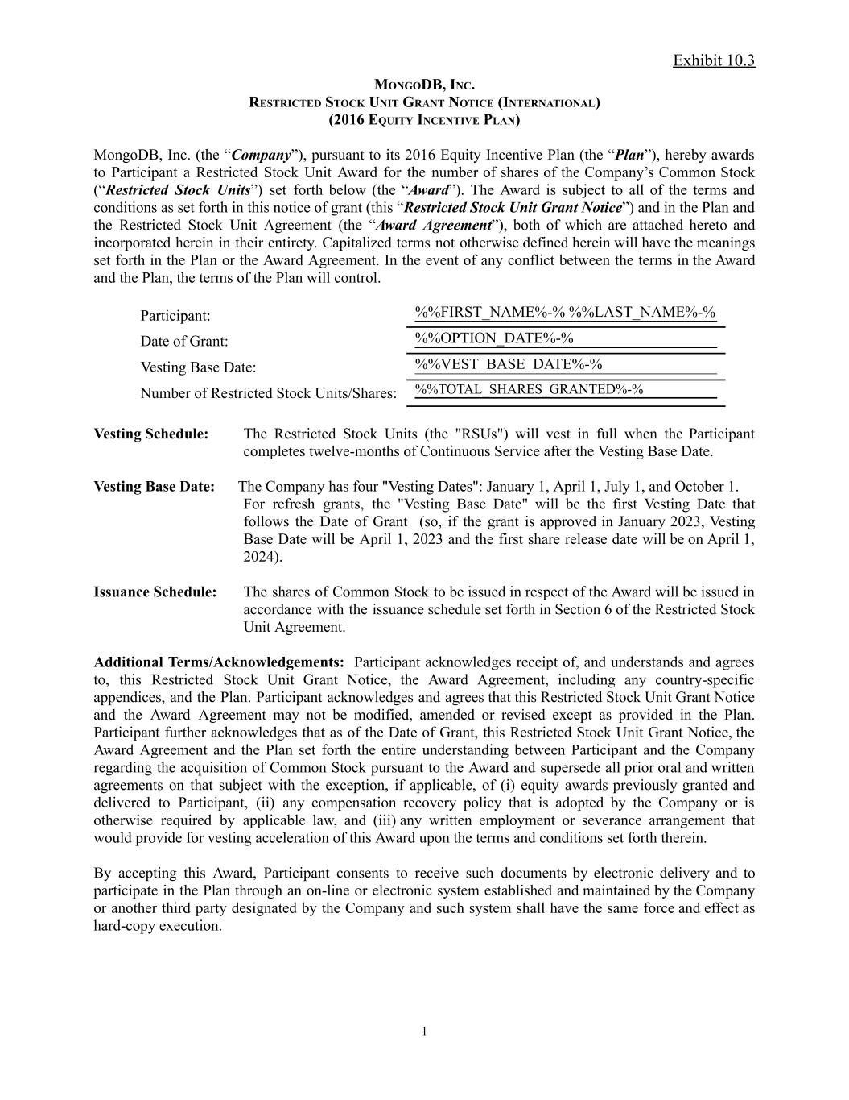

Exhibit 10.3 MONGODB, INC. RESTRICTED STOCK UNIT GRANT NOTICE (INTERNATIONAL)​ (2016 EQUITY INCENTIVE PLAN) MongoDB, Inc. (the “Company”), pursuant to its 2016 Equity Incentive Plan (the “Plan”), hereby awards to Participant a Restricted Stock Unit Award for the number of shares of the Company’s Common Stock (“Restricted Stock Units”) set forth below (the “Award”). The Award is subject to all of the terms and conditions as set forth in this notice of grant (this “Restricted Stock Unit Grant Notice”) and in the Plan and the Restricted Stock Unit Agreement (the “Award Agreement”), both of which are attached hereto and incorporated herein in their entirety. Capitalized terms not otherwise defined herein will have the meanings set forth in the Plan or the Award Agreement. In the event of any conflict between the terms in the Award and the Plan, the terms of the Plan will control. Participant: %%FIRST_NAME%-% %%LAST_NAME%-% Date of Grant: %%OPTION_DATE%-% Vesting Base Date: %%VEST_BASE_DATE%-% Number of Restricted Stock Units/Shares: %%TOTAL_SHARES_GRANTED%-% Vesting Schedule: ​ The Restricted Stock Units (the "RSUs") will vest in full when the Participant completes twelve-months of Continuous Service after the Vesting Base Date. Vesting Base Date: The Company has four "Vesting Dates": January 1, April 1, July 1, and October 1. ​ For refresh grants, the "Vesting Base Date" will be the first Vesting Date that follows the Date of Grant (so, if the grant is approved in January 2023, Vesting Base Date will be April 1, 2023 and the first share release date will be on April 1, 2024). Issuance Schedule:​ The shares of Common Stock to be issued in respect of the Award will be issued in accordance with the issuance schedule set forth in Section 6 of the Restricted Stock Unit Agreement. Additional Terms/Acknowledgements: Participant acknowledges receipt of, and understands and agrees to, this Restricted Stock Unit Grant Notice, the Award Agreement, including any country-specific appendices, and the Plan. Participant acknowledges and agrees that this Restricted Stock Unit Grant Notice and the Award Agreement may not be modified, amended or revised except as provided in the Plan. Participant further acknowledges that as of the Date of Grant, this Restricted Stock Unit Grant Notice, the Award Agreement and the Plan set forth the entire understanding between Participant and the Company regarding the acquisition of Common Stock pursuant to the Award and supersede all prior oral and written agreements on that subject with the exception, if applicable, of (i) equity awards previously granted and delivered to Participant, (ii) any compensation recovery policy that is adopted by the Company or is otherwise required by applicable law, and (iii) any written employment or severance arrangement that would provide for vesting acceleration of this Award upon the terms and conditions set forth therein. By accepting this Award, Participant consents to receive such documents by electronic delivery and to participate in the Plan through an on-line or electronic system established and maintained by the Company or another third party designated by the Company and such system shall have the same force and effect as hard-copy execution. 1


Exhibit 10.3 MONGODB, INC.​ PARTICIPANT By: Signature Date: ​ ATTACHMENTS: ​ Award Agreement, 2016 Equity Incentive Plan 2

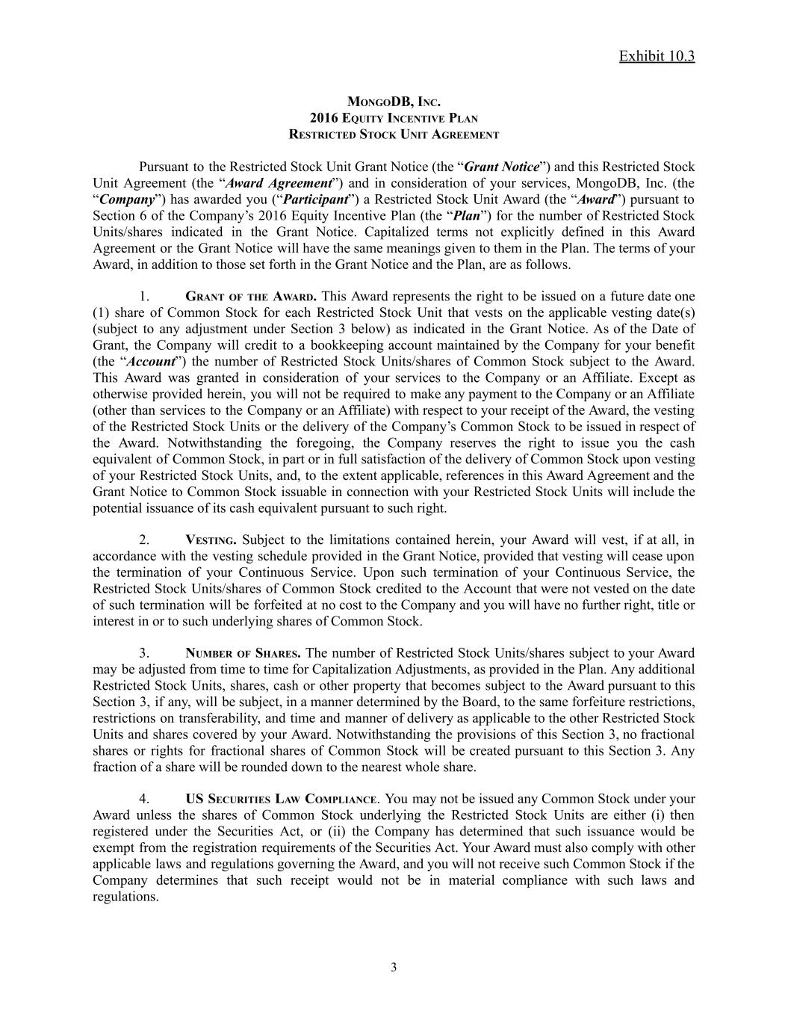
Exhibit 10.3 MONGODB, INC. 2016 EQUITY INCENTIVE PLAN RESTRICTED STOCK UNIT AGREEMENT Pursuant to the Restricted Stock Unit Grant Notice (the “Grant Notice”) and this Restricted Stock Unit Agreement (the “Award Agreement”) and in consideration of your services, MongoDB, Inc. (the “Company”) has awarded you (“Participant”) a Restricted Stock Unit Award (the “Award”) pursuant to Section 6 of the Company’s 2016 Equity Incentive Plan (the “Plan”) for the number of Restricted Stock Units/shares indicated in the Grant Notice. Capitalized terms not explicitly defined in this Award Agreement or the Grant Notice will have the same meanings given to them in the Plan. The terms of your Award, in addition to those set forth in the Grant Notice and the Plan, are as follows. 1.​ GRANT OF THE AWARD. This Award represents the right to be issued on a future date one (1) share of Common Stock for each Restricted Stock Unit that vests on the applicable vesting date(s) (subject to any adjustment under Section 3 below) as indicated in the Grant Notice. As of the Date of Grant, the Company will credit to a bookkeeping account maintained by the Company for your benefit (the “Account”) the number of Restricted Stock Units/shares of Common Stock subject to the Award. This Award was granted in consideration of your services to the Company or an Affiliate. Except as otherwise provided herein, you will not be required to make any payment to the Company or an Affiliate (other than services to the Company or an Affiliate) with respect to your receipt of the Award, the vesting of the Restricted Stock Units or the delivery of the Company’s Common Stock to be issued in respect of the Award. Notwithstanding the foregoing, the Company reserves the right to issue you the cash equivalent of Common Stock, in part or in full satisfaction of the delivery of Common Stock upon vesting of your Restricted Stock Units, and, to the extent applicable, references in this Award Agreement and the Grant Notice to Common Stock issuable in connection with your Restricted Stock Units will include the potential issuance of its cash equivalent pursuant to such right. 2.​ VESTING. Subject to the limitations contained herein, your Award will vest, if at all, in accordance with the vesting schedule provided in the Grant Notice, provided that vesting will cease upon the termination of your Continuous Service. Upon such termination of your Continuous Service, the Restricted Stock Units/shares of Common Stock credited to the Account that were not vested on the date of such termination will be forfeited at no cost to the Company and you will have no further right, title or interest in or to such underlying shares of Common Stock. 3.​ NUMBER OF SHARES. The number of Restricted Stock Units/shares subject to your Award may be adjusted from time to time for Capitalization Adjustments, as provided in the Plan. Any additional Restricted Stock Units, shares, cash or other property that becomes subject to the Award pursuant to this Section 3, if any, will be subject, in a manner determined by the Board, to the same forfeiture restrictions, restrictions on transferability, and time and manner of delivery as applicable to the other Restricted Stock Units and shares covered by your Award. Notwithstanding the provisions of this Section 3, no fractional shares or rights for fractional shares of Common Stock will be created pursuant to this Section 3. Any fraction of a share will be rounded down to the nearest whole share. 4.​ US SECURITIES LAW COMPLIANCE. You may not be issued any Common Stock under your Award unless the shares of Common Stock underlying the Restricted Stock Units are either (i) then registered under the Securities Act, or (ii) the Company has determined that such issuance would be exempt from the registration requirements of the Securities Act. Your Award must also comply with other applicable laws and regulations governing the Award, and you will not receive such Common Stock if the Company determines that such receipt would not be in material compliance with such laws and regulations. ​ 3

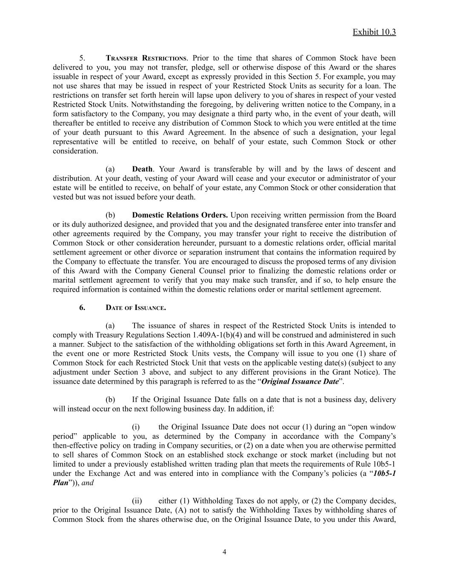
Exhibit 10.3 5.​ TRANSFER RESTRICTIONS. Prior to the time that shares of Common Stock have been delivered to you, you may not transfer, pledge, sell or otherwise dispose of this Award or the shares issuable in respect of your Award, except as expressly provided in this Section 5. For example, you may not use shares that may be issued in respect of your Restricted Stock Units as security for a loan. The restrictions on transfer set forth herein will lapse upon delivery to you of shares in respect of your vested Restricted Stock Units. Notwithstanding the foregoing, by delivering written notice to the Company, in a form satisfactory to the Company, you may designate a third party who, in the event of your death, will thereafter be entitled to receive any distribution of Common Stock to which you were entitled at the time of your death pursuant to this Award Agreement. In the absence of such a designation, your legal representative will be entitled to receive, on behalf of your estate, such Common Stock or other consideration. (a)​ Death. Your Award is transferable by will and by the laws of descent and distribution. At your death, vesting of your Award will cease and your executor or administrator of your estate will be entitled to receive, on behalf of your estate, any Common Stock or other consideration that vested but was not issued before your death. (b)​ Domestic Relations Orders. Upon receiving written permission from the Board or its duly authorized designee, and provided that you and the designated transferee enter into transfer and other agreements required by the Company, you may transfer your right to receive the distribution of Common Stock or other consideration hereunder, pursuant to a domestic relations order, official marital settlement agreement or other divorce or separation instrument that contains the information required by the Company to effectuate the transfer. You are encouraged to discuss the proposed terms of any division of this Award with the Company General Counsel prior to finalizing the domestic relations order or marital settlement agreement to verify that you may make such transfer, and if so, to help ensure the required information is contained within the domestic relations order or marital settlement agreement. 6.​ DATE OF ISSUANCE. (a)​ The issuance of shares in respect of the Restricted Stock Units is intended to comply with Treasury Regulations Section 1.409A-1(b)(4) and will be construed and administered in such a manner. Subject to the satisfaction of the withholding obligations set forth in this Award Agreement, in the event one or more Restricted Stock Units vests, the Company will issue to you one (1) share of Common Stock for each Restricted Stock Unit that vests on the applicable vesting date(s) (subject to any adjustment under Section 3 above, and subject to any different provisions in the Grant Notice). The issuance date determined by this paragraph is referred to as the “Original Issuance Date”. (b)​ If the Original Issuance Date falls on a date that is not a business day, delivery will instead occur on the next following business day. In addition, if: (i)​ the Original Issuance Date does not occur (1) during an “open window period” applicable to you, as determined by the Company in accordance with the Company’s then-effective policy on trading in Company securities, or (2) on a date when you are otherwise permitted to sell shares of Common Stock on an established stock exchange or stock market (including but not limited to under a previously established written trading plan that meets the requirements of Rule 10b5-1 under the Exchange Act and was entered into in compliance with the Company’s policies (a “10b5-1 Plan”)), and (ii)​ either (1) Withholding Taxes do not apply, or (2) the Company decides, prior to the Original Issuance Date, (A) not to satisfy the Withholding Taxes by withholding shares of Common Stock from the shares otherwise due, on the Original Issuance Date, to you under this Award, ​ 4

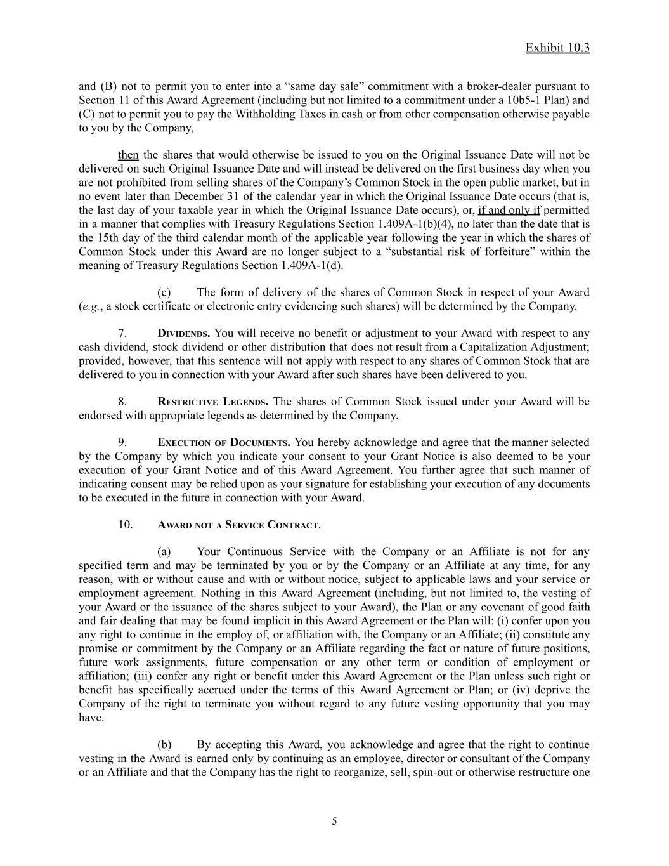
Exhibit 10.3 and (B) not to permit you to enter into a “same day sale” commitment with a broker-dealer pursuant to Section 11 of this Award Agreement (including but not limited to a commitment under a 10b5-1 Plan) and (C) not to permit you to pay the Withholding Taxes in cash or from other compensation otherwise payable to you by the Company, then the shares that would otherwise be issued to you on the Original Issuance Date will not be delivered on such Original Issuance Date and will instead be delivered on the first business day when you are not prohibited from selling shares of the Company’s Common Stock in the open public market, but in no event later than December 31 of the calendar year in which the Original Issuance Date occurs (that is, the last day of your taxable year in which the Original Issuance Date occurs), or, if and only if permitted in a manner that complies with Treasury Regulations Section 1.409A-1(b)(4), no later than the date that is the 15th day of the third calendar month of the applicable year following the year in which the shares of Common Stock under this Award are no longer subject to a “substantial risk of forfeiture” within the meaning of Treasury Regulations Section 1.409A-1(d). (c)​ The form of delivery of the shares of Common Stock in respect of your Award (e.g., a stock certificate or electronic entry evidencing such shares) will be determined by the Company. 7.​ DIVIDENDS. You will receive no benefit or adjustment to your Award with respect to any cash dividend, stock dividend or other distribution that does not result from a Capitalization Adjustment; provided, however, that this sentence will not apply with respect to any shares of Common Stock that are delivered to you in connection with your Award after such shares have been delivered to you. 8.​ RESTRICTIVE LEGENDS. The shares of Common Stock issued under your Award will be endorsed with appropriate legends as determined by the Company. 9.​ EXECUTION OF DOCUMENTS. You hereby acknowledge and agree that the manner selected by the Company by which you indicate your consent to your Grant Notice is also deemed to be your execution of your Grant Notice and of this Award Agreement. You further agree that such manner of indicating consent may be relied upon as your signature for establishing your execution of any documents to be executed in the future in connection with your Award. 10.​ AWARD NOT A SERVICE CONTRACT. (a)​ Your Continuous Service with the Company or an Affiliate is not for any specified term and may be terminated by you or by the Company or an Affiliate at any time, for any reason, with or without cause and with or without notice, subject to applicable laws and your service or employment agreement. Nothing in this Award Agreement (including, but not limited to, the vesting of your Award or the issuance of the shares subject to your Award), the Plan or any covenant of good faith and fair dealing that may be found implicit in this Award Agreement or the Plan will: (i) confer upon you any right to continue in the employ of, or affiliation with, the Company or an Affiliate; (ii) constitute any promise or commitment by the Company or an Affiliate regarding the fact or nature of future positions, future work assignments, future compensation or any other term or condition of employment or affiliation; (iii) confer any right or benefit under this Award Agreement or the Plan unless such right or benefit has specifically accrued under the terms of this Award Agreement or Plan; or (iv) deprive the Company of the right to terminate you without regard to any future vesting opportunity that you may have. (b)​ By accepting this Award, you acknowledge and agree that the right to continue vesting in the Award is earned only by continuing as an employee, director or consultant of the Company or an Affiliate and that the Company has the right to reorganize, sell, spin-out or otherwise restructure one ​ 5

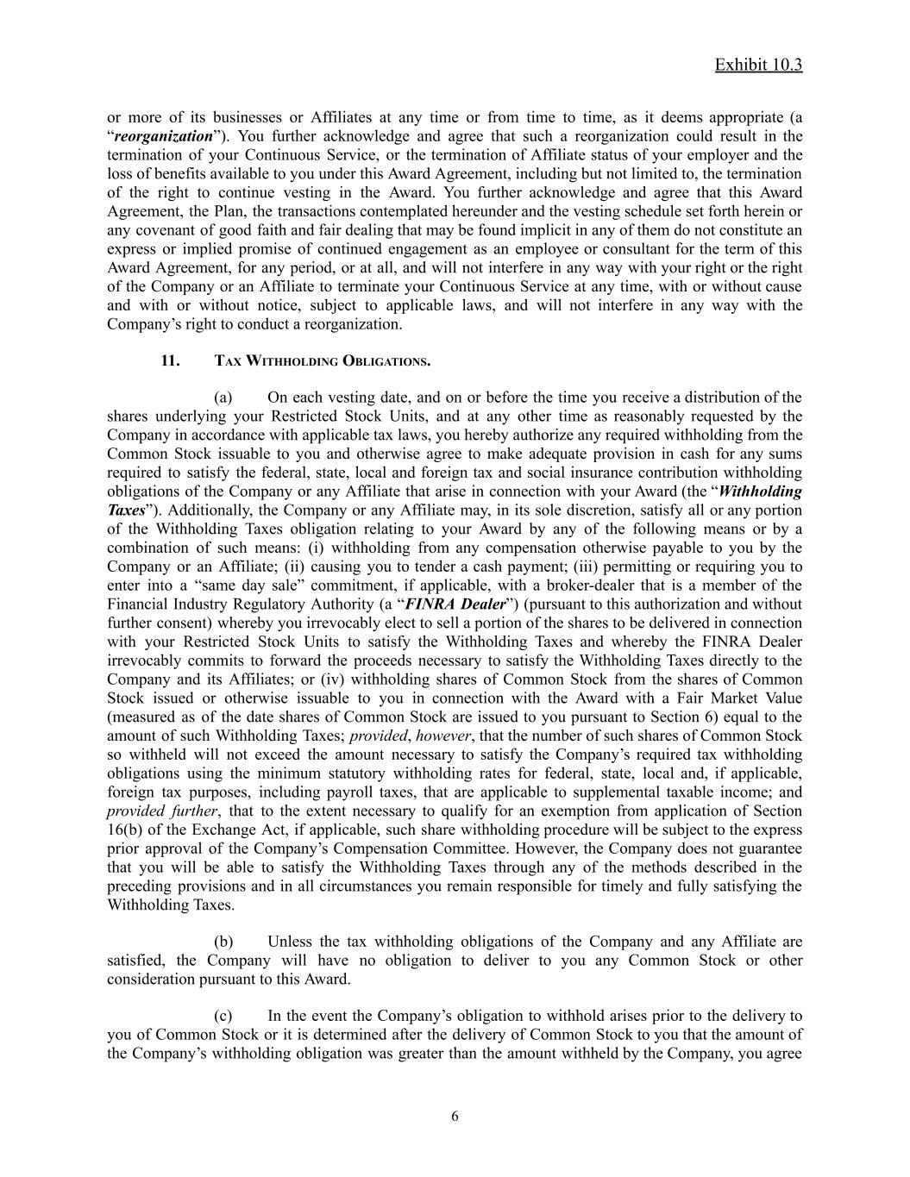
Exhibit 10.3 or more of its businesses or Affiliates at any time or from time to time, as it deems appropriate (a “reorganization”). You further acknowledge and agree that such a reorganization could result in the termination of your Continuous Service, or the termination of Affiliate status of your employer and the loss of benefits available to you under this Award Agreement, including but not limited to, the termination of the right to continue vesting in the Award. You further acknowledge and agree that this Award Agreement, the Plan, the transactions contemplated hereunder and the vesting schedule set forth herein or any covenant of good faith and fair dealing that may be found implicit in any of them do not constitute an express or implied promise of continued engagement as an employee or consultant for the term of this Award Agreement, for any period, or at all, and will not interfere in any way with your right or the right of the Company or an Affiliate to terminate your Continuous Service at any time, with or without cause and with or without notice, subject to applicable laws, and will not interfere in any way with the Company’s right to conduct a reorganization. 11.​ TAX WITHHOLDING OBLIGATIONS. (a)​ On each vesting date, and on or before the time you receive a distribution of the shares underlying your Restricted Stock Units, and at any other time as reasonably requested by the Company in accordance with applicable tax laws, you hereby authorize any required withholding from the Common Stock issuable to you and otherwise agree to make adequate provision in cash for any sums required to satisfy the federal, state, local and foreign tax and social insurance contribution withholding obligations of the Company or any Affiliate that arise in connection with your Award (the “Withholding Taxes”). Additionally, the Company or any Affiliate may, in its sole discretion, satisfy all or any portion of the Withholding Taxes obligation relating to your Award by any of the following means or by a combination of such means: (i) withholding from any compensation otherwise payable to you by the Company or an Affiliate; (ii) causing you to tender a cash payment; (iii) permitting or requiring you to enter into a “same day sale” commitment, if applicable, with a broker-dealer that is a member of the Financial Industry Regulatory Authority (a “FINRA Dealer”) (pursuant to this authorization and without further consent) whereby you irrevocably elect to sell a portion of the shares to be delivered in connection with your Restricted Stock Units to satisfy the Withholding Taxes and whereby the FINRA Dealer irrevocably commits to forward the proceeds necessary to satisfy the Withholding Taxes directly to the Company and its Affiliates; or (iv) withholding shares of Common Stock from the shares of Common Stock issued or otherwise issuable to you in connection with the Award with a Fair Market Value (measured as of the date shares of Common Stock are issued to you pursuant to Section 6) equal to the amount of such Withholding Taxes; provided, however, that the number of such shares of Common Stock so withheld will not exceed the amount necessary to satisfy the Company’s required tax withholding obligations using the minimum statutory withholding rates for federal, state, local and, if applicable, foreign tax purposes, including payroll taxes, that are applicable to supplemental taxable income; and provided further, that to the extent necessary to qualify for an exemption from application of Section 16(b) of the Exchange Act, if applicable, such share withholding procedure will be subject to the express prior approval of the Company’s Compensation Committee. However, the Company does not guarantee that you will be able to satisfy the Withholding Taxes through any of the methods described in the preceding provisions and in all circumstances you remain responsible for timely and fully satisfying the Withholding Taxes. (b)​ Unless the tax withholding obligations of the Company and any Affiliate are satisfied, the Company will have no obligation to deliver to you any Common Stock or other consideration pursuant to this Award. (c)​ In the event the Company’s obligation to withhold arises prior to the delivery to you of Common Stock or it is determined after the delivery of Common Stock to you that the amount of the Company’s withholding obligation was greater than the amount withheld by the Company, you agree ​ 6

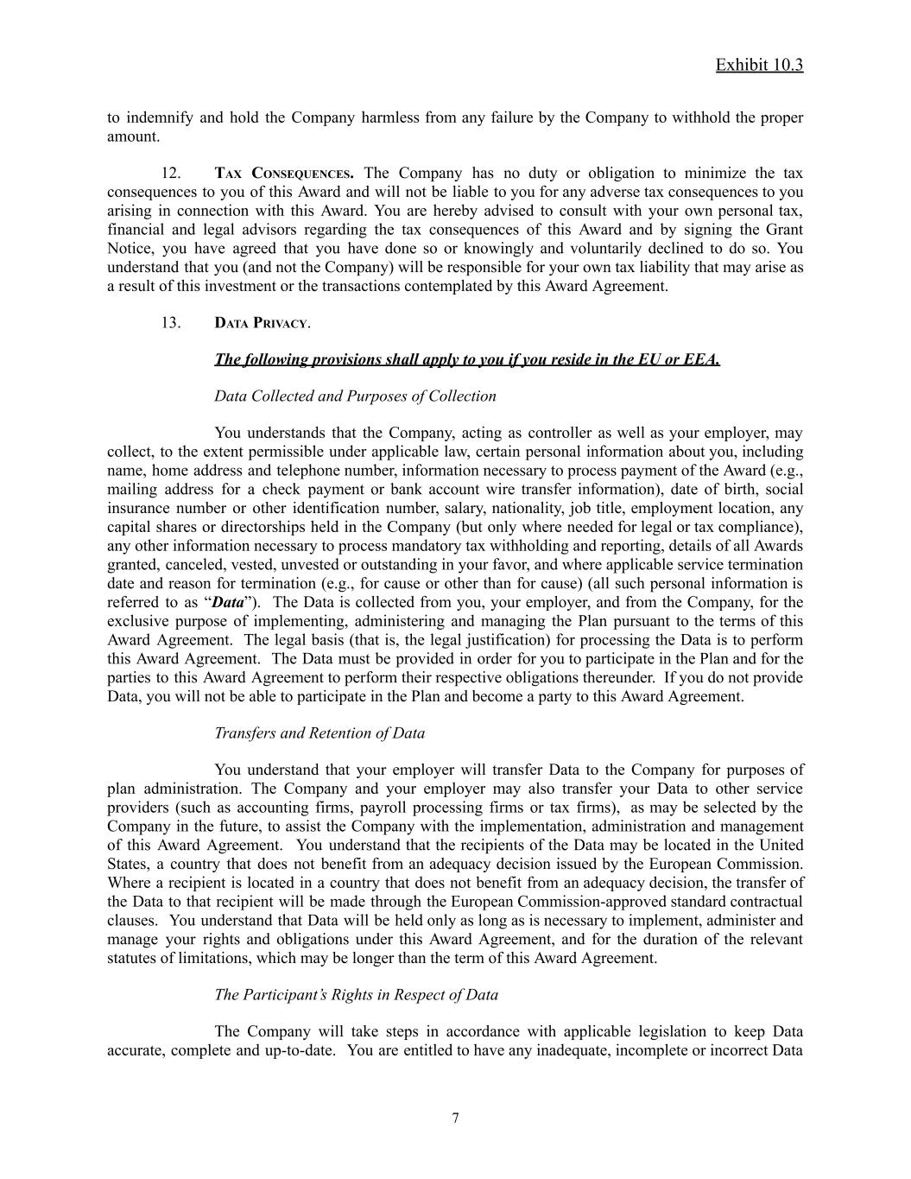
Exhibit 10.3 to indemnify and hold the Company harmless from any failure by the Company to withhold the proper amount. 12.​ TAX CONSEQUENCES. The Company has no duty or obligation to minimize the tax consequences to you of this Award and will not be liable to you for any adverse tax consequences to you arising in connection with this Award. You are hereby advised to consult with your own personal tax, financial and legal advisors regarding the tax consequences of this Award and by signing the Grant Notice, you have agreed that you have done so or knowingly and voluntarily declined to do so. You understand that you (and not the Company) will be responsible for your own tax liability that may arise as a result of this investment or the transactions contemplated by this Award Agreement. 13.​ DATA PRIVACY. The following provisions shall apply to you if you reside in the EU or EEA. Data Collected and Purposes of Collection You understands that the Company, acting as controller as well as your employer, may collect, to the extent permissible under applicable law, certain personal information about you, including name, home address and telephone number, information necessary to process payment of the Award (e.g., mailing address for a check payment or bank account wire transfer information), date of birth, social insurance number or other identification number, salary, nationality, job title, employment location, any capital shares or directorships held in the Company (but only where needed for legal or tax compliance), any other information necessary to process mandatory tax withholding and reporting, details of all Awards granted, canceled, vested, unvested or outstanding in your favor, and where applicable service termination date and reason for termination (e.g., for cause or other than for cause) (all such personal information is referred to as “Data”). The Data is collected from you, your employer, and from the Company, for the exclusive purpose of implementing, administering and managing the Plan pursuant to the terms of this Award Agreement. The legal basis (that is, the legal justification) for processing the Data is to perform this Award Agreement. The Data must be provided in order for you to participate in the Plan and for the parties to this Award Agreement to perform their respective obligations thereunder. If you do not provide Data, you will not be able to participate in the Plan and become a party to this Award Agreement. Transfers and Retention of Data You understand that your employer will transfer Data to the Company for purposes of plan administration. The Company and your employer may also transfer your Data to other service providers (such as accounting firms, payroll processing firms or tax firms), as may be selected by the Company in the future, to assist the Company with the implementation, administration and management of this Award Agreement. You understand that the recipients of the Data may be located in the United States, a country that does not benefit from an adequacy decision issued by the European Commission. Where a recipient is located in a country that does not benefit from an adequacy decision, the transfer of the Data to that recipient will be made through the European Commission-approved standard contractual clauses. You understand that Data will be held only as long as is necessary to implement, administer and manage your rights and obligations under this Award Agreement, and for the duration of the relevant statutes of limitations, which may be longer than the term of this Award Agreement. The Participant’s Rights in Respect of Data The Company will take steps in accordance with applicable legislation to keep Data accurate, complete and up-to-date. You are entitled to have any inadequate, incomplete or incorrect Data ​ 7

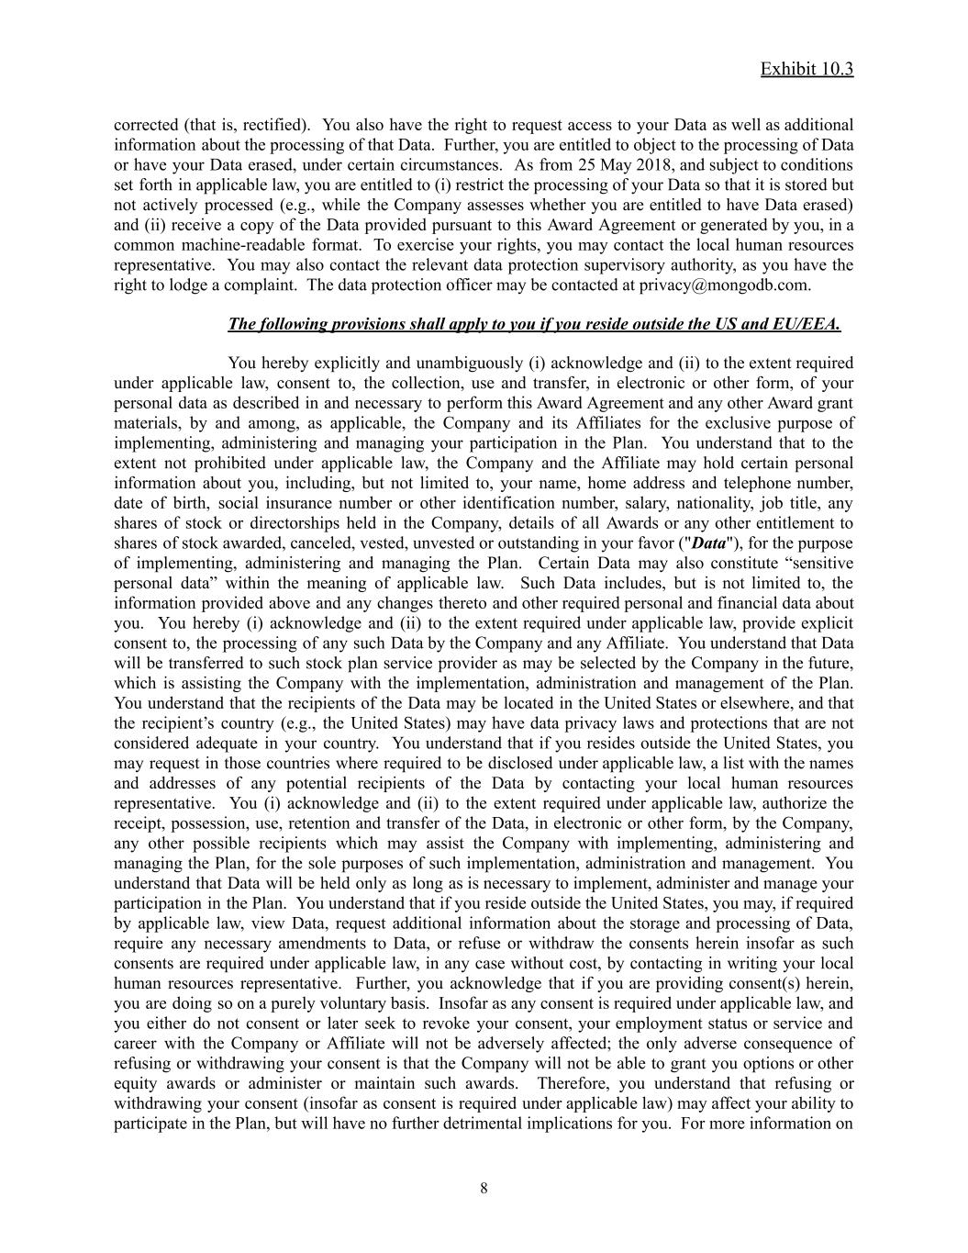
Exhibit 10.3 corrected (that is, rectified). You also have the right to request access to your Data as well as additional information about the processing of that Data. Further, you are entitled to object to the processing of Data or have your Data erased, under certain circumstances. As from 25 May 2018, and subject to conditions set forth in applicable law, you are entitled to (i) restrict the processing of your Data so that it is stored but not actively processed (e.g., while the Company assesses whether you are entitled to have Data erased) and (ii) receive a copy of the Data provided pursuant to this Award Agreement or generated by you, in a common machine-readable format. To exercise your rights, you may contact the local human resources representative. You may also contact the relevant data protection supervisory authority, as you have the right to lodge a complaint. The data protection officer may be contacted at privacy@mongodb.com. The following provisions shall apply to you if you reside outside the US and EU/EEA. You hereby explicitly and unambiguously (i) acknowledge and (ii) to the extent required under applicable law, consent to, the collection, use and transfer, in electronic or other form, of your personal data as described in and necessary to perform this Award Agreement and any other Award grant materials, by and among, as applicable, the Company and its Affiliates for the exclusive purpose of implementing, administering and managing your participation in the Plan. You understand that to the extent not prohibited under applicable law, the Company and the Affiliate may hold certain personal information about you, including, but not limited to, your name, home address and telephone number, date of birth, social insurance number or other identification number, salary, nationality, job title, any shares of stock or directorships held in the Company, details of all Awards or any other entitlement to shares of stock awarded, canceled, vested, unvested or outstanding in your favor ("Data"), for the purpose of implementing, administering and managing the Plan. Certain Data may also constitute “sensitive personal data” within the meaning of applicable law. Such Data includes, but is not limited to, the information provided above and any changes thereto and other required personal and financial data about you. You hereby (i) acknowledge and (ii) to the extent required under applicable law, provide explicit consent to, the processing of any such Data by the Company and any Affiliate. You understand that Data will be transferred to such stock plan service provider as may be selected by the Company in the future, which is assisting the Company with the implementation, administration and management of the Plan. You understand that the recipients of the Data may be located in the United States or elsewhere, and that the recipient’s country (e.g., the United States) may have data privacy laws and protections that are not considered adequate in your country. You understand that if you resides outside the United States, you may request in those countries where required to be disclosed under applicable law, a list with the names and addresses of any potential recipients of the Data by contacting your local human resources representative. You (i) acknowledge and (ii) to the extent required under applicable law, authorize the receipt, possession, use, retention and transfer of the Data, in electronic or other form, by the Company, any other possible recipients which may assist the Company with implementing, administering and managing the Plan, for the sole purposes of such implementation, administration and management. You understand that Data will be held only as long as is necessary to implement, administer and manage your participation in the Plan. You understand that if you reside outside the United States, you may, if required by applicable law, view Data, request additional information about the storage and processing of Data, require any necessary amendments to Data, or refuse or withdraw the consents herein insofar as such consents are required under applicable law, in any case without cost, by contacting in writing your local human resources representative. Further, you acknowledge that if you are providing consent(s) herein, you are doing so on a purely voluntary basis. Insofar as any consent is required under applicable law, and you either do not consent or later seek to revoke your consent, your employment status or service and career with the Company or Affiliate will not be adversely affected; the only adverse consequence of refusing or withdrawing your consent is that the Company will not be able to grant you options or other equity awards or administer or maintain such awards. Therefore, you understand that refusing or withdrawing your consent (insofar as consent is required under applicable law) may affect your ability to participate in the Plan, but will have no further detrimental implications for you. For more information on ​ 8

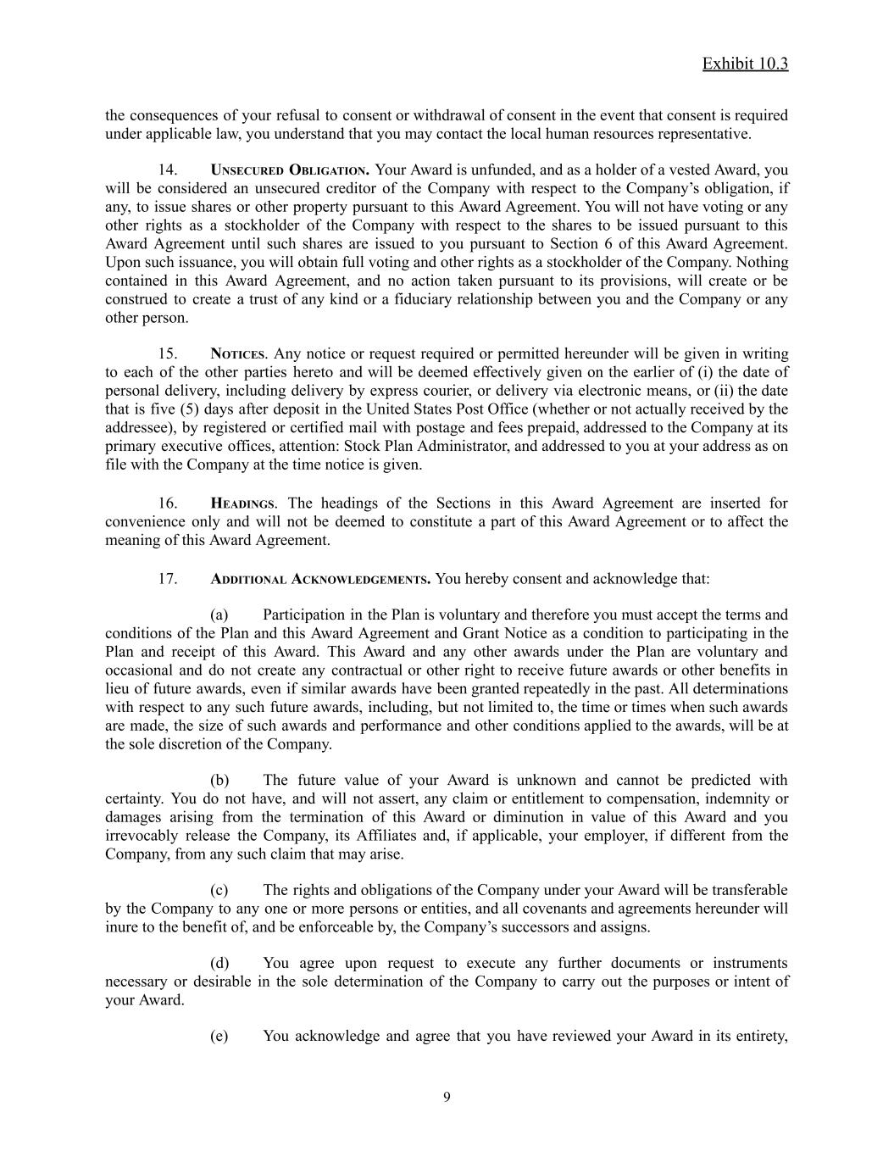
Exhibit 10.3 the consequences of your refusal to consent or withdrawal of consent in the event that consent is required under applicable law, you understand that you may contact the local human resources representative. 14.​ UNSECURED OBLIGATION. Your Award is unfunded, and as a holder of a vested Award, you will be considered an unsecured creditor of the Company with respect to the Company’s obligation, if any, to issue shares or other property pursuant to this Award Agreement. You will not have voting or any other rights as a stockholder of the Company with respect to the shares to be issued pursuant to this Award Agreement until such shares are issued to you pursuant to Section 6 of this Award Agreement. Upon such issuance, you will obtain full voting and other rights as a stockholder of the Company. Nothing contained in this Award Agreement, and no action taken pursuant to its provisions, will create or be construed to create a trust of any kind or a fiduciary relationship between you and the Company or any other person. 15.​ NOTICES. Any notice or request required or permitted hereunder will be given in writing to each of the other parties hereto and will be deemed effectively given on the earlier of (i) the date of personal delivery, including delivery by express courier, or delivery via electronic means, or (ii) the date that is five (5) days after deposit in the United States Post Office (whether or not actually received by the addressee), by registered or certified mail with postage and fees prepaid, addressed to the Company at its primary executive offices, attention: Stock Plan Administrator, and addressed to you at your address as on file with the Company at the time notice is given. 16.​ HEADINGS. The headings of the Sections in this Award Agreement are inserted for convenience only and will not be deemed to constitute a part of this Award Agreement or to affect the meaning of this Award Agreement. 17.​ ADDITIONAL ACKNOWLEDGEMENTS. You hereby consent and acknowledge that: (a)​ Participation in the Plan is voluntary and therefore you must accept the terms and conditions of the Plan and this Award Agreement and Grant Notice as a condition to participating in the Plan and receipt of this Award. This Award and any other awards under the Plan are voluntary and occasional and do not create any contractual or other right to receive future awards or other benefits in lieu of future awards, even if similar awards have been granted repeatedly in the past. All determinations with respect to any such future awards, including, but not limited to, the time or times when such awards are made, the size of such awards and performance and other conditions applied to the awards, will be at the sole discretion of the Company. (b)​ The future value of your Award is unknown and cannot be predicted with certainty. You do not have, and will not assert, any claim or entitlement to compensation, indemnity or damages arising from the termination of this Award or diminution in value of this Award and you irrevocably release the Company, its Affiliates and, if applicable, your employer, if different from the Company, from any such claim that may arise. (c)​ The rights and obligations of the Company under your Award will be transferable by the Company to any one or more persons or entities, and all covenants and agreements hereunder will inure to the benefit of, and be enforceable by, the Company’s successors and assigns. (d)​ You agree upon request to execute any further documents or instruments necessary or desirable in the sole determination of the Company to carry out the purposes or intent of your Award. (e)​ You acknowledge and agree that you have reviewed your Award in its entirety, ​ 9

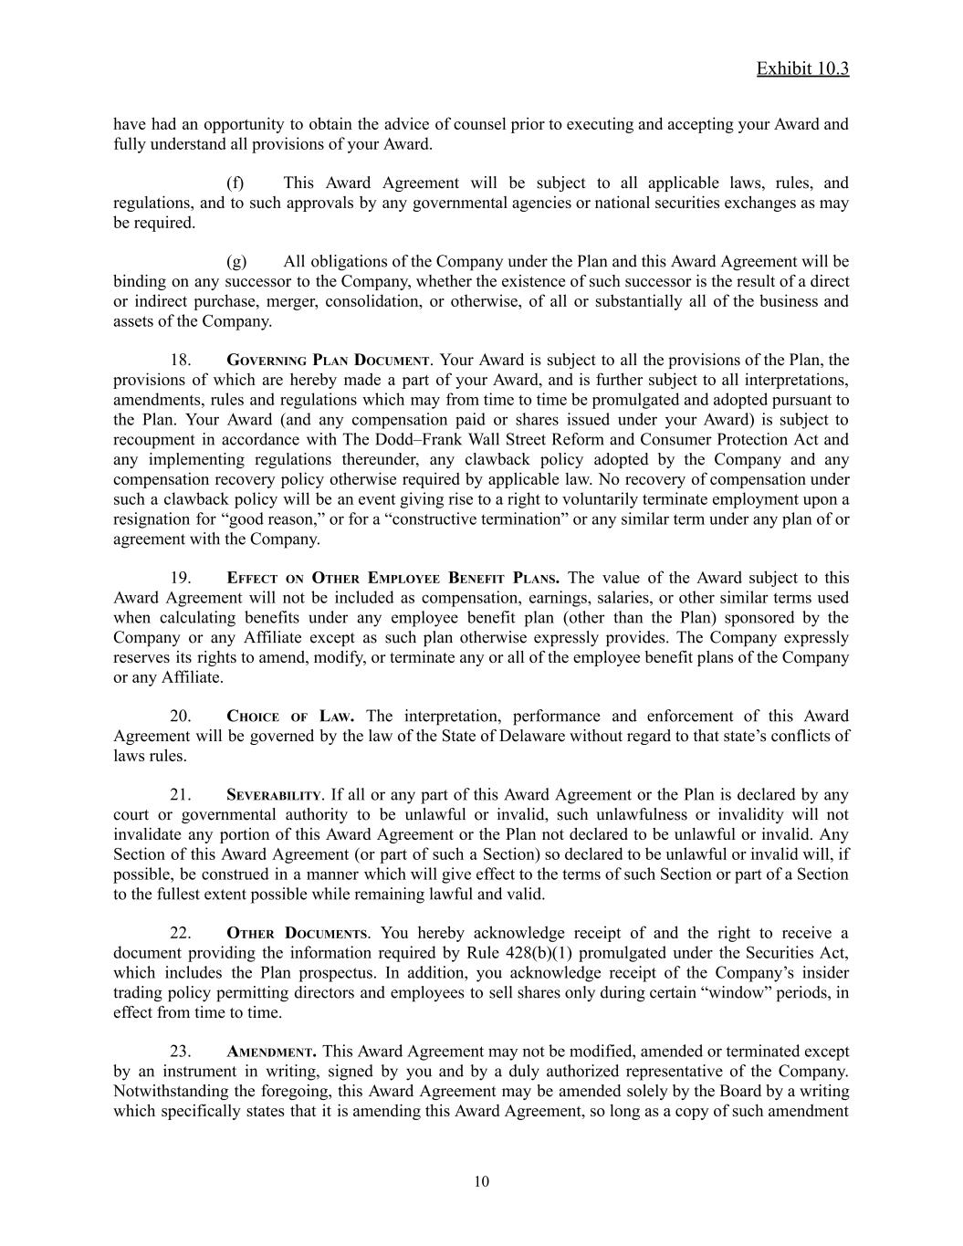
Exhibit 10.3 have had an opportunity to obtain the advice of counsel prior to executing and accepting your Award and fully understand all provisions of your Award. (f)​ This Award Agreement will be subject to all applicable laws, rules, and regulations, and to such approvals by any governmental agencies or national securities exchanges as may be required. (g)​ All obligations of the Company under the Plan and this Award Agreement will be binding on any successor to the Company, whether the existence of such successor is the result of a direct or indirect purchase, merger, consolidation, or otherwise, of all or substantially all of the business and assets of the Company. 18.​ GOVERNING PLAN DOCUMENT. Your Award is subject to all the provisions of the Plan, the provisions of which are hereby made a part of your Award, and is further subject to all interpretations, amendments, rules and regulations which may from time to time be promulgated and adopted pursuant to the Plan. Your Award (and any compensation paid or shares issued under your Award) is subject to recoupment in accordance with The Dodd–Frank Wall Street Reform and Consumer Protection Act and any implementing regulations thereunder, any clawback policy adopted by the Company and any compensation recovery policy otherwise required by applicable law. No recovery of compensation under such a clawback policy will be an event giving rise to a right to voluntarily terminate employment upon a resignation for “good reason,” or for a “constructive termination” or any similar term under any plan of or agreement with the Company. 19.​ EFFECT ON OTHER EMPLOYEE BENEFIT PLANS. The value of the Award subject to this Award Agreement will not be included as compensation, earnings, salaries, or other similar terms used when calculating benefits under any employee benefit plan (other than the Plan) sponsored by the Company or any Affiliate except as such plan otherwise expressly provides. The Company expressly reserves its rights to amend, modify, or terminate any or all of the employee benefit plans of the Company or any Affiliate. 20.​ CHOICE OF LAW. The interpretation, performance and enforcement of this Award Agreement will be governed by the law of the State of Delaware without regard to that state’s conflicts of laws rules. 21.​ SEVERABILITY. If all or any part of this Award Agreement or the Plan is declared by any court or governmental authority to be unlawful or invalid, such unlawfulness or invalidity will not invalidate any portion of this Award Agreement or the Plan not declared to be unlawful or invalid. Any Section of this Award Agreement (or part of such a Section) so declared to be unlawful or invalid will, if possible, be construed in a manner which will give effect to the terms of such Section or part of a Section to the fullest extent possible while remaining lawful and valid. 22.​ OTHER DOCUMENTS. You hereby acknowledge receipt of and the right to receive a document providing the information required by Rule 428(b)(1) promulgated under the Securities Act, which includes the Plan prospectus. In addition, you acknowledge receipt of the Company’s insider trading policy permitting directors and employees to sell shares only during certain “window” periods, in effect from time to time. 23.​ AMENDMENT. This Award Agreement may not be modified, amended or terminated except by an instrument in writing, signed by you and by a duly authorized representative of the Company. Notwithstanding the foregoing, this Award Agreement may be amended solely by the Board by a writing which specifically states that it is amending this Award Agreement, so long as a copy of such amendment ​ 10

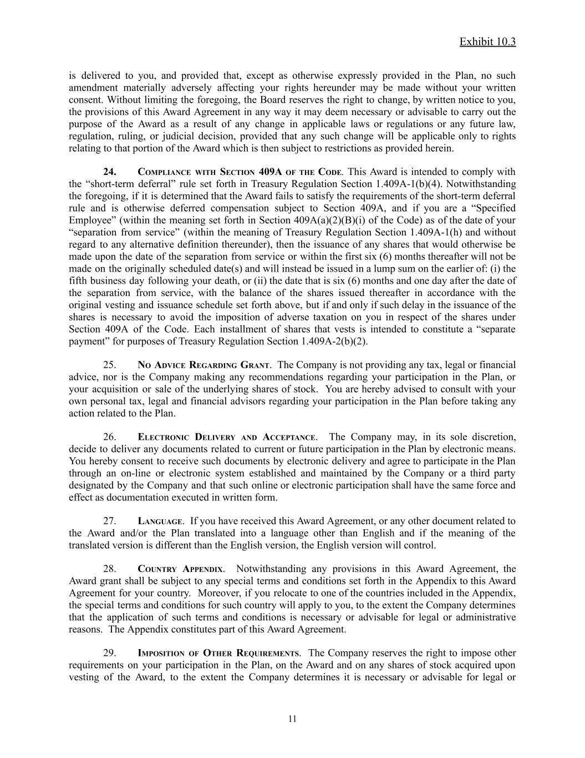
Exhibit 10.3 is delivered to you, and provided that, except as otherwise expressly provided in the Plan, no such amendment materially adversely affecting your rights hereunder may be made without your written consent. Without limiting the foregoing, the Board reserves the right to change, by written notice to you, the provisions of this Award Agreement in any way it may deem necessary or advisable to carry out the purpose of the Award as a result of any change in applicable laws or regulations or any future law, regulation, ruling, or judicial decision, provided that any such change will be applicable only to rights relating to that portion of the Award which is then subject to restrictions as provided herein. 24.​ COMPLIANCE WITH SECTION 409A OF THE CODE. This Award is intended to comply with the “short-term deferral” rule set forth in Treasury Regulation Section 1.409A-1(b)(4). Notwithstanding the foregoing, if it is determined that the Award fails to satisfy the requirements of the short-term deferral rule and is otherwise deferred compensation subject to Section 409A, and if you are a “Specified Employee” (within the meaning set forth in Section 409A(a)(2)(B)(i) of the Code) as of the date of your “separation from service” (within the meaning of Treasury Regulation Section 1.409A-1(h) and without regard to any alternative definition thereunder), then the issuance of any shares that would otherwise be made upon the date of the separation from service or within the first six (6) months thereafter will not be made on the originally scheduled date(s) and will instead be issued in a lump sum on the earlier of: (i) the fifth business day following your death, or (ii) the date that is six (6) months and one day after the date of the separation from service, with the balance of the shares issued thereafter in accordance with the original vesting and issuance schedule set forth above, but if and only if such delay in the issuance of the shares is necessary to avoid the imposition of adverse taxation on you in respect of the shares under Section 409A of the Code. Each installment of shares that vests is intended to constitute a “separate payment” for purposes of Treasury Regulation Section 1.409A-2(b)(2). 25.​ NO ADVICE REGARDING GRANT. The Company is not providing any tax, legal or financial advice, nor is the Company making any recommendations regarding your participation in the Plan, or your acquisition or sale of the underlying shares of stock. You are hereby advised to consult with your own personal tax, legal and financial advisors regarding your participation in the Plan before taking any action related to the Plan. 26.​ ELECTRONIC DELIVERY AND ACCEPTANCE. The Company may, in its sole discretion, decide to deliver any documents related to current or future participation in the Plan by electronic means. You hereby consent to receive such documents by electronic delivery and agree to participate in the Plan through an on-line or electronic system established and maintained by the Company or a third party designated by the Company and that such online or electronic participation shall have the same force and effect as documentation executed in written form. 27.​ LANGUAGE. If you have received this Award Agreement, or any other document related to the Award and/or the Plan translated into a language other than English and if the meaning of the translated version is different than the English version, the English version will control. 28.​ COUNTRY APPENDIX. Notwithstanding any provisions in this Award Agreement, the Award grant shall be subject to any special terms and conditions set forth in the Appendix to this Award Agreement for your country. Moreover, if you relocate to one of the countries included in the Appendix, the special terms and conditions for such country will apply to you, to the extent the Company determines that the application of such terms and conditions is necessary or advisable for legal or administrative reasons. The Appendix constitutes part of this Award Agreement. 29.​ IMPOSITION OF OTHER REQUIREMENTS. The Company reserves the right to impose other requirements on your participation in the Plan, on the Award and on any shares of stock acquired upon vesting of the Award, to the extent the Company determines it is necessary or advisable for legal or ​ 11


Exhibit 10.3 administrative reasons, and to require you to sign any additional agreements or undertakings that may be necessary to accomplish the foregoing. * * * * * ​ This Award Agreement will be deemed to be signed by the Company and the Participant upon the signing or electronic acceptance by the Participant of the Restricted Stock Unit Grant Notice to which it is attached. ​ 12

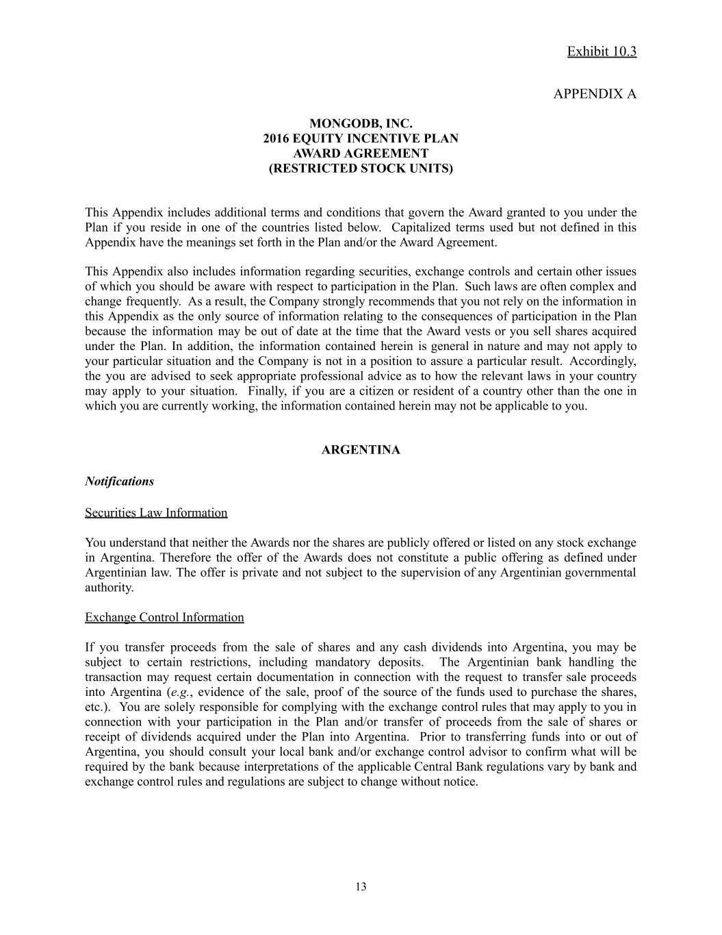
Exhibit 10.3 APPENDIX A MONGODB, INC. 2016 EQUITY INCENTIVE PLAN AWARD AGREEMENT (RESTRICTED STOCK UNITS) This Appendix includes additional terms and conditions that govern the Award granted to you under the Plan if you reside in one of the countries listed below. Capitalized terms used but not defined in this Appendix have the meanings set forth in the Plan and/or the Award Agreement. This Appendix also includes information regarding securities, exchange controls and certain other issues of which you should be aware with respect to participation in the Plan. Such laws are often complex and change frequently. As a result, the Company strongly recommends that you not rely on the information in this Appendix as the only source of information relating to the consequences of participation in the Plan because the information may be out of date at the time that the Award vests or you sell shares acquired under the Plan. In addition, the information contained herein is general in nature and may not apply to your particular situation and the Company is not in a position to assure a particular result. Accordingly, the you are advised to seek appropriate professional advice as to how the relevant laws in your country may apply to your situation. Finally, if you are a citizen or resident of a country other than the one in which you are currently working, the information contained herein may not be applicable to you. ARGENTINA Notifications Securities Law Information You understand that neither the Awards nor the shares are publicly offered or listed on any stock exchange in Argentina. Therefore the offer of the Awards does not constitute a public offering as defined under Argentinian law. The offer is private and not subject to the supervision of any Argentinian governmental authority. Exchange Control Information If you transfer proceeds from the sale of shares and any cash dividends into Argentina, you may be subject to certain restrictions, including mandatory deposits. The Argentinian bank handling the transaction may request certain documentation in connection with the request to transfer sale proceeds into Argentina (e.g., evidence of the sale, proof of the source of the funds used to purchase the shares, etc.). You are solely responsible for complying with the exchange control rules that may apply to you in connection with your participation in the Plan and/or transfer of proceeds from the sale of shares or receipt of dividends acquired under the Plan into Argentina. Prior to transferring funds into or out of Argentina, you should consult your local bank and/or exchange control advisor to confirm what will be required by the bank because interpretations of the applicable Central Bank regulations vary by bank and exchange control rules and regulations are subject to change without notice. ​ 13

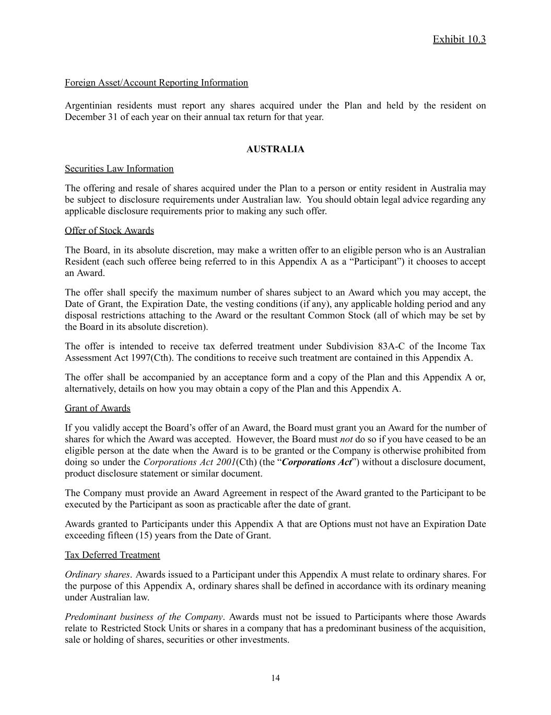
Exhibit 10.3 Foreign Asset/Account Reporting Information Argentinian residents must report any shares acquired under the Plan and held by the resident on December 31 of each year on their annual tax return for that year. AUSTRALIA Securities Law Information The offering and resale of shares acquired under the Plan to a person or entity resident in Australia may be subject to disclosure requirements under Australian law. You should obtain legal advice regarding any applicable disclosure requirements prior to making any such offer. Offer of Stock Awards The Board, in its absolute discretion, may make a written offer to an eligible person who is an Australian Resident (each such offeree being referred to in this Appendix A as a “Participant”) it chooses to accept an Award. The offer shall specify the maximum number of shares subject to an Award which you may accept, the Date of Grant, the Expiration Date, the vesting conditions (if any), any applicable holding period and any disposal restrictions attaching to the Award or the resultant Common Stock (all of which may be set by the Board in its absolute discretion). The offer is intended to receive tax deferred treatment under Subdivision 83A-C of the Income Tax Assessment Act 1997(Cth). The conditions to receive such treatment are contained in this Appendix A. The offer shall be accompanied by an acceptance form and a copy of the Plan and this Appendix A or, alternatively, details on how you may obtain a copy of the Plan and this Appendix A. Grant of Awards If you validly accept the Board’s offer of an Award, the Board must grant you an Award for the number of shares for which the Award was accepted. However, the Board must not do so if you have ceased to be an eligible person at the date when the Award is to be granted or the Company is otherwise prohibited from doing so under the Corporations Act 2001(Cth) (the “Corporations Act”) without a disclosure document, product disclosure statement or similar document. The Company must provide an Award Agreement in respect of the Award granted to the Participant to be executed by the Participant as soon as practicable after the date of grant. Awards granted to Participants under this Appendix A that are Options must not have an Expiration Date exceeding fifteen (15) years from the Date of Grant. Tax Deferred Treatment Ordinary shares. Awards issued to a Participant under this Appendix A must relate to ordinary shares. For the purpose of this Appendix A, ordinary shares shall be defined in accordance with its ordinary meaning under Australian law. Predominant business of the Company. Awards must not be issued to Participants where those Awards relate to Restricted Stock Units or shares in a company that has a predominant business of the acquisition, sale or holding of shares, securities or other investments. ​ 14

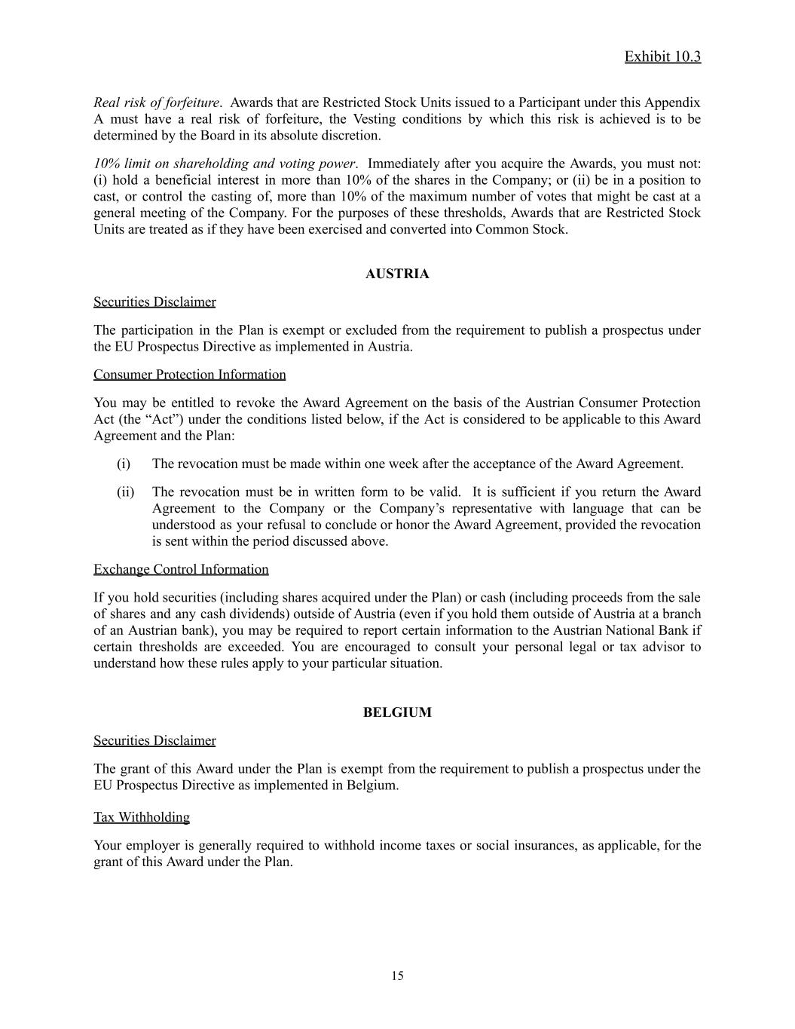
Exhibit 10.3 Real risk of forfeiture. Awards that are Restricted Stock Units issued to a Participant under this Appendix A must have a real risk of forfeiture, the Vesting conditions by which this risk is achieved is to be determined by the Board in its absolute discretion. 10% limit on shareholding and voting power. Immediately after you acquire the Awards, you must not: (i) hold a beneficial interest in more than 10% of the shares in the Company; or (ii) be in a position to cast, or control the casting of, more than 10% of the maximum number of votes that might be cast at a general meeting of the Company. For the purposes of these thresholds, Awards that are Restricted Stock Units are treated as if they have been exercised and converted into Common Stock. AUSTRIA Securities Disclaimer The participation in the Plan is exempt or excluded from the requirement to publish a prospectus under the EU Prospectus Directive as implemented in Austria. Consumer Protection Information You may be entitled to revoke the Award Agreement on the basis of the Austrian Consumer Protection Act (the “Act”) under the conditions listed below, if the Act is considered to be applicable to this Award Agreement and the Plan: (i)​ The revocation must be made within one week after the acceptance of the Award Agreement. (ii)​ The revocation must be in written form to be valid. It is sufficient if you return the Award Agreement to the Company or the Company’s representative with language that can be understood as your refusal to conclude or honor the Award Agreement, provided the revocation is sent within the period discussed above. Exchange Control Information If you hold securities (including shares acquired under the Plan) or cash (including proceeds from the sale of shares and any cash dividends) outside of Austria (even if you hold them outside of Austria at a branch of an Austrian bank), you may be required to report certain information to the Austrian National Bank if certain thresholds are exceeded. You are encouraged to consult your personal legal or tax advisor to understand how these rules apply to your particular situation. BELGIUM Securities Disclaimer The grant of this Award under the Plan is exempt from the requirement to publish a prospectus under the EU Prospectus Directive as implemented in Belgium. Tax Withholding Your employer is generally required to withhold income taxes or social insurances, as applicable, for the grant of this Award under the Plan. ​ 15

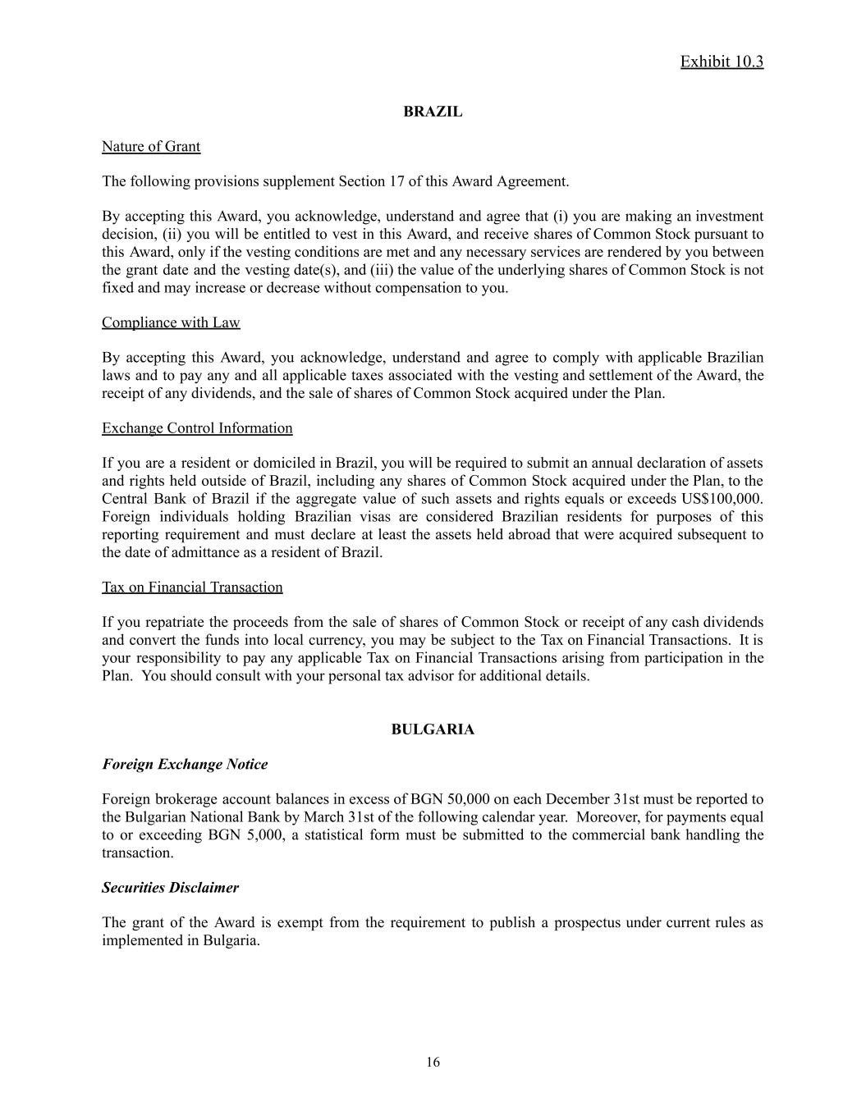
Exhibit 10.3 BRAZIL Nature of Grant The following provisions supplement Section 17 of this Award Agreement. By accepting this Award, you acknowledge, understand and agree that (i) you are making an investment decision, (ii) you will be entitled to vest in this Award, and receive shares of Common Stock pursuant to this Award, only if the vesting conditions are met and any necessary services are rendered by you between the grant date and the vesting date(s), and (iii) the value of the underlying shares of Common Stock is not fixed and may increase or decrease without compensation to you. Compliance with Law By accepting this Award, you acknowledge, understand and agree to comply with applicable Brazilian laws and to pay any and all applicable taxes associated with the vesting and settlement of the Award, the receipt of any dividends, and the sale of shares of Common Stock acquired under the Plan. Exchange Control Information If you are a resident or domiciled in Brazil, you will be required to submit an annual declaration of assets and rights held outside of Brazil, including any shares of Common Stock acquired under the Plan, to the Central Bank of Brazil if the aggregate value of such assets and rights equals or exceeds US$100,000. Foreign individuals holding Brazilian visas are considered Brazilian residents for purposes of this reporting requirement and must declare at least the assets held abroad that were acquired subsequent to the date of admittance as a resident of Brazil. Tax on Financial Transaction If you repatriate the proceeds from the sale of shares of Common Stock or receipt of any cash dividends and convert the funds into local currency, you may be subject to the Tax on Financial Transactions. It is your responsibility to pay any applicable Tax on Financial Transactions arising from participation in the Plan. You should consult with your personal tax advisor for additional details. BULGARIA Foreign Exchange Notice Foreign brokerage account balances in excess of BGN 50,000 on each December 31st must be reported to the Bulgarian National Bank by March 31st of the following calendar year. Moreover, for payments equal to or exceeding BGN 5,000, a statistical form must be submitted to the commercial bank handling the transaction. Securities Disclaimer The grant of the Award is exempt from the requirement to publish a prospectus under current rules as implemented in Bulgaria. ​ 16

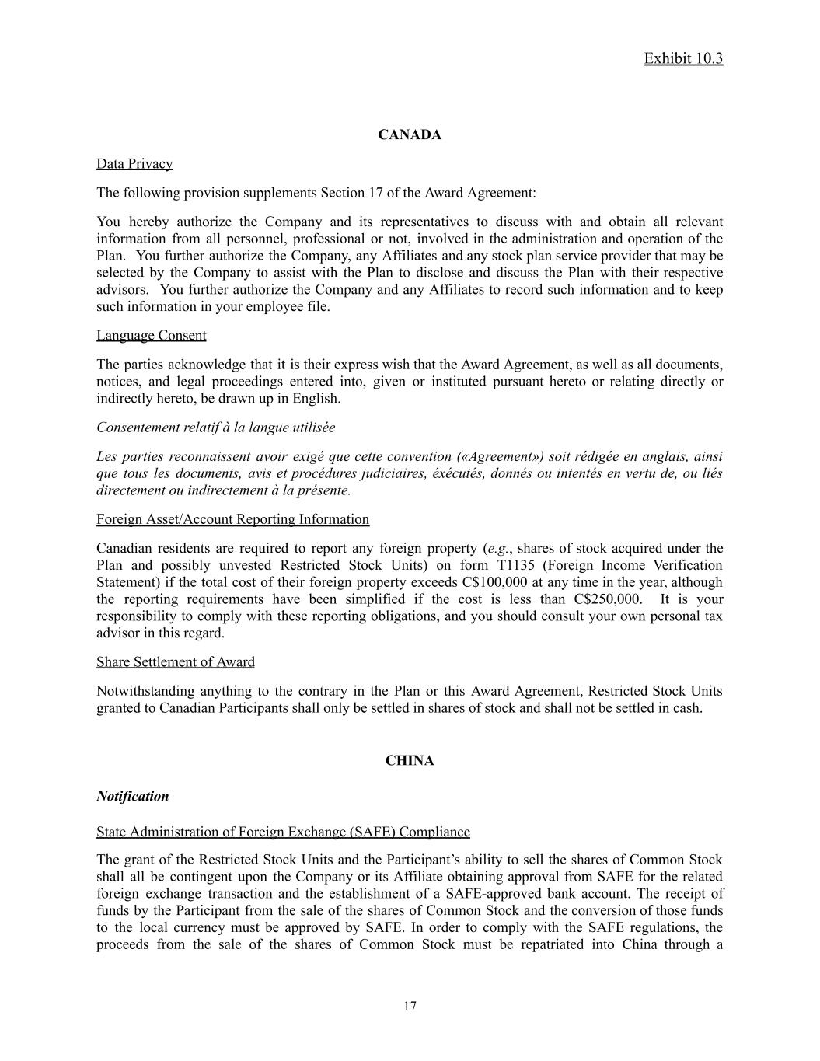
Exhibit 10.3 CANADA Data Privacy The following provision supplements Section 17 of the Award Agreement: You hereby authorize the Company and its representatives to discuss with and obtain all relevant information from all personnel, professional or not, involved in the administration and operation of the Plan. You further authorize the Company, any Affiliates and any stock plan service provider that may be selected by the Company to assist with the Plan to disclose and discuss the Plan with their respective advisors. You further authorize the Company and any Affiliates to record such information and to keep such information in your employee file. Language Consent The parties acknowledge that it is their express wish that the Award Agreement, as well as all documents, notices, and legal proceedings entered into, given or instituted pursuant hereto or relating directly or indirectly hereto, be drawn up in English. Consentement relatif à la langue utilisée Les parties reconnaissent avoir exigé que cette convention («Agreement») soit rédigée en anglais, ainsi que tous les documents, avis et procédures judiciaires, éxécutés, donnés ou intentés en vertu de, ou liés directement ou indirectement à la présente. Foreign Asset/Account Reporting Information Canadian residents are required to report any foreign property (e.g., shares of stock acquired under the Plan and possibly unvested Restricted Stock Units) on form T1135 (Foreign Income Verification Statement) if the total cost of their foreign property exceeds C$100,000 at any time in the year, although the reporting requirements have been simplified if the cost is less than C$250,000. It is your responsibility to comply with these reporting obligations, and you should consult your own personal tax advisor in this regard. Share Settlement of Award Notwithstanding anything to the contrary in the Plan or this Award Agreement, Restricted Stock Units granted to Canadian Participants shall only be settled in shares of stock and shall not be settled in cash. CHINA Notification State Administration of Foreign Exchange (SAFE) Compliance The grant of the Restricted Stock Units and the Participant’s ability to sell the shares of Common Stock shall all be contingent upon the Company or its Affiliate obtaining approval from SAFE for the related foreign exchange transaction and the establishment of a SAFE-approved bank account. The receipt of funds by the Participant from the sale of the shares of Common Stock and the conversion of those funds to the local currency must be approved by SAFE. In order to comply with the SAFE regulations, the proceeds from the sale of the shares of Common Stock must be repatriated into China through a ​ 17

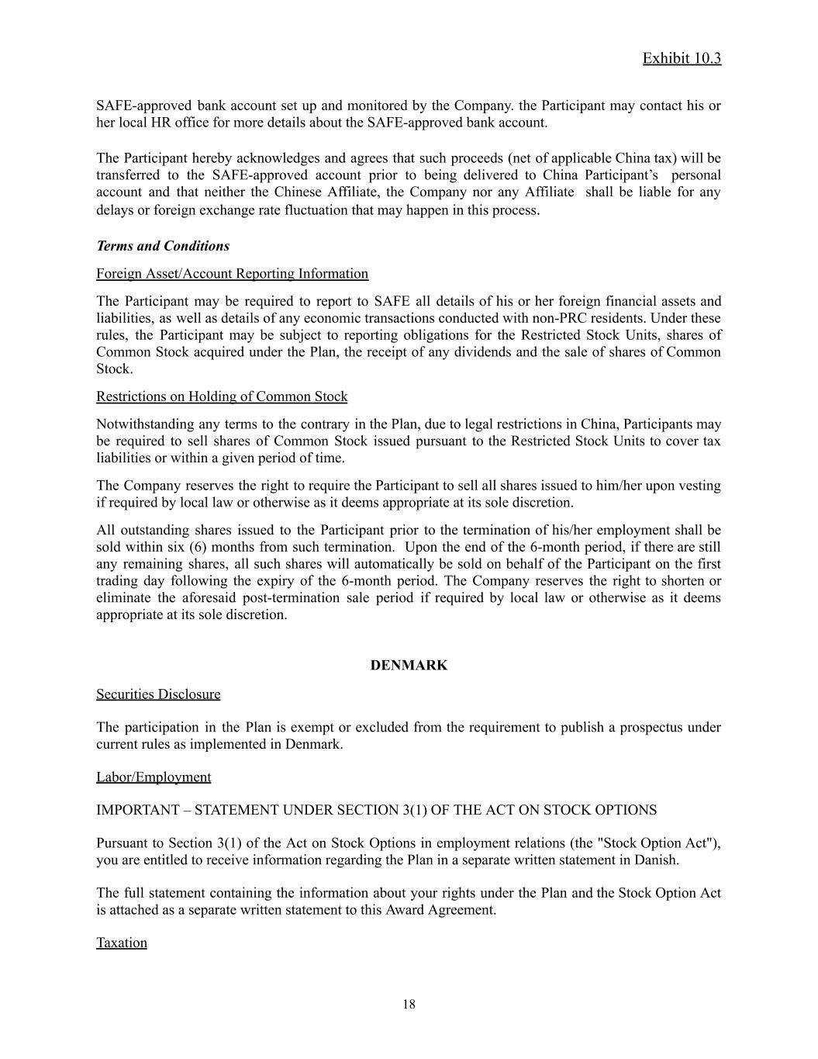
Exhibit 10.3 SAFE-approved bank account set up and monitored by the Company. the Participant may contact his or her local HR office for more details about the SAFE-approved bank account. The Participant hereby acknowledges and agrees that such proceeds (net of applicable China tax) will be transferred to the SAFE-approved account prior to being delivered to China Participant’s personal account and that neither the Chinese Affiliate, the Company nor any Affiliate shall be liable for any delays or foreign exchange rate fluctuation that may happen in this process. Terms and Conditions Foreign Asset/Account Reporting Information The Participant may be required to report to SAFE all details of his or her foreign financial assets and liabilities, as well as details of any economic transactions conducted with non-PRC residents. Under these rules, the Participant may be subject to reporting obligations for the Restricted Stock Units, shares of Common Stock acquired under the Plan, the receipt of any dividends and the sale of shares of Common Stock. Restrictions on Holding of Common Stock Notwithstanding any terms to the contrary in the Plan, due to legal restrictions in China, Participants may be required to sell shares of Common Stock issued pursuant to the Restricted Stock Units to cover tax liabilities or within a given period of time. The Company reserves the right to require the Participant to sell all shares issued to him/her upon vesting if required by local law or otherwise as it deems appropriate at its sole discretion. All outstanding shares issued to the Participant prior to the termination of his/her employment shall be sold within six (6) months from such termination. Upon the end of the 6-month period, if there are still any remaining shares, all such shares will automatically be sold on behalf of the Participant on the first trading day following the expiry of the 6-month period. The Company reserves the right to shorten or eliminate the aforesaid post-termination sale period if required by local law or otherwise as it deems appropriate at its sole discretion. DENMARK Securities Disclosure The participation in the Plan is exempt or excluded from the requirement to publish a prospectus under current rules as implemented in Denmark. Labor/Employment IMPORTANT – STATEMENT UNDER SECTION 3(1) OF THE ACT ON STOCK OPTIONS Pursuant to Section 3(1) of the Act on Stock Options in employment relations (the "Stock Option Act"), you are entitled to receive information regarding the Plan in a separate written statement in Danish. The full statement containing the information about your rights under the Plan and the Stock Option Act is attached as a separate written statement to this Award Agreement. Taxation ​ 18

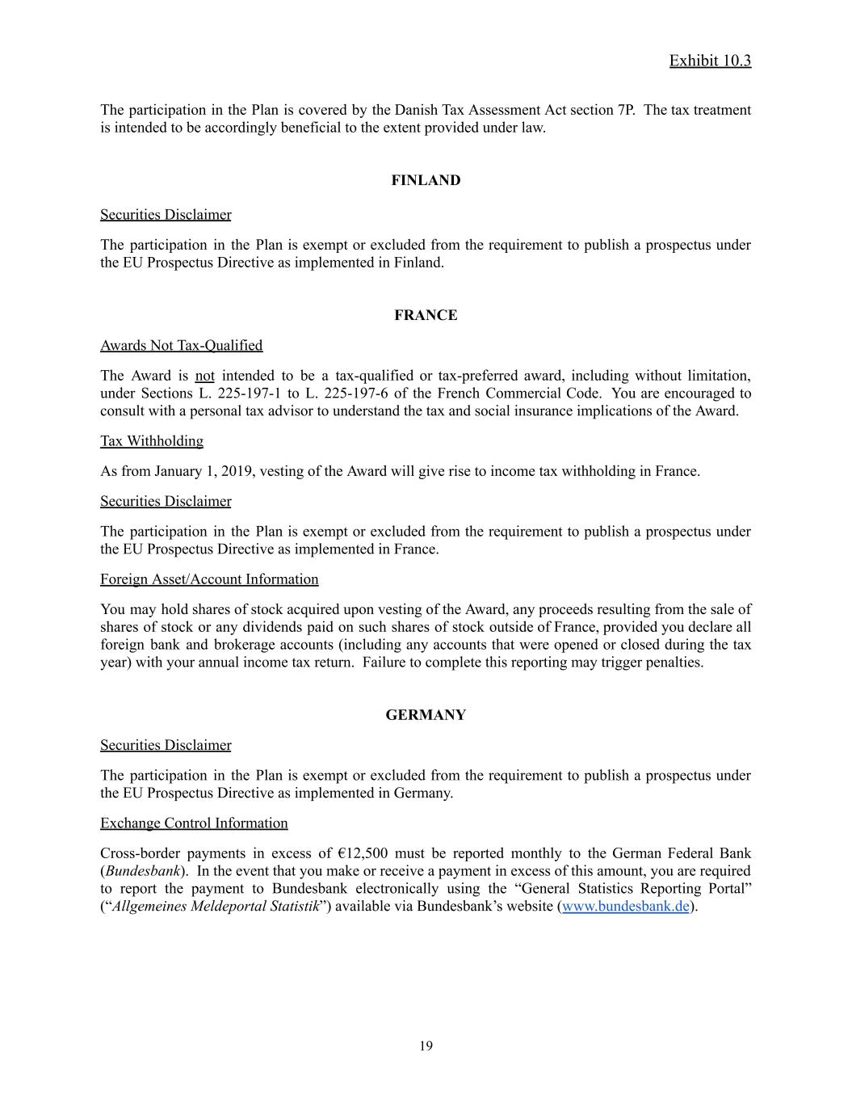
Exhibit 10.3 The participation in the Plan is covered by the Danish Tax Assessment Act section 7P. The tax treatment is intended to be accordingly beneficial to the extent provided under law. FINLAND Securities Disclaimer The participation in the Plan is exempt or excluded from the requirement to publish a prospectus under the EU Prospectus Directive as implemented in Finland. FRANCE Awards Not Tax-Qualified The Award is not intended to be a tax-qualified or tax-preferred award, including without limitation, under Sections L. 225-197-1 to L. 225-197-6 of the French Commercial Code. You are encouraged to consult with a personal tax advisor to understand the tax and social insurance implications of the Award. Tax Withholding As from January 1, 2019, vesting of the Award will give rise to income tax withholding in France. Securities Disclaimer The participation in the Plan is exempt or excluded from the requirement to publish a prospectus under the EU Prospectus Directive as implemented in France. Foreign Asset/Account Information You may hold shares of stock acquired upon vesting of the Award, any proceeds resulting from the sale of shares of stock or any dividends paid on such shares of stock outside of France, provided you declare all foreign bank and brokerage accounts (including any accounts that were opened or closed during the tax year) with your annual income tax return. Failure to complete this reporting may trigger penalties. GERMANY Securities Disclaimer The participation in the Plan is exempt or excluded from the requirement to publish a prospectus under the EU Prospectus Directive as implemented in Germany. Exchange Control Information Cross-border payments in excess of €12,500 must be reported monthly to the German Federal Bank (Bundesbank). In the event that you make or receive a payment in excess of this amount, you are required to report the payment to Bundesbank electronically using the “General Statistics Reporting Portal” (“Allgemeines Meldeportal Statistik”) available via Bundesbank’s website (www.bundesbank.de). ​ 19

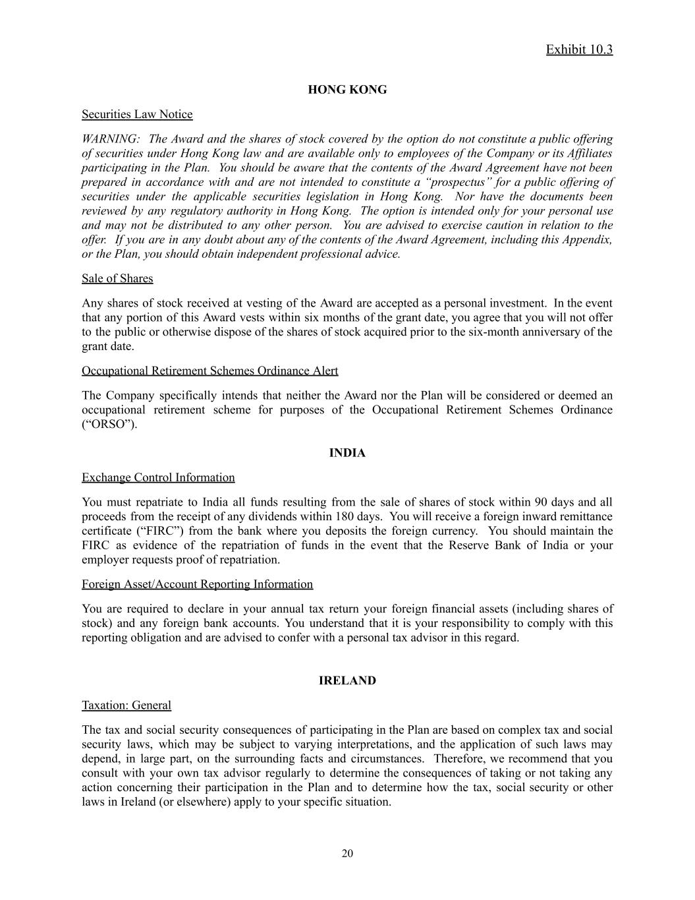
Exhibit 10.3 HONG KONG Securities Law Notice WARNING: The Award and the shares of stock covered by the option do not constitute a public offering of securities under Hong Kong law and are available only to employees of the Company or its Affiliates participating in the Plan. You should be aware that the contents of the Award Agreement have not been prepared in accordance with and are not intended to constitute a “prospectus” for a public offering of securities under the applicable securities legislation in Hong Kong. Nor have the documents been reviewed by any regulatory authority in Hong Kong. The option is intended only for your personal use and may not be distributed to any other person. You are advised to exercise caution in relation to the offer. If you are in any doubt about any of the contents of the Award Agreement, including this Appendix, or the Plan, you should obtain independent professional advice. Sale of Shares Any shares of stock received at vesting of the Award are accepted as a personal investment. In the event that any portion of this Award vests within six months of the grant date, you agree that you will not offer to the public or otherwise dispose of the shares of stock acquired prior to the six-month anniversary of the grant date. Occupational Retirement Schemes Ordinance Alert The Company specifically intends that neither the Award nor the Plan will be considered or deemed an occupational retirement scheme for purposes of the Occupational Retirement Schemes Ordinance (“ORSO”). INDIA Exchange Control Information You must repatriate to India all funds resulting from the sale of shares of stock within 90 days and all proceeds from the receipt of any dividends within 180 days. You will receive a foreign inward remittance certificate (“FIRC”) from the bank where you deposits the foreign currency. You should maintain the FIRC as evidence of the repatriation of funds in the event that the Reserve Bank of India or your employer requests proof of repatriation. Foreign Asset/Account Reporting Information You are required to declare in your annual tax return your foreign financial assets (including shares of stock) and any foreign bank accounts. You understand that it is your responsibility to comply with this reporting obligation and are advised to confer with a personal tax advisor in this regard. IRELAND Taxation: General The tax and social security consequences of participating in the Plan are based on complex tax and social security laws, which may be subject to varying interpretations, and the application of such laws may depend, in large part, on the surrounding facts and circumstances. Therefore, we recommend that you consult with your own tax advisor regularly to determine the consequences of taking or not taking any action concerning their participation in the Plan and to determine how the tax, social security or other laws in Ireland (or elsewhere) apply to your specific situation. ​ 20

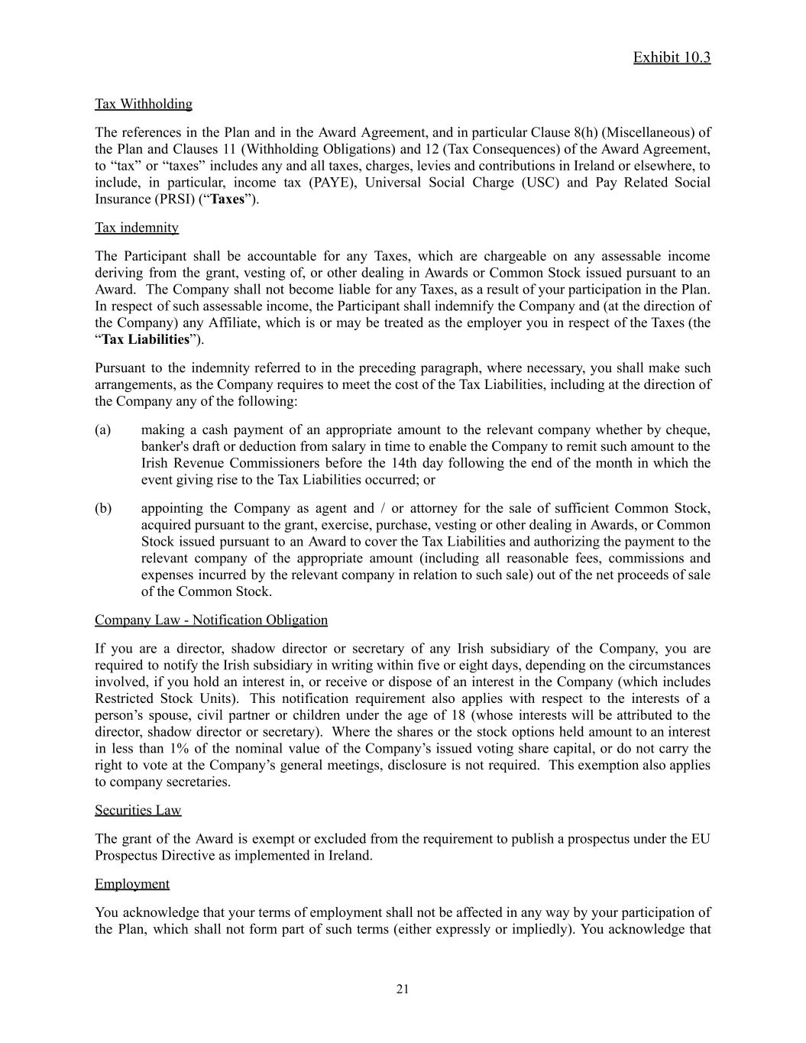
Exhibit 10.3 Tax Withholding The references in the Plan and in the Award Agreement, and in particular Clause 8(h) (Miscellaneous) of the Plan and Clauses 11 (Withholding Obligations) and 12 (Tax Consequences) of the Award Agreement, to “tax” or “taxes” includes any and all taxes, charges, levies and contributions in Ireland or elsewhere, to include, in particular, income tax (PAYE), Universal Social Charge (USC) and Pay Related Social Insurance (PRSI) (“Taxes”). Tax indemnity The Participant shall be accountable for any Taxes, which are chargeable on any assessable income deriving from the grant, vesting of, or other dealing in Awards or Common Stock issued pursuant to an Award. The Company shall not become liable for any Taxes, as a result of your participation in the Plan. In respect of such assessable income, the Participant shall indemnify the Company and (at the direction of the Company) any Affiliate, which is or may be treated as the employer you in respect of the Taxes (the “Tax Liabilities”). Pursuant to the indemnity referred to in the preceding paragraph, where necessary, you shall make such arrangements, as the Company requires to meet the cost of the Tax Liabilities, including at the direction of the Company any of the following: (a)​ making a cash payment of an appropriate amount to the relevant company whether by cheque, banker's draft or deduction from salary in time to enable the Company to remit such amount to the Irish Revenue Commissioners before the 14th day following the end of the month in which the event giving rise to the Tax Liabilities occurred; or (b)​ appointing the Company as agent and / or attorney for the sale of sufficient Common Stock, acquired pursuant to the grant, exercise, purchase, vesting or other dealing in Awards, or Common Stock issued pursuant to an Award to cover the Tax Liabilities and authorizing the payment to the relevant company of the appropriate amount (including all reasonable fees, commissions and expenses incurred by the relevant company in relation to such sale) out of the net proceeds of sale of the Common Stock. Company Law - Notification Obligation If you are a director, shadow director or secretary of any Irish subsidiary of the Company, you are required to notify the Irish subsidiary in writing within five or eight days, depending on the circumstances involved, if you hold an interest in, or receive or dispose of an interest in the Company (which includes Restricted Stock Units). This notification requirement also applies with respect to the interests of a person’s spouse, civil partner or children under the age of 18 (whose interests will be attributed to the director, shadow director or secretary). Where the shares or the stock options held amount to an interest in less than 1% of the nominal value of the Company’s issued voting share capital, or do not carry the right to vote at the Company’s general meetings, disclosure is not required. This exemption also applies to company secretaries. Securities Law The grant of the Award is exempt or excluded from the requirement to publish a prospectus under the EU Prospectus Directive as implemented in Ireland. Employment You acknowledge that your terms of employment shall not be affected in any way by your participation of the Plan, which shall not form part of such terms (either expressly or impliedly). You acknowledge that ​ 21

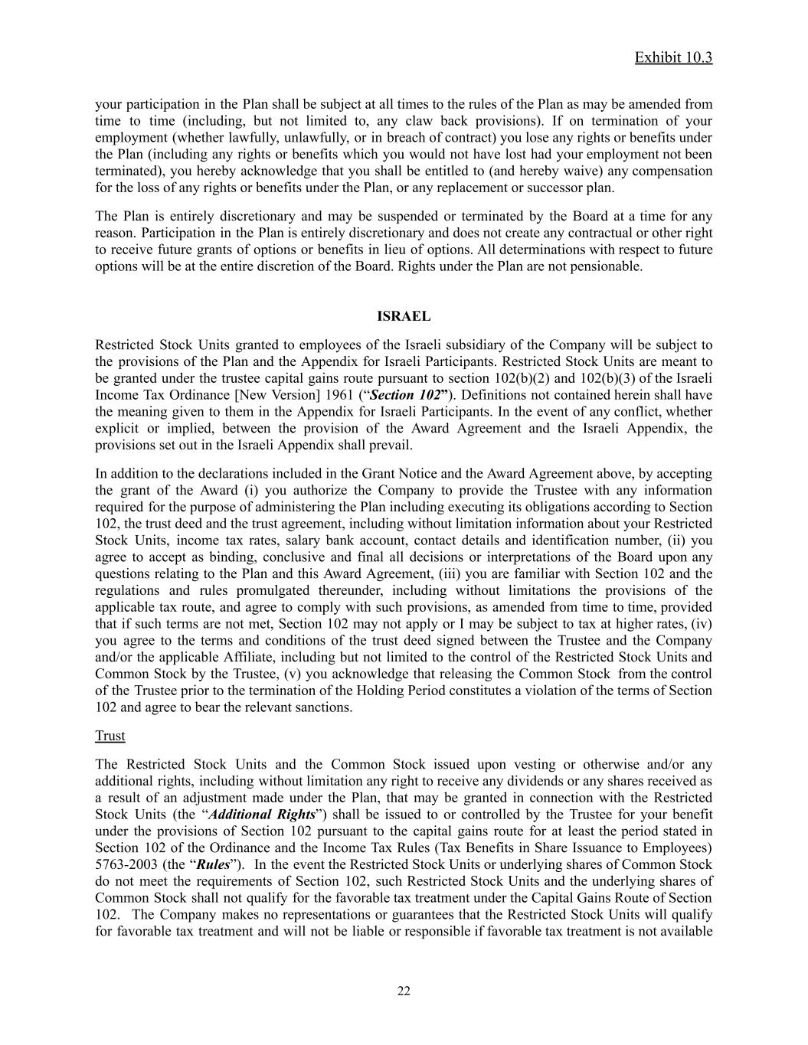
Exhibit 10.3 your participation in the Plan shall be subject at all times to the rules of the Plan as may be amended from time to time (including, but not limited to, any claw back provisions). If on termination of your employment (whether lawfully, unlawfully, or in breach of contract) you lose any rights or benefits under the Plan (including any rights or benefits which you would not have lost had your employment not been terminated), you hereby acknowledge that you shall be entitled to (and hereby waive) any compensation for the loss of any rights or benefits under the Plan, or any replacement or successor plan. The Plan is entirely discretionary and may be suspended or terminated by the Board at a time for any reason. Participation in the Plan is entirely discretionary and does not create any contractual or other right to receive future grants of options or benefits in lieu of options. All determinations with respect to future options will be at the entire discretion of the Board. Rights under the Plan are not pensionable. ISRAEL Restricted Stock Units granted to employees of the Israeli subsidiary of the Company will be subject to the provisions of the Plan and the Appendix for Israeli Participants. Restricted Stock Units are meant to be granted under the trustee capital gains route pursuant to section 102(b)(2) and 102(b)(3) of the Israeli Income Tax Ordinance [New Version] 1961 (“Section 102”). Definitions not contained herein shall have the meaning given to them in the Appendix for Israeli Participants. In the event of any conflict, whether explicit or implied, between the provision of the Award Agreement and the Israeli Appendix, the provisions set out in the Israeli Appendix shall prevail. In addition to the declarations included in the Grant Notice and the Award Agreement above, by accepting the grant of the Award (i) you authorize the Company to provide the Trustee with any information required for the purpose of administering the Plan including executing its obligations according to Section 102, the trust deed and the trust agreement, including without limitation information about your Restricted Stock Units, income tax rates, salary bank account, contact details and identification number, (ii) you agree to accept as binding, conclusive and final all decisions or interpretations of the Board upon any questions relating to the Plan and this Award Agreement, (iii) you are familiar with Section 102 and the regulations and rules promulgated thereunder, including without limitations the provisions of the applicable tax route, and agree to comply with such provisions, as amended from time to time, provided that if such terms are not met, Section 102 may not apply or I may be subject to tax at higher rates, (iv) you agree to the terms and conditions of the trust deed signed between the Trustee and the Company and/or the applicable Affiliate, including but not limited to the control of the Restricted Stock Units and Common Stock by the Trustee, (v) you acknowledge that releasing the Common Stock from the control of the Trustee prior to the termination of the Holding Period constitutes a violation of the terms of Section 102 and agree to bear the relevant sanctions. Trust The Restricted Stock Units and the Common Stock issued upon vesting or otherwise and/or any additional rights, including without limitation any right to receive any dividends or any shares received as a result of an adjustment made under the Plan, that may be granted in connection with the Restricted Stock Units (the “Additional Rights”) shall be issued to or controlled by the Trustee for your benefit under the provisions of Section 102 pursuant to the capital gains route for at least the period stated in Section 102 of the Ordinance and the Income Tax Rules (Tax Benefits in Share Issuance to Employees) 5763-2003 (the “Rules”). In the event the Restricted Stock Units or underlying shares of Common Stock do not meet the requirements of Section 102, such Restricted Stock Units and the underlying shares of Common Stock shall not qualify for the favorable tax treatment under the Capital Gains Route of Section 102. The Company makes no representations or guarantees that the Restricted Stock Units will qualify for favorable tax treatment and will not be liable or responsible if favorable tax treatment is not available ​ 22

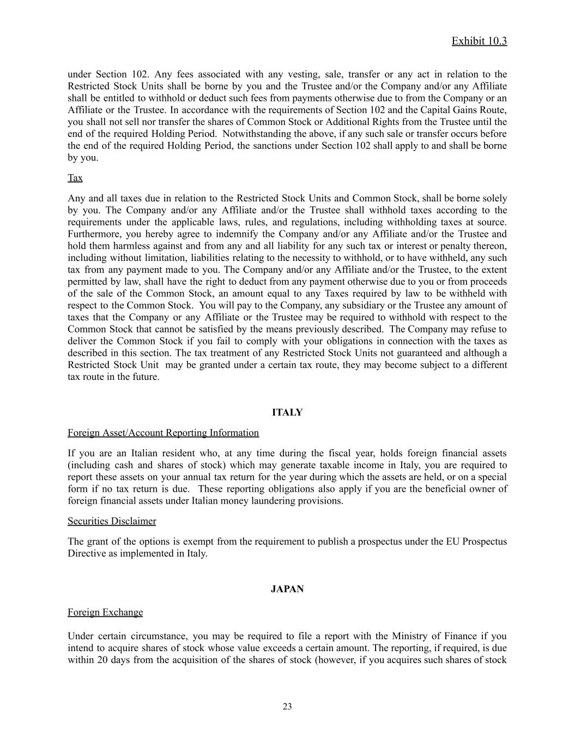
Exhibit 10.3 under Section 102. Any fees associated with any vesting, sale, transfer or any act in relation to the Restricted Stock Units shall be borne by you and the Trustee and/or the Company and/or any Affiliate shall be entitled to withhold or deduct such fees from payments otherwise due to from the Company or an Affiliate or the Trustee. In accordance with the requirements of Section 102 and the Capital Gains Route, you shall not sell nor transfer the shares of Common Stock or Additional Rights from the Trustee until the end of the required Holding Period. Notwithstanding the above, if any such sale or transfer occurs before the end of the required Holding Period, the sanctions under Section 102 shall apply to and shall be borne by you. Tax Any and all taxes due in relation to the Restricted Stock Units and Common Stock, shall be borne solely by you. The Company and/or any Affiliate and/or the Trustee shall withhold taxes according to the requirements under the applicable laws, rules, and regulations, including withholding taxes at source. Furthermore, you hereby agree to indemnify the Company and/or any Affiliate and/or the Trustee and hold them harmless against and from any and all liability for any such tax or interest or penalty thereon, including without limitation, liabilities relating to the necessity to withhold, or to have withheld, any such tax from any payment made to you. The Company and/or any Affiliate and/or the Trustee, to the extent permitted by law, shall have the right to deduct from any payment otherwise due to you or from proceeds of the sale of the Common Stock, an amount equal to any Taxes required by law to be withheld with respect to the Common Stock. You will pay to the Company, any subsidiary or the Trustee any amount of taxes that the Company or any Affiliate or the Trustee may be required to withhold with respect to the Common Stock that cannot be satisfied by the means previously described. The Company may refuse to deliver the Common Stock if you fail to comply with your obligations in connection with the taxes as described in this section. The tax treatment of any Restricted Stock Units not guaranteed and although a Restricted Stock Unit may be granted under a certain tax route, they may become subject to a different tax route in the future. ITALY Foreign Asset/Account Reporting Information If you are an Italian resident who, at any time during the fiscal year, holds foreign financial assets (including cash and shares of stock) which may generate taxable income in Italy, you are required to report these assets on your annual tax return for the year during which the assets are held, or on a special form if no tax return is due. These reporting obligations also apply if you are the beneficial owner of foreign financial assets under Italian money laundering provisions. Securities Disclaimer The grant of the options is exempt from the requirement to publish a prospectus under the EU Prospectus Directive as implemented in Italy. JAPAN Foreign Exchange Under certain circumstance, you may be required to file a report with the Ministry of Finance if you intend to acquire shares of stock whose value exceeds a certain amount. The reporting, if required, is due within 20 days from the acquisition of the shares of stock (however, if you acquires such shares of stock ​ 23

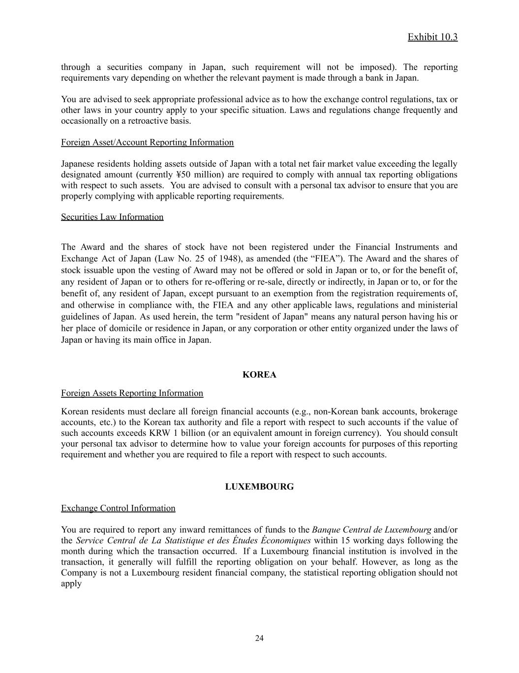
Exhibit 10.3 through a securities company in Japan, such requirement will not be imposed). The reporting requirements vary depending on whether the relevant payment is made through a bank in Japan. You are advised to seek appropriate professional advice as to how the exchange control regulations, tax or other laws in your country apply to your specific situation. Laws and regulations change frequently and occasionally on a retroactive basis. Foreign Asset/Account Reporting Information Japanese residents holding assets outside of Japan with a total net fair market value exceeding the legally designated amount (currently ¥50 million) are required to comply with annual tax reporting obligations with respect to such assets. You are advised to consult with a personal tax advisor to ensure that you are properly complying with applicable reporting requirements. Securities Law Information The Award and the shares of stock have not been registered under the Financial Instruments and Exchange Act of Japan (Law No. 25 of 1948), as amended (the “FIEA”). The Award and the shares of stock issuable upon the vesting of Award may not be offered or sold in Japan or to, or for the benefit of, any resident of Japan or to others for re-offering or re-sale, directly or indirectly, in Japan or to, or for the benefit of, any resident of Japan, except pursuant to an exemption from the registration requirements of, and otherwise in compliance with, the FIEA and any other applicable laws, regulations and ministerial guidelines of Japan. As used herein, the term "resident of Japan" means any natural person having his or her place of domicile or residence in Japan, or any corporation or other entity organized under the laws of Japan or having its main office in Japan. KOREA Foreign Assets Reporting Information Korean residents must declare all foreign financial accounts (e.g., non-Korean bank accounts, brokerage accounts, etc.) to the Korean tax authority and file a report with respect to such accounts if the value of such accounts exceeds KRW 1 billion (or an equivalent amount in foreign currency). You should consult your personal tax advisor to determine how to value your foreign accounts for purposes of this reporting requirement and whether you are required to file a report with respect to such accounts. LUXEMBOURG Exchange Control Information You are required to report any inward remittances of funds to the Banque Central de Luxembourg and/or the Service Central de La Statistique et des Études Économiques within 15 working days following the month during which the transaction occurred. If a Luxembourg financial institution is involved in the transaction, it generally will fulfill the reporting obligation on your behalf. However, as long as the Company is not a Luxembourg resident financial company, the statistical reporting obligation should not apply ​ 24

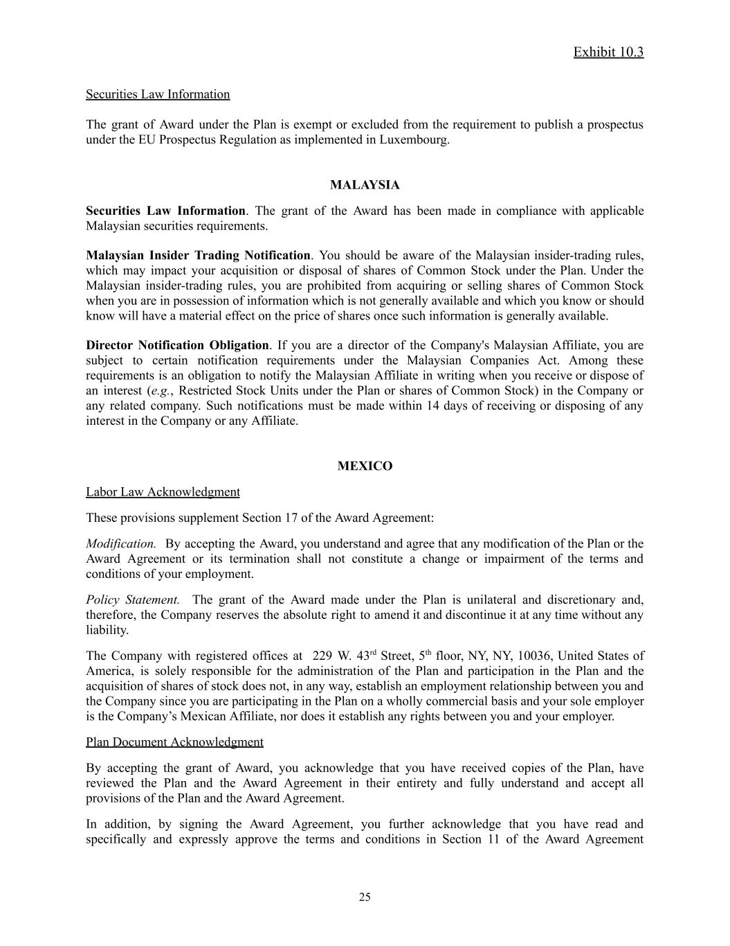
Exhibit 10.3 Securities Law Information The grant of Award under the Plan is exempt or excluded from the requirement to publish a prospectus under the EU Prospectus Regulation as implemented in Luxembourg. MALAYSIA Securities Law Information. The grant of the Award has been made in compliance with applicable Malaysian securities requirements. Malaysian Insider Trading Notification. You should be aware of the Malaysian insider-trading rules, which may impact your acquisition or disposal of shares of Common Stock under the Plan. Under the Malaysian insider-trading rules, you are prohibited from acquiring or selling shares of Common Stock when you are in possession of information which is not generally available and which you know or should know will have a material effect on the price of shares once such information is generally available. Director Notification Obligation. If you are a director of the Company's Malaysian Affiliate, you are subject to certain notification requirements under the Malaysian Companies Act. Among these requirements is an obligation to notify the Malaysian Affiliate in writing when you receive or dispose of an interest (e.g., Restricted Stock Units under the Plan or shares of Common Stock) in the Company or any related company. Such notifications must be made within 14 days of receiving or disposing of any interest in the Company or any Affiliate. MEXICO Labor Law Acknowledgment These provisions supplement Section 17 of the Award Agreement: Modification. By accepting the Award, you understand and agree that any modification of the Plan or the Award Agreement or its termination shall not constitute a change or impairment of the terms and conditions of your employment. Policy Statement. The grant of the Award made under the Plan is unilateral and discretionary and, therefore, the Company reserves the absolute right to amend it and discontinue it at any time without any liability. The Company with registered offices at 229 W. 43rd Street, 5th floor, NY, NY, 10036, United States of America, is solely responsible for the administration of the Plan and participation in the Plan and the acquisition of shares of stock does not, in any way, establish an employment relationship between you and the Company since you are participating in the Plan on a wholly commercial basis and your sole employer is the Company’s Mexican Affiliate, nor does it establish any rights between you and your employer. Plan Document Acknowledgment By accepting the grant of Award, you acknowledge that you have received copies of the Plan, have reviewed the Plan and the Award Agreement in their entirety and fully understand and accept all provisions of the Plan and the Award Agreement. In addition, by signing the Award Agreement, you further acknowledge that you have read and specifically and expressly approve the terms and conditions in Section 11 of the Award Agreement ​ 25

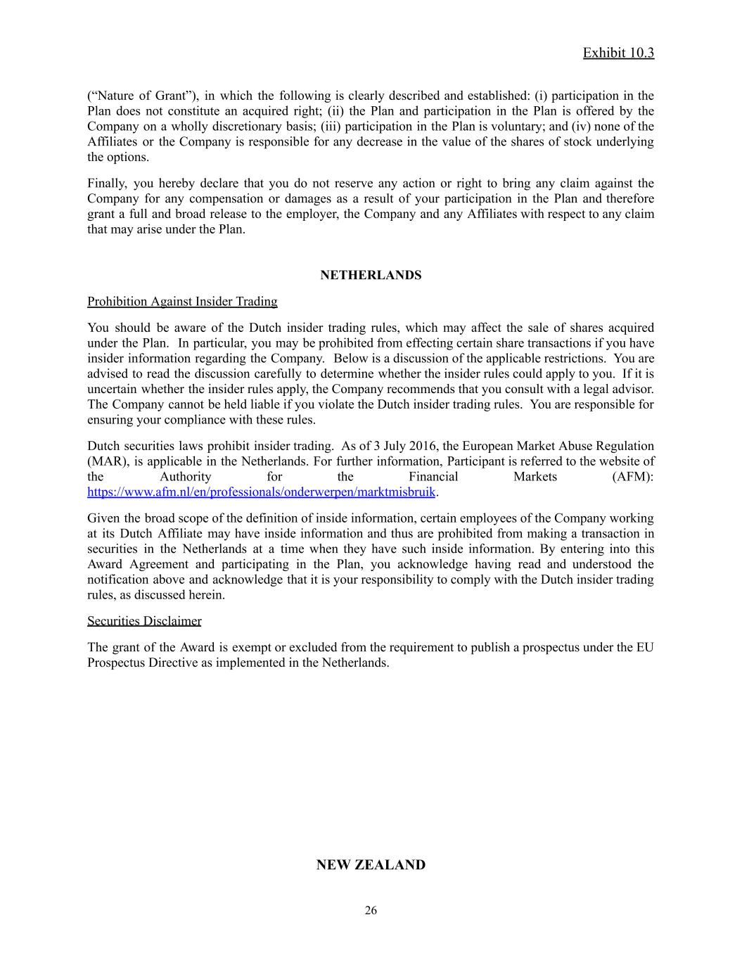
Exhibit 10.3 (“Nature of Grant”), in which the following is clearly described and established: (i) participation in the Plan does not constitute an acquired right; (ii) the Plan and participation in the Plan is offered by the Company on a wholly discretionary basis; (iii) participation in the Plan is voluntary; and (iv) none of the Affiliates or the Company is responsible for any decrease in the value of the shares of stock underlying the options. Finally, you hereby declare that you do not reserve any action or right to bring any claim against the Company for any compensation or damages as a result of your participation in the Plan and therefore grant a full and broad release to the employer, the Company and any Affiliates with respect to any claim that may arise under the Plan. NETHERLANDS Prohibition Against Insider Trading You should be aware of the Dutch insider trading rules, which may affect the sale of shares acquired under the Plan. In particular, you may be prohibited from effecting certain share transactions if you have insider information regarding the Company. Below is a discussion of the applicable restrictions. You are advised to read the discussion carefully to determine whether the insider rules could apply to you. If it is uncertain whether the insider rules apply, the Company recommends that you consult with a legal advisor. The Company cannot be held liable if you violate the Dutch insider trading rules. You are responsible for ensuring your compliance with these rules. Dutch securities laws prohibit insider trading. As of 3 July 2016, the European Market Abuse Regulation (MAR), is applicable in the Netherlands. For further information, Participant is referred to the website of the Authority for the Financial Markets (AFM): https://www.afm.nl/en/professionals/onderwerpen/marktmisbruik. Given the broad scope of the definition of inside information, certain employees of the Company working at its Dutch Affiliate may have inside information and thus are prohibited from making a transaction in securities in the Netherlands at a time when they have such inside information. By entering into this Award Agreement and participating in the Plan, you acknowledge having read and understood the notification above and acknowledge that it is your responsibility to comply with the Dutch insider trading rules, as discussed herein. Securities Disclaimer The grant of the Award is exempt or excluded from the requirement to publish a prospectus under the EU Prospectus Directive as implemented in the Netherlands. NEW ZEALAND ​ 26

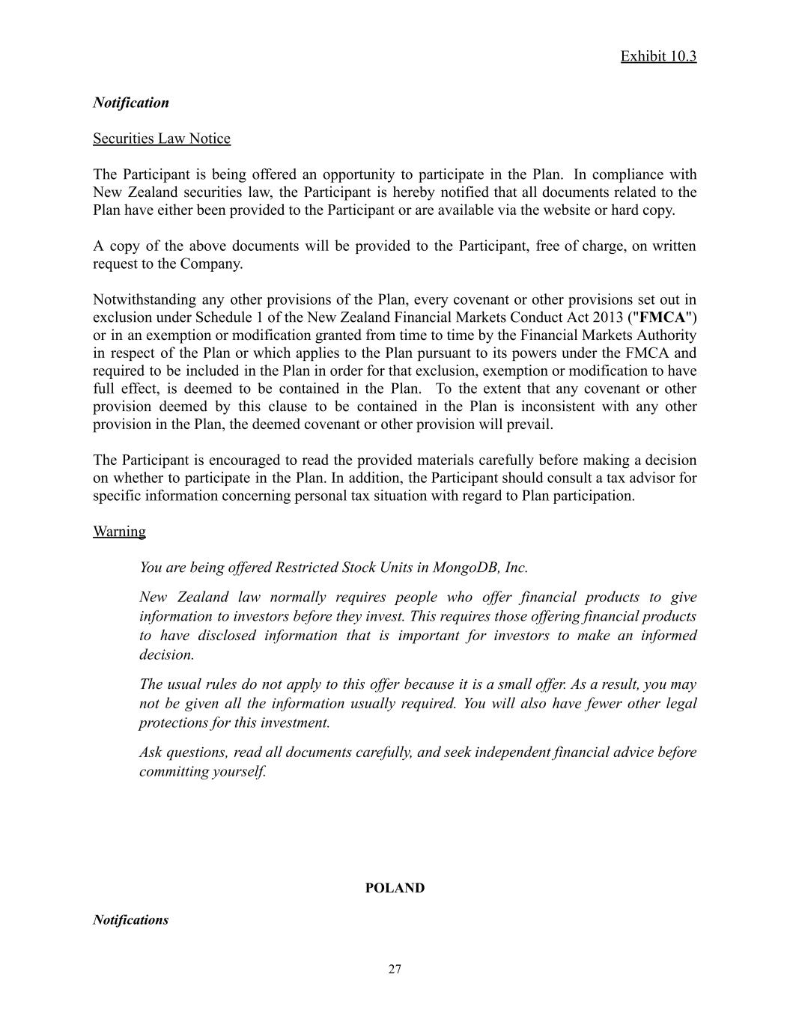
Exhibit 10.3 Notification Securities Law Notice The Participant is being offered an opportunity to participate in the Plan. In compliance with New Zealand securities law, the Participant is hereby notified that all documents related to the Plan have either been provided to the Participant or are available via the website or hard copy. A copy of the above documents will be provided to the Participant, free of charge, on written request to the Company. Notwithstanding any other provisions of the Plan, every covenant or other provisions set out in exclusion under Schedule 1 of the New Zealand Financial Markets Conduct Act 2013 ("FMCA") or in an exemption or modification granted from time to time by the Financial Markets Authority in respect of the Plan or which applies to the Plan pursuant to its powers under the FMCA and required to be included in the Plan in order for that exclusion, exemption or modification to have full effect, is deemed to be contained in the Plan. To the extent that any covenant or other provision deemed by this clause to be contained in the Plan is inconsistent with any other provision in the Plan, the deemed covenant or other provision will prevail. The Participant is encouraged to read the provided materials carefully before making a decision on whether to participate in the Plan. In addition, the Participant should consult a tax advisor for specific information concerning personal tax situation with regard to Plan participation. Warning You are being offered Restricted Stock Units in MongoDB, Inc. New Zealand law normally requires people who offer financial products to give information to investors before they invest. This requires those offering financial products to have disclosed information that is important for investors to make an informed decision. The usual rules do not apply to this offer because it is a small offer. As a result, you may not be given all the information usually required. You will also have fewer other legal protections for this investment. Ask questions, read all documents carefully, and seek independent financial advice before committing yourself. POLAND Notifications ​ 27

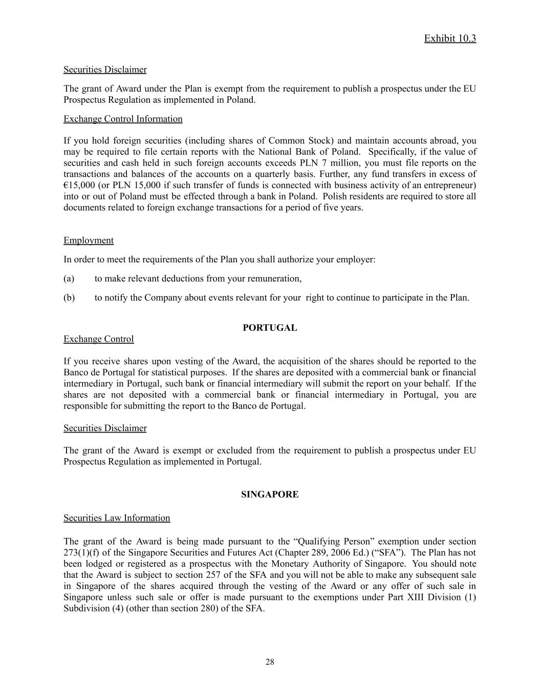
Exhibit 10.3 Securities Disclaimer The grant of Award under the Plan is exempt from the requirement to publish a prospectus under the EU Prospectus Regulation as implemented in Poland. Exchange Control Information If you hold foreign securities (including shares of Common Stock) and maintain accounts abroad, you may be required to file certain reports with the National Bank of Poland. Specifically, if the value of securities and cash held in such foreign accounts exceeds PLN 7 million, you must file reports on the transactions and balances of the accounts on a quarterly basis. Further, any fund transfers in excess of €15,000 (or PLN 15,000 if such transfer of funds is connected with business activity of an entrepreneur) into or out of Poland must be effected through a bank in Poland. Polish residents are required to store all documents related to foreign exchange transactions for a period of five years. Employment In order to meet the requirements of the Plan you shall authorize your employer: (a)​ to make relevant deductions from your remuneration, (b)​ to notify the Company about events relevant for your right to continue to participate in the Plan. PORTUGAL Exchange Control If you receive shares upon vesting of the Award, the acquisition of the shares should be reported to the Banco de Portugal for statistical purposes. If the shares are deposited with a commercial bank or financial intermediary in Portugal, such bank or financial intermediary will submit the report on your behalf. If the shares are not deposited with a commercial bank or financial intermediary in Portugal, you are responsible for submitting the report to the Banco de Portugal. Securities Disclaimer The grant of the Award is exempt or excluded from the requirement to publish a prospectus under EU Prospectus Regulation as implemented in Portugal. SINGAPORE Securities Law Information The grant of the Award is being made pursuant to the “Qualifying Person” exemption under section 273(1)(f) of the Singapore Securities and Futures Act (Chapter 289, 2006 Ed.) (“SFA”). The Plan has not been lodged or registered as a prospectus with the Monetary Authority of Singapore. You should note that the Award is subject to section 257 of the SFA and you will not be able to make any subsequent sale in Singapore of the shares acquired through the vesting of the Award or any offer of such sale in Singapore unless such sale or offer is made pursuant to the exemptions under Part XIII Division (1) Subdivision (4) (other than section 280) of the SFA. ​ 28

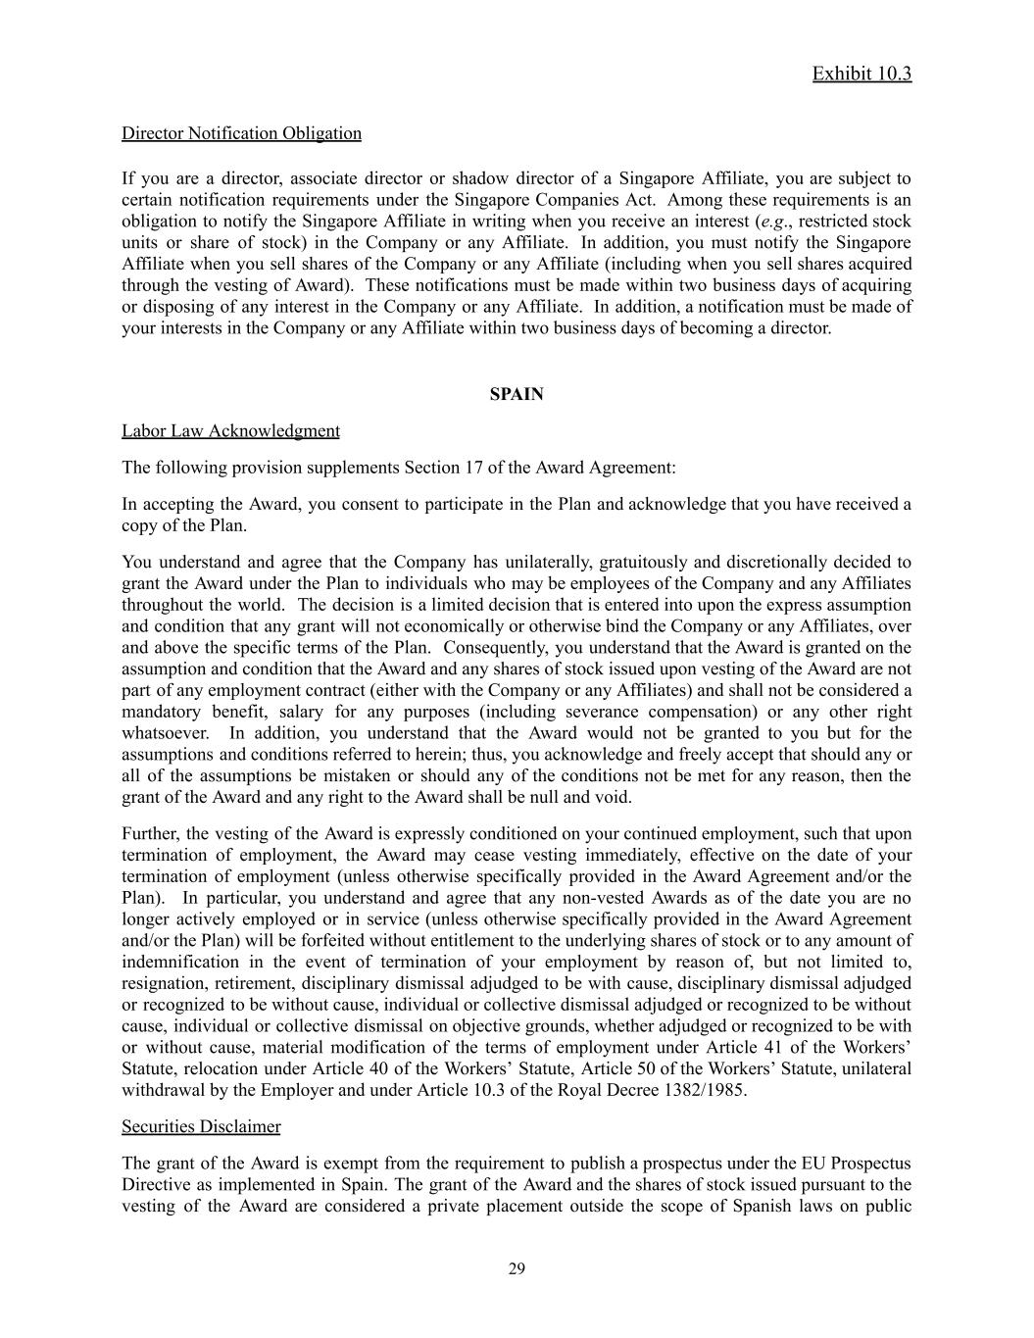
Exhibit 10.3 Director Notification Obligation If you are a director, associate director or shadow director of a Singapore Affiliate, you are subject to certain notification requirements under the Singapore Companies Act. Among these requirements is an obligation to notify the Singapore Affiliate in writing when you receive an interest (e.g., restricted stock units or share of stock) in the Company or any Affiliate. In addition, you must notify the Singapore Affiliate when you sell shares of the Company or any Affiliate (including when you sell shares acquired through the vesting of Award). These notifications must be made within two business days of acquiring or disposing of any interest in the Company or any Affiliate. In addition, a notification must be made of your interests in the Company or any Affiliate within two business days of becoming a director. SPAIN Labor Law Acknowledgment The following provision supplements Section 17 of the Award Agreement: In accepting the Award, you consent to participate in the Plan and acknowledge that you have received a copy of the Plan. You understand and agree that the Company has unilaterally, gratuitously and discretionally decided to grant the Award under the Plan to individuals who may be employees of the Company and any Affiliates throughout the world. The decision is a limited decision that is entered into upon the express assumption and condition that any grant will not economically or otherwise bind the Company or any Affiliates, over and above the specific terms of the Plan. Consequently, you understand that the Award is granted on the assumption and condition that the Award and any shares of stock issued upon vesting of the Award are not part of any employment contract (either with the Company or any Affiliates) and shall not be considered a mandatory benefit, salary for any purposes (including severance compensation) or any other right whatsoever. In addition, you understand that the Award would not be granted to you but for the assumptions and conditions referred to herein; thus, you acknowledge and freely accept that should any or all of the assumptions be mistaken or should any of the conditions not be met for any reason, then the grant of the Award and any right to the Award shall be null and void. Further, the vesting of the Award is expressly conditioned on your continued employment, such that upon termination of employment, the Award may cease vesting immediately, effective on the date of your termination of employment (unless otherwise specifically provided in the Award Agreement and/or the Plan). In particular, you understand and agree that any non-vested Awards as of the date you are no longer actively employed or in service (unless otherwise specifically provided in the Award Agreement and/or the Plan) will be forfeited without entitlement to the underlying shares of stock or to any amount of indemnification in the event of termination of your employment by reason of, but not limited to, resignation, retirement, disciplinary dismissal adjudged to be with cause, disciplinary dismissal adjudged or recognized to be without cause, individual or collective dismissal adjudged or recognized to be without cause, individual or collective dismissal on objective grounds, whether adjudged or recognized to be with or without cause, material modification of the terms of employment under Article 41 of the Workers’ Statute, relocation under Article 40 of the Workers’ Statute, Article 50 of the Workers’ Statute, unilateral withdrawal by the Employer and under Article 10.3 of the Royal Decree 1382/1985. Securities Disclaimer The grant of the Award is exempt from the requirement to publish a prospectus under the EU Prospectus Directive as implemented in Spain. The grant of the Award and the shares of stock issued pursuant to the vesting of the Award are considered a private placement outside the scope of Spanish laws on public ​ 29

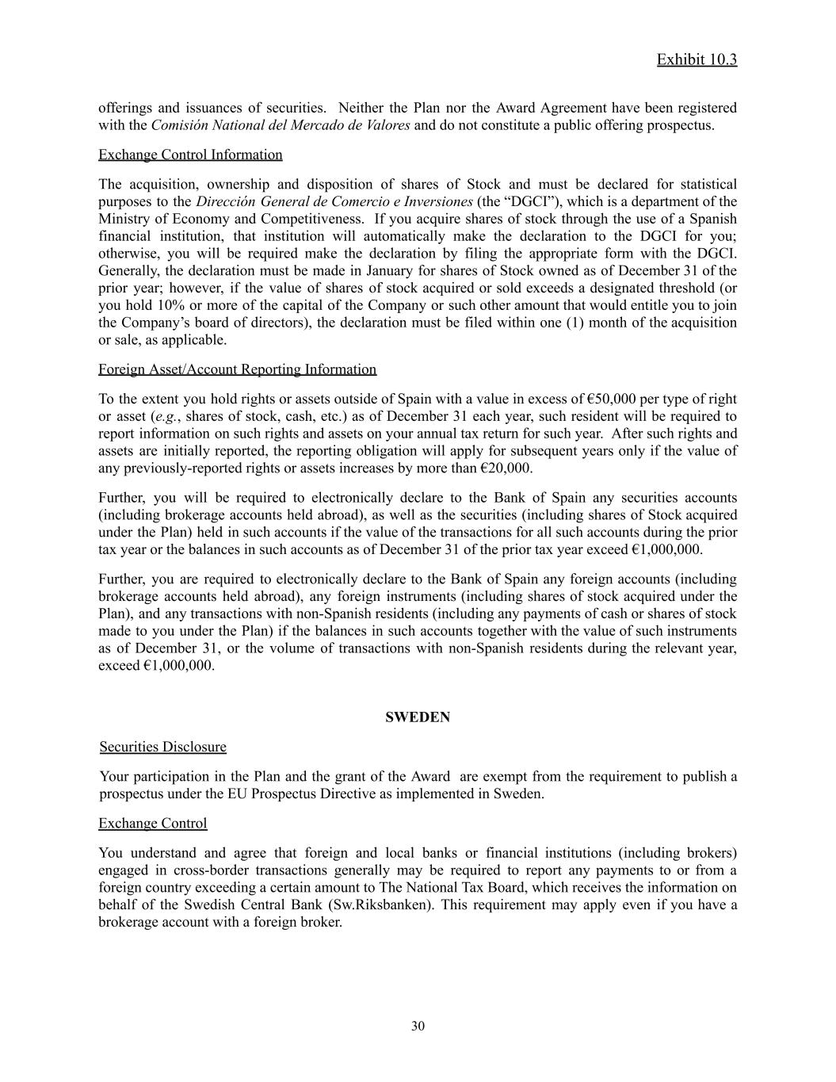
Exhibit 10.3 offerings and issuances of securities. Neither the Plan nor the Award Agreement have been registered with the Comisión National del Mercado de Valores and do not constitute a public offering prospectus. Exchange Control Information The acquisition, ownership and disposition of shares of Stock and must be declared for statistical purposes to the Dirección General de Comercio e Inversiones (the “DGCI”), which is a department of the Ministry of Economy and Competitiveness. If you acquire shares of stock through the use of a Spanish financial institution, that institution will automatically make the declaration to the DGCI for you; otherwise, you will be required make the declaration by filing the appropriate form with the DGCI. Generally, the declaration must be made in January for shares of Stock owned as of December 31 of the prior year; however, if the value of shares of stock acquired or sold exceeds a designated threshold (or you hold 10% or more of the capital of the Company or such other amount that would entitle you to join the Company’s board of directors), the declaration must be filed within one (1) month of the acquisition or sale, as applicable. Foreign Asset/Account Reporting Information To the extent you hold rights or assets outside of Spain with a value in excess of €50,000 per type of right or asset (e.g., shares of stock, cash, etc.) as of December 31 each year, such resident will be required to report information on such rights and assets on your annual tax return for such year. After such rights and assets are initially reported, the reporting obligation will apply for subsequent years only if the value of any previously-reported rights or assets increases by more than €20,000. Further, you will be required to electronically declare to the Bank of Spain any securities accounts (including brokerage accounts held abroad), as well as the securities (including shares of Stock acquired under the Plan) held in such accounts if the value of the transactions for all such accounts during the prior tax year or the balances in such accounts as of December 31 of the prior tax year exceed €1,000,000. Further, you are required to electronically declare to the Bank of Spain any foreign accounts (including brokerage accounts held abroad), any foreign instruments (including shares of stock acquired under the Plan), and any transactions with non-Spanish residents (including any payments of cash or shares of stock made to you under the Plan) if the balances in such accounts together with the value of such instruments as of December 31, or the volume of transactions with non-Spanish residents during the relevant year, exceed €1,000,000. SWEDEN Securities Disclosure Your participation in the Plan and the grant of the Award are exempt from the requirement to publish a prospectus under the EU Prospectus Directive as implemented in Sweden. Exchange Control You understand and agree that foreign and local banks or financial institutions (including brokers) engaged in cross-border transactions generally may be required to report any payments to or from a foreign country exceeding a certain amount to The National Tax Board, which receives the information on behalf of the Swedish Central Bank (Sw.Riksbanken). This requirement may apply even if you have a brokerage account with a foreign broker. ​ 30

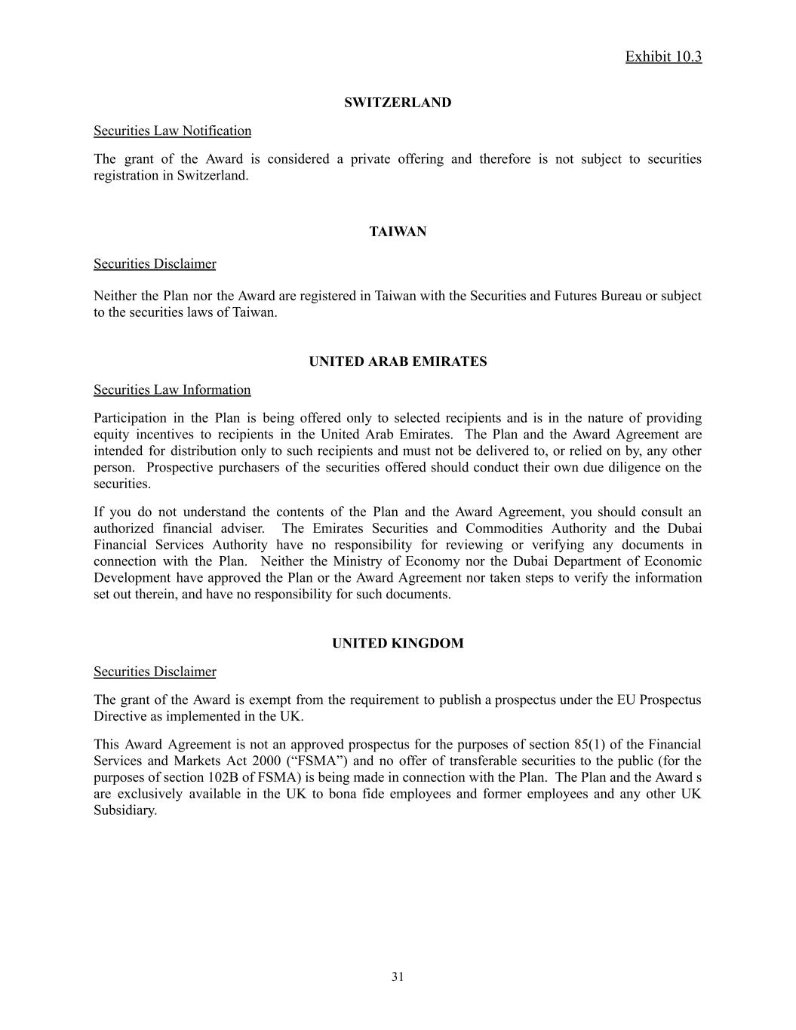
Exhibit 10.3 SWITZERLAND Securities Law Notification The grant of the Award is considered a private offering and therefore is not subject to securities registration in Switzerland. TAIWAN Securities Disclaimer Neither the Plan nor the Award are registered in Taiwan with the Securities and Futures Bureau or subject to the securities laws of Taiwan. UNITED ARAB EMIRATES Securities Law Information Participation in the Plan is being offered only to selected recipients and is in the nature of providing equity incentives to recipients in the United Arab Emirates. The Plan and the Award Agreement are intended for distribution only to such recipients and must not be delivered to, or relied on by, any other person. Prospective purchasers of the securities offered should conduct their own due diligence on the securities. If you do not understand the contents of the Plan and the Award Agreement, you should consult an authorized financial adviser. The Emirates Securities and Commodities Authority and the Dubai Financial Services Authority have no responsibility for reviewing or verifying any documents in connection with the Plan. Neither the Ministry of Economy nor the Dubai Department of Economic Development have approved the Plan or the Award Agreement nor taken steps to verify the information set out therein, and have no responsibility for such documents. UNITED KINGDOM Securities Disclaimer The grant of the Award is exempt from the requirement to publish a prospectus under the EU Prospectus Directive as implemented in the UK. This Award Agreement is not an approved prospectus for the purposes of section 85(1) of the Financial Services and Markets Act 2000 (“FSMA”) and no offer of transferable securities to the public (for the purposes of section 102B of FSMA) is being made in connection with the Plan. The Plan and the Award s are exclusively available in the UK to bona fide employees and former employees and any other UK Subsidiary. ​ 31

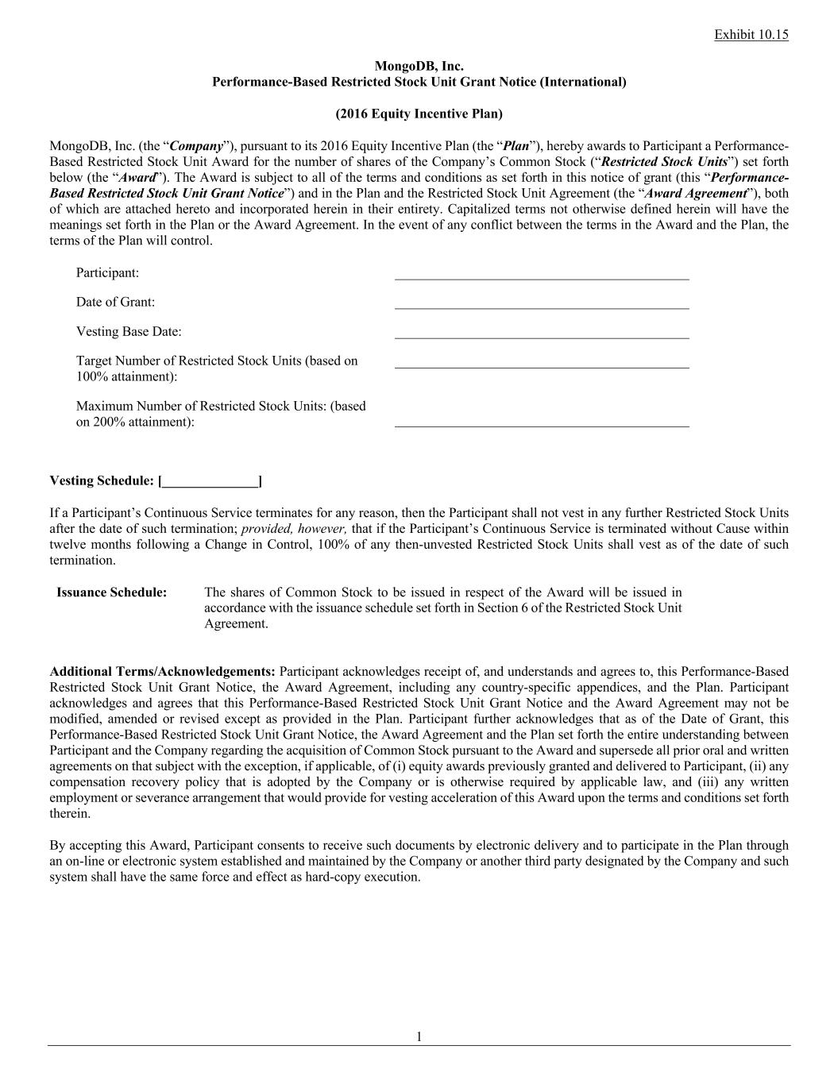
Exhibit 10.15 1 MongoDB, Inc. Performance-Based Restricted Stock Unit Grant Notice (International) (2016 Equity Incentive Plan) MongoDB, Inc. (the “Company”), pursuant to its 2016 Equity Incentive Plan (the “Plan”), hereby awards to Participant a Performance- Based Restricted Stock Unit Award for the number of shares of the Company’s Common Stock (“Restricted Stock Units”) set forth below (the “Award”). The Award is subject to all of the terms and conditions as set forth in this notice of grant (this “Performance- Based Restricted Stock Unit Grant Notice”) and in the Plan and the Restricted Stock Unit Agreement (the “Award Agreement”), both of which are attached hereto and incorporated herein in their entirety. Capitalized terms not otherwise defined herein will have the meanings set forth in the Plan or the Award Agreement. In the event of any conflict between the terms in the Award and the Plan, the terms of the Plan will control. Participant: Date of Grant: Vesting Base Date: Target Number of Restricted Stock Units (based on 100% attainment): Maximum Number of Restricted Stock Units: (based on 200% attainment): ___________________________________________ ___________________________________________ ___________________________________________ ___________________________________________ ___________________________________________ Vesting Schedule: [______________] If a Participant’s Continuous Service terminates for any reason, then the Participant shall not vest in any further Restricted Stock Units after the date of such termination; provided, however, that if the Participant’s Continuous Service is terminated without Cause within twelve months following a Change in Control, 100% of any then-unvested Restricted Stock Units shall vest as of the date of such termination. Issuance Schedule: The shares of Common Stock to be issued in respect of the Award will be issued in accordance with the issuance schedule set forth in Section 6 of the Restricted Stock Unit Agreement. Additional Terms/Acknowledgements: Participant acknowledges receipt of, and understands and agrees to, this Performance-Based Restricted Stock Unit Grant Notice, the Award Agreement, including any country-specific appendices, and the Plan. Participant acknowledges and agrees that this Performance-Based Restricted Stock Unit Grant Notice and the Award Agreement may not be modified, amended or revised except as provided in the Plan. Participant further acknowledges that as of the Date of Grant, this Performance-Based Restricted Stock Unit Grant Notice, the Award Agreement and the Plan set forth the entire understanding between Participant and the Company regarding the acquisition of Common Stock pursuant to the Award and supersede all prior oral and written agreements on that subject with the exception, if applicable, of (i) equity awards previously granted and delivered to Participant, (ii) any compensation recovery policy that is adopted by the Company or is otherwise required by applicable law, and (iii) any written employment or severance arrangement that would provide for vesting acceleration of this Award upon the terms and conditions set forth therein. By accepting this Award, Participant consents to receive such documents by electronic delivery and to participate in the Plan through an on-line or electronic system established and maintained by the Company or another third party designated by the Company and such system shall have the same force and effect as hard-copy execution.


Exhibit 10.15 2 MongoDB, Inc. Participant By: _ ________________________________ Signature Signature Title: Date: ___________________________ Date: _________________________ Attachments: Award Agreement, 2016 Equity Incentive Plan

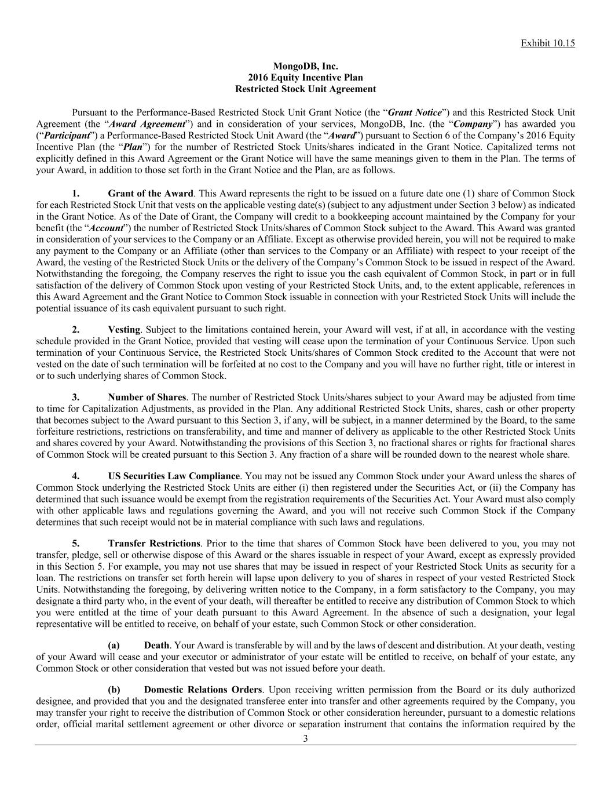
Exhibit 10.15 3 MongoDB, Inc. 2016 Equity Incentive Plan Restricted Stock Unit Agreement Pursuant to the Performance-Based Restricted Stock Unit Grant Notice (the “Grant Notice”) and this Restricted Stock Unit Agreement (the “Award Agreement”) and in consideration of your services, MongoDB, Inc. (the “Company”) has awarded you (“Participant”) a Performance-Based Restricted Stock Unit Award (the “Award”) pursuant to Section 6 of the Company’s 2016 Equity Incentive Plan (the “Plan”) for the number of Restricted Stock Units/shares indicated in the Grant Notice. Capitalized terms not explicitly defined in this Award Agreement or the Grant Notice will have the same meanings given to them in the Plan. The terms of your Award, in addition to those set forth in the Grant Notice and the Plan, are as follows. 1. Grant of the Award. This Award represents the right to be issued on a future date one (1) share of Common Stock for each Restricted Stock Unit that vests on the applicable vesting date(s) (subject to any adjustment under Section 3 below) as indicated in the Grant Notice. As of the Date of Grant, the Company will credit to a bookkeeping account maintained by the Company for your benefit (the “Account”) the number of Restricted Stock Units/shares of Common Stock subject to the Award. This Award was granted in consideration of your services to the Company or an Affiliate. Except as otherwise provided herein, you will not be required to make any payment to the Company or an Affiliate (other than services to the Company or an Affiliate) with respect to your receipt of the Award, the vesting of the Restricted Stock Units or the delivery of the Company’s Common Stock to be issued in respect of the Award. Notwithstanding the foregoing, the Company reserves the right to issue you the cash equivalent of Common Stock, in part or in full satisfaction of the delivery of Common Stock upon vesting of your Restricted Stock Units, and, to the extent applicable, references in this Award Agreement and the Grant Notice to Common Stock issuable in connection with your Restricted Stock Units will include the potential issuance of its cash equivalent pursuant to such right. 2. Vesting. Subject to the limitations contained herein, your Award will vest, if at all, in accordance with the vesting schedule provided in the Grant Notice, provided that vesting will cease upon the termination of your Continuous Service. Upon such termination of your Continuous Service, the Restricted Stock Units/shares of Common Stock credited to the Account that were not vested on the date of such termination will be forfeited at no cost to the Company and you will have no further right, title or interest in or to such underlying shares of Common Stock. 3. Number of Shares. The number of Restricted Stock Units/shares subject to your Award may be adjusted from time to time for Capitalization Adjustments, as provided in the Plan. Any additional Restricted Stock Units, shares, cash or other property that becomes subject to the Award pursuant to this Section 3, if any, will be subject, in a manner determined by the Board, to the same forfeiture restrictions, restrictions on transferability, and time and manner of delivery as applicable to the other Restricted Stock Units and shares covered by your Award. Notwithstanding the provisions of this Section 3, no fractional shares or rights for fractional shares of Common Stock will be created pursuant to this Section 3. Any fraction of a share will be rounded down to the nearest whole share. 4. US Securities Law Compliance. You may not be issued any Common Stock under your Award unless the shares of Common Stock underlying the Restricted Stock Units are either (i) then registered under the Securities Act, or (ii) the Company has determined that such issuance would be exempt from the registration requirements of the Securities Act. Your Award must also comply with other applicable laws and regulations governing the Award, and you will not receive such Common Stock if the Company determines that such receipt would not be in material compliance with such laws and regulations. 5. Transfer Restrictions. Prior to the time that shares of Common Stock have been delivered to you, you may not transfer, pledge, sell or otherwise dispose of this Award or the shares issuable in respect of your Award, except as expressly provided in this Section 5. For example, you may not use shares that may be issued in respect of your Restricted Stock Units as security for a loan. The restrictions on transfer set forth herein will lapse upon delivery to you of shares in respect of your vested Restricted Stock Units. Notwithstanding the foregoing, by delivering written notice to the Company, in a form satisfactory to the Company, you may designate a third party who, in the event of your death, will thereafter be entitled to receive any distribution of Common Stock to which you were entitled at the time of your death pursuant to this Award Agreement. In the absence of such a designation, your legal representative will be entitled to receive, on behalf of your estate, such Common Stock or other consideration. (a) Death. Your Award is transferable by will and by the laws of descent and distribution. At your death, vesting of your Award will cease and your executor or administrator of your estate will be entitled to receive, on behalf of your estate, any Common Stock or other consideration that vested but was not issued before your death. (b) Domestic Relations Orders. Upon receiving written permission from the Board or its duly authorized designee, and provided that you and the designated transferee enter into transfer and other agreements required by the Company, you may transfer your right to receive the distribution of Common Stock or other consideration hereunder, pursuant to a domestic relations order, official marital settlement agreement or other divorce or separation instrument that contains the information required by the

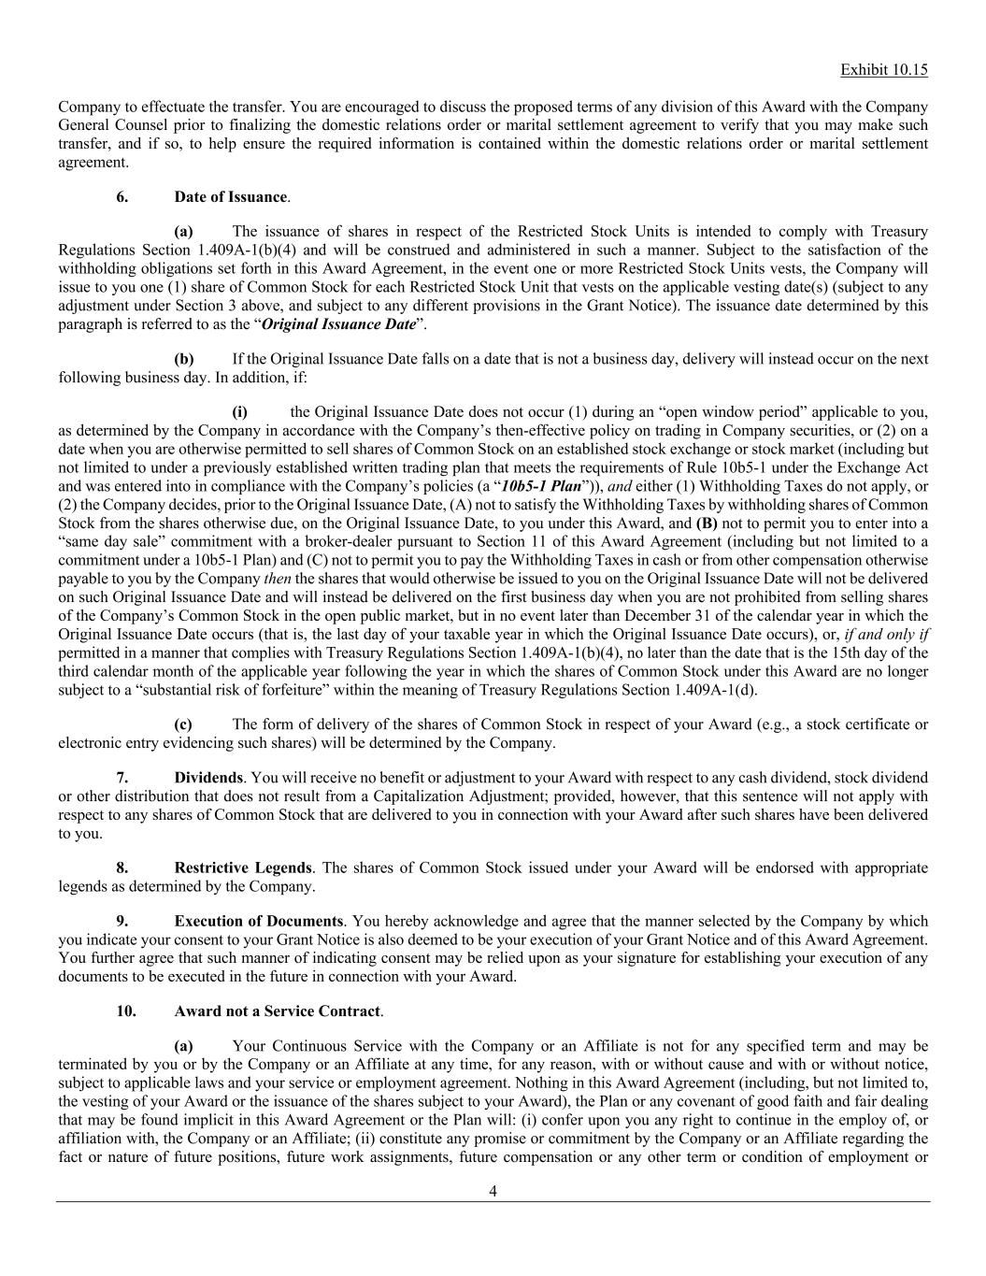
Exhibit 10.15 4 Company to effectuate the transfer. You are encouraged to discuss the proposed terms of any division of this Award with the Company General Counsel prior to finalizing the domestic relations order or marital settlement agreement to verify that you may make such transfer, and if so, to help ensure the required information is contained within the domestic relations order or marital settlement agreement. 6. Date of Issuance. (a) The issuance of shares in respect of the Restricted Stock Units is intended to comply with Treasury Regulations Section 1.409A-1(b)(4) and will be construed and administered in such a manner. Subject to the satisfaction of the withholding obligations set forth in this Award Agreement, in the event one or more Restricted Stock Units vests, the Company will issue to you one (1) share of Common Stock for each Restricted Stock Unit that vests on the applicable vesting date(s) (subject to any adjustment under Section 3 above, and subject to any different provisions in the Grant Notice). The issuance date determined by this paragraph is referred to as the “Original Issuance Date”. (b) If the Original Issuance Date falls on a date that is not a business day, delivery will instead occur on the next following business day. In addition, if: (i) the Original Issuance Date does not occur (1) during an “open window period” applicable to you, as determined by the Company in accordance with the Company’s then-effective policy on trading in Company securities, or (2) on a date when you are otherwise permitted to sell shares of Common Stock on an established stock exchange or stock market (including but not limited to under a previously established written trading plan that meets the requirements of Rule 10b5-1 under the Exchange Act and was entered into in compliance with the Company’s policies (a “10b5-1 Plan”)), and either (1) Withholding Taxes do not apply, or (2) the Company decides, prior to the Original Issuance Date, (A) not to satisfy the Withholding Taxes by withholding shares of Common Stock from the shares otherwise due, on the Original Issuance Date, to you under this Award, and (B) not to permit you to enter into a “same day sale” commitment with a broker-dealer pursuant to Section 11 of this Award Agreement (including but not limited to a commitment under a 10b5-1 Plan) and (C) not to permit you to pay the Withholding Taxes in cash or from other compensation otherwise payable to you by the Company then the shares that would otherwise be issued to you on the Original Issuance Date will not be delivered on such Original Issuance Date and will instead be delivered on the first business day when you are not prohibited from selling shares of the Company’s Common Stock in the open public market, but in no event later than December 31 of the calendar year in which the Original Issuance Date occurs (that is, the last day of your taxable year in which the Original Issuance Date occurs), or, if and only if permitted in a manner that complies with Treasury Regulations Section 1.409A-1(b)(4), no later than the date that is the 15th day of the third calendar month of the applicable year following the year in which the shares of Common Stock under this Award are no longer subject to a “substantial risk of forfeiture” within the meaning of Treasury Regulations Section 1.409A-1(d). (c) The form of delivery of the shares of Common Stock in respect of your Award (e.g., a stock certificate or electronic entry evidencing such shares) will be determined by the Company. 7. Dividends. You will receive no benefit or adjustment to your Award with respect to any cash dividend, stock dividend or other distribution that does not result from a Capitalization Adjustment; provided, however, that this sentence will not apply with respect to any shares of Common Stock that are delivered to you in connection with your Award after such shares have been delivered to you. 8. Restrictive Legends. The shares of Common Stock issued under your Award will be endorsed with appropriate legends as determined by the Company. 9. Execution of Documents. You hereby acknowledge and agree that the manner selected by the Company by which you indicate your consent to your Grant Notice is also deemed to be your execution of your Grant Notice and of this Award Agreement. You further agree that such manner of indicating consent may be relied upon as your signature for establishing your execution of any documents to be executed in the future in connection with your Award. 10. Award not a Service Contract. (a) Your Continuous Service with the Company or an Affiliate is not for any specified term and may be terminated by you or by the Company or an Affiliate at any time, for any reason, with or without cause and with or without notice, subject to applicable laws and your service or employment agreement. Nothing in this Award Agreement (including, but not limited to, the vesting of your Award or the issuance of the shares subject to your Award), the Plan or any covenant of good faith and fair dealing that may be found implicit in this Award Agreement or the Plan will: (i) confer upon you any right to continue in the employ of, or affiliation with, the Company or an Affiliate; (ii) constitute any promise or commitment by the Company or an Affiliate regarding the fact or nature of future positions, future work assignments, future compensation or any other term or condition of employment or

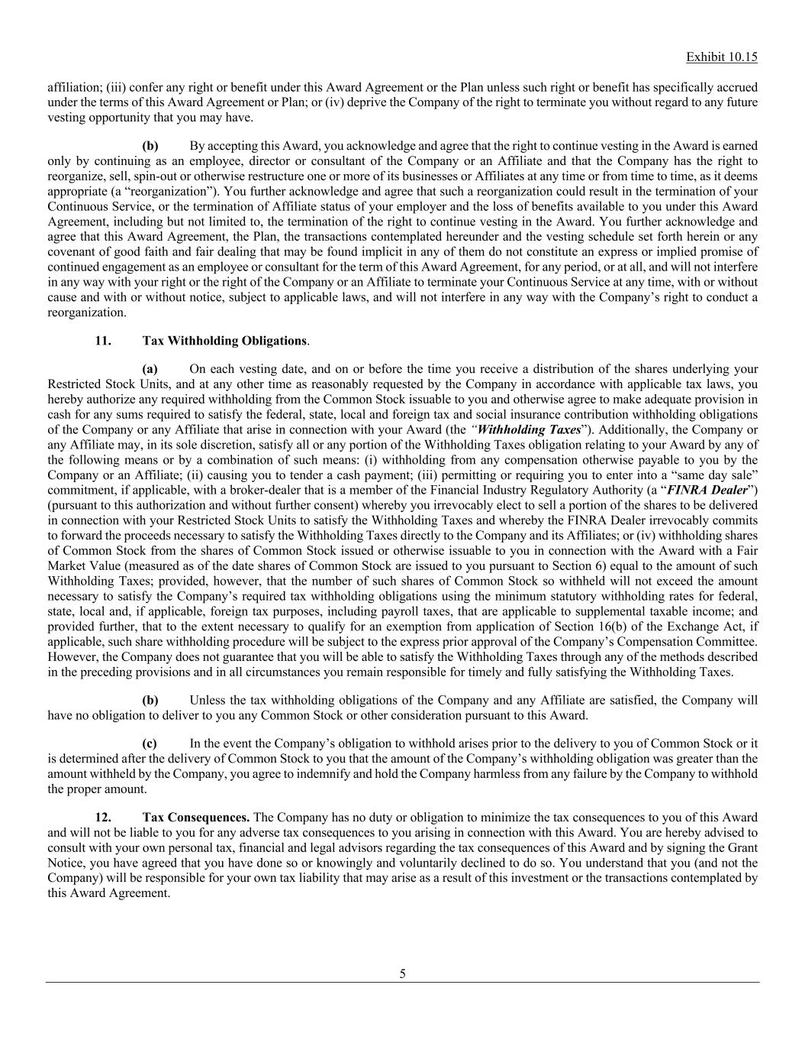
Exhibit 10.15 5 affiliation; (iii) confer any right or benefit under this Award Agreement or the Plan unless such right or benefit has specifically accrued under the terms of this Award Agreement or Plan; or (iv) deprive the Company of the right to terminate you without regard to any future vesting opportunity that you may have. (b) By accepting this Award, you acknowledge and agree that the right to continue vesting in the Award is earned only by continuing as an employee, director or consultant of the Company or an Affiliate and that the Company has the right to reorganize, sell, spin-out or otherwise restructure one or more of its businesses or Affiliates at any time or from time to time, as it deems appropriate (a “reorganization”). You further acknowledge and agree that such a reorganization could result in the termination of your Continuous Service, or the termination of Affiliate status of your employer and the loss of benefits available to you under this Award Agreement, including but not limited to, the termination of the right to continue vesting in the Award. You further acknowledge and agree that this Award Agreement, the Plan, the transactions contemplated hereunder and the vesting schedule set forth herein or any covenant of good faith and fair dealing that may be found implicit in any of them do not constitute an express or implied promise of continued engagement as an employee or consultant for the term of this Award Agreement, for any period, or at all, and will not interfere in any way with your right or the right of the Company or an Affiliate to terminate your Continuous Service at any time, with or without cause and with or without notice, subject to applicable laws, and will not interfere in any way with the Company’s right to conduct a reorganization. 11. Tax Withholding Obligations. (a) On each vesting date, and on or before the time you receive a distribution of the shares underlying your Restricted Stock Units, and at any other time as reasonably requested by the Company in accordance with applicable tax laws, you hereby authorize any required withholding from the Common Stock issuable to you and otherwise agree to make adequate provision in cash for any sums required to satisfy the federal, state, local and foreign tax and social insurance contribution withholding obligations of the Company or any Affiliate that arise in connection with your Award (the “Withholding Taxes”). Additionally, the Company or any Affiliate may, in its sole discretion, satisfy all or any portion of the Withholding Taxes obligation relating to your Award by any of the following means or by a combination of such means: (i) withholding from any compensation otherwise payable to you by the Company or an Affiliate; (ii) causing you to tender a cash payment; (iii) permitting or requiring you to enter into a “same day sale” commitment, if applicable, with a broker-dealer that is a member of the Financial Industry Regulatory Authority (a “FINRA Dealer”) (pursuant to this authorization and without further consent) whereby you irrevocably elect to sell a portion of the shares to be delivered in connection with your Restricted Stock Units to satisfy the Withholding Taxes and whereby the FINRA Dealer irrevocably commits to forward the proceeds necessary to satisfy the Withholding Taxes directly to the Company and its Affiliates; or (iv) withholding shares of Common Stock from the shares of Common Stock issued or otherwise issuable to you in connection with the Award with a Fair Market Value (measured as of the date shares of Common Stock are issued to you pursuant to Section 6) equal to the amount of such Withholding Taxes; provided, however, that the number of such shares of Common Stock so withheld will not exceed the amount necessary to satisfy the Company’s required tax withholding obligations using the minimum statutory withholding rates for federal, state, local and, if applicable, foreign tax purposes, including payroll taxes, that are applicable to supplemental taxable income; and provided further, that to the extent necessary to qualify for an exemption from application of Section 16(b) of the Exchange Act, if applicable, such share withholding procedure will be subject to the express prior approval of the Company’s Compensation Committee. However, the Company does not guarantee that you will be able to satisfy the Withholding Taxes through any of the methods described in the preceding provisions and in all circumstances you remain responsible for timely and fully satisfying the Withholding Taxes. (b) Unless the tax withholding obligations of the Company and any Affiliate are satisfied, the Company will have no obligation to deliver to you any Common Stock or other consideration pursuant to this Award. (c) In the event the Company’s obligation to withhold arises prior to the delivery to you of Common Stock or it is determined after the delivery of Common Stock to you that the amount of the Company’s withholding obligation was greater than the amount withheld by the Company, you agree to indemnify and hold the Company harmless from any failure by the Company to withhold the proper amount. 12. Tax Consequences. The Company has no duty or obligation to minimize the tax consequences to you of this Award and will not be liable to you for any adverse tax consequences to you arising in connection with this Award. You are hereby advised to consult with your own personal tax, financial and legal advisors regarding the tax consequences of this Award and by signing the Grant Notice, you have agreed that you have done so or knowingly and voluntarily declined to do so. You understand that you (and not the Company) will be responsible for your own tax liability that may arise as a result of this investment or the transactions contemplated by this Award Agreement.

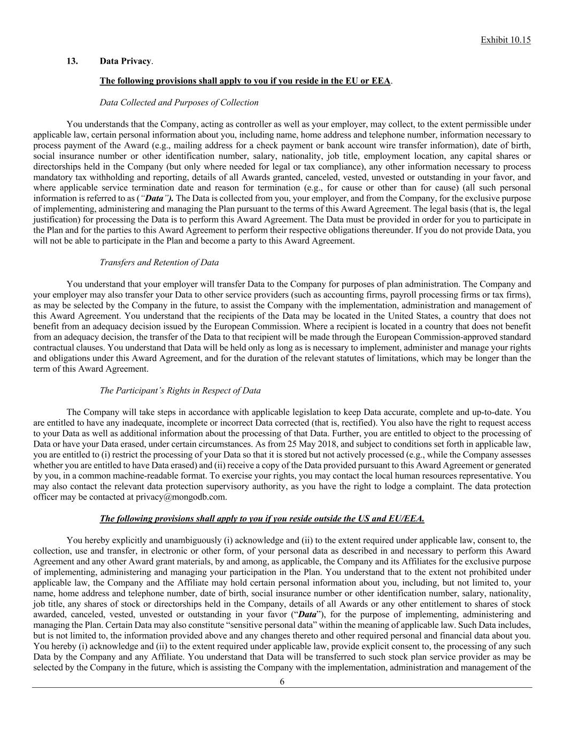
Exhibit 10.15 6 13. Data Privacy. The following provisions shall apply to you if you reside in the EU or EEA. Data Collected and Purposes of Collection You understands that the Company, acting as controller as well as your employer, may collect, to the extent permissible under applicable law, certain personal information about you, including name, home address and telephone number, information necessary to process payment of the Award (e.g., mailing address for a check payment or bank account wire transfer information), date of birth, social insurance number or other identification number, salary, nationality, job title, employment location, any capital shares or directorships held in the Company (but only where needed for legal or tax compliance), any other information necessary to process mandatory tax withholding and reporting, details of all Awards granted, canceled, vested, unvested or outstanding in your favor, and where applicable service termination date and reason for termination (e.g., for cause or other than for cause) (all such personal information is referred to as (“Data”). The Data is collected from you, your employer, and from the Company, for the exclusive purpose of implementing, administering and managing the Plan pursuant to the terms of this Award Agreement. The legal basis (that is, the legal justification) for processing the Data is to perform this Award Agreement. The Data must be provided in order for you to participate in the Plan and for the parties to this Award Agreement to perform their respective obligations thereunder. If you do not provide Data, you will not be able to participate in the Plan and become a party to this Award Agreement. Transfers and Retention of Data You understand that your employer will transfer Data to the Company for purposes of plan administration. The Company and your employer may also transfer your Data to other service providers (such as accounting firms, payroll processing firms or tax firms), as may be selected by the Company in the future, to assist the Company with the implementation, administration and management of this Award Agreement. You understand that the recipients of the Data may be located in the United States, a country that does not benefit from an adequacy decision issued by the European Commission. Where a recipient is located in a country that does not benefit from an adequacy decision, the transfer of the Data to that recipient will be made through the European Commission-approved standard contractual clauses. You understand that Data will be held only as long as is necessary to implement, administer and manage your rights and obligations under this Award Agreement, and for the duration of the relevant statutes of limitations, which may be longer than the term of this Award Agreement. The Participant’s Rights in Respect of Data The Company will take steps in accordance with applicable legislation to keep Data accurate, complete and up-to-date. You are entitled to have any inadequate, incomplete or incorrect Data corrected (that is, rectified). You also have the right to request access to your Data as well as additional information about the processing of that Data. Further, you are entitled to object to the processing of Data or have your Data erased, under certain circumstances. As from 25 May 2018, and subject to conditions set forth in applicable law, you are entitled to (i) restrict the processing of your Data so that it is stored but not actively processed (e.g., while the Company assesses whether you are entitled to have Data erased) and (ii) receive a copy of the Data provided pursuant to this Award Agreement or generated by you, in a common machine-readable format. To exercise your rights, you may contact the local human resources representative. You may also contact the relevant data protection supervisory authority, as you have the right to lodge a complaint. The data protection officer may be contacted at privacy@mongodb.com. The following provisions shall apply to you if you reside outside the US and EU/EEA. You hereby explicitly and unambiguously (i) acknowledge and (ii) to the extent required under applicable law, consent to, the collection, use and transfer, in electronic or other form, of your personal data as described in and necessary to perform this Award Agreement and any other Award grant materials, by and among, as applicable, the Company and its Affiliates for the exclusive purpose of implementing, administering and managing your participation in the Plan. You understand that to the extent not prohibited under applicable law, the Company and the Affiliate may hold certain personal information about you, including, but not limited to, your name, home address and telephone number, date of birth, social insurance number or other identification number, salary, nationality, job title, any shares of stock or directorships held in the Company, details of all Awards or any other entitlement to shares of stock awarded, canceled, vested, unvested or outstanding in your favor (“Data”), for the purpose of implementing, administering and managing the Plan. Certain Data may also constitute “sensitive personal data” within the meaning of applicable law. Such Data includes, but is not limited to, the information provided above and any changes thereto and other required personal and financial data about you. You hereby (i) acknowledge and (ii) to the extent required under applicable law, provide explicit consent to, the processing of any such Data by the Company and any Affiliate. You understand that Data will be transferred to such stock plan service provider as may be selected by the Company in the future, which is assisting the Company with the implementation, administration and management of the

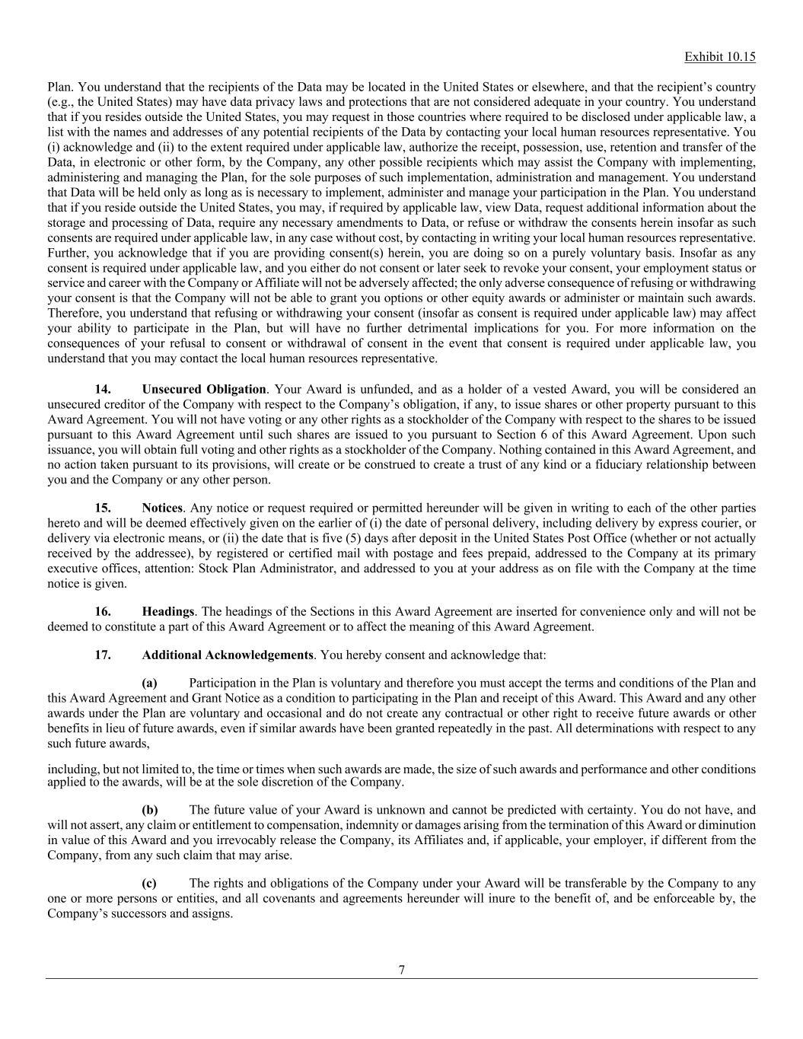
Exhibit 10.15 7 Plan. You understand that the recipients of the Data may be located in the United States or elsewhere, and that the recipient’s country (e.g., the United States) may have data privacy laws and protections that are not considered adequate in your country. You understand that if you resides outside the United States, you may request in those countries where required to be disclosed under applicable law, a list with the names and addresses of any potential recipients of the Data by contacting your local human resources representative. You (i) acknowledge and (ii) to the extent required under applicable law, authorize the receipt, possession, use, retention and transfer of the Data, in electronic or other form, by the Company, any other possible recipients which may assist the Company with implementing, administering and managing the Plan, for the sole purposes of such implementation, administration and management. You understand that Data will be held only as long as is necessary to implement, administer and manage your participation in the Plan. You understand that if you reside outside the United States, you may, if required by applicable law, view Data, request additional information about the storage and processing of Data, require any necessary amendments to Data, or refuse or withdraw the consents herein insofar as such consents are required under applicable law, in any case without cost, by contacting in writing your local human resources representative. Further, you acknowledge that if you are providing consent(s) herein, you are doing so on a purely voluntary basis. Insofar as any consent is required under applicable law, and you either do not consent or later seek to revoke your consent, your employment status or service and career with the Company or Affiliate will not be adversely affected; the only adverse consequence of refusing or withdrawing your consent is that the Company will not be able to grant you options or other equity awards or administer or maintain such awards. Therefore, you understand that refusing or withdrawing your consent (insofar as consent is required under applicable law) may affect your ability to participate in the Plan, but will have no further detrimental implications for you. For more information on the consequences of your refusal to consent or withdrawal of consent in the event that consent is required under applicable law, you understand that you may contact the local human resources representative. 14. Unsecured Obligation. Your Award is unfunded, and as a holder of a vested Award, you will be considered an unsecured creditor of the Company with respect to the Company’s obligation, if any, to issue shares or other property pursuant to this Award Agreement. You will not have voting or any other rights as a stockholder of the Company with respect to the shares to be issued pursuant to this Award Agreement until such shares are issued to you pursuant to Section 6 of this Award Agreement. Upon such issuance, you will obtain full voting and other rights as a stockholder of the Company. Nothing contained in this Award Agreement, and no action taken pursuant to its provisions, will create or be construed to create a trust of any kind or a fiduciary relationship between you and the Company or any other person. 15. Notices. Any notice or request required or permitted hereunder will be given in writing to each of the other parties hereto and will be deemed effectively given on the earlier of (i) the date of personal delivery, including delivery by express courier, or delivery via electronic means, or (ii) the date that is five (5) days after deposit in the United States Post Office (whether or not actually received by the addressee), by registered or certified mail with postage and fees prepaid, addressed to the Company at its primary executive offices, attention: Stock Plan Administrator, and addressed to you at your address as on file with the Company at the time notice is given. 16. Headings. The headings of the Sections in this Award Agreement are inserted for convenience only and will not be deemed to constitute a part of this Award Agreement or to affect the meaning of this Award Agreement. 17. Additional Acknowledgements. You hereby consent and acknowledge that: (a) Participation in the Plan is voluntary and therefore you must accept the terms and conditions of the Plan and this Award Agreement and Grant Notice as a condition to participating in the Plan and receipt of this Award. This Award and any other awards under the Plan are voluntary and occasional and do not create any contractual or other right to receive future awards or other benefits in lieu of future awards, even if similar awards have been granted repeatedly in the past. All determinations with respect to any such future awards, including, but not limited to, the time or times when such awards are made, the size of such awards and performance and other conditions applied to the awards, will be at the sole discretion of the Company. (b) The future value of your Award is unknown and cannot be predicted with certainty. You do not have, and will not assert, any claim or entitlement to compensation, indemnity or damages arising from the termination of this Award or diminution in value of this Award and you irrevocably release the Company, its Affiliates and, if applicable, your employer, if different from the Company, from any such claim that may arise. (c) The rights and obligations of the Company under your Award will be transferable by the Company to any one or more persons or entities, and all covenants and agreements hereunder will inure to the benefit of, and be enforceable by, the Company’s successors and assigns.

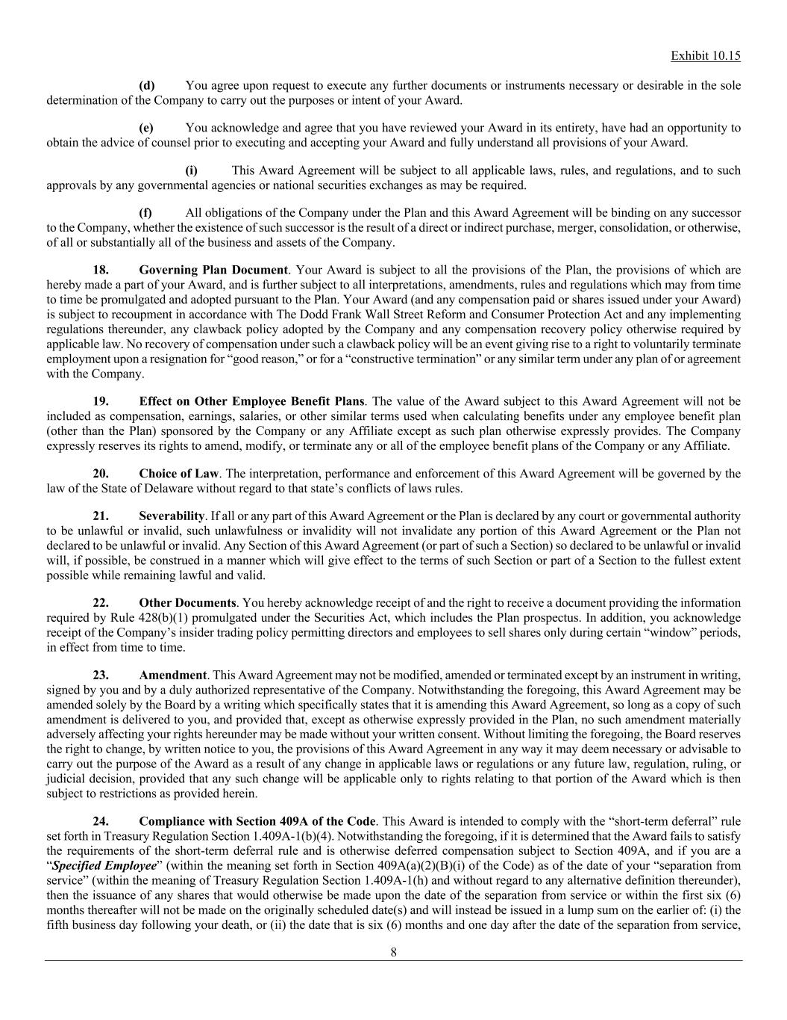
Exhibit 10.15 8 (d) You agree upon request to execute any further documents or instruments necessary or desirable in the sole determination of the Company to carry out the purposes or intent of your Award. (e) You acknowledge and agree that you have reviewed your Award in its entirety, have had an opportunity to obtain the advice of counsel prior to executing and accepting your Award and fully understand all provisions of your Award. (i) This Award Agreement will be subject to all applicable laws, rules, and regulations, and to such approvals by any governmental agencies or national securities exchanges as may be required. (f) All obligations of the Company under the Plan and this Award Agreement will be binding on any successor to the Company, whether the existence of such successor is the result of a direct or indirect purchase, merger, consolidation, or otherwise, of all or substantially all of the business and assets of the Company. 18. Governing Plan Document. Your Award is subject to all the provisions of the Plan, the provisions of which are hereby made a part of your Award, and is further subject to all interpretations, amendments, rules and regulations which may from time to time be promulgated and adopted pursuant to the Plan. Your Award (and any compensation paid or shares issued under your Award) is subject to recoupment in accordance with The Dodd Frank Wall Street Reform and Consumer Protection Act and any implementing regulations thereunder, any clawback policy adopted by the Company and any compensation recovery policy otherwise required by applicable law. No recovery of compensation under such a clawback policy will be an event giving rise to a right to voluntarily terminate employment upon a resignation for “good reason,” or for a “constructive termination” or any similar term under any plan of or agreement with the Company. 19. Effect on Other Employee Benefit Plans. The value of the Award subject to this Award Agreement will not be included as compensation, earnings, salaries, or other similar terms used when calculating benefits under any employee benefit plan (other than the Plan) sponsored by the Company or any Affiliate except as such plan otherwise expressly provides. The Company expressly reserves its rights to amend, modify, or terminate any or all of the employee benefit plans of the Company or any Affiliate. 20. Choice of Law. The interpretation, performance and enforcement of this Award Agreement will be governed by the law of the State of Delaware without regard to that state’s conflicts of laws rules. 21. Severability. If all or any part of this Award Agreement or the Plan is declared by any court or governmental authority to be unlawful or invalid, such unlawfulness or invalidity will not invalidate any portion of this Award Agreement or the Plan not declared to be unlawful or invalid. Any Section of this Award Agreement (or part of such a Section) so declared to be unlawful or invalid will, if possible, be construed in a manner which will give effect to the terms of such Section or part of a Section to the fullest extent possible while remaining lawful and valid. 22. Other Documents. You hereby acknowledge receipt of and the right to receive a document providing the information required by Rule 428(b)(1) promulgated under the Securities Act, which includes the Plan prospectus. In addition, you acknowledge receipt of the Company’s insider trading policy permitting directors and employees to sell shares only during certain “window” periods, in effect from time to time. 23. Amendment. This Award Agreement may not be modified, amended or terminated except by an instrument in writing, signed by you and by a duly authorized representative of the Company. Notwithstanding the foregoing, this Award Agreement may be amended solely by the Board by a writing which specifically states that it is amending this Award Agreement, so long as a copy of such amendment is delivered to you, and provided that, except as otherwise expressly provided in the Plan, no such amendment materially adversely affecting your rights hereunder may be made without your written consent. Without limiting the foregoing, the Board reserves the right to change, by written notice to you, the provisions of this Award Agreement in any way it may deem necessary or advisable to carry out the purpose of the Award as a result of any change in applicable laws or regulations or any future law, regulation, ruling, or judicial decision, provided that any such change will be applicable only to rights relating to that portion of the Award which is then subject to restrictions as provided herein. 24. Compliance with Section 409A of the Code. This Award is intended to comply with the “short-term deferral” rule set forth in Treasury Regulation Section 1.409A-1(b)(4). Notwithstanding the foregoing, if it is determined that the Award fails to satisfy the requirements of the short-term deferral rule and is otherwise deferred compensation subject to Section 409A, and if you are a “Specified Employee” (within the meaning set forth in Section 409A(a)(2)(B)(i) of the Code) as of the date of your “separation from service” (within the meaning of Treasury Regulation Section 1.409A-1(h) and without regard to any alternative definition thereunder), then the issuance of any shares that would otherwise be made upon the date of the separation from service or within the first six (6) months thereafter will not be made on the originally scheduled date(s) and will instead be issued in a lump sum on the earlier of: (i) the fifth business day following your death, or (ii) the date that is six (6) months and one day after the date of the separation from service,

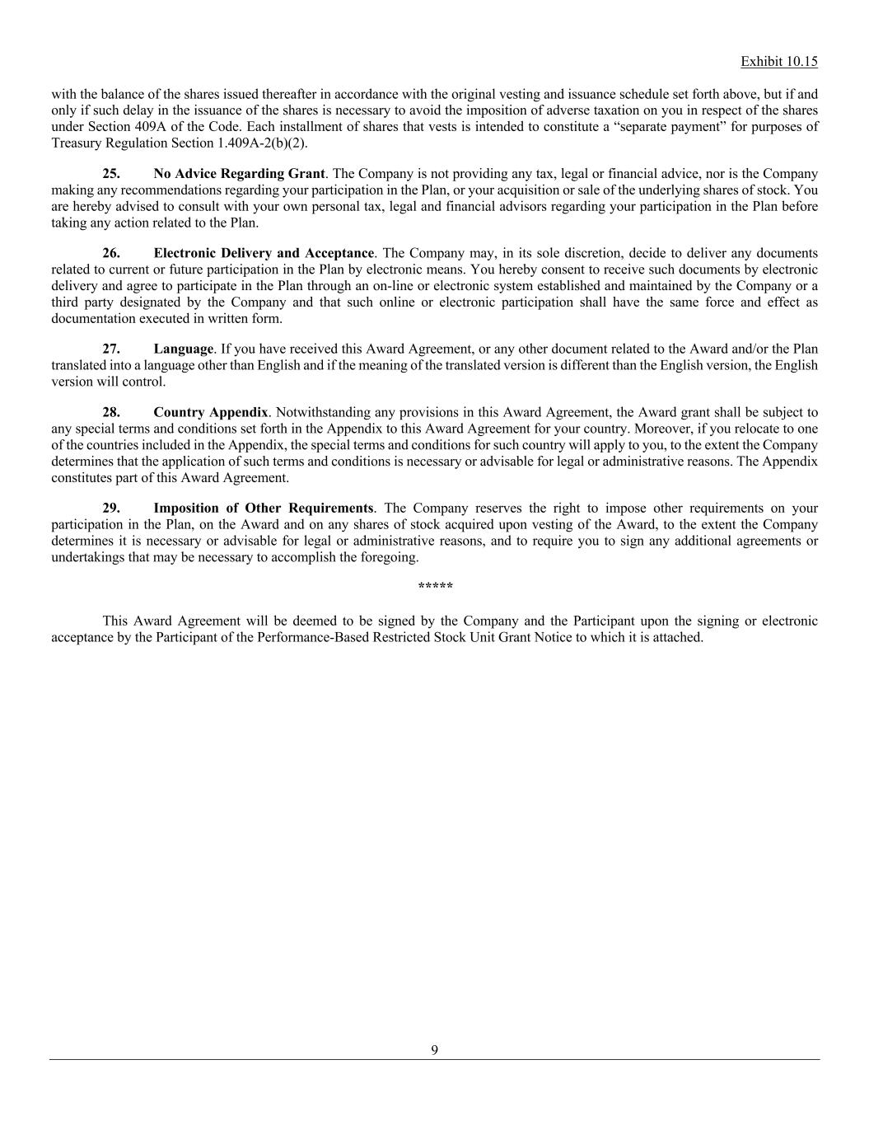
Exhibit 10.15 9 with the balance of the shares issued thereafter in accordance with the original vesting and issuance schedule set forth above, but if and only if such delay in the issuance of the shares is necessary to avoid the imposition of adverse taxation on you in respect of the shares under Section 409A of the Code. Each installment of shares that vests is intended to constitute a “separate payment” for purposes of Treasury Regulation Section 1.409A-2(b)(2). 25. No Advice Regarding Grant. The Company is not providing any tax, legal or financial advice, nor is the Company making any recommendations regarding your participation in the Plan, or your acquisition or sale of the underlying shares of stock. You are hereby advised to consult with your own personal tax, legal and financial advisors regarding your participation in the Plan before taking any action related to the Plan. 26. Electronic Delivery and Acceptance. The Company may, in its sole discretion, decide to deliver any documents related to current or future participation in the Plan by electronic means. You hereby consent to receive such documents by electronic delivery and agree to participate in the Plan through an on-line or electronic system established and maintained by the Company or a third party designated by the Company and that such online or electronic participation shall have the same force and effect as documentation executed in written form. 27. Language. If you have received this Award Agreement, or any other document related to the Award and/or the Plan translated into a language other than English and if the meaning of the translated version is different than the English version, the English version will control. 28. Country Appendix. Notwithstanding any provisions in this Award Agreement, the Award grant shall be subject to any special terms and conditions set forth in the Appendix to this Award Agreement for your country. Moreover, if you relocate to one of the countries included in the Appendix, the special terms and conditions for such country will apply to you, to the extent the Company determines that the application of such terms and conditions is necessary or advisable for legal or administrative reasons. The Appendix constitutes part of this Award Agreement. 29. Imposition of Other Requirements. The Company reserves the right to impose other requirements on your participation in the Plan, on the Award and on any shares of stock acquired upon vesting of the Award, to the extent the Company determines it is necessary or advisable for legal or administrative reasons, and to require you to sign any additional agreements or undertakings that may be necessary to accomplish the foregoing. ***** This Award Agreement will be deemed to be signed by the Company and the Participant upon the signing or electronic acceptance by the Participant of the Performance-Based Restricted Stock Unit Grant Notice to which it is attached.

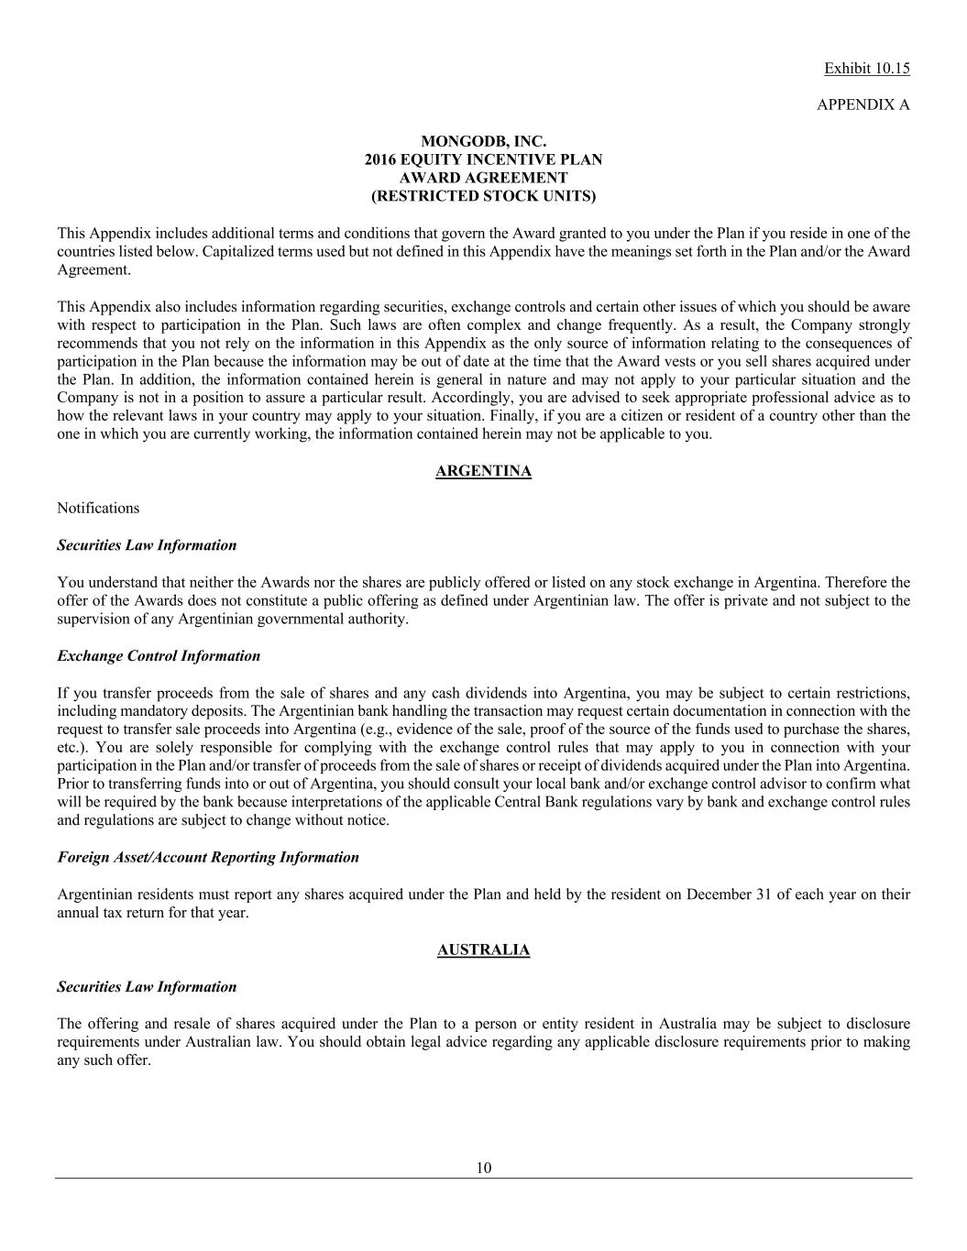
Exhibit 10.15 10 APPENDIX A MONGODB, INC. 2016 EQUITY INCENTIVE PLAN AWARD AGREEMENT (RESTRICTED STOCK UNITS) This Appendix includes additional terms and conditions that govern the Award granted to you under the Plan if you reside in one of the countries listed below. Capitalized terms used but not defined in this Appendix have the meanings set forth in the Plan and/or the Award Agreement. This Appendix also includes information regarding securities, exchange controls and certain other issues of which you should be aware with respect to participation in the Plan. Such laws are often complex and change frequently. As a result, the Company strongly recommends that you not rely on the information in this Appendix as the only source of information relating to the consequences of participation in the Plan because the information may be out of date at the time that the Award vests or you sell shares acquired under the Plan. In addition, the information contained herein is general in nature and may not apply to your particular situation and the Company is not in a position to assure a particular result. Accordingly, you are advised to seek appropriate professional advice as to how the relevant laws in your country may apply to your situation. Finally, if you are a citizen or resident of a country other than the one in which you are currently working, the information contained herein may not be applicable to you. ARGENTINA Notifications Securities Law Information You understand that neither the Awards nor the shares are publicly offered or listed on any stock exchange in Argentina. Therefore the offer of the Awards does not constitute a public offering as defined under Argentinian law. The offer is private and not subject to the supervision of any Argentinian governmental authority. Exchange Control Information If you transfer proceeds from the sale of shares and any cash dividends into Argentina, you may be subject to certain restrictions, including mandatory deposits. The Argentinian bank handling the transaction may request certain documentation in connection with the request to transfer sale proceeds into Argentina (e.g., evidence of the sale, proof of the source of the funds used to purchase the shares, etc.). You are solely responsible for complying with the exchange control rules that may apply to you in connection with your participation in the Plan and/or transfer of proceeds from the sale of shares or receipt of dividends acquired under the Plan into Argentina. Prior to transferring funds into or out of Argentina, you should consult your local bank and/or exchange control advisor to confirm what will be required by the bank because interpretations of the applicable Central Bank regulations vary by bank and exchange control rules and regulations are subject to change without notice. Foreign Asset/Account Reporting Information Argentinian residents must report any shares acquired under the Plan and held by the resident on December 31 of each year on their annual tax return for that year. AUSTRALIA Securities Law Information The offering and resale of shares acquired under the Plan to a person or entity resident in Australia may be subject to disclosure requirements under Australian law. You should obtain legal advice regarding any applicable disclosure requirements prior to making any such offer.

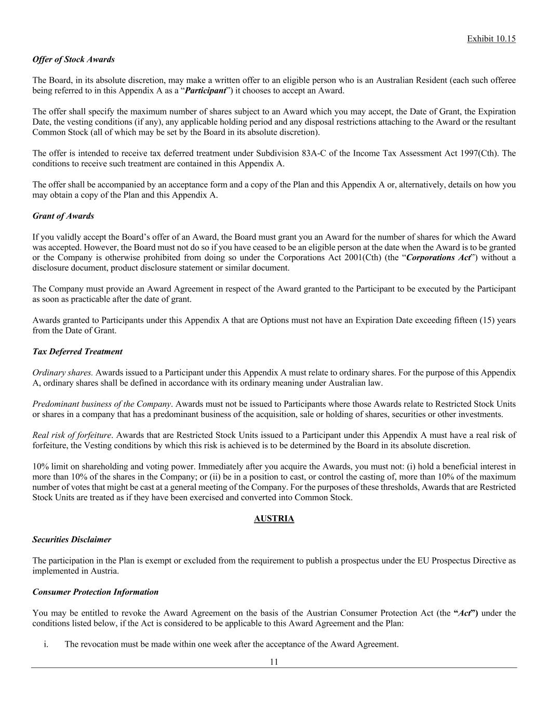
Exhibit 10.15 11 Offer of Stock Awards The Board, in its absolute discretion, may make a written offer to an eligible person who is an Australian Resident (each such offeree being referred to in this Appendix A as a “Participant”) it chooses to accept an Award. The offer shall specify the maximum number of shares subject to an Award which you may accept, the Date of Grant, the Expiration Date, the vesting conditions (if any), any applicable holding period and any disposal restrictions attaching to the Award or the resultant Common Stock (all of which may be set by the Board in its absolute discretion). The offer is intended to receive tax deferred treatment under Subdivision 83A-C of the Income Tax Assessment Act 1997(Cth). The conditions to receive such treatment are contained in this Appendix A. The offer shall be accompanied by an acceptance form and a copy of the Plan and this Appendix A or, alternatively, details on how you may obtain a copy of the Plan and this Appendix A. Grant of Awards If you validly accept the Board’s offer of an Award, the Board must grant you an Award for the number of shares for which the Award was accepted. However, the Board must not do so if you have ceased to be an eligible person at the date when the Award is to be granted or the Company is otherwise prohibited from doing so under the Corporations Act 2001(Cth) (the “Corporations Act”) without a disclosure document, product disclosure statement or similar document. The Company must provide an Award Agreement in respect of the Award granted to the Participant to be executed by the Participant as soon as practicable after the date of grant. Awards granted to Participants under this Appendix A that are Options must not have an Expiration Date exceeding fifteen (15) years from the Date of Grant. Tax Deferred Treatment Ordinary shares. Awards issued to a Participant under this Appendix A must relate to ordinary shares. For the purpose of this Appendix A, ordinary shares shall be defined in accordance with its ordinary meaning under Australian law. Predominant business of the Company. Awards must not be issued to Participants where those Awards relate to Restricted Stock Units or shares in a company that has a predominant business of the acquisition, sale or holding of shares, securities or other investments. Real risk of forfeiture. Awards that are Restricted Stock Units issued to a Participant under this Appendix A must have a real risk of forfeiture, the Vesting conditions by which this risk is achieved is to be determined by the Board in its absolute discretion. 10% limit on shareholding and voting power. Immediately after you acquire the Awards, you must not: (i) hold a beneficial interest in more than 10% of the shares in the Company; or (ii) be in a position to cast, or control the casting of, more than 10% of the maximum number of votes that might be cast at a general meeting of the Company. For the purposes of these thresholds, Awards that are Restricted Stock Units are treated as if they have been exercised and converted into Common Stock. AUSTRIA Securities Disclaimer The participation in the Plan is exempt or excluded from the requirement to publish a prospectus under the EU Prospectus Directive as implemented in Austria. Consumer Protection Information You may be entitled to revoke the Award Agreement on the basis of the Austrian Consumer Protection Act (the “Act”) under the conditions listed below, if the Act is considered to be applicable to this Award Agreement and the Plan: i. The revocation must be made within one week after the acceptance of the Award Agreement.

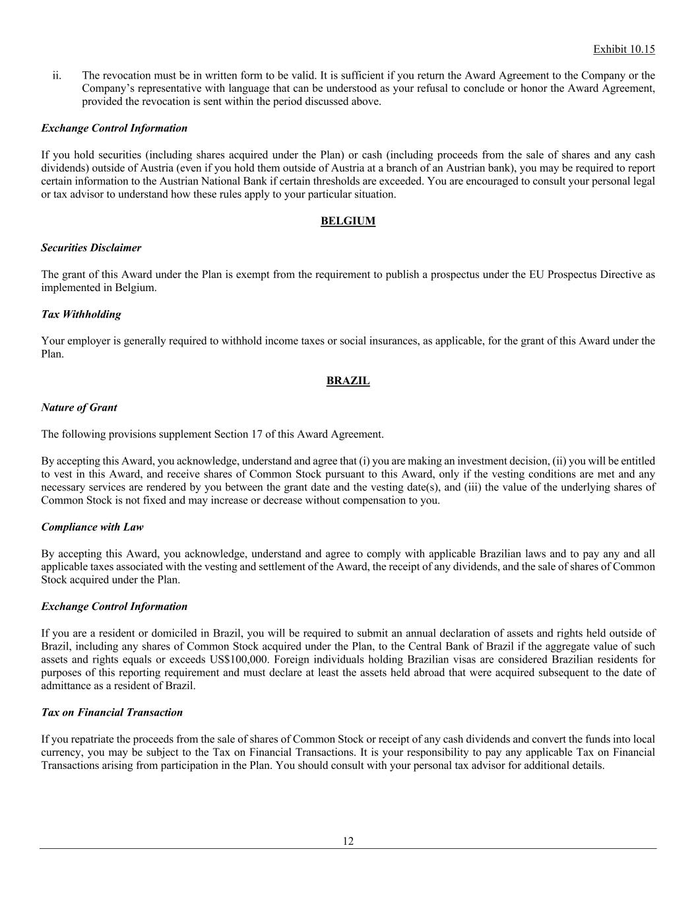
Exhibit 10.15 12 ii. The revocation must be in written form to be valid. It is sufficient if you return the Award Agreement to the Company or the Company’s representative with language that can be understood as your refusal to conclude or honor the Award Agreement, provided the revocation is sent within the period discussed above. Exchange Control Information If you hold securities (including shares acquired under the Plan) or cash (including proceeds from the sale of shares and any cash dividends) outside of Austria (even if you hold them outside of Austria at a branch of an Austrian bank), you may be required to report certain information to the Austrian National Bank if certain thresholds are exceeded. You are encouraged to consult your personal legal or tax advisor to understand how these rules apply to your particular situation. BELGIUM Securities Disclaimer The grant of this Award under the Plan is exempt from the requirement to publish a prospectus under the EU Prospectus Directive as implemented in Belgium. Tax Withholding Your employer is generally required to withhold income taxes or social insurances, as applicable, for the grant of this Award under the Plan. BRAZIL Nature of Grant The following provisions supplement Section 17 of this Award Agreement. By accepting this Award, you acknowledge, understand and agree that (i) you are making an investment decision, (ii) you will be entitled to vest in this Award, and receive shares of Common Stock pursuant to this Award, only if the vesting conditions are met and any necessary services are rendered by you between the grant date and the vesting date(s), and (iii) the value of the underlying shares of Common Stock is not fixed and may increase or decrease without compensation to you. Compliance with Law By accepting this Award, you acknowledge, understand and agree to comply with applicable Brazilian laws and to pay any and all applicable taxes associated with the vesting and settlement of the Award, the receipt of any dividends, and the sale of shares of Common Stock acquired under the Plan. Exchange Control Information If you are a resident or domiciled in Brazil, you will be required to submit an annual declaration of assets and rights held outside of Brazil, including any shares of Common Stock acquired under the Plan, to the Central Bank of Brazil if the aggregate value of such assets and rights equals or exceeds US$100,000. Foreign individuals holding Brazilian visas are considered Brazilian residents for purposes of this reporting requirement and must declare at least the assets held abroad that were acquired subsequent to the date of admittance as a resident of Brazil. Tax on Financial Transaction If you repatriate the proceeds from the sale of shares of Common Stock or receipt of any cash dividends and convert the funds into local currency, you may be subject to the Tax on Financial Transactions. It is your responsibility to pay any applicable Tax on Financial Transactions arising from participation in the Plan. You should consult with your personal tax advisor for additional details.

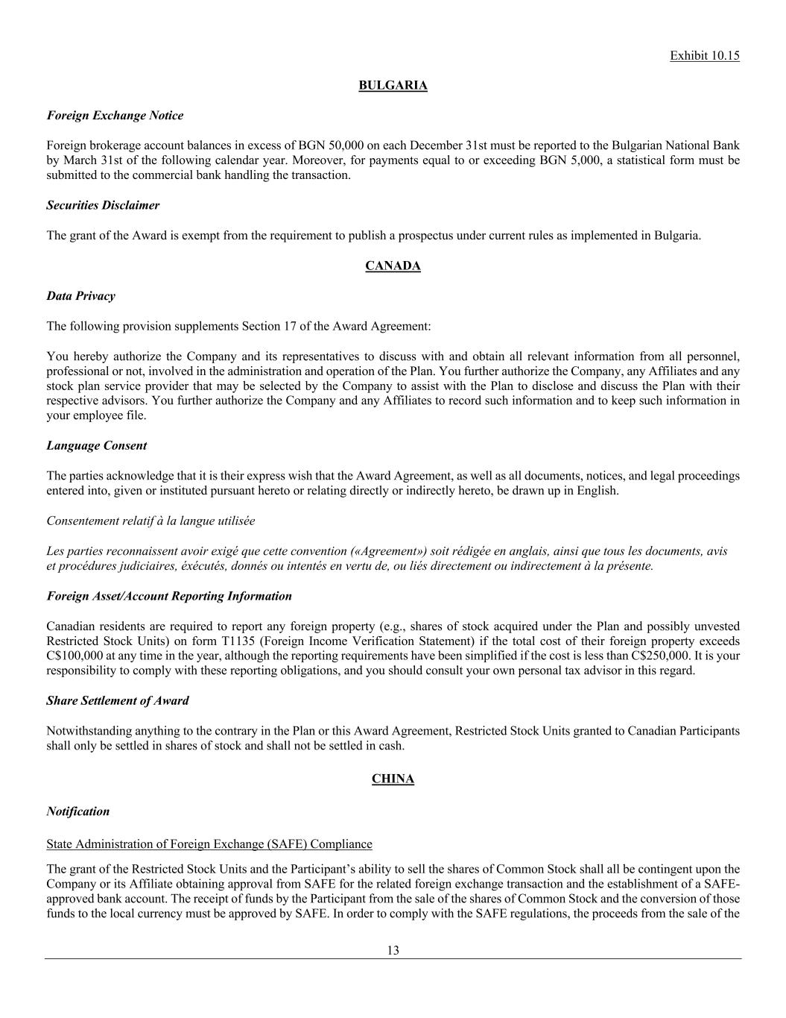
Exhibit 10.15 13 BULGARIA Foreign Exchange Notice Foreign brokerage account balances in excess of BGN 50,000 on each December 31st must be reported to the Bulgarian National Bank by March 31st of the following calendar year. Moreover, for payments equal to or exceeding BGN 5,000, a statistical form must be submitted to the commercial bank handling the transaction. Securities Disclaimer The grant of the Award is exempt from the requirement to publish a prospectus under current rules as implemented in Bulgaria. CANADA Data Privacy The following provision supplements Section 17 of the Award Agreement: You hereby authorize the Company and its representatives to discuss with and obtain all relevant information from all personnel, professional or not, involved in the administration and operation of the Plan. You further authorize the Company, any Affiliates and any stock plan service provider that may be selected by the Company to assist with the Plan to disclose and discuss the Plan with their respective advisors. You further authorize the Company and any Affiliates to record such information and to keep such information in your employee file. Language Consent The parties acknowledge that it is their express wish that the Award Agreement, as well as all documents, notices, and legal proceedings entered into, given or instituted pursuant hereto or relating directly or indirectly hereto, be drawn up in English. Consentement relatif à la langue utilisée Les parties reconnaissent avoir exigé que cette convention («Agreement») soit rédigée en anglais, ainsi que tous les documents, avis et procédures judiciaires, éxécutés, donnés ou intentés en vertu de, ou liés directement ou indirectement à la présente. Foreign Asset/Account Reporting Information Canadian residents are required to report any foreign property (e.g., shares of stock acquired under the Plan and possibly unvested Restricted Stock Units) on form T1135 (Foreign Income Verification Statement) if the total cost of their foreign property exceeds C$100,000 at any time in the year, although the reporting requirements have been simplified if the cost is less than C$250,000. It is your responsibility to comply with these reporting obligations, and you should consult your own personal tax advisor in this regard. Share Settlement of Award Notwithstanding anything to the contrary in the Plan or this Award Agreement, Restricted Stock Units granted to Canadian Participants shall only be settled in shares of stock and shall not be settled in cash. CHINA Notification State Administration of Foreign Exchange (SAFE) Compliance The grant of the Restricted Stock Units and the Participant’s ability to sell the shares of Common Stock shall all be contingent upon the Company or its Affiliate obtaining approval from SAFE for the related foreign exchange transaction and the establishment of a SAFE- approved bank account. The receipt of funds by the Participant from the sale of the shares of Common Stock and the conversion of those funds to the local currency must be approved by SAFE. In order to comply with the SAFE regulations, the proceeds from the sale of the

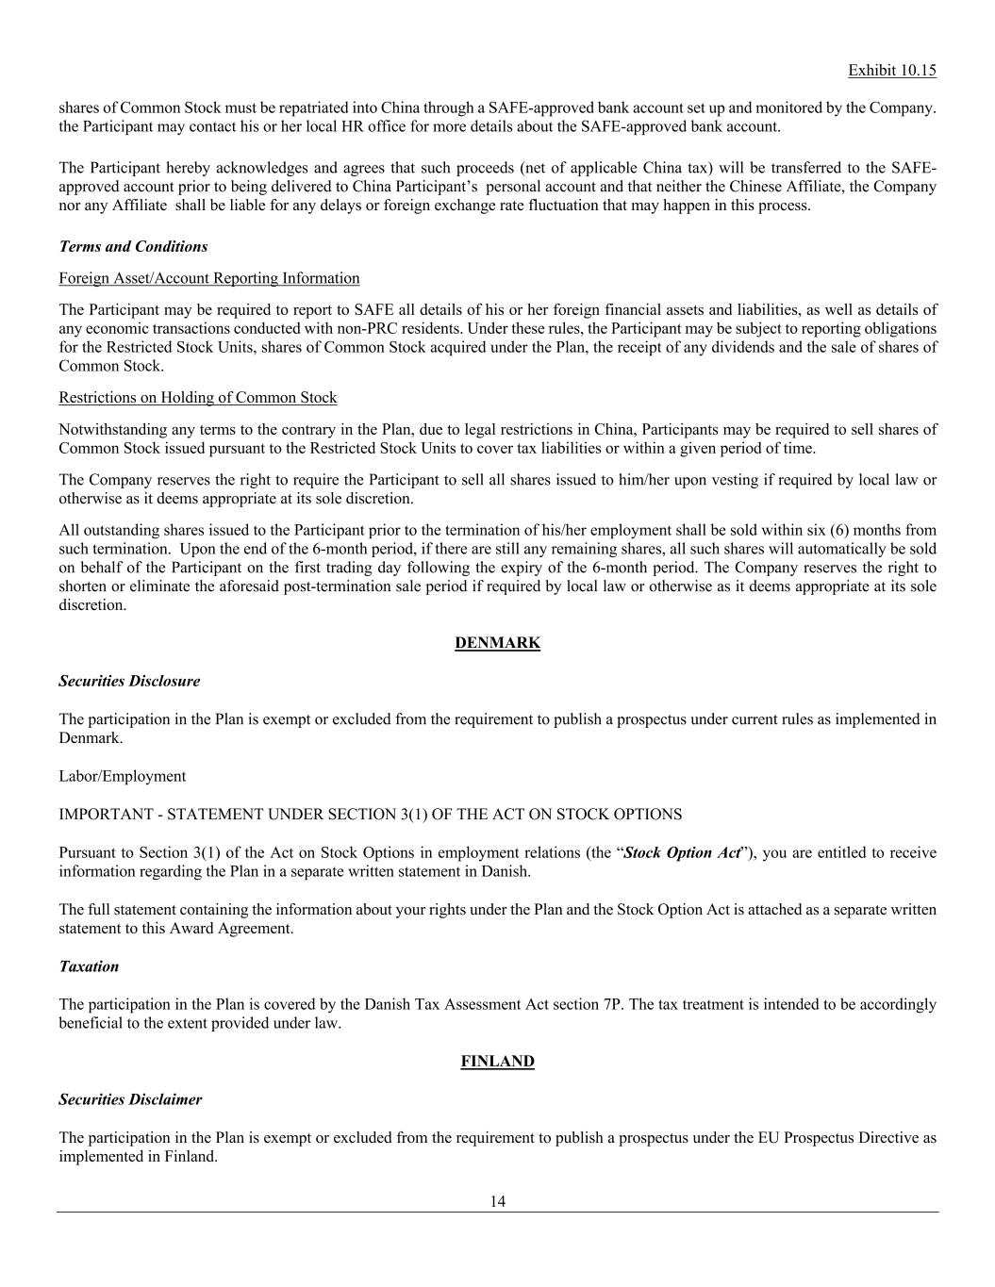
Exhibit 10.15 14 shares of Common Stock must be repatriated into China through a SAFE-approved bank account set up and monitored by the Company. the Participant may contact his or her local HR office for more details about the SAFE-approved bank account. The Participant hereby acknowledges and agrees that such proceeds (net of applicable China tax) will be transferred to the SAFE- approved account prior to being delivered to China Participant’s personal account and that neither the Chinese Affiliate, the Company nor any Affiliate shall be liable for any delays or foreign exchange rate fluctuation that may happen in this process. Terms and Conditions Foreign Asset/Account Reporting Information The Participant may be required to report to SAFE all details of his or her foreign financial assets and liabilities, as well as details of any economic transactions conducted with non-PRC residents. Under these rules, the Participant may be subject to reporting obligations for the Restricted Stock Units, shares of Common Stock acquired under the Plan, the receipt of any dividends and the sale of shares of Common Stock. Restrictions on Holding of Common Stock Notwithstanding any terms to the contrary in the Plan, due to legal restrictions in China, Participants may be required to sell shares of Common Stock issued pursuant to the Restricted Stock Units to cover tax liabilities or within a given period of time. The Company reserves the right to require the Participant to sell all shares issued to him/her upon vesting if required by local law or otherwise as it deems appropriate at its sole discretion. All outstanding shares issued to the Participant prior to the termination of his/her employment shall be sold within six (6) months from such termination. Upon the end of the 6-month period, if there are still any remaining shares, all such shares will automatically be sold on behalf of the Participant on the first trading day following the expiry of the 6-month period. The Company reserves the right to shorten or eliminate the aforesaid post-termination sale period if required by local law or otherwise as it deems appropriate at its sole discretion. DENMARK Securities Disclosure The participation in the Plan is exempt or excluded from the requirement to publish a prospectus under current rules as implemented in Denmark. Labor/Employment IMPORTANT - STATEMENT UNDER SECTION 3(1) OF THE ACT ON STOCK OPTIONS Pursuant to Section 3(1) of the Act on Stock Options in employment relations (the “Stock Option Act”), you are entitled to receive information regarding the Plan in a separate written statement in Danish. The full statement containing the information about your rights under the Plan and the Stock Option Act is attached as a separate written statement to this Award Agreement. Taxation The participation in the Plan is covered by the Danish Tax Assessment Act section 7P. The tax treatment is intended to be accordingly beneficial to the extent provided under law. FINLAND Securities Disclaimer The participation in the Plan is exempt or excluded from the requirement to publish a prospectus under the EU Prospectus Directive as implemented in Finland.

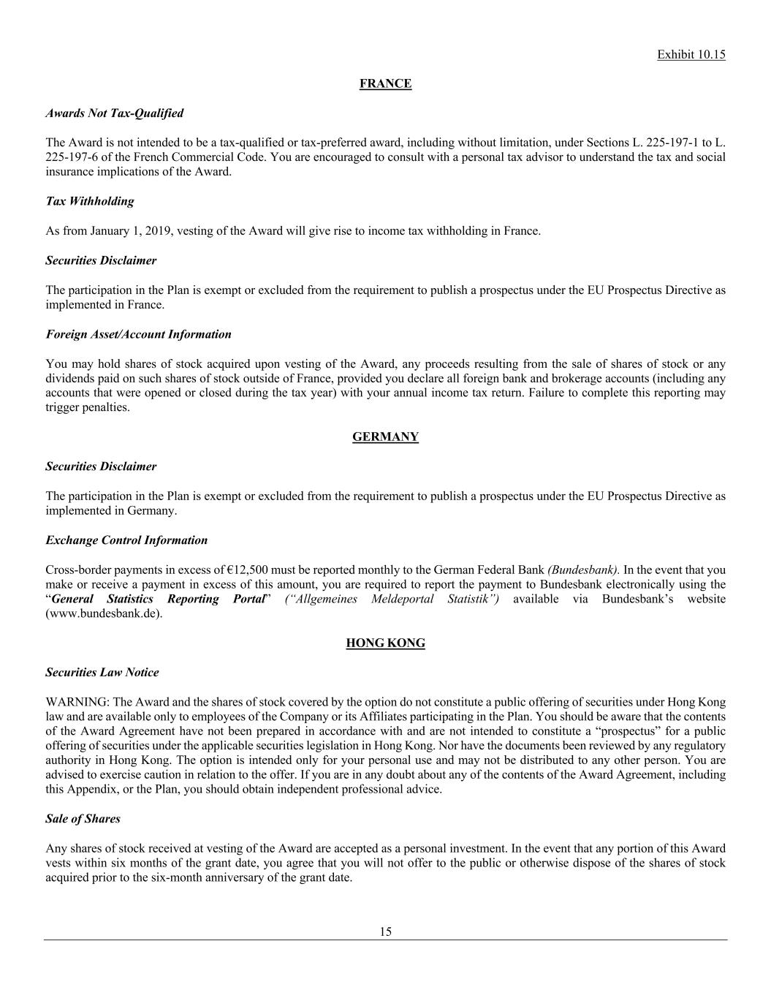
Exhibit 10.15 15 FRANCE Awards Not Tax-Qualified The Award is not intended to be a tax-qualified or tax-preferred award, including without limitation, under Sections L. 225-197-1 to L. 225-197-6 of the French Commercial Code. You are encouraged to consult with a personal tax advisor to understand the tax and social insurance implications of the Award. Tax Withholding As from January 1, 2019, vesting of the Award will give rise to income tax withholding in France. Securities Disclaimer The participation in the Plan is exempt or excluded from the requirement to publish a prospectus under the EU Prospectus Directive as implemented in France. Foreign Asset/Account Information You may hold shares of stock acquired upon vesting of the Award, any proceeds resulting from the sale of shares of stock or any dividends paid on such shares of stock outside of France, provided you declare all foreign bank and brokerage accounts (including any accounts that were opened or closed during the tax year) with your annual income tax return. Failure to complete this reporting may trigger penalties. GERMANY Securities Disclaimer The participation in the Plan is exempt or excluded from the requirement to publish a prospectus under the EU Prospectus Directive as implemented in Germany. Exchange Control Information Cross-border payments in excess of €12,500 must be reported monthly to the German Federal Bank (Bundesbank). In the event that you make or receive a payment in excess of this amount, you are required to report the payment to Bundesbank electronically using the “General Statistics Reporting Portal” (“Allgemeines Meldeportal Statistik”) available via Bundesbank’s website (www.bundesbank.de). HONG KONG Securities Law Notice WARNING: The Award and the shares of stock covered by the option do not constitute a public offering of securities under Hong Kong law and are available only to employees of the Company or its Affiliates participating in the Plan. You should be aware that the contents of the Award Agreement have not been prepared in accordance with and are not intended to constitute a “prospectus” for a public offering of securities under the applicable securities legislation in Hong Kong. Nor have the documents been reviewed by any regulatory authority in Hong Kong. The option is intended only for your personal use and may not be distributed to any other person. You are advised to exercise caution in relation to the offer. If you are in any doubt about any of the contents of the Award Agreement, including this Appendix, or the Plan, you should obtain independent professional advice. Sale of Shares Any shares of stock received at vesting of the Award are accepted as a personal investment. In the event that any portion of this Award vests within six months of the grant date, you agree that you will not offer to the public or otherwise dispose of the shares of stock acquired prior to the six-month anniversary of the grant date.

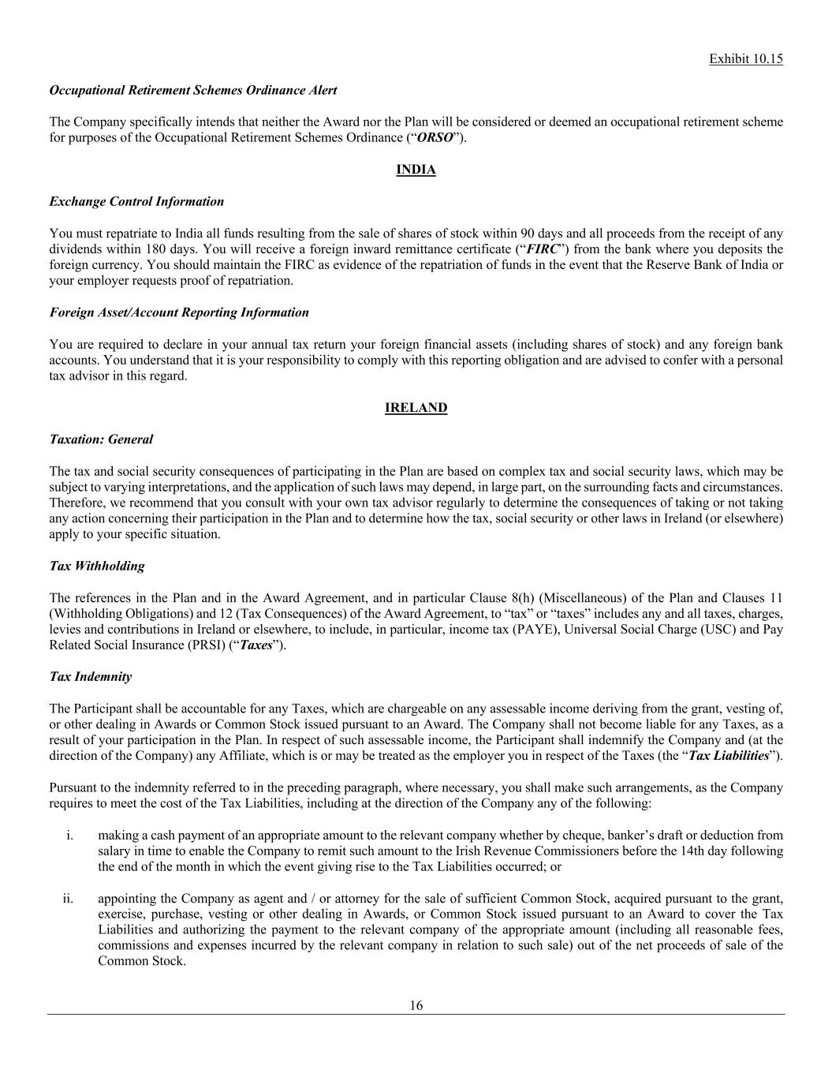
Exhibit 10.15 16 Occupational Retirement Schemes Ordinance Alert The Company specifically intends that neither the Award nor the Plan will be considered or deemed an occupational retirement scheme for purposes of the Occupational Retirement Schemes Ordinance (“ORSO”). INDIA Exchange Control Information You must repatriate to India all funds resulting from the sale of shares of stock within 90 days and all proceeds from the receipt of any dividends within 180 days. You will receive a foreign inward remittance certificate (“FIRC”) from the bank where you deposits the foreign currency. You should maintain the FIRC as evidence of the repatriation of funds in the event that the Reserve Bank of India or your employer requests proof of repatriation. Foreign Asset/Account Reporting Information You are required to declare in your annual tax return your foreign financial assets (including shares of stock) and any foreign bank accounts. You understand that it is your responsibility to comply with this reporting obligation and are advised to confer with a personal tax advisor in this regard. IRELAND Taxation: General The tax and social security consequences of participating in the Plan are based on complex tax and social security laws, which may be subject to varying interpretations, and the application of such laws may depend, in large part, on the surrounding facts and circumstances. Therefore, we recommend that you consult with your own tax advisor regularly to determine the consequences of taking or not taking any action concerning their participation in the Plan and to determine how the tax, social security or other laws in Ireland (or elsewhere) apply to your specific situation. Tax Withholding The references in the Plan and in the Award Agreement, and in particular Clause 8(h) (Miscellaneous) of the Plan and Clauses 11 (Withholding Obligations) and 12 (Tax Consequences) of the Award Agreement, to “tax” or “taxes” includes any and all taxes, charges, levies and contributions in Ireland or elsewhere, to include, in particular, income tax (PAYE), Universal Social Charge (USC) and Pay Related Social Insurance (PRSI) (“Taxes”). Tax Indemnity The Participant shall be accountable for any Taxes, which are chargeable on any assessable income deriving from the grant, vesting of, or other dealing in Awards or Common Stock issued pursuant to an Award. The Company shall not become liable for any Taxes, as a result of your participation in the Plan. In respect of such assessable income, the Participant shall indemnify the Company and (at the direction of the Company) any Affiliate, which is or may be treated as the employer you in respect of the Taxes (the “Tax Liabilities”). Pursuant to the indemnity referred to in the preceding paragraph, where necessary, you shall make such arrangements, as the Company requires to meet the cost of the Tax Liabilities, including at the direction of the Company any of the following: i. making a cash payment of an appropriate amount to the relevant company whether by cheque, banker’s draft or deduction from salary in time to enable the Company to remit such amount to the Irish Revenue Commissioners before the 14th day following the end of the month in which the event giving rise to the Tax Liabilities occurred; or ii. appointing the Company as agent and / or attorney for the sale of sufficient Common Stock, acquired pursuant to the grant, exercise, purchase, vesting or other dealing in Awards, or Common Stock issued pursuant to an Award to cover the Tax Liabilities and authorizing the payment to the relevant company of the appropriate amount (including all reasonable fees, commissions and expenses incurred by the relevant company in relation to such sale) out of the net proceeds of sale of the Common Stock.

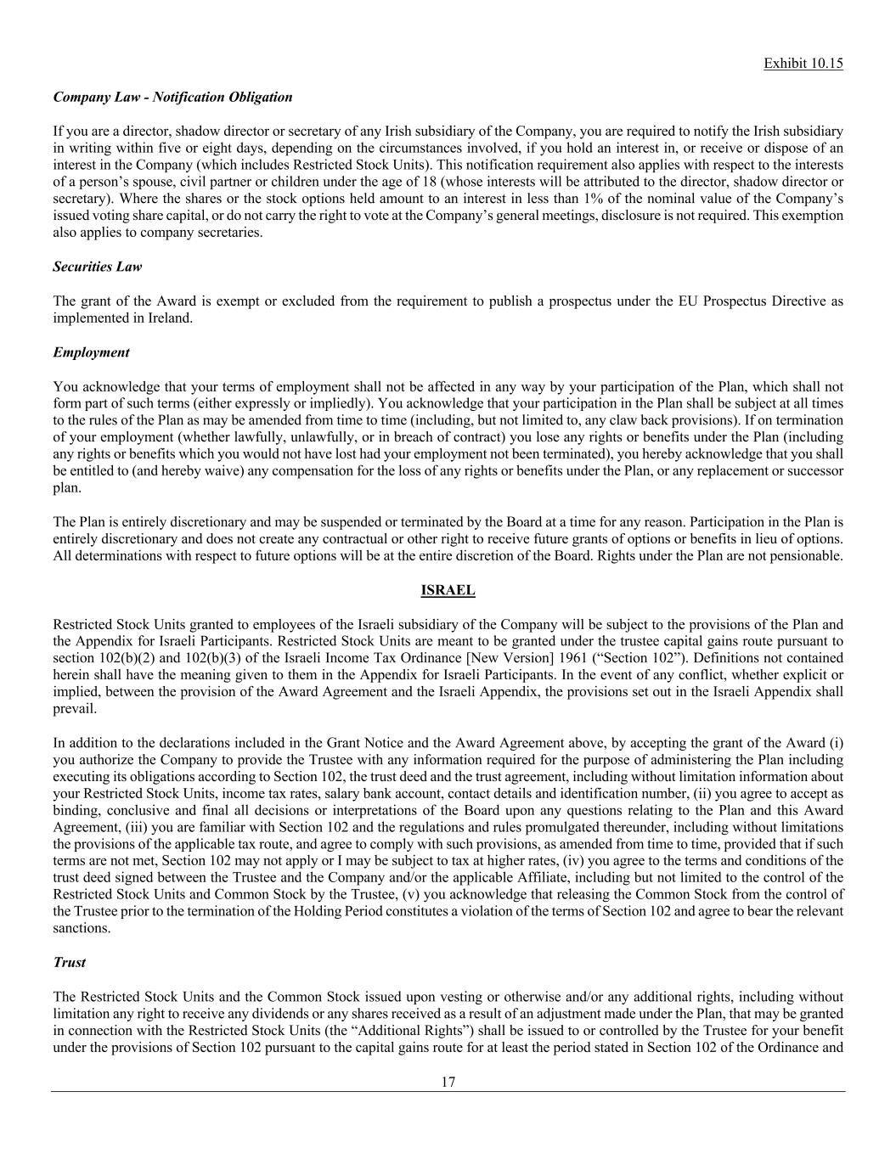
Exhibit 10.15 17 Company Law - Notification Obligation If you are a director, shadow director or secretary of any Irish subsidiary of the Company, you are required to notify the Irish subsidiary in writing within five or eight days, depending on the circumstances involved, if you hold an interest in, or receive or dispose of an interest in the Company (which includes Restricted Stock Units). This notification requirement also applies with respect to the interests of a person’s spouse, civil partner or children under the age of 18 (whose interests will be attributed to the director, shadow director or secretary). Where the shares or the stock options held amount to an interest in less than 1% of the nominal value of the Company’s issued voting share capital, or do not carry the right to vote at the Company’s general meetings, disclosure is not required. This exemption also applies to company secretaries. Securities Law The grant of the Award is exempt or excluded from the requirement to publish a prospectus under the EU Prospectus Directive as implemented in Ireland. Employment You acknowledge that your terms of employment shall not be affected in any way by your participation of the Plan, which shall not form part of such terms (either expressly or impliedly). You acknowledge that your participation in the Plan shall be subject at all times to the rules of the Plan as may be amended from time to time (including, but not limited to, any claw back provisions). If on termination of your employment (whether lawfully, unlawfully, or in breach of contract) you lose any rights or benefits under the Plan (including any rights or benefits which you would not have lost had your employment not been terminated), you hereby acknowledge that you shall be entitled to (and hereby waive) any compensation for the loss of any rights or benefits under the Plan, or any replacement or successor plan. The Plan is entirely discretionary and may be suspended or terminated by the Board at a time for any reason. Participation in the Plan is entirely discretionary and does not create any contractual or other right to receive future grants of options or benefits in lieu of options. All determinations with respect to future options will be at the entire discretion of the Board. Rights under the Plan are not pensionable. ISRAEL Restricted Stock Units granted to employees of the Israeli subsidiary of the Company will be subject to the provisions of the Plan and the Appendix for Israeli Participants. Restricted Stock Units are meant to be granted under the trustee capital gains route pursuant to section 102(b)(2) and 102(b)(3) of the Israeli Income Tax Ordinance [New Version] 1961 (“Section 102”). Definitions not contained herein shall have the meaning given to them in the Appendix for Israeli Participants. In the event of any conflict, whether explicit or implied, between the provision of the Award Agreement and the Israeli Appendix, the provisions set out in the Israeli Appendix shall prevail. In addition to the declarations included in the Grant Notice and the Award Agreement above, by accepting the grant of the Award (i) you authorize the Company to provide the Trustee with any information required for the purpose of administering the Plan including executing its obligations according to Section 102, the trust deed and the trust agreement, including without limitation information about your Restricted Stock Units, income tax rates, salary bank account, contact details and identification number, (ii) you agree to accept as binding, conclusive and final all decisions or interpretations of the Board upon any questions relating to the Plan and this Award Agreement, (iii) you are familiar with Section 102 and the regulations and rules promulgated thereunder, including without limitations the provisions of the applicable tax route, and agree to comply with such provisions, as amended from time to time, provided that if such terms are not met, Section 102 may not apply or I may be subject to tax at higher rates, (iv) you agree to the terms and conditions of the trust deed signed between the Trustee and the Company and/or the applicable Affiliate, including but not limited to the control of the Restricted Stock Units and Common Stock by the Trustee, (v) you acknowledge that releasing the Common Stock from the control of the Trustee prior to the termination of the Holding Period constitutes a violation of the terms of Section 102 and agree to bear the relevant sanctions. Trust The Restricted Stock Units and the Common Stock issued upon vesting or otherwise and/or any additional rights, including without limitation any right to receive any dividends or any shares received as a result of an adjustment made under the Plan, that may be granted in connection with the Restricted Stock Units (the “Additional Rights”) shall be issued to or controlled by the Trustee for your benefit under the provisions of Section 102 pursuant to the capital gains route for at least the period stated in Section 102 of the Ordinance and

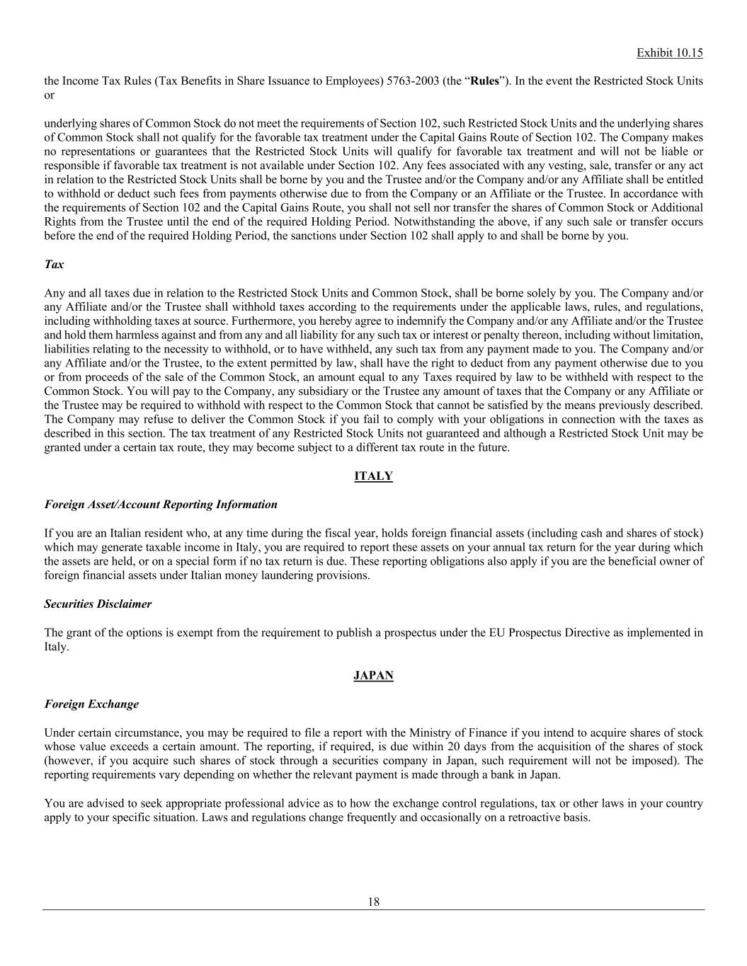
Exhibit 10.15 18 the Income Tax Rules (Tax Benefits in Share Issuance to Employees) 5763-2003 (the “Rules”). In the event the Restricted Stock Units or underlying shares of Common Stock do not meet the requirements of Section 102, such Restricted Stock Units and the underlying shares of Common Stock shall not qualify for the favorable tax treatment under the Capital Gains Route of Section 102. The Company makes no representations or guarantees that the Restricted Stock Units will qualify for favorable tax treatment and will not be liable or responsible if favorable tax treatment is not available under Section 102. Any fees associated with any vesting, sale, transfer or any act in relation to the Restricted Stock Units shall be borne by you and the Trustee and/or the Company and/or any Affiliate shall be entitled to withhold or deduct such fees from payments otherwise due to from the Company or an Affiliate or the Trustee. In accordance with the requirements of Section 102 and the Capital Gains Route, you shall not sell nor transfer the shares of Common Stock or Additional Rights from the Trustee until the end of the required Holding Period. Notwithstanding the above, if any such sale or transfer occurs before the end of the required Holding Period, the sanctions under Section 102 shall apply to and shall be borne by you. Tax Any and all taxes due in relation to the Restricted Stock Units and Common Stock, shall be borne solely by you. The Company and/or any Affiliate and/or the Trustee shall withhold taxes according to the requirements under the applicable laws, rules, and regulations, including withholding taxes at source. Furthermore, you hereby agree to indemnify the Company and/or any Affiliate and/or the Trustee and hold them harmless against and from any and all liability for any such tax or interest or penalty thereon, including without limitation, liabilities relating to the necessity to withhold, or to have withheld, any such tax from any payment made to you. The Company and/or any Affiliate and/or the Trustee, to the extent permitted by law, shall have the right to deduct from any payment otherwise due to you or from proceeds of the sale of the Common Stock, an amount equal to any Taxes required by law to be withheld with respect to the Common Stock. You will pay to the Company, any subsidiary or the Trustee any amount of taxes that the Company or any Affiliate or the Trustee may be required to withhold with respect to the Common Stock that cannot be satisfied by the means previously described. The Company may refuse to deliver the Common Stock if you fail to comply with your obligations in connection with the taxes as described in this section. The tax treatment of any Restricted Stock Units not guaranteed and although a Restricted Stock Unit may be granted under a certain tax route, they may become subject to a different tax route in the future. ITALY Foreign Asset/Account Reporting Information If you are an Italian resident who, at any time during the fiscal year, holds foreign financial assets (including cash and shares of stock) which may generate taxable income in Italy, you are required to report these assets on your annual tax return for the year during which the assets are held, or on a special form if no tax return is due. These reporting obligations also apply if you are the beneficial owner of foreign financial assets under Italian money laundering provisions. Securities Disclaimer The grant of the options is exempt from the requirement to publish a prospectus under the EU Prospectus Directive as implemented in Italy. JAPAN Foreign Exchange Under certain circumstance, you may be required to file a report with the Ministry of Finance if you intend to acquire shares of stock whose value exceeds a certain amount. The reporting, if required, is due within 20 days from the acquisition of the shares of stock (however, if you acquire such shares of stock through a securities company in Japan, such requirement will not be imposed). The reporting requirements vary depending on whether the relevant payment is made through a bank in Japan. You are advised to seek appropriate professional advice as to how the exchange control regulations, tax or other laws in your country apply to your specific situation. Laws and regulations change frequently and occasionally on a retroactive basis.

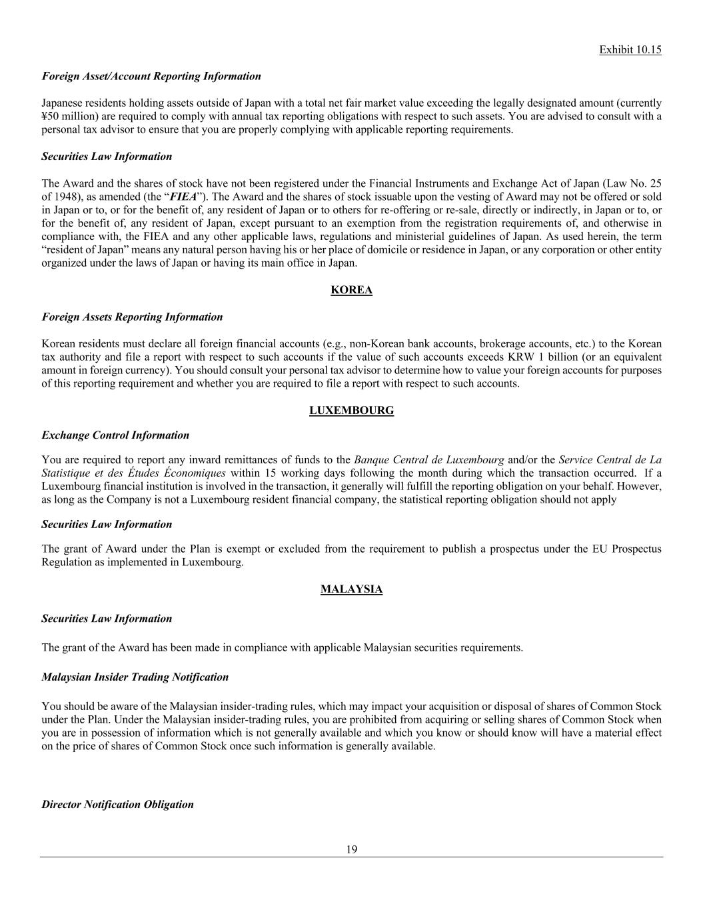
Exhibit 10.15 19 Foreign Asset/Account Reporting Information Japanese residents holding assets outside of Japan with a total net fair market value exceeding the legally designated amount (currently ¥50 million) are required to comply with annual tax reporting obligations with respect to such assets. You are advised to consult with a personal tax advisor to ensure that you are properly complying with applicable reporting requirements. Securities Law Information The Award and the shares of stock have not been registered under the Financial Instruments and Exchange Act of Japan (Law No. 25 of 1948), as amended (the “FIEA”). The Award and the shares of stock issuable upon the vesting of Award may not be offered or sold in Japan or to, or for the benefit of, any resident of Japan or to others for re-offering or re-sale, directly or indirectly, in Japan or to, or for the benefit of, any resident of Japan, except pursuant to an exemption from the registration requirements of, and otherwise in compliance with, the FIEA and any other applicable laws, regulations and ministerial guidelines of Japan. As used herein, the term “resident of Japan” means any natural person having his or her place of domicile or residence in Japan, or any corporation or other entity organized under the laws of Japan or having its main office in Japan. KOREA Foreign Assets Reporting Information Korean residents must declare all foreign financial accounts (e.g., non-Korean bank accounts, brokerage accounts, etc.) to the Korean tax authority and file a report with respect to such accounts if the value of such accounts exceeds KRW 1 billion (or an equivalent amount in foreign currency). You should consult your personal tax advisor to determine how to value your foreign accounts for purposes of this reporting requirement and whether you are required to file a report with respect to such accounts. LUXEMBOURG Exchange Control Information You are required to report any inward remittances of funds to the Banque Central de Luxembourg and/or the Service Central de La Statistique et des Études Économiques within 15 working days following the month during which the transaction occurred. If a Luxembourg financial institution is involved in the transaction, it generally will fulfill the reporting obligation on your behalf. However, as long as the Company is not a Luxembourg resident financial company, the statistical reporting obligation should not apply Securities Law Information The grant of Award under the Plan is exempt or excluded from the requirement to publish a prospectus under the EU Prospectus Regulation as implemented in Luxembourg. MALAYSIA Securities Law Information The grant of the Award has been made in compliance with applicable Malaysian securities requirements. Malaysian Insider Trading Notification You should be aware of the Malaysian insider-trading rules, which may impact your acquisition or disposal of shares of Common Stock under the Plan. Under the Malaysian insider-trading rules, you are prohibited from acquiring or selling shares of Common Stock when you are in possession of information which is not generally available and which you know or should know will have a material effect on the price of shares of Common Stock once such information is generally available. Director Notification Obligation

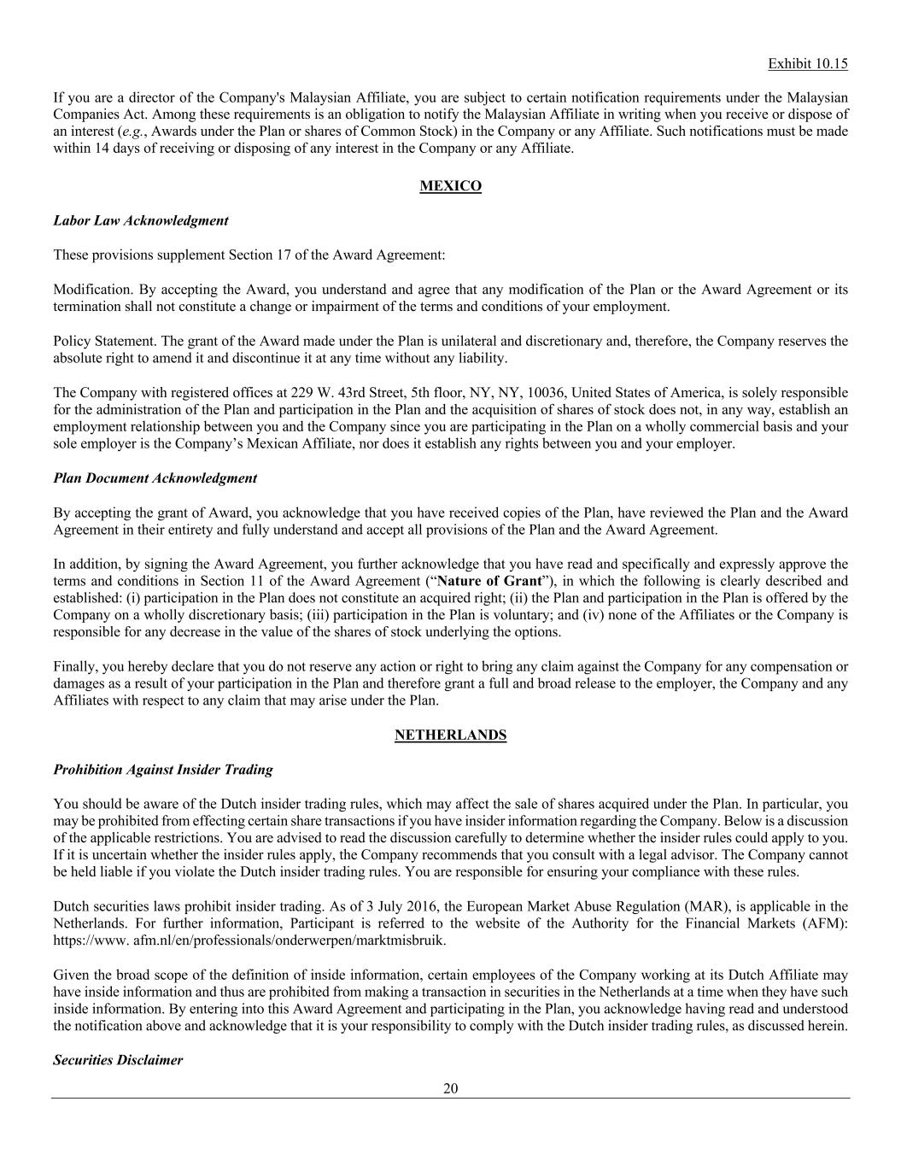
Exhibit 10.15 20 If you are a director of the Company's Malaysian Affiliate, you are subject to certain notification requirements under the Malaysian Companies Act. Among these requirements is an obligation to notify the Malaysian Affiliate in writing when you receive or dispose of an interest (e.g., Awards under the Plan or shares of Common Stock) in the Company or any Affiliate. Such notifications must be made within 14 days of receiving or disposing of any interest in the Company or any Affiliate. MEXICO Labor Law Acknowledgment These provisions supplement Section 17 of the Award Agreement: Modification. By accepting the Award, you understand and agree that any modification of the Plan or the Award Agreement or its termination shall not constitute a change or impairment of the terms and conditions of your employment. Policy Statement. The grant of the Award made under the Plan is unilateral and discretionary and, therefore, the Company reserves the absolute right to amend it and discontinue it at any time without any liability. The Company with registered offices at 229 W. 43rd Street, 5th floor, NY, NY, 10036, United States of America, is solely responsible for the administration of the Plan and participation in the Plan and the acquisition of shares of stock does not, in any way, establish an employment relationship between you and the Company since you are participating in the Plan on a wholly commercial basis and your sole employer is the Company’s Mexican Affiliate, nor does it establish any rights between you and your employer. Plan Document Acknowledgment By accepting the grant of Award, you acknowledge that you have received copies of the Plan, have reviewed the Plan and the Award Agreement in their entirety and fully understand and accept all provisions of the Plan and the Award Agreement. In addition, by signing the Award Agreement, you further acknowledge that you have read and specifically and expressly approve the terms and conditions in Section 11 of the Award Agreement (“Nature of Grant”), in which the following is clearly described and established: (i) participation in the Plan does not constitute an acquired right; (ii) the Plan and participation in the Plan is offered by the Company on a wholly discretionary basis; (iii) participation in the Plan is voluntary; and (iv) none of the Affiliates or the Company is responsible for any decrease in the value of the shares of stock underlying the options. Finally, you hereby declare that you do not reserve any action or right to bring any claim against the Company for any compensation or damages as a result of your participation in the Plan and therefore grant a full and broad release to the employer, the Company and any Affiliates with respect to any claim that may arise under the Plan. NETHERLANDS Prohibition Against Insider Trading You should be aware of the Dutch insider trading rules, which may affect the sale of shares acquired under the Plan. In particular, you may be prohibited from effecting certain share transactions if you have insider information regarding the Company. Below is a discussion of the applicable restrictions. You are advised to read the discussion carefully to determine whether the insider rules could apply to you. If it is uncertain whether the insider rules apply, the Company recommends that you consult with a legal advisor. The Company cannot be held liable if you violate the Dutch insider trading rules. You are responsible for ensuring your compliance with these rules. Dutch securities laws prohibit insider trading. As of 3 July 2016, the European Market Abuse Regulation (MAR), is applicable in the Netherlands. For further information, Participant is referred to the website of the Authority for the Financial Markets (AFM): https://www. afm.nl/en/professionals/onderwerpen/marktmisbruik. Given the broad scope of the definition of inside information, certain employees of the Company working at its Dutch Affiliate may have inside information and thus are prohibited from making a transaction in securities in the Netherlands at a time when they have such inside information. By entering into this Award Agreement and participating in the Plan, you acknowledge having read and understood the notification above and acknowledge that it is your responsibility to comply with the Dutch insider trading rules, as discussed herein. Securities Disclaimer

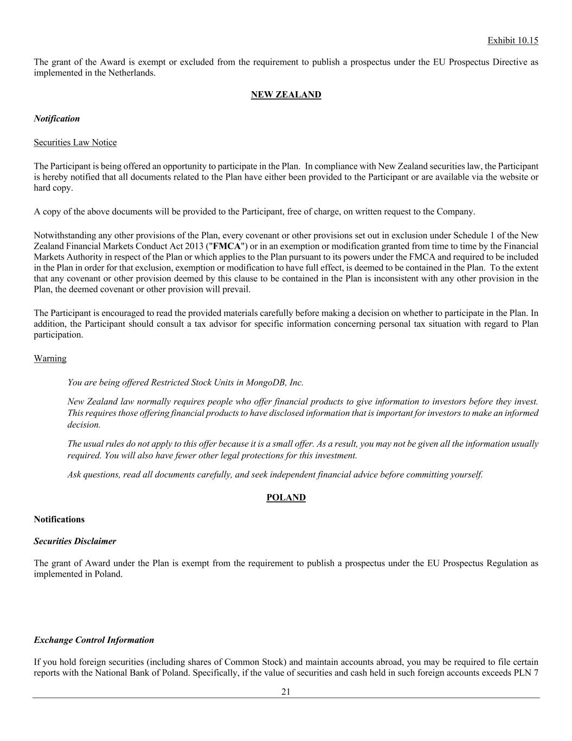
Exhibit 10.15 21 The grant of the Award is exempt or excluded from the requirement to publish a prospectus under the EU Prospectus Directive as implemented in the Netherlands. NEW ZEALAND Notification Securities Law Notice The Participant is being offered an opportunity to participate in the Plan. In compliance with New Zealand securities law, the Participant is hereby notified that all documents related to the Plan have either been provided to the Participant or are available via the website or hard copy. A copy of the above documents will be provided to the Participant, free of charge, on written request to the Company. Notwithstanding any other provisions of the Plan, every covenant or other provisions set out in exclusion under Schedule 1 of the New Zealand Financial Markets Conduct Act 2013 ("FMCA") or in an exemption or modification granted from time to time by the Financial Markets Authority in respect of the Plan or which applies to the Plan pursuant to its powers under the FMCA and required to be included in the Plan in order for that exclusion, exemption or modification to have full effect, is deemed to be contained in the Plan. To the extent that any covenant or other provision deemed by this clause to be contained in the Plan is inconsistent with any other provision in the Plan, the deemed covenant or other provision will prevail. The Participant is encouraged to read the provided materials carefully before making a decision on whether to participate in the Plan. In addition, the Participant should consult a tax advisor for specific information concerning personal tax situation with regard to Plan participation. Warning You are being offered Restricted Stock Units in MongoDB, Inc. New Zealand law normally requires people who offer financial products to give information to investors before they invest. This requires those offering financial products to have disclosed information that is important for investors to make an informed decision. The usual rules do not apply to this offer because it is a small offer. As a result, you may not be given all the information usually required. You will also have fewer other legal protections for this investment. Ask questions, read all documents carefully, and seek independent financial advice before committing yourself. POLAND Notifications Securities Disclaimer The grant of Award under the Plan is exempt from the requirement to publish a prospectus under the EU Prospectus Regulation as implemented in Poland. Exchange Control Information If you hold foreign securities (including shares of Common Stock) and maintain accounts abroad, you may be required to file certain reports with the National Bank of Poland. Specifically, if the value of securities and cash held in such foreign accounts exceeds PLN 7

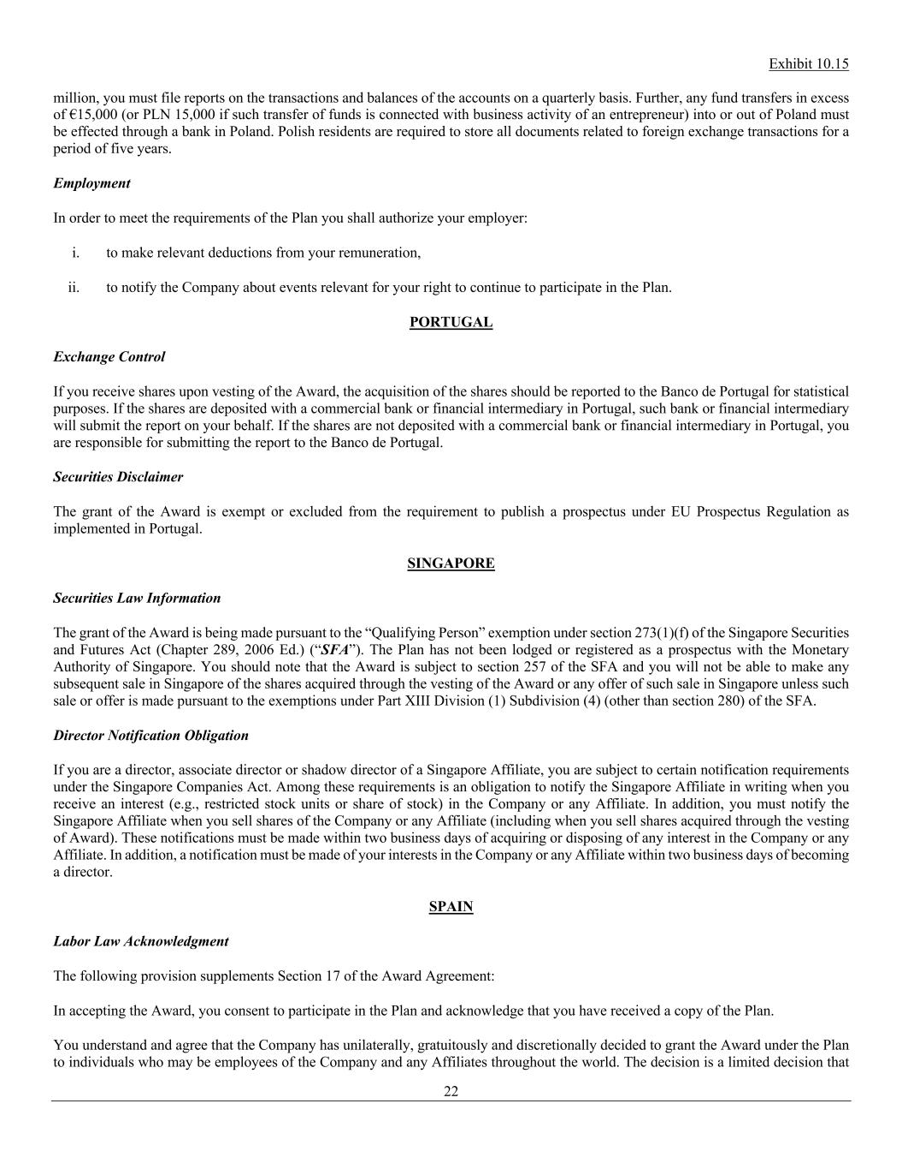
Exhibit 10.15 22 million, you must file reports on the transactions and balances of the accounts on a quarterly basis. Further, any fund transfers in excess of €15,000 (or PLN 15,000 if such transfer of funds is connected with business activity of an entrepreneur) into or out of Poland must be effected through a bank in Poland. Polish residents are required to store all documents related to foreign exchange transactions for a period of five years. Employment In order to meet the requirements of the Plan you shall authorize your employer: i. to make relevant deductions from your remuneration, ii. to notify the Company about events relevant for your right to continue to participate in the Plan. PORTUGAL Exchange Control If you receive shares upon vesting of the Award, the acquisition of the shares should be reported to the Banco de Portugal for statistical purposes. If the shares are deposited with a commercial bank or financial intermediary in Portugal, such bank or financial intermediary will submit the report on your behalf. If the shares are not deposited with a commercial bank or financial intermediary in Portugal, you are responsible for submitting the report to the Banco de Portugal. Securities Disclaimer The grant of the Award is exempt or excluded from the requirement to publish a prospectus under EU Prospectus Regulation as implemented in Portugal. SINGAPORE Securities Law Information The grant of the Award is being made pursuant to the “Qualifying Person” exemption under section 273(1)(f) of the Singapore Securities and Futures Act (Chapter 289, 2006 Ed.) (“SFA”). The Plan has not been lodged or registered as a prospectus with the Monetary Authority of Singapore. You should note that the Award is subject to section 257 of the SFA and you will not be able to make any subsequent sale in Singapore of the shares acquired through the vesting of the Award or any offer of such sale in Singapore unless such sale or offer is made pursuant to the exemptions under Part XIII Division (1) Subdivision (4) (other than section 280) of the SFA. Director Notification Obligation If you are a director, associate director or shadow director of a Singapore Affiliate, you are subject to certain notification requirements under the Singapore Companies Act. Among these requirements is an obligation to notify the Singapore Affiliate in writing when you receive an interest (e.g., restricted stock units or share of stock) in the Company or any Affiliate. In addition, you must notify the Singapore Affiliate when you sell shares of the Company or any Affiliate (including when you sell shares acquired through the vesting of Award). These notifications must be made within two business days of acquiring or disposing of any interest in the Company or any Affiliate. In addition, a notification must be made of your interests in the Company or any Affiliate within two business days of becoming a director. SPAIN Labor Law Acknowledgment The following provision supplements Section 17 of the Award Agreement: In accepting the Award, you consent to participate in the Plan and acknowledge that you have received a copy of the Plan. You understand and agree that the Company has unilaterally, gratuitously and discretionally decided to grant the Award under the Plan to individuals who may be employees of the Company and any Affiliates throughout the world. The decision is a limited decision that

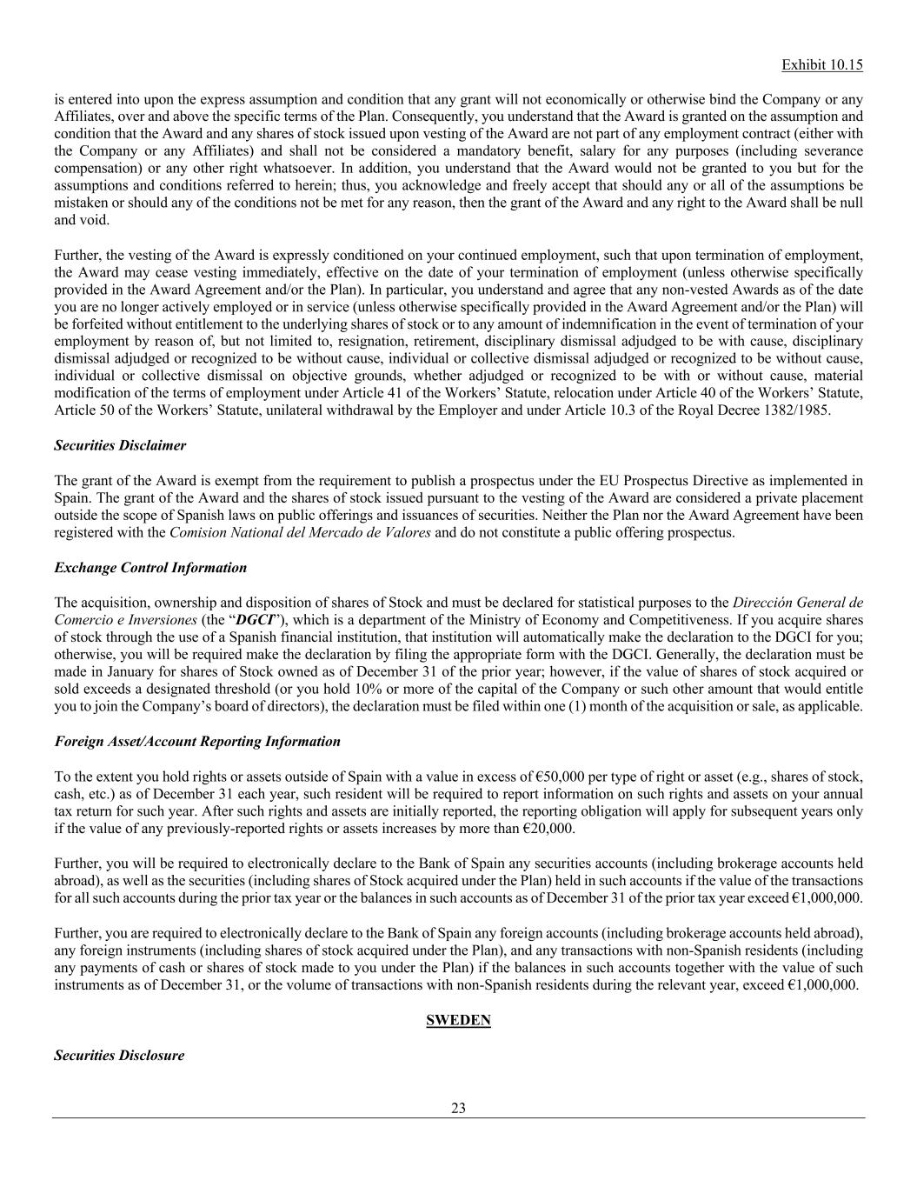
Exhibit 10.15 23 is entered into upon the express assumption and condition that any grant will not economically or otherwise bind the Company or any Affiliates, over and above the specific terms of the Plan. Consequently, you understand that the Award is granted on the assumption and condition that the Award and any shares of stock issued upon vesting of the Award are not part of any employment contract (either with the Company or any Affiliates) and shall not be considered a mandatory benefit, salary for any purposes (including severance compensation) or any other right whatsoever. In addition, you understand that the Award would not be granted to you but for the assumptions and conditions referred to herein; thus, you acknowledge and freely accept that should any or all of the assumptions be mistaken or should any of the conditions not be met for any reason, then the grant of the Award and any right to the Award shall be null and void. Further, the vesting of the Award is expressly conditioned on your continued employment, such that upon termination of employment, the Award may cease vesting immediately, effective on the date of your termination of employment (unless otherwise specifically provided in the Award Agreement and/or the Plan). In particular, you understand and agree that any non-vested Awards as of the date you are no longer actively employed or in service (unless otherwise specifically provided in the Award Agreement and/or the Plan) will be forfeited without entitlement to the underlying shares of stock or to any amount of indemnification in the event of termination of your employment by reason of, but not limited to, resignation, retirement, disciplinary dismissal adjudged to be with cause, disciplinary dismissal adjudged or recognized to be without cause, individual or collective dismissal adjudged or recognized to be without cause, individual or collective dismissal on objective grounds, whether adjudged or recognized to be with or without cause, material modification of the terms of employment under Article 41 of the Workers’ Statute, relocation under Article 40 of the Workers’ Statute, Article 50 of the Workers’ Statute, unilateral withdrawal by the Employer and under Article 10.3 of the Royal Decree 1382/1985. Securities Disclaimer The grant of the Award is exempt from the requirement to publish a prospectus under the EU Prospectus Directive as implemented in Spain. The grant of the Award and the shares of stock issued pursuant to the vesting of the Award are considered a private placement outside the scope of Spanish laws on public offerings and issuances of securities. Neither the Plan nor the Award Agreement have been registered with the Comision National del Mercado de Valores and do not constitute a public offering prospectus. Exchange Control Information The acquisition, ownership and disposition of shares of Stock and must be declared for statistical purposes to the Direcciόn General de Comercio e Inversiones (the “DGCI”), which is a department of the Ministry of Economy and Competitiveness. If you acquire shares of stock through the use of a Spanish financial institution, that institution will automatically make the declaration to the DGCI for you; otherwise, you will be required make the declaration by filing the appropriate form with the DGCI. Generally, the declaration must be made in January for shares of Stock owned as of December 31 of the prior year; however, if the value of shares of stock acquired or sold exceeds a designated threshold (or you hold 10% or more of the capital of the Company or such other amount that would entitle you to join the Company’s board of directors), the declaration must be filed within one (1) month of the acquisition or sale, as applicable. Foreign Asset/Account Reporting Information To the extent you hold rights or assets outside of Spain with a value in excess of €50,000 per type of right or asset (e.g., shares of stock, cash, etc.) as of December 31 each year, such resident will be required to report information on such rights and assets on your annual tax return for such year. After such rights and assets are initially reported, the reporting obligation will apply for subsequent years only if the value of any previously-reported rights or assets increases by more than €20,000. Further, you will be required to electronically declare to the Bank of Spain any securities accounts (including brokerage accounts held abroad), as well as the securities (including shares of Stock acquired under the Plan) held in such accounts if the value of the transactions for all such accounts during the prior tax year or the balances in such accounts as of December 31 of the prior tax year exceed €1,000,000. Further, you are required to electronically declare to the Bank of Spain any foreign accounts (including brokerage accounts held abroad), any foreign instruments (including shares of stock acquired under the Plan), and any transactions with non-Spanish residents (including any payments of cash or shares of stock made to you under the Plan) if the balances in such accounts together with the value of such instruments as of December 31, or the volume of transactions with non-Spanish residents during the relevant year, exceed €1,000,000. SWEDEN Securities Disclosure

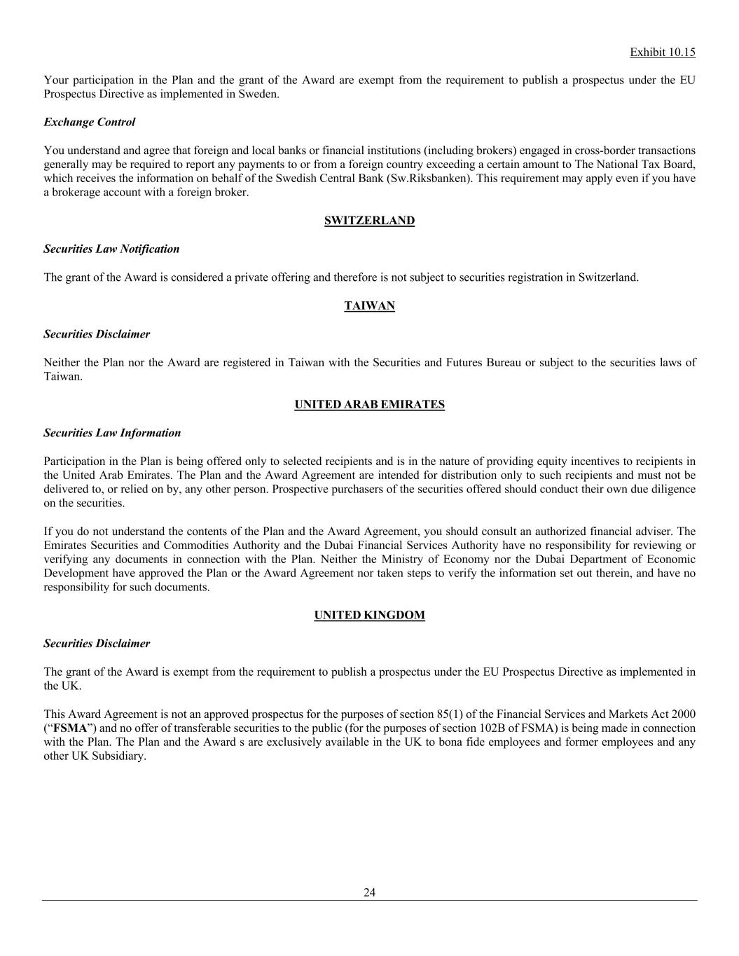
Exhibit 10.15 24 Your participation in the Plan and the grant of the Award are exempt from the requirement to publish a prospectus under the EU Prospectus Directive as implemented in Sweden. Exchange Control You understand and agree that foreign and local banks or financial institutions (including brokers) engaged in cross-border transactions generally may be required to report any payments to or from a foreign country exceeding a certain amount to The National Tax Board, which receives the information on behalf of the Swedish Central Bank (Sw.Riksbanken). This requirement may apply even if you have a brokerage account with a foreign broker. SWITZERLAND Securities Law Notification The grant of the Award is considered a private offering and therefore is not subject to securities registration in Switzerland. TAIWAN Securities Disclaimer Neither the Plan nor the Award are registered in Taiwan with the Securities and Futures Bureau or subject to the securities laws of Taiwan. UNITED ARAB EMIRATES Securities Law Information Participation in the Plan is being offered only to selected recipients and is in the nature of providing equity incentives to recipients in the United Arab Emirates. The Plan and the Award Agreement are intended for distribution only to such recipients and must not be delivered to, or relied on by, any other person. Prospective purchasers of the securities offered should conduct their own due diligence on the securities. If you do not understand the contents of the Plan and the Award Agreement, you should consult an authorized financial adviser. The Emirates Securities and Commodities Authority and the Dubai Financial Services Authority have no responsibility for reviewing or verifying any documents in connection with the Plan. Neither the Ministry of Economy nor the Dubai Department of Economic Development have approved the Plan or the Award Agreement nor taken steps to verify the information set out therein, and have no responsibility for such documents. UNITED KINGDOM Securities Disclaimer The grant of the Award is exempt from the requirement to publish a prospectus under the EU Prospectus Directive as implemented in the UK. This Award Agreement is not an approved prospectus for the purposes of section 85(1) of the Financial Services and Markets Act 2000 (“FSMA”) and no offer of transferable securities to the public (for the purposes of section 102B of FSMA) is being made in connection with the Plan. The Plan and the Award s are exclusively available in the UK to bona fide employees and former employees and any other UK Subsidiary.

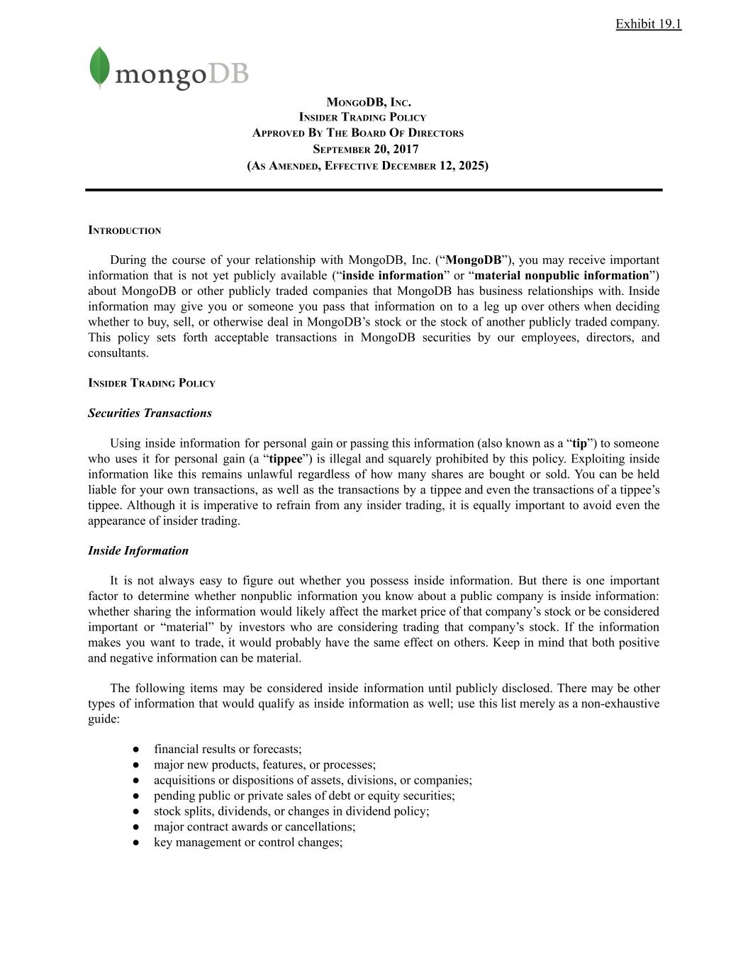
Exhibit 19.1 MONGODB, INC. INSIDER TRADING POLICY APPROVED BY THE BOARD OF DIRECTORS SEPTEMBER 20, 2017 (AS AMENDED, EFFECTIVE DECEMBER 12, 2025) INTRODUCTION During the course of your relationship with MongoDB, Inc. (“MongoDB”), you may receive important information that is not yet publicly available (“inside information” or “material nonpublic information”) about MongoDB or other publicly traded companies that MongoDB has business relationships with. Inside information may give you or someone you pass that information on to a leg up over others when deciding whether to buy, sell, or otherwise deal in MongoDB’s stock or the stock of another publicly traded company. This policy sets forth acceptable transactions in MongoDB securities by our employees, directors, and consultants. INSIDER TRADING POLICY Securities Transactions Using inside information for personal gain or passing this information (also known as a “tip”) to someone who uses it for personal gain (a “tippee”) is illegal and squarely prohibited by this policy. Exploiting inside information like this remains unlawful regardless of how many shares are bought or sold. You can be held liable for your own transactions, as well as the transactions by a tippee and even the transactions of a tippee’s tippee. Although it is imperative to refrain from any insider trading, it is equally important to avoid even the appearance of insider trading. Inside Information It is not always easy to figure out whether you possess inside information. But there is one important factor to determine whether nonpublic information you know about a public company is inside information: whether sharing the information would likely affect the market price of that company’s stock or be considered important or “material” by investors who are considering trading that company’s stock. If the information makes you want to trade, it would probably have the same effect on others. Keep in mind that both positive and negative information can be material. The following items may be considered inside information until publicly disclosed. There may be other types of information that would qualify as inside information as well; use this list merely as a non-exhaustive guide: ●​ financial results or forecasts; ●​ major new products, features, or processes; ●​ acquisitions or dispositions of assets, divisions, or companies; ●​ pending public or private sales of debt or equity securities; ●​ stock splits, dividends, or changes in dividend policy; ●​ major contract awards or cancellations; ●​ key management or control changes;

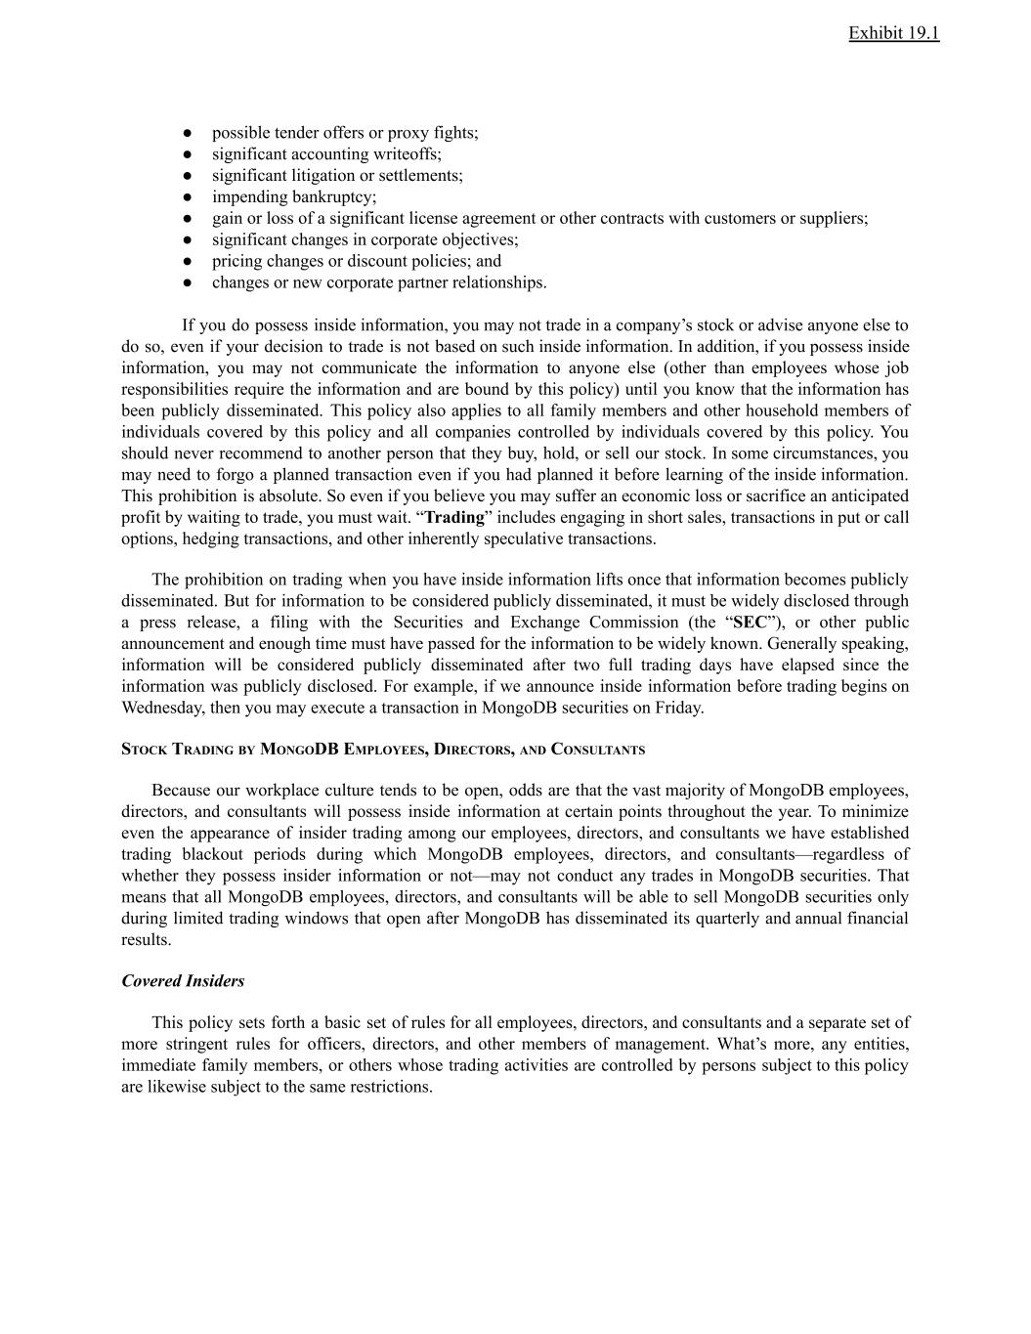
Exhibit 19.1 ●​ possible tender offers or proxy fights; ●​ significant accounting writeoffs; ●​ significant litigation or settlements; ●​ impending bankruptcy; ●​ gain or loss of a significant license agreement or other contracts with customers or suppliers; ●​ significant changes in corporate objectives; ●​ pricing changes or discount policies; and ●​ changes or new corporate partner relationships. If you do possess inside information, you may not trade in a company’s stock or advise anyone else to do so, even if your decision to trade is not based on such inside information. In addition, if you possess inside information, you may not communicate the information to anyone else (other than employees whose job responsibilities require the information and are bound by this policy) until you know that the information has been publicly disseminated. This policy also applies to all family members and other household members of individuals covered by this policy and all companies controlled by individuals covered by this policy. You should never recommend to another person that they buy, hold, or sell our stock. In some circumstances, you may need to forgo a planned transaction even if you had planned it before learning of the inside information. This prohibition is absolute. So even if you believe you may suffer an economic loss or sacrifice an anticipated profit by waiting to trade, you must wait. “Trading” includes engaging in short sales, transactions in put or call options, hedging transactions, and other inherently speculative transactions. The prohibition on trading when you have inside information lifts once that information becomes publicly disseminated. But for information to be considered publicly disseminated, it must be widely disclosed through a press release, a filing with the Securities and Exchange Commission (the “SEC”), or other public announcement and enough time must have passed for the information to be widely known. Generally speaking, information will be considered publicly disseminated after two full trading days have elapsed since the information was publicly disclosed. For example, if we announce inside information before trading begins on Wednesday, then you may execute a transaction in MongoDB securities on Friday. STOCK TRADING BY MONGODB EMPLOYEES, DIRECTORS, AND CONSULTANTS Because our workplace culture tends to be open, odds are that the vast majority of MongoDB employees, directors, and consultants will possess inside information at certain points throughout the year. To minimize even the appearance of insider trading among our employees, directors, and consultants we have established trading blackout periods during which MongoDB employees, directors, and consultants—regardless of whether they possess insider information or not—may not conduct any trades in MongoDB securities. That means that all MongoDB employees, directors, and consultants will be able to sell MongoDB securities only during limited trading windows that open after MongoDB has disseminated its quarterly and annual financial results. Covered Insiders This policy sets forth a basic set of rules for all employees, directors, and consultants and a separate set of more stringent rules for officers, directors, and other members of management. What’s more, any entities, immediate family members, or others whose trading activities are controlled by persons subject to this policy are likewise subject to the same restrictions.

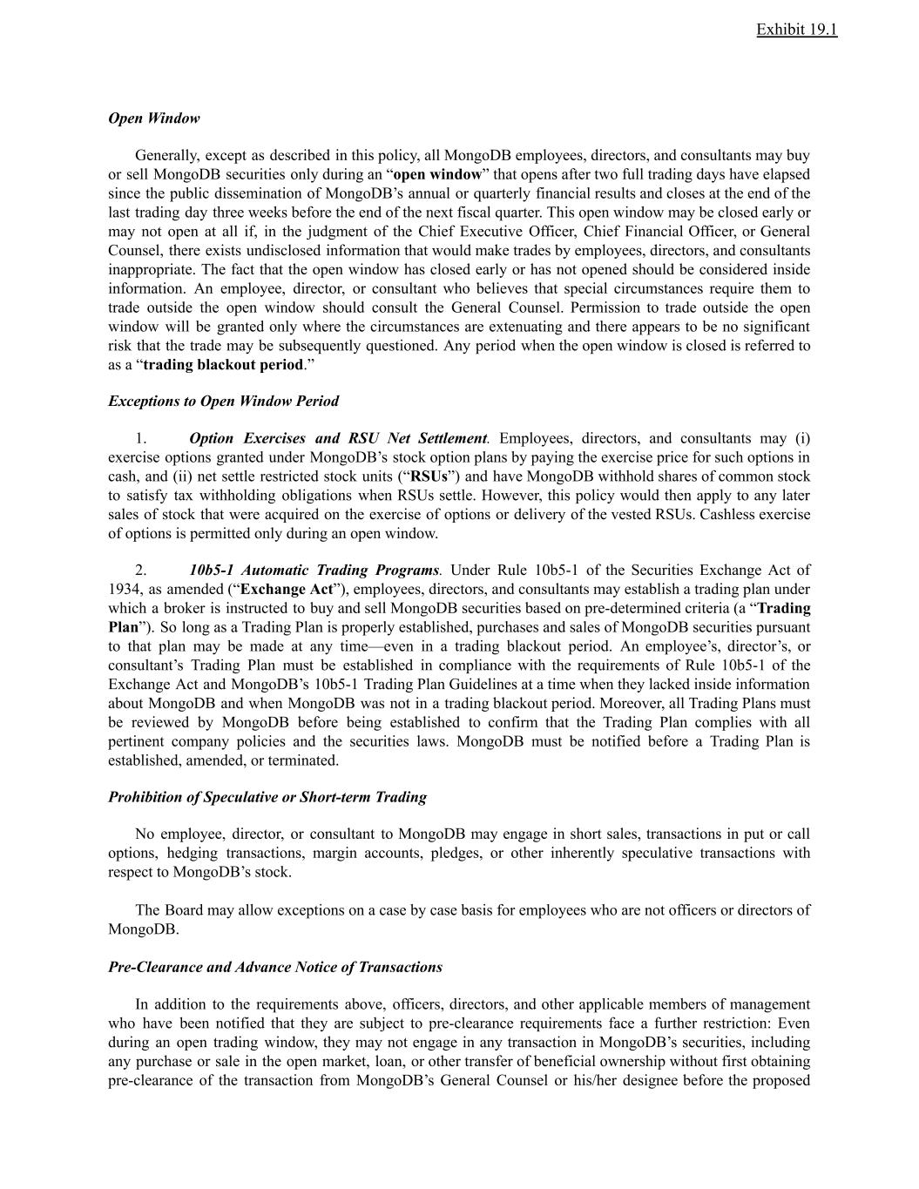
Exhibit 19.1 Open Window Generally, except as described in this policy, all MongoDB employees, directors, and consultants may buy or sell MongoDB securities only during an “open window” that opens after two full trading days have elapsed since the public dissemination of MongoDB’s annual or quarterly financial results and closes at the end of the last trading day three weeks before the end of the next fiscal quarter. This open window may be closed early or may not open at all if, in the judgment of the Chief Executive Officer, Chief Financial Officer, or General Counsel, there exists undisclosed information that would make trades by employees, directors, and consultants inappropriate. The fact that the open window has closed early or has not opened should be considered inside information. An employee, director, or consultant who believes that special circumstances require them to trade outside the open window should consult the General Counsel. Permission to trade outside the open window will be granted only where the circumstances are extenuating and there appears to be no significant risk that the trade may be subsequently questioned. Any period when the open window is closed is referred to as a “trading blackout period.” Exceptions to Open Window Period 1.​ Option Exercises and RSU Net Settlement. Employees, directors, and consultants may (i) exercise options granted under MongoDB’s stock option plans by paying the exercise price for such options in cash, and (ii) net settle restricted stock units (“RSUs”) and have MongoDB withhold shares of common stock to satisfy tax withholding obligations when RSUs settle. However, this policy would then apply to any later sales of stock that were acquired on the exercise of options or delivery of the vested RSUs. Cashless exercise of options is permitted only during an open window. 2.​ 10b5-1 Automatic Trading Programs. Under Rule 10b5-1 of the Securities Exchange Act of 1934, as amended (“Exchange Act”), employees, directors, and consultants may establish a trading plan under which a broker is instructed to buy and sell MongoDB securities based on pre-determined criteria (a “Trading Plan”). So long as a Trading Plan is properly established, purchases and sales of MongoDB securities pursuant to that plan may be made at any time—even in a trading blackout period. An employee’s, director’s, or consultant’s Trading Plan must be established in compliance with the requirements of Rule 10b5-1 of the Exchange Act and MongoDB’s 10b5-1 Trading Plan Guidelines at a time when they lacked inside information about MongoDB and when MongoDB was not in a trading blackout period. Moreover, all Trading Plans must be reviewed by MongoDB before being established to confirm that the Trading Plan complies with all pertinent company policies and the securities laws. MongoDB must be notified before a Trading Plan is established, amended, or terminated. Prohibition of Speculative or Short-term Trading No employee, director, or consultant to MongoDB may engage in short sales, transactions in put or call options, hedging transactions, margin accounts, pledges, or other inherently speculative transactions with respect to MongoDB’s stock. The Board may allow exceptions on a case by case basis for employees who are not officers or directors of MongoDB. Pre-Clearance and Advance Notice of Transactions In addition to the requirements above, officers, directors, and other applicable members of management who have been notified that they are subject to pre-clearance requirements face a further restriction: Even during an open trading window, they may not engage in any transaction in MongoDB’s securities, including any purchase or sale in the open market, loan, or other transfer of beneficial ownership without first obtaining pre-clearance of the transaction from MongoDB’s General Counsel or his/her designee before the proposed

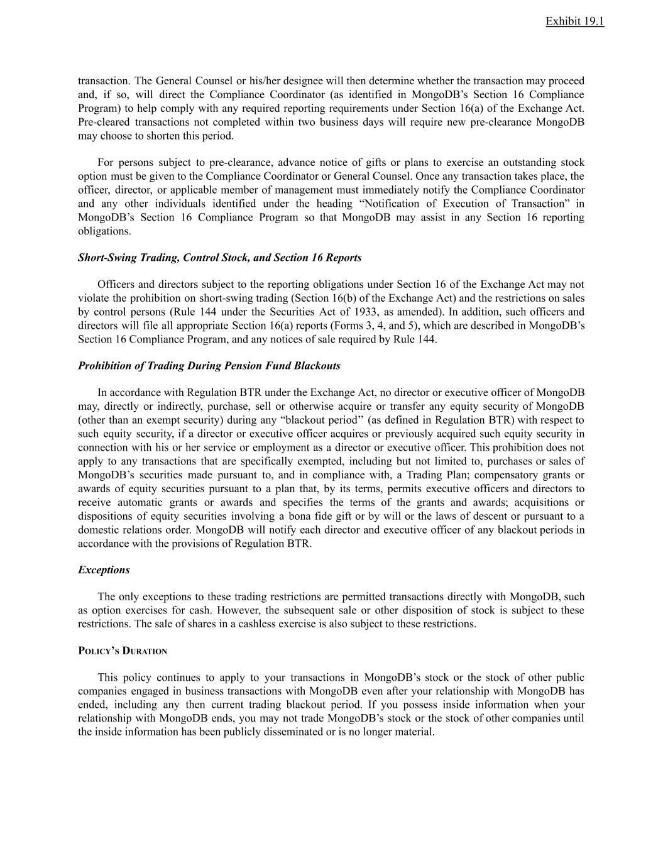
Exhibit 19.1 transaction. The General Counsel or his/her designee will then determine whether the transaction may proceed and, if so, will direct the Compliance Coordinator (as identified in MongoDB’s Section 16 Compliance Program) to help comply with any required reporting requirements under Section 16(a) of the Exchange Act. Pre-cleared transactions not completed within two business days will require new pre-clearance MongoDB may choose to shorten this period. For persons subject to pre-clearance, advance notice of gifts or plans to exercise an outstanding stock option must be given to the Compliance Coordinator or General Counsel. Once any transaction takes place, the officer, director, or applicable member of management must immediately notify the Compliance Coordinator and any other individuals identified under the heading “Notification of Execution of Transaction” in MongoDB’s Section 16 Compliance Program so that MongoDB may assist in any Section 16 reporting obligations. Short-Swing Trading, Control Stock, and Section 16 Reports Officers and directors subject to the reporting obligations under Section 16 of the Exchange Act may not violate the prohibition on short-swing trading (Section 16(b) of the Exchange Act) and the restrictions on sales by control persons (Rule 144 under the Securities Act of 1933, as amended). In addition, such officers and directors will file all appropriate Section 16(a) reports (Forms 3, 4, and 5), which are described in MongoDB’s Section 16 Compliance Program, and any notices of sale required by Rule 144. Prohibition of Trading During Pension Fund Blackouts In accordance with Regulation BTR under the Exchange Act, no director or executive officer of MongoDB may, directly or indirectly, purchase, sell or otherwise acquire or transfer any equity security of MongoDB (other than an exempt security) during any “blackout period’’ (as defined in Regulation BTR) with respect to such equity security, if a director or executive officer acquires or previously acquired such equity security in connection with his or her service or employment as a director or executive officer. This prohibition does not apply to any transactions that are specifically exempted, including but not limited to, purchases or sales of MongoDB’s securities made pursuant to, and in compliance with, a Trading Plan; compensatory grants or awards of equity securities pursuant to a plan that, by its terms, permits executive officers and directors to receive automatic grants or awards and specifies the terms of the grants and awards; acquisitions or dispositions of equity securities involving a bona fide gift or by will or the laws of descent or pursuant to a domestic relations order. MongoDB will notify each director and executive officer of any blackout periods in accordance with the provisions of Regulation BTR. Exceptions The only exceptions to these trading restrictions are permitted transactions directly with MongoDB, such as option exercises for cash. However, the subsequent sale or other disposition of stock is subject to these restrictions. The sale of shares in a cashless exercise is also subject to these restrictions. POLICY’S DURATION This policy continues to apply to your transactions in MongoDB’s stock or the stock of other public companies engaged in business transactions with MongoDB even after your relationship with MongoDB has ended, including any then current trading blackout period. If you possess inside information when your relationship with MongoDB ends, you may not trade MongoDB’s stock or the stock of other companies until the inside information has been publicly disseminated or is no longer material.


Exhibit 19.1 PENALTIES Anyone who engages in insider trading or otherwise violates this policy may be subject to both civil liability and criminal penalties. Violators also risk disciplinary action by MongoDB, including termination. Anyone who has questions about this policy should contact their own attorney or trading@mongodb.com. Please also see Frequently Asked Questions, which are attached as EXHIBIT A.

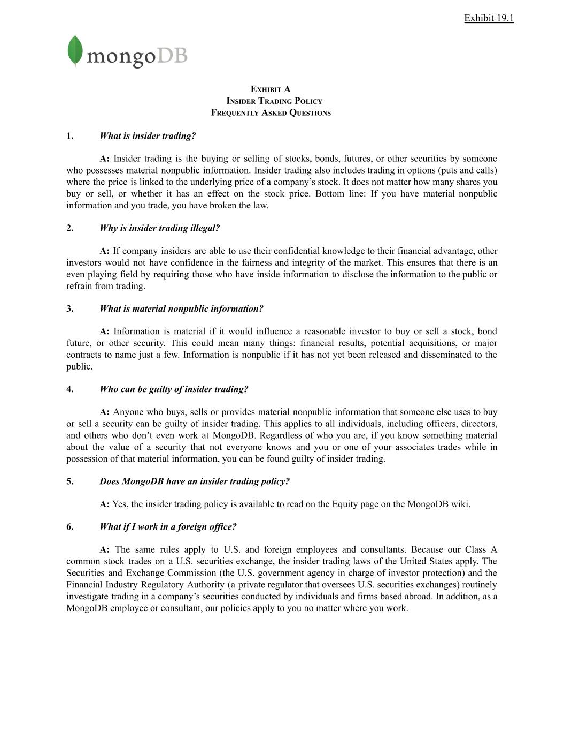
Exhibit 19.1 EXHIBIT A INSIDER TRADING POLICY FREQUENTLY ASKED QUESTIONS 1.​ What is insider trading? A: Insider trading is the buying or selling of stocks, bonds, futures, or other securities by someone who possesses material nonpublic information. Insider trading also includes trading in options (puts and calls) where the price is linked to the underlying price of a company’s stock. It does not matter how many shares you buy or sell, or whether it has an effect on the stock price. Bottom line: If you have material nonpublic information and you trade, you have broken the law. 2.​ Why is insider trading illegal? A: If company insiders are able to use their confidential knowledge to their financial advantage, other investors would not have confidence in the fairness and integrity of the market. This ensures that there is an even playing field by requiring those who have inside information to disclose the information to the public or refrain from trading. 3.​ What is material nonpublic information? A: Information is material if it would influence a reasonable investor to buy or sell a stock, bond future, or other security. This could mean many things: financial results, potential acquisitions, or major contracts to name just a few. Information is nonpublic if it has not yet been released and disseminated to the public. 4.​ Who can be guilty of insider trading? A: Anyone who buys, sells or provides material nonpublic information that someone else uses to buy or sell a security can be guilty of insider trading. This applies to all individuals, including officers, directors, and others who don’t even work at MongoDB. Regardless of who you are, if you know something material about the value of a security that not everyone knows and you or one of your associates trades while in possession of that material information, you can be found guilty of insider trading. 5.​ Does MongoDB have an insider trading policy? A: Yes, the insider trading policy is available to read on the Equity page on the MongoDB wiki. 6.​ What if I work in a foreign office? A: The same rules apply to U.S. and foreign employees and consultants. Because our Class A common stock trades on a U.S. securities exchange, the insider trading laws of the United States apply. The Securities and Exchange Commission (the U.S. government agency in charge of investor protection) and the Financial Industry Regulatory Authority (a private regulator that oversees U.S. securities exchanges) routinely investigate trading in a company’s securities conducted by individuals and firms based abroad. In addition, as a MongoDB employee or consultant, our policies apply to you no matter where you work.

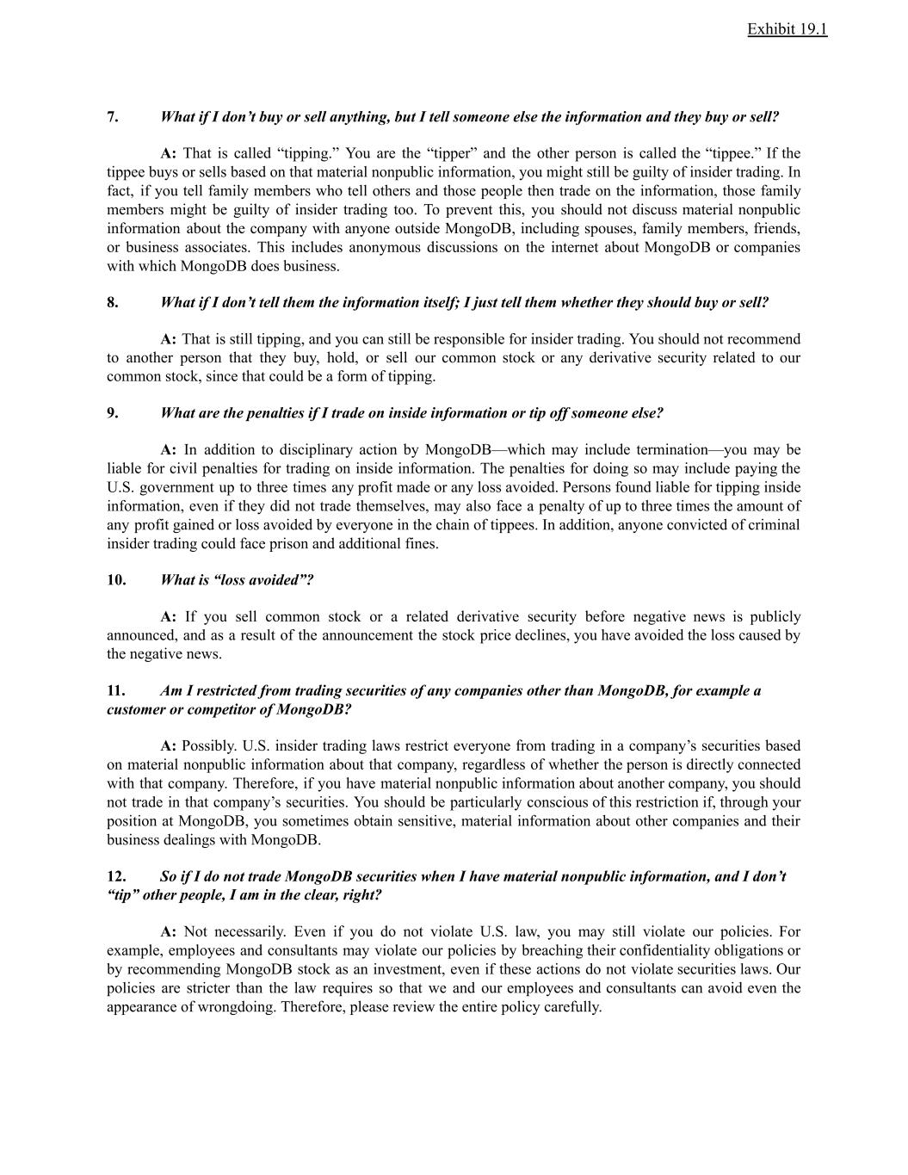
Exhibit 19.1 7.​ What if I don’t buy or sell anything, but I tell someone else the information and they buy or sell? A: That is called “tipping.” You are the “tipper” and the other person is called the “tippee.” If the tippee buys or sells based on that material nonpublic information, you might still be guilty of insider trading. In fact, if you tell family members who tell others and those people then trade on the information, those family members might be guilty of insider trading too. To prevent this, you should not discuss material nonpublic information about the company with anyone outside MongoDB, including spouses, family members, friends, or business associates. This includes anonymous discussions on the internet about MongoDB or companies with which MongoDB does business. 8.​ What if I don’t tell them the information itself; I just tell them whether they should buy or sell? A: That is still tipping, and you can still be responsible for insider trading. You should not recommend to another person that they buy, hold, or sell our common stock or any derivative security related to our common stock, since that could be a form of tipping. 9.​ What are the penalties if I trade on inside information or tip off someone else? A: In addition to disciplinary action by MongoDB—which may include termination—you may be liable for civil penalties for trading on inside information. The penalties for doing so may include paying the U.S. government up to three times any profit made or any loss avoided. Persons found liable for tipping inside information, even if they did not trade themselves, may also face a penalty of up to three times the amount of any profit gained or loss avoided by everyone in the chain of tippees. In addition, anyone convicted of criminal insider trading could face prison and additional fines. 10.​ What is “loss avoided”? A: If you sell common stock or a related derivative security before negative news is publicly announced, and as a result of the announcement the stock price declines, you have avoided the loss caused by the negative news. 11.​ Am I restricted from trading securities of any companies other than MongoDB, for example a customer or competitor of MongoDB? A: Possibly. U.S. insider trading laws restrict everyone from trading in a company’s securities based on material nonpublic information about that company, regardless of whether the person is directly connected with that company. Therefore, if you have material nonpublic information about another company, you should not trade in that company’s securities. You should be particularly conscious of this restriction if, through your position at MongoDB, you sometimes obtain sensitive, material information about other companies and their business dealings with MongoDB. 12.​ So if I do not trade MongoDB securities when I have material nonpublic information, and I don’t “tip” other people, I am in the clear, right? A: Not necessarily. Even if you do not violate U.S. law, you may still violate our policies. For example, employees and consultants may violate our policies by breaching their confidentiality obligations or by recommending MongoDB stock as an investment, even if these actions do not violate securities laws. Our policies are stricter than the law requires so that we and our employees and consultants can avoid even the appearance of wrongdoing. Therefore, please review the entire policy carefully.

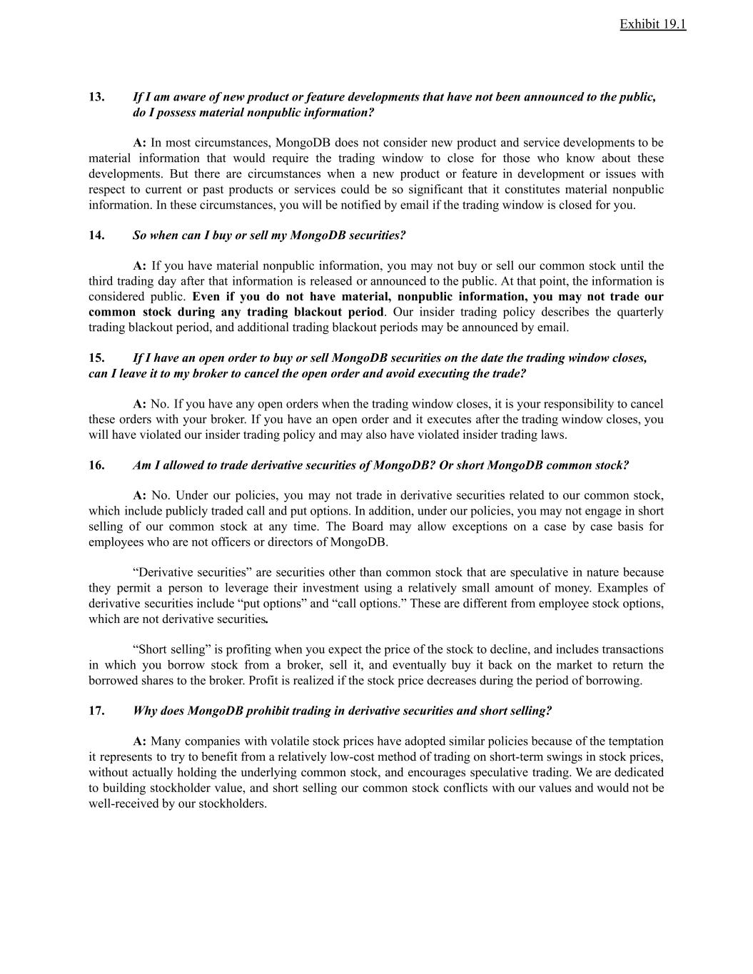
Exhibit 19.1 13.​ If I am aware of new product or feature developments that have not been announced to the public, do I possess material nonpublic information? A: In most circumstances, MongoDB does not consider new product and service developments to be material information that would require the trading window to close for those who know about these developments. But there are circumstances when a new product or feature in development or issues with respect to current or past products or services could be so significant that it constitutes material nonpublic information. In these circumstances, you will be notified by email if the trading window is closed for you. 14.​ So when can I buy or sell my MongoDB securities? A: If you have material nonpublic information, you may not buy or sell our common stock until the third trading day after that information is released or announced to the public. At that point, the information is considered public. Even if you do not have material, nonpublic information, you may not trade our common stock during any trading blackout period. Our insider trading policy describes the quarterly trading blackout period, and additional trading blackout periods may be announced by email. 15.​ If I have an open order to buy or sell MongoDB securities on the date the trading window closes, can I leave it to my broker to cancel the open order and avoid executing the trade? A: No. If you have any open orders when the trading window closes, it is your responsibility to cancel these orders with your broker. If you have an open order and it executes after the trading window closes, you will have violated our insider trading policy and may also have violated insider trading laws. 16.​ Am I allowed to trade derivative securities of MongoDB? Or short MongoDB common stock? A: No. Under our policies, you may not trade in derivative securities related to our common stock, which include publicly traded call and put options. In addition, under our policies, you may not engage in short selling of our common stock at any time. The Board may allow exceptions on a case by case basis for employees who are not officers or directors of MongoDB. “Derivative securities” are securities other than common stock that are speculative in nature because they permit a person to leverage their investment using a relatively small amount of money. Examples of derivative securities include “put options” and “call options.” These are different from employee stock options, which are not derivative securities. “Short selling” is profiting when you expect the price of the stock to decline, and includes transactions in which you borrow stock from a broker, sell it, and eventually buy it back on the market to return the borrowed shares to the broker. Profit is realized if the stock price decreases during the period of borrowing. 17.​ Why does MongoDB prohibit trading in derivative securities and short selling? A: Many companies with volatile stock prices have adopted similar policies because of the temptation it represents to try to benefit from a relatively low-cost method of trading on short-term swings in stock prices, without actually holding the underlying common stock, and encourages speculative trading. We are dedicated to building stockholder value, and short selling our common stock conflicts with our values and would not be well-received by our stockholders.

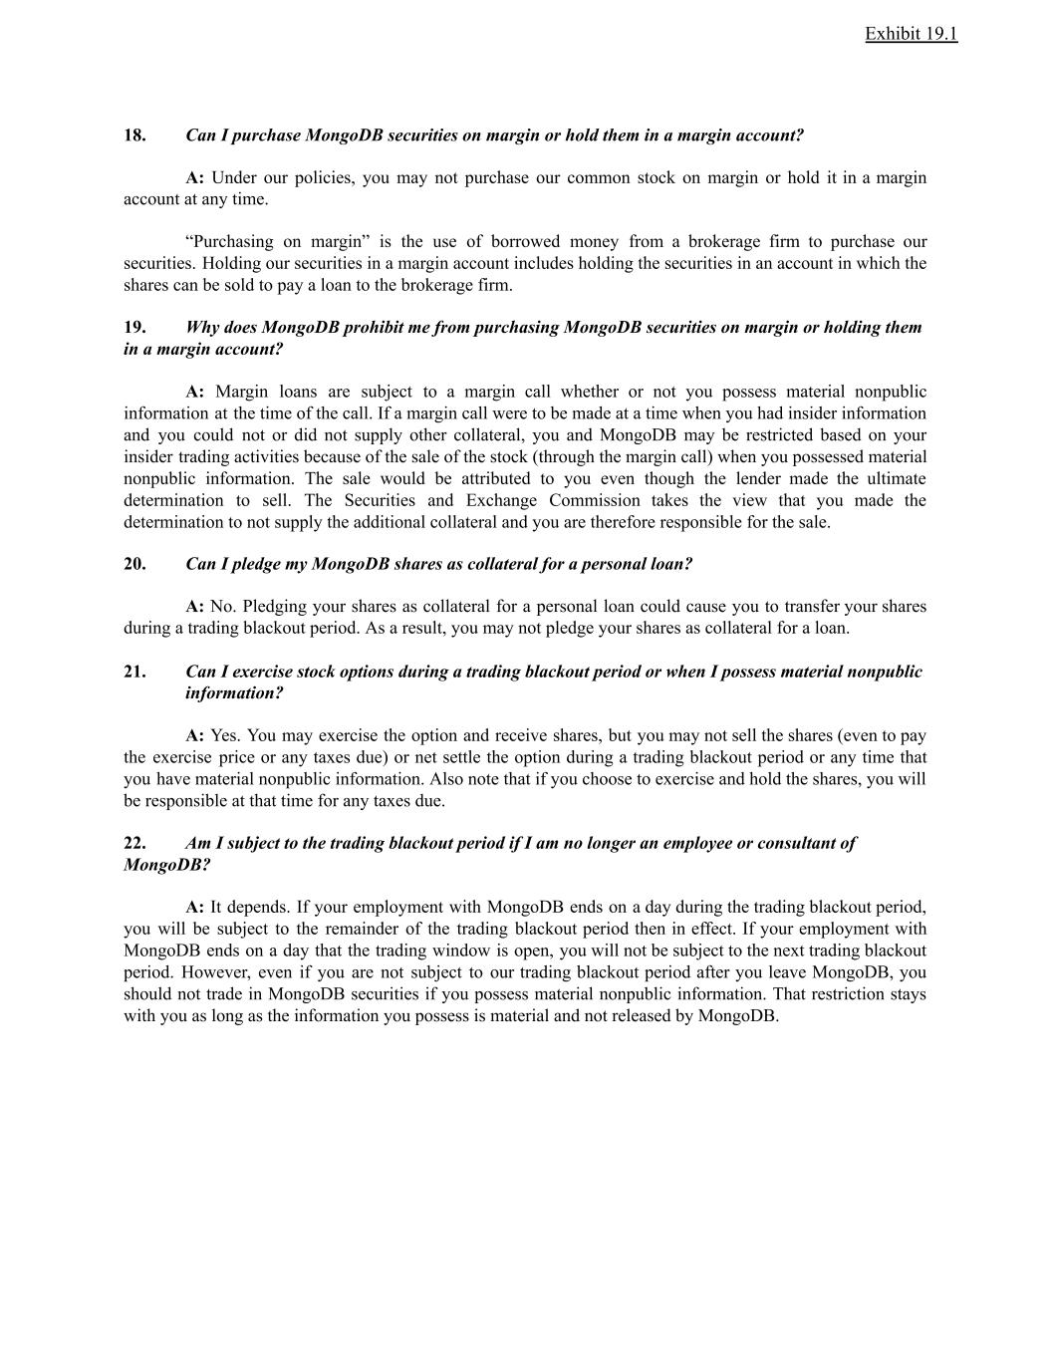
Exhibit 19.1 18.​ Can I purchase MongoDB securities on margin or hold them in a margin account? A: Under our policies, you may not purchase our common stock on margin or hold it in a margin account at any time. “Purchasing on margin” is the use of borrowed money from a brokerage firm to purchase our securities. Holding our securities in a margin account includes holding the securities in an account in which the shares can be sold to pay a loan to the brokerage firm. 19.​ Why does MongoDB prohibit me from purchasing MongoDB securities on margin or holding them in a margin account? A: Margin loans are subject to a margin call whether or not you possess material nonpublic information at the time of the call. If a margin call were to be made at a time when you had insider information and you could not or did not supply other collateral, you and MongoDB may be restricted based on your insider trading activities because of the sale of the stock (through the margin call) when you possessed material nonpublic information. The sale would be attributed to you even though the lender made the ultimate determination to sell. The Securities and Exchange Commission takes the view that you made the determination to not supply the additional collateral and you are therefore responsible for the sale. 20.​ Can I pledge my MongoDB shares as collateral for a personal loan? A: No. Pledging your shares as collateral for a personal loan could cause you to transfer your shares during a trading blackout period. As a result, you may not pledge your shares as collateral for a loan. 21.​ Can I exercise stock options during a trading blackout period or when I possess material nonpublic information? A: Yes. You may exercise the option and receive shares, but you may not sell the shares (even to pay the exercise price or any taxes due) or net settle the option during a trading blackout period or any time that you have material nonpublic information. Also note that if you choose to exercise and hold the shares, you will be responsible at that time for any taxes due. 22.​ Am I subject to the trading blackout period if I am no longer an employee or consultant of MongoDB? A: It depends. If your employment with MongoDB ends on a day during the trading blackout period, you will be subject to the remainder of the trading blackout period then in effect. If your employment with MongoDB ends on a day that the trading window is open, you will not be subject to the next trading blackout period. However, even if you are not subject to our trading blackout period after you leave MongoDB, you should not trade in MongoDB securities if you possess material nonpublic information. That restriction stays with you as long as the information you possess is material and not released by MongoDB.

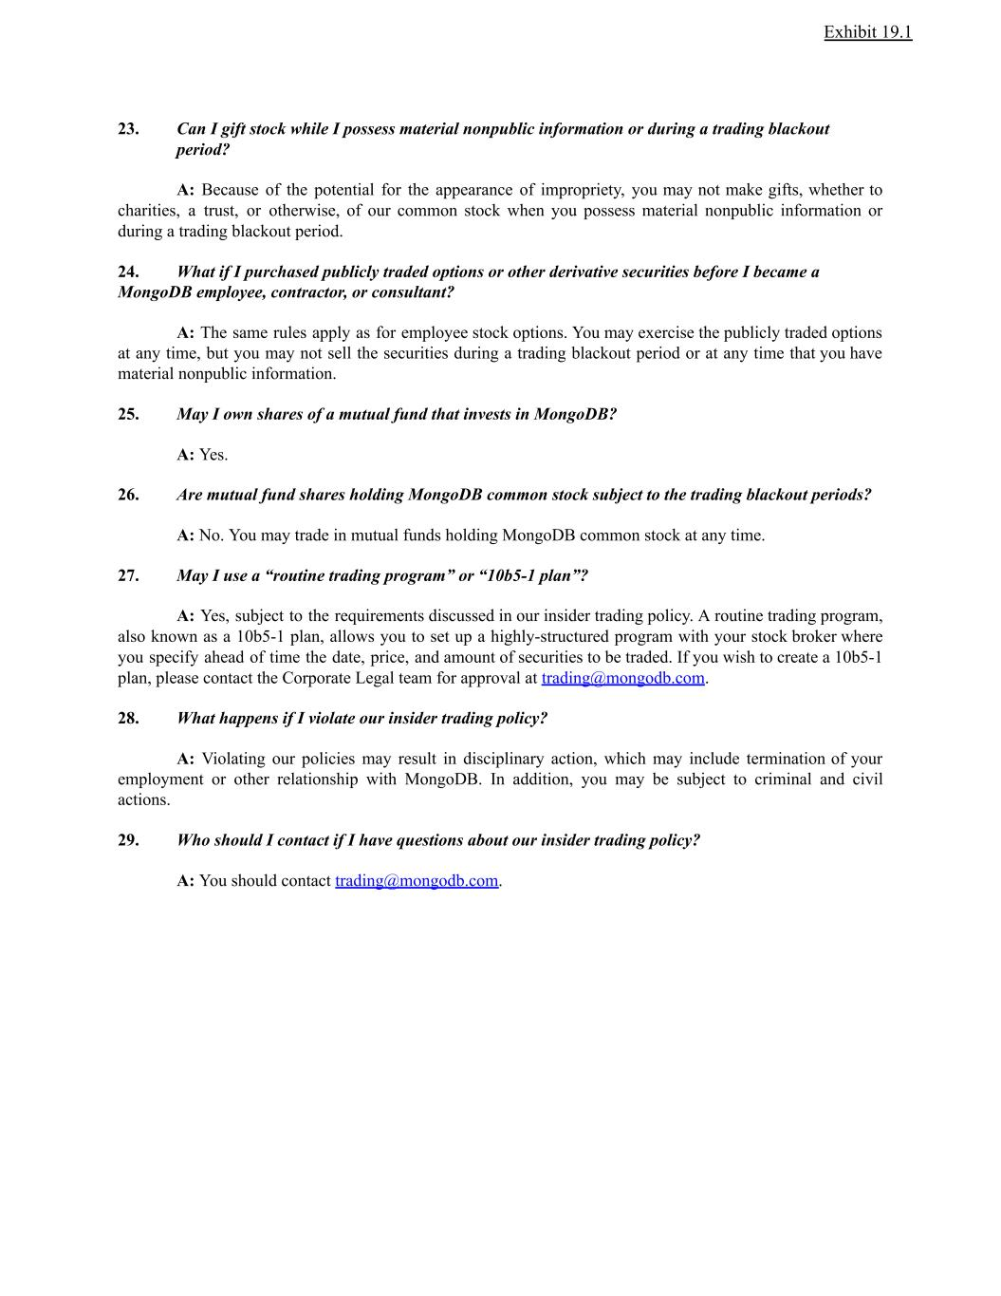
Exhibit 19.1 23.​ Can I gift stock while I possess material nonpublic information or during a trading blackout period? A: Because of the potential for the appearance of impropriety, you may not make gifts, whether to charities, a trust, or otherwise, of our common stock when you possess material nonpublic information or during a trading blackout period. 24.​ What if I purchased publicly traded options or other derivative securities before I became a MongoDB employee, contractor, or consultant? A: The same rules apply as for employee stock options. You may exercise the publicly traded options at any time, but you may not sell the securities during a trading blackout period or at any time that you have material nonpublic information. 25.​ May I own shares of a mutual fund that invests in MongoDB? A: Yes. 26.​ Are mutual fund shares holding MongoDB common stock subject to the trading blackout periods? A: No. You may trade in mutual funds holding MongoDB common stock at any time. 27.​ May I use a “routine trading program” or “10b5-1 plan”? A: Yes, subject to the requirements discussed in our insider trading policy. A routine trading program, also known as a 10b5-1 plan, allows you to set up a highly-structured program with your stock broker where you specify ahead of time the date, price, and amount of securities to be traded. If you wish to create a 10b5-1 plan, please contact the Corporate Legal team for approval at trading@mongodb.com. 28.​ What happens if I violate our insider trading policy? A: Violating our policies may result in disciplinary action, which may include termination of your employment or other relationship with MongoDB. In addition, you may be subject to criminal and civil actions. 29.​ Who should I contact if I have questions about our insider trading policy? A: You should contact trading@mongodb.com.

Exhibit 23.1
A CONSENT OF INDEPENDENT REGISTERED PUBLIC ACCOUNTING FIRM
We hereby consent to the incorporation by reference in the Registration Statements on Form S-8 (No. 333-221028, 333-224058, 333-230661, 333-237570, 333-254592, 333-263701, 333-270654, 333-277993, and 333-285984) of MongoDB, Inc. of our report dated March 11, 2026 relating to the financial statements and the effectiveness of internal control over financial reporting, which appears in this Form 10-K.
/s/ PricewaterhouseCoopers LLP
San Francisco, California
March 11, 2026

Exhibit 31.1

Certification by the Chief Executive Officer pursuant to
Securities Exchange Act Rules 13a-14(a) and 15d-14(a)
as adopted pursuant to Section 302 of the Sarbanes-Oxley Act of 2002

I, Chirantan J. Desai, certify that:

1.I have reviewed this Annual Report on Form 10-K of MongoDB, Inc. (the “registrant”) for the fiscal year ended January 31, 2026;

2.Based on my knowledge, this report does not contain any untrue statement of a material fact or omit to state a material fact necessary to make the statements made, in light of the circumstances under which such statements were made, not misleading with respect to the period covered by this report;

3.Based on my knowledge, the financial statements, and other financial information included in this report, fairly present in all material respects the financial condition, results of operations and cash flows of the registrant as of, and for, the periods presented in this report;

4.The registrant's other certifying officer(s) and I are responsible for establishing and maintaining disclosure controls and procedures (as defined in Exchange Act Rules 13a-15(e) and 15d-15(e)) and internal control over financial reporting (as defined in Exchange Act Rules 13a-15(f) and 15d-15(f)) for the registrant and have:
a)Designed such disclosure controls and procedures, or caused such disclosure controls and procedures to be designed under our supervision, to ensure that material information relating to the registrant, including its consolidated subsidiaries, is made known to us by others within those entities, particularly during the period in which this report is being prepared;
b)Designed such internal control over financial reporting, or caused such internal control over financial reporting to be designed under our supervision, to provide reasonable assurance regarding the reliability of financial reporting and the preparation of financial statements for external purposes in accordance with generally accepted accounting principles;
c)Evaluated the effectiveness of the registrant's disclosure controls and procedures and presented in this report our conclusions about the effectiveness of the disclosure controls and procedures, as of the end of the period covered by this report based on such evaluation; and
d)Disclosed in this report any change in the registrant's internal control over financial reporting that occurred during the registrant's most recent fiscal quarter (the registrant's fourth fiscal quarter in the case of an annual report) that has materially affected, or is reasonably likely to materially affect, the registrant's internal control over financial reporting; and

5.The registrant's other certifying officer(s) and I have disclosed, based on our most recent evaluation of internal control over financial reporting, to the registrant's auditors and the audit committee of the registrant's board of directors (or persons performing the equivalent functions):
a)All significant deficiencies and material weaknesses in the design or operation of internal control over financial reporting which are reasonably likely to adversely affect the registrant's ability to record, process, summarize and report financial information; and
b)Any fraud, whether or not material, that involves management or other employees who have a significant role in the registrant's internal control over financial reporting.
Date: March 11, 2026 |  |  | By: |  |  |  |  |  | /s/ Chirantan J. Desai
 |  |  |  |  |  | Name: |  |  | Chirantan J. Desai
 |  |  |  |  |  | Title: |  |  | President and Chief Executive Officer
 |  |  |  |  |  |  |  |  | (Principal Executive Officer)

Exhibit 31.2

Certification by the Chief Financial Officer pursuant to
Securities Exchange Act Rules 13a-14(a) and 15d-14(a)
as adopted pursuant to Section 302 of the Sarbanes-Oxley Act of 2002

I, Michael J. Berry, certify that:

1.I have reviewed this Annual Report on Form 10-K of MongoDB, Inc. (the “registrant”) for the fiscal year ended January 31, 2026;

2.Based on my knowledge, this report does not contain any untrue statement of a material fact or omit to state a material fact necessary to make the statements made, in light of the circumstances under which such statements were made, not misleading with respect to the period covered by this report;

3.Based on my knowledge, the financial statements, and other financial information included in this report, fairly present in all material respects the financial condition, results of operations and cash flows of the registrant as of, and for, the periods presented in this report;

4.The registrant's other certifying officer(s) and I are responsible for establishing and maintaining disclosure controls and procedures (as defined in Exchange Act Rules 13a-15(e) and 15d-15(e)) and internal control over financial reporting (as defined in Exchange Act Rules 13a-15(f) and 15d-15(f)) for the registrant and have:
a)Designed such disclosure controls and procedures, or caused such disclosure controls and procedures to be designed under our supervision, to ensure that material information relating to the registrant, including its consolidated subsidiaries, is made known to us by others within those entities, particularly during the period in which this report is being prepared;
b)Designed such internal control over financial reporting, or caused such internal control over financial reporting to be designed under our supervision, to provide reasonable assurance regarding the reliability of financial reporting and the preparation of financial statements for external purposes in accordance with generally accepted accounting principles;
c)Evaluated the effectiveness of the registrant's disclosure controls and procedures and presented in this report our conclusions about the effectiveness of the disclosure controls and procedures, as of the end of the period covered by this report based on such evaluation; and
d)Disclosed in this report any change in the registrant's internal control over financial reporting that occurred during the registrant's most recent fiscal quarter (the registrant's fourth fiscal quarter in the case of an annual report) that has materially affected, or is reasonably likely to materially affect, the registrant's internal control over financial reporting; and

5.The registrant's other certifying officer(s) and I have disclosed, based on our most recent evaluation of internal control over financial reporting, to the registrant's auditors and the audit committee of the registrant's board of directors (or persons performing the equivalent functions):
a)All significant deficiencies and material weaknesses in the design or operation of internal control over financial reporting which are reasonably likely to adversely affect the registrant's ability to record, process, summarize and report financial information; and
b)Any fraud, whether or not material, that involves management or other employees who have a significant role in the registrant's internal control over financial reporting.
Date: March 11, 2026 |  |  | By: |  |  |  |  |  | /s/ Michael J. Berry
 |  |  |  |  |  | Name: |  |  | Michael J. Berry
 |  |  |  |  |  | Title: |  |  | Chief Financial Officer
 |  |  |  |  |  |  |  |  | (Principal Financial Officer)

Exhibit 32.1

CERTIFICATION OF PRINCIPAL EXECUTIVE OFFICER
PURSUANT TO 18 U.S.C. SECTION 1350,
AS ADOPTED PURSUANT TO
SECTION 906 OF THE SARBANES-OXLEY ACT OF 2002

I, Chirantan J. Desai, certify, pursuant to 18 U.S.C. Section 1350, as adopted pursuant to Section 906 of the Sarbanes-Oxley Act of 2002, that the Annual Report on Form 10-K of MongoDB, Inc. for the fiscal year ended January 31, 2026 fully complies with the requirements of Section 13(a) or 15(d) of the Securities Exchange Act of 1934, as amended, and that information contained in such Annual Report on Form 10-K fairly presents, in all material respects, the financial condition and results of operations of MongoDB, Inc.

Date: March 11, 2026 |  |  | By: |  |  |  |  |  | /s/ Chirantan J. Desai
 |  |  |  |  |  | Name: |  |  | Chirantan J. Desai
 |  |  |  |  |  | Title: |  |  | President and Chief Executive Officer
 |  |  |  |  |  |  |  |  | (Principal Executive Officer)

This certification accompanies the Annual Report, is not deemed filed with the Securities and Exchange Commission and is not to be incorporated by reference into any filing of MongoDB, Inc. under the Securities Act of 1933, as amended, or the Securities Exchange Act of 1934, as amended (whether made before or after the date of the Annual Report on Form 10-K), irrespective of any general incorporation language contained in such filing.

Exhibit 32.2

CERTIFICATION OF PRINCIPAL FINANCIAL OFFICER
PURSUANT TO 18 U.S.C. SECTION 1350,
AS ADOPTED PURSUANT TO
SECTION 906 OF THE SARBANES-OXLEY ACT OF 2002

I, Michael J. Berry, certify, pursuant to 18 U.S.C. Section 1350, as adopted pursuant to Section 906 of the Sarbanes-Oxley Act of 2002, that the Annual Report on Form 10-K of MongoDB, Inc. for the fiscal year ended January 31, 2026 fully complies with the requirements of Section 13(a) or 15(d) of the Securities Exchange Act of 1934, as amended, and that information contained in such Annual Report on Form 10-K fairly presents, in all material respects, the financial condition and results of operations of MongoDB, Inc.

Date: March 11, 2026 |  |  | By: |  |  |  |  |  | /s/ Michael J. Berry
 |  |  |  |  |  | Name: |  |  | Michael J. Berry
 |  |  |  |  |  | Title: |  |  | Chief Financial Officer
 |  |  |  |  |  |  |  |  | (Principal Financial Officer)

This certification accompanies the Annual Report, is not deemed filed with the Securities and Exchange Commission and is not to be incorporated by reference into any filing of MongoDB, Inc. under the Securities Act of 1933, as amended, or the Securities Exchange Act of 1934, as amended (whether made before or after the date of the Annual Report on Form 10-K), irrespective of any general incorporation language contained in such filing.

