UNITED STATES

SECURITIES AND EXCHANGE COMMISSION

WASHINGTON, DC 20549

___________________

FORM 10-Q

___________________

(Mark One)

- QUARTERLY REPORT PURSUANT TO SECTION 13 OR 15(d) OF THE SECURITIES EXCHANGE ACT OF 1934

For the quarterly period ended October 31, 2025

OR

- TRANSITION REPORT PURSUANT TO SECTION 13 OR 15(d) OF THE SECURITIES EXCHANGE ACT OF 1934

For the transition period from |  | to
Commission File Number: 001-38240
___________________
MONGODB, INC.

(Exact Name of Registrant as Specified in its Charter)

___________________

Delaware | 26-1463205
(State or other jurisdiction of | (I.R.S. Employer
incorporation or organization) | Identification No.)
1633 Broadway, 38th Floor
New York, NY | 10019
(Address of principal executive offices) | (Zip Code)

Registrant’s telephone number, including area code: 646-727-4092

Securities registered pursuant to Section 12(b) of the Act:

Title of each class |  | Trading Symbol(s) |  | Name of each exchange on which registered
Common Stock, par value $0.001 per |  | MDB |  | The Nasdaq Stock Market LLC
share |  |  |  | (Nasdaq Global Market)

Indicate by check mark whether the registrant (1) has filed all reports required to be filed by Section 13 or 15(d) of the Securities Exchange Act of 1934 during the preceding 12 months (or for such shorter period that the registrant was required to file such reports), and (2) has been subject to such filing requirements for the past 90 days. Yes ☑ No ☐

Indicate by check mark whether the registrant has submitted electronically every Interactive Data File required to be submitted pursuant to Rule 405 of Regulation S-T (§ 232.405 of this chapter) during the preceding 12 months (or for such shorter period that the registrant was required to submit such files). Yes ☑ No ☐
Indicate by check mark whether the registrant is a large accelerated filer, an accelerated filer, a non-accelerated filer, a smaller reporting company or an emerging growth company. See the definitions of “large accelerated filer,” “accelerated filer,” “smaller reporting company” and “emerging growth company” in Rule 12b-2 of the Exchange Act.

Large accelerated filer

Non-accelerated filer

☑

☐

Accelerated filer

Smaller reporting company

Emerging growth company

☐

☐

☐

If an emerging growth company, indicate by check mark if the registrant has elected not to use the extended transition period for complying with any new or revised financial accounting standards provided pursuant to Section 13(a) of the Exchange Act. ☐

Indicate by check mark whether the registrant is a shell company (as defined in Rule 12b-2 of the Exchange Act). Yes ☐ No ☑ As of November 28, 2025, there were 81,391,760 shares of the registrant’s common stock, par value $0.001 per share, outstanding.

Item 1.

Item 2.

Item 3.

Item 4.

Item 1. Item 1A. Item 2. Item 3. Item 4. Item 5. Item 6. Signatures

Table of Contents

 |  |  |  |  |  |  |  |  |  |  |  |  |  |  |  |  |  |  |  |  | Page
 |  |  |  |  |  |  |  | PART I. FINANCIAL INFORMATION
Financial Statements |  |  |  |  |  |  |  |  |  |  |  |  |  |  |  |  |  |  |  |  | 1
 | Unaudited Condensed Consolidated Balance Sheets as of October 31, 2025 and January 31, 2025 |  |  |  |  |  |  |  |  |  |  |  |  |  |  |  |  |  |  |  | 1
 | Unaudited Condensed Consolidated Statements of Operations for the three and nine months ended October 31, 2025 and 2024 |  |  |  |  |  |  |  |  |  |  |  |  |  |  |  |  |  |  |  | 2
 | Unaudited Condensed Consolidated Statements of Comprehensive Loss for the three and nine months ended October 31, 2025 and 2024 |  |  |  |  |  |  |  |  |  |  |  |  |  |  |  |  |  |  |  | 3
 | Unaudited Condensed Consolidated Statements of Stockholders’ Equity for the three and nine months ended October 31, 2025 and 2024 |  |  |  |  |  |  |  |  |  |  |  |  |  |  |  |  |  |  |  | 4
 | Unaudited Condensed Consolidated Statements of Cash Flows for the nine months ended October 31, 2025 and 2024 |  |  |  |  |  |  |  |  |  |  |  |  |  |  |  |  |  |  |  | 6
 | Notes to Condensed Consolidated Financial Statements (unaudited) |  |  |  |  |  |  |  |  |  |  |  |  |  |  |  |  |  |  |  | 7
Management’s Discussion and Analysis of Financial Condition and Results of Operations |  |  |  |  |  |  |  |  |  |  |  |  |  |  |  |  |  |  |  |  | 21
Quantitative and Qualitative Disclosures About Market Risk |  |  |  |  |  |  |  |  |  |  |  |  |  |  |  |  |  |  |  |  |  | 34
Controls and Procedures |  |  |  |  |  |  |  |  |  |  |  |  |  |  |  |  |  |  |  |  | 35
 |  |  |  |  |  |  |  |  |  | PART II. OTHER INFORMATION
Legal Proceedings |  |  |  |  |  |  |  |  |  |  |  |  |  |  |  |  |  |  |  |  |  | 36
Risk Factors |  |  |  |  |  |  |  |  |  |  |  |  |  |  |  |  |  |  |  |  | 36
Unregistered Sales of Equity Securities and Use of Proceeds |  |  |  |  |  |  |  |  |  |  |  |  |  |  |  |  |  |  |  |  | 72
Defaults Upon Senior Securities |  |  |  |  |  |  |  |  |  |  |  |  |  |  |  |  |  |  |  |  |  | 73
Mine Safety Disclosures |  |  |  |  |  |  |  |  |  |  |  |  |  |  |  |  |  |  |  |  | 73
Other Information |  |  |  |  |  |  |  |  |  |  |  |  |  |  |  |  |  |  |  |  |  | 73
Exhibits |  |  |  |  |  |  |  |  |  |  |  |  |  |  |  |  |  |  |  |  |  | 74
 |  |  |  |  |  |  |  |  |  |  |  |  |  |  |  |  |  |  |  |  |  | 75

Table of Contents

PART I—FINANCIAL INFORMATION

ITEM 1. FINANCIAL STATEMENTS.

MONGODB, INC.

CONDENSED CONSOLIDATED BALANCE SHEETS

(in thousands of U.S. dollars, except share and per share data)

(unaudited)

Assets

Current assets:

Cash and cash equivalents $

Short-term investments

Accounts receivable, net of allowance for doubtful accounts of $12,305 and $8,888 as of October 31, 2025 and January 31, 2025, respectively

Deferred commissions

Prepaid expenses and other current assets

Total current assets

Property and equipment, net

Operating lease right-of-use assets

Goodwill

Intangible assets, net

Deferred tax assets

Other assets

Total assets | $
Liabilities and Stockholders’ Equity
Current liabilities:
Accounts payable | $
Accrued compensation and benefits

Operating lease liabilities

Other accrued liabilities

Deferred revenue

Total current liabilities

Deferred tax liability

Operating lease liabilities

Deferred revenue

Other liabilities

Total liabilities

Commitments and contingencies (Note 8)

Stockholders’ equity:

Common stock, par value of $0.001 per share; 1,000,000,000 shares authorized as of October 31, 2025 and January 31, 2025; 82,919,928 shares issued and 81,357,418 shares outstanding as of October 31, 2025; 80,558,847 shares issued and 80,467,811 shares outstanding as of January 31, 2025

Additional paid-in capital

Treasury stock, 1,562,510 shares (repurchased at an average of $221.86 per share) as of October 31, 2025 and 99,371 shares (repurchased at an average of $13.27 per share) as of January 31, 2025

Accumulated other comprehensive income (loss)

Accumulated deficit

October 31, 2025 |  | January 31, 2025
834,092 | $ | 490,133
1,471,669 |  | 1,846,444
416,494 |  | 393,099
122,882 |  | 112,632
87,177 |  | 81,214
2,932,314 |  | 2,923,522
40,704 |  | 46,377
30,914 |  | 34,607
189,641 |  | 69,679
38,308 |  | 24,597
23,012 |  | 20,810
311,756 |  | 310,701
3,566,649 | $ | 3,430,293
14,811 | $ | 10,467
131,760 |  | 120,354
9,145 |  | 9,126
101,444 |  | 87,659
300,873 |  | 334,381
558,033 |  | 561,987
560 |  | 262
25,480 |  | 27,374
66,173 |  | 25,404
27,964 |  | 33,042
678,210 |  | 648,069
81 |  | 78
5,152,122 |  | 4,625,093
(346,654) |  | (1,319)
10,275 |  | (924)
(1,927,385) |  | (1,840,704)

Total stockholders’ equity |  | 2,888,439 |  |  | 2,782,224
Total liabilities and stockholders’ equity | $ | 3,566,649 |  | $ | 3,430,293

The accompanying notes are an integral part of these unaudited condensed consolidated financial statements.

1

Table of Contents

MONGODB, INC.

CONDENSED CONSOLIDATED STATEMENTS OF OPERATIONS

(in thousands of U.S. dollars, except share and per share data)

(unaudited)

 |  | Three Months Ended October 31, |  |  |  |  |  | Nine Months Ended October 31,
 |  | 2025 |  |  | 2024 |  |  | 2025 |  |  | 2024
Revenue:
Subscription | $ | 609,067 |  | $ | 512,205 |  | $ | 1,712,877 |  | $ | 1,412,906
Services |  | 19,242 |  |  | 17,170 |  |  | 55,848 |  |  | 45,139
Total revenue |  | 628,309 |  |  | 529,375 |  |  | 1,768,725 |  |  | 1,458,045
Cost of revenue:
Subscription |  | 146,921 |  |  | 111,150 |  |  | 416,455 |  |  | 318,728
Services |  | 32,256 |  |  | 24,181 |  |  | 92,191 |  |  | 67,553
Total cost of revenue |  | 179,177 |  |  | 135,331 |  |  | 508,646 |  |  | 386,281
Gross profit |  | 449,132 |  |  | 394,044 |  |  | 1,260,079 |  |  | 1,071,764
Operating expenses:
Sales and marketing |  | 230,864 |  |  | 217,954 |  |  | 695,852 |  |  | 658,937
Research and development |  | 176,610 |  |  | 151,410 |  |  | 527,178 |  |  | 446,437
General and administrative |  | 60,082 |  |  | 52,556 |  |  | 174,321 |  |  | 163,892
Total operating expenses |  | 467,556 |  |  | 421,920 |  |  | 1,397,351 |  |  | 1,269,266
Loss from operations |  | (18,424) |  |  | (27,876) |  |  | (137,272) |  |  | (197,502)
Other income (expense):
Interest income |  | 21,160 |  |  | 23,869 |  |  | 68,255 |  |  | 71,240
Interest expense |  | (801) |  |  | (2,278) |  |  | (3,340) |  |  | (6,457)
Other income (expense), net |  | (585) |  |  | (824) |  |  | (2,737) |  |  | (3,034)
Income (loss) before provision for income taxes |  | 1,350 |  |  | (7,109) |  |  | (75,094) |  |  | (135,753)
Provision for income taxes |  | 3,357 |  |  | 2,667 |  |  | 11,587 |  |  | 9,145
Net loss | $ | (2,007) |  | $ | (9,776) |  | $ | (86,681) |  | $ | (144,898)
Net loss per share, basic and diluted | $ | (0.02) |  | $ | (0.13) |  | $ | (1.07) |  | $ | (1.97)
Weighted-average shares used to compute net loss per share, basic and diluted
 |  | 81,401,853 |  |  | 74,020,593 |  |  | 81,245,331 |  |  | 73,472,900

The accompanying notes are an integral part of these unaudited condensed consolidated financial statements.

2

Table of Contents

MONGODB, INC.

CONDENSED CONSOLIDATED STATEMENTS OF COMPREHENSIVE LOSS

(in thousands of U.S. dollars)

(unaudited)

 | Three Months Ended October 31, |  |  |  |  |  | Nine Months Ended October 31,
 | 2025 |  |  | 2024 |  |  | 2025 |  |  |  | 2024
Net loss | $ | (2,007) |  | $ | (9,776) |  | $ | (86,681) |  | $ | (144,898)
Other comprehensive income (loss), net of tax:
Unrealized income (loss) on available-for-sale securities |  | 3,845 |  |  | 1,734 |  |  | 4,853 |  |  | (818)
Foreign currency translation adjustment |  | 849 |  |  | (29) |  |  | 6,346 |  |  | (1,121)
Other comprehensive income (loss) |  | 4,694 |  |  | 1,705 |  |  | 11,199 |  |  | (1,939)
Total comprehensive income (loss) | $ | 2,687 |  | $ | (8,071) |  | $ | (75,482) |  | $ | (146,837)

The accompanying notes are an integral part of these unaudited condensed consolidated financial statements.

3

Table of Contents

MONGODB, INC.

CONDENSED CONSOLIDATED STATEMENTS OF STOCKHOLDERS’ EQUITY

(in thousands of U.S. dollars, except share data)

(unaudited)

 |  | Common Stock |  |  |  |  |  |  |  |  |  |  |  | Accumulated Other
 |  | Shares |  | Amount |  |  |  | Additional Paid-In |  |  | Treasury Stock |  |  | Comprehensive Income |  |  | Accumulated Deficit |  |  | Total Stockholders’
 |  |  |  | Amount |  |  |  | Capital |  |  |  |  |  | (Loss) |  |  |  |  |  | Equity
 | Balances as of January 31, 2025 | 80,467,811 |  | $ | 78 |  | $ | 4,625,093 |  | $ | (1,319) |  | $ | (924) |  | $ | (1,840,704) |  | $ | 2,782,224
 | Stock option exercises | 77,519 |  |  | — |  |  | 579 |  |  | — |  |  | — |  |  | — |  |  | 579
 | Vesting of restricted stock units | 381,937 |  |  | 1 |  |  | — |  |  | — |  |  | — |  |  | — |  |  | 1
 | Vesting of performance stock units | 91,319 |  |  | — |  |  | — |  |  | — |  |  | — |  |  | — |  |  | —
 | Issuance of common stock in connection with a business combination
 | subject to future vesting | 213,023 |  |  | — |  |  | — |  |  | — |  |  | — |  |  | — |  |  | —
 | Issuance of common stock in connection with a business combination | 484,169 |  |  | 1 |  |  | 141,401 |  |  | — |  |  | — |  |  | — |  |  | 141,402
 | Stock-based compensation | — |  |  | — |  |  | 132,431 |  |  | — |  |  | — |  |  | — |  |  | 132,431
 | Unrealized gain on available-for-sale securities | — |  |  | — |  |  | — |  |  | — |  |  | 6,858 |  |  | — |  |  | 6,858
 | Foreign currency translation adjustment | — |  |  | — |  |  | — |  |  | — |  |  | 7,081 |  |  | — |  |  | 7,081
 | Net loss | — |  |  | — |  |  | — |  |  | — |  |  | — |  |  | (37,626) |  |  | (37,626)
 | Balances as of April 30, 2025 | 81,715,778 |  |  | 80 |  |  | 4,899,504 |  |  | (1,319) |  |  | 13,015 |  |  | (1,878,330) |  |  | 3,032,950
 | Stock option exercises
 | Stock option exercises | 168,293 |  |  | — |  |  | 1,210 |  |  | — |  |  | — |  |  | — |  |  | 1,210
 | Vesting of restricted stock units | 460,554 |  |  | 1 |  |  | — |  |  | — |  |  | — |  |  | — |  |  | 1
 | Stock-based compensation | — |  |  | — |  |  | 140,400 |  |  | — |  |  | — |  |  | — |  |  | 140,400
 | Repurchases of common stock | (929,674) |  |  | — |  |  | — |  |  | (200,022) |  |  | — |  |  | — |  |  | (200,022)
 | Issuance of common stock under the Employee Stock Purchase Plan | 131,117 |  |  | — |  |  | 22,917 |  |  | — |  |  | — |  |  | — |  |  | 22,917
 | Unrealized loss on available-for-sale securities | — |  |  | — |  |  | — |  |  | — |  |  | (5,850) |  |  | — |  |  | (5,850)
 | Foreign currency translation adjustment | — |  |  | — |  |  | — |  |  | — |  |  | (1,584) |  |  | — |  |  | (1,584)
 | Net loss | — |  |  | — |  |  | — |  |  | — |  |  | — |  |  | (47,048) |  |  | (47,048)
 | Balances as of July 31, 2025 | 81,546,068 |  | $ | 81 |  | $ | 5,064,031 |  | $ | (201,341) |  | $ | 5,581 |  | $ | (1,925,378) |  | $ | 2,942,974
 | Stock option exercises | 68,076 |  |  | — |  |  | 533 |  |  | — |  |  | — |  |  | — |  |  | 533
 | Vesting of restricted stock units | 425,178 |  |  | — |  |  | — |  |  | — |  |  | — |  |  | — |  |  | —
 | Shares withheld related to net share settlement of equity awards | (148,439) |  |  | — |  |  | (46,072) |  |  | — |  |  | — |  |  | — |  |  | (46,072)
 | Stock-based compensation | — |  |  | — |  |  | 133,630 |  |  | — |  |  | — |  |  | — |  |  | 133,630
 | Repurchases of common stock | (513,620) |  |  | — |  |  | — |  |  | (145,313) |  |  | — |  |  | — |  |  | (145,313)
 | RSA forfeitures | (19,845) |  |  | — |  |  | — |  |  | — |  |  | — |  |  | — |  |  | —
 | Unrealized gain on available-for-sale securities | — |  |  | — |  |  | — |  |  | — |  |  | 3,845 |  |  | — |  |  | 3,845
 | Foreign currency translation adjustment | — |  |  | — |  |  | — |  |  | — |  |  | 849 |  |  | — |  |  | 849
 | Net loss | — |  |  | — |  |  | — |  |  | — |  |  | — |  |  | (2,007) |  |  | (2,007)
 | Balances as of October 31, 2025 | 81,357,418 |  | $ | 81 |  | $ | 5,152,122 |  | $ | (346,654) |  | $ | 10,275 |  | $ | (1,927,385) |  | $ | 2,888,439
 |  |  |  |  |  |  |  | 4

Table of Contents

 | Common Stock |  |  |  |  |  |  |  |  |  |  |  | Accumulated Other
 |  |  |  |  |  |  | Additional Paid-In |  |  |  |  |  | Comprehensive Income |  |  |  |  |  | Total Stockholders’
 | Shares |  | Amount |  |  |  |  |  |  | Treasury Stock |  |  |  |  |  | Accumulated Deficit |  |  | Total Stockholders’
 |  |  | Amount |  |  |  | Capital |  |  |  |  |  | (Loss) |  |  |  |  |  | Equity
Balances as of January 31, 2024 | 72,741,321 |  | $ | 73 |  | $ | 2,777,322 |  | $ | (1,319) |  | $ | 4,545 |  | $ | (1,711,632) |  | $ | 1,068,989
Stock option exercises | 132,617 |  |  | — |  |  | 953 |  |  | — |  |  | — |  |  | — |  |  | 953
Vesting of restricted stock units | 399,213 |  |  | — |  |  | — |  |  | — |  |  | — |  |  | — |  |  | —
Vesting of performance stock units | 77,444 |  |  | — |  |  | — |  |  | — |  |  | — |  |  | — |  |  | —
Stock-based compensation | — |  |  | — |  |  | 120,763 |  |  | — |  |  | — |  |  | — |  |  | 120,763
Unrealized loss on available-for-sale securities | — |  |  | — |  |  | — |  |  | — |  |  | (9,541) |  |  | — |  |  | (9,541)
Foreign currency translation adjustment | — |  |  | — |  |  | — |  |  | — |  |  | (1,007) |  |  | — |  |  | (1,007)
Reclassification of derivative related to the Capped Call associated with
the 2024 Notes | — |  |  | — |  |  | 169,692 |  |  | — |  |  | — |  |  | — |  |  | 169,692
Net loss | — |  |  | — |  |  | — |  |  | — |  |  | — |  |  | (80,593) |  |  | (80,593)
Balances as of April 30, 2024 | 73,350,595 |  | $ | 73 |  | $ | 3,068,730 |  | $ | (1,319) |  | $ | (6,003) |  | $ | (1,792,225) |  | $ | 1,269,256
Stock option exercises | 41,954 |  |  | — |  |  | 353 |  |  | — |  |  | — |  |  | — |  |  | 353
Vesting of restricted stock units | 374,560 |  |  | — |  |  | — |  |  | — |  |  | — |  |  | — |  |  | —
Stock-based compensation | — |  |  | — |  |  | 122,423 |  |  | — |  |  | — |  |  | — |  |  | 122,423
Issuance of common stock under the Employee Stock Purchase Plan | 96,603 |  |  | — |  |  | 18,640 |  |  | — |  |  | — |  |  | — |  |  | 18,640
Unrealized gain on available-for-sale securities | — |  |  | — |  |  | — |  |  | — |  |  | 6,989 |  |  | — |  |  | 6,989
Foreign currency translation adjustment | — |  |  | — |  |  | — |  |  | — |  |  | (85) |  |  | — |  |  | (85)
Net loss | — |  |  | — |  |  | — |  |  | — |  |  | — |  |  | (54,529) |  |  | (54,529)
Balances as of July 31, 2024 | 73,863,712 |  |  | 73 |  |  | 3,210,146 |  |  | (1,319) |  |  | 901 |  |  | (1,846,754) |  |  | 1,363,047
Stock option exercises | 40,672 |  |  | — |  |  | 315 |  |  | — |  |  | — |  |  | — |  |  | 315
Vesting of restricted stock units | 385,695 |  |  | — |  |  | — |  |  | — |  |  | — |  |  | — |  |  | —
Stock-based compensation | — |  |  | — |  |  | 125,712 |  |  | — |  |  | — |  |  | — |  |  | 125,712
Conversion of convertible senior notes | 103,696 |  |  | — |  |  | 20,973 |  |  | — |  |  | — |  |  | — |  |  | 20,973
Unrealized gain on available-for-sale securities | — |  |  | — |  |  | — |  |  | — |  |  | 1,734 |  |  | — |  |  | 1,734
Foreign currency translation adjustment | — |  |  | — |  |  | — |  |  | — |  |  | (29) |  |  | — |  |  | (29)
Net loss | — |  |  | — |  |  | — |  |  | — |  |  | — |  |  | (9,776) |  |  | (9,776)
Balances as of October 31, 2024 | 74,393,775 |  | $ | 73 |  | $ | 3,357,146 |  | $ | (1,319) |  | $ | 2,606 |  | $ | (1,856,530) |  | $ | 1,501,976

The accompanying notes are an integral part of these unaudited condensed consolidated financial statements.

5

Table of Contents

MONGODB, INC.

CONDENSED CONSOLIDATED STATEMENTS OF CASH FLOWS

(in thousands of U.S. dollars)

(unaudited)

 |  | Nine Months Ended October 31,
 | 2025 |  |  |  | 2024
Cash flows from operating activities
Net loss | $ | (86,681) |  | $ | (144,898)
Adjustments to reconcile net loss to net cash provided by operating activities:
Depreciation and amortization |  | 16,654 |  |  | 9,580
Stock-based compensation |  | 406,461 |  |  | 368,898
Amortization of debt discount and issuance costs |  | — |  |  | 2,419
Amortization of finance right-of-use assets |  | 2,981 |  |  | 2,981
Amortization of operating right-of-use assets |  | 8,498 |  |  | 8,300
Deferred income taxes |  | (687) |  |  | (799)
Amortization of premium and accretion of discount on short-term investments, net |  | (8,749) |  |  | (19,117)
Realized and unrealized loss (gain) on financial instruments, net |  | 563 |  |  | (1,190)
Unrealized foreign exchange loss |  | 1,040 |  |  | 1,992
Change in operating assets and liabilities:
Accounts receivable, net |  | (25,188) |  |  | (11,258)
Prepaid expenses and other current assets |  | (1,883) |  |  | (582)
Deferred commissions |  | 10,952 |  |  | (38,794)
Other long-term assets |  | (13,999) |  |  | (17,704)
Accounts payable |  | 3,555 |  |  | 1,569
Accrued liabilities |  | 10,923 |  |  | 22,494
Operating lease liabilities |  | (8,321) |  |  | (9,145)
Deferred revenue |  | 9,459 |  |  | (71,352)
Other liabilities, non-current |  | (34) |  |  | (3,741)
Net cash provided by operating activities |  | 325,544 |  |  | 99,653
Cash flows from investing activities
Purchases of property, equipment and other assets |  | (3,826) |  |  | (3,571)
Business combination, net of cash acquired |  | (2,032) |  |  | —
Investments in non-marketable securities |  | (8,322) |  |  | (5,750)
Proceeds from maturities of marketable securities |  | 595,970 |  |  | 570,000
Proceeds from the sales of marketable securities |  | 127,660 |  |  | —
Purchases of marketable securities |  | (337,292) |  |  | (971,803)
Net cash provided by (used in) investing activities |  | 372,158 |  |  | (411,124)
Cash flows from financing activities
Repurchases of common stock |  | (343,079) |  |  | —
Proceeds from settlement of capped calls |  | — |  |  | 170,589
Proceeds from the issuance of common stock under the Employee Stock Purchase Plan |  | 22,917 |  |  | 18,640
Proceeds from exercise of stock options |  | 2,322 |  |  | 1,621
Taxes paid related to net share settlement of equity awards |  | (38,496) |  |  | —
Principal payments of finance leases |  | (5,800) |  |  | (4,534)
Net cash (used in) provided by financing activities |  | (362,136) |  |  | 186,316
Effect of exchange rate changes on cash, cash equivalents and restricted cash |  | 8,851 |  |  | (2,825)
Net increase in cash, cash equivalents and restricted cash |  | 344,417 |  |  | (127,980)
Cash, cash equivalents and restricted cash, beginning of period |  | 492,753 |  |  | 803,643
Cash, cash equivalents and restricted cash, end of period | $ | 837,170 |  | $ | 675,663
Supplemental cash flow disclosure
Cash paid during the period for:
Income taxes, net of refunds | $ | 10,644 |  | $ | 11,703
Interest expense |  | 1,459 |  |  | 3,236
Noncash investing and financing activities:
Issuance of common stock in connection with a business combination |  | 141,402 |  |  | —
Purchases of property and equipment included in accounts payable and accrued liabilities |  | 1,402 |  |  | 1,296
Unpaid taxes for net share settlement of equity awards included in accrued compensation and benefits |  | 7,576 |  |  | —
Reconciliation of cash, cash equivalents and restricted cash within the condensed consolidated balance sheets, end of period, to the amounts shown in the
statements of cash flows above:
Cash and cash equivalents | $ | 834,092 |  | $ | 673,054
Restricted cash, non-current |  | 3,078 |  |  | 2,609
Total cash, cash equivalents and restricted cash | $ | 837,170 |  | $ | 675,663

The accompanying notes are an integral part of these unaudited condensed consolidated financial statements.

6

Table of Contents

MONGODB, INC.

NOTES TO UNAUDITED CONDENSED CONSOLIDATED FINANCIAL STATEMENTS

1. Organization and Description of Business

MongoDB, Inc. (“MongoDB” or the “Company”) was originally incorporated in the state of Delaware in November 2007 under the name 10Gen, Inc. In August 2013, the Company changed its name to MongoDB, Inc. The Company is headquartered in New York City. MongoDB is the developer data platform company. The foundation of the Company’s offering is the leading, modern general purpose database, which is built on a unique document-based architecture. Organizations can deploy the Company’s database at scale in the cloud, on-premises, or in a hybrid environment. The Company’s robust platform enables developers to build and modernize applications rapidly and cost-effectively across a broad range of use cases. In addition to selling subscriptions to its software, the Company provides post-contract support, training and consulting services for its offerings. The Company’s fiscal year ends on January 31.

2. Summary of Significant Accounting Policies

Basis of Presentation

The accompanying interim condensed consolidated financial statements are unaudited and have been prepared in accordance with generally accepted accounting principles in the United States of America ("U.S. GAAP") for interim financial information and the instructions to Form 10-Q and Rule 10-01 of Regulation S-X. These interim unaudited condensed consolidated financial statements include the accounts of the Company and all of its wholly-owned subsidiaries. The interim unaudited condensed consolidated financial statements have been prepared on a basis consistent with the annual consolidated financial statements and in the opinion of management, reflect all adjustments, including normal recurring adjustments, which are considered necessary for the fair statement of the Company’s financial position, results of operations and cash flows for the periods presented. All intercompany transactions and accounts have been eliminated. The results of operations for the interim periods should not be considered indicative of results for the full year or for any other future year or interim period.

The year-end condensed balance sheet data was derived from audited financial statements but does not include all disclosures required by U.S. GAAP. Therefore, these interim unaudited condensed consolidated financial statements and accompanying footnotes should be read in conjunction with the Company’s annual consolidated financial statements and related footnotes included in its Annual Report on Form 10-K for the fiscal year ended January 31, 2025 (the “2025 Form 10-K”).

Use of Estimates

The preparation of the interim unaudited condensed consolidated financial statements in conformity with U.S. GAAP requires management to make estimates, assumptions and judgments that affect the reported amounts of assets and liabilities, the disclosure of contingent assets and liabilities at the date of the financial statements and the reported amounts of revenue and expenses during the reporting periods. Such estimates include, but are not limited to, revenue recognition, allowances for doubtful accounts, the period of benefit for deferred contract acquisition costs, the incremental borrowing rate related to the Company’s lease liabilities, stock-based compensation, legal contingencies, fair value of acquired intangible assets and goodwill, useful lives and carrying values of intangible assets and property and equipment, fair value of non-marketable securities and accounting for income taxes. The Company bases these estimates on historical and anticipated results, trends and various other assumptions that it believes are reasonable under the circumstances, including assumptions as to future events.

Estimates and assumptions about future events and their effects cannot be determined with certainty and therefore require the exercise of judgment. As of the date of issuance of these financial statements, the Company is not aware of any specific event or circumstance that would require the Company to update its estimates, assumptions and judgments or adjust the carrying value of its assets or liabilities. These estimates may change as new events occur and additional information is obtained and are recognized in the condensed consolidated financial statements as soon as they become known. Actual results could differ from those estimates and any such differences may be material to the Company’s financial statements.

Significant Accounting Policies

With the exception of the policies discussed below, there have been no other changes to the Company’s significant accounting policies as described in the Company’s 2025 Form 10-K. Business Combinations

7

Table of Contents

MONGODB, INC.

NOTES TO UNAUDITED CONDENSED CONSOLIDATED FINANCIAL STATEMENTS (CONTINUED)

The Company applies a screen test to evaluate if substantially all of the fair value of the gross assets acquired is concentrated in a single identifiable asset or group of similar identifiable assets to determine whether a transaction is accounted for as an asset acquisition or business combination. When the Company acquires a business, the purchase consideration is allocated to the tangible assets acquired, liabilities assumed, and intangible assets acquired based on their estimated respective fair values. The excess of the fair value of purchase consideration over the fair values of these identifiable assets and liabilities is recorded as goodwill. Estimates used in valuing certain intangible assets include, but are not limited to, time and resources required to recreate the assets acquired. These estimates are based on information obtained from the management of the acquired companies, the Company’s assessment of the information, and historical experience. The Company’s estimates of fair value are based upon assumptions believed to be reasonable, but which are inherently uncertain and unpredictable and, as a result, actual results may differ from estimates. During the measurement period, the Company may record adjustments to the preliminary fair value of the assets acquired and liabilities assumed. After the measurement period, any subsequent adjustments are reflected in the consolidated statements of operations and comprehensive income (loss). Acquisition costs are expensed as incurred.

Treasury Stock

Treasury stock is accounted for using the cost method and recorded as a reduction to stockholders’ equity on the condensed consolidated balance sheets. Incremental direct costs to purchase treasury stock are included in the cost of the shares acquired.

Recently Issued Accounting Pronouncements

Improvements to Income Tax Disclosures. In December 2023, the FASB issued ASU 2023-09, Income Taxes (Topic 740): Improvements to Income Tax Disclosures, which requires companies to disclose additional information about income taxes, primarily their rate reconciliation information and income taxes paid. The new guidance requires companies to disclose in their rate reconciliation table additional categories of information about federal, state and foreign income taxes and to provide more details about the reconciling items in some categories if the items meet a quantitative threshold. Additionally, companies will be required to disclose annually income taxes paid (net of refunds received) disaggregated by federal, state and foreign taxes and to disaggregate the information by jurisdiction based on a quantitative threshold. The guidance is effective for the Company for the fiscal year ending January 31, 2026, and may be applied on a retrospective or prospective basis, with early adoption permitted. The Company is currently evaluating the impact of ASU 2023-09 on its consolidated financial statements.

Disaggregation—Income Statement Expenses. In November 2024, the FASB issued ASU 2024-03, Income Statement—Reporting Comprehensive Income—Expense Disaggregation Disclosures (Subtopic 220-40): Disaggregation of Income Statement Expenses, which requires disclosures about specific types of expenses included in the expense captions presented on the Statement of Operations as well as disclosures about selling expenses. The guidance is effective for annual filings for the Company's fiscal year beginning February 1, 2027, and interim filings for the fiscal year beginning February 1, 2028, and can be applied either prospectively or retrospectively, with early adoption permitted. The Company is currently evaluating the impact of ASU 2024-03 on its consolidated financial statements.

Targeted Improvements to the Accounting for Internal-Use Software. In September 2025, the FASB issued an update to ASU 2025-06, Intangibles—Goodwill and Other—Internal-Use Software (Subtopic 350-40): Targeted Improvements to the Accounting for Internal-Use Software, which removes all references to prescriptive and sequential software development stages and allows software development costs to be capitalized once management commits to funding the project and it is probable that the project will be completed and used as intended. The new guidance introduces the concept of "significant development uncertainty," which if present, prevents capitalization. The guidance is effective for annual filings for the Company's fiscal year beginning February 1, 2028, and interim reporting periods within those annual reporting periods, and can be applied using a prospective, retrospective, or modified transition approach, with early adoption permitted. The Company is currently evaluating the impact of the updates to ASU 2025-06 on its consolidated financial statements.

3. Fair Value Measurements

The following tables present information about the Company’s financial assets that have been measured at fair value on a recurring basis as of October 31, 2025 and January 31, 2025 and indicate the fair value hierarchy of the valuation inputs utilized to determine such fair value (in thousands):

8

Table of Contents

Financial Assets:

Cash and cash equivalents:

Money market funds

Short-term investments:

U.S. government treasury securities Total financial assets

MONGODB, INC.

NOTES TO UNAUDITED CONDENSED CONSOLIDATED FINANCIAL STATEMENTS (CONTINUED)

Fair Value Measurement as of October 31, 2025

 | Level 1 |  |  | Level 2 |  | Level 3 |  |  |  | Total
$ | 250,305 |  | $ | — |  | $ | — |  | $ | 250,305
 | 1,471,669 |  |  | — |  |  | — |  |  | 1,471,669
$ | 1,721,974 |  | $ | — |  | $ | — |  | $ | 1,721,974
 |  |  |  | Fair Value Measurement as of January 31, 2025
 | Level 1 |  |  | Level 2 |  | Level 3 |  |  |  | Total

Financial Assets:
Cash and cash equivalents:
Money market funds | $ | 152,588 |  | $ | — |  | $ | — |  | $ | 152,588
Short-term investments:
U.S. government treasury securities |  | 1,846,444 |  |  | — |  |  | — |  |  | 1,846,444
Total financial assets | $ | 1,999,032 |  | $ | — |  | $ | — |  | $ | 1,999,032

The Company utilized the market approach and Level 1 valuation inputs to value its money market mutual funds and U.S. government treasury securities because published net asset values were readily available.

The following table summarizes the amortized cost and fair value of the Company’s short-term investments by remaining contractual maturity as of October 31, 2025 and January 31, 2025 (in thousands):

 |  |  |  |  | October 31, 2025 |  |  |  |  |  |  |  |  | January 31, 2025
 |  | Amortized |  |  | Net Unrealized |  |  | Fair Value |  |  | Amortized |  |  | Net Unrealized |  |  | Fair Value
 |  | Cost |  |  | Gains |  |  |  |  |  | Cost |  |  | Gains |  |  | Fair Value
Due within one year | $ | 907,233 |  | $ | 2,157 |  | $ | 909,390 |  | $ | 968,748 |  | $ | 944 |  | $ | 969,692
Due after one year and within three years |  | 558,042 |  |  | 4,237 |  |  | 562,279 |  |  | 876,154 |  |  | 598 |  |  | 876,752
Total short-term investments | $ | 1,465,275 |  | $ | 6,394 |  | $ | 1,471,669 |  | $ | 1,844,902 |  | $ | 1,542 |  | $ | 1,846,444

As of October 31, 2025 and January 31, 2025, net unrealized gains on the Company’s U.S. government treasury securities were approximately $6.4 million and $1.5 million, respectively. These net unrealized gains were caused by fluctuations in interest rates, which results in changes to the market value of these securities. Since the fluctuation in fair value is due to changes in interest rates and not credit quality, and because the Company does not intend to sell the investments and it is not more likely than not that the Company will be required to sell the investments before recovery of their amortized cost bases, which may be at maturity, the Company concluded that an allowance for credit losses was unnecessary for short-term investments as of October 31, 2025. Gross realized gains and losses were not material for each of the three and nine months ended October 31, 2025 and 2024. There were no material short-term investments in a continuous loss position for greater than twelve months.

Non-marketable Securities

As of October 31, 2025 and January 31, 2025, the total amount of non-marketable equity securities included in other assets on the Company’s condensed consolidated balance sheets were

$31.9 million and $24.2 million, respectively. The Company invested an additional $8.5 million and $5.8 million of its cash in non-marketable equity securities during the nine months ended October

31, 2025 and 2024, respectively. The Company recognized immaterial net unrealized losses on certain of these non-marketable securities during the three and nine months ended October 31, 2025.

The Company recognized immaterial net unrealized gains on certain of these non-marketable securities during the three and nine months ended October 31, 2024.

9

Table of Contents

MONGODB, INC.

NOTES TO UNAUDITED CONDENSED CONSOLIDATED FINANCIAL STATEMENTS (CONTINUED)

4. Business Combinations

Voyage AI Innovations, Inc.

On February 17, 2025 (the “Acquisition Date”), the Company acquired all outstanding shares of Voyage AI Innovations, Inc. (“Voyage AI”), an AI-powered software company that specializes in embedding and reranking models. The Company acquired Voyage AI for its developed technology and talent.

The Company accounted for the transaction as a business acquisition under the acquisition method of accounting.
The acquisition date fair value of the purchase consideration was $160.9 million, which comprised the following (in thousands):
 |  | Estimated Fair Value
Cash | $ | 19,464
Common stock⁽¹⁾ |  | 141,402
Total | $ | 160,866

- Approximately 484,169 shares of the Company’s common stock were included in the purchase consideration and the fair values of these shares were determined based on the opening market price of $292.05 per share on February 18, 2025. Because the acquisition closed on a market holiday, the Company elected to use the opening market price on the first trading day subsequent to the acquisition date.

In connection with this business combination, the Company also issued to certain of Voyage AI’s employees a total of 213,023 shares of restricted stock awards and 35,152 shares of restricted stock units in exchange for a portion of their Voyage AI stock. These shares are subject to vesting agreements contingent upon each of these employees’ continued employment with the Company or its affiliates, pursuant to which the shares will vest over the weighted-average requisite service period of 2.7 years. The $62.2 million fair value of these restricted stock awards and $10.3 million fair value of these restricted stock units are accounted for as post-combination stock-based compensation expense over the weighted-average requisite service period.

The following table summarizes the preliminary allocation of purchase consideration to assets acquired and liabilities assumed based on their respective estimated fair values as of the date of acquisition:

 | Estimated Fair Value |  | Estimated Useful Life
 | (in thousands) |  | (in years)
Cash and cash equivalents | $ | 17,365
Prepaid expenses and other current assets |  | 1,435
Goodwill |  | 119,962
Developed technology intangible asset |  | 24,000 | 2.0
Accounts payable and accrued expenses |  | (954)
Deferred tax liabilities, net⁽¹⁾ |  | (942)
Total purchase price | $ | 160,866

- Deferred tax liabilities, net primarily relate to the intangible asset acquired and the amount presented is net of deferred tax assets.

The fair value of the developed technology was estimated using the reproduction cost method (Level 3), which utilized assumptions for the cost to replace, such as the workforce, timing and resources required, as well as a theoretical profit margin and opportunity cost. The Company determined the economic useful life to be two years based on the expected time period that the asset would contribute to the Company’s future cash flows without significant upgrades. The values assigned to the assets acquired and liabilities assumed are based on preliminary estimates of fair value available as of the date of this Quarterly Report on Form 10-Q. The Company continues to collect information with regards to the estimates and assumptions, including identification of potential liabilities, contingencies, and the allocation of the purchase price. Adjustments to the fair value of the net assets acquired, liabilities assumed and goodwill will be recorded within the measurement period, if necessary.

Goodwill related to the acquisition, which represents the difference between the purchase price and fair values of identifiable net assets, is not tax deductible for U.S. income tax purposes. The Company believes the goodwill balance

10

Table of Contents

MONGODB, INC.

NOTES TO UNAUDITED CONDENSED CONSOLIDATED FINANCIAL STATEMENTS (CONTINUED)

associated with this business combination is attributable to the assembled workforce as well as synergies expected from expanded market opportunities when integrating the acquired developed technology with the Company’s offerings.

The Company incurred acquisition-related costs for the Voyage AI acquisition of $1.5 million during the nine months ended October 31, 2025. These acquisition-related costs were included in general and administrative expenses in the Company’s interim condensed consolidated statements of operations.

From the date of acquisition through October 31, 2025, revenue attributable to Voyage AI, included in the Company’s interim condensed consolidated statements of operations for the three and nine months ended October 31, 2025, was not material.

Grainite, Inc.

On September 27, 2023, the Company acquired the assets of Grainite, Inc. (“Grainite”), for total cash consideration of $15.0 million. Grainite is a stream processing application company and the transaction is intended to accelerate the development of the Company’s stream processing offering. The Company accounted for the transaction as a business combination, after determining that the acquired set of assets, the fair value of which was not concentrated in a single asset, or group of similar assets, and included (a) an assembled workforce and (b) intangible asset, met the definition of a business. As a result, the Company allocated the estimated fair value of $3.1 million of the identifiable asset acquired to the developed technology intangible asset. The fair value assigned to the intangible asset was determined through the use of a third-party valuation firm using replacement cost approach methodology, and includes the expected profit margin of a hypothetical third-party developer and a market participant’s opportunity cost. Judgment was applied for a number of assumptions used in the valuation of the identified intangible asset. The excess of the cash consideration over the identifiable intangible assets in the amount of $11.9 million was allocated to goodwill. This transaction is accounted for as an asset acquisition for tax purposes, and therefore both the goodwill and acquired intangible asset are deductible for tax purposes. Tax impacts were not material. Acquisition-related transaction costs were not material and have been expensed as incurred and included in general and administrative expenses in the condensed consolidated statements of operations. The business combination did not have a material impact on the Company’s consolidated financial statements for the year ended January 31, 2024.

5. Goodwill and Intangible Assets, Net

The following table summarizes the changes in the carrying amount of goodwill during the periods presented (in thousands):

 |  |  | October 31, 2025 |  |  |  | January 31, 2025
Balance, beginning of year | $ |  |  |  | 69,679 |  | $ |  |  | 69,679
Increase in goodwill related to business combinations |  |  |  |  | 119,962 |  |  |  |  | —
Balance, end of period | $ |  |  |  | 189,641 |  | $ |  |  | 69,679
The gross carrying amount and accumulated amortization of the Company’s intangible assets are as follows (in thousands):
 |  |  |  |  | October 31, 2025
 |  |  | Gross Carrying Value |  | Accumulated Amortization |  |  |  |  | Net Book Value
Developed technology |  | $ | 65,200 |  | $ |  | (49,333) |  | $ | 15,867
Customer relationships |  |  | 15,200 |  |  |  | (15,200) |  |  | —
IP addresses |  |  | 24,445 |  |  |  | (2,004) |  |  | 22,441
Total |  | $ | 104,845 |  | $ |  | (66,537) |  | $ | 38,308
 | 11

Table of Contents

MONGODB, INC.

NOTES TO UNAUDITED CONDENSED CONSOLIDATED FINANCIAL STATEMENTS (CONTINUED)

 |  |  |  |  | January 31, 2025
 |  | Gross Carrying Value |  |  | Accumulated Amortization |  |  | Net Book Value
Developed technology | $ | 41,200 |  | $ | (40,407) |  | $ | 793
Customer relationships |  | 15,200 |  |  | (15,200) |  |  | —
IP addresses |  | 23,986 |  |  | (182) |  |  | 23,804
Total | $ | 80,386 |  | $ | (55,789) |  | $ | 24,597

Intangible assets are primarily acquired through business combinations. See Note 4, Business Combinations, for further details. During the year ended January 31, 2025, the Company purchased $24.0 million of intangible assets for IP addresses and the costs are amortized on a straight-line basis over an estimated useful life of ten years.

Intangible assets are amortized on a straight-line basis. Amortization expense of intangible assets was $3.8 million and $10.7 million for the three and nine months ended October 31, 2025, respectively and $0.2 million and $3.0 million for the three and nine months ended October 31, 2024, respectively. Amortization expense for developed technology is included as cost of subscription revenue and research and development expense in the Company’s interim condensed consolidated statements of operations. Amortization expense for customer relationships is included as sales and marketing expense in the Company’s interim condensed consolidated statements of operations. Amortization expense for IP addresses is included as cost of subscription revenue in the Company’s interim condensed consolidated statements of operations.

As of October 31, 2025, future amortization expense related to the intangible assets is as follows (in thousands):
Fiscal Period:
Remainder of 2026 | $ | 3,806
2027 |  | 14,558
2028 |  | 3,003
2029 |  | 2,444
2030 |  | 2,444
Thereafter |  | 12,053
Total | $ | 38,308

6. Convertible Senior Notes

In January 2020, the Company issued $1.0 billion aggregate principal amount of 0.25% convertible senior notes due 2026 in a private placement and, also in January 2020, the Company issued an additional $150.0 million aggregate principal amount of convertible senior notes pursuant to the exercise in full of the initial purchasers’ option to purchase additional convertible senior notes (collectively, the “2026 Notes”). The 2026 Notes were senior unsecured obligations of the Company and interest was payable semiannually in arrears on July 15 and January 15 of each year, beginning on July 15, 2020, at a rate of 0.25% per year. The 2026 Notes had an original maturity date of January 15, 2026, unless earlier converted, redeemed or repurchased. The total net proceeds from the offering, after deducting initial purchase discounts and estimated debt issuance costs, were approximately $1.1 billion.

In October 2024, the optional redemption feature of the 2026 Notes was satisfied as the last reported sale price of the Company’s common stock was more than or equal to 130% of the conversion price for at least 20 trading days in the period of 30 consecutive trading days. On October 16, 2024, the Company issued a notice of redemption (the “Redemption Notice”) for all aggregate principal amount outstanding of its 2026 Notes. Pursuant to the Redemption Notice, on December 16, 2024 (the “Redemption Date”), the Company redeemed all 2026 Notes that had not been converted prior to such date at a redemption price in cash equal to 100% of the principal amount of such 2026 Notes, plus accrued and unpaid interest from July 15, 2024 to, but excluding, the Redemption Date (the “Redemption Price”). On the Redemption Date, the Redemption Price was due and payable upon each 2026 Notes redeemed and interest thereon ceased to accrue on and after the Redemption Date.

The 2026 Notes called for redemption were converted by holders at any time before 5:00 p.m. (New York City time) on December 13, 2024 (the “Conversion Deadline”). The Conversion Rate for 2026 Notes converted after the date of the

12

Table of Contents

MONGODB, INC.

NOTES TO UNAUDITED CONDENSED CONSOLIDATED FINANCIAL STATEMENTS (CONTINUED)

Redemption Notice and prior to the Conversion Deadline equaled to 4.9260 shares of the Company’s common stock, par value $0.001 per share, per $1,000 principal amount of the 2026 Notes, which included an increase of the conversion rate of 0.1911 additional shares of the Company’s common stock per $1,000 principal amount of the 2026 Notes as a result of the 2026 Notes being called for optional redemption.

The Company satisfied its conversion obligations with respect to conversions occurring after the date of the Redemption Notice and prior to the Redemption Date by delivering shares of the Company’s common stock, plus cash in lieu of any resulting fractional shares. Pursuant to the Redemption Notice, on the Redemption Date, the Company redeemed the outstanding principal of the 2026 Notes that were not converted prior to such date at a redemption price in cash equal to 100% of the principal amount of the 2026 Notes, plus accrued and unpaid interest. Approximately $1.1 billion aggregate principal amount was converted to 5,662,979 shares of the Company’s common stock with $0.4 million settled in cash. The Company recorded the carrying amount of the converted debt into common stock and additional paid-in-capital with no material gain or loss recognized.

Refer to Note 6, Convertible Senior Notes, in the Notes to Consolidated Financial Statements included in Part II, Item 8 of the Company’s 2025 Form 10-K for further information on the 2026 Notes.

Capped Calls

In connection with the pricing of the issuance of the Company’s convertible notes due June 15, 2024 which were converted or extinguished in December 2021 (the “2024 Notes”) and the 2026 Notes, the Company entered into privately negotiated capped call transactions with certain counterparties (the “Capped Calls”). The Capped Calls associated with the 2024 Notes each had an initial strike price of approximately $68.15 per share, subject to certain adjustments, which corresponded to the initial conversion price of the 2024 Notes. These Capped Calls had initial cap prices of $106.90 per share, subject to certain adjustments.

In April 2024, the Company elected cash settlement for the Capped Calls associated with the 2024 Notes. Upon the cash settlement election, the instrument, initially indexed to the Company’s own stock, no longer met the criteria for equity classification and was reclassified from stockholder’s equity to assets on the Company’s condensed consolidated balance sheet. The reclassification resulted in the recognition of a derivative asset, with an estimated fair value at cash settlement election date of $169.7 million, with a corresponding increase in additional paid in capital. In June 2024, the derivative asset was settled and the Company received $170.6 million in cash and recognized a realized gain of $0.9 million three and six months ended July 31, 2024, which was recorded in other income (expense), net, on the Company’s interim condensed consolidated statements of operations.

The Capped Calls associated with the 2026 Notes each have an initial strike price of approximately $211.20 per share, subject to certain adjustments, which corresponds to the initial conversion price of the 2026 Notes. These Capped Calls have initial cap prices of $296.42 per share, subject to certain adjustments. The Company did not unwind any of these Capped Calls through October 31, 2025.

Refer to Note 6, Convertible Senior Notes, in the Notes to Consolidated Financial Statements included in Part II, Item 8 of the Company’s 2025 Form 10-K for further information on the Capped Calls.

7. Leases

The Company has entered into non-cancelable operating and finance lease agreements, principally real estate for office space globally. The Company may receive renewal or expansion options, leasehold improvement allowances or other incentives on certain lease agreements. Lease terms range from one to 12 years and may include renewal options, which the Company deems reasonably certain to be renewed. The exercise of the lease renewal option is at the Company's discretion.

13

Table of Contents

MONGODB, INC.

NOTES TO UNAUDITED CONDENSED CONSOLIDATED FINANCIAL STATEMENTS (CONTINUED)

Lease Costs

The components of the Company’s lease costs included in its interim condensed consolidated statements of operations were as follows (in thousands):

 | Three Months Ended October 31, |  |  |  |  |  |  | Nine Months Ended October 31,
 | 2025 |  |  | 2024 |  |  |  | 2025 |  |  | 2024
Finance lease cost:
Amortization of finance lease right-of-use assets | $ | 995 |  | $ | 994 |  | $ | 2,981 |  | $ | 2,981
Interest on finance lease liabilities |  | 463 |  |  | 556 |  |  | 1,459 |  |  | 1,733
Operating lease cost |  | 3,398 |  |  | 3,716 |  |  | 9,992 |  |  | 9,873
Short-term lease cost |  | 1,128 |  |  | 1,222 |  |  | 3,330 |  |  | 4,254
Variable lease cost |  | 1,238 |  |  | 945 |  |  | 3,643 |  |  | 2,931
Total lease cost | $ | 7,222 |  | $ | 7,433 |  | $ | 21,405 |  | $ | 21,772

Balance Sheet Components

The balances of the Company’s finance and operating leases were recorded on the condensed consolidated balance sheets as follows (in thousands):

 | October 31, 2025 |  |  |  | January 31, 2025
Finance Lease:
Property and equipment, net | $ | 16,559 |  | $ | 19,540
Other accrued liabilities, current |  | 6,381 |  |  | 6,814
Other liabilities, non-current |  | 25,330 |  |  | 30,697
Operating Leases:
Operating lease right-of-use assets | $ | 30,914 |  | $ | 34,607
Operating lease liabilities, current |  | 9,145 |  |  | 9,126
Operating lease liabilities, non-current |  | 25,480 |  |  | 27,374

Maturities of Lease Liabilities

Future minimum lease payments under non-cancelable finance and operating leases on an annual undiscounted cash flow basis as of October 31, 2025 were as follows (in thousands):

Fiscal Period: |  |  | Finance Lease |  |  | Operating Leases
Remainder of 2026 |  | $ | 1,452 |  | $ | 2,114
2027 |  |  | 8,711 |  |  | 11,986
2028 |  |  | 8,711 |  |  | 8,810
2029 |  |  | 8,711 |  |  | 6,856
2030 |  |  | 7,985 |  |  | 4,118
Thereafter |  |  | — |  |  | 5,303
Total minimum payments |  |  | 35,570 |  |  | 39,187
Less imputed interest |  |  | (3,859) |  |  | (4,562)
Present value of future minimum lease payments |  |  | 31,711 |  |  | 34,625
Less current obligations under leases |  |  | (6,381) |  |  | (9,145)
Non-current lease obligations |  | $ | 25,330 |  | $ | 25,480

14

Table of Contents

MONGODB, INC.

NOTES TO UNAUDITED CONDENSED CONSOLIDATED FINANCIAL STATEMENTS (CONTINUED)

8. Commitments and Contingencies

Non-cancelable Material Commitments

During the three months ended October 31, 2025, the Company entered into a renewal agreement with a cloud infrastructure provider that includes a non-cancelable commitment of $300 million to be paid over a period from October 2025 through October 2028.

During the nine months ended October 31, 2025, other than certain non-cancelable operating leases described in Note 7, Leases and the renewal agreement with a cloud infrastructure provider, there have been no material changes outside the ordinary course of business to the Company’s contractual obligations and commitments from those disclosed in the 2025 Form 10-K.

Legal Matters

The Company investigates all claims, litigation and other legal matters as they arise. From time to time, the Company has become involved in claims, litigation and other legal matters arising in the ordinary course of business, including intellectual property, labor and employment and breach of contract claims. For example, on July 9, 2024, a putative class action lawsuit, captioned Baxter v. MongoDB, Inc., et al., was filed in the United States District Court for the Southern District of New York against MongoDB, former CEO Dev Ittycheria, and former COO and CFO Michael Gordon. On January 27, 2025, the lead plaintiff in the lawsuit (the “Securities Action”) filed an Amended Complaint naming former Senior Vice President of Finance and former Interim CFO Srdjan Tanjga as an additional defendant. The operative complaint asserts claims under Sections 10(b) and 20(a) of the Securities Exchange Act, and alleges that defendants made material misstatements and/or omissions, including regarding MongoDB’s sales strategy and its financial results. The complaint is purportedly brought on behalf of a putative class of persons who purchased or otherwise acquired MongoDB common stock between June 1, 2023 and May 30, 2024. It seeks unspecified monetary damages, costs and attorneys’ fees, and other unspecified relief. Defendants filed a motion to dismiss the complaint on May 9, 2025. Plaintiffs filed an opposition brief on July 1, 2025, and defendants filed their reply brief on July 29, 2025. The Court has not yet ruled on Defendants’ motion. The Company is unable to estimate any reasonably possible loss, or range of loss, with respect to these matters at this time. The Company intends to vigorously defend itself in this matter.

On October 7, 2024, a purported shareholder derivative lawsuit was filed in the U.S. District Court for the Southern District of New York, Case. No. 1:24-cv-07594, against the Company, as a nominal defendant, and former CEO Dev Ittycheria, former COO and CFO Michael Gordon, and several of the Company’s current and former directors. The case is captioned Roy v. Ittycheria et al. The lawsuit alleges that the individual defendants breached their fiduciary duties and committed other alleged misconduct in connection with the statements at issue in the Securities Action and by causing the Company to issue allegedly false and misleading statements to investors. Another similar case was subsequently filed in the same district and has been consolidated with the Roy action with the caption In re MongoDB, Inc. Shareholder Litigation (the “S.D.N.Y. Derivative Litigation”). On September 12, 2025 another purported derivative action was filed in the Court of Chancery of the State of Delaware, Case No. 2025-1030, against the Company, as a nominal defendant, and former CEO Dev Ittycheria, former COO and CFO Michael Gordon, and several of the Company’s current and former directors. The case is captioned Sansone v. Ittycheria, et al. The lawsuit, like the S.D.N.Y. Derivative Action, alleges that the individual defendants breached their fiduciary duties and committed other alleged misconduct in connection with the statements at issue in the Securities Action and by causing the Company to issue allegedly false and misleading statements to investors. The S.D.N.Y. Derivative Litigation and the Delaware Derivative Action are both at early stages and have both been stayed pending the outcome of the Court’s decision on the defendants’ motion to dismiss the Securities Action.

Although claims and litigation are inherently unpredictable, as of October 31, 2025, other than as disclosed above, the Company is currently not aware of any matters that, if determined adversely to the Company, would individually or taken together have a material adverse effect on its business, financial position, results of operations or cash flows. The Company accrues estimates for resolution of legal and other contingencies when losses are probable and estimable. Regardless of the outcome, litigation can have an adverse impact on the Company because of defense and settlement costs, diversion of management resources and other factors.

15

Table of Contents

MONGODB, INC.

NOTES TO UNAUDITED CONDENSED CONSOLIDATED FINANCIAL STATEMENTS (CONTINUED)

Indemnification

The Company enters into indemnification provisions under its agreements with other companies in the ordinary course of business, including business partners, landlords, contractors and parties performing its research and development. Pursuant to these arrangements, the Company agrees to indemnify, hold harmless and reimburse the indemnified party for certain losses suffered or incurred by the indemnified party as a result of the Company’s activities. The terms of these indemnification agreements are generally perpetual. The maximum potential amount of future payments the Company could be required to make under these agreements is not determinable. To date, the Company has not incurred material costs as a result of such commitments. The Company maintains commercial general liability insurance and product liability insurance to offset certain of the Company’s potential liabilities under these indemnification provisions.

The Company has entered into indemnification agreements with each of its directors and executive officers. These agreements require the Company to indemnify such individuals, to the fullest extent permitted by Delaware law, for certain liabilities to which they may become subject as a result of their affiliation with the Company.

9. Revenue

Disaggregation of Revenue

The Company believes that the nature, amount, timing and uncertainty of its revenue and cash flows and how they are affected by economic factors is most appropriately depicted through the Company’s primary geographical markets and subscription product categories. The Company’s primary geographical markets are North and South America (“Americas”); Europe, Middle East and Africa (“EMEA”); and Asia Pacific. The Company also disaggregates its subscription products between its MongoDB Atlas-related offerings and other subscription products, which include MongoDB Enterprise Advanced.

The following table presents the Company’s revenues disaggregated by primary geographical markets, subscription product categories and services (in thousands):

 | Three Months Ended October 31, |  |  |  |  |  |  | Nine Months Ended October 31,
 | 2025 |  |  | 2024 |  |  |  | 2025 |  |  | 2024
Primary geographical markets:
Americas | $ | 380,004 |  | $ | 325,076 |  | $ | 1,077,115 |  | $ | 881,958
EMEA |  | 175,348 |  |  | 140,744 |  |  | 487,074 |  |  | 400,864
Asia Pacific |  | 72,957 |  |  | 63,555 |  |  | 204,536 |  |  | 175,223
Total | $ | 628,309 |  | $ | 529,375 |  | $ | 1,768,725 |  | $ | 1,458,045
Subscription product categories and services:
MongoDB Atlas-related | $ | 470,399 |  | $ | 362,604 |  | $ | 1,305,262 |  | $ | 1,016,142
Other subscription |  | 138,668 |  |  | 149,601 |  |  | 407,615 |  |  | 396,764
Services |  | 19,242 |  |  | 17,170 |  |  | 55,848 |  |  | 45,139
Total | $ | 628,309 |  | $ | 529,375 |  | $ | 1,768,725 |  | $ | 1,458,045

Contract Liabilities

The Company’s contract liabilities are recorded as deferred revenue in the Company’s condensed consolidated balance sheets and consist of customer invoices issued or payments received in advance of revenues being recognized from the Company’s subscription and services contracts. Deferred revenue, including current and non-current balances, as of October 31, 2025 and January 31, 2025 was $367.0 million and $359.8 million, respectively. Approximately 17% and 22% of the total revenue recognized for the nine months ended October 31, 2025 and 2024, respectively, was from deferred revenue at the beginning of each respective period.

16

Table of Contents

MONGODB, INC.

NOTES TO UNAUDITED CONDENSED CONSOLIDATED FINANCIAL STATEMENTS (CONTINUED)

Remaining Performance Obligations

Remaining performance obligations represent the aggregate amount of the transaction price in contracts allocated to performance obligations not delivered, or partially undelivered, as of the end of the reporting period. Remaining performance obligations include unearned revenue, multi-year contracts with future installment payments and certain unfulfilled orders against accepted customer contracts at the end of any given period. As of October 31, 2025, the aggregate transaction price allocated to remaining performance obligations was $994.3 million. Approximately 55% is expected to be recognized as revenue over the next 12 months, 42% in 13 to 36 months and the remainder thereafter. The Company applies the practical expedient to omit disclosure with respect to the amount of the transaction price allocated to remaining performance obligations if the related contract has a total duration of 12 months or less.

Unbilled Receivables

Revenue recognized in excess of invoiced amounts creates an unbilled receivable, which represents the Company’s unconditional right to consideration in exchange for goods or services that the Company has transferred to the customer. Unbilled receivables are recorded as part of accounts receivable, net in the Company’s condensed consolidated balance sheets. As of October 31, 2025 and January 31, 2025, unbilled receivables were $17.3 million and $22.5 million, respectively.

Allowance for Doubtful Accounts

The Company considers expectations of forward-looking losses, in addition to historical loss rates, to estimate its allowance for doubtful accounts on its accounts receivable. The following is a summary of the changes in the Company’s allowance for doubtful accounts (in thousands):

 |  | Allowance for Doubtful Accounts
Balance at January 31, 2025 | $ | 8,888
Provision |  | 11,302
Recoveries/write-offs |  | (7,885)
Balance as of October 31, 2025 | $ | 12,305

Costs Capitalized to Obtain Contracts with Customers

Deferred commissions were $352.4 million and $363.4 million as of October 31, 2025 and January 31, 2025, respectively, of which $229.5 million and $250.7 million comprised the non-current portion and was included in other assets on the Company’s consolidated balance sheets as of October 31, 2025 and January 31, 2025, respectively. Amortization expense with respect to deferred commissions, which is included in sales and marketing expense in the Company’s interim condensed consolidated statements of operations, was $33.1 million and $101.2 million for the three and nine months ended October 31, 2025, respectively, and $28.6 million and $82.2 million for the three and nine months ended October 31, 2024, respectively. There was no impairment loss in relation to the costs capitalized for the periods presented.

10. Equity

Equity Incentive Plan

The Company adopted the 2008 Stock Incentive Plan (as amended, the “2008 Plan”) and the 2016 Equity Incentive Plan (as amended the “2016 Plan”), primarily for the purpose of granting stock-based awards to eligible employees, directors and consultants, including stock options, restricted stock units (“RSUs”), restricted stock awards (“RSAs”) and other stock-based awards. With the establishment of the 2016 Plan in December 2016, all shares available for grant under the 2008 Plan were transferred to the 2016 Plan. The Company no longer grants any stock-based awards under the 2008 Plan and any shares underlying stock options canceled under the 2008 Plan will be automatically transferred to the 2016 Plan.

17

Table of Contents

MONGODB, INC.

NOTES TO UNAUDITED CONDENSED CONSOLIDATED FINANCIAL STATEMENTS (CONTINUED)

Stock Options

The following table summarizes stock option activity for the nine months ended October 31, 2025 (in thousands, except share and per share data and years):

 |  |  | Weighted-Average |  |  | Weighted- Average |  |  |  | Aggregate
 |  |  | Weighted-Average |  |  | Remaining |  |  |  | Aggregate
 | Shares |  | Exercise |  |  | Contractual Term |  |  |  | Intrinsic
 | Shares |  | Price Per Share |  |  | (In Years) |  |  |  | Value
Balance - January 31, 2025
Balance - January 31, 2025 | 567,425 | $ |  | 8.41 |  |  | 1.5 |  | $ | 150,319
Stock options exercised | (313,888) |  |  | 7.72
Stock options forfeited and expired | — |  |  | —
Balance - October 31, 2025 | 253,537 |  |  | 9.26 |  |  | 1.2 |  |  | 88,883
Vested and exercisable - January 31, 2025
Vested and exercisable - January 31, 2025 | 567,425 |  |  | 8.41 |  |  | 1.5 |  |  | 150,319
Vested and exercisable - October 31, 2025 | 253,537 | $ |  | 9.26 |  |  | 1.2 |  | $ | 88,883

Restricted Stock Units

During the three months ended October 31, 2025, the Company began funding withholding taxes in certain jurisdictions due upon the vesting of employee RSUs and executive PSUs by net share settlement, rather than its previous approach of selling shares of the Company’s common stock. The amount of withholding taxes related to net share settlement of employee RSUs and executive PSUs are reflected as (i) a reduction to additional paid-in-capital, and (ii) cash outflows for financing activities when the payments are made. The shares withheld by the Company as a result of the net share settlement of RSUs and executive PSUs are not considered issued and outstanding, and do not impact the calculation of basic net income (loss) per share attributable to common stockholders. No executive PSUs vested during the three months ended October 31, 2025.

The following table summarizes RSU activity for the nine months ended October 31, 2025:

 | Shares |  |  | Weighted-Average Grant Date Fair
 | Shares |  |  |  | Value per RSU
Unvested - January 31, 2025 |  | 3,533,507 | $ |  | 291.43
RSUs granted |  | 3,005,681 |  |  | 215.79
RSUs vested |  | (1,267,669) |  |  | 282.32
RSUs forfeited and canceled |  | (766,082) |  |  | 254.07
Unvested - October 31, 2025 |  | 4,505,437 | $ |  | 249.89

Restricted Stock Awards

The Company has granted restricted common stock outside of the Plans. Restricted common stock is not deemed to be outstanding for accounting purposes until it vests. Refer to Note 4, Business Combinations, for further details on the issuance of restricted stock awards in connection with the acquisition of Voyage AI.

The following table summarizes RSA activity for the nine months ended October 31, 2025:

 | Shares |  |  | Weighted-Average Grant Date Fair
 | Shares |  |  |  | Value per RSA
Unvested - January 31, 2025 |  | — | $ |  | —
RSAs granted |  | 213,023 |  |  | 292.05
RSAs vested |  | (61,408) |  |  | 292.05
RSAs forfeited and canceled |  | (19,845) |  |  | 292.05
Unvested - October 31, 2025 |  | 131,770 | $ |  | 292.05
18

Table of Contents

MONGODB, INC.

NOTES TO UNAUDITED CONDENSED CONSOLIDATED FINANCIAL STATEMENTS (CONTINUED)

Executive Performance Share Awards

The following table summarizes PSU activity for the nine months ended October 31, 2025:

 | Shares |  |  | Weighted-Average Grant Date Fair
 | Shares |  |  |  | Value per PSU
Unvested - January 31, 2025 |  | 146,284 | $ |  | 287.57
PSUs granted |  | 115,708 |  |  | 192.99
PSUs vested |  | (91,319) |  |  | 266.18
Adjustment for performance achievement |  | 17,955 |  |  | 216.79
PSUs forfeited and canceled |  | (30,403) |  |  | 274.62
Unvested - October 31, 2025 |  | 158,225 | $ |  | 225.21

2017 Employee Stock Purchase Plan

In October 2017, the Company’s Board of Directors adopted, and stockholders approved, the 2017 Employee Stock Purchase Plan (the “2017 ESPP”). Subject to any plan limitations, the 2017 ESPP allows eligible employees to contribute, normally through payroll deductions, up to 15% of their earnings for the purchase of the Company’s common stock at a discounted price per share. In June 2025, the Company issued 131,117 shares of its common stock under the 2017 ESPP. The Company’s current offering period began on June 16, 2025 and is expected to end December 15, 2025.

Stock-Based Compensation Expense

Total stock-based compensation expense recognized in the Company’s interim condensed consolidated statements of operations is as follows (in thousands):

 | Three Months Ended October 31, |  |  |  |  |  | Nine Months Ended October 31,
 | 2025 |  |  | 2024 |  |  | 2025 |  |  | 2024
Cost of revenue—subscription | $ | 8,990 |  | $ | 7,884 |  | $ | 26,216 |  | $ | 21,566
Cost of revenue—services |  | 4,572 |  |  | 3,495 |  |  | 12,739 |  |  | 10,151
Sales and marketing |  | 36,965 |  |  | 40,540 |  |  | 112,332 |  |  | 121,193
Research and development |  | 67,255 |  |  | 57,850 |  |  | 208,773 |  |  | 168,211
General and administrative |  | 15,848 |  |  | 15,943 |  |  | 46,401 |  |  | 47,777
Total stock-based compensation expense | $ | 133,630 |  | $ | 125,712 |  | $ | 406,461 |  | $ | 368,898

Share Repurchase Program

In February 2025, the Company’s Board of Directors authorized a program to repurchase up to $200.0 million of the Company’s common stock (the “Share Repurchase Program”). Repurchases under the Share Repurchase Program may be effected through open market purchases, privately-negotiated transactions, or otherwise in accordance with applicable federal securities laws, including through Rule 10b5-1 trading plans and under Rule 10b-18 of the Securities Exchange Act of 1934. The timing and actual number of shares repurchased will depend on a variety of factors, including price, general business and market conditions and alternate uses of capital. The current authorization may be suspended or discontinued at any time and does not have a specified expiration date. In June 2025, the Company’s Board of Directors authorized an additional $800.0 million in repurchases under the Share Repurchase Program, bringing the aggregate authorized repurchase amount to $1.0 billion.

During the three and nine months ended October 31, 2025, the Company repurchased 513,620 and 1,443,294 shares of common stock for $145.3 million and $345.3 million, respectively, of which, $2.3 million is included in other accrued liabilities on the Company’s condensed consolidated balance sheet as of October 31, 2025. The average price per share for the three and nine months ended October 31, 2025 was $294.01 and $265.88, respectively. All repurchases were made in open market transactions and recorded in treasury stock. As of October 31, 2025, our total remaining authorization under our stock repurchase plan is $654.7 million.

19

Table of Contents

MONGODB, INC.

NOTES TO UNAUDITED CONDENSED CONSOLIDATED FINANCIAL STATEMENTS (CONTINUED)

11. Net Loss Per Share

The Company calculates basic net loss per share by dividing the net loss by the weighted-average number of shares of common stock outstanding during the period, less shares subject to repurchase. Diluted net loss per share is computed by giving effect to all potentially dilutive common shares outstanding for the period, including stock options, restricted stock units and restricted stock awards. Basic and diluted net loss per share was the same for each period presented, as the inclusion of all potential common shares outstanding would have been anti-dilutive due to the net loss reported for each period presented.

The following table sets forth the computation of basic and diluted net loss per share (in thousands, except share and per share data):

 |  | Three Months Ended October 31, |  |  |  |  |  | Nine Months Ended October 31,
 |  | 2025 |  |  | 2024 |  |  | 2025 |  |  | 2024
Numerator:
Net loss | $ | (2,007) |  | $ | (9,776) |  | $ | (86,681) |  | $ | (144,898)
Denominator:
Weighted-average shares used to compute net loss per share, basic and diluted |  | 81,401,853 |  |  | 74,020,593 |  |  | 81,245,331 |  |  | 73,472,900
Net loss per share, basic and diluted | $ | (0.02) |  | $ | (0.13) |  | $ | (1.07) |  | $ | (1.97)

In connection with the issuance of the 2024 Notes and 2026 Notes, the Company entered into Capped Calls, which were not included for the purpose of calculating the number of diluted shares outstanding, as their effect would have been anti-dilutive. The Capped Calls were expected to partially offset the potential dilution to the Company’s common stock upon any conversion of the 2026 Notes. During the three months ended April 30, 2024, the Company elected a settlement in cash, as opposed to the Company’s common stock, of the Capped Calls associated with 2024 Notes. In June 2024 the related derivative was settled and the Capped Calls associated with the 2024 Notes were successfully unwound, refer to Note 6. Convertible Senior Notes for more information.

The following shares of common stock were excluded from the computation of diluted net loss per share attributable to the Company for the periods presented because including them would have been anti-dilutive as the Company has reported net loss for each of the periods presented:

 | Three Months Ended October 31, |  |  |  | Nine Months Ended October 31,
 | 2025 |  | 2024 |  | 2025 |  | 2024
Stock options pursuant to the 2016 Equity Incentive Plan | 190,117 |  | 303,833 |  | 190,117 |  | 326,151
Stock options pursuant to the 2008 Stock Incentive Plan | 63,420 |  | 336,783 |  | 63,420 |  | 364,653
Unvested restricted stock units | 4,505,437 |  | 3,814,958 |  | 4,505,437 |  | 3,877,567
Unvested restricted stock awards | 131,770 |  | — |  | 131,770 |  | —
Unvested executive PSUs | 158,225 |  | 179,053 |  | 158,225 |  | 184,532
Shares underlying the conversion option of the 2026 Notes | — |  | 5,561,065 |  | — |  | 5,483,690
Total | 5,048,969 |  | 10,195,692 |  | 5,048,969 |  | 10,236,593

12. Income Taxes

The Company recorded a provision for income taxes of $3.4 million and 11.6 million for the three and nine months ended October 31, 2025, respectively, and $2.7 million and $9.1 million for the three and nine months ended October 31, 2024, respectively. The provisions recorded during each of the three and nine months ended October 31, 2025 and 2024 were driven by an increase in global income and the associated foreign taxes as the Company continues its global expansion. The calculation of income taxes was based upon the estimated annual effective tax rates for the year applied to the jurisdictional mix of current period loss before tax plus the tax effect of any significant unusual items, discrete events or changes in tax law.

20

Table of Contents

MONGODB, INC.

NOTES TO UNAUDITED CONDENSED CONSOLIDATED FINANCIAL STATEMENTS (CONTINUED)

The Company regularly assesses the need for a valuation allowance against its deferred tax assets. In making that assessment, the Company considers both positive and negative evidence related to the likelihood of realization of the deferred tax assets to determine, based on the weight of available evidence, whether it is more likely than not that some or all of the deferred tax assets will not be realized. The Company has maintained a valuation allowance on U.S. and Ireland net deferred tax assets, as it is more likely than not that some or all of the deferred tax assets will not be realized.

The Company assesses uncertain tax positions in accordance with ASC 740-10, Accounting for Uncertainties in Tax. As of January 31, 2025, the Company’s net unrecognized tax benefits totaled $104.5 million, $1.3 million of which would have an impact on the Company’s effective tax rate if recognized.

On July 4, 2025, the One Big Beautiful Bill Act (“OBBBA”) was enacted in the United States. The OBBBA includes significant provisions, such as the permanent extension of certain expiring provisions of the Tax Cuts and Jobs Act, modifications to the international tax framework and the restoration of favorable tax treatment for certain business provisions including the immediate expensing of United States research and development expenditures. The legislation has multiple effective dates, with certain provisions effective in the current fiscal period and others in the fiscal year ended January 31, 2027. We have completed a current fiscal year assessment of the related tax impacts this quarter on our condensed consolidated financial statements. Given the ongoing tax losses and full valuation allowance against our domestic deferred tax assets, we do not expect any material impacts from the provisions effective in the fiscal year ended January 31, 2026 on our consolidated financial statements.

The Company continues to monitor and interpret the impact of proposed and enacted global tax legislation. To date, globally enacted tax legislation has not materially impacted income tax expense of the financial statements due to the presence of net operating losses and full valuation allowances within the Company’s two most significant tax jurisdictions, the United States and Ireland.

13. Segment and Geographic Information

Segment Information

The Company’s chief operating decision maker (“CODM”), the Chief Executive Officer, manages the Company’s business activities as a single operating and reportable segment at the consolidated level. Accordingly, the CODM uses consolidated net loss to make operating decisions, allocate resources and assess performance. The CODM uses consolidated net loss to evaluate cost optimization and allocate resources, including personnel-related and financial or capital resources, in the annual budget and forecasting process, as well as budget-to-actual variances on a monthly basis. Further, the CODM reviews and utilizes functional expenses (cost of revenues, sales and marketing, research and development, and general and administrative) at the consolidated level to manage the Company’s operations. Other segment items included in consolidated net loss are interest income, interest expense, other income (expense), net and the provision for income taxes, which are reflected in the interim condensed consolidated statements of operations.

Geographic Information

Customers located in the United States accounted for 53% and 54% of total revenue for the three and nine months ended October 31, 2025, respectively, and 55% and 54% of total revenue for the three and nine months ended October 31, 2024, respectively. No other country accounted for 10% or more of revenue for the periods presented.

Long-lived assets located in the United States accounted for 85% of total long-lived assets as of October 31, 2025 and 86% as of October 31, 2024. No other countries accounted for 10% or more of long-lived assets as of October 31, 2025 and October 31, 2024.

ITEM 2. MANAGEMENT’S DISCUSSION AND ANALYSIS OF FINANCIAL CONDITION AND RESULTS OF OPERATIONS.

Unless the context otherwise indicates, references in this report to the terms “MongoDB,” “the Company,” “we,” “our” and “us” refer to MongoDB, Inc., its divisions and its subsidiaries. The following discussion and analysis of our financial condition and results of operations should be read in conjunction with (1) our interim unaudited condensed consolidated financial statements and related notes appearing elsewhere in this Quarterly Report on Form 10-Q and (2) the audited consolidated financial statements and the related notes and the discussion under the heading “Management’s Discussion and Analysis of Financial Condition and Results of Operations” included in our Annual Report on Form 10-K for the fiscal year

21

Table of Contents

MONGODB, INC.

ended January 31, 2025 (the “2025 Form 10-K”). All information presented herein is based on our fiscal calendar year, which ends January 31. Unless otherwise stated, references to particular years, quarters, months or periods refer to our fiscal years ended January 31 and the associated quarters, months and periods of those fiscal years.

This Quarterly Report on Form 10-Q contains “forward-looking statements” within the meaning of Section 27A of the Securities Act of 1933, as amended (the “Securities Act”), and Section 21E of the Securities Exchange Act of 1934, as amended (the “Exchange Act”). These statements are often identified by the use of words such as “anticipate,” “believe,” “continue,” “could,” “estimate,” “expect,” “intend,” “may,” “plan,” “project,” “will,” “would” or the negative or plural of these words or similar expressions or variations, including our expectations regarding our future growth opportunity, revenue and revenue growth, investments, strategy, operating expenses and the anticipated impact of the global economic uncertainty and financial market conditions, caused by the macroeconomic environment, on our business, results of operations and financial condition. Such forward-looking statements are subject to a number of risks, uncertainties, assumptions and other factors that could cause actual results and the timing of certain events to differ materially from future results expressed or implied by the forward-looking statements. Factors that could cause or contribute to such differences include, but are not limited to, those identified herein, and those discussed in the section titled “Risk Factors,” set forth in Part 2, Item 1A of this Quarterly Report on Form 10-Q. You should not rely upon forward-looking statements as predictions of future events. Furthermore, such forward-looking statements speak only as of the date of this report. Except as required by law, we undertake no obligation to update any forward-looking statements to reflect events or circumstances after the date of such statements.

Our corporate website is located at www.mongodb.com. We make available free of charge, on or through our corporate website, our annual, quarterly and current reports, and any amendments to those reports, as soon as reasonably practicable after electronically filing such reports with, or furnishing such reports to, the Securities and Exchange Commission (“SEC”). Information contained on our corporate website is not part of this Quarterly Report on Form 10-Q or any other report filed with or furnished to the SEC.

Overview

MongoDB is the developer data platform company whose mission is to empower developers to create, transform, and disrupt industries by unleashing the power of software and data. The foundation of our offering is the world’s leading, modern general purpose database. Organizations can deploy our database at scale in the cloud, on-premises, or in a hybrid environment. Built on our unique document-based architecture, our database is designed to meet the needs of organizations for performance, scalability, flexibility and reliability while maintaining the strengths of relational databases. In addition to the database, our developer data platform includes a set of, tightly integrated, capabilities such as search, time series, data lifecycle, application-driven analytics and stream processing that allow developers to address a broader range of application requirements. Our business model combines the developer mindshare and adoption benefits of open source with the economic benefits of a proprietary software subscription business model. MongoDB is headquartered in New York City and our total headcount increased to 5,639 as of October 31, 2025, from 5,436 as of October 31, 2024.

We generate revenue primarily from sales of subscriptions, which accounted for 97% of our total revenue for both the three and nine months ended October 31, 2025, respectively, and 97% for both the three and nine months ended October 31, 2024.

MongoDB Atlas is our hosted multi-cloud database-as-a-service (“DBaaS”) offering, which we run and manage in the cloud, and includes comprehensive infrastructure and management, as well as a host of additional features, such as MongoDB Atlas Search, Vector Search, time series, data lifecycle, application-driven analytics and stream processing. During the three and nine months ended October 31, 2025, MongoDB Atlas revenue represented 75% and 74%, respectively, as compared to 68% and 70% of our total revenue during the three and nine months ended October 31, 2024, respectively, reflecting the continued strength of MongoDB Atlas since its introduction in June 2016. We have experienced strong growth in self-serve customers of MongoDB Atlas, which are charged monthly in arrears based on their usage. We have also seen growth in MongoDB Atlas customers sold by our sales force, which typically sign annual contracts and pay in advance or are invoiced monthly in arrears based on usage. Customers sold by our sales force may also sign contracts that remain in effect until terminated and are invoiced monthly in arrears based on usage. We expect to continue to see a higher portion of our MongoDB Atlas contracts to be billed monthly in arrears based on usage without requiring upfront commitments.

MongoDB Enterprise Advanced is our proprietary commercial database server offering for enterprise customers that can run in the cloud, on-premises or in a hybrid environment. MongoDB Enterprise Advanced revenue represented 20% and 21% for the three and nine months ended October 31, 2025, respectively, and 25% and 24% of our subscription revenue for

22

Table of Contents

MONGODB, INC.

the three and nine months ended October 31, 2024, respectively. We sell subscriptions directly through our field and inside sales teams, as well as indirectly through channel partners. The majority of our subscription contracts are one year in duration and are invoiced upfront. When we enter into multi-year subscriptions, the customer is typically invoiced on an annual basis or pays upfront.

Many of our enterprise customers initially get to know our software by using Community Server, which is our free-to-download version of our database that includes the core functionality developers need to get started with MongoDB without all the features of our commercial platform. Our platform has been downloaded from our website more than 650 million times since February 2009. We also offer a free tier of MongoDB Atlas, which provides access to our hosted database solution with limited processing power and storage, as well as certain operational limitations. As a result, with the availability of both Community Server and MongoDB Atlas free tier offerings, our direct sales prospects are often familiar with our platform and may have already built applications using our technology. A core component of our growth strategy for MongoDB Atlas and MongoDB Enterprise Advanced is to convert developers and their organizations who are already using Community Server or the free tier of MongoDB Atlas to become customers of our commercial products and enjoy the benefits of either a self-managed or hosted offering.

We also generate revenue from services, which consist primarily of fees associated with consulting and training services. Revenue from services accounted for 3% of our total revenue for both the three and nine months ended October 31, 2025, and 3% for both the three and nine months ended October 31, 2024. We expect to continue to invest in our services organization as we believe it plays an important role in accelerating our customers’ realization of the benefits of our platform, which helps drive customer retention and expansion.

We believe the market for our offerings is large and growing. According to IDC, the worldwide data software market, which it refers to as the Data Management Software market, was $93 billion in 2024 growing to approximately $169 billion in 2029. This represents a 13% five year compound annual growth rate.

We have experienced rapid growth and have made substantial investments in developing our platform and expanding our sales and marketing footprint. We intend to continue to invest to grow our business to take advantage of our market opportunity.

Key Factors Affecting Our Performance

Macroeconomic and Other Factors

Our operational and financial performance is subject to risks including those caused by the adverse macroeconomic environment and the geopolitical landscape.

Adverse macroeconomic conditions include slower or negative economic growth and higher inflation. While the impact of these macroeconomic conditions on our business, results of operations and financial position remain uncertain over the long term, we expect to experience macroeconomic headwinds on growth rate for our existing MongoDB Atlas applications in the short term.

We continue to monitor the developments of the macroeconomic environment and the geopolitical landscape. As these factors develop and we evaluate their impact on our business, we may adjust our business practices accordingly. For further discussion of the potential impacts of these factors on our business, operating results, and financial condition, see the section titled “Risk Factors” included in Part II, Item 1A of this Quarterly Report on Form 10-Q. Other factors affecting our performance are discussed below.

Growing Our Customer Base and Expanding Our Global Reach

We are intensely focused on continuing to grow our customer base. We have invested, and expect to continue to invest, in our sales and marketing efforts and developer community outreach, which are critical to driving customer acquisition. As of October 31, 2025, we had over 62,500 customers across a wide range of industries and in over 100 countries, compared to over 52,600 customers as of October 31, 2024. All affiliated entities are counted as a single customer and our definition of “customer” excludes users of our free offerings.

As of October 31, 2025, we had over 7,000 customers that were sold through our direct sales force and channel partners, as compared to over 7,400 such customers as of October 31, 2024. These customers, which we refer to as our Direct Sales Customers, accounted for 87% of our subscription revenue for both the three and nine months ended October 31, 2025 and 88% for both the three and nine months ended October 31, 2024, respectively. We plan to continue to invest in acquiring

23

Table of Contents

MONGODB, INC.

new customers and additional workloads from existing customers across all of our channels. We had over 60,800 MongoDB Atlas customers as of October 31, 2025 compared to over 51,100 as of October 31, 2024. The growth in MongoDB Atlas customers included new customers to MongoDB and existing MongoDB Enterprise Advanced customers adding incremental MongoDB Atlas workloads.

Retaining and Expanding Revenue from Existing Customers

The economic attractiveness of our subscription-based model is demonstrated by customer renewals and increasing existing customer subscriptions over time, referred to as land-and-expand. We believe that there is a significant opportunity to drive additional sales to existing customers, and expect to invest in sales and marketing and customer success personnel and activities to achieve additional revenue growth from existing customers. If an application grows and requires additional capacity, our customers increase their usage of our platform. Our customers add incremental workloads or expand their subscriptions to our platform as they migrate additional existing applications or build new applications, either within the same department or in other lines of business or geographies. Also, as customers modernize their information technology infrastructure and move to the cloud, they may migrate applications from legacy databases. Our goal is to increase the number of customers that standardize on our platform within their organization, as well as add new workloads with new and existing customers. Over time, the subscription amount for our typical Direct Sales Customer has increased.

We calculate annualized recurring revenue (“ARR”) and annualized monthly recurring revenue (“MRR”) to help us measure our subscription revenue performance. ARR includes the revenue we expect to receive from our customers over the following 12 months based on contractual commitments and, in the case of Direct Sales Customers of MongoDB Atlas, by annualizing the prior 90 days of their actual usage of MongoDB Atlas, assuming no increases or reductions in their subscriptions or usage. For all other customers of our self-serve products, we calculate annualized MRR by annualizing the prior 30 days of their actual usage of such products, assuming no increases or reductions in usage. ARR and annualized MRR exclude professional services. The number of customers with $100,000 or greater in ARR and annualized MRR was 2,694 and 2,314 as of October 31, 2025 and 2024, respectively. Our ability to increase sales to existing customers will depend on a number of factors, including customers’ satisfaction or dissatisfaction with our products and services, competition, pricing, economic conditions or overall changes in our customers’ spending levels.

We also examine the rate at which our customers increase their spend with us, which we call net ARR expansion rate. We calculate net ARR expansion rate by dividing the ARR and annualized MRR at the close of a given period (the “measurement period”), from customers who were also customers at the close of the same period in the prior year (the “base period”), by the ARR and annualized MRR from all customers at the close of the base period, including those who churned or reduced their subscriptions. As of October 31, 2025, our net ARR expansion rate was 120%. Our net ARR expansion rate may fluctuate in future periods due to a variety of factors, including the volume and type of workloads that we onboard, growth rate of historical workloads on our platform and changes in the macroeconomic environment.

Components of Results of Operations

Revenue

Subscription Revenue. Our subscription revenue is comprised of term licenses and database-as-a-service solutions. Revenue from our MongoDB Atlas database-as-a-service offering is primarily generated on a usage basis and is billed either monthly in arrears or paid upfront. Subscriptions to term licenses include technical support and access to new software versions on a when-and-if available basis. Revenue from our term licenses is recognized upfront for the license component and ratably for the technical support and when-and-if available update components. Associated contracts are typically billed annually in advance. The majority of our subscription contracts are one year in duration. When we enter into multi-year subscriptions, the customer is typically invoiced on an annual basis or pays upfront. Our subscription contracts are generally non-cancelable and non-refundable.

Services Revenue. Services revenue is comprised of consulting and training services and is recognized over the period of delivery of the applicable services.

We expect our revenue may vary from period to period based on, among other things, the timing and size of new subscriptions, customer usage patterns, the proportion of term license contracts that commence within the period, the rate of customer renewals and expansions, delivery of professional services, the impact of significant transactions and seasonality of or fluctuations in usage from our MongoDB Atlas customers.

24

Table of Contents

MONGODB, INC.

Cost of Revenue

Cost of Subscription Revenue. Cost of subscription revenue primarily includes third-party cloud infrastructure expenses for our database-as-a-service solutions. We expect our cost of subscription revenue to increase in absolute dollars as our subscription revenue increases and, depending on the results of MongoDB Atlas, our cost of subscription revenue may increase as a percentage of subscription revenue as well. Cost of subscription revenue also includes personnel costs, including salaries, bonuses and benefits and stock-based compensation, for employees associated with our subscription arrangements principally related to technical support and allocated shared costs, as well as depreciation and amortization.

Cost of Services Revenue. Cost of services revenue primarily includes personnel costs, including salaries, bonuses and benefits, and stock‑based compensation, for employees associated with our professional service contracts, as well as, travel costs, allocated shared costs and depreciation and amortization. We expect our cost of services revenue to increase in absolute dollars as our services revenue increases.

Gross Profit and Gross Margin

Gross Profit. Gross profit represents revenue less cost of revenue.

Gross Margin. Gross margin, or gross profit as a percentage of revenue, has been and will continue to be affected by a variety of factors, including the average sales price of our products and services, the mix of products sold, transaction volume growth and the mix of revenue between subscriptions and services. We expect our gross margin to fluctuate over time depending on the factors described above and, to the extent MongoDB Atlas revenue increases as a percentage of total revenue, our gross margin may decline as a result of the associated hosting costs of MongoDB Atlas.

Operating Expenses

Our operating expenses consist of sales and marketing, research and development and general and administrative expenses. Personnel costs are the most significant component of each category of operating expenses. Operating expenses also include travel and related costs and allocated overhead costs for facilities, information technology and employee benefit costs.

Sales and Marketing. Sales and marketing expense consists primarily of personnel costs, including salaries, sales commission and benefits, bonuses and stock‑based compensation. These expenses also include costs related to marketing programs, travel‑related expenses and allocated overhead. Marketing programs consist of advertising, events, corporate communications, and brand‑building and developer‑community activities. We expect our sales and marketing expense to increase in absolute dollars over time as we expand our sales force and increase our marketing resources, expand into new markets and further develop our self-serve and partner channels.

Research and Development. Research and development expense consists primarily of personnel costs, including salaries, bonuses and benefits, and stock‑based compensation. It also includes amortization associated with intangible acquired assets and allocated overhead. We expect our research and development expenses to continue to increase in absolute dollars, as we continue to invest in our developer data platform and develop new products.

General and Administrative. General and administrative expense consists primarily of personnel costs, including salaries, bonuses and benefits, and stock‑based compensation for administrative functions including finance, legal, human resources and external legal and accounting fees, as well as allocated overhead. We expect general and administrative expense to increase in absolute dollars over time as we continue to invest in the growth of our business.

Other Income (Expense), Net

Other income (expense), net consists primarily of interest income, interest expense, gains and losses on financial instruments, net and gains and losses from foreign currency transactions.

Provision for Income Taxes

Provision for income taxes consists primarily of state income taxes in the United States and income taxes in certain foreign jurisdictions in which we conduct business.

25

Table of Contents

MONGODB, INC.

We account for income taxes and the related accounts under the liability method. Deferred tax liabilities and assets are determined based on the difference between the financial statement and tax bases of assets and liabilities, using enacted rates expected to be in effect during the year in which the basis differences reverse.

We regularly assess the need for a valuation allowance against our deferred tax assets. In making that assessment, we consider both positive and negative evidence related to the likelihood of realization of the deferred tax assets to determine, based on the weight of available evidence, whether it is more likely than not that some or all of the deferred tax assets will not be realized. We have maintained a valuation allowance on U.S. and Ireland net deferred tax assets, as it is more likely than not that some or all of the deferred tax assets will not be realized.

Results of Operations

The following tables set forth our results of operations for the periods presented in U.S. dollars (unaudited, in thousands) and as a percentage of our total revenue. Percentage of revenue figures are rounded and therefore may not subtotal exactly.

 |  |  | Three Months Ended October 31, |  |  |  |  |  |  | Nine Months Ended October 31,
 |  |  | 2025 |  |  | 2024 |  |  |  | 2025 |  |  | 2024
Consolidated Statements of Operations Data:
Revenue:
Subscription |  |  | $ | 609,067 |  | $ | 512,205 |  | $ | 1,712,877 |  | $ | 1,412,906
Services |  |  |  | 19,242 |  |  | 17,170 |  |  | 55,848 |  |  | 45,139
Total revenue |  |  |  | 628,309 |  |  | 529,375 |  |  | 1,768,725 |  |  | 1,458,045
Cost of revenue:
Subscription⁽¹⁾ |  |  |  | 146,921 |  |  | 111,150 |  |  | 416,455 |  |  | 318,728
Services⁽¹⁾ |  |  |  | 32,256 |  |  | 24,181 |  |  | 92,191 |  |  | 67,553
Total cost of revenue |  |  |  | 179,177 |  |  | 135,331 |  |  | 508,646 |  |  | 386,281
Gross profit |  |  |  | 449,132 |  |  | 394,044 |  |  | 1,260,079 |  |  | 1,071,764
Operating expenses:
Sales and marketing⁽¹⁾ |  |  |  | 230,864 |  |  | 217,954 |  |  | 695,852 |  |  | 658,937
Research and development⁽¹⁾ |  |  |  | 176,610 |  |  | 151,410 |  |  | 527,178 |  |  | 446,437
General and administrative⁽¹⁾ |  |  |  | 60,082 |  |  | 52,556 |  |  | 174,321 |  |  | 163,892
 | Total operating expenses |  |  | 467,556 |  |  | 421,920 |  |  | 1,397,351 |  |  | 1,269,266
Loss from operations |  |  |  | (18,424) |  |  | (27,876) |  |  | (137,272) |  |  | (197,502)
Other income, net |  |  |  | 19,774 |  |  | 20,767 |  |  | 62,178 |  |  | 61,749
Income (loss) before provision for income taxes |  |  |  | 1,350 |  |  | (7,109) |  |  | (75,094) |  |  | (135,753)
Provision for income taxes |  |  |  | 3,357 |  |  | 2,667 |  |  | 11,587 |  |  | 9,145
Net loss |  |  | $ | (2,007) |  | $ | (9,776) |  | $ | (86,681) |  | $ | (144,898)

- Includes stock‑based compensation expense as follows (unaudited, in thousands):

 | Three Months Ended October 31, |  |  |  |  |  |  | Nine Months Ended October 31,
 | 2025 |  |  | 2024 |  |  |  | 2025 |  |  | 2024
Cost of revenue—subscription | $ | 8,990 |  | $ | 7,884 |  | $ | 26,216 |  | $ | 21,566
Cost of revenue—services |  | 4,572 |  |  | 3,495 |  |  | 12,739 |  |  | 10,151
Sales and marketing |  | 36,965 |  |  | 40,540 |  |  | 112,332 |  |  | 121,193
Research and development |  | 67,255 |  |  | 57,850 |  |  | 208,773 |  |  | 168,211
General and administrative |  | 15,848 |  |  | 15,943 |  |  | 46,401 |  |  | 47,777
Total stock‑based compensation expense | $ | 133,630 |  | $ | 125,712 |  | $ | 406,461 |  | $ | 368,898

26

Table of Contents

Percentage of Revenue Data:

Revenue:

Subscription

Services

Total revenue

Cost of revenue:

Subscription

Services

Total cost of revenue

Gross profit

Operating expenses:

Sales and marketing

Research and development

General and administrative

Total operating expenses

Loss from operations

Other income, net

Income (loss) before provision for income taxes

Provision for income taxes

Net loss

Comparison of the Three Months Ended October 31, 2025 and 2024 Revenue

(unaudited, in thousands)

Subscription

Services

Total revenue

Headcount (at period end)

Subscription

Services

Total headcount

MONGODB, INC.

Three Months Ended October 31, |  |  |  | Nine Months Ended October 31,
2025 |  | 2024 |  | 2025 |  | 2024

97 % |  | 97 % |  | 97 % |  | 97 %
3 % |  | 3 % |  | 3 % |  | 3 %
100 % |  | 100 % |  | 100 % |  | 100 %
24 % |  | 21 % |  | 24 % |  | 21 %
5 % |  | 5 % |  | 5 % |  | 5 %
29 % |  | 26 % |  | 29 % |  | 26 %
71 % |  | 74 % |  | 71 % |  | 74 %
37 % |  | 41 % |  | 39 % |  | 45 %
28 % |  | 29 % |  | 30 % |  | 31 %
9 % |  | 9 % |  | 10 % |  | 11 %
74 % |  | 79 % |  | 79 % |  | 87 %
(3)% |  | (5)% |  | (8)% |  | (13)%
3 % |  | 4 % |  | 4 % |  | 4 %
— % |  | (1)% |  | (4)% |  | (9)%
1 % |  | 1 % |  | 1 % |  | 1 %
(1)% |  | (2)% |  | (5)% |  | (10)%

Three Months Ended October 31, |  |  |  |  |  |  | Change
2025 |  |  | 2024 |  |  |  | $ |  |  | %
$ | 609,067 |  | $ | 512,205 | $ |  | 96,862 |  |  | 19 %
 | 19,242 |  |  | 17,170 |  |  | 2,072 |  |  | 12 %
$ | 628,309 |  | $ | 529,375 | $ |  | 98,934 |  |  | 19 %
 | 483 |  |  | 458
 | 371 |  |  | 317
 | 854 |  |  | 775

Total revenue growth reflects increased demand for our platform and related services. Subscription revenue increased by $96.9 million primarily due to an increase in consumption of MongoDB Atlas by our large existing customers as evidenced by our net ARR expansion rate of 120% as of October 31, 2025.

27

Table of Contents

MONGODB, INC.

Cost of Revenue, Gross Profit and Gross Margin Percentage

 | Three Months Ended October 31, |  |  |  |  |  |  | Change
(unaudited, in thousands) | 2025 |  |  | 2024 |  |  | $ |  |  |  | %
Subscription cost of revenue | $ | 146,921 |  | $ | 111,150 |  | $ | 35,771 |  |  | 32 %
Services cost of revenue |  | 32,256 |  |  | 24,181 |  |  | 8,075 |  |  | 33 %
Total cost of revenue |  | 179,177 |  |  | 135,331 |  |  | 43,846 |  |  | 32 %
Gross profit | $ | 449,132 |  | $ | 394,044 |  | $ | 55,088 |  |  | 14 %
Gross margin | 71 % | 74 %
Subscription | 76 % | 78 %
Services | (68)% | (41)%

The increase in subscription cost of revenue was primarily due to a $26.5 million increase in third‑party cloud infrastructure costs, including costs associated with the growth of MongoDB Atlas, an increase of $5.0 million in personnel costs and stock-based compensation, and an increase of $3.0 million in amortization costs primarily related to acquired intangible assets. The increase in services cost of revenue was primarily due to a $4.8 million increase in personnel costs and stock-based compensation and a $2.5 million increase in third-party consultant costs related to the delivery of consulting and training services.

Our overall gross margin decreased to 71%. Our subscription gross margin declined to 76% due to an increase in subscription revenue from MongoDB Atlas as a percentage of our total subscription revenue. Services gross margin decreased due to the impact of higher third-party consultant and training costs, services personnel costs and stock-based compensation related to growth in headcount.

Operating Expenses

Sales and Marketing

 |  | Three Months Ended October 31, |  |  |  |  |  | Change
(unaudited, in thousands) |  | 2025 |  | 2024 |  |  |  | $ |  |  | %
Sales and marketing | $ | 230,864 |  | $ | 217,954 |  | $ | 12,910 |  |  | 6 %
Headcount (at period end) |  | 2,421 |  |  | 2,489

The increase in sales and marketing expense was primarily driven by a $7.7 million increase in spend on in-person events and digital marketing programs and a $6.7 million increase in commissions, partially offset by a $2.2 million decrease in overhead costs and travel-related expenses.

Research and Development

 |  | Three Months Ended October 31, |  |  |  |  |  | Change
(unaudited, in thousands) |  | 2025 |  | 2024 |  |  |  | $ |  |  | %
Research and development | $ | 176,610 |  | $ | 151,410 |  | $ | 25,200 |  |  | 17 %
Headcount (at period end) |  | 1,476 |  |  | 1,308

The increase in research and development expense was primarily driven by a $20.0 million increase in personnel costs and stock-based compensation and a $2.6 million increase in third-party infrastructure expenses to support ongoing product development and testing activities.

General and Administrative

 |  | Three Months Ended October 31, |  |  |  |  |  | Change
(unaudited, in thousands) |  | 2025 |  | 2024 |  |  |  | $ |  |  | %
General and administrative | $ | 60,082 |  | $ | 52,556 |  | $ | 7,526 |  |  | 14 %
Headcount (at period end) |  | 888 |  |  | 864

The increase in general and administrative expense was due to higher costs to support the growth of our business. In particular, these higher costs were driven by a $3.8 million increase in personnel cost and stock-based compensation and a

28

Table of Contents

MONGODB, INC.

$3.5 million increase in software, hosting, and IT-related expenses associated with ongoing initiatives to enhance systems and operational efficiency.

Other Income, Net

 | Three Months Ended October 31, |  |  |  |  |  |  | Change
(unaudited, in thousands) | 2025 |  |  | 2024 |  |  | $ |  |  |  | %
Other income, net | $ | 19,774 |  | $ | 20,767 |  | $ | (993) |  |  | (5)%

Other income, net for the three months ended October 31, 2025 decreased primarily due to lower interest income from our short-term investments.

Provision for Income Taxes

 | Three Months Ended October 31, |  |  |  |  |  |  | Change
(unaudited, in thousands) | 2025 |  |  | 2024 |  |  | $ |  |  |  | %
Provision for income taxes | $ | 3,357 |  | $ | 2,667 |  | $ | 690 |  |  | 26 %

The increase in the provision for income taxes during the three months ended October 31, 2025 was primarily due to an increase in foreign taxes as we continue our global expansion.

Comparison of the Nine Months Ended October 31, 2025 and 2024

Revenue

 |  | Nine Months Ended October 31, |  |  |  |  |  | Change
(unaudited, dollars in thousands) |  | 2025 |  | 2024 |  |  |  | $ |  |  | %
Subscription | $ | 1,712,877 |  | $ | 1,412,906 | $ |  | 299,971 |  |  | 21 %
Services |  | 55,848 |  |  | 45,139 |  |  | 10,709 |  |  | 24 %
Total revenue | $ | 1,768,725 |  | $ | 1,458,045 | $ |  | 310,680 |  |  | 21 %
Headcount (at period end)
Subscription |  | 483 |  |  | 458
Services |  | 371 |  |  | 317
Total headcount |  | 854 |  |  | 775

Total revenue growth reflects increased demand for our platform and related services. Subscription revenue increased by $300.0 million primarily due to an increase in consumption of MongoDB Atlas by our large existing customers as evidenced by our net ARR expansion rate of 120% as of October 31, 2025.

Cost of Revenue, Gross Profit and Gross Margin Percentage

 |  | Nine Months Ended October 31, |  |  |  |  |  | Change
(unaudited, dollars in thousands) |  | 2025 |  |  | 2024 |  | $ |  |  |  | %
Subscription cost of revenue | $ | 416,455 |  | $ | 318,728 |  | $ | 97,727 |  |  | 31 %
Services cost of revenue |  | 92,191 |  |  | 67,553 |  |  | 24,638 |  |  | 36 %
Total cost of revenue |  | 508,646 |  |  | 386,281 |  |  | 122,365 |  |  | 32 %
Gross profit | $ | 1,260,079 |  | $ | 1,071,764 |  | $ | 188,315 |  |  | 18 %
Gross margin | 71 % | 74 %
Subscription | 76 % | 77 %
Services | (65)% | (50)%

The increase in subscription cost of revenue was primarily due to a $70.4 million increase in third‑party cloud

29

Table of Contents

MONGODB, INC.

infrastructure costs, including costs associated with the growth of MongoDB Atlas, and increase of $15.2 million personnel costs and stock-based compensation and $8.4 million increase in amortization costs primarily related to acquired intangible assets. The increase in third‑party cloud infrastructure costs was partially offset by continued cost efficiencies realized as we scale MongoDB Atlas. The increase in services cost of revenue was primarily due to a $14.3 million increase in personnel costs and stock-based compensation and a $7.9 million increase in third-party consultant costs related to the delivery of consulting and training services.

Our overall gross margin decreased to 71%. Our subscription gross margin declined to 76% due to an increase in subscription revenue from MongoDB Atlas as a percentage of our total subscription revenue. Services gross margin decreased due to the impact of higher third-party consultant and training costs, services personnel costs and stock-based compensation related to growth in headcount.

Operating Expenses

Sales and Marketing

 |  | Nine Months Ended October 31, |  |  |  |  |  | Change
(unaudited, dollars in thousands) |  | 2025 |  | 2024 |  |  |  | $ |  |  | %
Sales and marketing | $ | 695,852 |  | $ | 658,937 |  | $ | 36,915 |  |  | 6 %
Headcount (at period end) |  | 2,421 |  |  | 2,489

The increase in sales and marketing expense was primarily driven by a $26.5 million increase in commissions, a $22.6 million increase in personnel costs, $4.8 million in restructuring costs and a $4.1 million increase in spend on in-person events and digital marketing programs. The increase in sales and marketing was partially offset by a $13.9 million decrease in travel-related expenses due to reduced internal travel and sales events and a $8.9 million decrease in stock-based compensation.

Research and Development

 |  | Nine Months Ended October 31, |  |  |  |  |  | Change
(unaudited, dollars in thousands) |  | 2025 |  | 2024 |  |  |  | $ |  |  | %
Research and development | $ | 527,178 |  | $ | 446,437 |  | $ | 80,741 |  |  | 18 %
Headcount (at period end) |  | 1,476 |  |  | 1,308

The increase in research and development expense was primarily driven by a $71.7 million increase in personnel costs and stock-based compensation, a $5.5 million increase in third-party infrastructure expenses to support ongoing product development and testing activities, and a $3.2 million increase in allocated overhead costs.

General and Administrative

 |  | Nine Months Ended October 31, |  |  |  |  |  | Change
(unaudited, dollars in thousands) |  | 2025 |  | 2024 |  |  |  | $ |  |  | %
General and administrative | $ | 174,321 |  | $ | 163,892 |  | $ | 10,429 |  |  | 6 %
Headcount (at period end) |  | 888 |  |  | 864

The increase in general and administrative expense was primarily driven by a $11.3 million increase in personnel costs and a $6.6 million increase in software and hosting expenses associated with ongoing initiatives to enhance systems and operational efficiency, which was partially offset by a $7.2 million release of reserves for value-added tax expense related to our operations in certain non-US jurisdictions.

30

Table of Contents

MONGODB, INC.

Other Income, Net

 | Nine Months Ended October 31, |  |  |  |  |  |  | Change
(unaudited, dollars in thousands) | 2025 |  |  | 2024 |  |  | $ |  |  |  | %
Other income, net | $ | 62,178 |  | $ | 61,749 | $ |  | 429 |  |  | 1 %

Other income, net, for the nine months ended October 31, 2025 improved primarily due to higher interest income from our short-term investments.

Provision for Income Taxes

 | Nine Months Ended October 31, |  |  |  |  |  |  | Change
(unaudited, dollars in thousands) | 2025 |  |  | 2024 |  |  | $ |  |  |  | %
Provision for income taxes | $ | 11,587 |  | $ | 9,145 | $ |  | 2,442 |  |  | 27 %

The increase in the provision for income taxes during the nine months ended October 31, 2025, was primarily due to an increase in foreign taxes as we continue our global expansion. Liquidity and Capital Resources

As of October 31, 2025, our principal sources of liquidity were cash, cash equivalents, short-term investments and restricted cash totaling $2.3 billion. Our cash and cash equivalents primarily consist of bank deposits and money market funds. Our short-term investments consist of U.S. government treasury securities, and our restricted cash represents collateral for our available credit on corporate credit cards. We believe our existing cash and cash equivalents and short-term investments will be sufficient to fund our operating and capital needs for at least the next 12 months.

In June 2025, the Company’s Board of Directors authorized an additional $800.0 million in repurchases under the Share Repurchase Program, bringing the aggregate authorized repurchase amount to $1.0 billion. During the nine months ended October 31, 2025, the Company repurchased 1,443,294 shares of common stock for $345.3 million, of which, $2.3 million is included in other accrued liabilities on the Company’s condensed consolidated balance sheet as of October 31, 2025, at an average price per share of $265.88. Refer to Note 10, Equity, in our Notes to Unaudited Condensed Consolidated Financial Statements included in Part I, Item 1, and “Purchases of Equity Securities by the Issuer” included in Part II, Item 5 of this Quarterly Report on Form 10-Q for further details.

During the three months ended October 31, 2025, we began funding withholding taxes in certain jurisdictions due on the vesting of employee RSUs by net share settlement, rather than our previous approach of selling shares of our common stock to cover taxes upon vesting of such awards. The amount of withholding taxes paid related to net share settlement of employee RSUs was $38.5 million for the three months ended October 31, 2025.

We have generated significant operating losses as reflected in our accumulated deficit of $1.9 billion as of October 31, 2025. While we generated positive cash flows from operations in recent years, we have generated negative cash flows from operations in the past as reflected in our historical consolidated statements of cash flows. We expect to continue to incur operating losses, may experience negative cash flows from operations in the future and may require additional capital resources to execute strategic initiatives to grow our business. Our future capital requirements and adequacy of available funds will depend on many factors, including our growth rate and any impact on it from global macroeconomic conditions, including rising interest rates, inflation, the timing and extent of spending to support development efforts, the expansion of sales and marketing and international operation activities, the timing and size of new subscription introductions and customer usage of our developer data platform, the continuing market acceptance of our subscriptions and services and the impact of the macroeconomic conditions on the global economy and our business, financial condition and results of operations. As the impact of macroeconomic conditions on the global economy and our operations continues to evolve, we will continue to assess our liquidity needs. In the future, we may enter into arrangements to acquire or invest in complementary businesses, services and technologies, including intellectual property rights. We may be required to seek additional equity or debt financing. In the event that additional financing is required from outside sources, we may not be able to raise it on terms acceptable to us or at all. If we are unable to raise additional capital when desired, our business, operating results and financial condition would be adversely affected.

31

Table of Contents

MONGODB, INC.

The following table summarizes our cash flows for the periods presented (unaudited, in thousands):

 | Nine Months Ended October 31,
 | 2025 |  |  | 2024
Net cash provided by operating activities | $ | 325,544 |  | $ | 99,653
Net cash provided by (used in) investing activities |  | 372,158 |  |  | (411,124)
Net cash (used in) provided by financing activities |  | (362,136) |  |  | 186,316

Operating Activities

Cash provided by operating activities during the nine months ended October 31, 2025 was $325.5 million, driven primarily by an increase in our cash collections reflecting the overall growth of our sales and expansion of our customer base. Our net loss of $86.7 million, includes $406.5 million of stock‑based compensation, $16.7 million of depreciation and amortization, $11.0 million of deferred commissions, $9.5 million of deferred revenue and $7.9 million of other net non-cash charges. Partially offsetting these benefits to our operating cash flow were an increase accounts receivable of $25.2 million and an increase in other long-term assets of $14.0 million.

Cash provided by operating activities during the nine months ended October 31, 2024 was $99.7 million, driven primarily by an increase in our cash collections reflecting the overall growth of our sales and expansion of our customer base. Accordingly, our accounts receivable increased by $11.3 million. In addition, our net loss of $144.9 million, includes non‑cash charges of $368.9 million for stock‑based compensation and $9.6 million for depreciation and amortization. Our accrued liabilities increased by $22.5 million reflecting our increase in expenses and timing of payments. Partially offsetting these benefits to our operating cash flow were a decrease in deferred revenue of $71.4 million, amortization of premium and accretion of discount on short-term investments, net of $19.1 million, an increase in deferred commissions of $38.8 million and other net non-cash charges of $15.9 million.

Investing Activities

Cash provided by investing activities during the nine months ended October 31, 2025 was $372.2 million, due to proceeds from maturities and sales of marketable securities, net of purchases, of $386.3 million, partially offset by cash used for investments in non-marketable securities of $8.3 million, purchases of property and equipment of $3.8 million and payments related to a business combination, net of cash acquired of $2.0 million.

Cash used in investing activities during the nine months ended October 31, 2024 was $411.1 million, due to purchases of marketable securities, net of maturities, of $401.8 million, cash used for investments in non-marketable securities of $5.8 million and purchases of property and equipment of $3.6 million.

Financing Activities

Cash used in financing activities during the nine months ended October 31, 2025 was $362.1 million, due to repurchases of common stock of $343 million, $38.5 million due to taxes paid related to net share settlement of equity awards, and principal payments of finance leases of $5.8 million, offset by proceeds from the issuance of common stock under the Employee Stock Purchase Plan of $22.9 million and proceeds from the exercises of stock options of $2.3 million.

Cash provided by financing activities during the nine months ended October 31, 2024 was $186.3 million, due to proceeds from the settlement of capped calls of $170.6 million, proceeds from the issuance of common stock under the Employee Stock Purchase Plan and exercises of stock options of $20.3 million, partly offset by principal payments of finance leases of $4.5 million.

Seasonality

We have experienced seasonal fluctuations in our revenue and operating results and this trend may continue in the future. We may experience variability and reduced comparability of our quarterly revenue and operating results with respect to the timing and nature of certain contracts, particularly multi-year contracts that contain a term license. We may also experience fluctuations as MongoDB Atlas revenue is recorded on a consumption basis and varies with usage, inclusive of

32

Table of Contents

MONGODB, INC.

seasonal variability. As MongoDB Atlas revenue continues to increase as a percentage of total revenue, these fluctuations may have a greater impact on our results of operations.

Contractual Obligations and Commitments

During the nine months ended October 31, 2025, the Company entered into a renewal agreement with a cloud infrastructure provider that includes a non-cancelable commitment of

$300 million to be paid over a period from October 2025 through October 2028. There were no other material changes outside the ordinary course of business to our contractual obligations and

commitments from those disclosed in our 2025 Form 10-K. Refer to Note 7, Leases and Note 8, Commitments and Contingencies, in our Notes to Unaudited Condensed Consolidated Financial

Statements included in Part I, Item 1 of this Quarterly Report on Form 10-Q for further details.

Critical Accounting Estimates

Our financial statements are prepared in accordance with GAAP. The preparation of these financial statements requires us to make estimates and assumptions that affect the reported amounts of assets, liabilities, revenue, expenses and related disclosures. We evaluate our estimates and assumptions on an ongoing basis. Our estimates are based on historical experience and various other assumptions that we believe to be reasonable under the circumstances. Our actual results could differ from these estimates.

With the exception of Business Combinations, as described below, there have been no other changes in our critical accounting estimates from those disclosed in Part II, Item 7, “Management’s Discussion and Analysis of Financial Condition and Results of Operations” of the 2025 Form 10-K.

Business Combinations

The Company applies a screen test to evaluate if substantially all of the fair value of the gross assets acquired is concentrated in a single identifiable asset or group of similar identifiable assets to determine whether a transaction is accounted for as an asset acquisition or business combination. When the Company acquires a business, the purchase consideration is allocated to the tangible assets acquired, liabilities assumed, and intangible assets acquired based on their estimated respective fair values. The excess of the fair value of purchase consideration over the fair values of these identifiable assets and liabilities is recorded as goodwill. Estimates used in valuing certain intangible assets include, but are not limited to, time and resources required to recreate the assets acquired. These estimates are based on information obtained from the management of the acquired companies, the Company’s assessment of the information, and historical experience. The Company’s estimates of fair value are based upon assumptions believed to be reasonable, but which are inherently uncertain and unpredictable and, as a result, actual results may differ from estimates. During the measurement period, the Company may record adjustments to the preliminary fair value of the assets acquired and liabilities assumed. After the measurement period, any subsequent adjustments are reflected in the consolidated statements of operations and comprehensive income (loss). Acquisition costs are expensed as incurred.

Recently Issued Accounting Pronouncements

Refer to Note 2, Summary of Significant Accounting Policies, in our Notes to Unaudited Condensed Consolidated Financial Statements included in Part I, Item 1 of this Quarterly Report on Form 10-Q for further details.

33

Table of Contents

MONGODB, INC.

ITEM 3. QUANTITATIVE AND QUALITATIVE DISCLOSURES ABOUT MARKET RISK.

We have operations both within the United States and internationally, and we are exposed to market risk in the ordinary course of business. The uncertainty that exists in the global economic environment has introduced significant volatility in the financial markets.

Interest Rate Risk

Our cash and cash equivalents primarily consist of bank deposits and money market funds, and our short-term investments consist of U.S. government treasury securities. As of October 31, 2025, we had cash, cash equivalents, restricted cash and short-term investments of $2.3 billion. The carrying amount of our cash equivalents reasonably approximates fair value, due to the short maturities of these instruments. The primary objectives of our investment activities are the preservation of capital, the fulfillment of liquidity needs and the fiduciary control of cash and investments. We do not enter into investments for trading or speculative purposes. Our investments are exposed to market risk due to a fluctuation in interest rates, which may affect our interest income and the fair market value of our investments. The effect of a hypothetical 10% increase or decrease in interest rates would not have had a material impact on the fair market value of our investments as of October 31, 2025.

Foreign Currency Risk

Our sales contracts are primarily denominated in U.S. dollars, British pounds (“GBP”) or Euros (“EUR”). A portion of our operating expenses are incurred outside the United States and denominated in foreign currencies and are subject to fluctuations due to changes in foreign currency exchange rates, particularly changes in the GBP and EUR. Additionally, fluctuations in foreign currency exchange rates may cause us to recognize transaction gains and losses in our statements of operations. The effect of a hypothetical 10% change in foreign currency exchange rates applicable to our business would not have a material impact on our historical consolidated financial statements for the three months ended October 31, 2025 and 2024. Given the impact of foreign currency exchange rates has not been material to our historical operating results, we have not entered into derivative or hedging transactions, but we may do so in the future if our exposure to foreign currency should become more significant. As our international operations grow, we will continue to reassess our approach to manage our risk relating to fluctuations in currency rates.

Market Risk

We could experience additional volatility to our consolidated statements of operations due to observable price changes and impairments to our non-marketable securities. These changes could be material based on market conditions and events, particularly in periods of significant market fluctuations that affect our non-marketable securities. Our non-marketable securities are subject to a risk of partial or total loss of invested capital. As of October 31, 2025 and January 31, 2025, the total amount of non-marketable securities included in other assets on our balance sheets was $31.9 million and $24.2 million, respectively.

34

Table of Contents

MONGODB, INC.

ITEM 4. CONTROLS AND PROCEDURES.

Evaluation of Disclosure Controls and Procedures

We maintain “disclosure controls and procedures,” as defined in Rule 13a-15(e) and Rule 15d-15(e) under the Exchange Act that are designed to ensure that information required to be disclosed by a company in the reports that it files or submits under the Exchange Act is recorded, processed, summarized and reported, within the time periods specified in the SEC’s rules and forms. Disclosure controls and procedures include, without limitation, controls and procedures designed to ensure that information required to be disclosed by a company in the reports that it files or submits under the Exchange Act is accumulated and communicated to our management, including our principal executive and principal financial officers, as appropriate to allow timely decisions regarding required disclosure.

Our management, with the participation of our Chief Executive Officer and our Chief Financial Officer, evaluated the effectiveness of our disclosure controls and procedures as of October 31,

2025. Based on the evaluation of our disclosure controls and procedures as of October 31, 2025, our Chief Executive Officer and Chief Financial Officer concluded that, as of such date, our disclosure controls and procedures were effective at the reasonable assurance level.

Changes in Internal Control Over Financial Reporting

There was no change in our internal control over financial reporting identified in connection with the evaluation required by Rule 13a-15(d) and Rule 15d-15(d) of the Exchange Act that occurred during the three months ended October 31, 2025 that has materially affected, or is reasonably likely to materially affect, our internal control over financial reporting.

Inherent Limitations on Effectiveness of Controls

Our management, including our Chief Executive Officer and Chief Financial Officer, believes that our disclosure controls and procedures and internal control over financial reporting are designed to provide reasonable assurance of achieving their objectives and are effective at the reasonable assurance level. However, our management does not expect that our disclosure controls and procedures or our internal control over financial reporting will prevent all errors and all fraud. A control system, no matter how well conceived and operated, can provide only reasonable, not absolute, assurance that the objectives of the control system are met. Further, the design of a control system must reflect the fact that there are resource constraints and the benefits of controls must be considered relative to their costs. Because of the inherent limitations in all control systems, no evaluation of controls can provide absolute assurance that all control issues and instances of fraud, if any, have been detected. These inherent limitations include the realities that judgments in decision making can be faulty, and that breakdowns can occur because of a simple error or mistake. Additionally, controls can be circumvented by the individual acts of some persons, by collusion of two or more people or by management override of the controls. The design of any system of controls also is based in part upon certain assumptions about the likelihood of future events, and there can be no assurance that any design will succeed in achieving its stated goals under all potential future conditions; over time, controls may become inadequate because of changes in conditions, or the degree of compliance with policies or procedures may deteriorate. Because of the inherent limitations in a cost-effective control system, misstatements due to error or fraud may occur and not be detected.

35

Table of Contents

MONGODB, INC.

PART II—OTHER INFORMATION

ITEM 1. LEGAL PROCEEDINGS.

The information required to be set forth under this Item 1 is incorporated by reference to Note 8, Commitments and Contingencies of the Notes to Condensed Consolidated Financial Statements included in this Form 10-Q.

On July 9, 2024, a putative class action lawsuit, captioned Baxter v. MongoDB, Inc., et al., was filed in the United States District Court for the Southern District of New York against MongoDB, former CEO Dev Ittycheria, and former COO and CFO Michael Gordon. On January 27, 2025, the lead plaintiff in the lawsuit (the “Securities Action”) filed an Amended Complaint naming former Senior Vice President of Finance and former Interim CFO Srdjan Tanjga as an additional defendant. The operative complaint asserts claims under Sections 10(b) and 20(a) of the Securities Exchange Act, and alleges that defendants made material misstatements and/or omissions, including regarding MongoDB’s sales strategy and its financial results. The complaint is purportedly brought on behalf of a putative class of persons who purchased or otherwise acquired MongoDB common stock between June 1, 2023 and May 30, 2024. It seeks unspecified monetary damages, costs and attorneys’ fees, and other unspecified relief. Defendants filed a motion to dismiss the complaint on May 9, 2025. Plaintiffs filed an opposition brief on July 1, 2025, and defendants filed their reply brief on July 29, 2025. The Court has not yet ruled on Defendants’ motion. The Company is unable to estimate any reasonably possible loss, or range of loss, with respect to these matters at this time. The Company intends to vigorously defend itself in this matter.

On October 7, 2024, a purported shareholder derivative lawsuit was filed in the U.S. District Court for the Southern District of New York , Case. No. 1:24-cv-07594, against the Company, as nominal defendant, and former CEO Dev Ittycheria, former COO and CFO Michael Gordon, and several of the Company’s current and former directors. The case is captioned Roy v. Ittycheria et al. The lawsuit alleges that the individual defendants breached their fiduciary duties and committed other alleged misconduct in connection with the statements at issue in the Securities Action and by causing the Company to issue allegedly false and misleading statements to investors. Another similar case was subsequently filed in the same district and has been consolidated with the Roy action with the caption In re MongoDB, Inc. Shareholder Litigation (the “S.D.N.Y Derivative Litigation”). On September 12, 2025 another purported derivative action was filed in the Court of Chancery of the State of Delaware, Case No. 2025-1030, against the Company, as a nominal defendant, and former CEO Dev Ittycheria, former COO and CFO Michael Gordon, and several of the Company’s current and former directors. The case is captioned Sansone v. Ittycheria, et al. The lawsuit, like the S.D.N.Y. Derivative Action, alleges that the individual defendants breached their fiduciary duties and committed other alleged misconduct in connection with the statements at issue in the Securities Action and by causing the Company to issue allegedly false and misleading statements to investors. The S.D.N.Y. Derivative Litigation and the Delaware Derivative Action are both at early stages and have both been stayed, pending the outcome of the Court's decision on the defendants' motion to dismiss the Securities Action.

From time to time, we may be subject to other legal proceedings and claims in the ordinary course of business.

Future litigation may be necessary to defend ourselves, our partners and our customers by determining the scope, enforceability and validity of third-party proprietary rights, or to establish our proprietary rights. The results of any current or future litigation cannot be predicted with certainty and, regardless of the outcome, litigation can have an adverse impact on us because of defense and settlement costs, diversion of management resources and other factors.

ITEM 1A. RISK FACTORS.

Our operations and financial results are subject to various risks and uncertainties including those described below. You should consider carefully the risks and uncertainties described below, in addition to other information contained in this Form 10-Q, including our consolidated financial statements and related notes. The risks and uncertainties described below are not the only ones we face. Additional risks and uncertainties that we are unaware of, or that we currently believe are not material, may also become important factors that adversely affect our business. If any of the following risks or others not specified below materialize, our business, financial condition and results of operations could be materially and adversely affected. In that case, the trading price of our common stock could decline.

36

Table of Contents

MONGODB, INC.

Risk Factors Summary

Investing in our common stock involves a high degree of risk because we are subject to numerous risks and uncertainties that could negatively impact our business, financial condition and results of operations, as more fully described below. These risks and uncertainties include, but are not limited to, the following:

- Unfavorable conditions in our industry or the global economy or reductions in information technology spending could limit our ability to grow our business and materially and adversely affect our results of operations.

- Our business and results of operations depend substantially on our customers renewing their subscriptions with us and expanding their usage of software and related services. Any decline in our customer renewals or failure to convince our customers to broaden their usage of subscription offerings and related services could materially and adversely harm our business, results of operations and financial condition.

- We may fail to meet our publicly announced guidance or other expectations about our business and future operating results, which would cause our stock price to decline.

- We have a limited operating history at our current scale, which makes it difficult to predict our future results of operations.

- We have a history of losses and as our costs increase, we may not be able to generate sufficient revenue to achieve or sustain profitability.

- Because we derive more than the majority of our revenue from MongoDB Atlas, failure of MongoDB Atlas to satisfy customer demands could adversely affect our business, results of operations, financial condition and growth prospects and our future revenue may be more difficult to predict.

- We currently face significant competition and expect that intense competition will continue.

- If we do not effectively expand our sales and marketing organization, we may be unable to add new customers or increase sales to our existing customers.

- Our decision to offer Community Server under the Server Side Public License (“SSPL”) may harm the adoption of Community Server.

- We could be negatively impacted if the GNU Affero General Public License Version 3 (the “AGPL”), the SSPL and other open source licenses under which some of our software is licensed are not enforceable.

- Our licensing model for Community Server could negatively affect our ability to monetize and protect our intellectual property rights.

- We could incur substantial costs in obtaining, maintaining, protecting, defending or enforcing our intellectual property rights and any failure to obtain, maintain, protect, defend or enforce our intellectual property rights could reduce the value of our software and brand.

- If we are not able to introduce new features or services successfully and to make enhancements to our software or services, our business and results of operations could be adversely affected.

- We have experienced rapid growth in recent periods. If we fail to continue to grow and to manage our growth effectively, we may be unable to execute our business plan, increase our revenue, improve our results of operations, maintain high levels of service, or adequately address competitive challenges.

- If we or our third-party service providers, experience a security breach or other security incident, or unauthorized access to personal, proprietary, confidential or other sensitive data is otherwise obtained, our software may be perceived as not being secure, customers may reduce or terminate their use of our software and we may face litigation, regulatory investigations, significant liability and reputational damage.

- We rely on the performance of highly skilled personnel, including senior management and our engineering, professional services, sales and technology professionals; if we are unable to retain or motivate key personnel or hire, retain and motivate qualified personnel, our business would be harmed.

- If we are not able to maintain and enhance our brand, especially among developers, our business and results of operations may be adversely affected.

37

Table of Contents

MONGODB, INC.

Risks Related to Our Business and Industry

Unfavorable conditions in our industry or the global economy or reductions in information technology spending could limit our ability to grow our business and materially and adversely affect our results of operations.

Our overall performance depends in part on worldwide economic conditions and our results of operations may vary based on the impact of changes in our industry or the global economy on us or our customers. The revenue growth and potential profitability of our business depend on demand for database software and services generally and for our subscription offering and related services in particular. Current or future economic uncertainties or downturns could materially and adversely affect our business and results of operations. Negative conditions in the general economy both in the United States and abroad, including conditions resulting from changes in gross domestic product growth, labor shortages, supply chain disruptions, inflationary pressures, rising interest rates, financial and credit market fluctuations, changes in trade policies, such as trade wars, tariffs or other trade restrictions or the threat of such actions, international trade relations, political turmoil, natural catastrophes, regional or global outbreaks of contagious diseases, such as the COVID-19 pandemic, volatility in the banking sector, warfare and terrorist attacks on the United States, Europe, the Asia Pacific region or elsewhere, such as the conflict in the Middle East, could cause a decrease in business investments, including spending on information technology, disrupt the timing and cadence of key industry and marketing events and otherwise could materially and adversely affect the growth of our business and results of operations. Geopolitical risks, including those arising from trade tension and/or the imposition of trade tariffs, terrorist activity or acts of civil or international hostility, are increasing. In particular, there is currently significant uncertainty about trade policies, treaties, tariffs and taxes, which may lead to continuing volatility in U.S. and global financial and economic conditions and commodity markets, declining consumer confidence, significant inflation and diminished expectations for the economy, and which may ultimately lead to reduced usage or demand for our products. Similarly, the ongoing military conflict between Russia and Ukraine has had negative impacts on the global economy, including by contributing to rapidly rising costs of living (driven largely by higher energy prices) in Europe and creating uncertainty in the global capital markets and is expected to have further global economic consequences, including disruptions of the global supply chain and energy markets. The ongoing military conflict between Israel and Hamas, and any resulting conflicts in the region, may have similar negative impacts. Further, other events outside of our control, including natural disasters, climate change-related events, pandemics (such as the COVID-19 pandemic) or health crises may arise from time to time and be accompanied by governmental actions that may increase international tension. Any such events and responses, including regulatory developments, may cause significant volatility and declines in the global markets, disproportionate impacts to certain industries or sectors, disruptions to commerce (including to economic activity, travel and supply chains), loss of life and property damage, and may materially and adversely affect the global economy or capital markets, as well as our business and results of operations.

Additionally, the global economy, including credit and financial markets, has experienced extreme volatility and disruptions and may continue to experience such disruptions in the future, including severely diminished liquidity and credit availability, declines in consumer confidence, declines in economic growth, increases in unemployment rates, increases in inflation rates, higher interest rates and uncertainty about economic stability. As a result of these factors, our revenues may be affected by both decreased customer acquisition and lower than anticipated revenue growth from existing customers. For example, the COVID-19 pandemic resulted in widespread unemployment, economic slowdown and extreme volatility. Similarly, the ongoing military conflict between Russia and Ukraine has created extreme volatility in the global capital markets and has caused and could continue to cause disruptions of the global supply chain and energy markets. The ongoing military conflict between Israel and Hamas, and any resulting conflicts in the region, has caused and may continue to cause similar negative impacts. Any such volatility and disruptions may have material and adverse consequences on us, the third parties on whom we rely or our customers. Increased inflation and/or interest rates can adversely affect us by increasing our costs, including labor and employee benefit costs. Any significant increases in inflation and related increase in interest rates could have a material and adverse effect on our business, financial condition or results of operations.

Further, to the extent there is a sustained general economic downturn and our database software is perceived by customers and potential customers as costly, or too difficult to deploy or migrate to, our revenue may be disproportionately affected by delays or reductions in general information technology spending. This could also result in an extension of our sales cycle with potential customers, thus increasing the time and cost associated with our sales process. Further, if our customers experience reductions in their technology spending, even if they choose to use our products, they may not purchase additional products and services in the future due to budget limitations.

In addition, the banking sector has previously experienced increased volatility as a result of several distressed or closed banks and financial institutions. While we have not suffered any material effects as a result of the increased financial market volatility, we do regularly maintain cash balances at third-party financial institutions in excess of government- insured limits,

38

Table of Contents

MONGODB, INC.

and if financial institutions used by us or our customers face insolvency or illiquidity challenges due to events affecting the banking system and / or financial markets, our and our customers' ability to access existing cash, cash equivalents, and investments may be threatened. To the extent that the resulting receivership or insolvency causes customers to be unable to, or causes delays, in accessing bank deposits, our customers may not be able to pay us on time or at all for the products and services that we provide them and they may not renew their subscriptions with us. The failure of banks or financial institutions and the measures taken by governments, businesses and other organizations in response to such events could adversely impact our business, financial condition and results of operations.

Also, competitors, many of whom are larger and more established than we are, may respond to market conditions by lowering prices and attempting to lure away our customers. In addition, the increased pace of consolidation in certain industries may result in reduced overall spending on our subscription offerings and related services. We cannot predict the timing, strength or duration of any economic slowdown, instability or recovery, generally or within any particular industry. If the economic conditions of the general economy or markets in which we operate worsen from present levels, our business, results of operations and financial condition could be materially and adversely affected.

We have a limited operating history at our current scale, which makes it difficult to predict our future results of operations.

As a result of our limited operating history at our current scale, our ability to forecast our future results of operations is limited and subject to a number of uncertainties, including our ability to accurately predict future growth. Our historical revenue growth has been inconsistent and should not be considered indicative of our future performance. Further, in future periods, our revenue growth could slow or our revenue could decline for a number of reasons, including slowing adoption or usage of MongoDB or demand for our subscription offerings and related services, reduced conversion of users of our free offerings to paying customers, increasing competition, changes to technology or our intellectual property or our failure, for any reason, to continue to capitalize on growth opportunities. We have also encountered and will encounter risks and uncertainties frequently experienced by growing companies in rapidly changing industries, such as the risks and uncertainties described herein. If our assumptions regarding these risks and uncertainties and our future revenue growth are incorrect or change, or if we do not address these risks successfully, our operating and financial results could differ materially from our expectations and our business could suffer.

We have a history of losses and as our costs increase, we may not be able to generate sufficient revenue to achieve or sustain profitability.

We have incurred net losses in each period since our inception, including net losses of $129.1 million, $176.6 million and $345.4 million for the fiscal years ended January 31, 2025, 2024 and 2023, respectively. We had an accumulated deficit of $1.8 billion as of January 31, 2025. We expect our operating expenses to increase significantly as we increase our sales and marketing efforts, continue to invest in research and development and expand our operations and infrastructure, both domestically and internationally. In particular, we have entered into non-cancelable multi-year capacity commitments with respect to cloud infrastructure services with certain third-party cloud providers, which require us to pay for such capacity irrespective of actual usage. In addition, we have incurred and expect to continue to incur significant additional legal, accounting and other expenses related to being a public company. While our revenue has grown in recent years, if our revenue declines or fails to grow at a rate faster than these increases in our operating expenses, we will not be able to achieve and maintain profitability in future periods. As a result, we expect to continue to generate losses. We cannot assure you that we will achieve profitability in the future or that, if we do become profitable, we will be able to sustain profitability.

Because we derive more than the majority of our revenue from MongoDB Atlas, failure of MongoDB Atlas to satisfy customer demands could adversely affect our business, results of operations, financial condition and growth prospects and our future revenue may be more difficult to predict.

We derive and expect to continue to derive more than the majority of our revenue from MongoDB Atlas, our database-as-a-service offering, which is primarily recognized on a usage-basis. As such, market adoption and usage of MongoDB Atlas is critical to our continued success. Although MongoDB Atlas has seen rapid adoption since its commercial launch in June 2016, and though we intend to continue to direct a significant portion of our financial and operating resources to develop and grow MongoDB Atlas, including offering a free tier of MongoDB Atlas to generate developer usage and awareness, we cannot guarantee that rate of adoption will continue at the same pace or at all. Demand for MongoDB Atlas is affected by a number of factors, many of which are beyond our control, including economic downturns, continued market acceptance by developers, the availability of our Community Server offering, the continued volume, variety and velocity of data that is generated, timing of development and release of new offerings by our competitors, technological change and the rate of

39

Table of Contents

MONGODB, INC.

growth in our market. For instance, among other factors, the adverse macroeconomic conditions resulted in slower than historical growth of our existing Atlas applications for the nine months ended October 31, 2025. If we are unable to continue to meet the demands of our customers and the developer community, our business operations, financial results and growth prospects will be materially and adversely affected. In addition, because our customers’ usage of MongoDB Atlas may vary for a number of reasons, our visibility into the timing of revenue recognition is limited. There is a risk that customers will consume our MongoDB Atlas offering more slowly than we expect, and our actual results may differ from our forecasts and our future revenue may be less predictable going forward due to, among other things, fluctuations in the rate of customer renewals and expansions and seasonality of, or fluctuations in, usage of MongoDB Atlas.

Our business and results of operations depend substantially on our customers renewing their subscriptions with us and expanding their usage of software and related services. Any decline in our customer renewals or failure to convince our customers to broaden their usage of subscription offerings and related services could materially and adversely harm our business, results of operations and financial condition.

Our subscription offerings are term-based and a majority of our subscription contracts are one year in duration. In order for us to maintain or improve our results of operations, it is important that our customers renew their subscriptions with us when the existing subscription term expires and renew on the same or more favorable quantity and terms. Our customers have no obligation to renew their subscriptions and we may not be able to accurately predict customer renewal rates. In addition, the growth of our business depends in part on our customers expanding their use of subscription offerings and related services, including increasing their usage and workloads with us. Historically, some of our customers have elected not to renew their subscriptions with us or have not expanded their usage of our services over time for a variety of reasons, including as a result of changes in their strategic IT priorities, budgets, costs and, in some instances, due to competing solutions. Our retention rate and our net ARR expansion rate may also decline or fluctuate as a result of a number of other factors, including our customers’ satisfaction or dissatisfaction with our software, the increase in the contract value of subscription and support contracts from new customers, the effectiveness of our customer support services, our pricing, the prices of competing products or services, mergers and acquisitions affecting our customer base, global economic conditions and the other risk factors described herein. As a result, we cannot assure you that customers will renew subscriptions or increase their usage of our software and related services. If our customers do not renew their subscriptions or renew on less favorable terms, or if we are unable to expand our customers’ usage of our software, our business, results of operations and financial condition could be materially and adversely affected.

Further, to the extent there is a sustained general economic downturn and our database software is perceived by customers and potential customers as costly, or too difficult to deploy or migrate to, our revenue may be disproportionately affected by delays or reductions in general information technology spending. See “—Unfavorable conditions in our industry or the global economy or reductions in information technology spending could limit our ability to grow our business and materially and adversely affect our results of operations.”

We currently face significant competition and expect that intense competition will continue.

The database software market, for both relational and non-relational database products, is highly competitive and rapidly evolving, and others may put out competing databases or sell services in connection with existing open source or source available databases, including ours. The principal competitive factors in our market include: mindshare with software developers and information technology (“IT”) executives; product capabilities, including flexibility, scalability, performance, security and reliability; flexible deployment options, including fully managed as a service or self-managed in the cloud, on-premises or in a hybrid environment and ease of deployment; breadth of use cases supported; ease of integration with existing IT infrastructure; robustness of professional services and customer support; price and total cost of ownership; adherence to industry standards and certifications, including cybersecurity standards and certifications; size of customer base and level of user adoption; strength of sales and marketing efforts; and brand awareness and reputation. If we fail to compete effectively with respect to any of these competitive factors, we may fail to attract new customers or lose or fail to renew existing customers, which would cause our business and results of operations to suffer.

We primarily compete with established legacy database software providers such as IBM, Microsoft, Oracle and other similar companies. We also compete with public cloud providers such as Amazon Web Services (“AWS”), Google Cloud Platform (“GCP”) and Microsoft Azure that offer database functionality and with smaller, emerging database software providers. In addition, other large software and internet companies may seek to enter our market.

Some of our actual and potential competitors, in particular the legacy relational database providers and large cloud providers, have advantages over us, such as longer operating histories, more established relationships with current or

40

Table of Contents

MONGODB, INC.

potential customers and commercial partners, significantly greater financial, technical, marketing or other resources, stronger brand recognition, larger intellectual property portfolios and broader global distribution and presence. Such competitors may make their products available at a low cost or no cost basis in order to enhance their overall relationships with current or potential customers. Our competitors may also be able to respond more quickly and effectively than we can to new or changing opportunities, technologies, standards or customer requirements, or may be able to devote greater resources than we can to the development, promotion, and sale of their products and services. As we introduce new technologies and product enhancements, and as our existing markets see more market entry, we expect competition to intensify in the future. In addition, some of our larger competitors have substantially broader offerings and can bundle competing products with hardware or other software offerings, including their cloud computing and customer relationship management platforms. As a result, customers may choose a bundled offering from our competitors, even if individual products have more limited functionality compared to our software. These larger competitors are also often in a better position to withstand any significant reduction in technology spending and will therefore not be as susceptible to competition or economic downturns. In addition, some competitors may offer products or services that address one or a limited number of functions at lower prices, with greater depth than our products or in geographies where we do not operate.

Furthermore, our actual and potential competitors may establish cooperative relationships among themselves or with third parties that may further enhance their resources and offerings in the markets we address. In addition, third parties with greater available resources may acquire current or potential competitors. As a result of such relationships and acquisitions, our actual or potential competitors might be able to adapt more quickly to new technologies and customer needs, devote greater resources to the promotion or sale of their products, initiate or withstand substantial price competition, take advantage of other opportunities more readily or develop and expand their offerings more quickly than we do. For all of these reasons, we may not be able to compete successfully against our current or future competitors.

If we do not effectively expand our sales and marketing organization, we may be unable to add new customers or increase sales to our existing customers.

Increasing our customer base and achieving broader market acceptance of our subscription offerings and related services will depend, to a significant extent, on our ability to timely and effectively expand our sales and marketing operations and activities. We are substantially dependent on our direct sales force and our marketing efforts to obtain new customers. We believe that there is significant competition for experienced sales professionals with the sales skills and technical knowledge that we require, particularly as we continue to target larger enterprises. Our ability to achieve significant revenue growth in the future will depend, in part, on our success in recruiting, training and retaining a sufficient number of experienced sales professionals, especially in highly competitive markets. New hires require significant training and time before they achieve full productivity, particularly in new or developing sales territories. Our recent hires and planned hires may not become as productive as quickly as we expect, and we may be unable to hire or retain sufficient numbers of qualified individuals in the future in the markets where we do business. Because of our limited operating history, we cannot predict whether, or to what extent, our sales will increase as we expand our sales and marketing organization or how long it will take for sales personnel to become productive. Our business and results of operations could be harmed if the expansion of our sales and marketing organization does not generate a significant increase in revenue.

Our adoption strategies include offering Community Server and a free tier of MongoDB Atlas and we may not be able to realize the intended benefits of these strategies.

To encourage developer usage, familiarity and adoption of our platform, we offer Community Server as a “freemium” offering. Community Server is a free-to-download version of our database that does not include all of the features of our commercial platform. We also offer a free tier of MongoDB Atlas in order to accelerate adoption, promote usage and drive brand and product awareness. We do not know if we will be able to convert these users to paying customers of our platform. Our marketing strategy also depends in part on persuading users who use one of these free versions to convince others within their organization to purchase and deploy our platform. To the extent that users of Community Server or our free tier of MongoDB Atlas do not become, or lead others to become, paying customers, we will not realize the intended benefits of these strategies and our ability to grow our business or achieve profitability may be harmed.

Our decision to offer Community Server under the SSPL, may harm the adoption of Community Server.

On October 16, 2018, we announced that we were changing the license for Community Server from the AGPL to a new software license, the SSPL. The SSPL builds on the spirit of the AGPL, but includes an explicit condition that any organization attempting to exploit MongoDB as a service must open source the software that it uses to offer such service. Since the SSPL is a new license and has not been interpreted by any court, developers and the companies they work for may

41

Table of Contents

MONGODB, INC.

be hesitant to adopt Community Server because of uncertainty around the provisions of the SSPL and how it will be interpreted and enforced. In addition, the SSPL has not been approved by the Open Source Initiative, nor has it been included in the Free Software Foundation’s list of free software licenses. This may negatively impact the adoption of Community Server, which in turn could lead to reduced brand and product awareness, ultimately leading to a decline in paying customers and our ability to grow our business or achieve profitability may be harmed.

We track certain operational metrics with internal systems and tools and do not independently verify such metrics. Certain of our operational metrics are subject to inherent challenges in measurement, and any real or perceived inaccuracies in such metrics may adversely affect our business and reputation.

We track certain operational metrics, including annualized recurring revenue (“ARR”), annualized monthly recurring revenue (“MRR”), ARR expansion rate, total customers, direct sales customers, MongoDB Atlas customers, customers over 100K and downloads of our platform and non-GAAP metrics such as non-GAAP gross profit, non-GAAP gross margin, non-GAAP operating expenses, non-GAAP income (loss) from operations, non-GAAP net income (loss), non-GAAP net income (loss) per share and free cash flow. These operational metrics are tracked with internal systems and tools that are not independently verified by any third party and which may differ from estimates or similar metrics published by third parties due to differences in sources, methodologies, or the assumptions on which we rely. Our internal systems and tools have a number of limitations, and our methodologies for tracking these metrics may change over time, which could result in unexpected changes to our metrics, including the metrics we publicly disclose. If the internal systems and tools we use to track these metrics undercount or overcount performance or contain algorithmic or other technical errors, the data we report may not be accurate. While these numbers are based on what we believe to be reasonable estimates of our metrics for the applicable period of measurement, there are inherent challenges in measuring how our platform is used across large populations. In addition, limitations or errors with respect to how we measure data or with respect to the data that we measure may affect our understanding of certain details of our business, which could affect our long-term strategies. If our operating metrics are not accurate representations of our business, if investors do not perceive our operating metrics to be accurate, or if we discover material inaccuracies with respect to these figures, we expect that our business, reputation, financial condition, and results of operations would be adversely affected.

We could be negatively impacted if the AGPL, the SSPL and other open source licenses under which some of our software is licensed are not enforceable.

The versions of Community Server released prior to October 16, 2018 are licensed under the AGPL. This license states that any program licensed under it may be copied, modified and distributed provided certain conditions are met. On October 16, 2018, we issued a new software license, the SSPL, for all versions of Community Server released on or after that date. The SSPL builds on the spirit of the AGPL, but includes an explicit condition that any organization using Community Server to offer MongoDB as a third-party service must open source the software that it uses to offer such service. It is possible that a court could hold the SSPL or AGPL to be unenforceable. If a court held either license or certain aspects of this license to be unenforceable, others may be able to use our software to compete with us in the marketplace in a manner not subject to the restrictions set forth in the SSPL or AGPL.

Our licensing model for Community Server could negatively affect our ability to monetize and protect our intellectual property rights.

We make our Community Server offering available under either the SSPL (for versions released on or after October 16, 2018) or the AGPL (for versions released prior to October 16, 2018). Community Server is a free-to-download version of our database that includes the core functionality developers need to get started with MongoDB but not all of the features of our commercial platform. Both the SSPL and the AGPL grant licensees broad freedom to view, use, copy, modify and redistribute the source code of Community Server provided certain conditions are met. Some commercial enterprises consider SSPL- or AGPL-licensed software to be unsuitable for commercial use because of the “copyleft” requirements of those licenses. However, some of those same commercial enterprises do not have the same concerns regarding using the software under the SSPL or AGPL for internal purposes. As a result, these commercial enterprises may never convert to paying customers of our platform. Anyone can obtain a free copy of Community Server from the internet and we do not know who all of our SSPL or AGPL licensees are. Competitors could develop modifications of our software to compete with us in the marketplace. We do not have visibility into how our software is being used by licensees, so our ability to detect violations of the SSPL or AGPL is extremely limited.

In addition to Community Server, we contribute other source code to open source projects under open source licenses and release internal software projects under open source licenses and anticipate doing so in the future. Because the source

42

Table of Contents

MONGODB, INC.

code for Community Server and any other software we contribute to open source projects or distribute under open source licenses is publicly available, our ability to monetize and protect our intellectual property rights with respect to such source code may be limited or, in some cases, lost entirely.

Our software incorporates third-party open source software, which could negatively affect our ability to sell our products and subject us to possible litigation.

Our software includes third-party open source software and we intend to continue to incorporate third-party open source software in our products in the future. There is a risk that the use of third-party open source software in our software could impose conditions or restrictions on our ability to monetize our software. Although we monitor the incorporation of open source software into our products to avoid such restrictions, we cannot be certain that we have not incorporated open source software in our products or platform in a manner that is inconsistent with our licensing model or that we have not breached the terms of an applicable open source license agreement, in part because open source license terms are often ambiguous. Certain open source projects also include other open source software and there is a risk that those dependent open source libraries may be subject to inconsistent licensing terms. This could create further uncertainties as to the governing terms for the open source software we incorporate.

In addition, the terms of certain open source licenses to which we are subject have not been interpreted by U.S. or foreign courts and there is a risk that open source software licenses could be construed in a manner that imposes unanticipated restrictions or conditions on our use of such software. Additionally, we may from time to time face claims from third parties claiming ownership of, or demanding release of, the software or derivative works that we developed using such open source software, which could include proprietary portions of our source code, or otherwise seeking to enforce the terms of the applicable open source licenses. These claims could result in litigation and could require us to make those proprietary portions of our source code freely available, purchase a costly license or cease offering the implicated software or services unless and until we can re-engineer them to avoid infringement. This re-engineering process could require significant additional research and development resources and we may not be able to complete it successfully.

In addition to risks related to license requirements, the use of third-party open source software can lead to greater risks than the use of third-party commercial software, as open source licensors generally do not provide warranties, indemnities or other contractual protections with respect to the software (for example, non-infringement or functionality). There is typically no support available for open source software, and we cannot ensure that the authors of such open source software will implement or push updates to address security risks or will not abandon further development and maintenance. Our use of open source software may also present additional security risks because the source code for open source software is publicly available, which may make it easier for hackers and other third parties to determine how to breach our systems and networks that rely on open source software. In addition, licensors of open source software included in our offerings may, from time to time, modify the terms of their license agreements in such a manner that those license terms may become incompatible with our licensing model and thus could, among other consequences, prevent us from incorporating the software subject to the modified license.

Any of these risks could be difficult to eliminate or manage and if not addressed, could have a negative effect on our business, results of operations and financial condition.

If we are not able to introduce new features or services successfully and to make enhancements to our software or services, our business and results of operations could be adversely affected.

Our ability to attract new customers and increase revenue from existing customers depends in part on our ability to enhance and improve our software and to introduce new features and services. To grow our business and remain competitive, we must continue to enhance our software and develop features that reflect the constantly evolving nature of technology and our customers’ needs. For instance, with the development of next-generation solutions that utilize new and advanced features, including artificial intelligence (“AI”) and machine learning (“ML”), we may be required to commit significant resources to developing new products, enhancements and developments. The success of new products, enhancements and developments depends on several factors: our anticipation of market changes and demands for product features, including timely product introduction and conclusion, sufficient customer demand, cost effectiveness in our product development efforts and the proliferation of new technologies that are able to deliver competitive products and services at lower prices, more efficiently, more conveniently or more securely. In addition, because our software is designed to operate with a variety of systems, applications, data and devices, we will need to continuously modify and enhance our software to keep pace with changes in such systems. We may not be successful in developing these modifications and enhancements. Furthermore, the addition of features and solutions to our software will increase our research and development expenses. Any new features that we

43

Table of Contents

MONGODB, INC.

develop may not be introduced in a timely or cost-effective manner or may not achieve the market acceptance necessary to generate sufficient revenue to justify the related expenses. It is difficult to predict customer adoption of new features. Such uncertainty limits our ability to forecast our future results of operations and subjects us to a number of challenges, including our ability to plan for and model future growth. If we cannot address such uncertainties and successfully develop new features, enhance our software or otherwise overcome technological challenges and competing technologies, our business and results of operations could be adversely affected.

We also offer professional services including consulting and training and must continually adapt to assist our customers in deploying our software in accordance with their specific IT strategies. If we cannot introduce new services or enhance our existing services to keep pace with changes in our customers’ deployment strategies, we may not be able to attract new customers, retain existing customers and expand their use of our software or secure renewal contracts, which are important for the future of our business.

Our success is highly dependent on our ability to penetrate the existing market for database products, as well as the growth and expansion of the market for database products.

Our future success will depend in large part on our ability to service existing demand, as well as the continued growth and expansion of the database market. It is difficult to predict demand for our offerings, the conversion from one to the other and related services and the size, growth rate and expansion of these markets, the entry of competitive products or the success of existing competitive products. Our ability to penetrate the existing database market and any expansion of the market depends on a number of factors, including cost, performance and perceived value associated with our subscription offerings, as well as our customers’ willingness to adopt an alternative approach to relational and other database products available in the market. Furthermore, many of our potential customers have made significant investments in relational databases, such as offerings from Oracle, and may be unwilling to invest in new products. If the market for databases fails to grow at the rate that we anticipate or decreases in size or we are not successful in penetrating the existing market, our business would be harmed.

Our future quarterly results may fluctuate significantly and if we fail to meet the expectations of analysts or investors, our stock price could decline substantially.

Our results of operations, including our revenue, operating expenses and cash flows may vary significantly in the future as a result of a variety of factors, many of which are outside of our control, may be difficult to predict and may or may not fully reflect the underlying performance of our business and period-to-period comparisons of our operating results may not be meaningful. Some of the factors that may cause our results of operations to fluctuate from quarter to quarter include:

- changes in actual and anticipated growth rates of our revenue, customers and other key operating metrics;

- new product announcements, pricing changes and other actions by competitors;

- the mix of revenue and associated costs attributable to subscriptions for our MongoDB Atlas and MongoDB Enterprise Advanced offerings (such as our non-cancelable multi-year cloud infrastructure capacity commitments, which require us to pay for such capacity irrespective of actual usage) and professional services, as such relative mix may impact our gross margins and operating income;

- the mix of revenue and associated costs attributable to sales where subscriptions are bundled with services versus sold on a standalone basis and sales by us and our partners;

- our ability to attract new customers;

- our ability to timely and effectively expand our sales and marketing capabilities and teams;

- our ability to retain customers and expand their usage of our software, particularly for our largest customers;

- our inability to enforce the AGPL or SSPL;

- delays in closing sales, including the timing of renewals, which may result in revenue being pushed into the next quarter, particularly because a large portion of our sales occur toward the end of each quarter;

- the timing of revenue recognition;

- the mix of revenue attributable to larger transactions as opposed to smaller transactions;

- changes in customers’ budgets and in the timing of their budgeting cycles and purchasing decisions;

44

Table of Contents

MONGODB, INC.

- changes in customers’ consumption of our platform;

- customers and potential customers opting for alternative products, including developing their own in-house solutions, or opting to use only the free version of our products;

- fluctuations in currency exchange rates;

- our ability to control costs, including our operating expenses;

- the timing and success of new products, features and services offered by us and our competitors or any other change in the competitive dynamics of our industry, including consolidation among competitors, customers or strategic partners;

- significant security breaches or other security incidents, technical difficulties, or interruptions with respect to the delivery and use of our software;

- our failure to maintain the level of service uptime and performance required by our customers;

- the collectability of receivables from customers and resellers, which may be hindered or delayed if these customers or resellers experience financial distress;

- changes in political and economic conditions, in domestic or international markets;

- general economic conditions, both domestically and internationally, including warfare and terrorist attacks on the United States and other regions in which we or our customers operate, such as the Russia-Ukraine conflict and the Israel-Hamas conflict, as well as economic conditions specifically affecting industries in which our customers participate;

- sales tax and other tax determinations by authorities in the jurisdictions in which we conduct business;

- timing, amount, and cost of our investments to expand the capacity of our public cloud providers;

- the amount and timing of legal expenses, including settlements, judgments, fines, legal fees, and other charges associated with litigation, governmental investigations or inquiries, regulatory investigations or inquiries, or other legal proceedings;

- the amount and timing of costs associated with hiring, training, and integrating new employees and retaining and motivating existing employees;

- the effects and timing of acquisitions and their integration;

- changes in regulatory or legal environments, including the interpretation or enforcement of regulatory or legal requirements, that may cause us to incur, among other things, expenses associated with compliance;

- the impact of new accounting pronouncements; and

- fluctuations in stock-based compensation expense.

The occurrence of one or more of the foregoing and other factors may cause our results of operations to vary significantly and be materially and adversely affected. For example, fluctuations in our quarterly operating results and the price of our common stock may be particularly pronounced in the current economic environment due to the ongoing geopolitical instability resulting from the conflicts between Russia and Ukraine and Israel and Hamas, severely diminished liquidity and credit availability, declines in consumer confidence, declines in economic growth, increases in unemployment rates, instability in the banking sector, increases in inflation rates, higher interest rates and uncertainty about economic stability. In response to the concerns over inflation risk, the U.S. Federal Reserve has raised interest rates multiple times, and signaled that they will continue to adjust interest rates to stabilize and reduce current levels of inflation. It is especially difficult to predict the impact of such events on the global economic markets, which have been and will continue to be highly dependent upon the actions of governments, businesses, and other enterprises in response to the pandemic and macroeconomic events, and the effectiveness of those actions. Any of these factors or any combination thereof could materially and adversely affect our business, results of operations and financial condition. For instance, among other factors, the adverse macroeconomic conditions resulted in slower than historical growth of our existing Atlas applications for the nine months ended October 31, 2025. We also intend to continue to invest to grow our business and to take advantage of our market opportunity. Accordingly, historical patterns and our results of operations in any one quarter may not be meaningful and should not be relied upon as indicative of future performance. Additionally, if our quarterly results of operations fall below the expectations of investors or securities analysts who follow our stock, the price of our common stock could decline

45

Table of Contents

MONGODB, INC.

substantially and we could face costly lawsuits, including securities class action suits. See the section titled “Legal Proceedings” included in Part II, Item 1 of this Quarterly Report on Form 10-Q.

We have experienced rapid growth in recent periods. If we fail to continue to grow and to manage our growth effectively, we may be unable to execute our business plan, increase our revenue, improve our results of operations, maintain high levels of service, or adequately address competitive challenges.

We have experienced rapid growth in our business, operations and employee headcount. For fiscal years 2025, 2024 and 2023, our total revenue was $2,006.4 million, $1,683.0 million, and $1,284.0 million, respectively, representing a 19% and 31% growth rate, respectively. We have also significantly increased the size of our customer base from over 3,200 customers as of January 31, 2017 to over 54,500 customers as of January 31, 2025, and we grew from 713 employees as of January 31, 2017 to 5,558 employees as of January 31, 2025. Our success will depend in part on our ability to continue to grow and to manage this growth, domestically and internationally, effectively.

Our current and anticipated growth is expected to place a significant strain on our management, administrative, operational and financial infrastructure. We will need to continue to improve our operational, financial and management processes and controls and our reporting procedures to manage the expected growth of our operations and personnel, which will require significant expenditures and allocation of valuable management and employee resources. If we fail to implement these infrastructure improvements effectively, our ability to ensure the uninterrupted operation of key business systems and comply with the rules and regulations that are applicable to public reporting companies will be impaired. Further, if we do not effectively manage the growth of our business and operations, the quality of our products and services could suffer, the preservation of our culture, values and entrepreneurial environment may change and we may not be able to adequately address competitive challenges. This could impair our ability to attract new customers, retain existing customers and expand their use of our products and services, all of which would adversely affect our brand, overall business, results of operations and financial condition.

If we or our third-party service providers experience a security breach or other security incident, or unauthorized access to personal, proprietary, confidential or other sensitive data is otherwise obtained, our software may be perceived as not being secure, customers may reduce or terminate their use of our software and we may face litigation, regulatory investigations, significant liability and reputational damage.

Cyberattacks, malicious internet-based activity, and online and offline fraud, and other similar activities threaten the confidentiality, integrity and availability of our personal, proprietary, confidential and other sensitive data and our information technology systems and networks, and those of the third parties upon which we rely to help deliver services to our customers. Such threats are prevalent, increasing in frequency, evolving in nature and becoming increasingly difficult to detect and their frequency may be increased, and effectiveness enhanced, by the use of AI. These threats come from a variety of sources, including traditional computer “hackers,” threat actors (including organized criminal threat actors), “hacktivists,” personnel (such as through theft or misuse), sophisticated nation-states, and nation-state-supported actors. In addition, some actors, such as sophisticated nation-states and nation-state supported actors now engage and are expected to continue to engage in cyberattacks, including without limitation for geopolitical reasons and in conjunction with military conflicts and defense activities. During times of war and other major conflicts, we and the third parties upon whom we rely may be vulnerable to a heightened risk of these attacks, including retaliatory cyberattacks, that could materially disrupt our systems and networks, operations and supply chain. We and the third parties upon which we rely may be subject to a variety of evolving threats, including but not limited to social-engineering attacks (including through phishing attacks), malicious code (such as viruses and worms), malware (including as a result of advanced persistent threat intrusions), denial-of-service attacks (such as credential stuffing), credential harvesting, account takeovers, personnel misconduct or error, fraud, ransomware attacks, supply-chain attacks, software bugs, server malfunctions, software or hardware failures, loss or theft of data or other information technology assets, adware, telecommunications failures, pandemics, earthquakes, fires, floods, and other similar threats.

Ransomware attacks, including by organized criminal threat actors, nation-states, and nation-state-supported actors, are becoming increasingly prevalent and severe and can lead to significant interruptions in our operations, loss of data and income, reputational harm, and diversion of funds. Extortion payments may alleviate the negative impact of a ransomware attack, but we may be unwilling or unable to make such payments due to, for example, applicable laws or regulations prohibiting such payments. Similarly, supply-chain attacks have increased in frequency and severity, and we cannot guarantee that third parties and infrastructure in our supply chain or our third-party partners’ supply chains have not been compromised or that they do not contain exploitable defects or bugs that could result in a breach of or disruption to our

46

Table of Contents

MONGODB, INC.

information technology systems (including our products) or the third-party information technology systems that support us and our services.

The COVID-19 pandemic increased our remote workforce, which increased risks to our information technology systems and data, as more of our employees work from home, utilizing network connections, computers and devices outside our premises or network, including while at home, in transit and in public locations. Additionally, cybersecurity risks may be heightened as a result of the ongoing global conflicts such as the military conflict between Russia and Ukraine and the related sanctions imposed by the United States and other countries or the ongoing military conflict between Israel and Hamas. Furthermore, future or past business transactions (such as acquisitions or integrations) could expose us to additional data security risks and vulnerabilities, as our systems could be negatively affected by vulnerabilities present in acquired or integrated entities’ systems and technologies. Risks related to data security will increase as we continue to grow the scale and functionality of our business and collect, store, transmit and otherwise process increasingly large amounts of our and our customers’ information and data, which may include personal, proprietary, confidential or other sensitive data.

Any of the above identified or similar threats could cause a security breach or other security incident that could result in unauthorized, unlawful, or accidental acquisition, modification, destruction, loss, alteration, encryption, disclosure, transfer, use or other processing of, or access to our information technology systems and networks or personal, proprietary, confidential or other sensitive information, or those of the third parties upon whom we rely. For example, in December 2023 we discovered that a previously unknown flaw in a third-party application used by MongoDB enabled an unauthorized third party to successfully phish and to gain access to certain corporate applications, including applications that we use to provide support services to MongoDB customers, which include customer contact information and related account metadata. In an effort to contain the impact of this security incident, we immediately activated our incident response process, promptly published an alert on our website and emailed customers notifying them of the situation and reminding them to stay vigilant. The investigation led by MongoDB into this incident uncovered no evidence of unauthorized access to MongoDB Atlas clusters, a finding that has been verified by our third-party forensic experts. To date, we have not experienced a cybersecurity event that had a material impact on our financial performance or operations, but it is possible that we might experience such an attack in the future. A security breach or other security incident could disrupt our ability (and that of third parties upon whom we rely) to provide our platform, products, and services.

We may expend significant resources or modify our business activities to try to protect against, mitigate or remediate actual or perceived security breaches and other security incidents. Certain data privacy and security obligations may require us to implement and maintain specific security measures, industry-standard or reasonable security measures to protect our information technology systems and networks and personal, proprietary, confidential or other sensitive information

While we have implemented security measures designed to protect against security breaches and other security incidents, there can be no assurance that these measures will be effective. We have not always been able in the past and may be unable in the future to detect vulnerabilities in our information technology systems and networks (including our products) because such threats and techniques change frequently, are often sophisticated in nature, and may not be detected until after a security breach or other security incident has occurred. For example, industry publications have reported ransomware attacks on MongoDB instances. We believe these attacks were successful due to the failure by users of our Community Server offering to properly turn on the recommended security settings when running these instances. Despite our efforts to identify and remediate vulnerabilities, if any, in our information technology systems and networks (including our products), our efforts may not be successful. Further, we may experience delays in developing and deploying remedial measures designed to address any such identified vulnerabilities.

We use third-party service providers and subprocessors to help us deliver services to our customers. These third-party service providers and subprocessors may collect, store, transmit or otherwise process personal data or other confidential information of our employees and our customers. Our ability to monitor these third parties’ information security practices is limited, and these third parties may not have adequate information security measures in place. Due to applicable laws, regulations, rules, standards, contractual obligations, policies and other obligations, we may be held responsible for security breaches or other security incidents attributed to our third-party service providers as they relate to the information we share with them.

Applicable data privacy and security obligations may require us to notify relevant stakeholders of security breaches and other security incidents. Such disclosures are costly, and the disclosures or the failure to comply with such requirements could lead to adverse consequences.

If we (or a third party upon whom we rely) experience or are perceived to have experienced a security breach or other security incident, or fail to make adequate or timely disclosures to the public, regulators, law enforcement agencies or

47

Table of Contents

MONGODB, INC.

affected individuals, as applicable, following any such event, we previously have, and may in the future, experience adverse consequences. These consequences may include: liability under applicable data privacy and security laws, regulations, rules, standards, contractual obligations, policies and other obligations; obligations to notify regulators and affected individuals; government enforcement actions (for example, investigations, fines, penalties, audits, and inspections); additional reporting requirements and/or oversight; restrictions on processing personal and other sensitive information; litigation (including class claims); indemnification and other contractual obligations; damages; negative publicity; reputational harm; monetary fund diversions; interruptions in our operations (including availability of data); financial loss; and other similar harms. Security breaches and other security incidents and attendant consequences may cause customers to stop using our platform, products, and services, deter new customers from using our platform, products, and services, and negatively impact our ability to grow and operate our business.

Our contracts may not contain limitations of liability, and even where they do, there can be no assurance that limitations of liability in our contracts are sufficient to protect us from liabilities, damages, or claims related to our data privacy and security obligations.

While we maintain general liability insurance coverage and coverage for errors or omissions, we cannot assure you that such coverage will be adequate or otherwise protect us from liabilities or damages with respect to claims alleging compromises of personal, proprietary, confidential or other sensitive data or otherwise relating to data privacy and security matters. The successful assertion of one or more large claims against us that exceeds our available insurance coverage, or results in changes to our insurance policies (including premium increases or the imposition of large deductible or co-insurance requirements), could have an adverse effect on our business. In addition, we cannot be sure that our existing insurance coverage and coverage for errors and omissions will continue to be available on acceptable terms or at all, or that our insurers will not deny coverage as to any future claim.

Our sales cycle may be long and is unpredictable and our sales efforts require considerable time and expense.

The timing of our sales and related revenue recognition is difficult to predict because of the length and unpredictability of the sales cycle for our offerings. We are often required to spend significant time and resources to better educate and familiarize potential customers with the value proposition of paying for our products and services. The length of our sales cycle, from initial evaluation to payment for our offerings is generally three to nine months, but can vary substantially from customer to customer or from application to application within a given customer. As the purchase and deployment of our products can be dependent upon customer initiatives, our sales cycle can extend to more than a year for some customers. Customers often view a subscription to our products and services as a strategic decision and significant investment and, as a result, frequently require considerable time to evaluate, test and qualify our product offering prior to entering into or expanding a subscription. During the sales cycle, we expend significant time and money on sales and marketing and contract negotiation activities, which may not result in a sale. Additional factors that may influence the length and variability of our sales cycle include:

- the effectiveness of our sales force, in particular new sales people as we increase the size of our sales force;

- the discretionary nature of purchasing and budget cycles and decisions;

- the obstacles placed by a customer’s procurement process;

- our ability to convert users of our free offerings to paying customers;

- economic conditions and other factors impacting customer budgets;

- customer evaluation of competing products during the purchasing process; and

- evolving customer demands.

Given these factors, it is difficult to predict whether and when a sale will be completed and when revenue from a sale will be recognized, particularly the timing of revenue recognition related to the term license portion of our subscription revenue. In addition, as a result of rising inflation and interest rates, and global economic uncertainty, potential customers may consider reducing or delaying, technology or other discretionary spending, which could also result in an extension of our sales cycle. This could impact the variability and comparability of our quarterly revenue results and may have an adverse effect on our business, results of operations and financial condition.

48

Table of Contents

MONGODB, INC.

We may be forced to reduce prices for our subscription offerings and as a result our revenue and results of operations will be harmed.

As the market for databases evolves, or as new competitors introduce new products or services that compete with ours, we may be unable to attract new customers or convert users of our free offerings to paying customers on terms or based on pricing models that we have used historically. In the past, we have been able to increase our prices for our subscription offerings, but we may choose not to introduce or be unsuccessful in implementing future price increases. As a result of these and other factors, in the future we may be required to reduce our prices or be unable to increase our prices, or it may be necessary for us to increase our services or product offerings without additional revenue to remain competitive, all of which could harm our results of operations and financial condition.

If we are unable to attract new customers in a manner that is cost-effective and assures customer success, we will not be able to grow our business, which would adversely affect our results of operations and financial condition.

In order to grow our business, we must continue to attract new customers in a cost-effective manner and enable these customers to realize the benefits associated with our products and services. We may not be able to attract new customers for a variety of reasons, including as a result of their use of traditional relational and/or other database products and their internal timing, budget or other constraints that hinder their ability to migrate to or adopt our products or services.

Even if we do attract new customers, the cost of new customer acquisition, product implementation and ongoing customer support may prove so high as to prevent us from achieving or sustaining profitability. For example, in fiscal years 2025, 2024 and 2023, total sales and marketing expense represented 43% , 47% and 54% of revenue, respectively. We intend to continue to hire additional sales personnel, increase our marketing activities to help educate the market about the benefits of our platform and services, grow our domestic and international operations and build brand awareness. We also intend to continue to cultivate our relationships with developers through continued investment in our MongoDB.local events, MongoDB Advocacy Hub, User Groups, MongoDB University and our partner ecosystem of global system integrators, value-added resellers and independent software vendors. If the costs of these sales and marketing efforts increase dramatically, if we do not experience a substantial increase in leverage from our partner ecosystem, or if our sales and marketing efforts do not result in substantial increases in revenue, our business, results of operations and financial condition may be adversely affected. In addition, while we expect to continue to invest in our professional services organization to accelerate our customers’ ability to adopt our products and ultimately create and expand their use of our products over time, we cannot assure you that any of these investments will lead to the cost-effective acquisition of additional customers.

If we fail to offer high quality support, our business and reputation could suffer.

Our customers rely on our personnel for support of our software and services included in our subscription packages. High-quality support is important for the renewal and expansion of our agreements with existing customers. The importance of high-quality support will increase as we expand our business and pursue new customers. If we do not help our customers quickly resolve issues and provide effective ongoing support, our ability to sell new software to existing and new customers could suffer and our reputation and relationships with existing or potential customers could be harmed.

Real or perceived errors, failures or bugs in our software could adversely affect our business, results of operations, financial condition and growth prospects.

Our software is complex and therefore, undetected errors, failures or bugs have occurred in the past and may occur in the future. Our software is used in IT environments with different operating systems, system management software, applications, devices, databases, servers, storage, middleware, custom and third-party applications and equipment and networking configurations, which may cause errors or failures in the IT environment into which our software is deployed. This diversity increases the likelihood of errors or failures in those IT environments. Despite testing by us, real or perceived errors, failures or bugs may not be found until our customers use our software. Real or perceived errors, failures or bugs in our products could result in negative publicity, security breaches or other security incidents, loss of or delay in market acceptance of our software, regulatory investigations and enforcement actions, harm to our brand, weakening of our competitive position, or claims by customers for losses sustained by them or failure to meet the stated service level commitments in our customer agreements. In such an event, we may be required, or may choose, for customer relations or other reasons, to expend significant additional resources in order to help correct the problem. Any real or perceived errors, failures or bugs in our software could also impair our ability to attract new customers, retain existing customers or expand their use of our software, which would adversely affect our business, results of operations and financial condition.

49

Table of Contents

MONGODB, INC.

We are subject to stringent and evolving U.S. and foreign laws, regulations, rules, standards, contractual obligations, policies and other obligations particularly related to data privacy and security. Our actual or perceived failure to comply with such obligations could lead to regulatory investigations or actions; litigation; fines and penalties; a disruption of our business operations; reputational harm; loss of revenue or profits; and other adverse business consequences.

Data privacy and security is a significant issue in the United States, Europe and in many other countries and jurisdictions where we offer our software and services. In the ordinary course of business, we collect, receive, store, generate, use, transfer, disclose, make accessible, protect, secure, dispose of, transmit, share and otherwise process personal data and other sensitive information, including proprietary and confidential business data, trade secrets, and intellectual property. We collect personal information from individuals located both in the United States and abroad and may store or otherwise process such information outside of the country in which it was collected. Our data processing activities subject us to numerous data privacy and security obligations, such as various laws, regulations, rules, guidance, industry standards, external and internal privacy and security policies, contracts, and other obligations that govern the processing of personal data by us and on our behalf.

In the United States, federal, state, and local governments have enacted numerous data privacy and security laws, including data breach notification laws, personal data privacy laws, and consumer protection laws. For example, at the federal level, Section 5 of the Federal Trade Commission Act prohibits unfair or deceptive acts or practices in or affecting commerce (which extends to data privacy and security practices), and the Health Insurance Portability and Accountability Act of 1996 (“HIPAA”), as amended by the Health Information Technology for Economic and Clinical Health Act (“HITECH”), imposes specific requirements relating to the privacy, security, and transmission of individually identifiable health information. At the state level, the California Consumer Privacy Act, as modified by the California Privacy Rights Act (collectively, the “CCPA”) gives California residents the right to, among other things, request disclosure of personal information collected about them and whether that information has been sold to others, request deletion of personal information (subject to certain exceptions), opt out of sales of their personal information, and not be discriminated against for exercising these rights. The CCPA also authorizes private lawsuits to recover statutory damages for certain data breaches. The effects of the CCPA are potentially significant and may require us to modify our data collection or processing practices and policies and increase our compliance costs and potential liability with respect to personal information we collect about California residents.

A number of other U.S. states have also enacted, or are considering enacting, comprehensive data privacy laws that share similarities with the CCPA. Certain state laws and regulations may be more stringent, broader in scope, or offer greater individual rights, with respect to personal data than federal or other state laws and regulations, and such laws and regulations may differ from each other, which may complicate compliance efforts and increase legal risk and compliance costs for us and the third parties upon whom we rely. In addition, laws in all 50 U.S. states generally require businesses to provide notice under certain circumstances to consumers whose personal data has been disclosed as a result of a data breach. These laws are not consistent, and compliance in the event of a widespread data breach is difficult and may be costly.

Furthermore, from time to time, U.S. presidential administrations have issued, and may in the future issue, Executive Orders related to cybersecurity practices that may affect our business. For example, on May 12, 2021, the Biden administration issued an Executive Order requiring federal agencies to implement additional IT security measures, including, among other things, requiring agencies to adopt multifactor authentication and encryption for data at rest and in transit, to the maximum extent consistent with federal records laws and other applicable laws. Additionally, the Executive Order called for the development of secure software development practices or criteria for a consumer software labeling program reflecting a baseline level of secure practices for development of software sold to the U.S. federal government. Due to the Executive Order, federal agencies may require us to modify our cybersecurity practices and policies and increase our compliance costs and, if we are unable to meet the requirements of the Executive Order, it could impede our ability to work with the U.S. government and result in a loss of revenue.

Internationally, virtually every jurisdiction in which we operate has established its own data privacy and security legal framework with which we or our customers must comply, including, but not limited to, the European Economic Area (“E.E.A.”), Switzerland, the United Kingdom (“U.K.”), Canada, Brazil and other countries. The collection, use, disclosure, transfer, or other processing of personal data regarding individuals in the E.E.A. is subject to the General Data Protection Regulation (the “GDPR”), and other European laws governing the processing of personal data. Data protection authorities in the E.E.A. have the power to impose administrative fines for violations of the GDPR of up to a maximum of €20 million or 4% of the entity’s total worldwide global turnover for the preceding financial year, whichever is higher. Further, the GDPR provides for private litigation related to the processing of personal data that can be brought by classes of data subjects or consumer protection organizations authorized at law to represent the data subjects’ interests. Since we act as a data processor for our MongoDB Atlas customers, we have taken steps to cause our processes to be compliant with applicable portions of

50

Table of Contents

MONGODB, INC.

the GDPR, but because of the ambiguities in the GDPR and the evolving interpretation of the GDPR by data protection authorities, we cannot assure you that such steps are complete or effective.

Following the exit of the U.K. from the European Union (“E.U.”), the GDPR was transposed into U.K. law (the “U.K. GDPR”) as supplemented by the U.K. Data Protection Act 2018, which currently imposes the same obligations as the GDPR in most material respects. Failure to comply with the U.K. GDPR can result in fines up to a maximum of £17.5 million or 4% of the entity’s total worldwide global turnover for the preceding financial year, whichever is higher. However, the U.K. GDPR will not automatically incorporate changes made to the GDPR going forward (which would need to be specifically incorporated by the U.K. government). Moreover, the U.K. government has adopted reforms to its data privacy and cybersecurity legal framework in its Data Use and Access Act 2025, which became law on June 19, 2025 (phasing in between June 2025 and June 2026) and which will introduce significant changes from the GDPR, all of which creates a risk of divergent parallel regimes and related uncertainty, along with the potential for increased compliance costs and risks for affected businesses.

The European Commission also revised its Cybersecurity Directive (“NIS2”), which came into force in January 2023 and applies extraterritorially similar to the GDPR. Among other things, NIS2 requires companies providing essential and digital services across key sectors in the EU economy, including cloud services providers, to adopt or update policies and procedures on issues such as incident handling and supply chain security. EU Member States have flexibility in identifying the types of entities considered “essential.” The deadline for EU Member States to transpose NIS2 into national law was October 17, 2024. However, only a small number of Member States have met that deadline, creating ongoing uncertainty around how NIS2 will impact our business. In addition, the EU’s Digital Operational Resiliency Act (“DORA”) for the financial sector took effect in January 2025. DORA standardizes how financial entities report cybersecurity incidents, test their digital operational resilience, and manage ICT third-party risk across the financial services sector and EU member states. We have taken steps to ensure our contracts with EU financial sector customers are DORA-compliant, however we cannot assure you that such steps are complete or effective.

Countries outside Europe are implementing significant limitations on the processing of personal data, similar to those in the GDPR. For example, Brazil has enacted the General Data Protection Law (Lei Geral Proteção de Dados Pessoais, or “LGPD”) (Law No. 13,709/2018). In addition, on June 5, 2020, Japan passed amendments to its Act on the Protection of Personal data, or APPI, which entered into force on April 1, 2022. Both of these laws broadly regulate the processing of personal data in a manner comparable to the GDPR, and violators of the LGPD and APPI face substantial penalties.

Some foreign data privacy and security laws, including, without limitation, the GDPR, the U.K. GDPR, and the Swiss Federal Act on Data Protection may restrict the cross-border transfer of personal data, such as transfers of data to the United States from the E.E.A., Switzerland or U.K. These laws may require data exporters and data importers - as a condition of cross-border data transfers - to implement specific safeguards to protect the transferred personal data. Existing mechanisms that facilitate cross-border personal data transfers may change or be invalidated. For example, the GDPR generally restricts the transfer of personal data to countries outside of the E.E.A. that the European Commission does not consider to provide an adequate level of data privacy and security, such as the United States, unless the parties to the transfer have implemented specific safeguards to protect the transferred personal data, such as, most commonly, the “Standard Contractual Clauses” (“SCCs”) released by the European Commission. Use of the SCCs imposes additional compliance burdens, such as conducting transfer impact assessments to determine whether additional security measures are necessary to protect the at-issue personal data. Although the U.K. currently has an adequacy decision from the European Commission, such that SCCs are not required for the transfer of personal data from the E.E.A. to the U.K., that decision will sunset in December 2025 and it may be revoked in the future by the European Commission if the U.K. data protection regime is reformed in ways that deviate substantially from the GDPR. Adding further complexity for international data transfers, in March 2022, the U.K. adopted its own International Data Transfer Agreement for transfers of personal data out of the U.K. to so-called third countries, as well as an international data transfer addendum that can be used with the SCCs for the same purpose. Moreover, on July 10, 2023 the European Commission adopted an adequacy decision concluding that the United States ensures an adequate level of protection for personal data transferred from the E.U. to the U.S. under the EU-U.S. Data Privacy Framework.

We are currently self-certified under the EU-U.S. Data Privacy Framework, however such adequacy decision is likely to face challenge at the Court of Justice of the European Union. While the EU-U.S. Data Privacy Framework does not apply to the U.K., on October 12, 2023, the U.K. government adopted an adequacy decision concluding that the United States ensures an adequate level of protection transferred from the U.K. to the United States under the U.K. Extension to the EU-U.S. Data Privacy Framework (“U.K. Data Privacy Framework”). We are currently self-certified under the U.K. Data Privacy Framework, and have also self-certified under the Swiss Data Privacy Framework. Both the U.K. and Swiss Data Privacy

51

Table of Contents

MONGODB, INC.

Frameworks could also be contested or otherwise affected by any challenges to the EU-U.S. Data Privacy Framework. Certain countries outside Europe (including Russia, China and Brazil) have also passed or are considering laws requiring local data residency or otherwise impeding the transfer of personal data across borders, any of which could increase the cost and complexity of doing business. If we cannot implement a valid compliance mechanism for cross-border data transfers, we may face increased exposure to regulatory actions, substantial fines, and injunctions against processing or transferring personal data from Europe or other foreign jurisdictions. The inability to import personal data to the United States could significantly and negatively impact our business operations; limit our ability to collaborate with parties that are subject to such cross-border data transfer or localization laws; or require us to increase our personal data processing capabilities and infrastructure in foreign jurisdictions at significant expense.

In addition to the GDPR, other European legislative proposals and present laws and regulations apply to cookies and similar tracking technologies, electronic communications, and marketing. In the E.E.A. and the U.K., regulators are increasingly focusing on compliance with requirements related to the online behavioral advertising ecosystem. For example, it is anticipated that the ePrivacy Regulation, which is still being negotiated, and national implementing laws will replace the current national laws implementing the ePrivacy Directive. Compliance with these laws and regulations may require us to make significant operational changes, limit the effectiveness of our marketing activities, divert the attention of our technology personnel, adversely affect our margins, and subject us to liabilities.

In addition to government regulation, we may be contractually subject to industry standards adopted by privacy advocates and industry groups and may become subject to such obligations in the future. We may also be bound by other contractual obligations related to data privacy and security, and our efforts to comply with such obligations may not be successful.

Further, because data privacy and security are critical competitive factors in our industry, we publish privacy policies and other documentation regarding our collection, use, disclosure and other processing of personal data and other confidential information. Although we endeavor to comply with our published policies, certifications and documentation, we may at times fail to do so, may be perceived to have failed to do so, or be alleged to have failed to do so. Moreover, despite our efforts, we may not be successful in achieving compliance if our employees or vendors fail to comply with our published policies, certifications and documentation. The publication of our privacy policies and other documentation that provide promises and assurances about data privacy and security can subject us to potential government or legal action if they are found to be deceptive, unfair or misrepresentative of our actual practices. Should any of these statements prove to be untrue or be perceived as untrue, even if because of circumstances beyond our reasonable control, we may face litigation, disputes, claims, investigations, inquiries or other proceedings by the U.S. Federal Trade Commission, federal, state and foreign regulators, our customers and private litigants, which could adversely affect our business, reputation, results of operations and financial condition.

Because the interpretation and application of data privacy and security laws, regulations, rules, standards and other obligations are still uncertain and likely to remain uncertain for the foreseeable future, it is possible that these laws, regulations, rules, standards and other actual or alleged obligations, including contractual or self-regulatory obligations, may be interpreted and applied in a manner that is inconsistent with our data management practices or the features of our software. If so, in addition to the possibility of fines, lawsuits and other claims, we could be required to fundamentally change our business activities and practices or modify our software, which we may be unable to do in a commercially reasonable manner or at all and which could have an adverse effect on our business. Any inability to adequately address data privacy and security concerns, even if unfounded, or the failure, or perceived failure, to comply with applicable data privacy and security laws, regulations, rules, standards, contractual obligations, policies and other actual or alleged obligations, could result in additional cost and liability to us, damage our reputation, inhibit sales and adversely affect our business.

Furthermore, the costs of compliance with and other burdens imposed by, the laws, regulations, rules, standards, contractual obligations, policies and other obligations related to data privacy and security that are applicable to the businesses of our customers may limit the use and adoption of, and reduce the overall demand for, our software. Privacy concerns, whether valid or not valid, may inhibit market adoption of our software particularly in certain industries and foreign countries.

Our estimates of market opportunity and forecasts of market growth may prove to be inaccurate and even if the market in which we compete achieves the forecasted growth, our business could fail to grow at similar rates, if at all.

Our market opportunity estimates and growth forecasts are subject to significant uncertainty and are based on third-party assumptions and estimates that may not prove to be accurate. The market in which we compete may not meet these size

52

Table of Contents

MONGODB, INC.

estimates and may not achieve these growth forecasts. Even if the market in which we compete meets such size estimates and the growth forecasts, our business could fail to grow at similar rates, if at all, for a variety of reasons, which would adversely affect our results of operations.

We could incur substantial costs in obtaining, maintaining, protecting, defending or enforcing our intellectual property rights and any failure to obtain, maintain, protect, defend or enforce our intellectual property rights could reduce the value of our software and brand.

Our success and ability to compete depend in part upon our intellectual property rights. As of January 31, 2025, we had 84 issued patents and 47 pending patent applications in the United States. Patent applications may not result in issued patents and even if a patent issues, we cannot assure you that such patent will be adequate to protect our business. In addition to patent protection, we primarily rely on copyright and trademark laws, trade secret protection and confidentiality or other contractual arrangements with our employees, customers, partners and others to protect our intellectual property rights. However, the steps we take to protect our intellectual property rights may not be adequate and we may be unable to detect the unauthorized use of, or prevent third parties from infringing, misappropriating or otherwise violating, our intellectual property rights. In order to protect our intellectual property rights, we may be required to spend significant resources to establish, monitor and enforce such rights. Litigation brought to enforce our intellectual property rights could be costly, time-consuming and distracting to management and could be met with defenses, counterclaims and countersuits attacking the validity and enforceability of our intellectual property rights. Additionally, because of the substantial amount of discovery required in connection with intellectual property litigation, there is a risk that some of our confidential information could be compromised by disclosure during this type of litigation. An adverse determination of any litigation proceedings could put our intellectual property at risk of being invalidated, interpreted narrowly or held unenforceable and could put our related intellectual property at risk of not issuing or being canceled. The local laws of some foreign countries do not protect our intellectual property rights to the same extent as the laws of the United States and effective intellectual property protection and mechanisms may not be available in those jurisdictions. We may need to expend additional resources to defend our intellectual property in these countries and our inability to do so could impair our business or adversely affect our international expansion. Our patent applications and patents arising from any patent applications we may file in the future may never be granted and, even if we are successful in obtaining effective protection, it is expensive to maintain these rights, both in terms of application and maintenance costs, and the time and cost required to defend our rights could be substantial. Additionally, the process of obtaining patent protection is expensive and time-consuming, and we may be unable to prosecute all necessary or desirable patent applications at a reasonable cost or in a timely manner. Even if we are able to secure our intellectual property rights, there can be no assurances that such rights will provide us with competitive advantages or distinguish our products and services from those of our competitors or that our competitors will not independently develop similar technology.

In addition, we regularly contribute source code under open source licenses and have made some of our own software available under open source or source available licenses and we include third-party open source software in our products. Because the source code for any software we contribute to open source projects or distribute under open source or source available licenses is publicly available, our ability to protect our intellectual property rights with respect to such source code may be limited or lost entirely. In addition, from time to time, we may face claims from third parties claiming ownership of, or demanding release of, the software or derivative works that we have developed using third-party open source software, which could include our proprietary source code, or otherwise seeking to enforce the terms of the applicable open-source license. See “—Our software incorporates third-party open source software, which could negatively affect our ability to sell our products and subject us to possible litigation.”

We have been and may in the future be, subject to intellectual property rights claims by third parties, which may be costly to defend, could require us to pay significant damages and could limit our ability to use certain technologies.

Companies in the software and technology industries, including some of our current and potential competitors, own large numbers of patents, copyrights, trademarks and trade secrets and frequently enter into litigation based on allegations of infringement, misappropriation or other violations of intellectual property rights. We have in the past and may in the future be subject to claims that we have misappropriated, misused, infringed or otherwise violated the intellectual property rights of our competitors, non-practicing entities or other third parties. This risk is exacerbated by the fact that our software incorporates third-party open source software.

Any intellectual property claims, with or without merit, could be very time-consuming and expensive and could divert our management’s attention and other resources. These claims could also subject us to significant liability for damages, potentially including treble damages if we are found to have willfully infringed patents or copyrights. These claims could also

53

Table of Contents

MONGODB, INC.

result in our having to stop using technology found to be in violation of a third party’s rights, some of which we have invested considerable effort and time to bring to market. We might be required to seek a license for the intellectual property, which may not be available on reasonable terms or at all. Even if a license is available, we could be required to pay significant royalties, which would increase our operating expenses. As a result, we may be required to develop alternative non-infringing technology, which could require significant effort and expense. If we cannot license or develop technology for any aspect of our business that may ultimately be determined to infringe, misappropriate or otherwise violate the intellectual property rights of another party, we could be forced to limit or stop sales of subscriptions to our software and may be unable to compete effectively. In addition, to the extent we hire personnel from competitors, we may be subject to allegations that such personnel have divulged proprietary or other confidential information to us. Further, we may be unaware of the intellectual property rights of others that may cover some or all of our products, and our insurance may not cover intellectual property rights infringement claims that may be made. Any of these results would adversely affect our business, results of operations and financial condition.

If we are unable to maintain successful relationships with our partners, our business, results of operations and financial condition could be harmed.

In addition to our direct sales force and our website, we use strategic partners, such as global system integrators, value-added resellers and independent software vendors to sell our subscription offerings and related services. Our agreements with our partners are generally nonexclusive, meaning our partners may offer their customers products and services of several different companies, including products and services that compete with ours, or may themselves be or become competitors. If our partners do not effectively market and sell our subscription offerings and related services, choose to use greater efforts to market and sell their own products and services or those of our competitors, or fail to meet the needs of our customers, our ability to grow our business and sell our subscription offerings and related services may be harmed. Our partners may cease marketing our subscription offerings or related services with limited or no notice and with little or no penalty. The loss of a substantial number of our partners, our possible inability to replace them, or the failure to recruit additional partners could harm our growth objectives and results of operations.

We rely upon third-party cloud providers to host our cloud offering; any disruption of or interference with our use of third-party cloud providers would adversely affect our business, results of operations and financial condition.

We outsource substantially all of the infrastructure relating to MongoDB Atlas across AWS, Microsoft Azure and GCP to host our cloud offering. If the hosting of MongoDB Atlas is disrupted or interfered with for any reason, our business would be negatively impacted. Customers of MongoDB Atlas need to be able to access our platform at any time, without interruption or degradation of performance and we provide them with service level commitments with respect to uptime. Third-party cloud providers run their own platforms that we access and we are, therefore, vulnerable to their service interruptions. We may experience interruptions, delays and outages in service and availability from time to time as a result of problems with our third-party cloud providers’ infrastructure.

Lack of availability of this infrastructure could be due to a number of potential causes including technical failures, natural disasters, fraud, cyberattacks, or security breaches or other security incidents that we cannot predict or prevent. Such interruptions, delays or outages could lead to the triggering of our service level agreements and the issuance of credits to our cloud offering customers, which may impact our business, results of operations and financial condition. In addition, if we or any of these third-party cloud providers, experience a security breach or other security incident, our software is unavailable or our customers are unable to use our software within a reasonable amount of time or at all, then our business, results of operations and financial condition could be adversely affected. In some instances, we may not be able to identify the cause or causes of these performance problems within a period of time acceptable to our customers. It is possible that our customers and potential customers would hold us accountable for any breach of security affecting a third-party cloud provider’s infrastructure and we may incur significant liability from those customers and from third parties with respect to any breach affecting these systems. We may not be able to recover a material portion of our liabilities to our customers and third parties from a third-party cloud provider. It may also become increasingly difficult to maintain and improve our performance, especially during peak usage times, as our software becomes more complex and the usage of our software increases. Any of the above circumstances or events may harm our business, results of operations and financial condition.

Interruptions or performance problems associated with our technology and infrastructure may adversely affect our business, results of operations and financial condition.

Our continued growth depends in part on the ability of our existing customers and new customers to access our software at any time and within an acceptable amount of time. We may experience service disruptions, outages and other performance problems due to a variety of factors, including infrastructure changes or failures, human or software errors,

54

Table of Contents

MONGODB, INC.

malicious acts, terrorism, security breaches or other security incidents, or capacity constraints. Capacity constraints could be due to a number of potential causes including technical failures, natural disasters, fraud, cyberattacks, data breaches or other security incidents. In some instances, we may not be able to identify and/or remedy the cause or causes of these performance problems within an acceptable period of time. It may become increasingly difficult to maintain and improve our performance as our software offerings and customer implementations become more complex. If our software is unavailable or if our customers are unable to access features of our software within a reasonable amount of time or at all, or if other performance problems occur, our business, results of operations and financial conditions may be adversely affected.

Incorrect or improper implementation or use of our software could result in customer dissatisfaction and harm our business, results of operations, financial condition and growth prospects.

Our database software and related services are designed to be deployed in a wide variety of technology environments, including in large-scale, complex technology environments and we believe our future success will depend at least, in part, on our ability to support such deployments. Implementations of our software may be technically complicated and it may not be easy to maximize the value of our software without proper implementation and training. For example, industry publications have reported ransomware attacks on MongoDB instances. We believe these attacks were successful due to the failure by users of our Community Server offering to properly turn on the recommended security settings when running these instances. If our customers are unable to implement our software successfully, or in a timely manner, customer perceptions of our company and our software may be impaired, our reputation and brand may suffer and customers may choose not to renew their subscriptions or increase their purchases of our related services.

Our customers and partners need regular training in the proper use of and the variety of benefits that can be derived from our software to maximize its potential. We often work with our customers to achieve successful implementations, particularly for large, complex deployments. Our failure to train customers on how to efficiently and effectively deploy and use our software, or our failure to provide effective support or professional services to our customers, whether actual or perceived, may result in negative publicity or legal actions against us. Also, as we continue to expand our customer base, any actual or perceived failure by us to properly provide these services will likely result in lost opportunities for follow-on sales of our related services.

If we fail to meet our service level commitments, our business, results of operations and financial condition could be adversely affected.

Our agreements with customers typically provide for service level commitments. Our MongoDB Enterprise Advanced customers typically get service level commitments with certain guaranteed response times and comprehensive 24x365 coverage. Our MongoDB Atlas customers typically get monthly uptime service level commitments, where we are required to provide a service credit for any extended periods of downtime. The complexity and quality of our customer’s implementation and the performance and availability of cloud services and cloud infrastructure are outside our control and, therefore, we are not in full control of whether we can meet these service level commitments. Our business, results of operations and financial condition could be adversely affected if we fail to meet our service level commitments for any reason. Any extended service outages could adversely affect our business, reputation and brand.

We rely on the performance of highly skilled personnel, including senior management and our engineering, professional services, sales and technology professionals; if we are unable to retain or motivate key personnel or hire, retain and motivate qualified personnel, our business would be harmed.

We believe our success has depended, and continues to depend, on the efforts and talents of our senior management team, particularly our Chief Executive Officer, and our highly skilled team members, including our sales personnel, customer-facing technical personnel, software engineers and AI-researchers or AI-skilled personnel.

We do not maintain key man insurance on any of our executive officers or key employees. From time to time, there may be changes in our senior management team resulting from the termination or departure of our executive officers and key employees. The majority of our senior management and key employees are employed on an at-will basis, which means that they could terminate their employment with us at any time. The loss of any of our senior management or key employees could adversely affect our ability to build on the efforts they have undertaken to execute our business plan and to execute against our market opportunity. We may not be able to find adequate replacements. We cannot ensure that we will be able to retain the services of any members of our senior management or other key employees. Further, if members of our management and other key personnel in critical functions across our organization are unable to perform their duties or have limited availability, we may not be able to execute on our business strategy and/or our operations may be negatively impacted.

55

Table of Contents

MONGODB, INC.

Our ability to successfully pursue our growth strategy and compete effectively also depends on our ability to attract, motivate and retain our personnel. Competition for well-qualified employees in all aspects of our business, including sales personnel, customer-facing technical personnel, software engineers and AI-researchers or AI-skilled personnel, is intense, and it may be even more challenging to retain qualified personnel as many companies have moved to offer a remote or hybrid work environment. Our recruiting efforts focus on elite organizations and our primary recruiting competition are well-known, high-paying technology companies. In response to competition, rising inflation rates and labor shortages, we may need to adjust employee compensation, which could affect our operating costs and margins, as well as potentially cause dilution to existing stockholders. We may also lose new employees to our competitors or other technology companies before we realize the benefit of our investment in recruiting and training them. If we do not succeed in attracting well-qualified employees or retaining and motivating existing employees, our business would be adversely affected.

If we are not able to maintain and enhance our brand, especially among developers, our business and results of operations may be adversely affected.

We believe that developing and maintaining widespread awareness of our brand, especially with developers, in a cost-effective manner is critical to achieving widespread acceptance of our software and attracting new customers. Brand promotion activities may not generate customer awareness or increase revenue and even if they do, any increase in revenue may not offset the expenses we incur in building our brand. For instance, our continued focus and investment in MongoDB .local events, MongoDB University and similar investments in our brand and customer engagement and education may not generate a sufficient financial return. If we fail to successfully promote and maintain our brand, or continue to incur substantial expenses, we may fail to attract or retain customers necessary to realize a sufficient return on our brand-building efforts, or to achieve the widespread brand awareness that is critical for broad customer adoption of our platform.

Our corporate culture has contributed to our success and if we cannot continue to maintain and develop this culture as we grow and evolve, we may be unable to execute effectively and could lose the innovation, creativity and entrepreneurial spirit we have worked hard to foster, which could harm our business.

We believe that our culture has been and will continue to be a key contributor to our success. Our workforce has increased significantly from January 31, 2017 and we expect to continue to hire as we expand, especially among research and development and sales and marketing personnel. Such headcount growth may result in a change to our corporate culture.

Our leadership team also plays a key role in our corporate culture. We may recruit and hire other senior executives in the future. Such management changes subject us to a number of risks, such as risks pertaining to coordination of responsibilities and tasks, creation of new management systems and processes, differences in management style, any of which could adversely impact our corporate culture. In addition, we may need to adapt our corporate culture and work environments to changing circumstances, such as during times of a natural disaster or pandemic.

If we do not continue to maintain and develop our corporate culture, we may be unable to execute effectively and foster the innovation, creativity and entrepreneurial spirit we believe we need to support our growth, which could harm our business.

We depend and rely upon SaaS technologies from third parties to operate our business and interruptions or performance problems with these technologies may adversely affect our business and results of operations.

We rely on hosted SaaS applications from third parties in order to operate critical functions of our business, including enterprise resource planning, order management, contract management billing, project management and accounting and other operational activities. If these services become unavailable due to extended outages, interruptions or because they are no longer available on commercially reasonable terms, our expenses could increase, our ability to manage finances could be interrupted and our processes for managing sales of our platform and supporting our customers could be impaired until equivalent services, if available, are identified, obtained and implemented, all of which could adversely affect our business.

Indemnity provisions in various agreements could expose us to substantial liability for data breaches, intellectual property infringement and other losses.

Our agreements with customers and other third parties may include indemnification provisions under which we agree to indemnify them for losses suffered or incurred as a result of claims of intellectual property infringement, damages caused by us to property or persons, security breaches or other security incidents, or other liabilities relating to or arising from our software, services or other contractual obligations. Large indemnity payments could harm our business, results of operations and financial condition. Although we normally contractually limit our liability with respect to such indemnity obligations, we

56

Table of Contents

MONGODB, INC.

may still incur substantial liability related to them. Any dispute with a customer with respect to such obligations could have adverse effects on our relationship with that customer and other existing customers and new customers and harm our business and results of operations.

Because our long-term growth strategy involves sales to customers outside the United States, our business is susceptible to risks associated with international operations.

A significant portion of our revenue is derived internationally and we are susceptible to risks related to our international operations. In the fiscal years ended January 31, 2025, 2024 and 2023, total revenue generated from customers outside the United States was 46%, 46% and 45%, respectively, of our total revenue. We currently have international offices outside of North America in Europe, the Middle East and Africa (“EMEA”), the Asia-Pacific region and South America, focusing primarily on selling our products and services in those regions. In addition, we expanded our reach in China in February 2021 when we announced a global partnership with Tencent Cloud that allows customers to easily adopt and use MongoDB-as-a-Service across Tencent’s global cloud infrastructure. In the future, we may continue to expand our presence in these regions or expand into other international locations. Our current international operations and future initiatives involve a variety of risks, including risks associated with:

- changes in a specific country’s or region’s political or economic conditions;

- the need to adapt and localize our products for specific countries;

- greater difficulty collecting accounts receivable and longer payment cycles;

- unexpected changes in laws, regulatory requirements, taxes or trade laws;

- shelter-in-place, occupancy limitations or similar orders, private travel limitation, or business disruption in regions affecting our operations, stemming from actual, imminent or perceived outbreak of contagious disease;

- more stringent regulations relating to data privacy and security and the unauthorized use of, or access to, commercial and personal data, particularly in EMEA;

- differing labor regulations, especially in EMEA, where labor laws are generally more advantageous to employees as compared to the United States, including deemed hourly wage and overtime regulations in these locations;

- challenges inherent in efficiently managing an increased number of employees over large geographic distances, including the need to implement appropriate systems, policies, benefits and compliance programs;

- difficulties in managing a business in new markets with diverse cultures, languages, customs, legal systems, alternative dispute systems and regulatory systems;

- increased costs associated with international operations, including travel, real estate, infrastructure and legal compliance costs;

- currency exchange rate fluctuations and the resulting effect on our revenue and expenses and the cost and risk of entering into hedging transactions if we chose to do so in the future;

- the effect of other economic factors, including inflation, pricing and currency devaluation;

- limitations on our ability to reinvest earnings from operations in one country to fund the capital needs of our operations in other countries;

- laws and business practices favoring local competitors or general preferences for local vendors;

- operating in new, developing or other markets in which there are significant uncertainties regarding the interpretation, application and enforceability of laws and regulations, including relating to contract and intellectual property rights;

- limited or insufficient intellectual property protection or difficulties enforcing our intellectual property;

- political instability, including any escalation in the geopolitical tensions between China and Taiwan, social unrest, terrorist activities, acts of civil or international hostility, such as the current military conflict and escalating tensions between Russia and Ukraine, natural disasters or regional or global outbreaks of contagious diseases, such as the COVID-19 pandemic;

- exposure to liabilities under anti-corruption and anti-money laundering laws, including the U.S. Foreign Corrupt Practices Act, U.K. Bribery Act and similar laws and regulations in other jurisdictions; and

57

Table of Contents

MONGODB, INC.

- adverse tax burdens and foreign exchange controls that could make it difficult to repatriate earnings and cash.

Our limited experience in operating our business internationally increases the risk that any potential future expansion efforts that we may undertake will not be successful. If we invest substantial time and resources to expand our international operations and are unable to do so successfully and in a timely manner, our business and results of operations will suffer.

Changes in government trade policies, including the imposition of tariffs and other trade barriers, could limit our ability to sell our products to certain customers and certain markets, which could adversely affect our business, financial condition and results of operations.

The United States or foreign governments may take administrative, legislative or regulatory action that could materially interfere with our ability to sell our offerings in certain countries. For instance, there is currently significant uncertainty about the future relationship between the United States and China with respect to trade policies, treaties, tariffs and taxes. If tariffs or other trade barriers are placed on offerings such as ours, this could have a direct or indirect adverse effect on our business. Even in the absence of tariffs or other trade barriers, the related uncertainty and the market's fears relating to international trade may lead to continuing volatility in U.S. and global financial and economic conditions and commodity markets, declining consumer confidence, significant inflation and diminished expectations for the economy, and may ultimately result in lower demand for our offerings, which could adversely affect our business, financial condition and results of operations.

If currency exchange rates fluctuate substantially in the future, our financial results, which are reported in U.S. dollars, could be adversely affected.

As we continue to expand our international operations, we become more exposed to the effects of fluctuations in currency exchange rates. Often, contracts executed by our foreign operations are denominated in the currency of that country or region and a portion of our revenue is therefore subject to foreign currency risks. However, a strengthening of the U.S. dollar could increase the real cost of our subscription offerings and related services to our customers outside of the United States, adversely affecting our business, results of operations and financial condition. We incur expenses for employee compensation and other operating expenses at our non-U.S. locations in the local currency. Fluctuations in the exchange rates between the U.S. dollar and other currencies could result in the dollar equivalent of such expenses being higher. This could have a negative impact on our reported results of operations. To date, we have not engaged in any hedging strategies and any such strategies, such as forward contracts, options and foreign exchange swaps related to transaction exposures that we may implement in the future to mitigate this risk may not eliminate our exposure to foreign exchange fluctuations. Moreover, the use of hedging instruments may introduce additional risks if we are unable to structure effective hedges with such instruments.

Changes in laws and regulations related to the internet or changes in the internet infrastructure itself may diminish the demand for our software and could have a negative impact on our business.

The future success of our business and particularly our cloud offerings, such as MongoDB Atlas, depends upon the continued use of the internet as a primary medium for commerce, communication and business applications. Federal, state or foreign government bodies or agencies have in the past adopted, and may in the future adopt, laws or regulations affecting the use of the internet as a commercial medium. Changes in these laws or regulations could require us to modify our software in order to comply with these changes. In addition, government agencies or private organizations may begin to impose taxes, fees or other charges for accessing the internet or commerce conducted via the internet. These laws or charges could limit the growth of internet-related commerce or communications generally, resulting in reductions in the demand for internet-based solutions such as ours.

In addition, the use of the internet as a business tool could be adversely affected due to delays in the development or adoption of new standards and protocols to handle increased demands of internet activity, security, reliability, cost, ease of use, accessibility and quality of service. The performance of the internet and its acceptance as a business tool have been adversely affected by a variety of evolving data security threats and the internet has experienced a variety of outages and other delays as a result of damage to portions of its infrastructure. If the use of the internet is adversely affected by these issues, demand for our subscription offerings and related services could suffer.

58

Table of Contents

MONGODB, INC.

Our corporate structure and intercompany arrangements are subject to the tax laws of various jurisdictions and we could be obligated to pay additional taxes, which would harm our results of operations.

Based on our current corporate structure, we may be subject to taxation in several jurisdictions around the world with increasingly complex tax laws, the application of which can be uncertain. The amount of taxes we pay in these jurisdictions could increase substantially as a result of changes in the applicable tax principles, including increased tax rates, new tax laws or revised interpretations of existing tax laws and precedents. The authorities in these jurisdictions could review our tax returns or require us to file tax returns in jurisdictions in which we are not currently filing and could impose additional tax, interest and penalties. In addition, the authorities could claim that various withholding requirements apply to us or our subsidiaries, assert that benefits of tax treaties are not available to us or our subsidiaries, or challenge our methodologies for valuing developed technology or intercompany arrangements, including our transfer pricing. The relevant taxing authorities may determine that the manner in which we operate our business does not achieve the intended tax consequences. If such a disagreement was to occur and our position was not sustained, we could be required to pay additional taxes and interest and penalties. Any increase in the amount of taxes we pay or that are imposed on us could increase our worldwide effective tax rate and harm our business and results of operations.

We have completed acquisitions in the past and may in the future expand through acquisitions or investments in strategic partnerships, each of which may divert our management’s attention, result in additional dilution to our stockholders, increase expenses, disrupt our operations, and harm our results of operations.

Our success will depend, in part, on our ability to grow our business in response to changing technologies, customer demands and competitive pressures. We have in the past acquired, and we may in the future expand through, acquisitions or investments in products or technologies that we believe could complement or expand our platform, enhance our technical capabilities or otherwise offer growth opportunities. The identification of suitable acquisition candidates can be difficult, time-consuming and costly and we may not be able to successfully complete identified acquisitions.

The risks we face in connection with any acquisitions or strategic investments include:

- the potential of incurring charges or assuming substantial debt or other liabilities, which may cause adverse tax consequences or unfavorable accounting treatment, and which may expose us to claims and disputes by stockholders and third parties, including intellectual property claims and disputes, or which may not generate sufficient financial return to offset additional costs and expenses related to the acquisition or strategic investment;

- we may encounter difficulties or unforeseen expenditures in integrating the business, technologies, products, personnel or operations of any company that we acquire or invest in, particularly if key personnel of the acquired company decide not to work for us;

- we may not be able to realize anticipated synergies;

- an acquisition or strategic investment may disrupt our ongoing business, divert resources, increase our expenses and distract our management;

- an acquisition may result in a delay or reduction of customer purchases for both us and the company acquired due to customer uncertainty about continuity and effectiveness of service from either company and we may experience increased customer churn with respect to the company acquired;

- we may encounter challenges integrating the employees of the acquired company into our company culture;

- for international transactions, we may face additional challenges related to the integration of operations across different cultures and languages and the economic, political and regulatory risks associated with specific countries;

- we may be unable to successfully sell any acquired products or increase adoption or usage of acquired products, or increase spend by acquired customers;

- our use of cash to pay for acquisitions or strategic investment would limit other potential uses for our cash;

- if we incur debt to fund any acquisitions, such debt may subject us to material restrictions on our ability to conduct our business, including financial maintenance covenants

- if we issue a significant amount of equity securities in connection with future acquisitions, existing stockholders may be diluted and earnings per share may decrease; and

- unforeseen legal liability arising from prior or ongoing acts or omissions by the acquired businesses which are not discovered by due diligence during the acquisition process or that prove to have a greater than anticipated adverse

59

Table of Contents

MONGODB, INC.

impact. There is no assurance that acquired businesses will have invested sufficient efforts in their own regulatory compliance, and we may need to invest in and seek to improve the regulatory compliance controls and systems of such businesses. Generally, if an acquired business fails to meet our expectations, or if we are unable to establish effective regulatory compliance controls with respect to an acquired business, our operating results, business, and financial condition may suffer.

The occurrence of any of these risks could have an adverse effect on our business, results of operations and financial condition.

We are subject to risks associated with our non-marketable securities, including partial or complete loss of invested capital. Significant changes in the fair value of our private investment portfolio could negatively impact our financial results.

We have non-marketable equity securities in privately-held companies. The financial success of our investments in any privately-held company is typically dependent on a liquidity event, such as a public offering, acquisition or other favorable market event reflecting appreciation to the cost of our initial investment. In addition, valuations of privately-held companies are inherently complex due to the lack of readily available market data.

We record all fair value adjustments of our non-marketable securities through the consolidated statements of operations. As a result, we may experience additional volatility to our statements of operations due to the valuation and timing of observable price changes or impairments of our non-marketable securities. Our ability to mitigate this volatility in any given period may be impacted by our contractual obligations to hold securities for a set period of time. All of our investments, especially our non-marketable securities, are subject to a risk of a partial or total loss of investment capital. Changes in the fair value or partial or total loss of investment capital of these individual companies could be material to our financial statements and negatively impact our business and financial results.

Failure to comply with anti-bribery, anti-corruption and anti-money laundering laws could subject us to penalties and other adverse consequences.

We are subject to the U.S. Foreign Corrupt Practices Act of 1977, as amended (the “FCPA”), the U.S. Travel Act, the U.K. Bribery Act (the “Bribery Act”) and other anti-corruption, anti-bribery and anti-money laundering laws in various jurisdictions around the world. The FCPA, Bribery Act and similar applicable laws generally prohibit companies, their officers, directors, employees and third-party intermediaries, business partners and agents from making improper payments or providing other improper things of value to government officials or other persons. We and our third-party intermediaries may have direct or indirect interactions with officials and employees of government agencies or state-owned or affiliated entities and other third parties where we may be held liable for the corrupt or other illegal activities of these third-party business partners and intermediaries, our employees, representatives, contractors, resellers and agents, even if we do not explicitly authorize such activities. While we have policies and procedures and internal controls to address compliance with such laws, we cannot assure you that all of our employees and agents will not take actions in violation of our policies and applicable law, for which we may be ultimately held responsible. To the extent that we learn that any of our employees, third-party intermediaries, agents, or business partners do not adhere to our policies, procedures, or internal controls, we are committed to taking appropriate remedial action. In the event that we believe or have reason to believe that our directors, officers, employees, third-party intermediaries, agents, or business partners have or may have violated such laws, we may be required to investigate or have outside counsel investigate the relevant facts and circumstances. Detecting, investigating and resolving actual or alleged violations can be extensive and require a significant diversion of time, resources and attention from senior management. Any violation of the FCPA, Bribery Act, or other applicable anti-bribery, anti-corruption laws and anti-money laundering laws could result in whistleblower complaints, adverse media coverage, investigations, loss of export privileges, severe criminal or civil sanctions, fines and penalties or suspension or debarment from U.S. government contracts, all of which may have a material adverse effect on our reputation, business, operating results and prospects and financial condition.

Our reported financial results may be adversely affected by changes in accounting principles generally accepted in the United States.

Generally accepted accounting principles in the United States (“GAAP”), are subject to interpretation by the FASB, the SEC and various bodies formed to promulgate and interpret appropriate accounting principles. A change in these principles or interpretations could have a significant effect on our reported financial results and could affect the reporting of transactions completed before the announcement of a change. New accounting pronouncements and varying interpretations of accounting pronouncements have occurred and may occur in the future. Changes to existing rules or the questioning of current practices may adversely affect our reported financial results or the way we conduct our business. For example, SEC

60

Table of Contents

MONGODB, INC.

proposals on climate-related disclosures may require us to update our accounting or operational policies, processes, or systems to reflect new or amended financial reporting standards. Such changes may adversely affect our business, financial condition and operating results.

If our estimates or judgments relating to our critical accounting policies prove to be incorrect, our results of operations could be adversely affected.

The preparation of financial statements in conformity with GAAP requires management to make estimates and assumptions that affect the amounts reported in the consolidated financial statements and accompanying notes. We base our estimates on historical experience and on various other assumptions that we believe to be reasonable under the circumstances, as described in Note 2, Summary of Significant Accounting Policies, in the Notes to Unaudited Condensed Consolidated Financial Statements included in Part I, Item 1 of this Quarterly Report on Form 10-Q. The results of these estimates form the basis for making judgments about the carrying values of assets, liabilities and equity and the amount of revenue and expenses that are not readily apparent from other sources. Significant assumptions and estimates used in preparing our Consolidated Financial Statements and Unaudited Condensed Consolidated Financial Statements include those related to revenue recognition, allowances for doubtful accounts, the period of benefit for deferred contract acquisition costs, the incremental borrowing rate related to the Company’s lease liabilities, stock-based compensation, legal contingencies, fair value of acquired intangible assets and goodwill, useful lives and carrying values of intangible assets and property and equipment, fair value of non-marketable securities and accounting for income taxes. Our results of operations may be adversely affected if our assumptions change or if actual circumstances differ from those in our assumptions, which could cause our results of operations to fall below the expectations of securities analysts and investors, resulting in a decline in the trading price of our common stock.

If we fail to maintain an effective system of disclosure controls and internal control over financial reporting, our ability to produce timely and accurate financial statements or comply with applicable regulations could be impaired.

As a public company, we are subject to the reporting requirements of the Exchange Act, the Sarbanes-Oxley Act and the rules and regulations of the applicable listing standards of the Nasdaq. We expect that the requirements of these rules and regulations will continue to increase our legal, accounting and financial compliance costs, make some activities more difficult, time-consuming and costly and place significant strain on our personnel, systems and resources.

The Sarbanes-Oxley Act requires, among other things, that we maintain effective disclosure controls and procedures and internal control over financial reporting. We have developed and are continuing to refine our disclosure controls and other procedures that are designed to ensure that information required to be disclosed by us in the reports that we will file with the SEC is recorded, processed, summarized and reported within the time periods specified in SEC rules and forms and that information required to be disclosed in reports under the Exchange Act is accumulated and communicated to our principal executive and financial officers. We are also continuing to improve our internal control over financial reporting. In order to maintain and improve the effectiveness of our disclosure controls and procedures and internal control over financial reporting, we have expended and anticipate that we will continue to expend, significant resources, including accounting-related costs and significant management oversight.

Our current controls and any new controls that we develop may become inadequate because of changes in conditions in our business. Further, weaknesses in our disclosure controls and internal control over financial reporting may be discovered in the future. Any failure to develop or maintain effective controls or any difficulties encountered in their implementation or improvement could harm our results of operations or cause us to fail to meet our reporting obligations and may result in a restatement of our financial statements for prior periods. Any failure to implement and maintain effective internal control over financial reporting also could adversely affect the results of periodic management evaluations and annual independent registered public accounting firm attestation reports regarding the effectiveness of our internal control over financial reporting that we are required to include in our periodic reports filed with the SEC. Ineffective disclosure controls and procedures and internal control over financial reporting could also cause investors to lose confidence in our reported financial and other information, which would likely have a negative effect on the trading price of our common stock. In addition, if we are unable to continue to meet these requirements, we may not be able to remain listed on the Nasdaq.

We are required, pursuant to SEC rules that implement Section 404 of the Sarbanes-Oxley Act, to furnish a report by management on, among other things, the effectiveness of our internal control over financial reporting on an annual basis. This assessment includes disclosure of any material weaknesses identified by our management in our internal control over financial reporting. In addition, we are required to have our independent registered public accounting firm issue an opinion on the effectiveness of our internal control over financial reporting on an annual basis. During the evaluation and testing process,

61

Table of Contents

MONGODB, INC.

if we identify one or more material weaknesses in our internal control over financial reporting, we will be unable to assert that our internal control over financial reporting is effective. If we are unable to assert that our internal control over financial reporting is effective, or if our independent registered public accounting firm is unable to express an opinion on the effectiveness of our internal control over financial reporting, we could lose investor confidence in the accuracy and completeness of our financial reports, which could have an adverse effect on our business and results of operations and could cause a decline in the price of our common stock and we may be subject to investigation or sanctions by the SEC.

We may require additional capital to support our operations or the growth of our business and we cannot be certain that this capital will be available on reasonable terms when required, or at all.

We intend to continue to make investments to support our business growth and may require additional funds to respond to business challenges, including the need to develop new features or otherwise enhance our database software, improve our operating infrastructure or acquire businesses and technologies. Accordingly, we may need to secure additional capital through equity or debt financings. If we raise additional capital, our existing stockholders could suffer significant dilution and any new equity securities we issue could have rights, preferences and privileges superior to those of holders of our common stock. Any debt financing that we may secure in the future could involve restrictive covenants relating to our capital raising activities and other financial and operational matters, which may make it more difficult for us to obtain additional capital and to pursue business opportunities, including potential acquisitions. We may not be able to obtain additional financing on terms that are favorable to us, if at all. If we are unable to obtain adequate financing or financing on terms that are satisfactory to us when we require it, our ability to continue to support our business growth and to respond to business challenges could be significantly impaired and our business may be harmed.

We are a multinational organization with a distributed workforce facing increasingly complex tax issues in many jurisdictions and we could be obligated to pay additional taxes in various jurisdictions.

As a multinational organization, we may be subject to taxation in several jurisdictions around the world with increasingly new and complex tax laws, the amount of taxes we pay in these jurisdictions could increase substantially as a result of changes in the applicable tax principles, including increased tax rates, new tax laws or revised interpretations of existing tax laws and precedents, which could have a material adverse effect on our liquidity and operating results. Additionally, the rise of flexible work policies resulting from the COVID-19 pandemic is likely to continue to increase the complexity of our payroll tax practices and may lead to challenges with our payments to tax authorities. Furthermore, authorities in the many jurisdictions in which we operate or have employees could review our tax returns and impose additional tax, interest and penalties and the authorities could claim that various withholding requirements apply to us or our subsidiaries or assert that benefits of certain tax treaties are not available to us or our subsidiaries, any of which could have a material impact on us and the results of our operations.

The enactment of legislation implementing changes in U.S. taxation of international business activities or the adoption of other tax reform policies could materially impact our financial position and results of operations.

Changes to U.S. tax laws, including limitations on the ability of taxpayers to claim and utilize foreign tax credits and the deferral of certain tax deductions until earnings outside of the United States are repatriated to the United States, as well as changes to U.S. tax laws that may be enacted in the future, could impact the tax treatment of our foreign earnings. Due to the expansion of our international business activities, any changes in the U.S. taxation of such activities may impact our evidence supporting a full valuation allowance or increase our worldwide effective tax rate and adversely affect our financial position and results of operations.

Potential tax reform globally and in the United States may result in significant changes to U.S. federal income tax law, including changes to the U.S. federal income taxation of corporations (including ours) and/or changes to the U.S. federal income taxation of stockholders in U.S. corporations, including investors in our common stock. For example, the U.S. Tax Cuts and Jobs Act of 2017 (the “Act”) was enacted on December 22, 2017 and significantly revised the U.S. corporate income tax law. Additional significant changes to U.S. federal corporate tax law were made by the Coronavirus Aid, Relief, and Economic Security Act, and the Inflation Reduction Act (“IRA”). The Company has determined that it is not currently subject to the tax effects of the IRA, which includes a corporate alternative minimum tax and an excise tax on stock buybacks. In addition, many jurisdictions have enacted legislation and adopted policies resulting from the Organization for Economic Cooperation and Development’s (“OECD”) Anti-Base Erosion and Profit Shifting Pillar Two Model Rules (“Pillar Two”). Rules adopted in response to the initiative establish a global per-country minimum tax of 15%. Many countries have enacted legislation, or have indicated their intent to adopt legislation, to implement these rules. The OECD and implementing countries are expected to continue to make further revisions to their legislation and release additional guidance. Pillar Two

62

Table of Contents

MONGODB, INC.

became effective for the Company in the first quarter of its fiscal year ending January 31, 2025. While the Company does not anticipate that Pillar Two will have a material impact on its tax provision or effective tax rate in the short-term, the Company continues to monitor evolving tax legislation in the jurisdictions in which it operates.

On July 4, 2025, the One Big Beautiful Bill Act (“OBBBA”) was enacted in the United States. The OBBBA includes significant provisions, such as the permanent extension of certain expiring provisions of the Tax Cuts and Jobs Act, modifications to the international tax framework and the restoration of favorable tax treatment for certain business provisions including the immediate expensing of United States research and development expenditures. The legislation has multiple effective dates, with certain provisions effective in the current fiscal period and others in the fiscal year ended January 31, 2027. We have completed a preliminary assessment of the related tax impact on our condensed consolidated financial statements. Given the ongoing tax losses and full valuation allowance against our domestic deferred tax assets, we do not expect any material impacts from the provisions effective in the fiscal year ended January 31, 2026 on our consolidated financial statements.

We continue to monitor the progression of new global and U.S. legislation impact on our effective tax rate. We are currently unable to predict whether any future changes will occur and, if so, the impact of such changes, including on the U.S. federal income tax considerations relating to the purchase, ownership and disposition of our common stock.

Our ability to use our net operating losses to offset future taxable income may be subject to certain limitations.

As of January 31, 2025, we had net operating loss (“NOL”) carryforwards for U.S. federal and state, Irish and U.K. income tax purposes. A lack of future taxable income would adversely affect our ability to utilize these NOLs before they expire. In general, under Section 382 of the Code, a corporation that undergoes an “ownership change” (as defined under Section 382 of the Code and applicable Treasury Regulations) is subject to limitations on its ability to utilize its pre-change NOLs to offset future taxable income. We may experience a future ownership change under Section 382 of the Code that could affect our ability to utilize the NOLs to offset our income. Furthermore, our ability to utilize NOLs of companies that we have acquired or may acquire in the future may be subject to limitations. There is also a risk that due to regulatory changes, such as suspensions on the use of NOLs or other unforeseen reasons, our existing NOLs could expire or otherwise be unavailable to reduce future income tax liabilities, including for state tax purposes.

For these reasons, we may not be able to utilize a material portion of the NOLs reflected on our balance sheet, even if we attain profitability, which could potentially result in increased future tax liability to us and could adversely affect our results of operations and financial condition.

Taxing authorities may successfully assert that we should have collected or in the future should collect sales and use, value added or similar taxes and we could be subject to liability with respect to past or future sales, which could adversely affect our results of operations.

We do not collect sales and use, value added or similar taxes in all jurisdictions in which we have sales and we believe that such taxes are not applicable to our products and services in certain jurisdictions. Sales and use, value added and similar tax laws and rates vary greatly by jurisdiction. Certain jurisdictions in which we do not collect such taxes may assert that such taxes are applicable, which could result in tax assessments, penalties and interest, to us or our end-customers for the past amounts and we may be required to collect such taxes in the future. If we are unsuccessful in collecting such taxes from our end-customers, we could be held liable for such costs. Such tax assessments, penalties and interest, or future requirements may adversely affect our results of operations.

We are subject to governmental export and import controls that could impair our ability to compete in international markets or subject us to liability if we violate the controls.

Our offerings are subject to U.S. export controls and we incorporate encryption technology into certain of our offerings. These encryption offerings and the underlying technology may be exported outside of the United States only with the required export authorizations, including by license.

Furthermore, our activities are subject to the economic sanctions laws and regulations by the U.S. and other jurisdictions that prohibit the shipment of certain products and services without the required export authorizations or export to countries, governments and persons targeted by the sanctions. While we take precautions to prevent our offerings from being exported in violation of these laws, including obtaining authorizations for our encryption offerings, implementing IP address blocking and screenings against U.S. Government and international lists of restricted and prohibited persons, we cannot guarantee that the precautions we take will prevent violations of export control and sanctions laws.

63

Table of Contents

MONGODB, INC.

We also note that if our channel partners fail to obtain appropriate import, export or re-export licenses or permits, we may also be adversely affected, through reputational harm as well as other negative consequences including government investigations and penalties. We presently incorporate export control compliance requirements in our channel partner agreements. Complying with export control and sanctions regulations for a particular sale may be time-consuming and may result in the delay or loss of sales opportunities.

If we fail to comply with U.S. and other sanctions and export control laws and regulations, we and certain of our employees could be subject to substantial civil or criminal penalties, including the possible loss of export or import privileges, fines, which may be imposed on us and responsible employees or managers and, in extreme cases, the incarceration of responsible employees or managers.

Also, various countries, in addition to the United States, regulate the import, export and sale of certain encryption and other technology, including permitting and licensing requirements and have enacted laws that could limit our ability to distribute our offerings or could limit our customers’ ability to implement our offerings in those countries. Changes in our offerings or future changes in export and import regulations may create delays in the introduction of our offerings in international markets, prevent our customers with international operations from deploying our offerings globally or, in some cases, prevent the export or import of our offerings to certain countries, governments, or persons altogether. Any change in export or import regulations, economic sanctions or related legislation, or change in the countries, governments, persons or technologies targeted by such regulations, could result in decreased use of our offerings by, or in our decreased ability to export or sell our offerings to, existing or potential customers with international operations. Any decreased use of our offerings or limitation on our ability to export or sell our offerings would likely adversely affect our business operations and financial results.

Our business is subject to the risks of earthquakes, fire, floods, pandemics and public health emergencies and other natural catastrophic events and to interruption by man-made problems such as power disruptions, security breaches or other security incidents, or terrorism.

As of October 31, 2025, we have customers in over 100 countries and employees in over 25 countries. A significant natural disaster or man-made problem, such as an earthquake, fire, flood, an act of terrorism, the regional or global outbreak of a contagious disease, such as the COVID-19 pandemic, or other catastrophic event occurring in any of these locations, could adversely affect our business, results of operations and financial condition. Further, if a natural disaster or man-made problem were to affect data centers used by our cloud infrastructure service providers this could adversely affect the ability of our customers to use our products. In addition, natural disasters, regional or global outbreaks of contagious diseases and acts of terrorism could cause disruptions in our or our customers’ businesses, national economies or the world economy as a whole. Moreover, these types of events could negatively impact consumer and business spending in the impacted regions or depending upon the severity, globally, which could adversely impact our operating results. For example, the COVID-19 pandemic and/or the precautionary measures that we, our customers, and the governmental authorities adopted resulted in operational challenges, including, among other things, adapting to new work-from-home arrangements. More generally, a catastrophic event could adversely affect economies and financial markets globally and lead to an economic downturn, which could decrease technology spending and adversely affect demand for our products and services. Any prolonged economic downturn or a recession could materially harm our business and operating results and those of our customers, could result in business closures, layoffs, or furloughs of, or reductions in the number of hours worked by, our and our customer's employees, and a significant increase in unemployment in the United States and elsewhere. Such events may also lead to a reduction in the capital and operating budgets that we or our customers have available, which could harm our business, financial condition, and operating results. As we experienced during the COVID-19 pandemic, the trading prices for our and other technology companies' common stock may be highly volatile as a result of a catastrophic event, which may reduce our ability to access capital on favorable terms or at all. In the event of a major disruption caused by a natural disaster or man-made problem, we may be unable to continue our operations and may endure system interruptions, reputational harm, delays in our development activities, lengthy interruptions in service, data breaches or other security incidents and loss of critical data, any of which could adversely affect our business, results of operations and financial condition.

In addition, data security threats have become more prevalent, we face increased risk from these activities to maintain the performance, reliability, security and availability of our subscription offerings and related services and technical infrastructure to the satisfaction of our customers, which may harm our reputation and our ability to retain existing customers and attract new customers.

64

Table of Contents

MONGODB, INC.

To the extent any of the above or similar events occur and adversely affect our business and results of operations, such event may also have the effect of heightening many of the other risks and uncertainties described in this “Risk Factors” section which may materially and adversely affect our business and results of operations.

We are subject to risks related to our environmental, social, and governance activities and disclosures.

We communicate certain environmental, social and governance (“ESG”) related initiatives and goals regarding environmental matters, diversity and other matters in our annually released ESG Report (formerly known as the Corporate Sustainability Report), on our website and elsewhere. The implementation of any of our current or future initiatives, goals and commitments may be difficult to achieve and may require considerable investment. Additionally, if these initiatives are not perceived to be adequate, or if the positions we take (or choose not to take) on social and ethical issues are unpopular with some of our employees, partners, or with our customers or potential customers, our reputation could be harmed, which could negatively impact our ability to attract or retain employees, partners or customers. If we fail to satisfy the expectations of investors, regulators, customers and other stakeholders, if our initiatives are not executed as planned, or if we fail to implement sufficient oversight or accurately capture and disclose ESG matters, our reputation and business, operating results and financial condition could be adversely impacted.

In addition, there is an increasing focus from regulators, certain investors, customers and other stakeholders concerning ESG matters, both in the United States and internationally. Some investors may use these non-financial performance factors to guide their investment strategies and, in some cases, may choose not to invest in us if they believe our ESG-related policies and actions are inadequate. The growing investor demand for measurement of non-financial performance is addressed by third-party providers of sustainability assessment and ESG ratings on companies. The criteria by which our ESG practices are assessed may change due to the constant evolution of the sustainability landscape, which could result in greater expectations of us and cause us to undertake costly initiatives to satisfy such new criteria. If we elect not to or are unable to satisfy such new criteria, investors and other stakeholders may conclude that our ESG-related policies and/or actions with respect to corporate social responsibility are inadequate. There have also been increasing allegations of greenwashing against companies making significant ESG claims due to a variety of perceived deficiencies in performance. As stakeholder perceptions of sustainability continue to evolve, we may face reputational damage and potential stakeholder engagement and/or litigation in the event that we do not meet the ESG standards set by various constituencies. In addition, there exists certain “anti-ESG” sentiment among some individuals and government institutions, and we may also face scrutiny, reputational risk, lawsuits, or market access restrictions from these parties regarding our ESG initiatives.

Standards for tracking and reporting ESG matters continue to evolve. Accordingly, there can be no assurance that our reporting frameworks and principles will be in compliance with any new environmental and social laws and regulations that may be promulgated in the United States and elsewhere, and the costs of changing any of our current practices to comply with any new legal and regulatory requirements, and to keep up with market trends and stay competitive among our peers, in the United States and elsewhere may be substantial. Our selection of voluntary disclosure frameworks and standards, and the interpretation or application of those frameworks and standards, may change from time to time or differ from those of others. Our processes and controls for reporting ESG matters across our operations and supply chain are evolving along with multiple disparate standards for identifying, measuring, and reporting metrics, including ESG -related disclosures pursuant to voluntary disclosure standards and those that are or may be required by the SEC and other regulators, and such standards, or interpretation and guidance thereof, may change over time, which could result in significant revisions to our current goals, reported progress in achieving such goals, or ability to achieve such goals in the future.

Social, ethical, security and regulatory issues relating to the use of new and evolving technologies, such as AI and ML, in our offerings or partnerships may result in reputational harm and liability.

Social, ethical, security and regulatory issues relating to the use of new and evolving technologies such as AI and ML, including generative AI and AI models, in our offerings, internal operations or partnerships, may result in reputational harm and liability, and may cause us to incur additional research and development costs to resolve such issues. As with many innovations, AI and ML presents risks and challenges that could affect its adoption, and therefore our business. Our offerings based on AI and ML may expose us to additional claims, demands and proceedings by private parties and regulatory authorities and subject us to legal liability as well as brand and reputational harm.

If we enable or offer solutions that draw controversy due to their perceived or actual impact on society or if the content, analyses or recommendations that AI and ML-powered solutions assist in producing in our products and services are, or are perceived to be, deficient, insufficient, inaccurate, biased, unethical or otherwise flawed, we may experience brand or reputational harm, competitive harm or legal liability. Potential government regulation related to AI and ML use and ethics

65

Table of Contents

MONGODB, INC.

may also increase the burden and cost of research and development in this area, and failure to properly remediate AI and ML usage or ethics issues may cause public confidence in AI and ML to be undermined. The rapid evolution of AI and ML will require the application of resources to develop, test and maintain any potential offerings or partnerships to help ensure that AI and ML are implemented ethically in order to minimize unintended, harmful impact.

In addition, the use of AI and ML may enhance intellectual property, cybersecurity, operational and technological risks. Examples of heightened cybersecurity threats emerging from the rise of generative AI include the use of deepfake technologies in phishing and social engineering attacks, and more sophisticated malware that can evade conventional detection tools. AI and ML also make it cheaper for attackers to create malware, phishing, code reviews, or other tools at a high volume. AI and ML may change the way our industry identifies and responds to cybersecurity threats, and businesses that are slow to adopt or fail to adopt such new technologies may face a competitive disadvantage. The use of AI also has resulted in, and may in the future result in, security breaches or other security incidents that implicate the personal data of users of AI-powered applications. If we experience security breaches or incidents in connection with our use of AI and ML, it could adversely affect our reputation and expose us to legal liability or regulatory risk.

As the regulatory framework for AI, ML and related technologies evolves, it is possible that new laws and regulations will be adopted, or that existing laws and regulations, including intellectual property, privacy, data protection and cybersecurity, consumer protection, competition and equal opportunity laws and regulations, may be interpreted in ways that would affect our business and the ways in which we or our partners use AI, ML or related technologies, our financial condition and our results of operations, including as a result of the cost to comply with such laws or regulations.

For example, if we or our third-party AI providers do not have sufficient rights to use the data or other material or content on which AI tools rely, or the output generated by our use of such AI tools, we may incur liability through the violation of such laws, third-party intellectual property, privacy or other rights, or contracts to which we are a party. Moreover, use of generative AI in our code development process, while offering various potential benefits, could also pose certain ownership and security risks with respect to our codebase, given the current legal uncertainties relating to ownership of AI- or ML-generated works and the potential for security flaws in output code. If any of our employees, contractors, vendors or service providers use any third-party AI-powered software in connection with our business or the services they provide to us, it may lead to the inadvertent disclosure of our confidential information, including inadvertent disclosure of our confidential information into publicly available third-party training sets, which may impact our ability to realize the benefit of, or adequately maintain, protect and enforce our intellectual property or confidential information, harming our competitive position and business. Our ability to mitigate risks associated with disclosure of our confidential information, including in connection with AI and ML-powered software, will depend on our implementation, maintenance, monitoring and enforcement of appropriate technical and administrative safeguards, policies and procedures governing the use of AI and ML in our business.

Moreover, any content created by us using generative AI tools may not be subject to copyright protection which may adversely affect our intellectual property rights in, or ability to commercialize or use, any such content. In the United States, a number of civil lawsuits have been initiated related to the foregoing and other concerns, the outcome of any one of which may, amongst other things, require us to limit the ways in which we use AI in our business. For example, the output produced by generative AI tools may include information subject to certain rights of publicity or privacy laws or constitute an unauthorized derivative work of the copyrighted material used in training the underlying AI model, any of which could also create a risk of liability for us, or adversely affect our business or operations. Our business, financial condition and results of operations may be adversely affected if content, recommendations, solutions or features or their development or deployment (including the collection, use, or other processing of data used to train or create such AI and ML solutions or features) are found to have or alleged to have infringed upon or misappropriated third-party intellectual property rights or violate applicable laws, regulations, or other actual or asserted legal obligations to which we are or may become subject.

Further, potential government regulation related to AI and ML use and ethics may also increase the burden and cost of research and development in this area, and failure to properly remediate AI and ML usage or ethics issues may cause public confidence in AI and ML to be undermined, which could slow adoption of AI and ML in our products and services. For example, the European Union’s Artificial Intelligence Act (the “EU AI Act”) entered into force on August 1, 2024, with the first set of provisions thereunder becoming effective on February 2, 2025. The EU AI Act establishes, among other things, a risk-based governance framework for regulating AI systems operating in the EU. This framework categorizes AI systems, based on the risks associated with such AI systems’ intended purposes, as creating unacceptable or high risks, with all other AI systems being considered low risk. The EU AI Act prohibits certain uses of AI systems and places numerous obligations on providers and deployers of permitted AI systems, with heightened requirements based on AI systems that are general purpose, which we currently have, or considered high risk. In addition, a patchwork of state-level AI-related

66

Table of Contents

MONGODB, INC.

legislation continues to emerge in the United States. We may not be able to anticipate how to respond to these rapidly evolving frameworks, and we may need to expend resources to adjust our operations or offerings in certain jurisdictions if the legal frameworks are inconsistent across jurisdictions. Furthermore, because AI and ML technology itself is highly complex and rapidly developing, it is not possible to predict all of the legal, operational or technological risks that may arise relating to the use of AI and ML. These and other developments may require us to make significant changes to our use of AI and ML, including by limiting or restricting our use of AI and ML, which may require us to make significant changes to our policies and practices. The cost to comply with such laws or regulations could be significant and would increase our operating expenses, which could adversely affect our business, financial condition and results of operations.

As the utilization of AI and ML becomes more prevalent, we anticipate that it will continue to present new or unanticipated ethical, reputational, technical, operational, legal, competitive and regulatory issues, among others. We expect that our incorporation of AI and ML in our business will require additional resources, including the incurrence of additional costs, to develop and maintain our products and solutions and features to minimize potentially harmful or unintended consequences, to comply with applicable and emerging laws and regulations, to maintain or extend our competitive position, and to address any ethical, reputational, technical, operational, legal, competitive or regulatory issues which may arise as a result of any of the foregoing. As a result, the challenges presented with our use of AI and ML could adversely affect our business, financial condition and results of operations.

The broader adoption, use and commercialization of AI and ML technologies, and the continued rapid pace of developments in the AI and ML field, are inherently uncertain. The use of AI and ML technologies in our product offerings and internal operations may not produce the desired benefits, and may result in increased reputational harm, or other adverse consequences.

We are increasingly utilizing and building AI and ML capabilities into our business, as well as incorporating AI and ML into our internal operations. We expect AI and ML solutions and features to help drive future growth in our business, but there can be no assurance that we will realize the desired or anticipated benefits from AI and ML. If we are unable to keep up with the changing AI landscape or in developing services to meet our customers’ evolving AI needs, or if the AI landscape does not develop to the extent we or our customers expect, our business, operating results, financial condition and future prospects may be adversely impacted

We may fail to properly implement or market our AI and ML solutions and features. Our competitors or other third parties may incorporate AI and ML into their products, offerings, and solutions more quickly or more successfully than us, which could impair our ability to compete effectively and adversely affect our results of operations. Our ability to effectively implement and market our AI and ML solutions and features will depend, in part, on our ability to attract and retain employees with AI and ML expertise, and we expect significant competition for professionals with the skills and technical knowledge that we will require.

In addition, we may incur significant costs and experience significant delays in developing new solutions and services or supporting or enhancing our product offerings to adapt to the changing AI and ML landscape, and we may not achieve a return on investment or capitalize on the opportunities presented by demand for AI and ML solutions. Moreover, while adoption of AI and ML is likely to continue and may accelerate, the long-term trajectory of this technological trend is uncertain. Further, market acceptance, understanding and valuation of solutions and services that incorporate AI and ML technologies is uncertain, and the perceived value of AI and ML technologies used and provided by our customers could be inaccurate. If AI and ML is not broadly adopted by enterprises to the extent we expect, or if new use cases do not arise, then our opportunity may be smaller than we expect. Such risks and challenges could undermine public confidence in AI and ML, which could slow or even halt their adoption and negatively affect our business. See “—Social, ethical, security and regulatory issues relating to the use of new and evolving technologies, such as AI and ML, in our offerings or partnerships may result in reputational harm and liability.”

Risks Related to Ownership of Our Common Stock

The trading price of our common stock has been and is likely to continue to be volatile, which could cause the value of our common stock to decline.

Technology stocks have historically experienced high levels of volatility. The trading price of our common has been and is likely to continue to be volatile. Factors that could cause fluctuations in the trading price of our common stock include the following:

- actual or anticipated changes or fluctuations in our results of operations;

- whether our results of operations meet the expectations of securities analysts or investors;

67

Table of Contents

MONGODB, INC.

- announcements of new products or technologies, commercial relationships, acquisitions or other events by us or our competitors;

- changes in how customers perceive the benefits of our product and future product offerings and releases;

- departures of key personnel;

- price and volume fluctuations in the overall stock market from time to time;

- fluctuations in the trading volume of our shares or the size of our public float;

- sales of large blocks of our common stock;

- changes in actual or future expectations of investors or securities analysts;

- significant data breach or other security incident involving our software;

- litigation involving us, our industry, or both;

- regulatory developments or changes in government trade policy in the United States, foreign countries or both;

- general economic conditions and trends;

- major catastrophic events in our domestic and foreign markets; and

- “flash crashes,” “freeze flashes” or other glitches that disrupt trading on the securities exchange on which we are listed.

In addition, if the market for technology stocks or the stock market in general experiences a loss of investor confidence, the trading price of our common stock could decline for reasons unrelated to our business, results of operations or financial condition. The trading price of our common stock might also decline in reaction to events that affect other companies in our industry even if these events do not directly affect us. In the past, following periods of volatility in the trading price of a company’s securities, securities class action litigation has often been brought against that company. If our stock price is volatile, we may become the target of securities litigation. Securities litigation could result in substantial costs and divert our management’s attention and resources from our business. This could have an adverse effect on our business, results of operations and financial condition.

We may fail to meet our publicly announced guidance or other expectations about our business and future operating results, which would cause our stock price to decline.

We release earnings guidance in our quarterly and annual earnings conference calls, quarterly and annual earnings releases, or otherwise, regarding our future performance that represents our management’s estimates as of the date of release. This guidance includes forward-looking statements based on projections prepared by our management. Projections are based upon a number of assumptions and estimates that, while presented with numerical specificity, are inherently subject to significant business, economic and competitive uncertainties and contingencies on our business, many of which are beyond our control and are based upon specific assumptions with respect to future business decisions, some of which will change. Some of those key assumptions relate to the macroeconomic environment, including inflation and interest rates, which are inherently difficult to predict. We intend to state possible outcomes as high and low ranges which are intended to provide a sensitivity analysis as variables are changed but are not intended to imply that actual results could not fall outside of the suggested ranges. The principal reason that we release guidance is to provide a basis for our management to discuss our business outlook with analysts and investors. Furthermore, analysts and investors may develop and publish their own projections of our business, which may form a consensus about our future performance. Our actual business results may vary significantly from such guidance or that consensus due to a number of factors, many of which are outside of our control, including due to the global economic uncertainty and financial market volatility, instability in the banking sector, the ongoing geopolitical instability resulting from the conflicts between Russia and Ukraine and Israel and Hamas, severely diminished liquidity and credit availability, declines in consumer confidence, declines in economic growth, increases in unemployment rates, increases in inflation rates, higher interest rates and uncertainty about economic stability, any of which or combination thereof could materially and adversely affect our business and future operating results. Furthermore, if we make downward revisions of our previously announced guidance, if we withdraw our previously announced guidance, or if our publicly announced guidance of future operating results fails to meet expectations of securities analysts, investors or other interested parties, the price of our common stock would decline.

Guidance is necessarily speculative in nature, and it can be expected that some or all of the assumptions underlying the guidance furnished by us will not materialize or will vary significantly from actual results. Accordingly, our guidance is only an estimate of what management believes is realizable as of the date of release. Actual results may vary from our guidance

68

Table of Contents

MONGODB, INC.

and the variations may be material. In light of the foregoing, investors are urged not to rely upon our guidance in making an investment decision regarding our common stock.

Any failure to successfully implement our operating strategy or the occurrence of any of the events or circumstances set forth in this “Risk Factors” section in this report could result in the actual operating results being different from our guidance, and the differences may be adverse and material.

Our issuance of additional capital stock in connection with financings, acquisitions, investments, our equity incentive plans or otherwise will dilute all other stockholders.

We expect to issue additional capital stock in the future that will result in dilution to all other stockholders. We expect to grant equity awards to employees, directors and consultants under our equity incentive plans. We may also raise capital through equity financings in the future. As part of our business strategy, we may acquire or make investments in companies, products or technologies and issue equity securities to pay for any such acquisition or investment. Any such issuances of additional capital stock may cause stockholders to experience significant dilution of their ownership interests and the per share value of our common stock to decline.

We do not intend to pay dividends on our common stock for the foreseeable future.

We have never declared or paid any dividends on our capital stock. We intend to retain any earnings to finance the operation and expansion of our business and we do not anticipate paying any dividends in the foreseeable future. As a result, investors in our common stock may only receive a return if the market price of our common stock increases.

The requirements of being a public company may strain our resources, divert management's attention and affect our ability to attract and retain additional executive management and qualified board members.

As a public company, we are subject to the reporting requirements of the Exchange Act, the Sarbanes-Oxley Act, the Dodd-Frank Wall Street Reform and Consumer Protection Act, the listing requirements of the Nasdaq and other applicable securities rules and regulations. Our management and other personnel devote a substantial amount of time to compliance with these requirements. Moreover, these laws, regulations and standards are subject to varying interpretations and their application in practice may evolve over time as regulatory and governing bodies issue revisions to, or new interpretations of, these public company requirements. Such changes could result in continuing uncertainty regarding compliance matters and higher legal and financial costs necessitated by ongoing revisions to disclosure and governance practices. We will continue to invest resources to comply with evolving laws, regulations and standards and this investment may result in increased general and administrative expenses and a diversion of management's time and attention from revenue-generating activities to compliance activities. If our efforts to comply with new laws, regulations and standards differ from the activities intended by regulatory or governing bodies due to ambiguities related to their application and practice, regulatory authorities may initiate legal proceedings against us and our business may be adversely affected.

Being a public company under these rules and regulations has made it more expensive for us to obtain director and officer liability insurance and in the future, we may be required to accept reduced coverage or incur substantially higher costs to obtain coverage. These factors could also make it more difficult for us to attract and retain qualified executive officers or members of our Board of Directors, particularly to serve on our audit and compensation committees.

As a result of the disclosures within our filings with the SEC, information about our business and our financial condition is available to competitors and other third parties, which may result in threatened or actual litigation, including by competitors and other third parties. If such claims are successful, our business and results of operations could be adversely affected. Even if the claims do not result in litigation or are resolved in our favor, these claims and the time and resources necessary to resolve them, could divert the resources of our management and adversely affect our business and results of operations.

Our amended and restated certificate of incorporation provides that the Court of Chancery of the State of Delaware and the federal district courts of the United States of America will be the exclusive forums for substantially all disputes between us and our stockholders, which could limit our stockholders’ ability to obtain a favorable judicial forum for disputes with us or our directors, officers, or employees.

Our amended and restated certificate of incorporation provides that the Court of Chancery of the State of Delaware is the exclusive forum for the following types of actions or proceedings under Delaware statutory or common law:

- any derivative action or proceeding brought on our behalf;

69

Table of Contents

MONGODB, INC.

- any action asserting a breach of fiduciary duty;

- any action asserting a claim against us arising under the Delaware General Corporation Law, our amended and restated certificate of incorporation, or our amended and restated bylaws; and

- any action asserting a claim against us that is governed by the internal-affairs doctrine.

This provision would not apply to suits brought to enforce a duty or liability created by the Exchange Act. Furthermore, Section 22 of the Securities Act creates concurrent jurisdiction for federal and state courts over all such Securities Act actions. Accordingly, both state and federal courts have jurisdiction to entertain such claims. To prevent having to litigate claims in multiple jurisdictions and the threat of inconsistent or contrary rulings by different courts, among other considerations, our amended and restated certificate of incorporation further provides that the federal district courts of the United States of America will be the exclusive forum for resolving any complaint asserting a cause of action arising under the Securities Act. These exclusive forum provisions may limit a stockholder’s ability to bring a claim in a judicial forum that it finds favorable for disputes with us or our directors, officers, or other employees, which may discourage lawsuits against us and our directors, officers and other employees. While the Delaware courts have determined that such choice of forum provisions are facially valid, a stockholder may nevertheless seek to bring a claim in a venue other than those designated in the exclusive forum provisions. In such instance, we would expect to vigorously assert the validity and enforceability of the exclusive forum provisions of our amended and restated certificate of incorporation. This may require significant additional costs, and there can be no assurance that the provisions will be enforced by a court in those other jurisdictions. If a court were to find either exclusive-forum provision in our amended and restated certificate of incorporation to be inapplicable or unenforceable in an action, we may incur further significant additional costs associated with resolving the dispute in other jurisdictions.

Delaware law and our corporate charter and bylaws contain anti-takeover provisions that could delay or discourage takeover attempts that stockholders may consider favorable.

Our amended and restated certificate of incorporation and amended and restated bylaws contain provisions that could delay or prevent a change in control of our company. These provisions could also make it difficult for stockholders to elect directors who are not nominated by the current members of our Board of Directors or take other corporate actions, including effecting changes in our management. These provisions include:

- a classified Board of Directors with three-year staggered terms, which could delay the ability of stockholders to change the membership of a majority of our Board of Directors;

- the ability of our Board of Directors to issue shares of preferred stock and to determine the price and other terms of those shares, including preferences and voting rights, without stockholder approval, which could be used to significantly dilute the ownership of a hostile acquirer;

- the exclusive right of our Board of Directors to elect a director to fill a vacancy created by the expansion of our Board of Directors or the resignation, death or removal of a director, which prevents stockholders from being able to fill vacancies on our Board of Directors;

- a prohibition on stockholder action by written consent, which forces stockholder action to be taken at an annual or special meeting of our stockholders;

- the requirement that a special meeting of stockholders may be called only by our Board of Directors, the chairperson of our Board of Directors or our chief executive officer, which limitations could delay the ability of our stockholders to force consideration of a proposal or to take action, including the removal of directors;

- the requirement for the affirmative vote of holders of a majority of the voting power of all of the then outstanding shares of the voting stock to amend the provisions of our amended and restated certificate of incorporation relating to the management of our business (including our classified board structure) or certain provisions of our amended and restated bylaws, which may inhibit the ability of an acquirer to effect such amendments to facilitate an unsolicited takeover attempt;

- the ability of our Board of Directors to amend our bylaws, which may allow our Board of Directors to take additional actions to prevent an unsolicited takeover and inhibit the ability of an acquirer to amend our bylaws to facilitate an unsolicited takeover attempt; and

- advance notice procedures with which stockholders must comply to nominate candidates to our Board of Directors or to propose matters to be acted upon at a stockholders’ meeting, which may discourage or deter a potential

70

Table of Contents

MONGODB, INC.

acquirer from conducting a solicitation of proxies to elect the acquirer’s own slate of directors or otherwise attempting to obtain control of us.

In addition, as a Delaware corporation, we are subject to Section 203 of the Delaware General Corporation Law, which may prohibit large stockholders, in particular those owning 15% or more of our outstanding voting stock, from merging or combining with us for a specified period of time.

Sales of substantial amounts of our common stock in the public markets, or the perception that they might occur, could cause the market price of our common stock to decline.

Sales of a substantial number of shares of our common stock into the public market, particularly sales by our directors, executive officers, and principal stockholders, or the perception that these sales might occur, could cause the market price of our common stock to decline.

In addition, we have options outstanding that, if fully exercised, would result in the issuance of shares of our common stock. We also have restricted stock units (“RSUs”) outstanding that, if vested and settled, would result in the issuance of shares of common stock. All of the shares of common stock issuable upon the exercise of stock options and vesting of RSUs and the shares reserved for future issuance under our equity incentive plans, are registered for public resale under the Securities Act. Accordingly, these shares will be able to be freely sold in the public market upon issuance, subject to applicable vesting requirements.

There can be no assurance that we will repurchase shares of our common stock or that we will repurchase shares at favorable prices.

We have a share repurchase program (the “Share Repurchase Program”) pursuant to which we are authorized to repurchase up to $1,000,000,000 of our common stock from time to time through open market transactions. The amount and timing of our share repurchases, if any, are subject to the availability of capital and our determination that the share repurchases are in the best interest of the Company and our stockholders. Our Share Repurchase Program does not obligate us to repurchase any specific number of shares and may be suspended at any time at our discretion.

Our ability to make share repurchases, if any, will depend upon market conditions, cash balances and future capital requirements, results of operations, financial condition, compliance with applicable legal requirements and other factors that we may deem relevant and which may be beyond our control. In addition, we can provide no assurance that we will repurchase stock at favorable prices, if at all. As a result, there can be no guarantee around the timing of our share repurchases. Any failure to repurchase stock after we have announced our intention to do so, a reduction in the frequency of repurchases, or the completion of our Share Repurchase Program could have a negative effect on our reputation, investor confidence in us and our stock price.

The existence of our Share Repurchase Program could cause our stock price to be higher than it otherwise would be and could potentially reduce the market liquidity for our stock. Although our Share Repurchase Program is intended to enhance long-term stockholder value, there is no assurance that it will do so because the market price of our common stock may decline below the levels at which we repurchase shares, and short-term stock price fluctuations could reduce the effectiveness of the program.

Repurchasing our common stock will reduce the amount of cash we have available to fund working capital, repayment of debt, capital expenditures, strategic acquisitions or business opportunities, and other general corporate purposes, and we may fail to realize the anticipated long-term stockholder value of our share repurchase programs.

Risks Related to our Indebtedness

In the past, we incurred significant amounts of debt and may in the future incur additional indebtedness. We may not have sufficient cash flow from our business to make payments on such debt when due.

We and our subsidiaries may incur substantial additional debt in the future, subject to the restrictions contained in our future debt agreements, some of which may be secured debt. We may be required to use a substantial portion of our cash flows from operations to pay interest and principal on our indebtedness. Our ability to make scheduled payments of the principal of, to pay interest on or to refinance our indebtedness, depends on our future performance, which is subject to economic, financial, competitive and other factors beyond our control. Such payments will reduce the funds available to us for working capital, capital expenditures and other corporate purposes and limit our ability to obtain additional financing for

71

Table of Contents

MONGODB, INC.

working capital, capital expenditures, expansion plans and other investments, which may in turn limit our ability to implement our business strategy, heighten our vulnerability to downturns in our business, the industry, or in the general economy, limit our flexibility in planning for, or reacting to, changes in our business and the industry and prevent us from taking advantage of business opportunities as they arise. Our business may not be able to generate cash flow from operations in the future sufficient to service our debt and make necessary capital expenditures. If we are unable to generate such cash flow, we may be required to adopt one or more alternatives, such as selling assets, restructuring debt or obtaining additional equity capital on terms that may be onerous or highly dilutive. We may not be able to engage in any of these activities or engage in these activities on desirable terms, which could result in a default on our debt obligations. Additionally, weakness and volatility in capital markets and the economy, in general or as a result of macroeconomic conditions such as rising inflation, could limit our access to capital markets and increase our costs of borrowing.

The capped call transactions may affect the value of our common stock.

In connection with the pricing of the 2026 Notes, all of which were redeemed in December 2024, we entered into privately negotiated capped call transactions with certain counterparties. The capped call transactions cover, subject to customary adjustments, the number of shares of our common stock initially underlying the 2026 Notes. In connection with establishing their initial hedges of the capped call transactions, the counterparties or their respective affiliates entered into various derivative transactions with respect to our common stock concurrently with or shortly after the pricing of the 2026 Notes.

The counterparties or their respective affiliates may modify their hedge positions by entering into or unwinding various derivatives with respect to our common stock and/or purchasing or selling our common stock or other securities of ours in secondary market transactions prior to the expiration of the capped call transactions (and are likely to do so on each exercise date of the capped call transactions, which are scheduled to occur during a 40 day trading day period prior to expiration of the capped call transactions). This activity could also cause or avoid an increase or a decrease in the market price of our common stock. We do not make any representation or prediction as to the direction or magnitude of any potential effect that the transactions described above may have on the price of shares of our common stock.

ITEM 2. UNREGISTERED SALES OF EQUITY SECURITIES AND USE OF PROCEEDS.

  - Recent Sales of Unregistered Equity Securities None.

  - Use of Proceeds None.

- Issuer Purchases of Equity Securities

 |  |  |  |  |  |  |  |  | Approximate Dollar Value of Shares that
 |  |  |  |  |  |  |  |  |  | May Yet Be Purchased Under the
Period |  | Total Number of Shares Purchased ⁽¹⁾ |  | Average Price Paid Per Share |  |  | Total Number of Shares Purchased as |  |  | Program
 |  |  |  |  | (2) |  | Part of Publicly Announced Program |  |  | (in thousands)
August 1 - August 31, 2025 |  | 206,075 |  |  | 224.89 |  | 206,075 | $ |  | 754,671
September 1 - September 30, 2025 |  | 147,443 |  |  | 322.54 |  | 147,443 |  |  | 707,142
October 1 - October 31, 2025 |  | 160,102 |  |  | 328.06 |  | 160,102 | $ |  | 654,665
Total |  | 513,620 |  | $ | 294.01 |  | 513,620

- On June 3, 2025, the Company’s Board of Directors authorized an additional $800.0 million in repurchases under the Company’s existing share repurchase program, bringing the aggregate authorized repurchase amount to $1.0 billion. Repurchases of the Company's common stock may be made from time to time, either through open market transactions or in privately negotiated transactions. The timing of the repurchases will depend on certain factors, including but not limited to, market conditions and prices and management’s discretion. The repurchases may be suspended, terminated or modified at any time for any reason, including market conditions, the cost of repurchasing shares, the availability of alternative investment opportunities, liquidity, and other factors deemed appropriate. These factors may also affect the timing and amount of share repurchases. The Company is not obligated to purchase any dollar amount or particular number of shares.

72

Table of Contents

MONGODB, INC.

- Average price paid includes costs associated with the repurchases, excluding the 1% excise tax as a result of the Inflation Reduction Act (“IRA”).

ITEM 3. DEFAULTS UPON SENIOR SECURITIES.

Not applicable.

ITEM 4. MINE SAFETY DISCLOSURES.

Not applicable.

ITEM 5. OTHER INFORMATION.

Rule 10b5-1 and Non-Rule 10b5-1 Trading Arrangements

Certain executive officers and directors of the Company may execute purchases and sales of the Company's common stock through Rule 10b5-1 equity trading plans and “non-Rule 10b5-1 equity trading arrangements” (as defined in Item 408(c) of Regulation S-K).

During the three months ended October 31, 2025, one of our executive officers and one of our board of directors engaged in the following Rule 10b5-1 trading arrangements:

On August 27, 2025, Cedric Pech, our President of Field Operations, terminated a previously disclosed trading plan intended to satisfy the conditions under Rule 10b5-1(c) of the Exchange Act, and which had been entered into on June 18, 2025. The terminated plan provided for the potential sale of up to 100% of the (net) shares of common stock resulting from the vesting of an aggregate of 48,196 RSUs and PSUs in amounts and prices determined in accordance with a formula set forth in the plan (net shares are net of tax withholding) over a period scheduled to end on the earlier of (i) the date that all the shares under the plan were sold and (ii) June 18, 2026, subject to early termination for certain specified events set forth in the plan. No further transactions will occur under the terminated plan.

On September 16, 2025, Hope Cochran, a member of our board of directors, adopted a trading plan intended to satisfy the conditions under Rule 10b5-1(c) of the Exchange Act. Ms. Cochran’s plan is for the sale of up to 4,698 shares of common stock underlying stock options and 4,000 shares of common stock, in amounts and prices determined in accordance with a formula set forth in the plan and terminates on the earlier of (i) the date that all the shares under the plan are sold and (ii) September 30, 2026, subject to early termination for certain specified events set forth in the plan.

During the three months ended October 31, 2025, other than noted above, none of our executive officers or directors terminated or modified a 10b5-1 equity trading plan, or adopted, terminated, or modified any “non-Rule 10b5-1 equity trading arrangement.

Chief Accounting Officer Transition

On December 1, 2025, Thomas Bull, the Company’s Chief Accounting Officer, announced his resignation from the Company, effective February 27, 2026.

73

Table of Contents

MONGODB, INC.

ITEM 6. EXHIBITS.

 |  |  |  |  |  |  |  |  |  |  |  |  |  |  |  |  |  |  |  |  |  | Incorporated by Reference |  |  |  | Filed Herewith
Exhibit |  |  | Description |  |  |  |  |  |  |  |  |  |  |  |  |  |  |  |  |  | Form | File No. | Exhibit | Filing Date
Number
3.1 |  |  | Amended and Restated Certificate of Incorporation of Registrant |  |  |  |  |  |  |  |  |  |  |  |  |  |  |  |  |  | 8-K | 001-38240 | 3.1 | 10/25/2017
3.1.1 |  |  | Certificate of Retirement |  |  |  |  |  |  |  |  |  |  |  |  |  |  |  |  |  | 8-K | 001-38240 | 3.1 | 6/16/2020
3.1.2 |  |  | Certificate of Amendment of the Amended and Restated Certificate of Incorporation of |  |  |  |  |  |  |  |  |  |  |  |  |  |  |  |  |  | 10-Q | 001-38240 | 3.1.2 | 8/27/2025
 |  |  | the Registrant
3.2 |  |  | Amended and Restated Bylaws of Registrant |  |  |  |  |  |  |  |  |  |  |  |  |  |  |  |  |  | 8-K | 001-38240 | 3.1 | 11/20/2024
10.1# |  |  | Advisory Services Agreement dated October 29, 2025, by and between the Company and |  |  |  |  |  |  |  |  |  |  |  |  |  |  |  |  |  |  |  |  |  |  | x
 |  |  | Dev Ittycheria
10.2# |  |  | Offer Letter dated October 29, 2025, by and between the Company and Chirantan J. Desai |  |  |  |  |  |  |  |  |  |  |  |  |  |  |  |  |  |  |  |  |  |  | x
31.1 |  |  | Certification of Principal Executive Officer Pursuant to Rules 13a-14(a) and 15d-14(a) |  |  |  |  |  |  |  |  |  |  |  |  |  |  |  |  |  |  |  |  |  |  | x
 |  |  | under the Securities Exchange Act of 1934, as Adopted Pursuant to Section 302 of the
 |  |  | Sarbanes-Oxley Act of 2002
31.2 |  |  | Certification of Principal Financial Officer Pursuant to Rules 13a-14(a) and 15d-14(a) |  |  |  |  |  |  |  |  |  |  |  |  |  |  |  |  |  |  |  |  |  |  | x
 |  |  | under the Securities Exchange Act of 1934, as Adopted Pursuant to Section 302 of the
 |  |  | Sarbanes-Oxley Act of 2002
32.1* |  |  | Certification of Principal Executive Officer Pursuant to 18 U.S.C. Section 1350, as |  |  |  |  |  |  |  |  |  |  |  |  |  |  |  |  |  |  |  |  |  |  | x
 |  |  | Adopted Pursuant to Section 906 of the Sarbanes-Oxley Act of 2002
32.2* |  |  | Certification of Principal Financial Officer Pursuant to 18 U.S.C. Section 1350, as |  |  |  |  |  |  |  |  |  |  |  |  |  |  |  |  |  |  |  |  |  |  | x
 |  |  | Adopted Pursuant to Section 906 of the Sarbanes-Oxley Act of 2002
101.INS |  |  | Inline XBRL Instance Document
101.SCH |  |  | Inline XBRL Taxonomy Extension Schema Document
101.CAL |  |  | Inline XBRL Taxonomy Extension Calculation Linkbase Document
101.DEF |  |  | Inline XBRL Taxonomy Extension Definition Linkbase Document
101.LAB |  |  | Inline XBRL Taxonomy Extension Label Linkbase Document
101.PRE |  |  | Inline XBRL Taxonomy Extension Presentation Linkbase Document

- Cover Page Interactive Data File (formatted as Inline XBRL and contained in Exhibit 101)

- Indicates management contract or compensatory plan.

- This certification is deemed not filed for purposes of Section 18 of the Securities Exchange Act of 1934, as amended, or otherwise subject to the liability of that section, nor shall it be deemed incorporated by reference into any filing under the Securities Act of 1933, as amended, or the Securities Exchange Act of 1934, as amended.

74

Table of Contents

MONGODB, INC.

SIGNATURES

Pursuant to the requirements of the Securities Exchange Act of 1934, the registrant has duly caused this report to be signed on its behalf by the undersigned thereunto duly authorized.

 | MONGODB, INC.
Date: December 2, 2025 | By: |  | /s/ Chirantan J. Desai
 |  | Name: | Chirantan J. Desai
 |  | Title: | President and Chief Executive Officer
 |  |  | (Principal Executive Officer)
 | By: |  | /s/ Michael J. Berry
 |  | Name: | Michael J. Berry
 |  | Title: | Chief Financial Officer
 |  |  | (Principal Financial Officer)

75

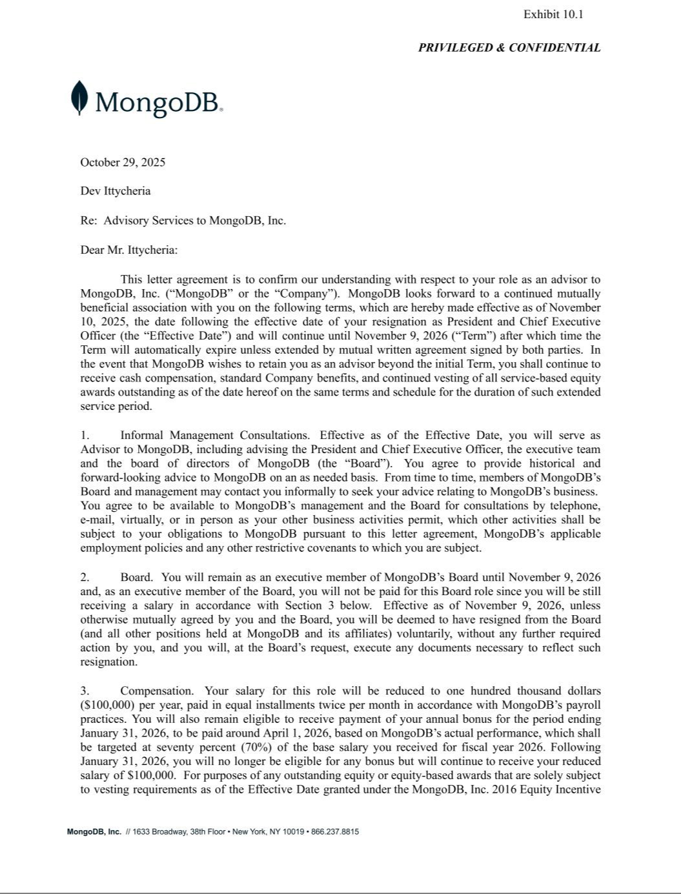

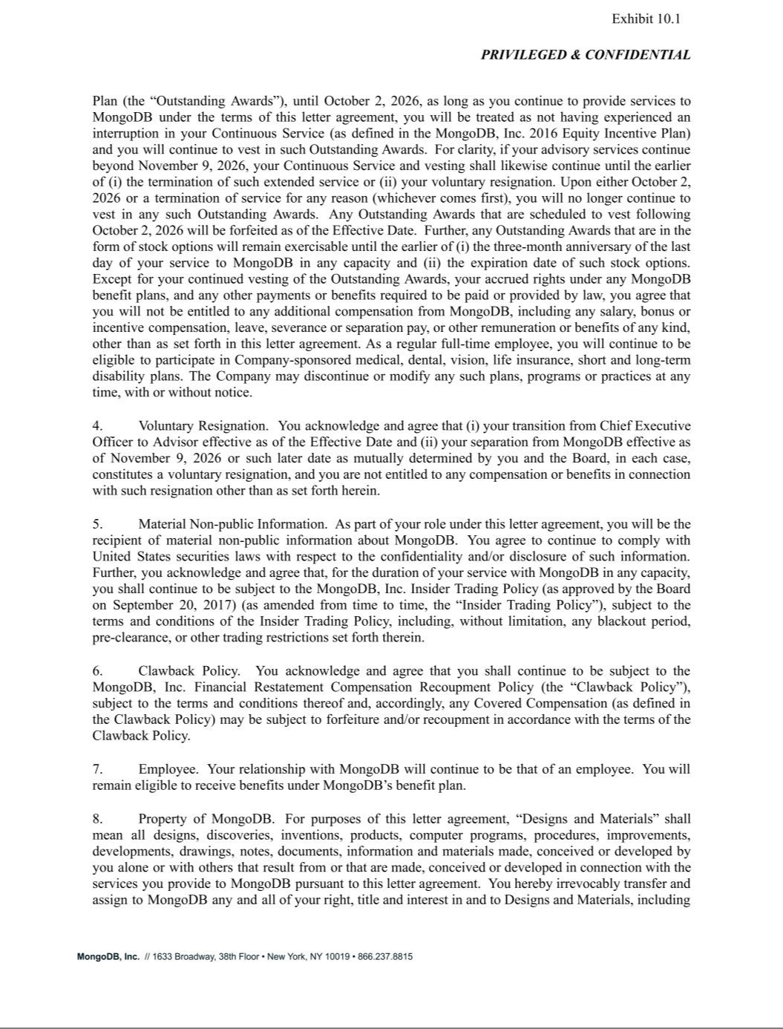

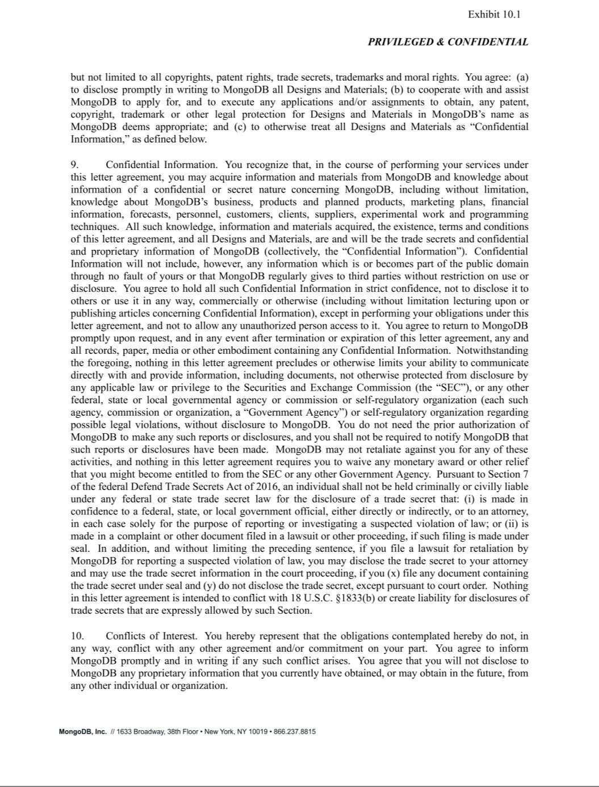

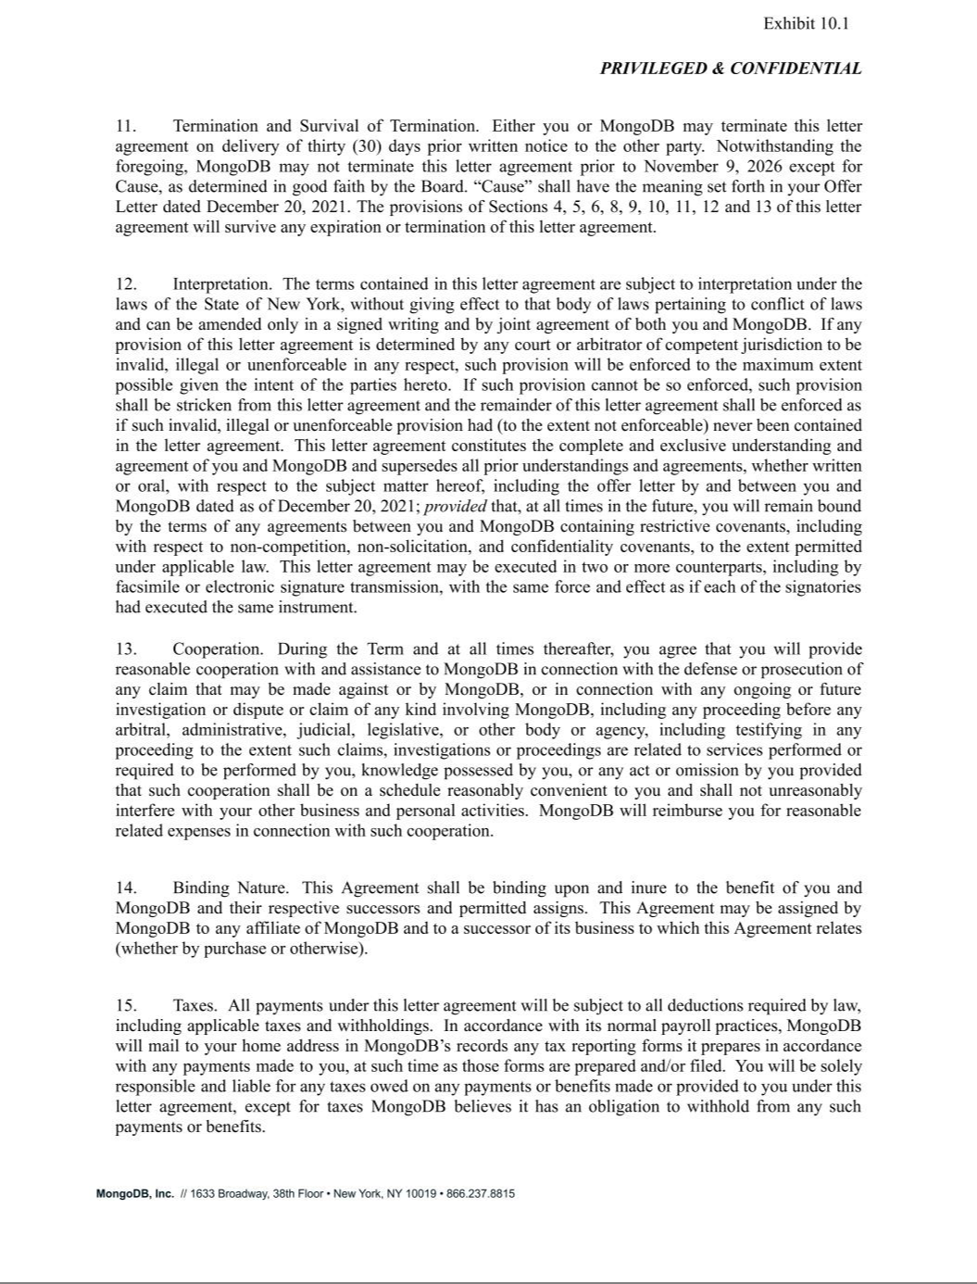

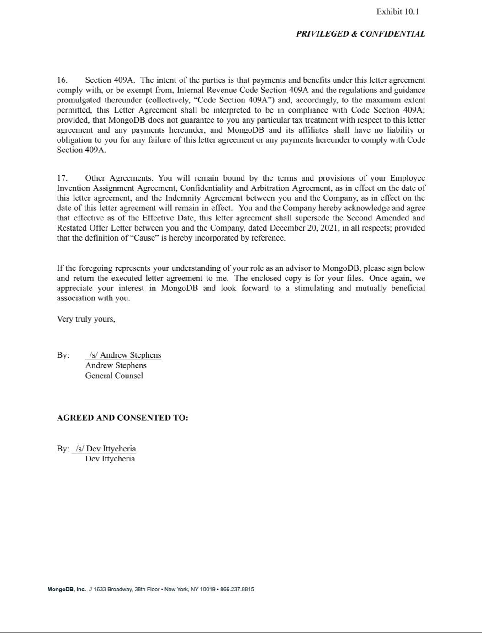

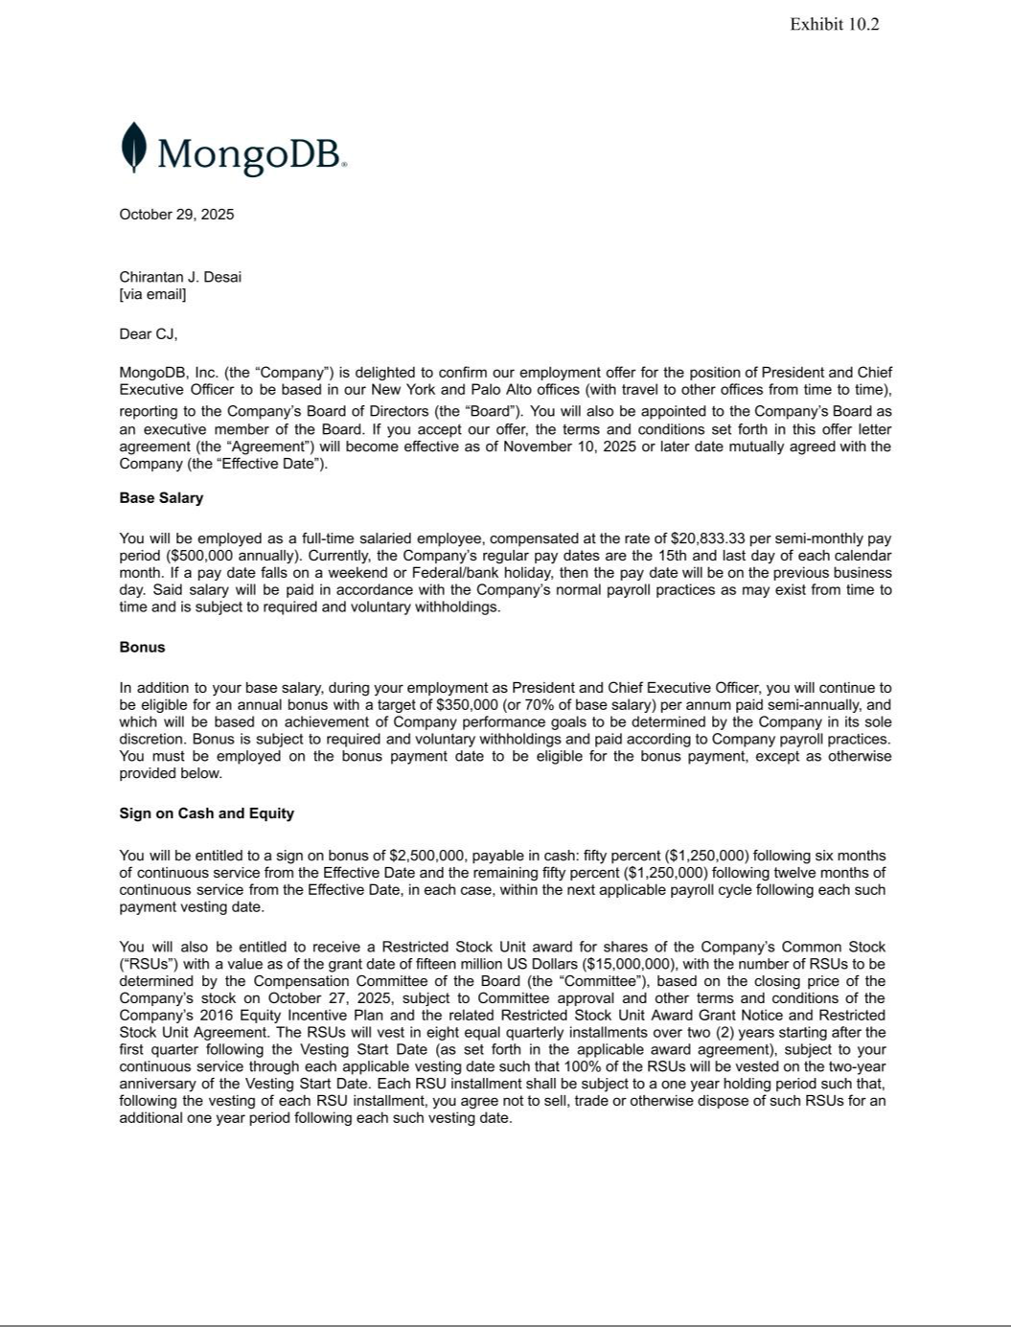

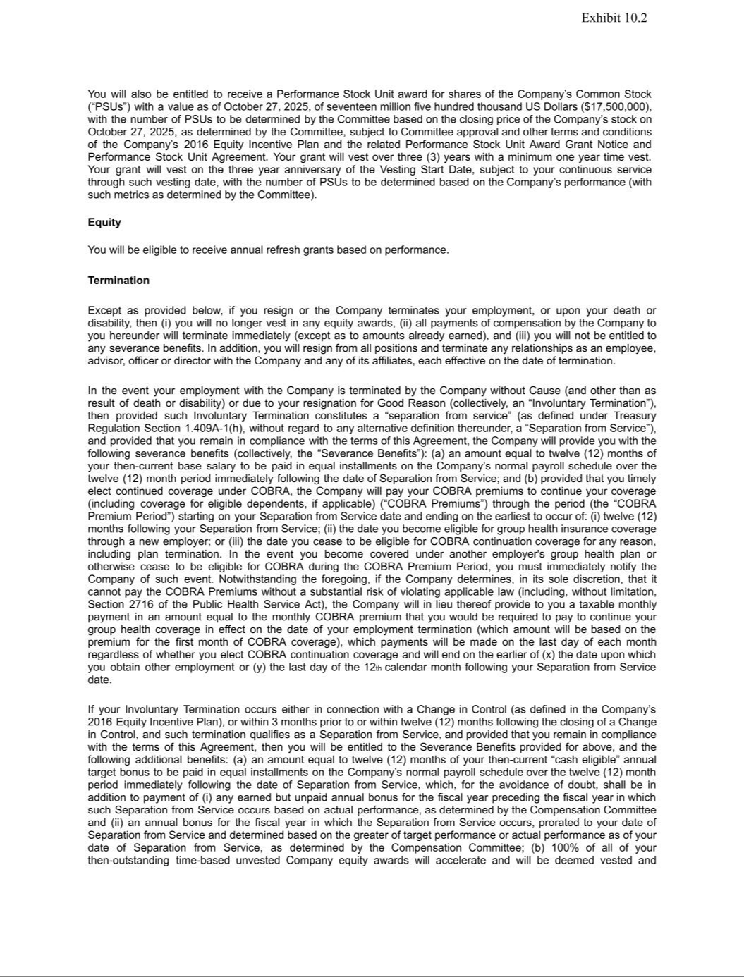

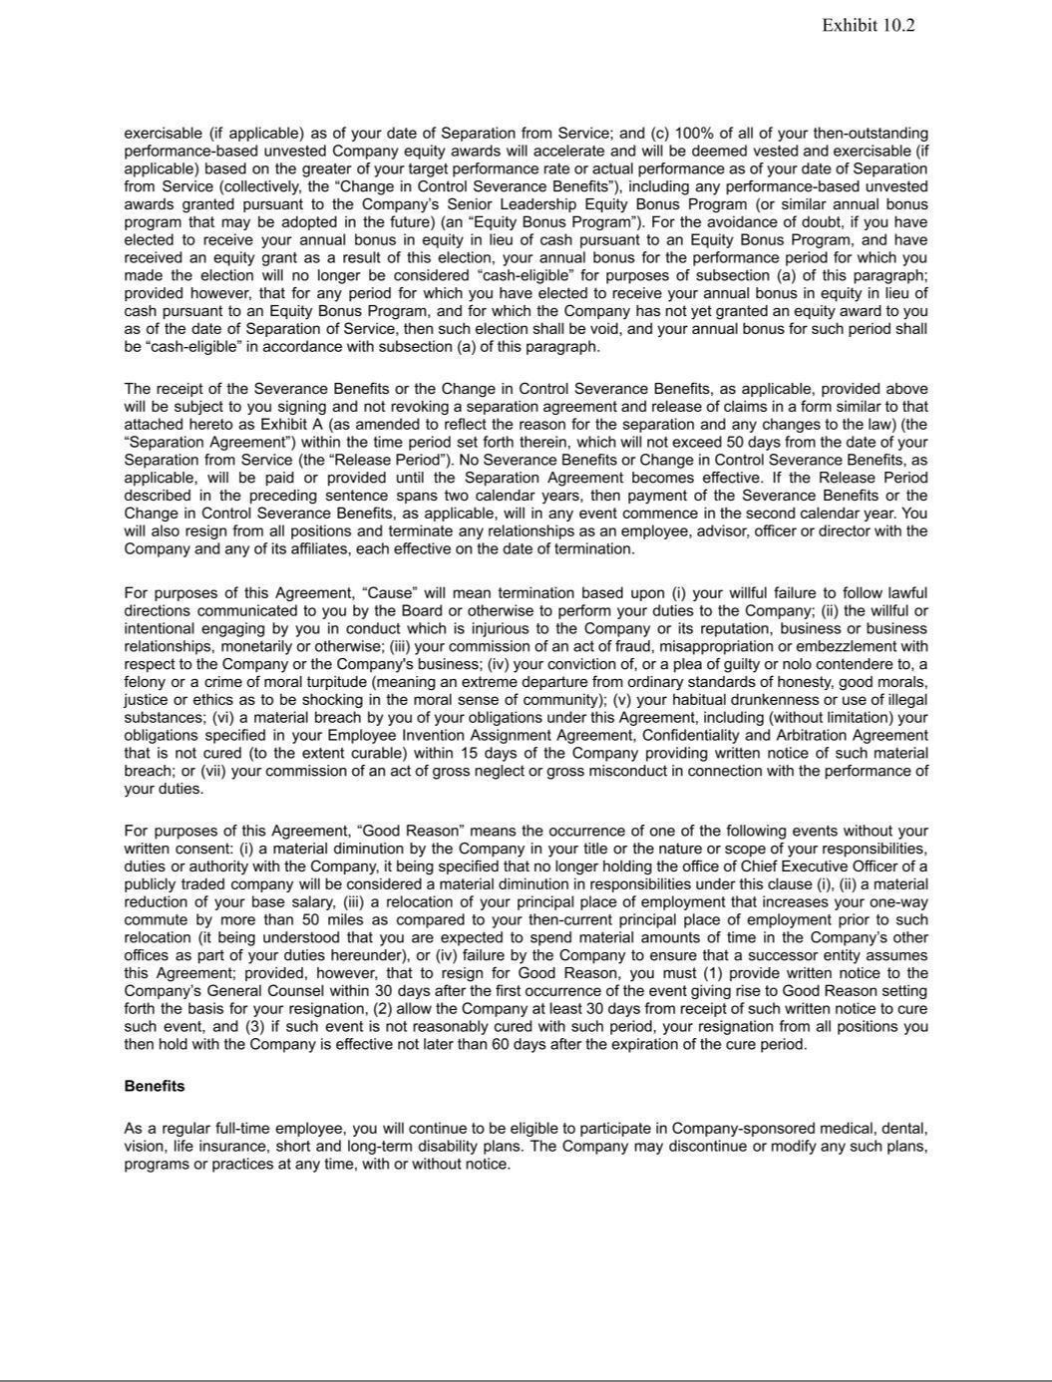

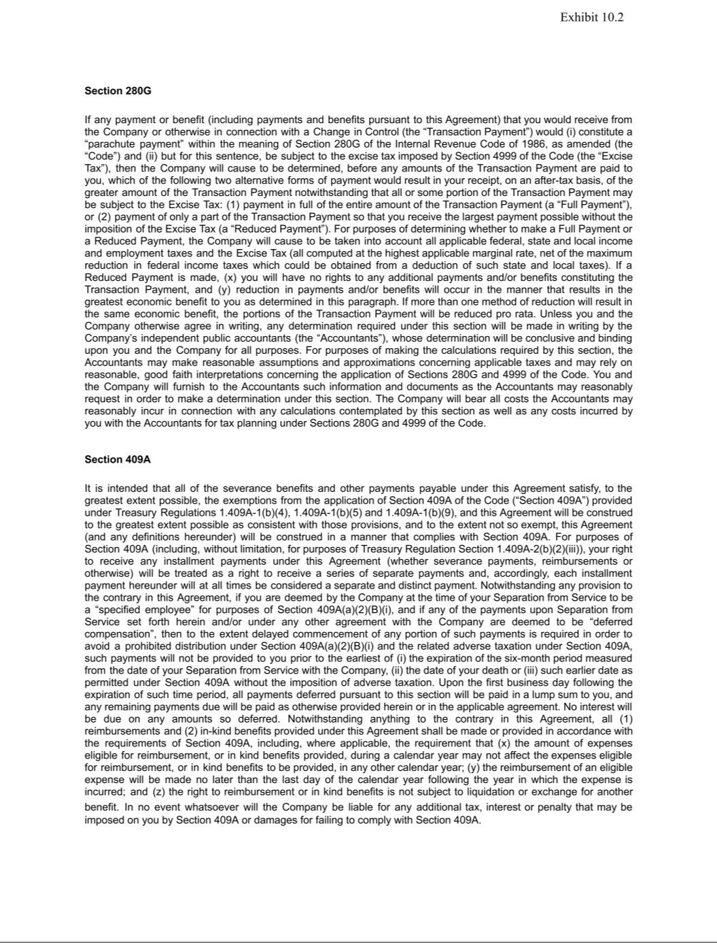

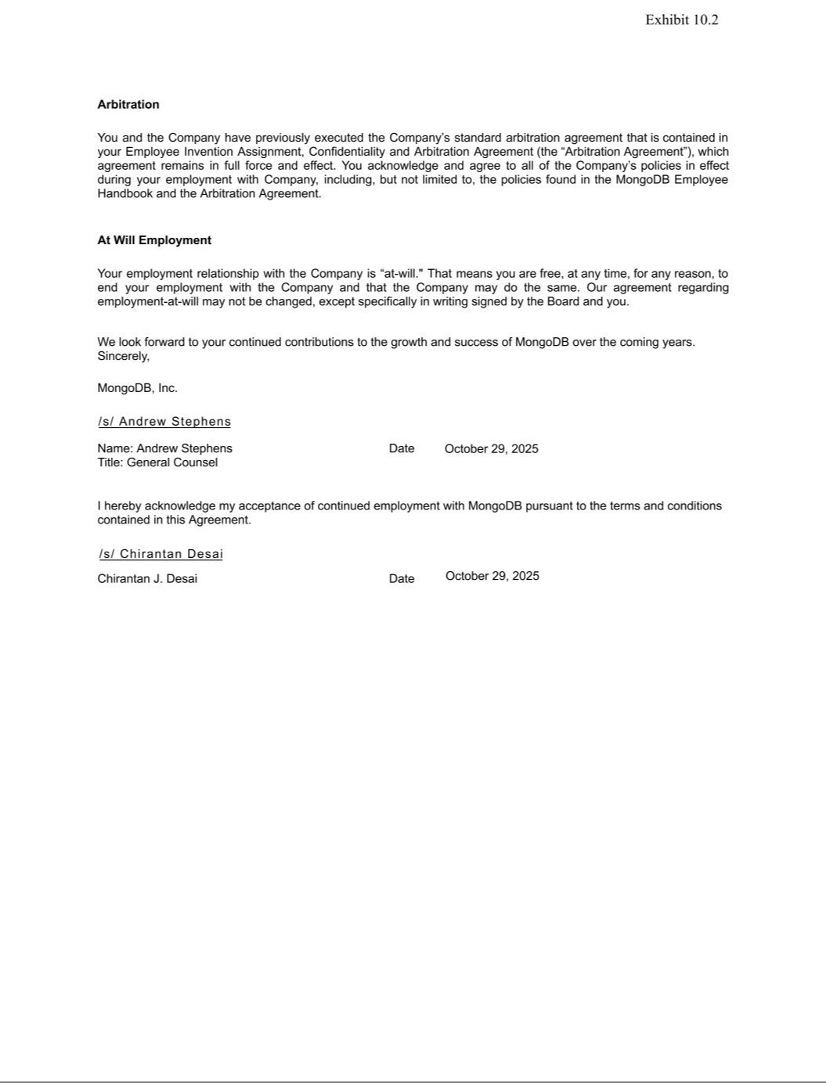

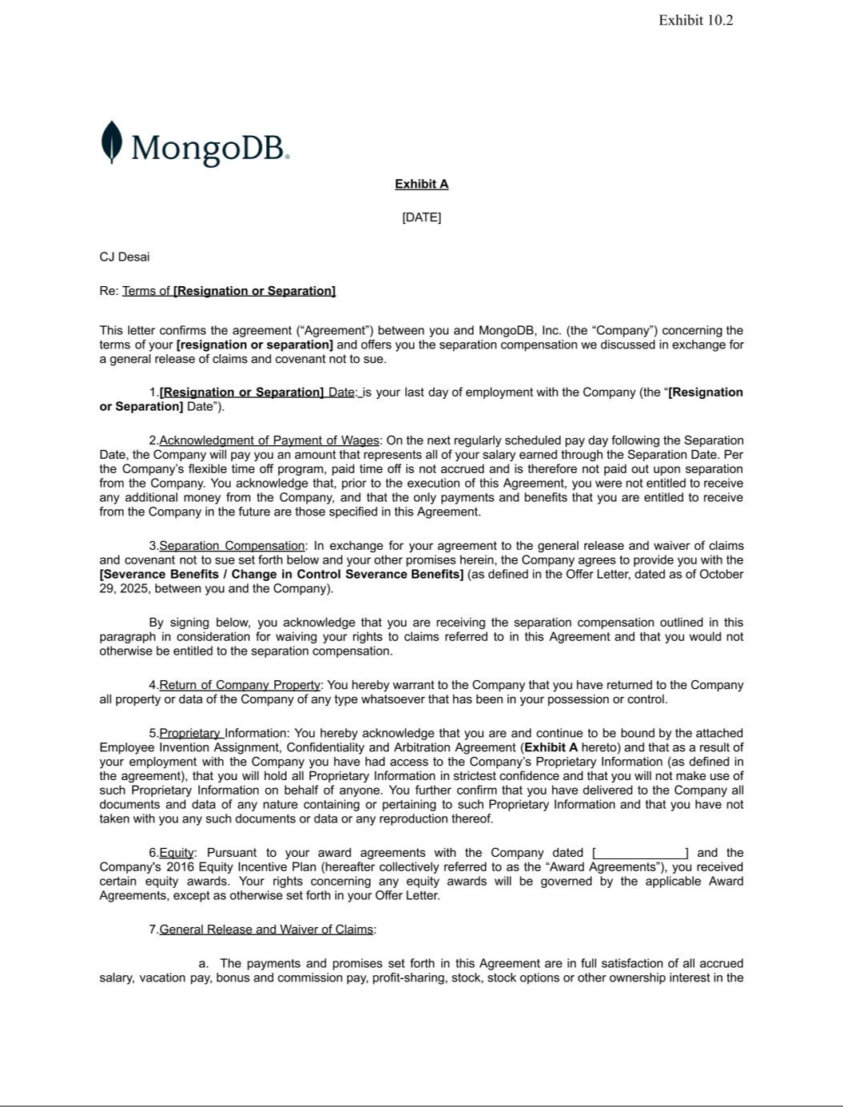

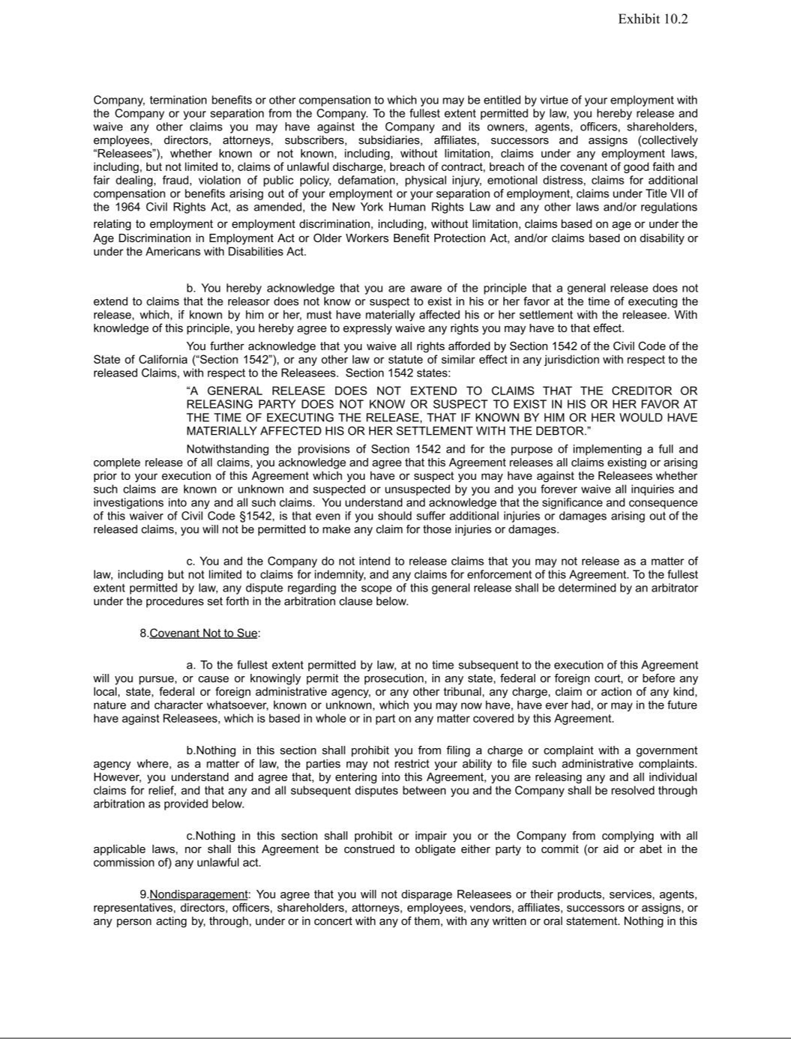

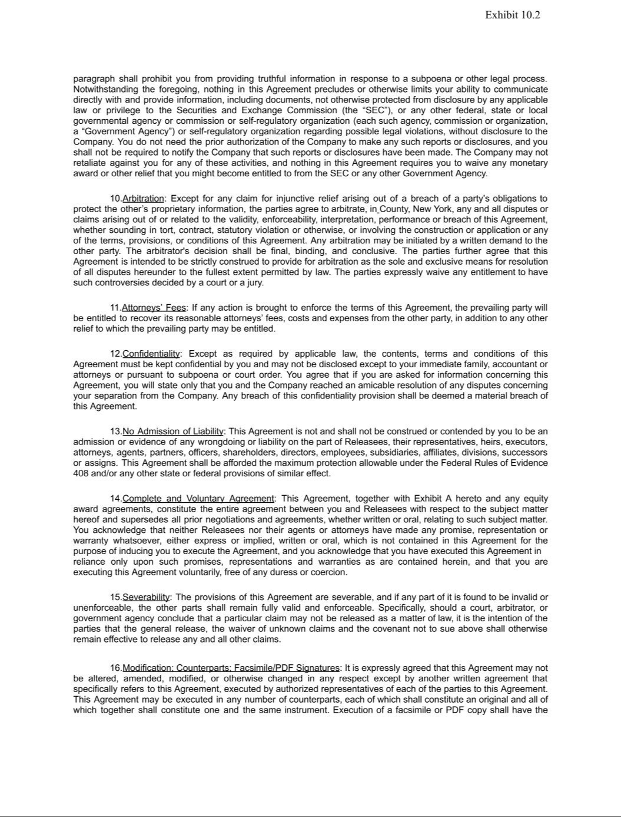



Exhibit 31.1

Certification by the Chief Executive Officer pursuant to

Securities Exchange Act Rules 13a-14(a) and 15d-14(a)

as adopted pursuant to Section 302 of the Sarbanes-Oxley Act of 2002

I, Chirantan J. Desai, certify that:

- I have reviewed this Quarterly Report on Form 10-Q of MongoDB, Inc. (the “registrant”);

- Based on my knowledge, this report does not contain any untrue statement of a material fact or omit to state a material fact necessary to make the statements made, in light of the circumstances under which such statements were made, not misleading with respect to the period covered by this report;

- Based on my knowledge, the financial statements, and other financial information included in this report, fairly present in all material respects the financial condition, results of operations and cash flows of the registrant as of, and for, the periods presented in this report;

- The registrant's other certifying officer(s) and I are responsible for establishing and maintaining disclosure controls and procedures (as defined in Exchange Act Rules 13a-15(e) and 15d-15(e)) and internal control over financial reporting (as defined in Exchange Act Rules 13a-15(f) and 15d-15(f)) for the registrant and have:

  - Designed such disclosure controls and procedures, or caused such disclosure controls and procedures to be designed under our supervision, to ensure that material information relating to the registrant, including its consolidated subsidiaries, is made known to us by others within those entities, particularly during the period in which this report is being prepared;

  - Designed such internal control over financial reporting, or caused such internal control over financial reporting to be designed under our supervision, to provide reasonable assurance regarding the reliability of financial reporting and the preparation of financial statements for external purposes in accordance with generally accepted accounting principles;

  - Evaluated the effectiveness of the registrant's disclosure controls and procedures and presented in this report our conclusions about the effectiveness of the disclosure controls and procedures, as of the end of the period covered by this report based on such evaluation; and

  - Disclosed in this report any change in the registrant's internal control over financial reporting that occurred during the registrant's most recent fiscal quarter (the registrant's fourth fiscal quarter in the case of an annual report) that has materially affected, or is reasonably likely to materially affect, the registrant's internal control over financial reporting; and

- The registrant's other certifying officer(s) and I have disclosed, based on our most recent evaluation of internal control over financial reporting, to the registrant's auditors and the audit committee of the registrant's board of directors (or persons performing the equivalent functions):

  - All significant deficiencies and material weaknesses in the design or operation of internal control over financial reporting which are reasonably likely to adversely affect the registrant's ability to record, process, summarize and report financial information; and

  - Any fraud, whether or not material, that involves management or other employees who have a significant role in the registrant's internal control over financial reporting.

Date: December 2, 2025 By: /s/ Chirantan J. Desai

Name: Chirantan J. Desai

Title: President and Chief Executive Officer

(Principal Executive Officer)

Exhibit 31.2

Certification by the Chief Financial Officer pursuant to

Securities Exchange Act Rules 13a-14(a) and 15d-14(a)

as adopted pursuant to Section 302 of the Sarbanes-Oxley Act of 2002

I, Michael J. Berry, certify that:

- I have reviewed this Quarterly Report on Form 10-Q of MongoDB, Inc. (the “registrant”);

- Based on my knowledge, this report does not contain any untrue statement of a material fact or omit to state a material fact necessary to make the statements made, in light of the circumstances under which such statements were made, not misleading with respect to the period covered by this report;

- Based on my knowledge, the financial statements, and other financial information included in this report, fairly present in all material respects the financial condition, results of operations and cash flows of the registrant as of, and for, the periods presented in this report;

- The registrant's other certifying officer(s) and I are responsible for establishing and maintaining disclosure controls and procedures (as defined in Exchange Act Rules 13a-15(e) and 15d-15(e)) and internal control over financial reporting (as defined in Exchange Act Rules 13a-15(f) and 15d-15(f)) for the registrant and have:

  - Designed such disclosure controls and procedures, or caused such disclosure controls and procedures to be designed under our supervision, to ensure that material information relating to the registrant, including its consolidated subsidiaries, is made known to us by others within those entities, particularly during the period in which this report is being prepared;

  - Designed such internal control over financial reporting, or caused such internal control over financial reporting to be designed under our supervision, to provide reasonable assurance regarding the reliability of financial reporting and the preparation of financial statements for external purposes in accordance with generally accepted accounting principles;

  - Evaluated the effectiveness of the registrant's disclosure controls and procedures and presented in this report our conclusions about the effectiveness of the disclosure controls and procedures, as of the end of the period covered by this report based on such evaluation; and

  - Disclosed in this report any change in the registrant's internal control over financial reporting that occurred during the registrant's most recent fiscal quarter (the registrant's fourth fiscal quarter in the case of an annual report) that has materially affected, or is reasonably likely to materially affect, the registrant's internal control over financial reporting; and

- The registrant's other certifying officer(s) and I have disclosed, based on our most recent evaluation of internal control over financial reporting, to the registrant's auditors and the audit committee of the registrant's board of directors (or persons performing the equivalent functions):

  - All significant deficiencies and material weaknesses in the design or operation of internal control over financial reporting which are reasonably likely to adversely affect the registrant's ability to record, process, summarize and report financial information; and

  - Any fraud, whether or not material, that involves management or other employees who have a significant role in the registrant's internal control over financial reporting.

Date: December 2, 2025 By: /s/ Michael J. Berry

Name: Michael J. Berry

Title: Chief Financial Officer

(Principal Financial Officer)

Exhibit 32.1

CERTIFICATION OF PRINCIPAL EXECUTIVE OFFICER

PURSUANT TO 18 U.S.C. SECTION 1350,

AS ADOPTED PURSUANT TO

SECTION 906 OF THE SARBANES-OXLEY ACT OF 2002

I, Chirantan J. Desai, certify, pursuant to 18 U.S.C. Section 1350, as adopted pursuant to Section 906 of the Sarbanes-Oxley Act of 2002, that the Quarterly Report on Form 10-Q of MongoDB, Inc. for the period ended October 31, 2025 fully complies with the requirements of Section 13(a) or 15(d) of the Securities Exchange Act of 1934, as amended, and that information contained in such Quarterly Report on Form 10-Q fairly presents, in all material respects, the financial condition and results of operations of MongoDB, Inc.

Date: December 2, 2025 By: /s/ Chirantan J. Desai

Name: Chirantan J. Desai

Title: President and Chief Executive Officer

(Principal Executive Officer)

This certification accompanies the Quarterly Report, is not deemed filed with the Securities and Exchange Commission and is not to be incorporated by reference into any filing of MongoDB, Inc. under the Securities Act of 1933, as amended, or the Securities Exchange Act of 1934, as amended (whether made before or after the date of the Quarterly Report on Form 10-Q), irrespective of any general incorporation language contained in such filing.

Exhibit 32.2

CERTIFICATION OF PRINCIPAL FINANCIAL OFFICER

PURSUANT TO 18 U.S.C. SECTION 1350,

AS ADOPTED PURSUANT TO

SECTION 906 OF THE SARBANES-OXLEY ACT OF 2002

I, Michael J. Berry, certify, pursuant to 18 U.S.C. Section 1350, as adopted pursuant to Section 906 of the Sarbanes-Oxley Act of 2002, that the Quarterly Report on Form 10-Q of MongoDB, Inc. for the period ended October 31, 2025 fully complies with the requirements of Section 13(a) or 15(d) of the Securities Exchange Act of 1934, as amended, and that information contained in such Quarterly Report on Form 10-Q fairly presents, in all material respects, the financial condition and results of operations of MongoDB, Inc.

Date: December 2, 2025 By: /s/ Michael J. Berry

Name: Michael J. Berry

Title: Chief Financial Officer

(Principal Financial Officer)

This certification accompanies the Quarterly Report, is not deemed filed with the Securities and Exchange Commission and is not to be incorporated by reference into any filing of MongoDB, Inc. under the Securities Act of 1933, as amended, or the Securities Exchange Act of 1934, as amended (whether made before or after the date of the Quarterly Report on Form 10-Q), irrespective of any general incorporation language contained in such filing.

