UNITED STATES
SECURITIES AND EXCHANGE COMMISSION
WASHINGTON, D.C. 20549
___________________
FORM 8-K
___________________
CURRENT REPORT
Pursuant to Section 13 or 15(d) of the Securities Exchange Act of 1934
Date of Report (Date of earliest event reported): September 25, 2026
___________________
MONGODB, INC.
(Exact Name of Registrant as Specified in its Charter)
___________________
Delaware |  |  |  |  |  | 001-38240 |  |  | 26-1463205
(State or Other Jurisdiction  of Incorporation) |  |  |  |  |  | (Commission File Number) |  |  | (IRS Employer  Identification No.)
1633 Broadway, |  |  | 38th Floor
New York, |  |  | NY |  |  |  |  |  | 10019
(Address of Principal Executive Offices) |  |  |  |  |  |  |  |  | (Zip Code)
646-727-4092
(Registrant’s Telephone Number, Including Area Code)
Not Applicable
(Former Name or Former Address, if Changed Since Last Report)
___________________
Securities registered pursuant to Section 12(b) of the Exchange Act:
Title of each class |  |  |  |  |  | Trading Symbol(s) |  |  |  |  |  | Name of each exchange on which registered
Common Stock, par value $0.001 per share |  |  |  |  |  | MDB |  |  |  |  |  | The Nasdaq Stock Market LLC
 |  |  |  |  |  |  |  |  |  |  |  | (Nasdaq Global Market)
Check the appropriate box below if the Form 8-K filing is intended to simultaneously satisfy the filing obligation of the registrant under any of the following provisions (see General Instructions A.2. below):
☐ Written communications pursuant to Rule 425 under the Securities Act (17 CFR 230.425)
☐ Soliciting material pursuant to Rule 14a-12 under the Exchange Act (17 CFR 240.14a-12)
☐ Pre-commencement communications pursuant to Rule 14d-2(b) under the Exchange Act (17 CFR 240.14d-2(b))
☐ Pre-commencement communications pursuant to Rule 13e-4(c) under the Exchange Act (17 CFR 240.13e-4(c))
Indicate by check mark whether the registrant is an emerging growth company as defined in Rule 405 of the Securities Act of 1933 (§230.405 of this chapter) or Rule 12b-2 of the Securities Exchange Act of 1934 (§240.12b-2 of this chapter).
Emerging growth company ☐
If an emerging growth company, indicate by check mark if the registrant has elected not to use the extended transition period for complying with any new or revised financial accounting standards provided pursuant to Section 13(a) of the Exchange Act. ☐

Item 7.01. Regulation FD Disclosure

On September 29, 2026, MongoDB, Inc. (the “Company”) hosted an Investor Day accessible via webcast during which members of the leadership team discussed the Company’s strategies to drive sustainable growth and deliver long-term shareholder value.

A copy of the presentation materials that were used by members of the Company’s leadership team and includes information regarding the matters addressed by the Company at Investor Day is furnished as Exhibit 99.1 to this Current Report on Form 8-K and is incorporated into this Item 7.01 of this Current Report on Form 8-K by reference.

The information in this Item 7.01 of this Current Report on Form 8-K, including Exhibit 99.1, shall not be deemed to be “filed” for purposes of Section 18 of the Securities Exchange Act of 1934, as amended (the “Exchange Act”), or otherwise subject to the liabilities of that section, nor shall it be deemed to be incorporated by reference in any filing under the Securities Act of 1933, as amended, or the Exchange Act except as shall be expressly set forth by the specific reference in such filing.

Item 8.01. Other Events.

On September 25, 2026, the Company’s Board of Directors authorized an additional $1.0 billion in repurchases under the Company’s existing share repurchase program, bringing the aggregate authorized repurchase amount to $2.0 billion, of which $1,353,700,000 remains available for future repurchases as of the date of this filing. Repurchases of the Company's common stock may be made from time to time, either through open market transactions or in privately negotiated transactions. The timing of the repurchases will depend on certain factors, including but not limited to, market conditions and prices and management’s discretion. The repurchases may be suspended, terminated or modified at any time for any reason, including market conditions, the cost of repurchasing shares, the availability of alternative investment opportunities, liquidity, and other factors deemed appropriate. These factors may also affect the timing and amount of share repurchases. The Company is not obligated to purchase any dollar amount or particular number of shares.

Item 9.01 Financial Statements and Exhibits.
(d) Exhibits
Exhibit No. |  |  |  |  |  | Description
99.1 |  |  |  |  |  | Investor Day Presentation
104 |  |  |  |  |  | Cover Page Interactive Data File (embedded within the Inline XBRL document)

SIGNATURES
Pursuant to the requirements of the Securities Exchange Act of 1934, as amended, the Registrant has duly caused this report to be signed on its behalf by the undersigned hereunto duly authorized.
 |  |  | MONGODB, INC.
Dated: September 29, 2026 |  |  | By: |  |  |  |  |  | /s/ Andrew Stephens
Name: Andrew Stephens
Title: Chief Legal Officer and Secretary

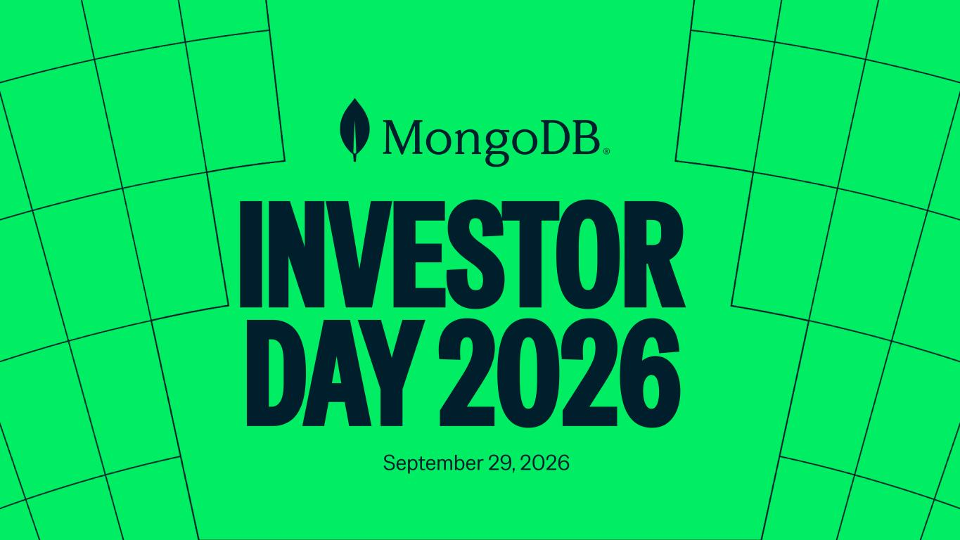

INVESTOR DAY 2026 September 29, 2026


I N V E S T O R D A Y Safe Harbor This presentation and the accompanying oral presentation have been prepared by MongoDB, Inc. (“MongoDB” or the “company”) for informational purposes only and not for any other purpose. Nothing contained in this presentation is, or should be construed as, a recommendation, promise or representation by the presenter or MongoDB or any officer, director, employee, agent or advisor of MongoDB. This presentation does not purport to be all-inclusive or to contain all of the information you may desire. Information provided in this presentation speaks only as of the date hereof, unless otherwise indicated. This presentation contains “forward-looking statements” within the meaning of Section 27A of the Securities Act of 1933, as amended, and Section 21E of the Securities Exchange Act of 1934, as amended, including but not limited to statements regarding our financial outlook, financial guidance for fiscal 2027 and beyond, long-term financial targets, product development, business strategy and plans, market trends and market size and opportunities, our ability to continue to increase revenue from our Atlas platform, the recently announced leadership transition and the expected financial impact of AI adoption and new product innovations. These forward-looking statements include, but are not limited to, plans, objectives, expectations and intentions and other statements contained in this presentation that are not historical facts and statements, and may be identified by words such as “anticipate,” “believe,” “continue,” “could,” “estimate,” “expect,” “intend,” “may,” “plan,” “project,” “will,” “would” or the negative or plural of these words or similar expressions or variations. These forward-looking statements reflect our current views about our plans, intentions, expectations, strategies and prospects, which are based on the information currently available to us and on assumptions we have made. Although we believe that our plans, intentions, expectations, strategies and prospects as reflected in or suggested by those forward-looking statements are reasonable, we can give no assurance that the plans, intentions, expectations or strategies will be attained or achieved. In particular, the development, release, and timing of any features or functionality described for MongoDB products remains at MongoDB's sole discretion. Product roadmaps do not represent a commitment, promise or legal obligation to deliver any material, code, or functionality and you should not rely on them to make your purchase decisions. Furthermore, actual results may differ materially from those described in the forward-looking statements and are subject to a variety of assumptions, uncertainties, risks and factors that are beyond our control including, without limitation: the effects of ongoing geopolitical instability, including the conflict in Iran, the unrest in Mexico, the conflicts between Russia and Ukraine, Israel and Hamas and recent events in Venezuela, on our business and future operating results; economic downturns and/or the effects of, changes in trade policies, rising interest rates, inflation and volatility in the global economy and financial markets on our business and future operating results; our potential failure to meet publicly announced guidance or other expectations about our business and future operating results; reputational harm or other adverse consequences resulting from use of AI and ML in our product offerings and internal operations if they do not produce the desired benefits; our limited operating history; our history of losses; failure of our platform to satisfy customer demands; the effects of increased competition; our investments in new products and our ability to introduce new features, services or enhancements, including AI and ML, for both traditional and emerging use cases; social, ethical, regulatory and security issues relating to the use of new and evolving technologies, such as artificial intelligence, in our offerings or partnerships; our ability to effectively expand our sales and marketing organization; our ability to continue to build and maintain credibility with the developer community; our ability to add new customers or increase sales to our existing customers; our ability to maintain, protect, enforce and enhance our intellectual property; our ability to continue to increase revenue from our Atlas platform; the effects of social, ethical and regulatory issues relating to the use of new and evolving technologies, such as AI and ML, in our offerings or partnerships; the growth and expansion of the market for database products and our ability to penetrate that market; our ability to integrate acquired businesses and technologies successfully or achieve the expected benefits of such acquisitions; our ability to work with our strategic partners effectively; our ability to maintain the security of our software and adequately address privacy concerns; our ability to manage our growth effectively and successfully recruit and retain additional highly-qualified personnel; risks associated with the recently announced leadership transition; and the price volatility of our common stock. These and other risks and uncertainties are more fully described in our filings with the Securities and Exchange Commission (“SEC”), including under the section entitled “Risk Factors” in our Annual Report on Form 10-K for the fiscal year ended January 31, 2026 and our Quarterly Report on Form 10-Q for the quarter ended July 31, 2026 and in other filings and reports we may file from time to time with the SEC. This presentation includes market and industry data and forecasts that the company has derived from independent consultant reports, publicly available information, various industry publications, other published industry sources, and its internal data and estimates. Independent consultant reports, industry publications and other published industry sources generally indicate that the information contained therein was obtained from sources believed to be reliable. Although the company believes that these third-party sources are reliable, it does not guarantee the accuracy or completeness of this information, and the company has not independently verified this information. The company's internal data and estimates are based upon information obtained from trade and business organizations and other contacts in the markets in which the company operates and management's understanding of industry conditions. Although the company believes that such information is reliable, it has not had this information verified by any independent sources. In addition, the information contained in this presentation is as of the date hereof (except where otherwise indicated), and the company has no obligation to update such information, including in the event that such information becomes inaccurate or if estimates change. Subsequent materials may be provided by or on behalf of the company in its discretion and such information may supplement, modify or supersede the information in these materials. Neither the company, nor any of its respective affiliates, advisors or representatives shall have any liability whatsoever (in negligence or otherwise) for any loss or damage howsoever arising from any use of these materials or their contents or otherwise arising in connection with these materials. This presentation includes the following financial measures defined as non-GAAP financial measures by the SEC: non-GAAP income from operations, non-GAAP operating margin, free cash flow and free cash flow conversion. Non-GAAP income from operations and non-GAAP operating margin exclude expenses associated with stock-based compensation including employer payroll taxes upon the vesting and exercising of stock-based awards and expenses related to stock appreciation rights previously issued to our employees in China, amortization of intangible assets for the acquired technology and acquired customer relationships associated with prior acquisitions, certain acquisition-related costs and other, including due diligence costs, professional fees in connection with an acquisition and certain integration-related expenses, and restructuring costs associated with a formal restructuring plan that are primarily related to workforce reductions. The Company excludes these expenses because they are not reflective of ordinary course ongoing business and operating results. Free cash flow represents net cash from/used in operating activities, less capital expenditures, principal payments of finance lease liabilities and capitalized software development costs, if any. MongoDB uses free cash flow to understand and evaluate its liquidity and to generate future operating plans. The exclusion of capital expenditures, principal payments of finance lease liabilities and amounts capitalized for software development facilitates comparisons of MongoDB's liquidity on a period-to-period basis and excludes items that it does not consider to be indicative of its liquidity. MongoDB believes that free cash flow is a measure of liquidity that provides useful information to investors in understanding and evaluating the strength of its liquidity and future ability to generate cash that can be used for strategic opportunities or investing in its business in the same manner as MongoDB's management and board of directors. MongoDB uses these non-GAAP financial measures internally in analyzing its financial results and believes they are useful to investors, as a supplement to GAAP measures, in evaluating MongoDB's ongoing operational performance. MongoDB believes that the use of these non-GAAP financial measures provides an additional tool for investors to use in evaluating ongoing operating results and trends and in comparing its financial results with other companies in MongoDB's industry, many of which may present similar non-GAAP financial measures to investors. Non-GAAP financial measures have limitations as an analytical tool and should not be considered in isolation from, or as a substitute for, financial information prepared in accordance with GAAP. In particular, other companies may report non-GAAP income from operations, non-GAAP operating margin, free cash flow and free cash flow conversion or similarly titled measures but calculate them differently, which reduces their usefulness as comparative measures. Investors are encouraged to review the reconciliation of these non-GAAP financial measures to their most directly comparable GAAP financial measures, as presented below. This presentation and any future presentations containing such non-GAAP reconciliations can also be found on the Investor Relations page of MongoDB's website at https://investors.mongodb.com. With respect to our forward-looking non-GAAP financial measures, we have not provided a reconciliation of such measures to the most directly comparable GAAP measures for long-term future guidance beyond FY 2027 because certain items are out of our control or cannot be reasonably predicted without unreasonable efforts due to the high variability, complexity and low visibility with respect to the charges excluded from these non-GAAP measures, in particular stock-based compensation expense. Except as required by law, we undertake no obligation to update any forward-looking statements included in this presentation as a result of new information, future events, changes in expectations or otherwise. Nothing in this presentation is, and should not be construed as, an offer to sell or a solicitation of an offer to buy, any securities.

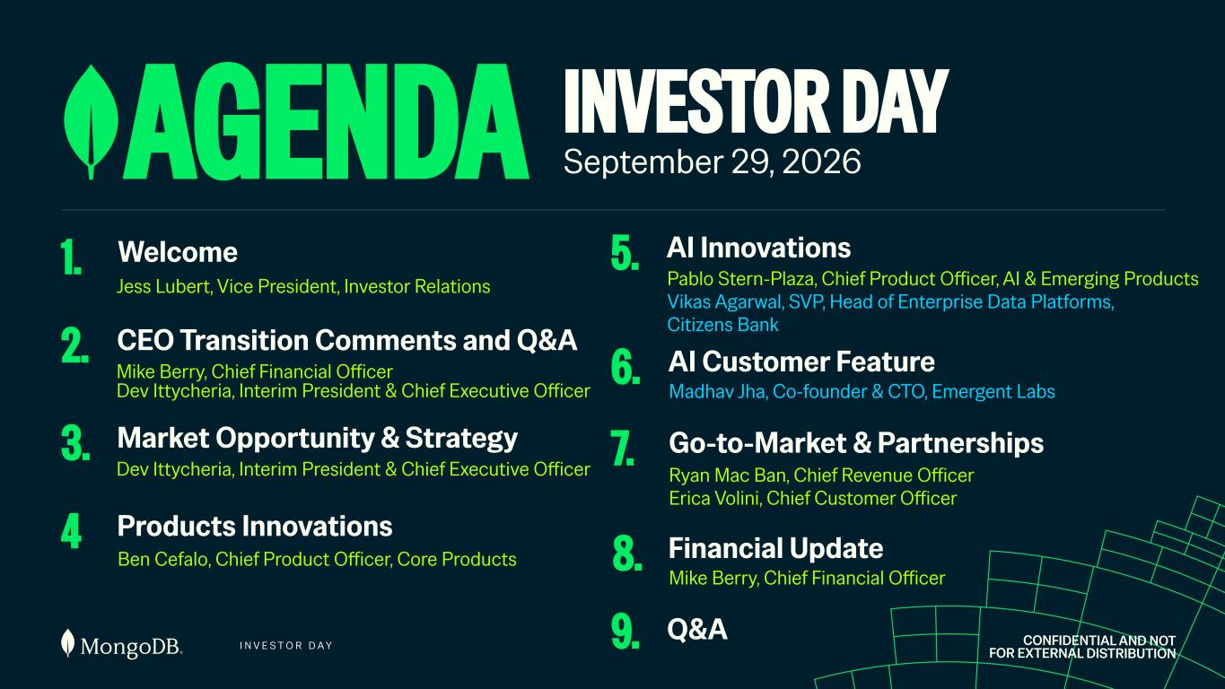
I N V E S T O R D A Y AGENDA 1. Welcome 2. CEO Transition Comments and Q&A 4 Products Innovations Ben Cefalo, Chief Product Officer, Core Products 5. AI Innovations 6. Go-to-Market & Partnerships CONFIDENTIAL AND NOT FOR EXTERNAL DISTRIBUTION Jess Lubert, Vice President, Investor Relations Mike Berry, Chief Financial Officer Dev Ittycheria, Interim President & Chief Executive Officer Pablo Stern-Plaza, Chief Product Officer, AI & Emerging Products Vikas Agarwal, SVP, Head of Enterprise Data Platforms, Citizens Bank 7. Financial Update Mike Berry, Chief Financial Officer Ryan Mac Ban, Chief Revenue Officer Erica Volini, Chief Customer Officer 8. AI Customer Feature INVESTOR DAY September 29, 2026 9. Q&A Madhav Jha, Co-founder & CTO, Emergent Labs 3. Market Opportunity & Strategy Dev Ittycheria, Interim President & Chief Executive Officer

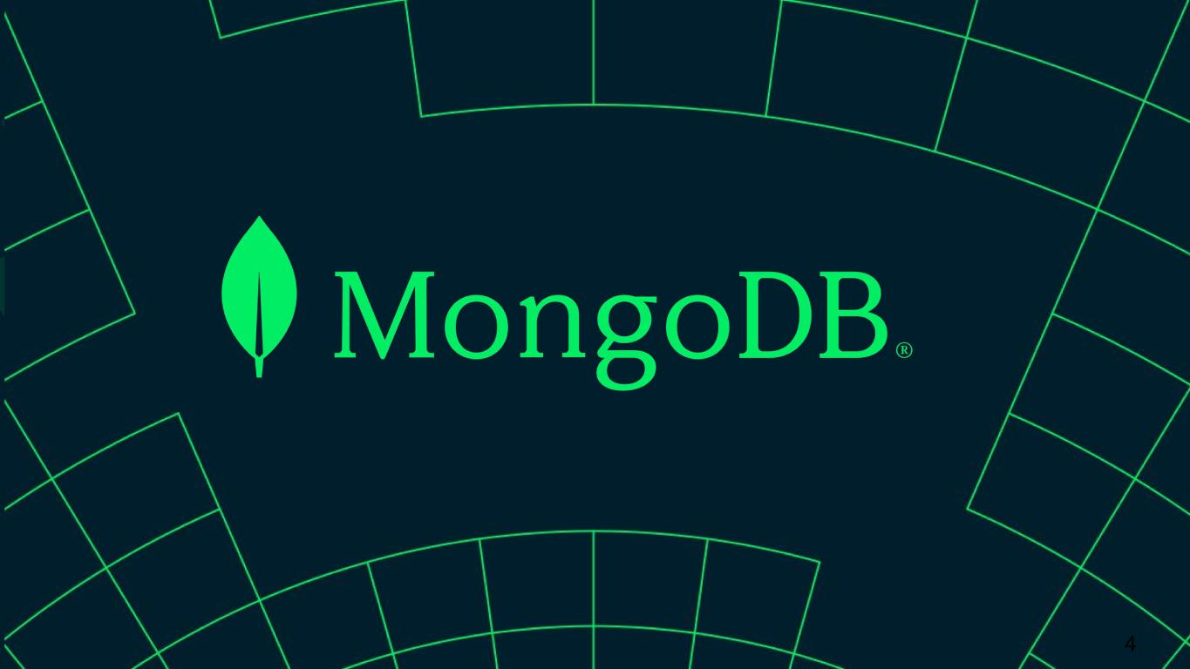
4


I N V E S T O R D A Y DURABLE GROWTH IN A LARGE MARKET Dev Ittycheria Interim President & Chief Executive Officer

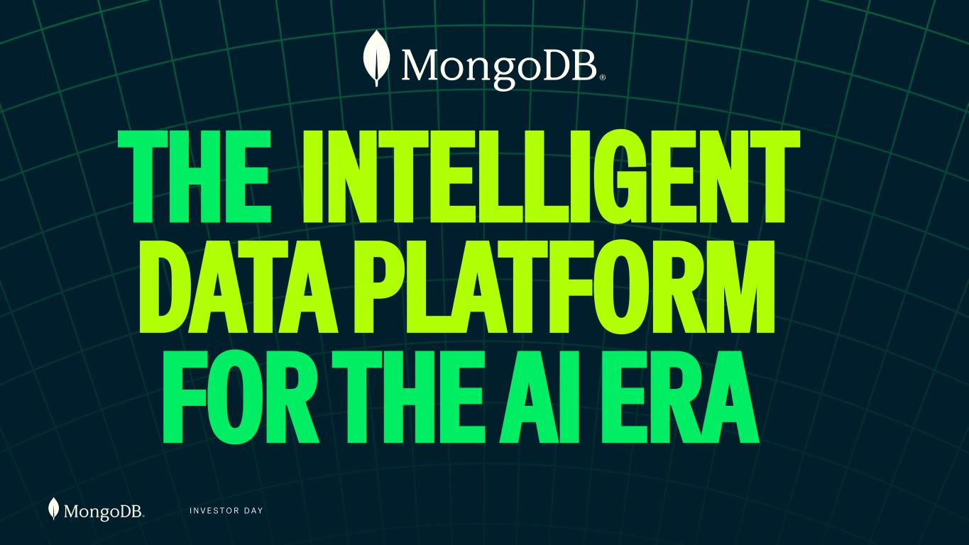
I N V E S T O R D A Y THE INTELLIGENT DATA PLATFORM FOR THE AI ERA

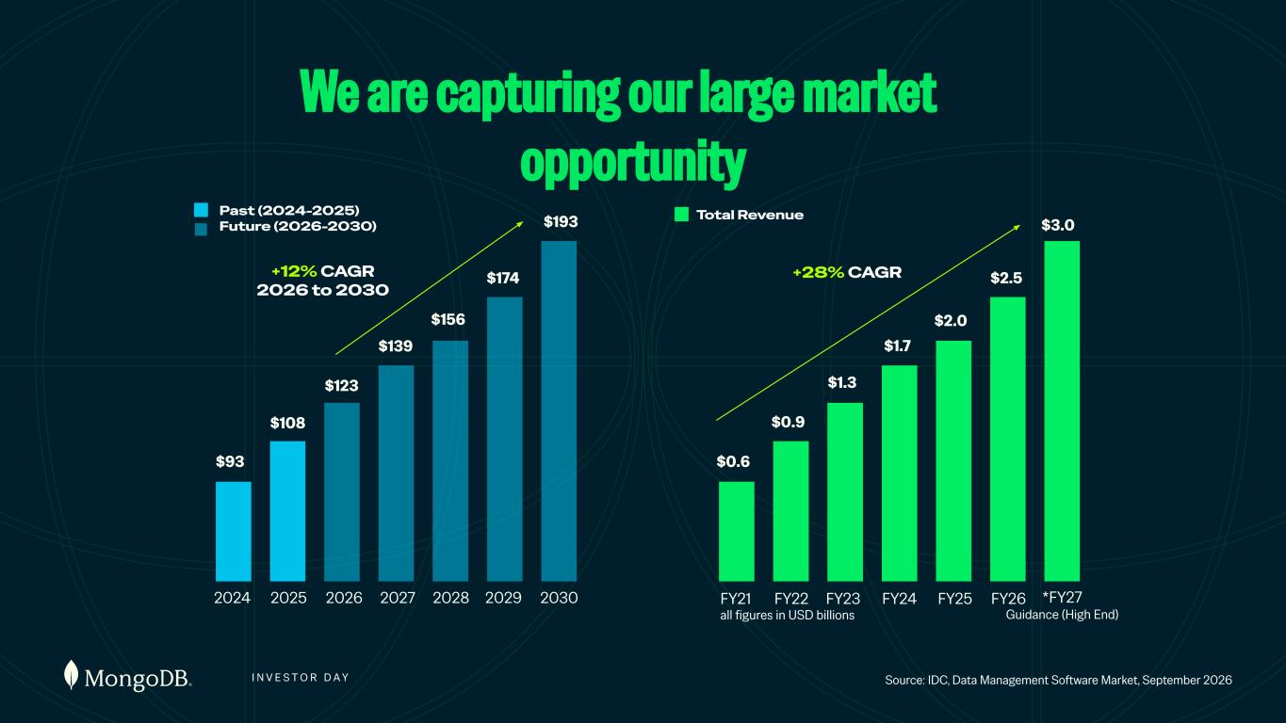
I N V E S T O R D A Y We are capturing our large market opportunity all figures in USD billions Source: IDC, Data Management Software Market, September 2026 $93 $108 $123 $139 $156 $174 $193 2029 20302024 2025 2026 2027 2028 $0.6 $0.9 $1.3 $1.7 $2.0 $2.5 FY21 FY22 FY23 FY24 FY25 FY26 *FY27 Guidance (High End) $3.0 +12% CAGR 2026 to 2030 +28% CAGR Past (2024-2025) Future (2026-2030) Total Revenue

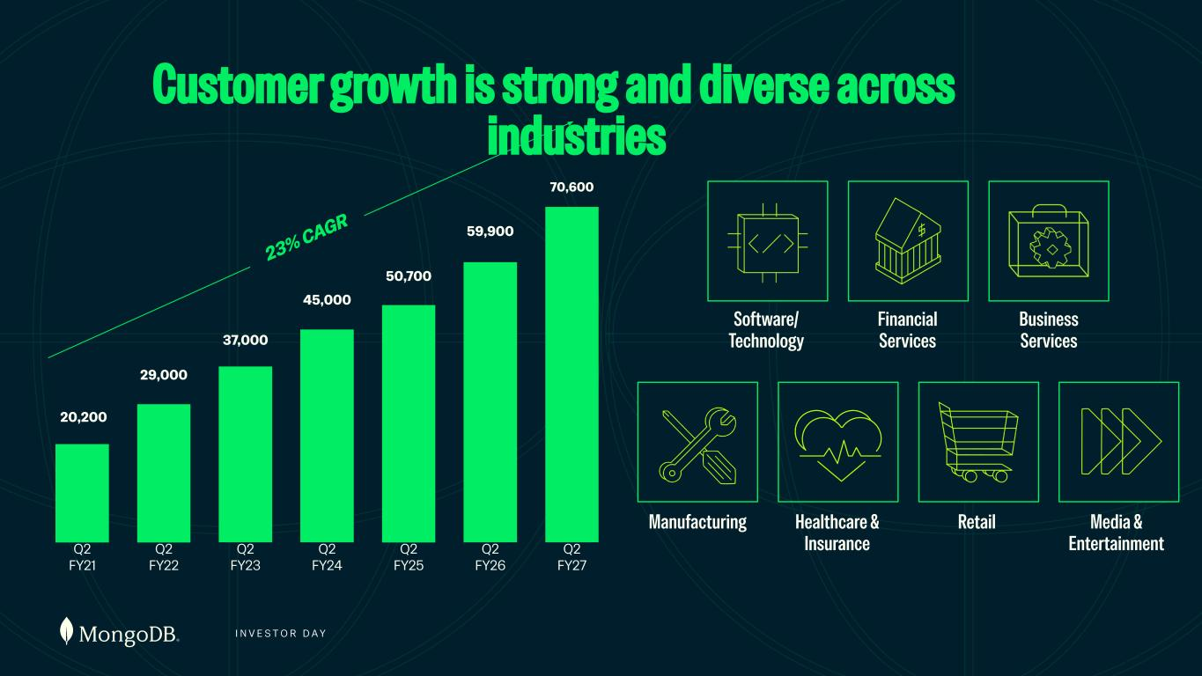
I N V E S T O R D A Y Customer growth is strong and diverse across industries Software/ Technology Financial Services Business Services Manufacturing Healthcare & Insurance Retail Media & Entertainment 20,200 Q2 FY21 Q2 FY22 Q2 FY23 Q2 FY24 Q2 FY25 Q2 FY26 Q2 FY27 29,000 37,000 45,000 50,700 59,900 23% CAGR 70,600

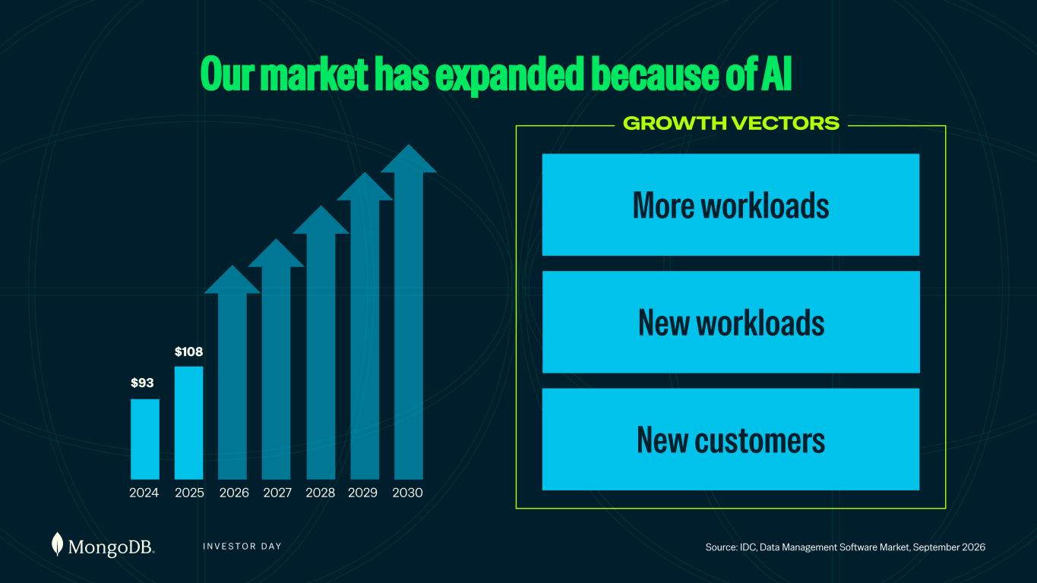
I N V E S T O R D A Y Our market has expanded because of AI Source: IDC, Data Management Software Market, September 2026 $93 $108 2029 20302024 2025 2026 2027 2028 New customers New workloads GROWTH VECTORS More workloads

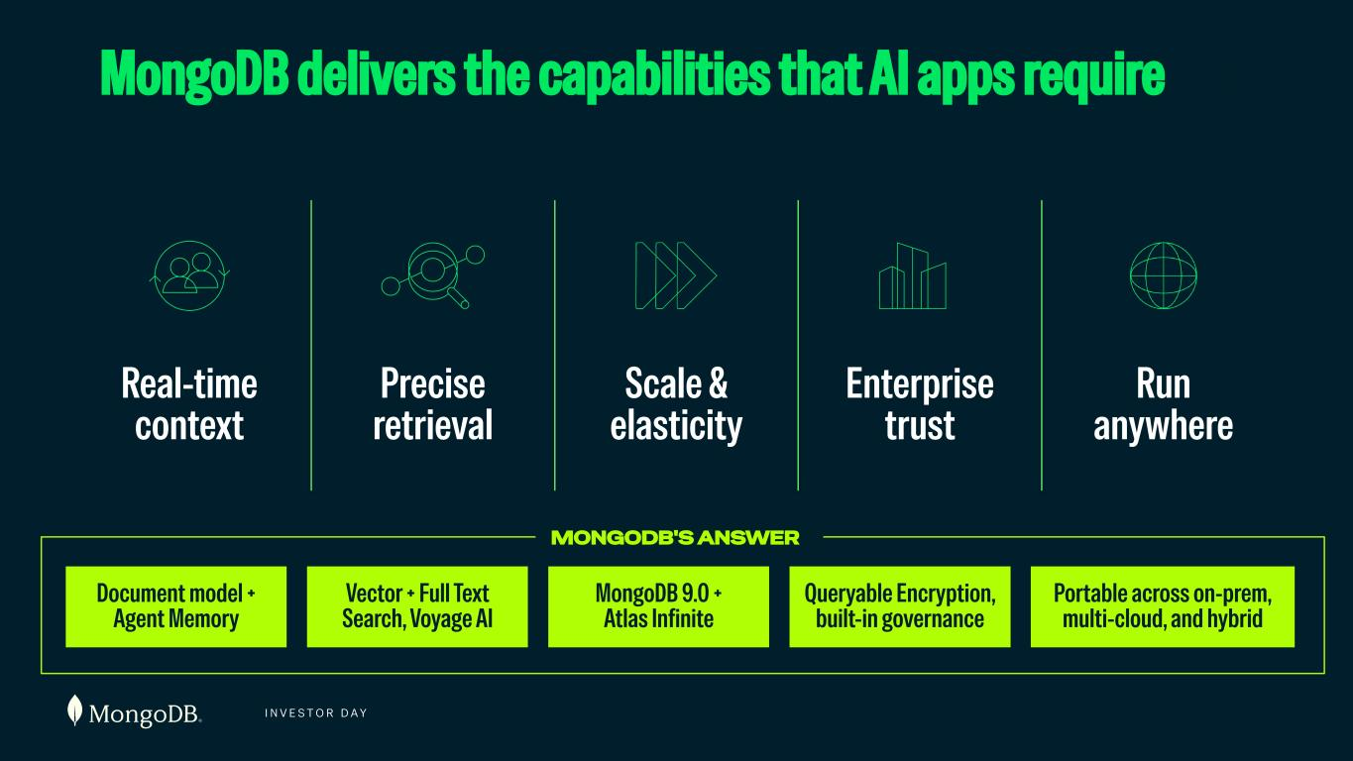
I N V E S T O R D A Y MongoDB delivers the capabilities that AI apps require MONGODB'S ANSWER Real-time context Precise retrieval Scale & elasticity Enterprise trust Run anywhere Document model + Agent Memory Vector + Full Text Search, Voyage AI MongoDB 9.0 + Atlas Infinite Queryable Encryption, built-in governance Portable across on-prem, multi-cloud, and hybrid

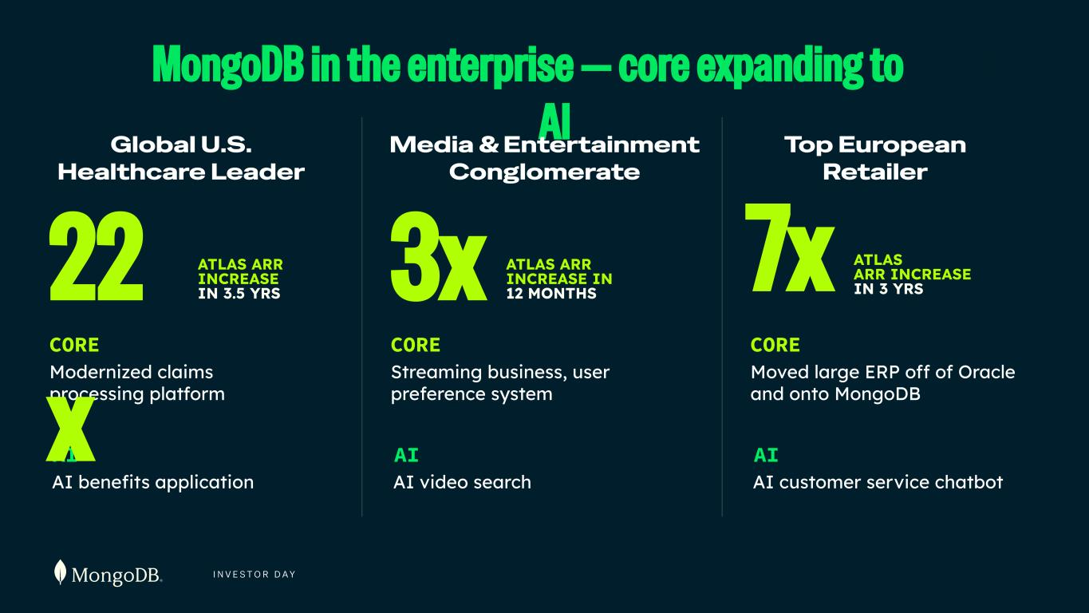
I N V E S T O R D A Y MongoDB in the enterprise — core expanding to AI ATLAS ARR INCREASE IN 3.5 YRS CORE Modernized claims processing platform AI Global U.S. Healthcare Leader 22 x Media & Entertainment Conglomerate 3x ATLAS ARR INCREASE IN 12 MONTHS Top European Retailer 7x ATLAS ARR INCREASE IN 3 YRS AI benefits application CORE Streaming business, user preference system AI AI video search CORE Moved large ERP off of Oracle and onto MongoDB AI AI customer service chatbot

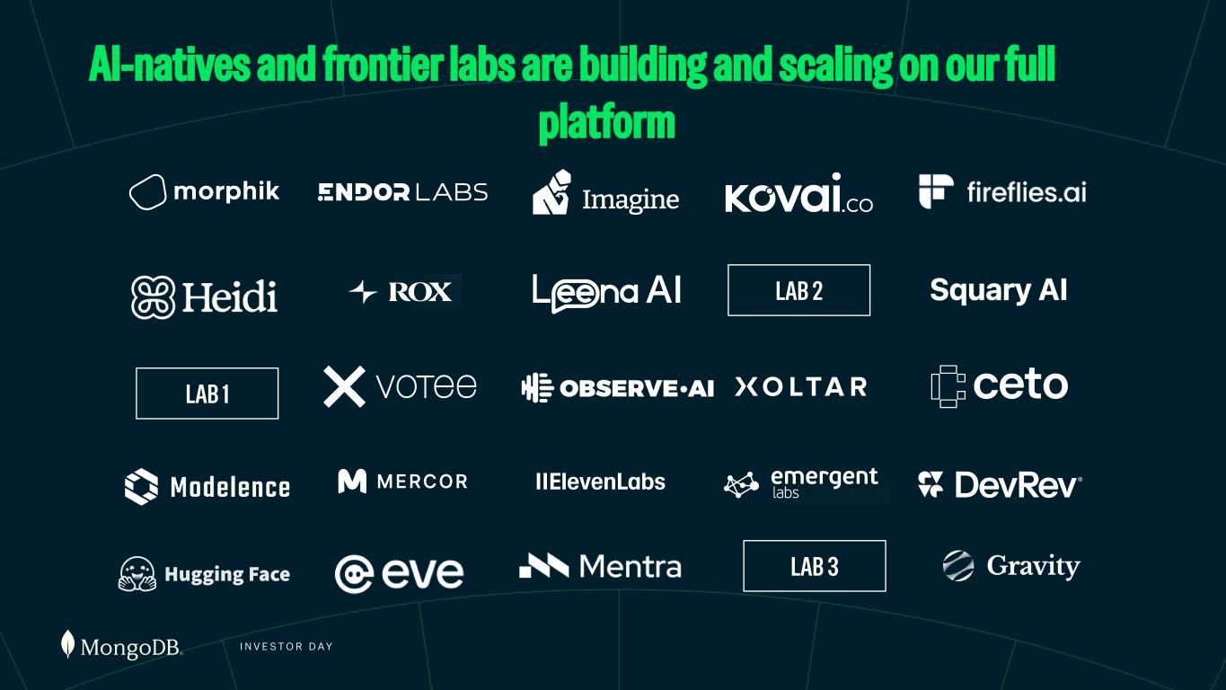
I N V E S T O R D A Y AI-natives and frontier labs are building and scaling on our full platform LAB 1 LAB 2 LAB 3

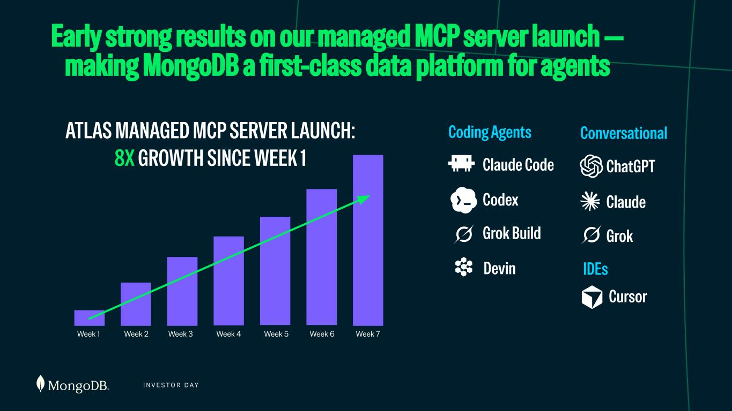
I N V E S T O R D A Y Early strong results on our managed MCP server launch — making MongoDB a first-class data platform for agents ATLAS MANAGED MCP SERVER LAUNCH: 8X GROWTH SINCE WEEK 1 Conversational Week 1 Week 2 Week 3 Week 4 Week 5 Week 6 Week 7 Coding Agents IDEs ChatGPT Claude Grok Claude Code Codex Grok Build Devin Cursor

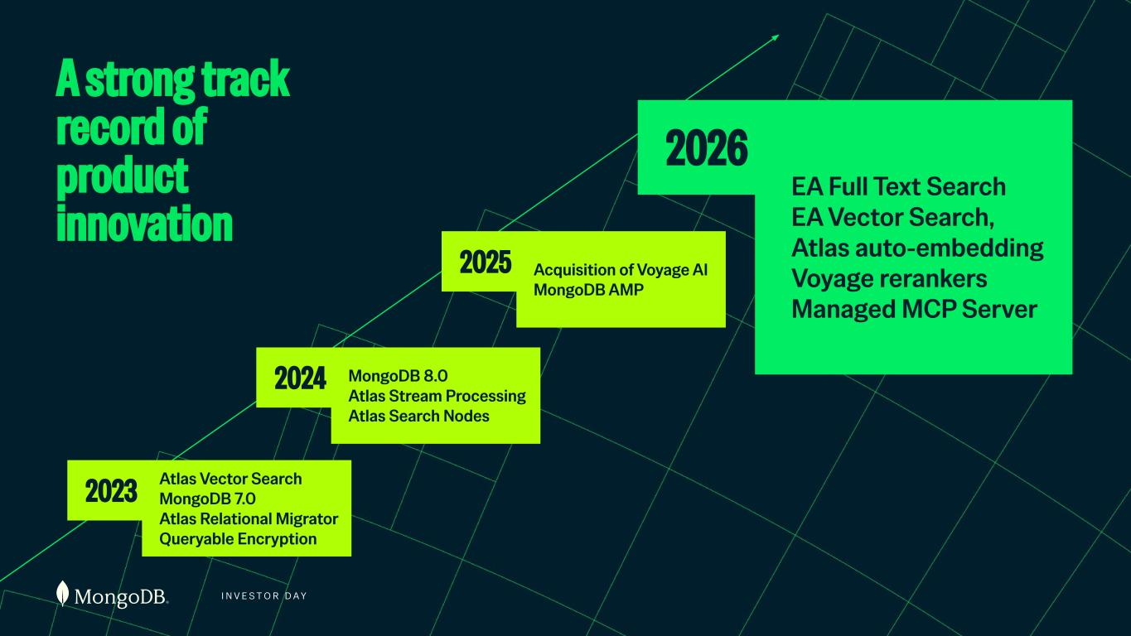
I N V E S T O R D A Y Atlas Vector Search MongoDB 7.0 Atlas Relational Migrator Queryable Encryption A strong track record of product innovation 2023 MongoDB 8.0 Atlas Stream Processing Atlas Search Nodes 2024 Acquisition of Voyage AI MongoDB AMP 2025 EA Full Text Search EA Vector Search, Atlas auto-embedding Voyage rerankers Managed MCP Server 2026

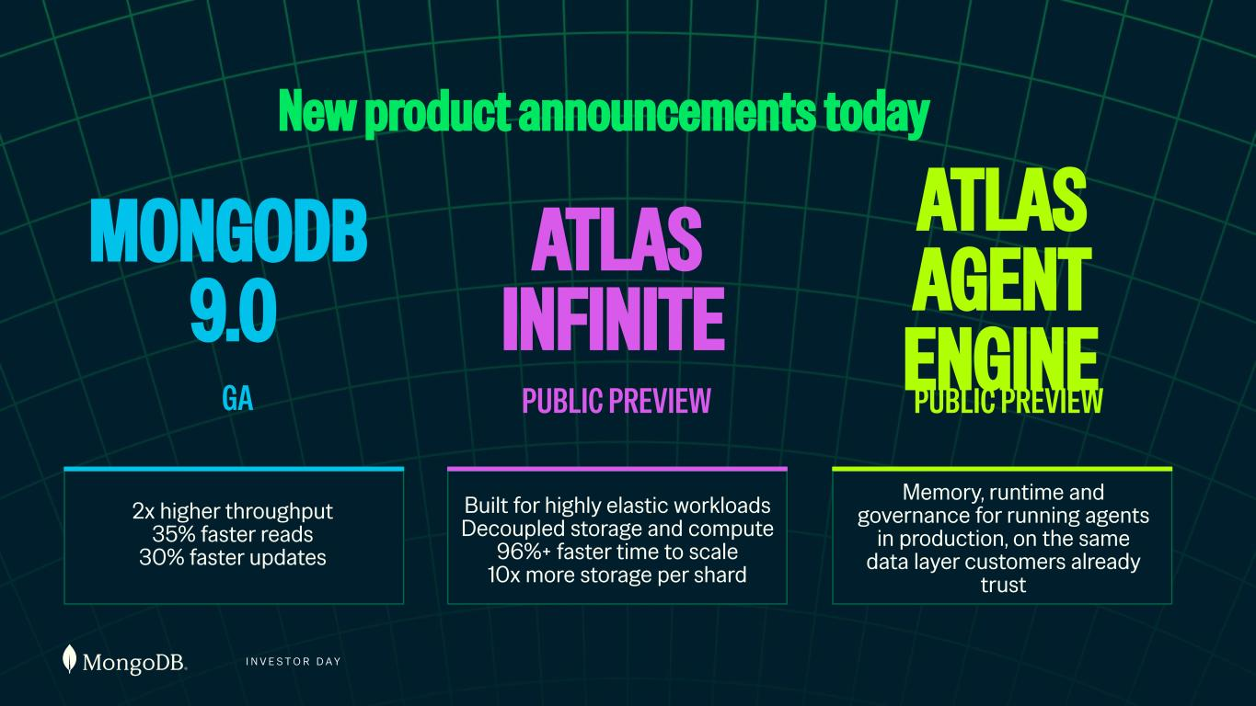
I N V E S T O R D A Y PUBLIC PREVIEW MONGODB 9.0 GA PUBLIC PREVIEW 2x higher throughput 35% faster reads 30% faster updates Built for highly elastic workloads Decoupled storage and compute 96%+ faster time to scale 10x more storage per shard Memory, runtime and governance for running agents in production, on the same data layer customers already trust ATLAS INFINITE ATLAS AGENT ENGINE New product announcements today

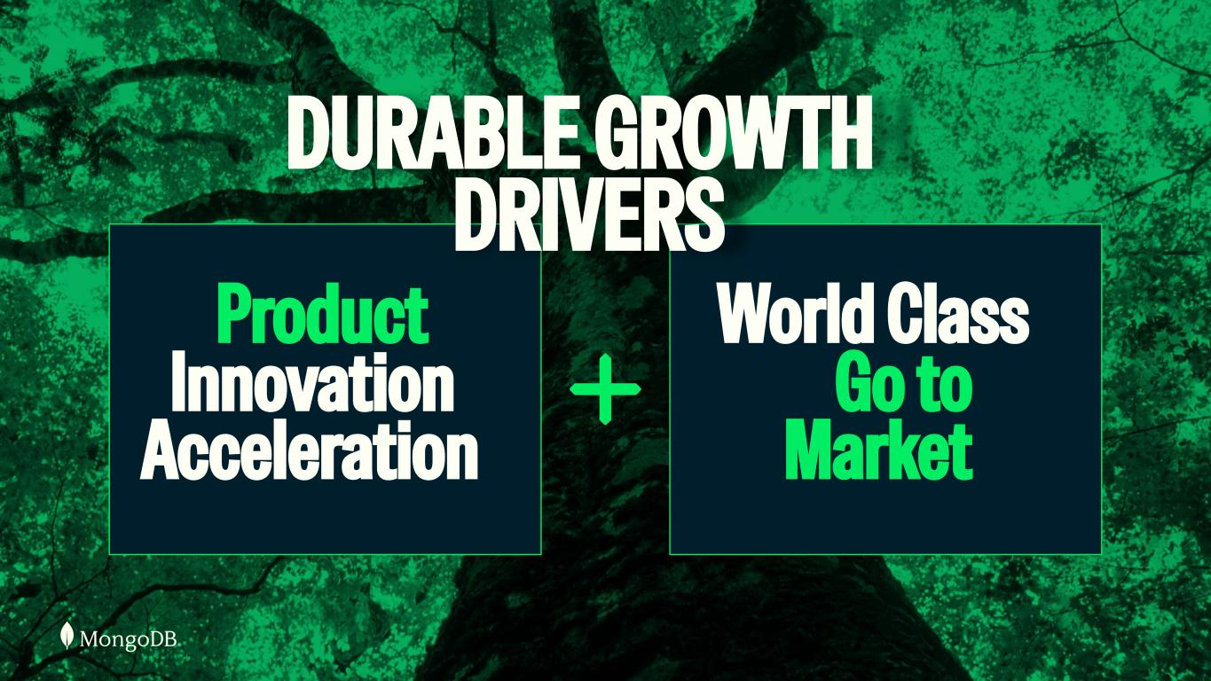
I N V E S T O R D A Y Product Innovation Acceleration World Class Go to Market DURABLE GROWTH DRIVERS

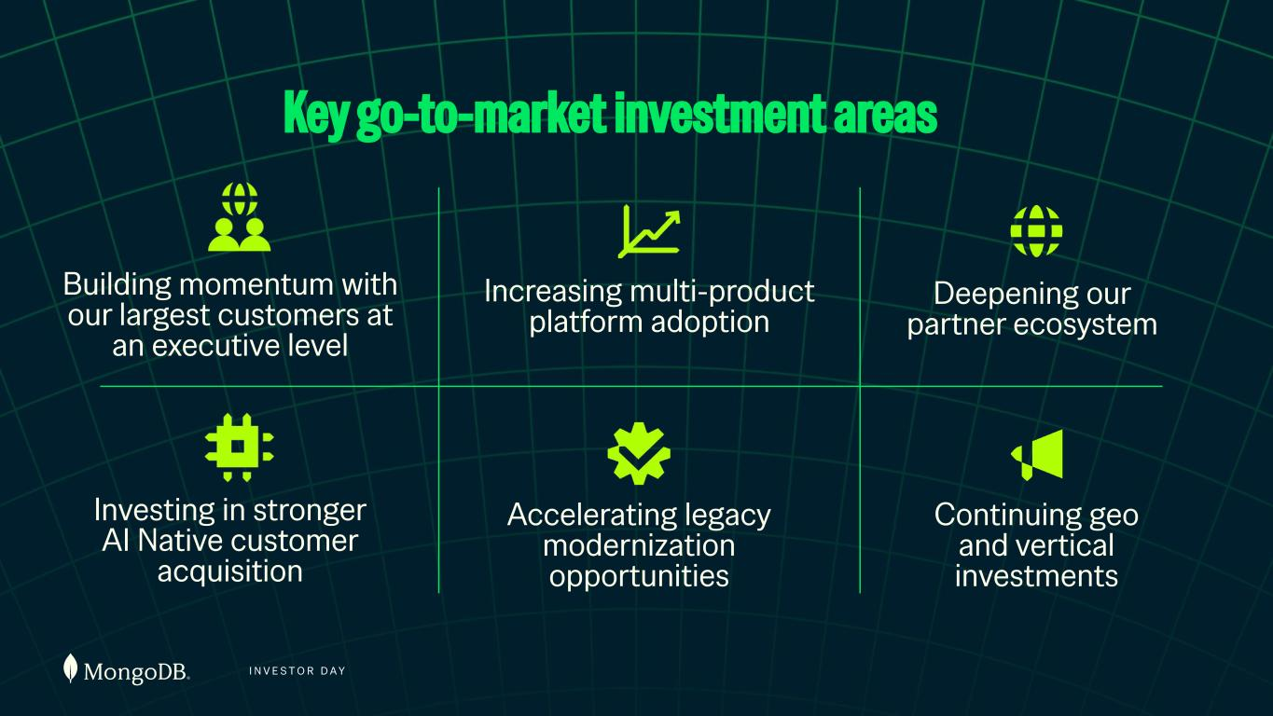
I N V E S T O R D A Y Key go-to-market investment areas Building momentum with our largest customers at an executive level Increasing multi-product platform adoption Investing in stronger AI Native customer acquisition Accelerating legacy modernization opportunities Deepening our partner ecosystem Continuing geo and vertical investments

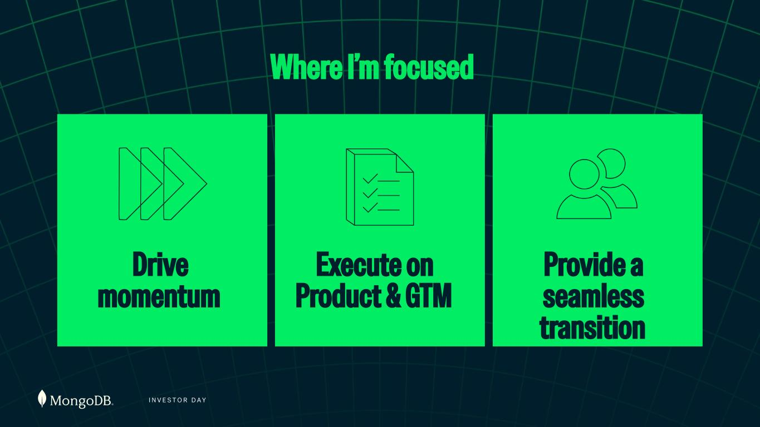
I N V E S T O R D A Y Where I’m focused Execute on Product & GTM Find my successor Drive momentum Drive momentum Provide a seamless transition

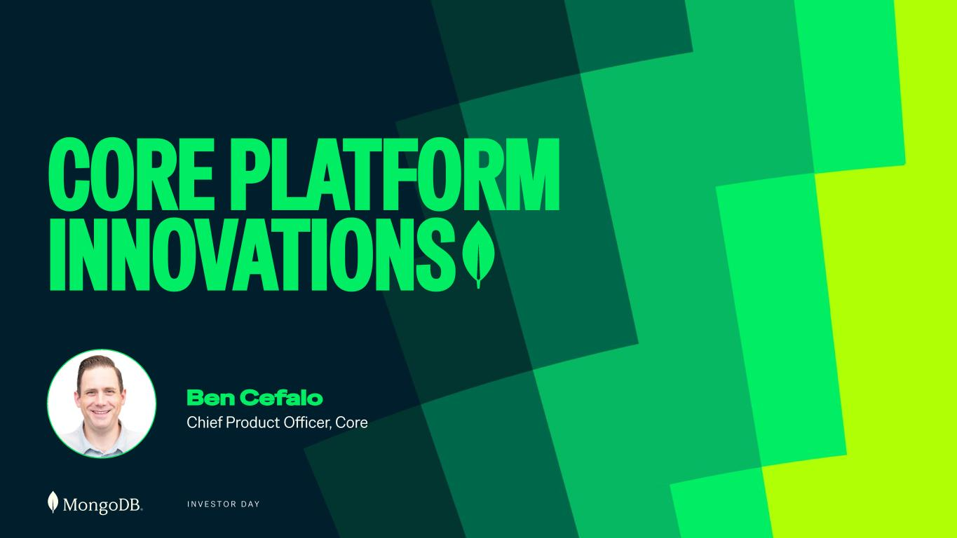
I N V E S T O R D A Y CORE PLATFORM INNOVATIONS Ben Cefalo Chief Product Officer, Core

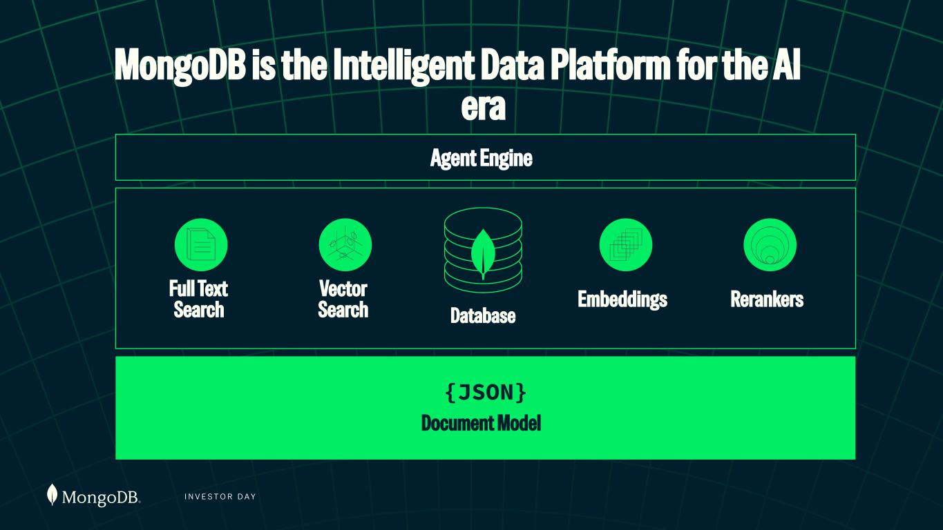
I N V E S T O R D A Y MongoDB is the Intelligent Data Platform for the AI era Database Full Text Search Embeddings RerankersVector Search {JSON} Document Model Agent Engine

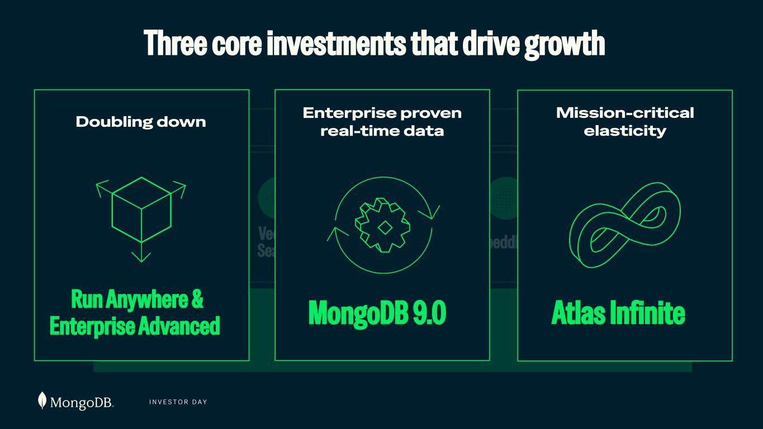
I N V E S T O R D A Y Database Full Text Search Embeddings RerankersVector Search {JSON} Document Model Agent Engine Three core investments that drive growth Run Anywhere & Enterprise Advanced Doubling down MongoDB 9.0 Enterprise proven real-time data Mission-critical elasticity Atlas Infinite

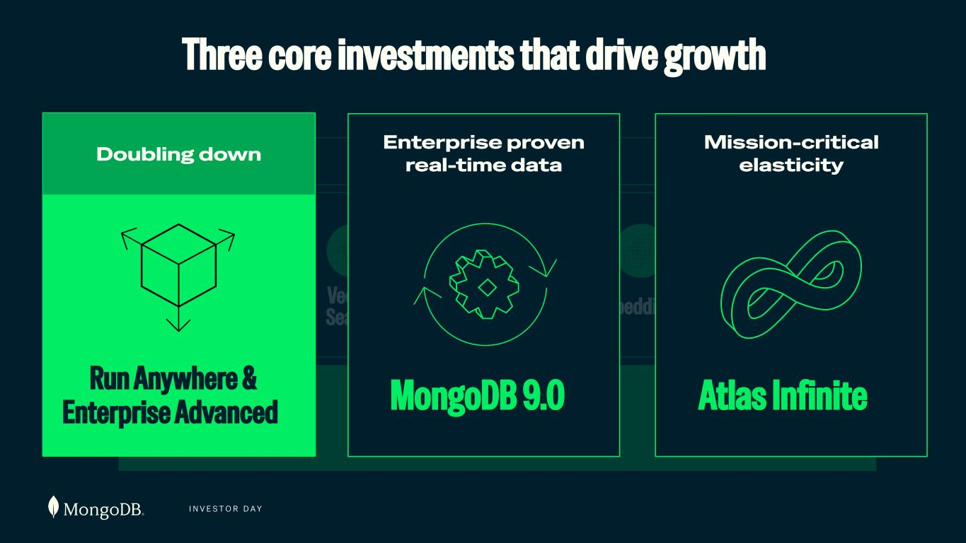
I N V E S T O R D A Y Database Full Text Search Embeddings RerankersVector Search {JSON} Document Model Agent EngineATLAS AGENT ENGINE Memory & Context Secure governed Agentic Runtime Database Policy guardrails Three core investments that drive growth Run Anywhere & Enterprise Advanced Doubling down MongoDB 9.0 Enterprise proven real-time data Mission-critical elasticity Atlas Infinite

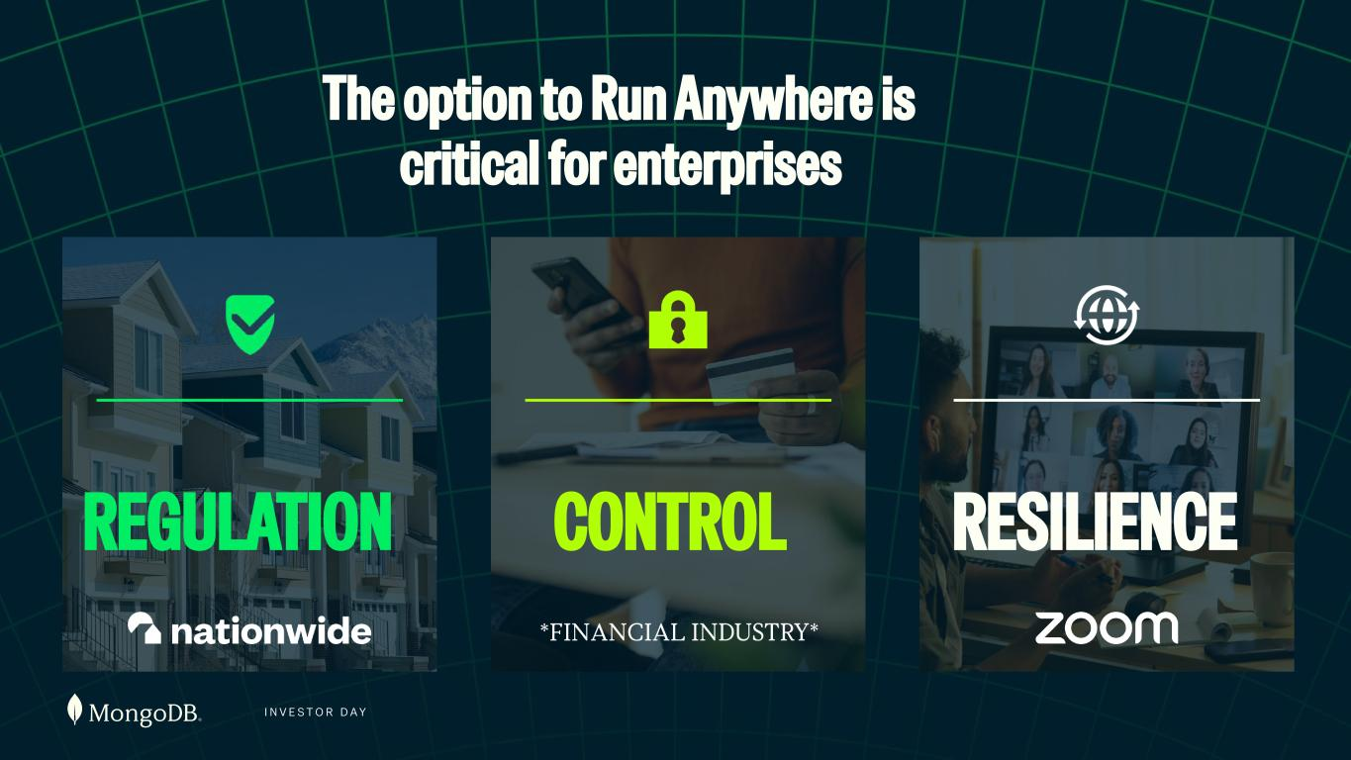
I N V E S T O R D A Y The option to Run Anywhere is critical for enterprises REGULATION CONTROL RESILIENCE

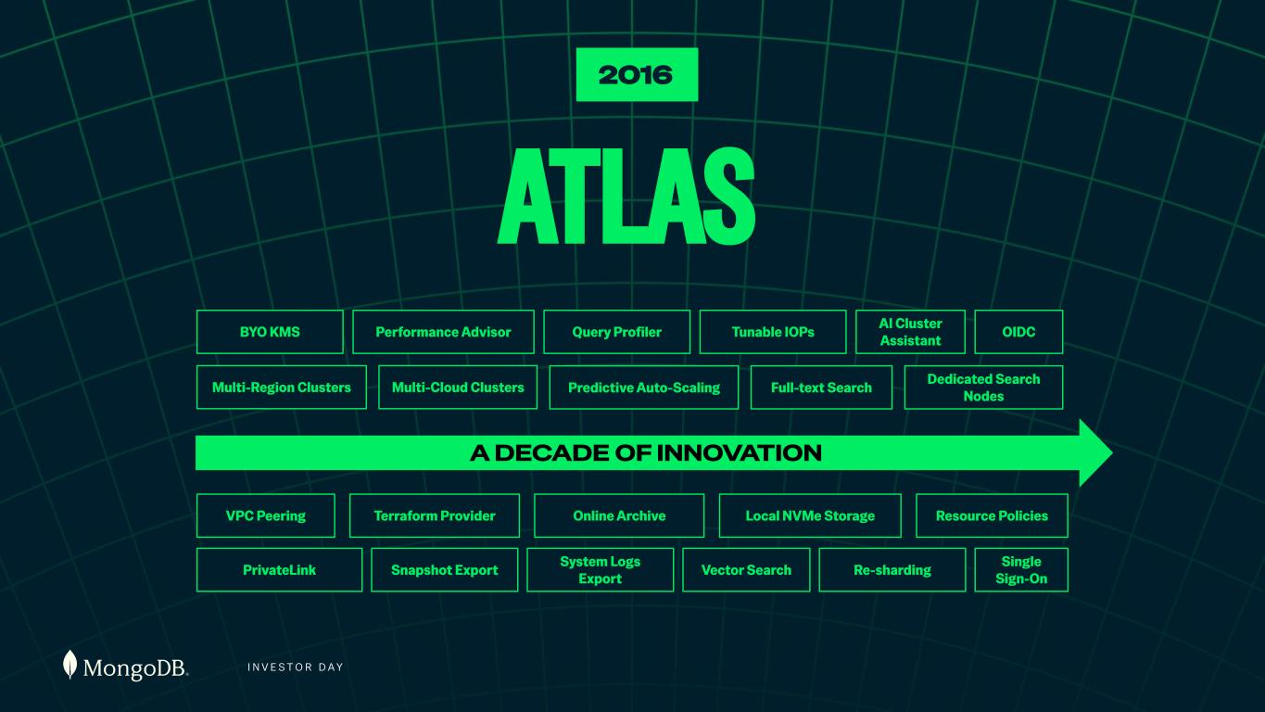
I N V E S T O R D A Y 2016 ATLAS Single Sign-On OIDC VPC Peering Multi-Region Clusters PrivateLink BYO KMS Dedicated Search Nodes Resource Policies AI Cluster Assistant Re-sharding Full-text Search Local NVMe Storage Tunable IOPs Vector Search Online Archive Predictive Auto-Scaling System Logs Export Query Profiler Multi-Cloud Clusters Terraform Provider Snapshot Export Performance Advisor A DECADE OF INNOVATION

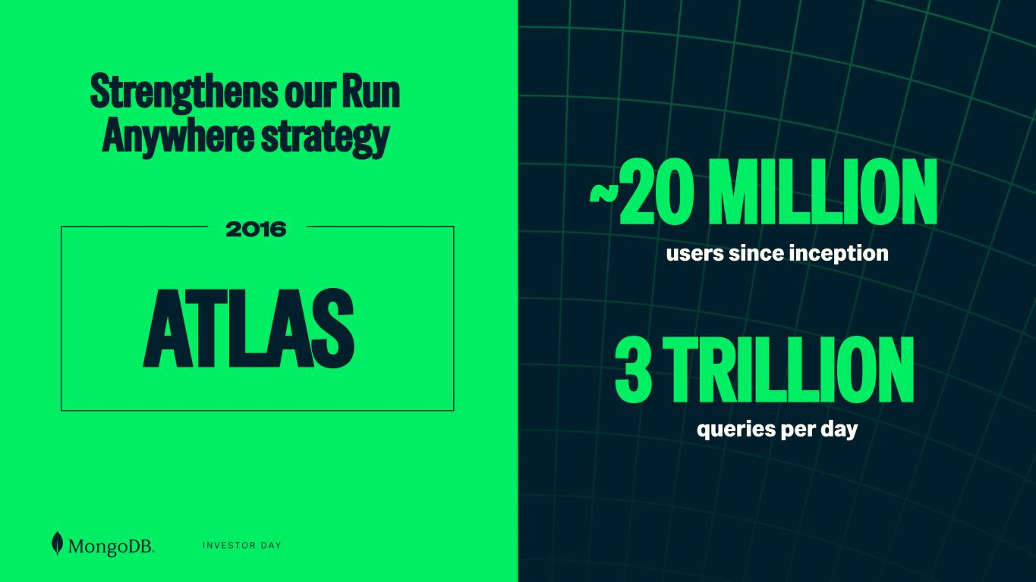
I N V E S T O R D A Y 2016 ~20 MILLION users since inception 3 TRILLION queries per day ATLAS Strengthens our Run Anywhere strategy

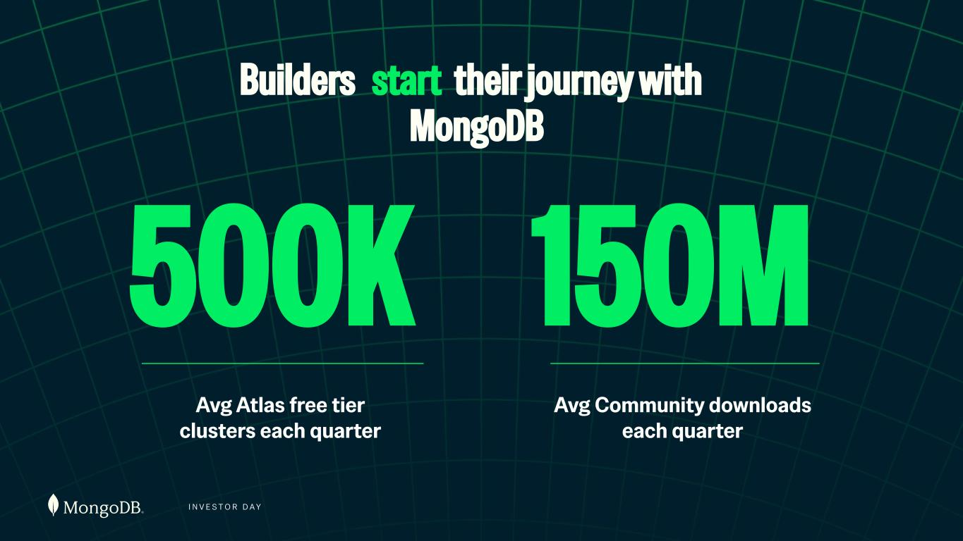
I N V E S T O R D A Y Builders start their journey with MongoDB Avg Atlas free tier clusters each quarter 500K Avg Community downloads each quarter 150M

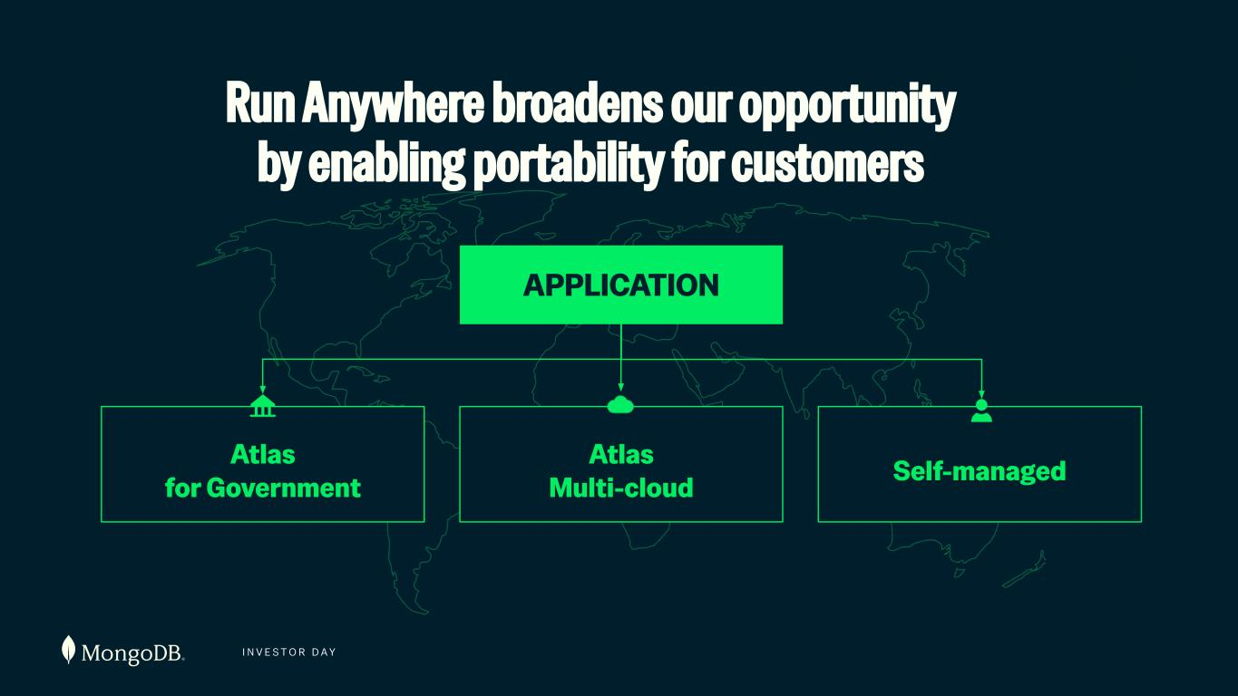
I N V E S T O R D A Y APPLICATION Atlas for Government Atlas Multi-cloud Self-managed Run Anywhere broadens our opportunity by enabling portability for customers

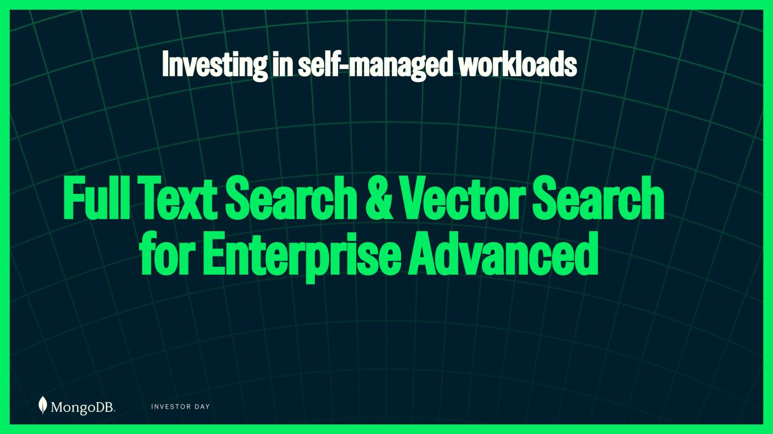
I N V E S T O R D A Y Full Text Search & Vector Search for Enterprise Advanced Investing in self-managed workloads

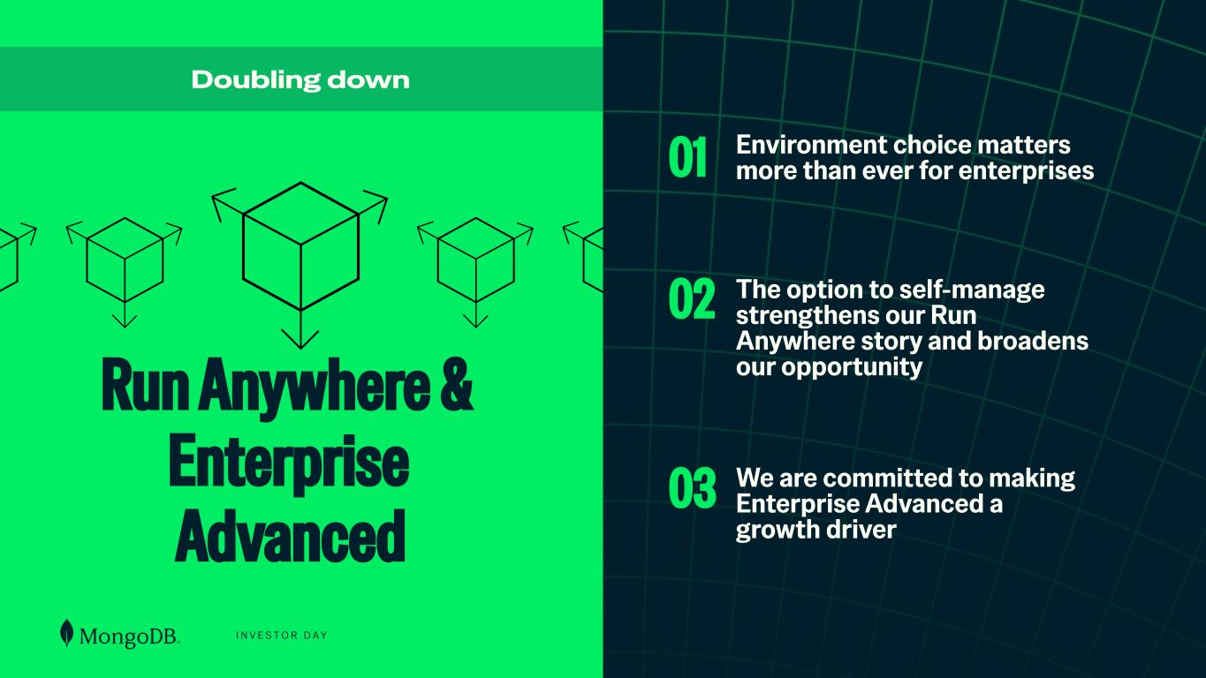
I N V E S T O R D A Y Environment choice matters more than ever for enterprises The option to self-manage strengthens our Run Anywhere story and broadens our opportunity We are committed to making Enterprise Advanced a growth driver Run Anywhere & Enterprise Advanced Doubling down 01 02 03

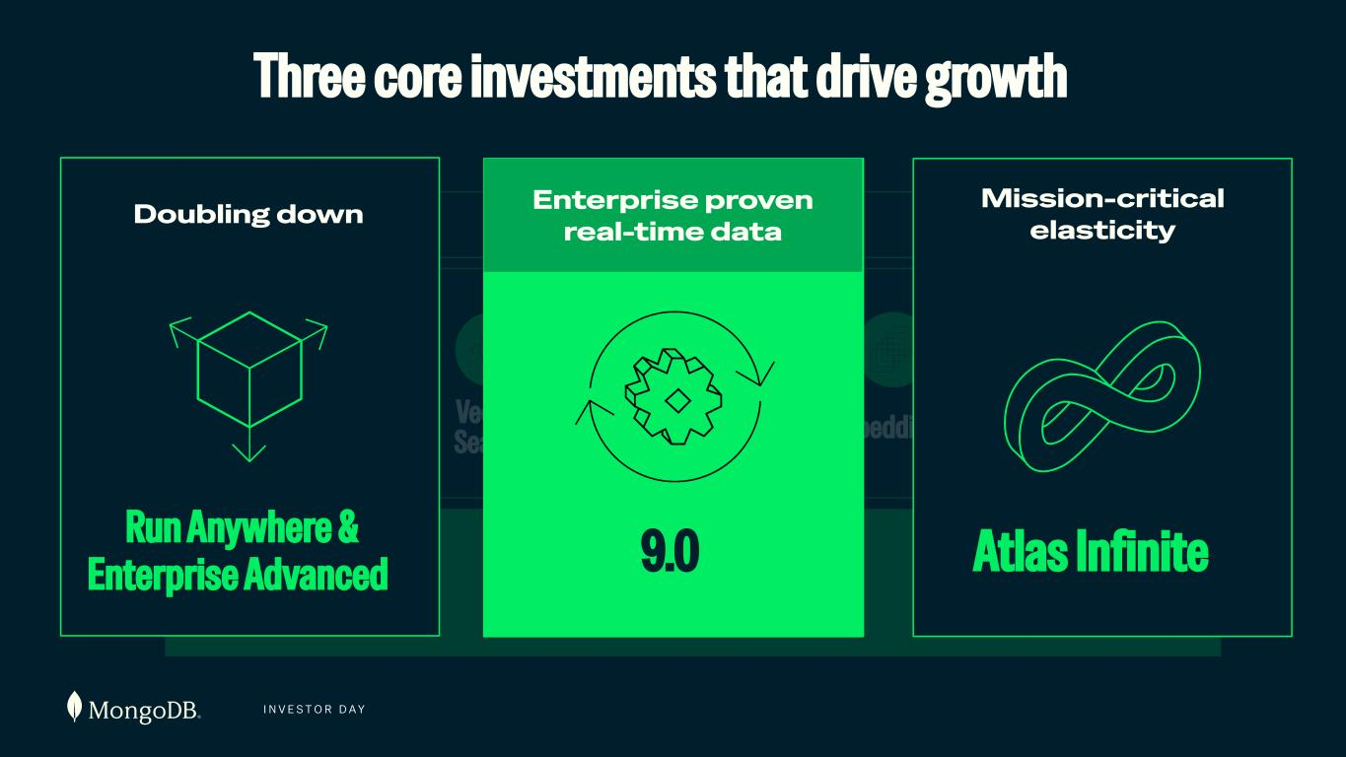
I N V E S T O R D A Y Database Full Text Search Embeddings RerankersVector Search {JSON} Document Model Agent Engine Three core investments that drive growth Run Anywhere & Enterprise Advanced Doubling down Mission-critical elasticity Atlas Infinite9.0 Enterprise proven real-time data

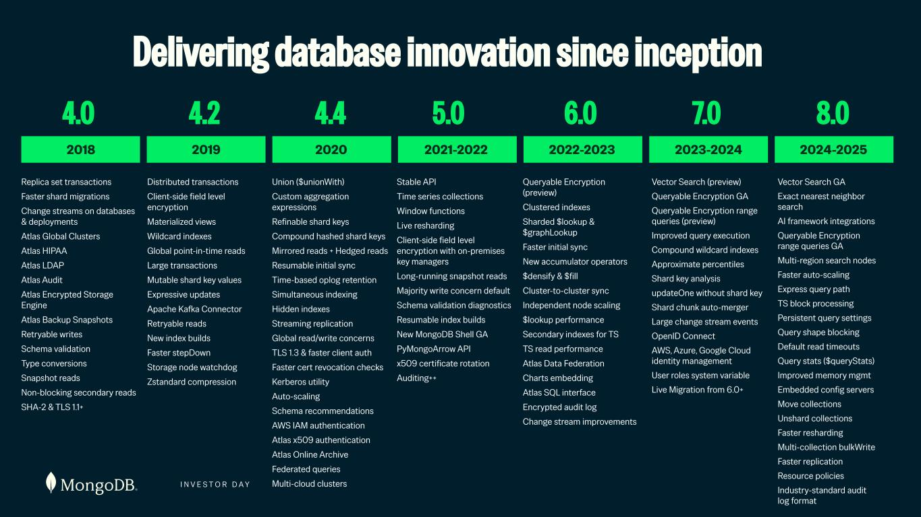
I N V E S T O R D A Y Replica set transactions Faster shard migrations Change streams on databases & deployments Atlas Global Clusters Atlas HIPAA Atlas LDAP Atlas Audit Atlas Encrypted Storage Engine Atlas Backup Snapshots Retryable writes Schema validation Type conversions Snapshot reads Non-blocking secondary reads SHA-2 & TLS 1.1+ 4.0 2018 Distributed transactions Client-side field level encryption Materialized views Wildcard indexes Global point-in-time reads Large transactions Mutable shard key values Expressive updates Apache Kafka Connector Retryable reads New index builds Faster stepDown Storage node watchdog Zstandard compression 2019 4.2 Union ($unionWith) Custom aggregation expressions Refinable shard keys Compound hashed shard keys Mirrored reads + Hedged reads Resumable initial sync Time-based oplog retention Simultaneous indexing Hidden indexes Streaming replication Global read/write concerns TLS 1.3 & faster client auth Faster cert revocation checks Kerberos utility Auto-scaling Schema recommendations AWS IAM authentication Atlas x509 authentication Atlas Online Archive Federated queries Multi-cloud clusters 2020 4.4 Stable API Time series collections Window functions Live resharding Client-side field level encryption with on-premises key managers Long-running snapshot reads Majority write concern default Schema validation diagnostics Resumable index builds New MongoDB Shell GA PyMongoArrow API x509 certificate rotation Auditing++ 2021-2022 5.0 Queryable Encryption (preview) Clustered indexes Sharded $lookup & $graphLookup Faster initial sync New accumulator operators $densify & $fill Cluster-to-cluster sync Independent node scaling $lookup performance Secondary indexes for TS TS read performance Atlas Data Federation Charts embedding Atlas SQL interface Encrypted audit log Change stream improvements 2022-2023 6.0 Vector Search (preview) Queryable Encryption GA Queryable Encryption range queries (preview) Improved query execution Compound wildcard indexes Approximate percentiles Shard key analysis updateOne without shard key Shard chunk auto-merger Large change stream events OpenID Connect AWS, Azure, Google Cloud identity management User roles system variable Live Migration from 6.0+ 2023-2024 7.0 Delivering database innovation since inception Vector Search GA Exact nearest neighbor search AI framework integrations Queryable Encryption range queries GA Multi-region search nodes Faster auto-scaling Express query path TS block processing Persistent query settings Query shape blocking Default read timeouts Query stats ($queryStats) Improved memory mgmt Embedded config servers Move collections Unshard collections Faster resharding Multi-collection bulkWrite Faster replication Resource policies Industry-standard audit log format 2024-2025 8.0

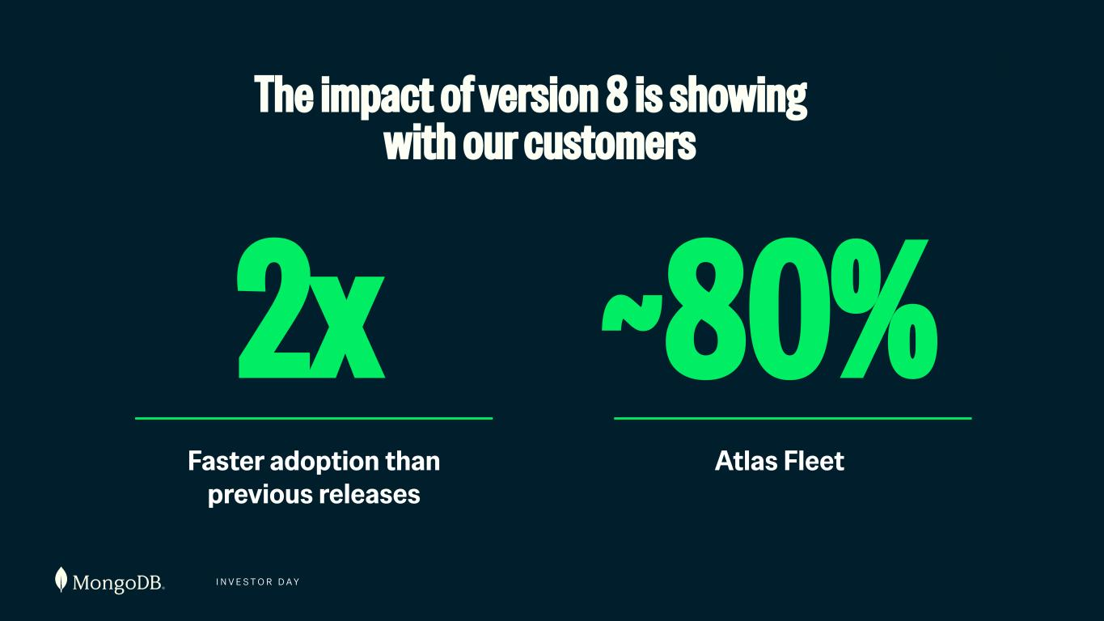
I N V E S T O R D A Y ~80% Atlas Fleet The impact of version 8 is showing with our customers 2x Faster adoption than previous releases

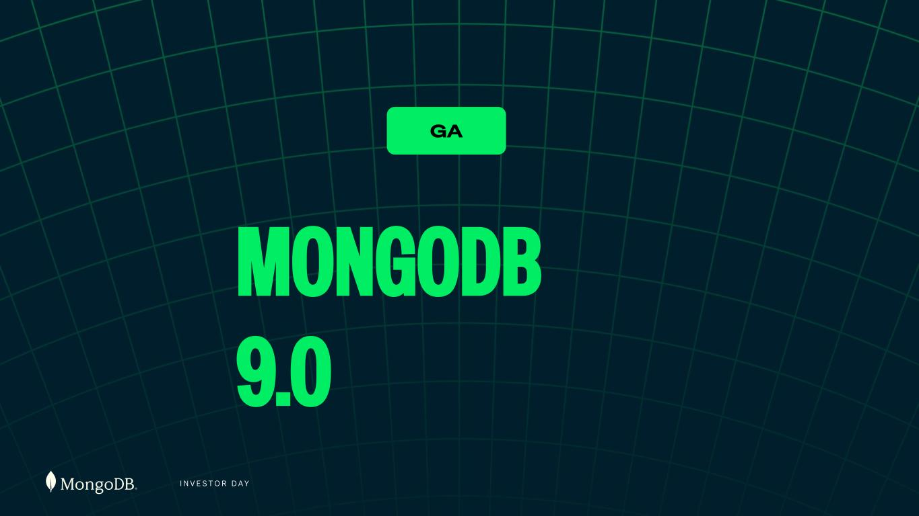
I N V E S T O R D A Y MONGODB 9.0 GA

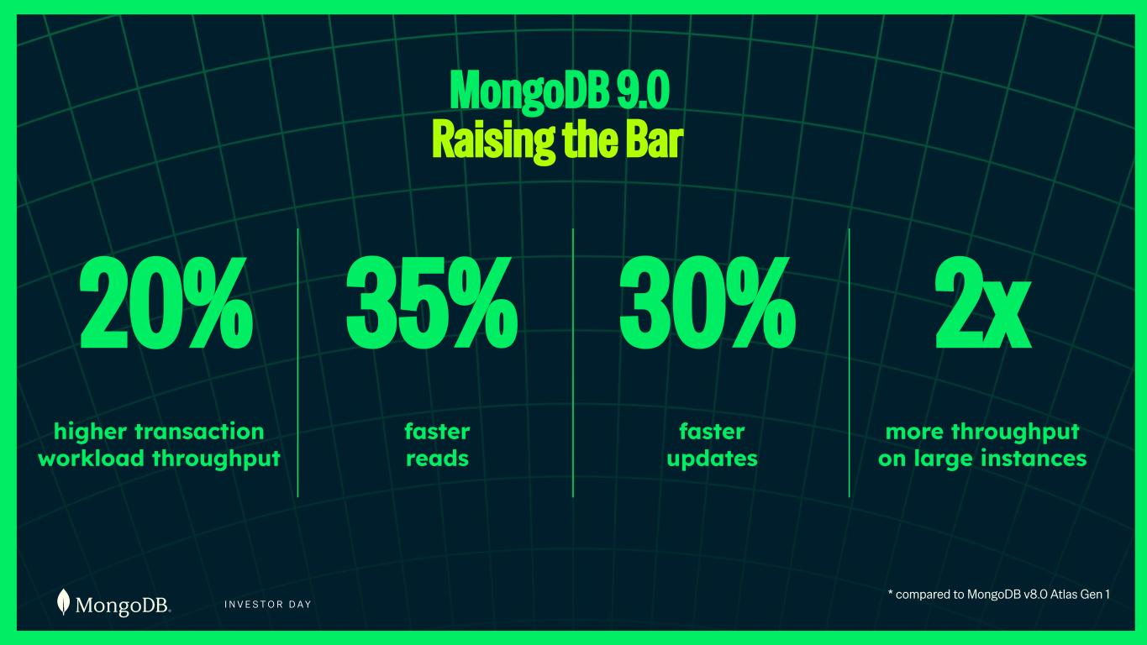
I N V E S T O R D A Y MongoDB 9.0 Raising the Bar 20% higher transaction workload throughput 35% faster reads 30% faster updates 2x more throughput on large instances * compared to MongoDB v8.0 Atlas Gen 1

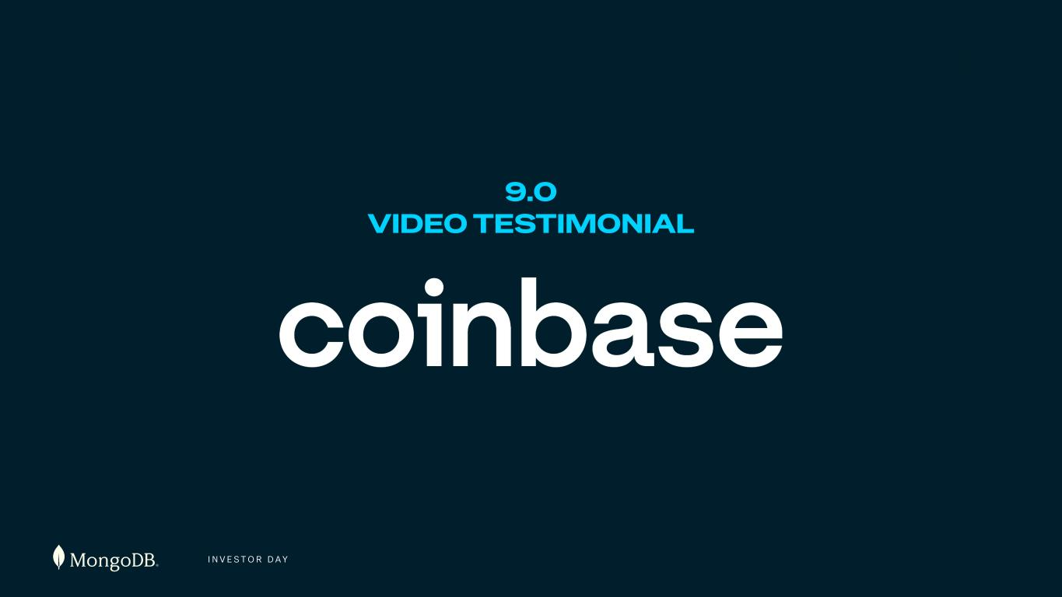
I N V E S T O R D A Y 9.0 VIDEO TESTIMONIAL

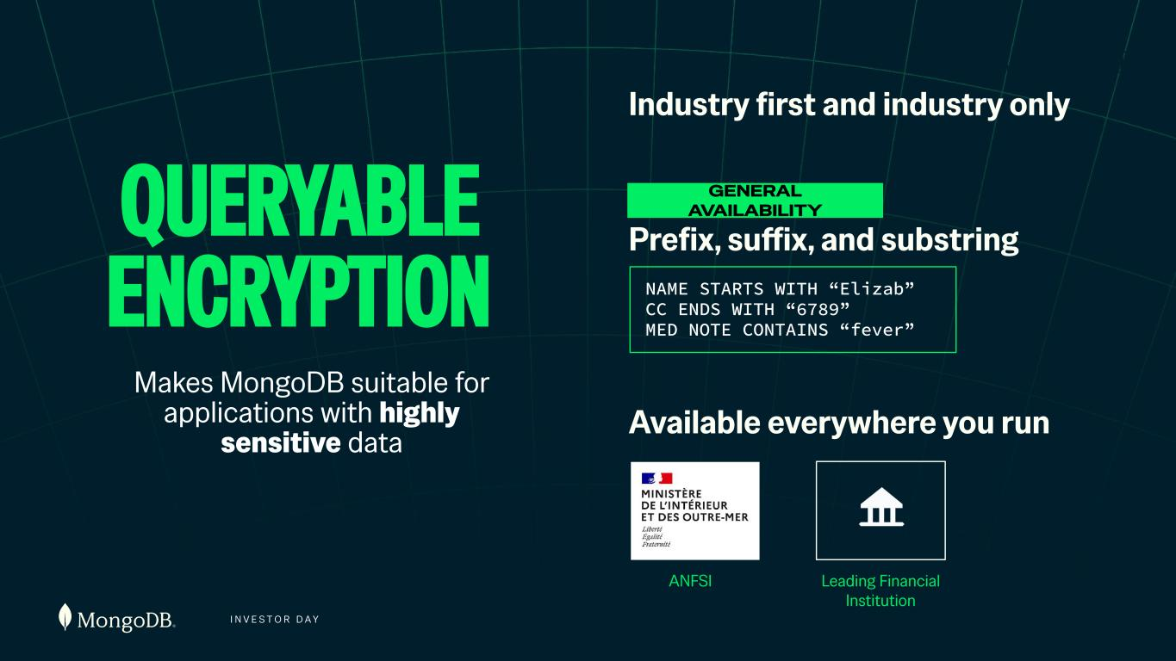
I N V E S T O R D A Y QUERYABLE ENCRYPTION Industry first and industry only Available everywhere you run Prefix, suffix, and substring GENERAL AVAILABILITY Makes MongoDB suitable for applications with highly sensitive data ANFSI Leading Financial Institution NAME STARTS WITH “Elizab” CC ENDS WITH “6789” MED NOTE CONTAINS “fever”

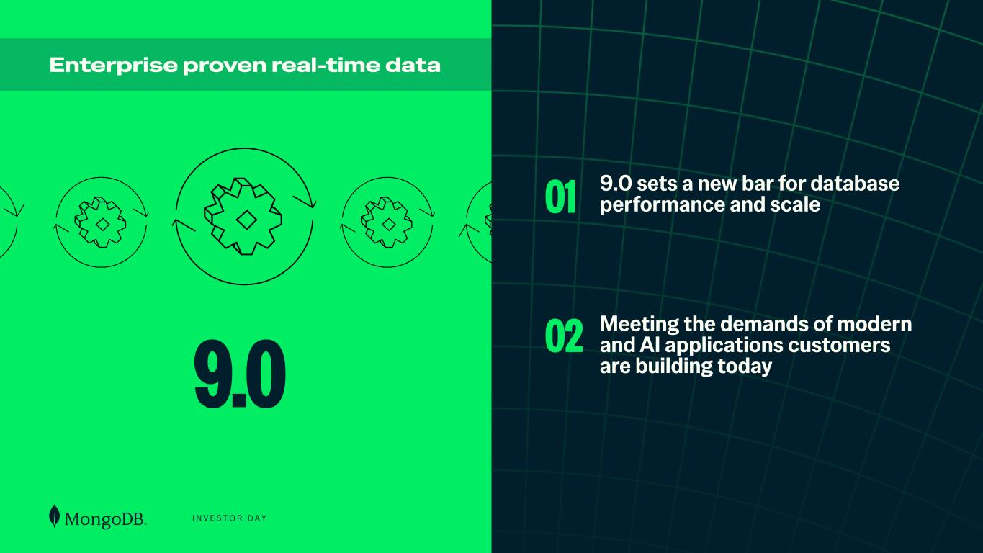
I N V E S T O R D A Y 9.0 sets a new bar for database performance and scale Meeting the demands of modern and AI applications customers are building today9.0 Enterprise proven real-time data 01 02

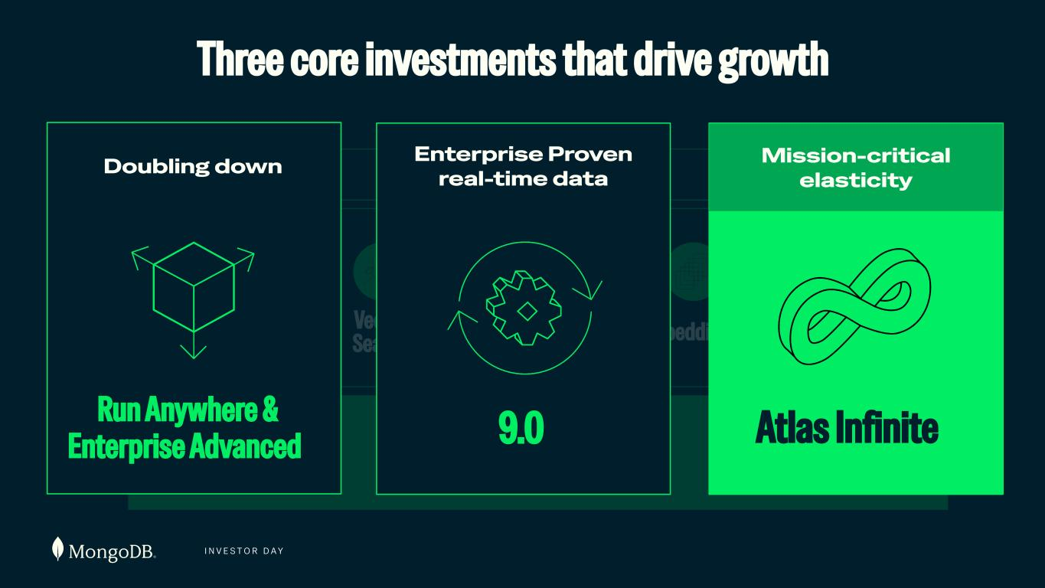
I N V E S T O R D A Y Database Full Text Search Embeddings RerankersVector Search {JSON} Document Model Agent Engine Three core investments that drive growth Run Anywhere & Enterprise Advanced Doubling down Database 9.0 Enterprise Proven real-time data Mission-critical elasticity Atlas Infinite

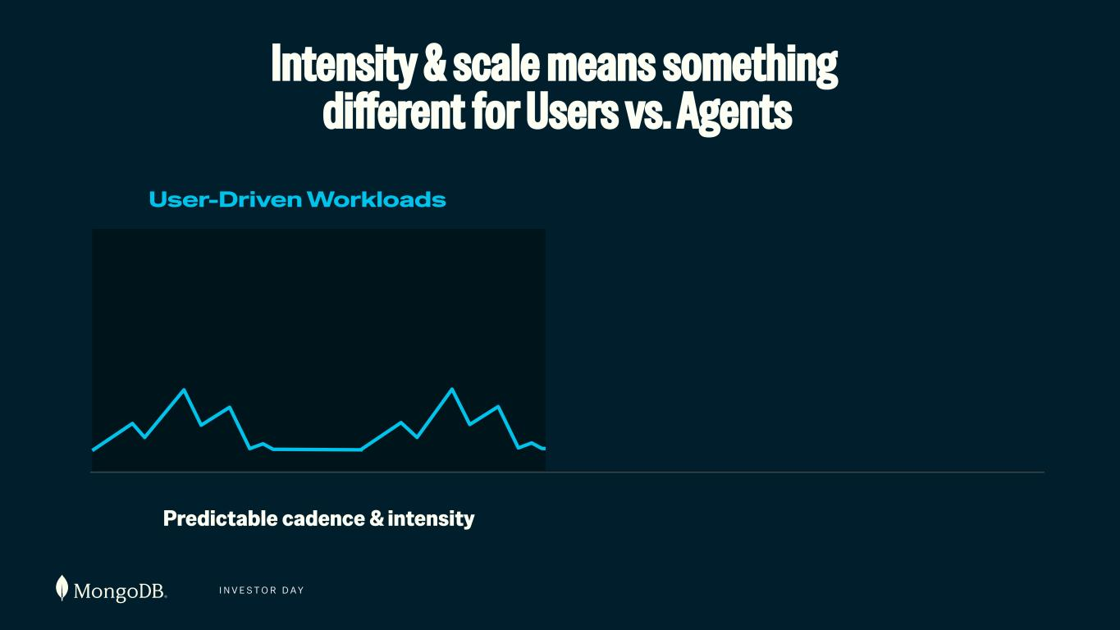
I N V E S T O R D A Y User-Driven Workloads Intensity & scale means something different for Users vs. Agents Predictable cadence & intensity

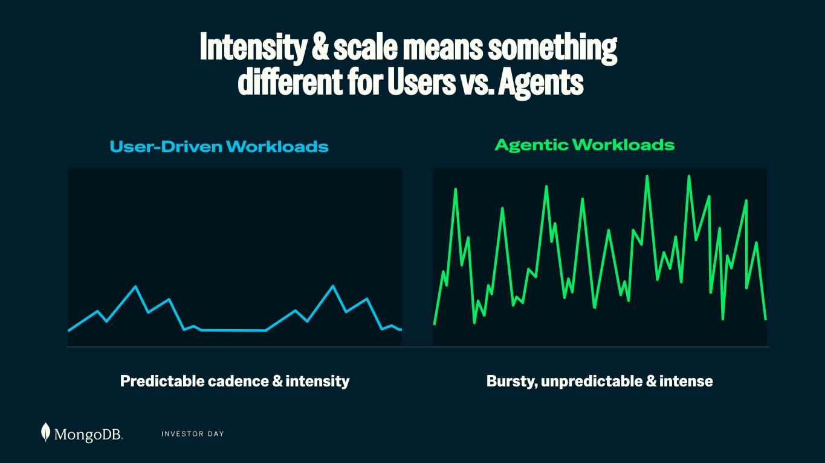
I N V E S T O R D A Y User-Driven Workloads Agentic Workloads Bursty, unpredictable & intensePredictable cadence & intensity Intensity & scale means something different for Users vs. Agents

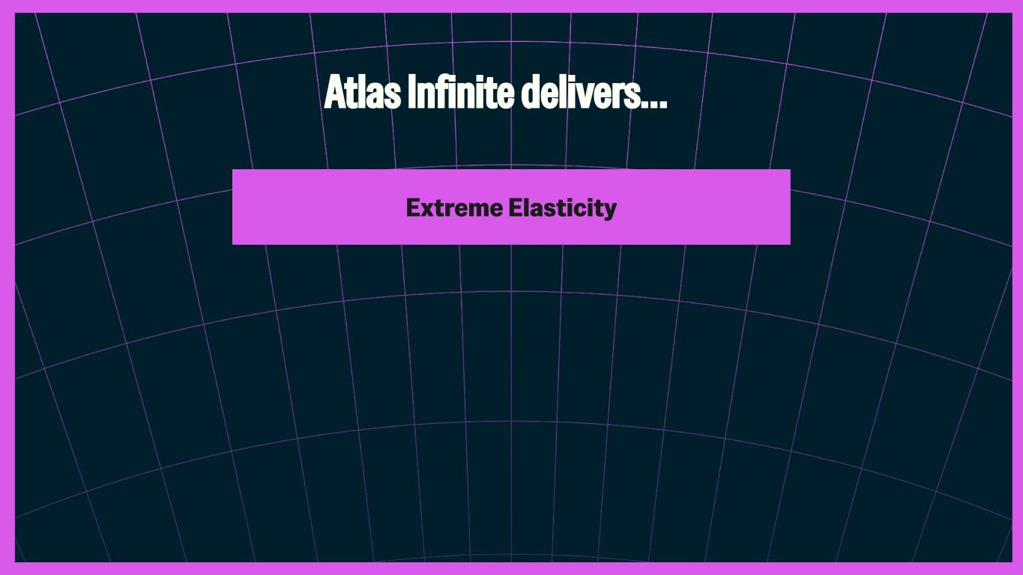
Extreme Elasticity Atlas Infinite delivers…

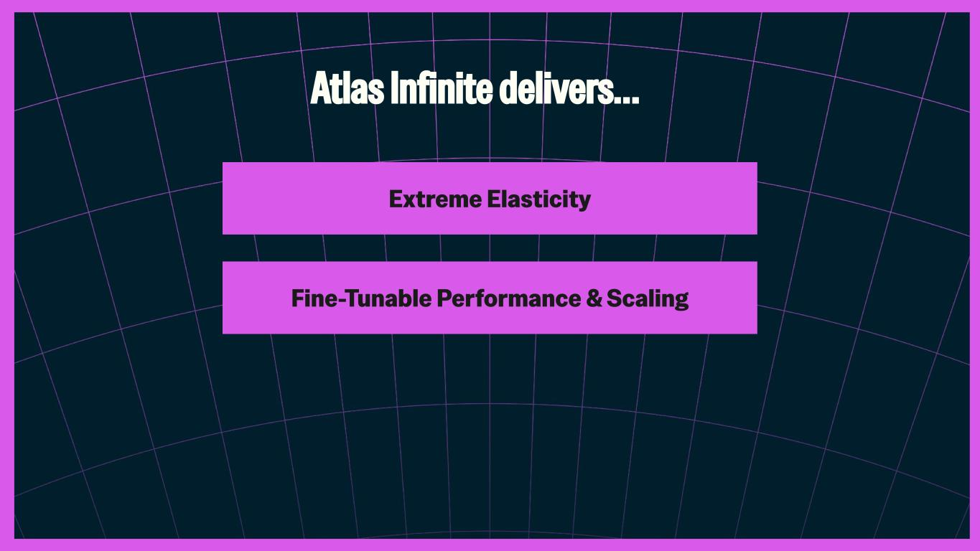
Extreme Elasticity Fine-Tunable Performance & Scaling Atlas Infinite delivers…

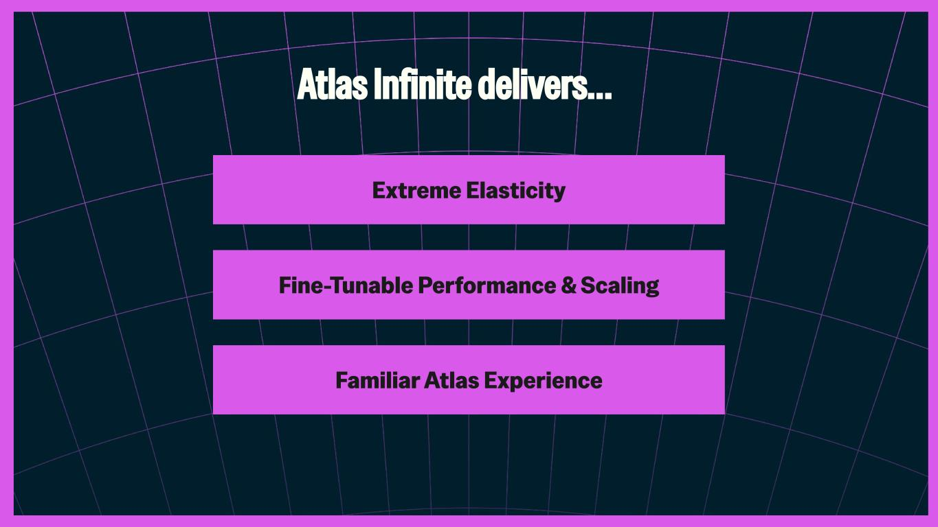
Extreme Elasticity Fine-Tunable Performance & Scaling Familiar Atlas Experience Atlas Infinite delivers…

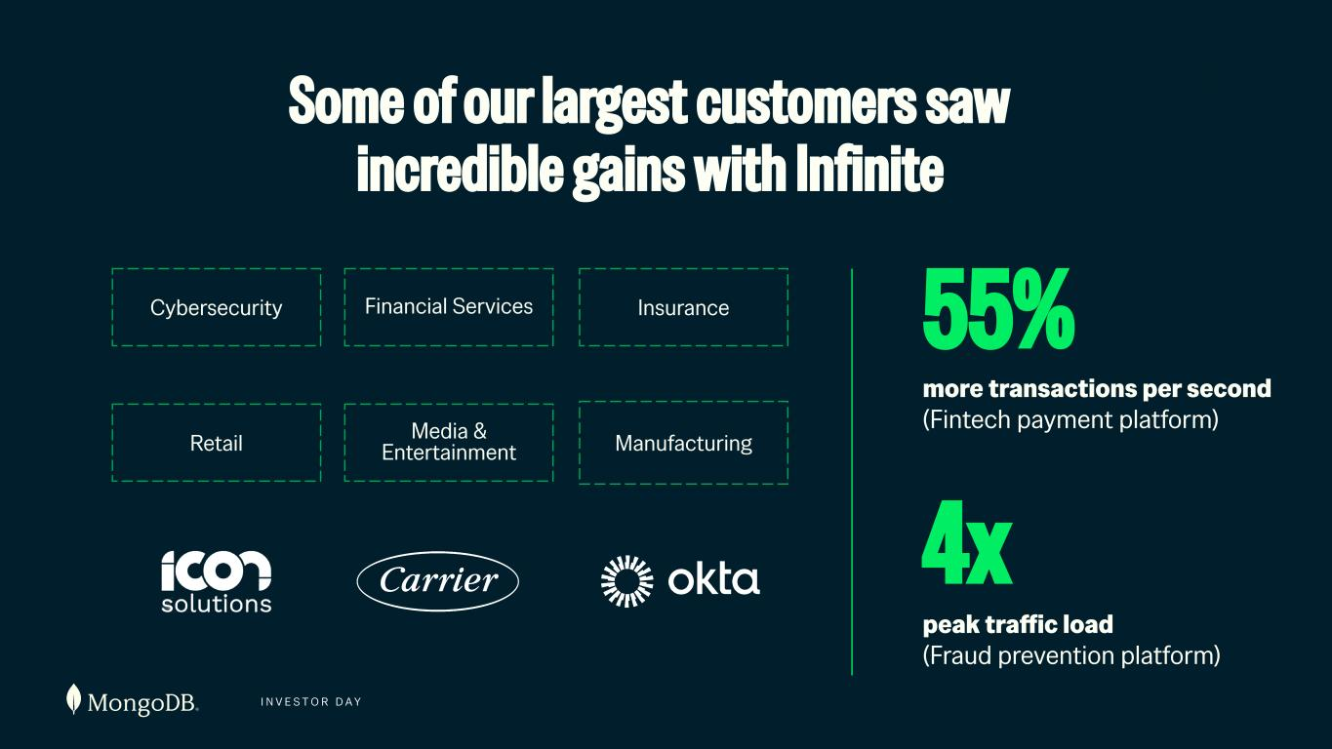
I N V E S T O R D A Y Some of our largest customers saw incredible gains with Infinite Cybersecurity Financial Services Insurance Retail Media & Entertainment 55% more transactions per second (Fintech payment platform) 4x peak traffic load (Fraud prevention platform) Manufacturing Icon Solutions

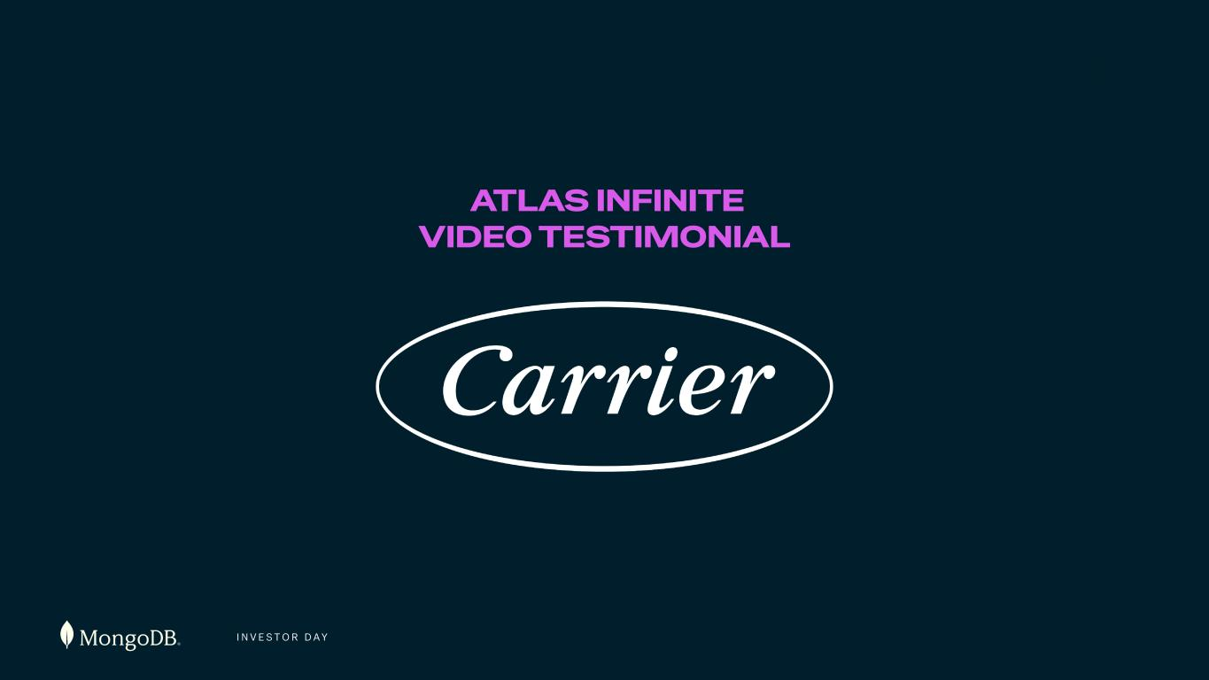
I N V E S T O R D A Y ATLAS INFINITE VIDEO TESTIMONIAL

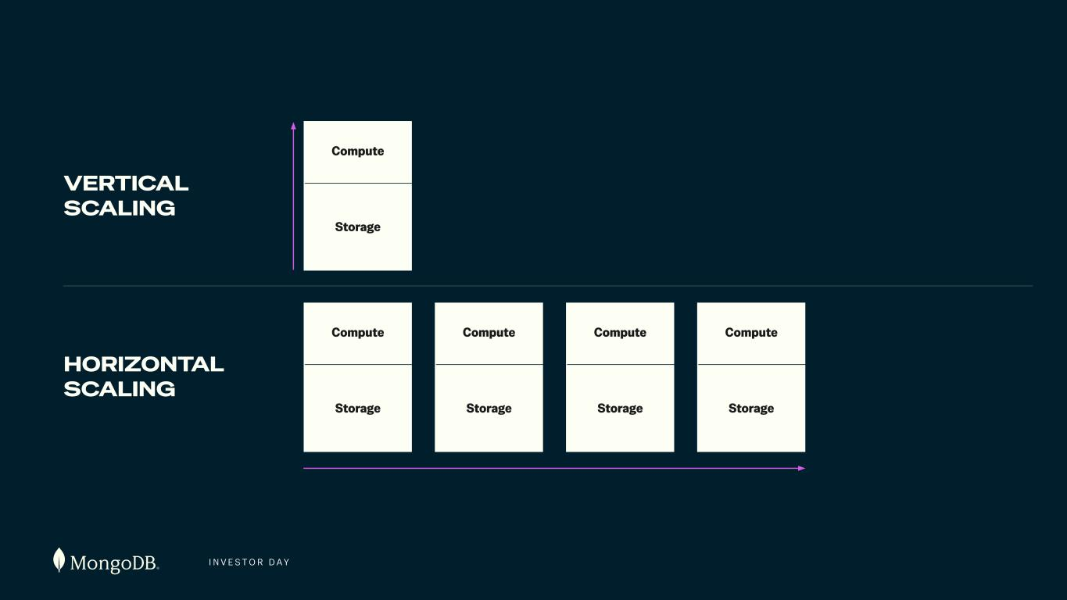
I N V E S T O R D A Y Compute Storage VERTICAL SCALING HORIZONTAL SCALING Compute Storage Compute Storage Compute Storage Compute Storage Compute Storage

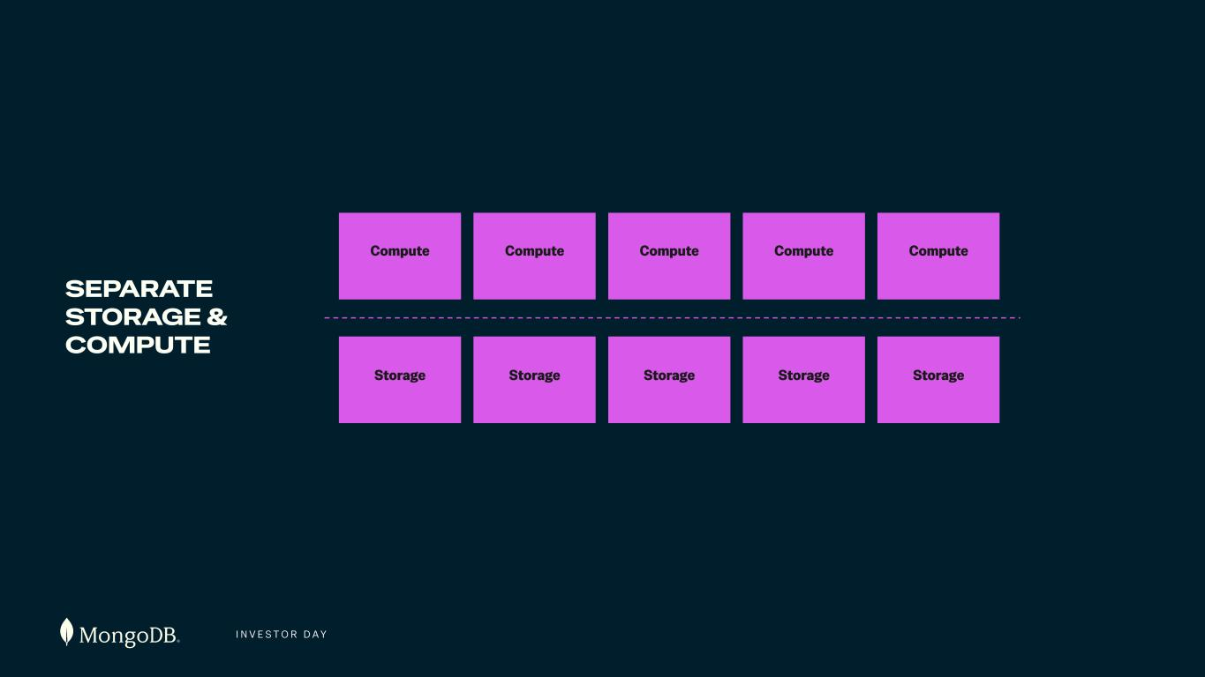
I N V E S T O R D A Y Compute Storage SEPARATE STORAGE & COMPUTE Compute Storage Storage Storage Storage Compute 1 Compute Compute

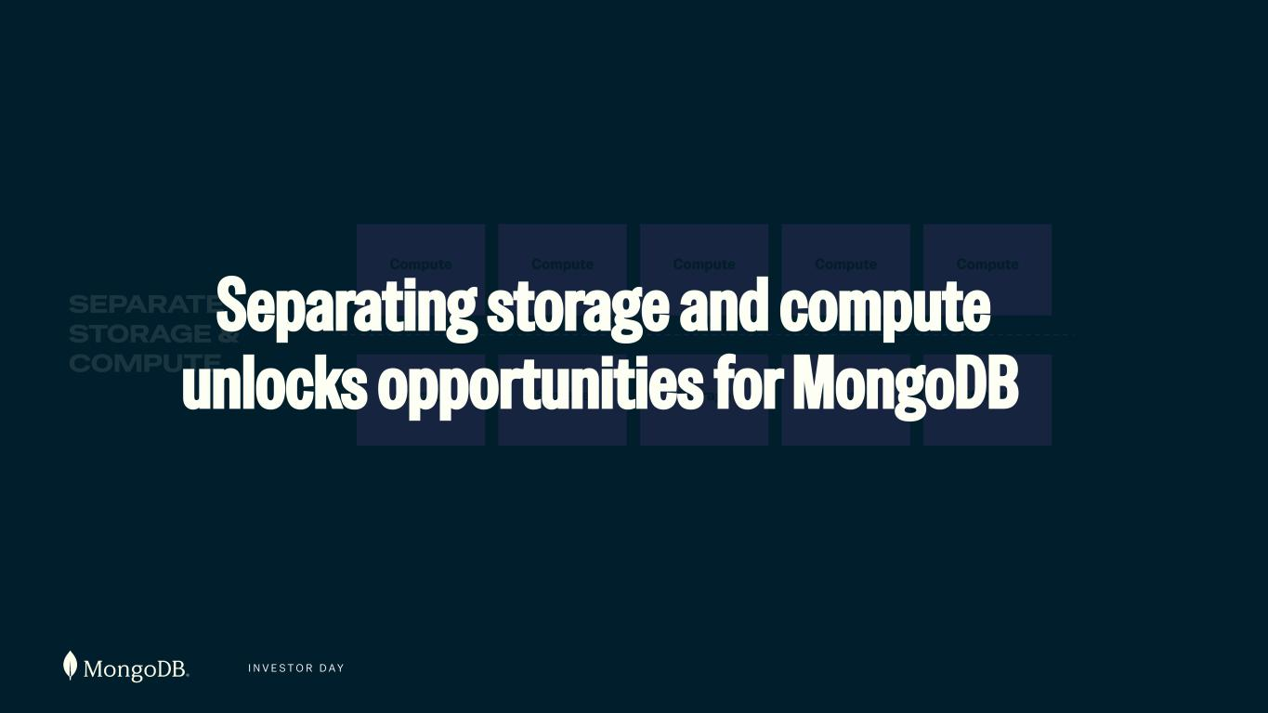
I N V E S T O R D A Y Compute Storage SEPARATE STORAGE & COMPUTE Compute Storage Storage Storage Storage Compute Compute Compute Separating storage and compute unlocks opportunities for M ngoDB

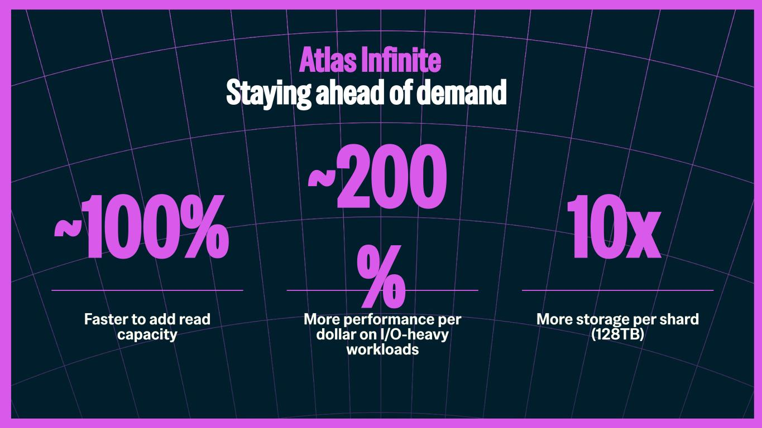
~100% Faster to add read capacity ~200 % More performance per dollar on I/O-heavy workloads 10x More storage per shard (128TB) Atlas Infinite Staying ahead of demand

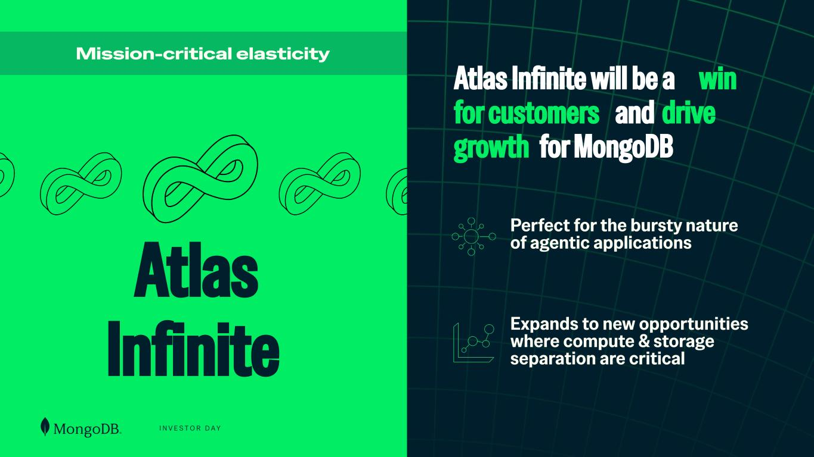
I N V E S T O R D A Y Perfect for the bursty nature of agentic applications Expands to new opportunities where compute & storage separation are critical Atlas Infinite Mission-critical elasticity Atlas Infinite will be a win for customers and drive growth for MongoDB

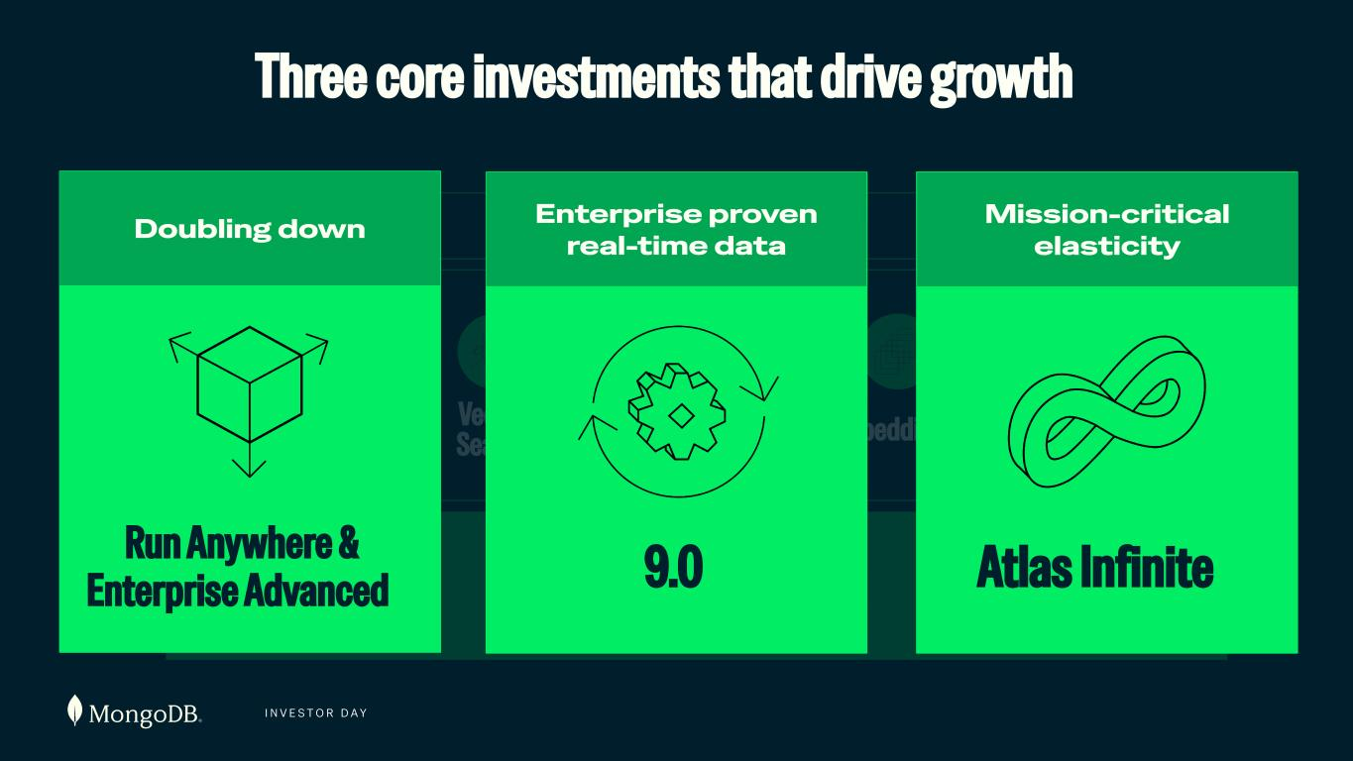
I N V E S T O R D A Y Database Full Text Search Embeddings RerankersVector Search {JSON} Document Model Agent Engine Three core investments that drive growth Run Anywhere & Enterprise Advanced Doubling down 9.0 Enterprise proven real-time data Mission-critical elasticity Atlas Infinite

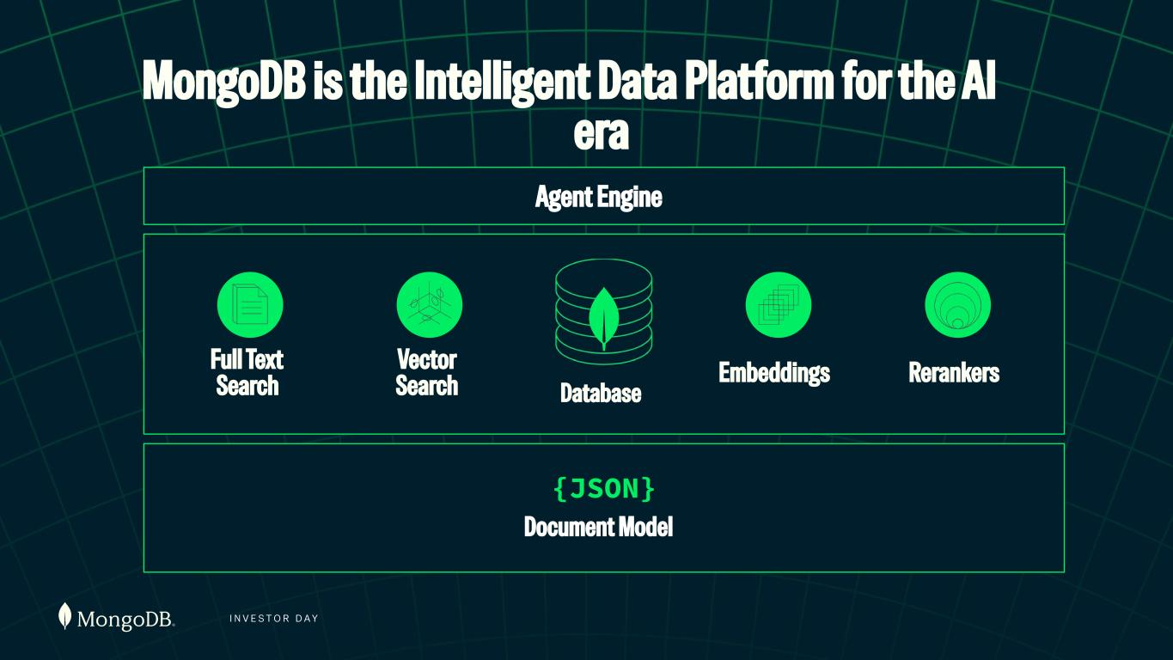
I N V E S T O R D A Y MongoDB is the Intelligent Data Platform for the AI era Database Full Text Search Embeddings RerankersVector Search {JSON} Document Model Agent Engine

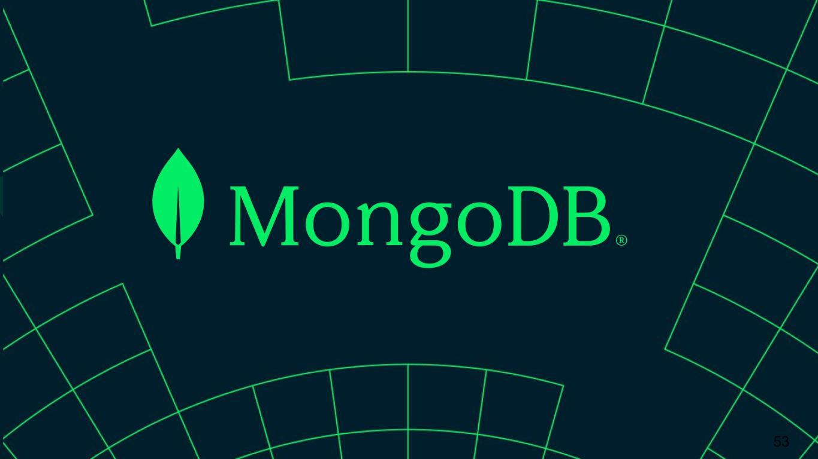
53


I N V E S T O R D A Y AI INNOVATIONS Pablo Stern Chief Product Officer, AI & Emerging Products

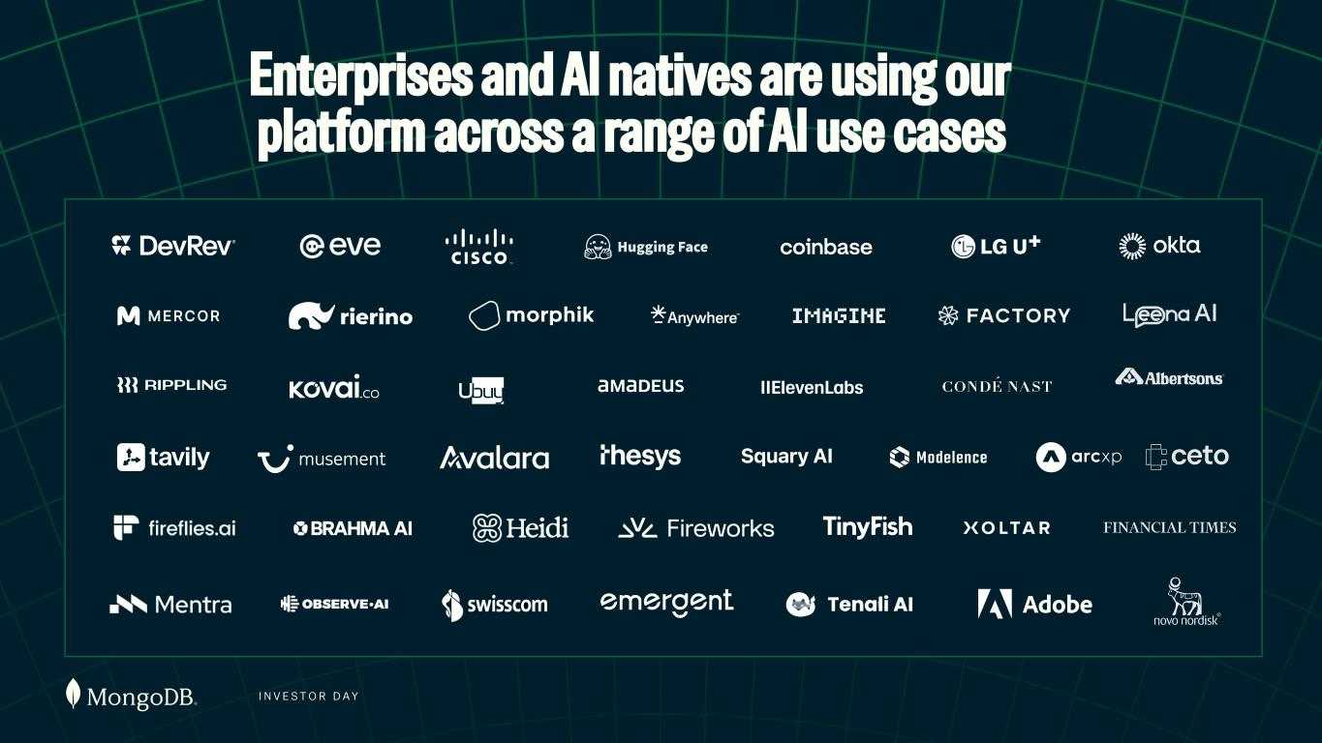
I N V E S T O R D A Y Enterprises and AI natives are using our platform across a range of AI use cases

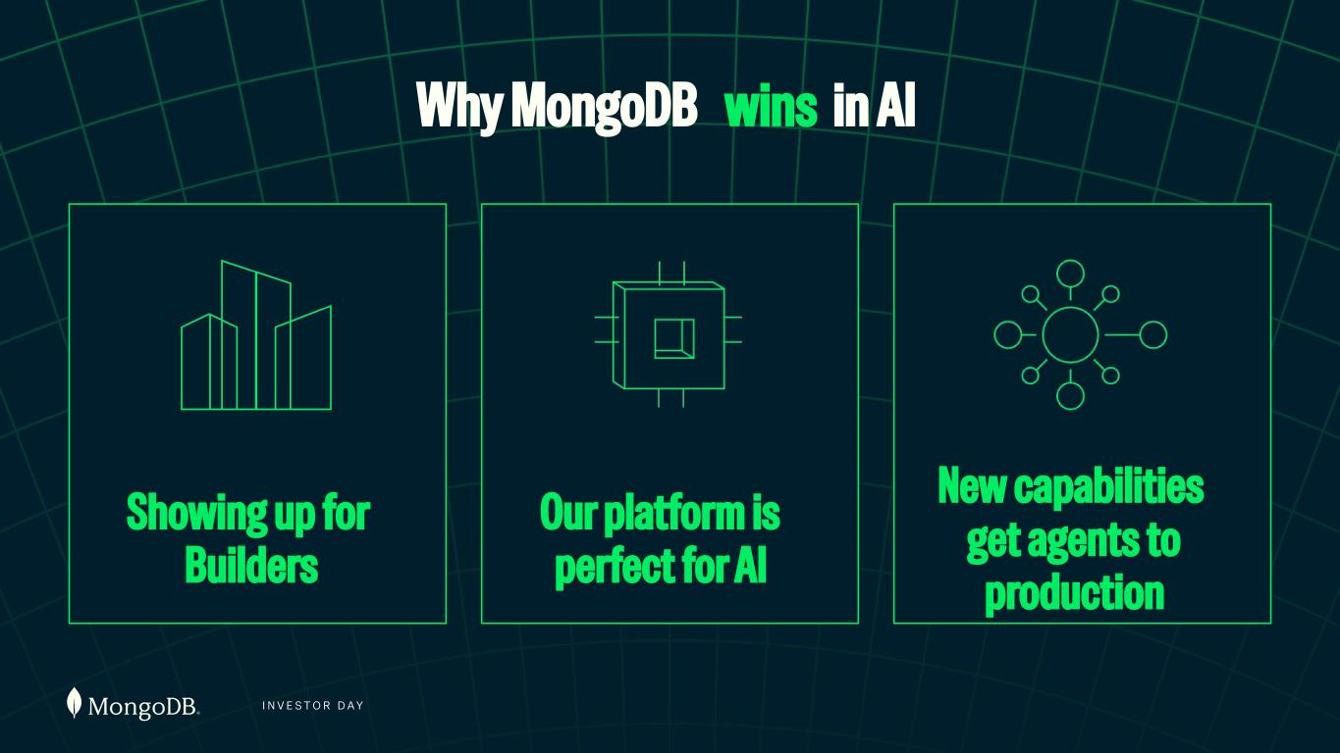
I N V E S T O R D A Y Why MongoDB wins in AI Showing up for Builders Our platform is perfect for AI New capabilities get agents to production

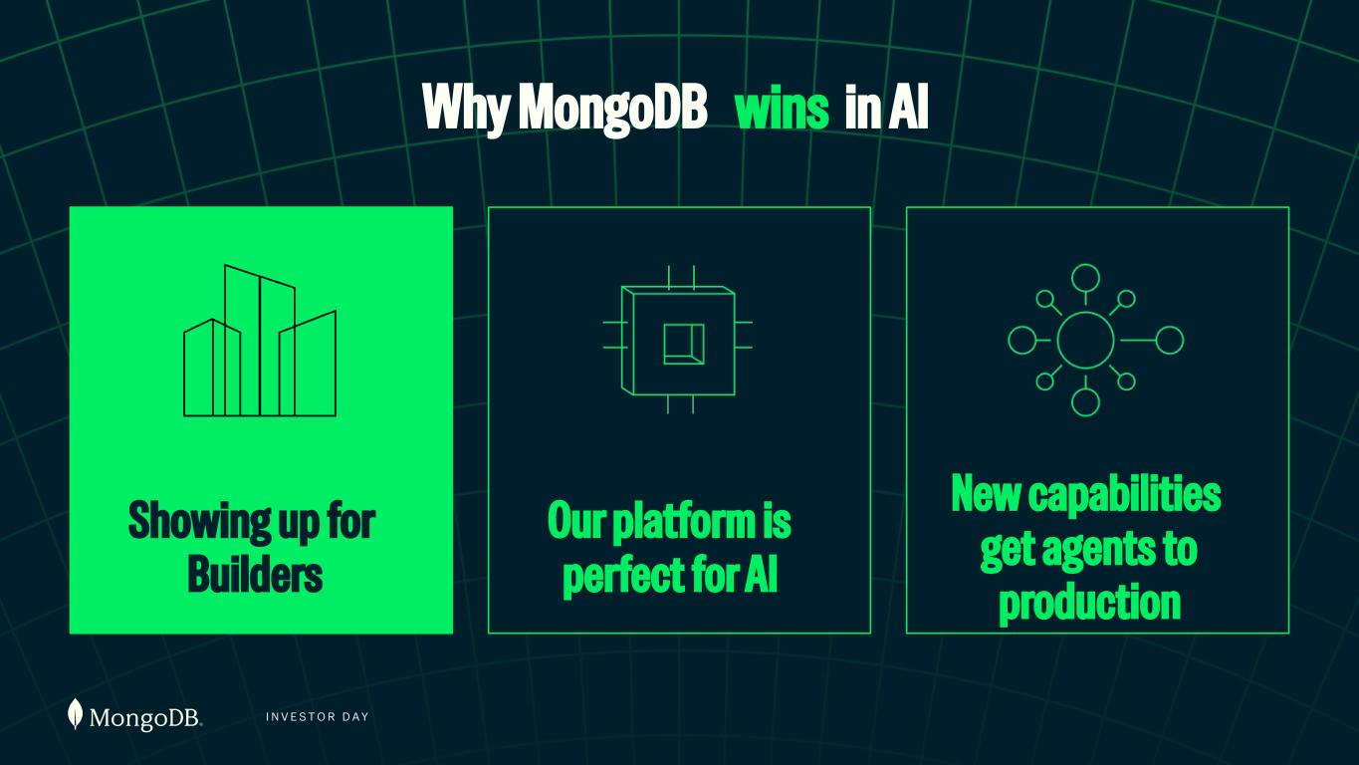
I N V E S T O R D A Y Showing up for Builders Our platform is perfect for AI New capabilities get agents to production Why MongoDB wins in AI

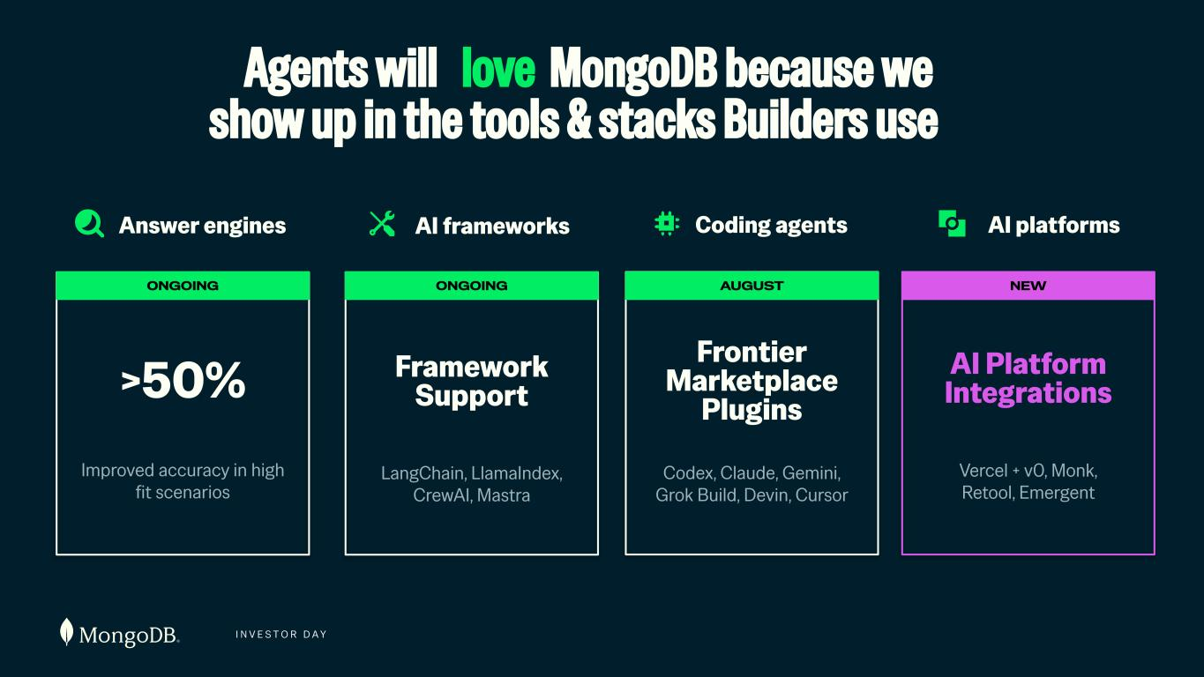
I N V E S T O R D A Y Answer engines AI frameworks Coding agents Framework Support LangChain, LlamaIndex, CrewAI, Mastra ONGOING Frontier Marketplace Plugins Codex, Claude, Gemini, Grok Build, Devin, Cursor AUGUST ONGOING Improved accuracy in high fit scenarios >50% Agents will love MongoDB because we show up in the tools & stacks Builders use AI platforms NEW AI Platform Integrations Vercel + v0, Monk, Retool, Emergent

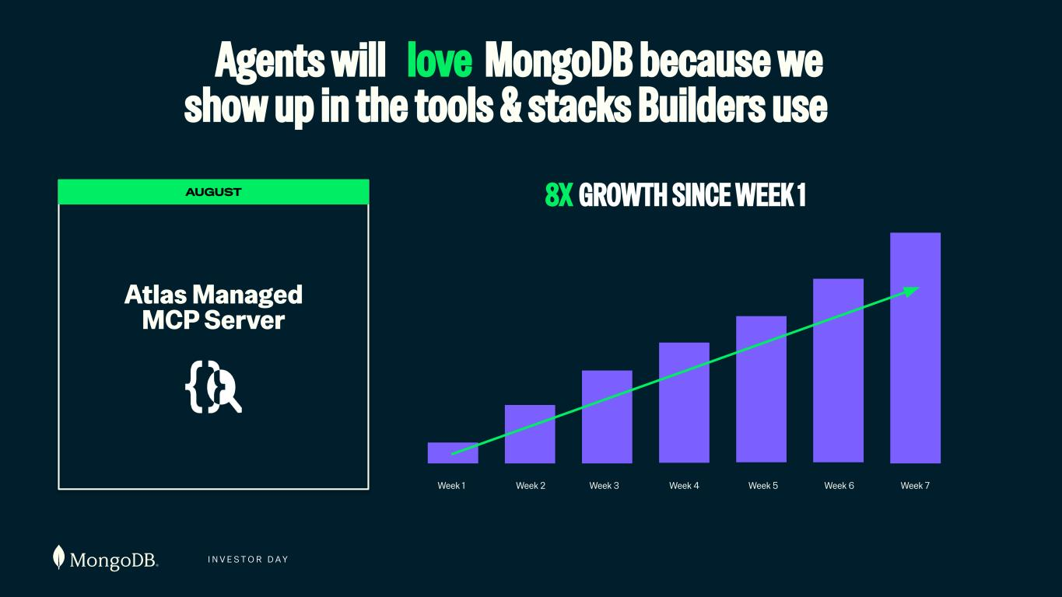
I N V E S T O R D A Y Agents will love MongoDB because we show up in the tools & stacks Builders use 8X GROWTH SINCE WEEK 1 Week 1 Week 2 Week 3 Week 4 Week 5 Week 6 Week 7 AUGUST Atlas Managed MCP Server

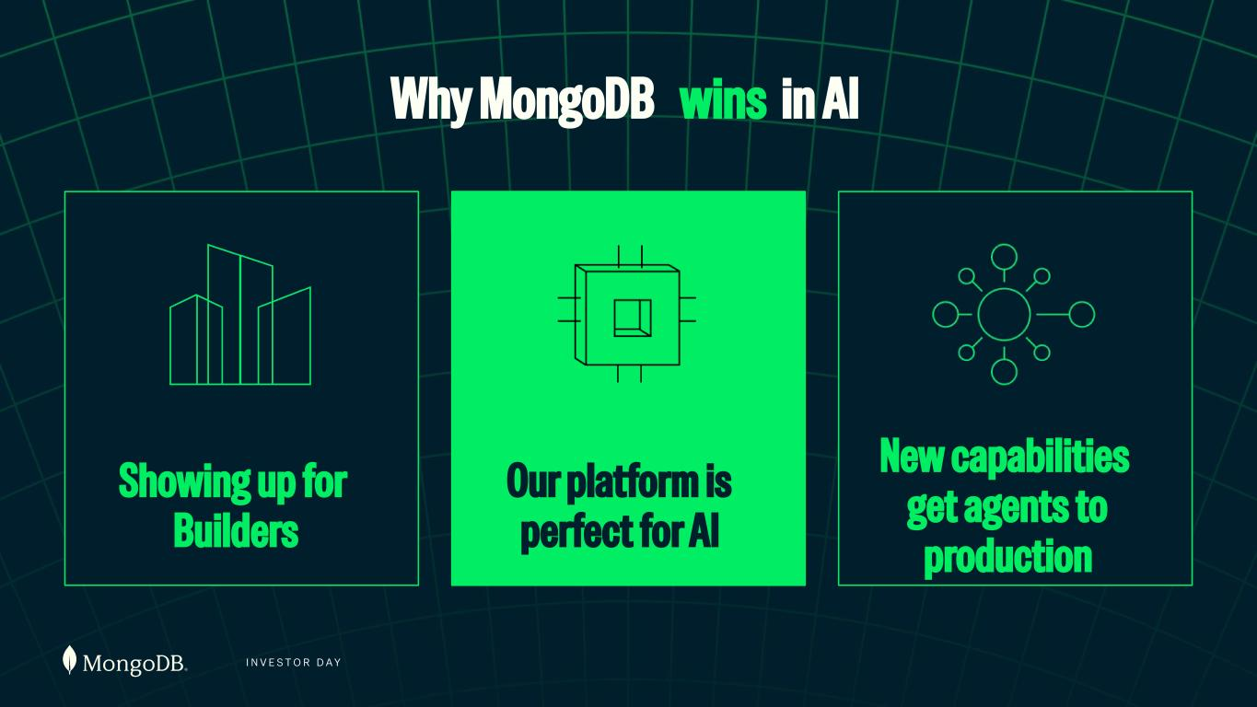
I N V E S T O R D A Y Showing up for Builders Our platform is perfect for AI New capabilities get agents to production Why MongoDB wins in AI

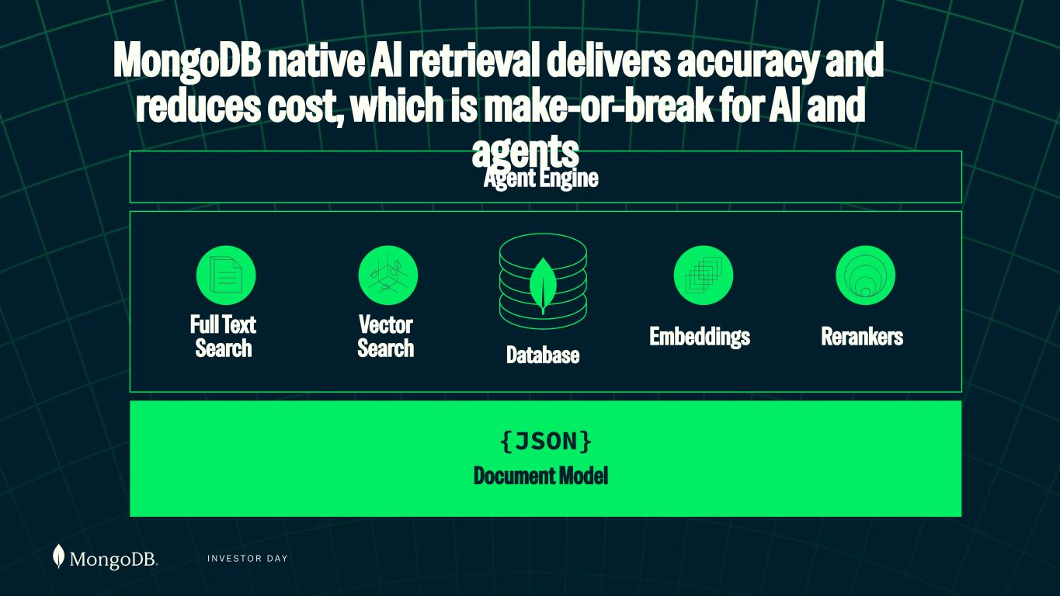
I N V E S T O R D A Y Database Full Text Search Embeddings RerankersVector Search {JSON} Document Model Agent Engine MongoDB native AI retrieval delivers accuracy and reduces cost, which is make-or-break for AI and agents

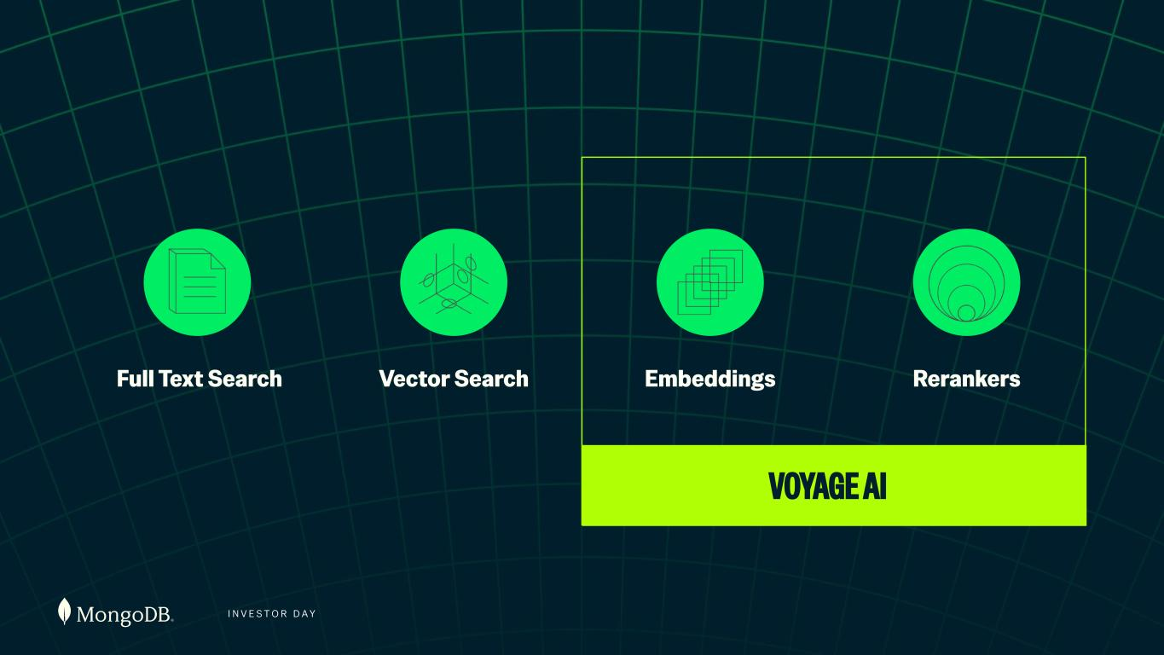
I N V E S T O R D A Y Full Text Search Vector Search Embeddings Rerankers VOYAGE AI VOYAGE AI

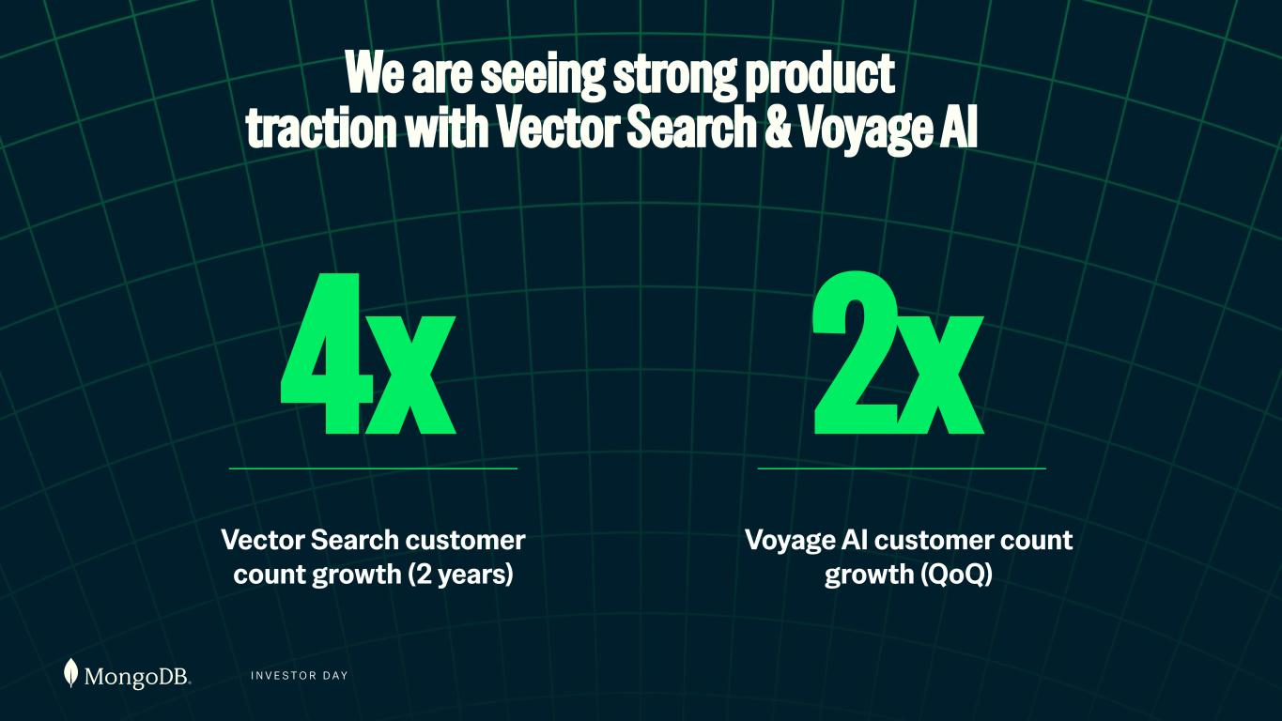
I N V E S T O R D A Y 2x Voyage AI customer count growth (QoQ) Vector Search - Customer Count We are seeing strong product traction with Vector Search & Voyage AI Vector Search customer count growth (2 years) 4x

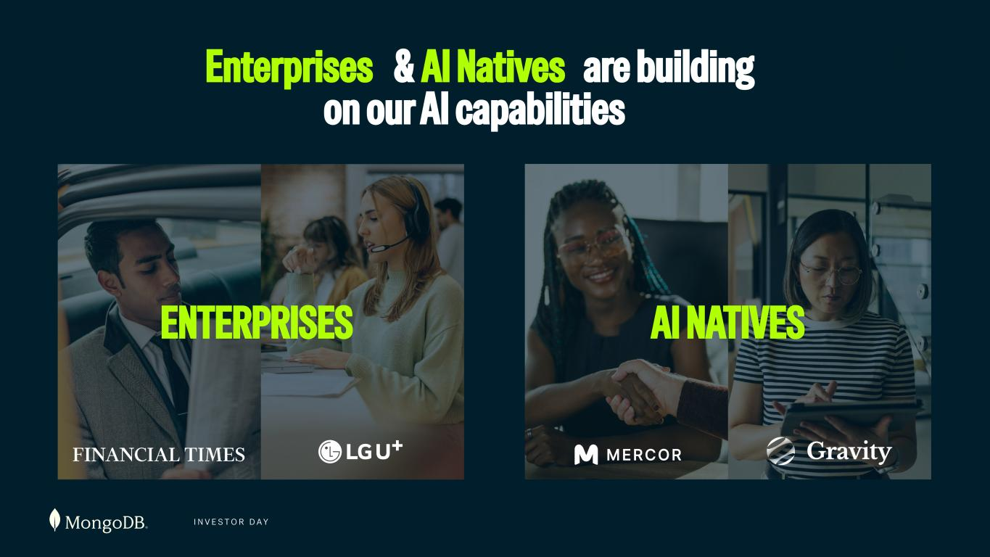
I N V E S T O R D A Y Enterprises & AI Natives are building on our AI capabilities ENTERPRISES AI NATIVES

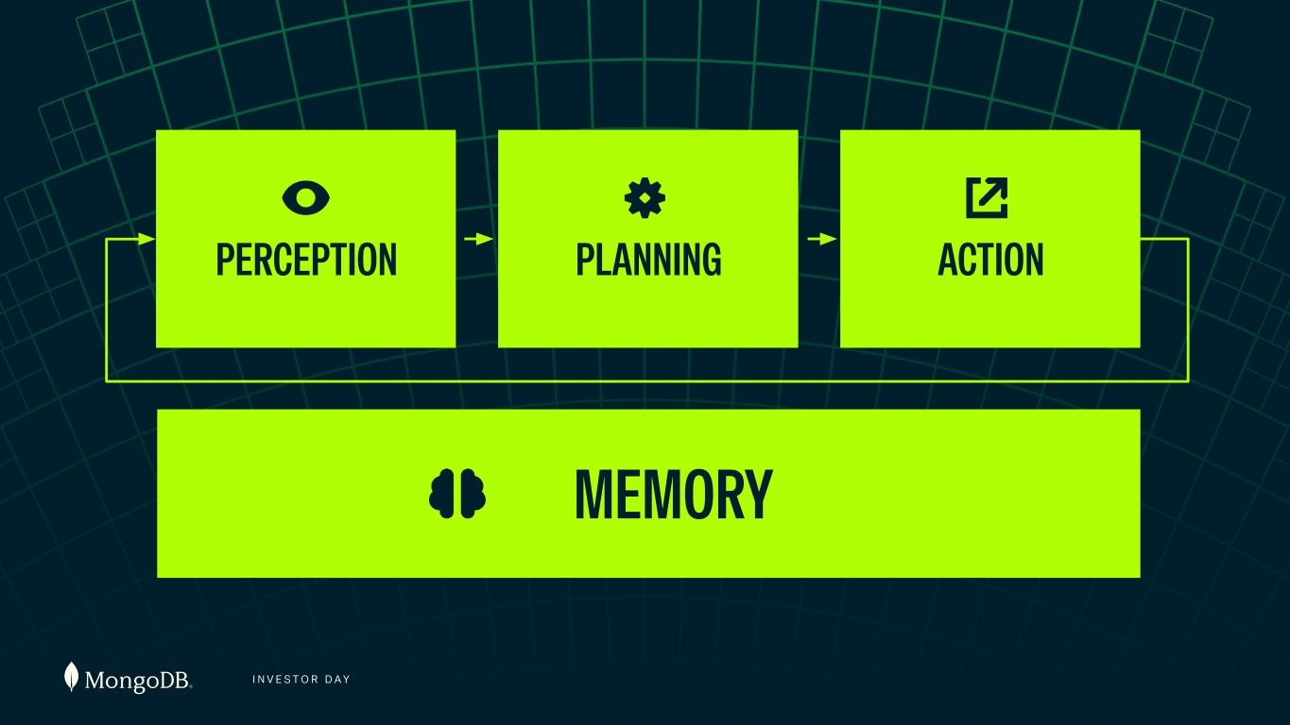
I N V E S T O R D A Y PLANNING ACTIONPERCEPTION MEMORY READY FOR DESIGN

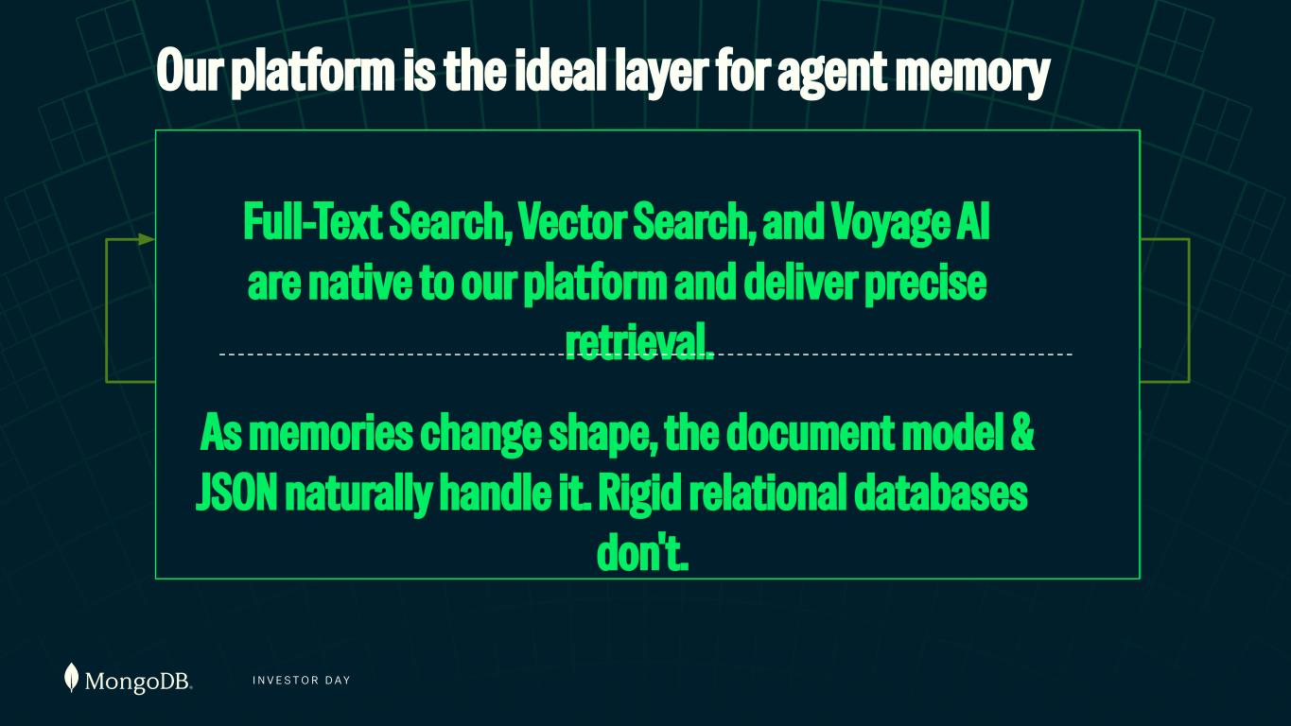
I N V E S T O R D A Y PLANNING ACTIONPERCEPTION MEMORY Our platform is the ideal layer for agent memory Full-Text Search, Vector Search, and Voyage AI are native to our platform and deliver precise retrieval. As memories change shape, the document model & JSON naturally handle it. Rigid relational databases don't.

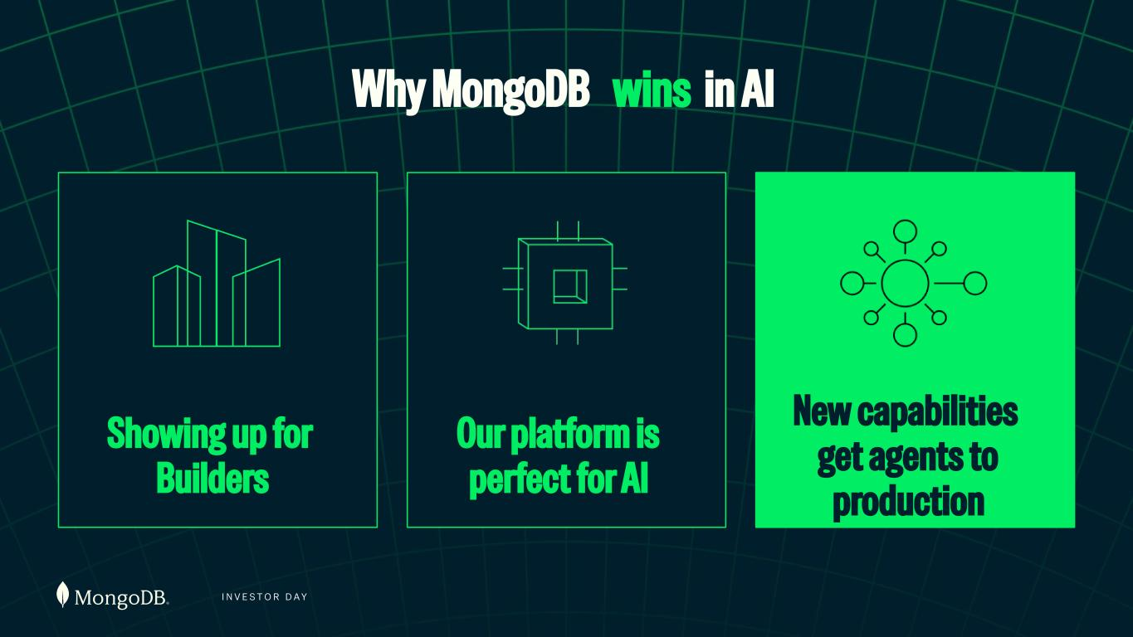
I N V E S T O R D A Y Showing up for Builders Our platform is perfect for AI New capabilities get agents to production Why MongoDB wins in AI

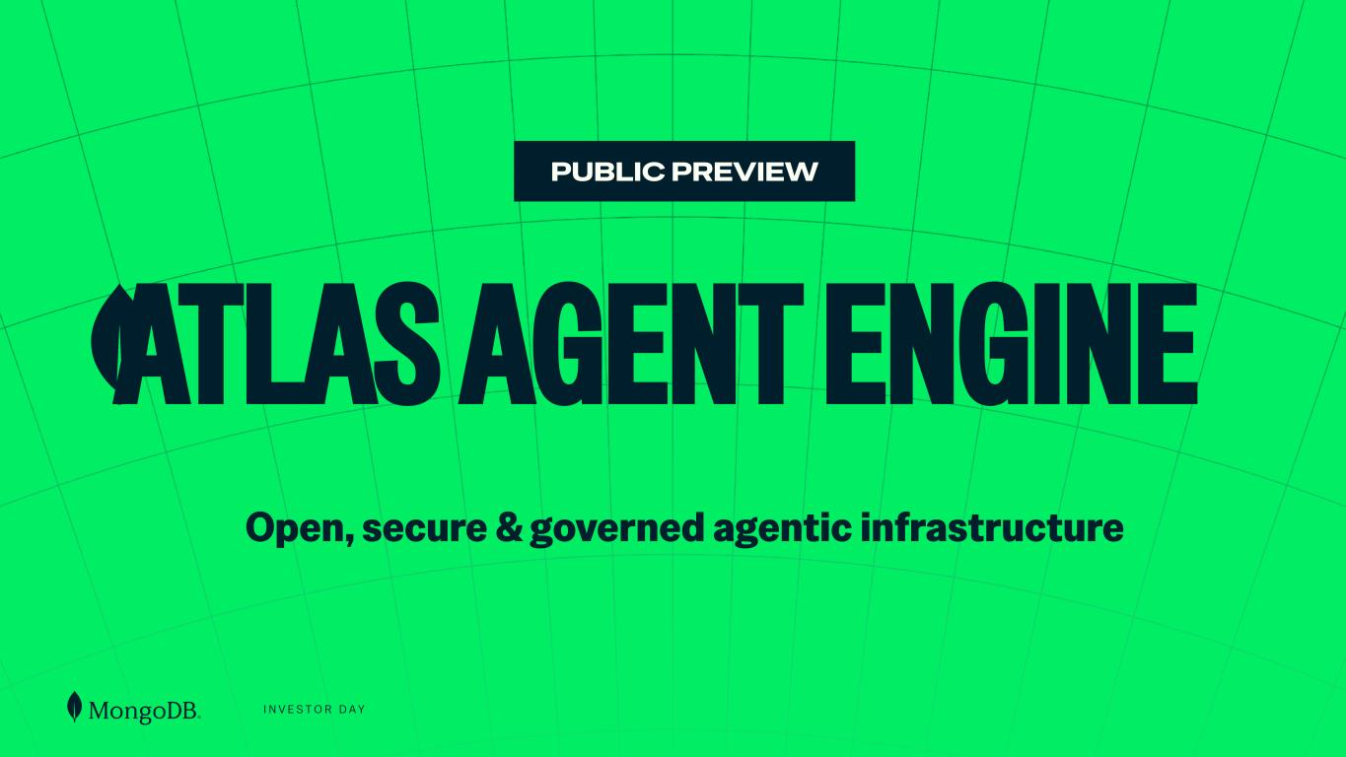
I N V E S T O R D A Y PUBLIC PREVIEW ATLAS AGENT ENGINE READY FOR DESIGN Open, secure & governed agentic infrastructure

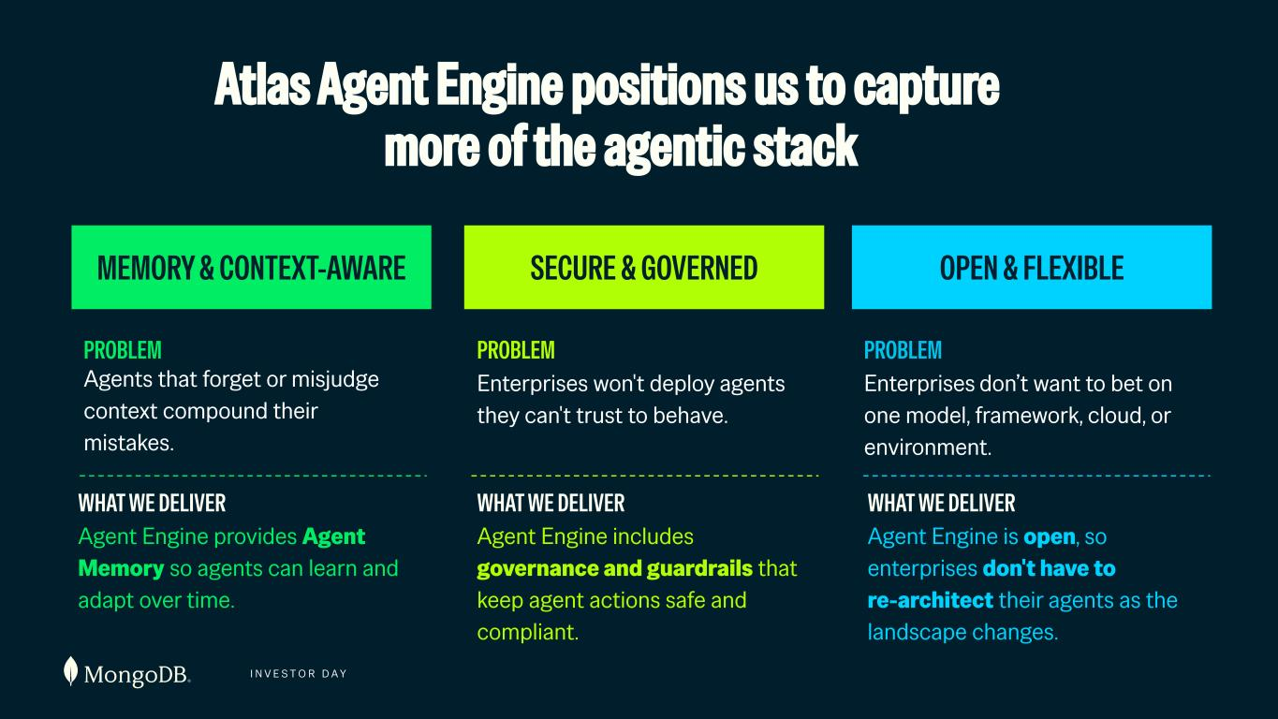
I N V E S T O R D A Y MEMORY & CONTEXT-AWARE SECURE & GOVERNED OPEN & FLEXIBLE PROBLEM Enterprises won't deploy agents they can't trust to behave. WHAT WE DELIVER Agent Engine includes governance and guardrails that keep agent actions safe and compliant. PROBLEM Enterprises don’t want to bet on one model, framework, cloud, or environment. WHAT WE DELIVER Agent Engine is open, so enterprises don't have to re-architect their agents as the landscape changes. PROBLEM Agents that forget or misjudge context compound their mistakes. WHAT WE DELIVER Agent Engine provides Agent Memory so agents can learn and adapt over time. Atlas Agent Engine positions us to capture more of the agentic stack

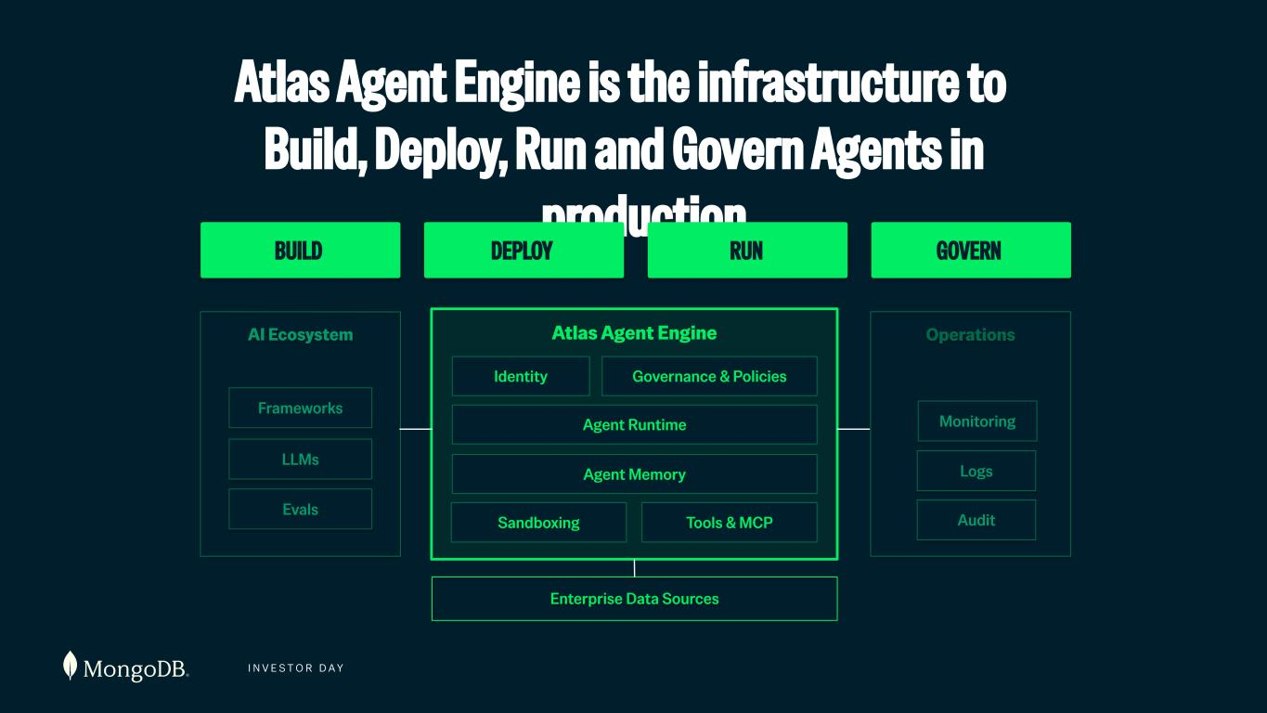
I N V E S T O R D A Y Operations Atlas Agent Engine is the infrastructure to Build, Deploy, Run and Govern Agents in production BUILD DEPLOY RUN GOVERN AI Ecosystem Atlas Agent Engine Agent Runtime Governance & Policies Tools & MCP Identity Agent Memory LLMs Logs Sandboxing Frameworks Monitoring Evals Audit Enterprise Data Sources

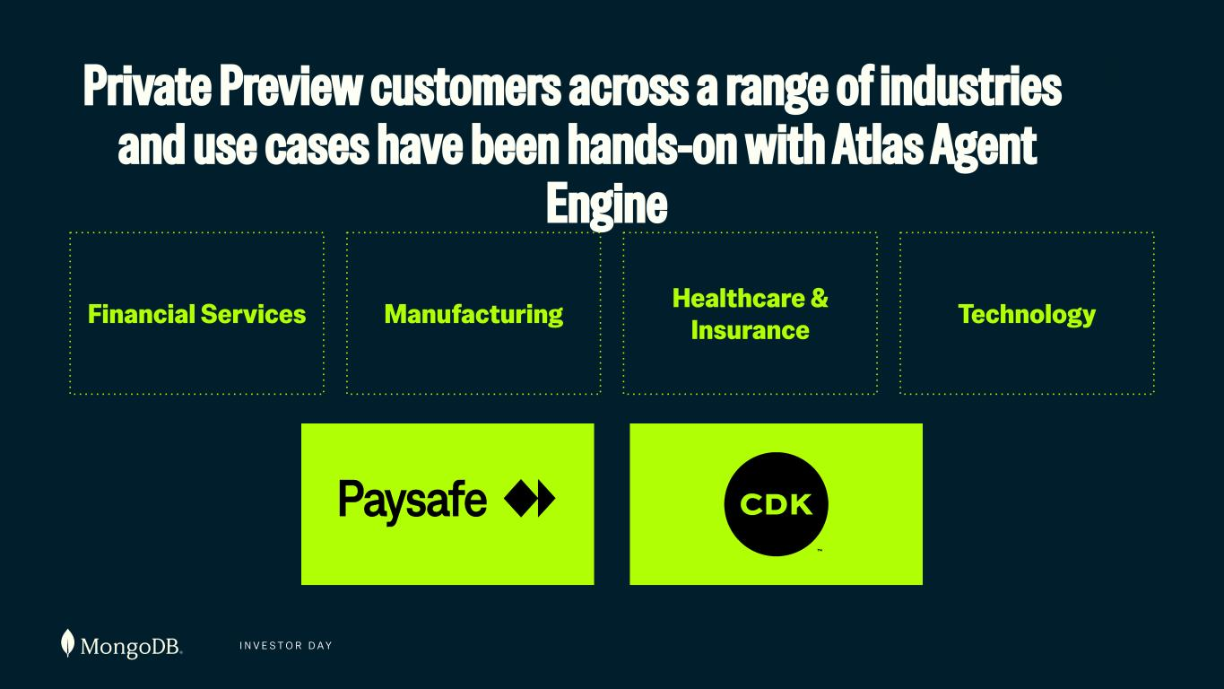
I N V E S T O R D A Y Financial Services Manufacturing Financial Services Healthcare & Insurance Private Preview customers across a range of industries and use cases have been hands-on with Atlas Agent Engine Manufacturing Healthcare & Insurance Technology

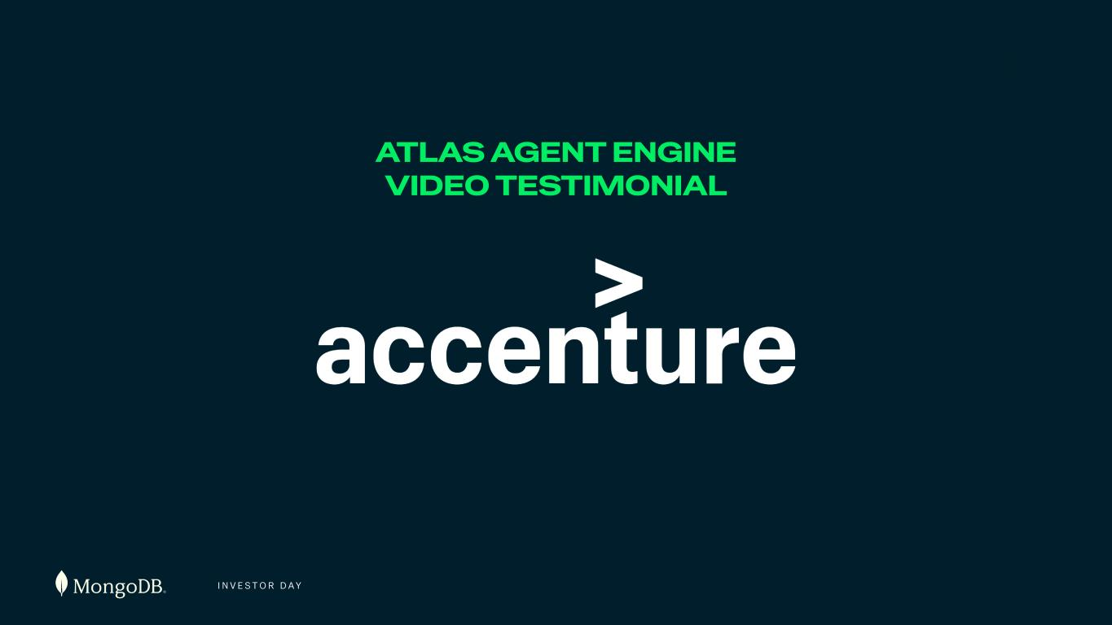
I N V E S T O R D A Y ATLAS AGENT ENGINE VIDEO TESTIMONIAL

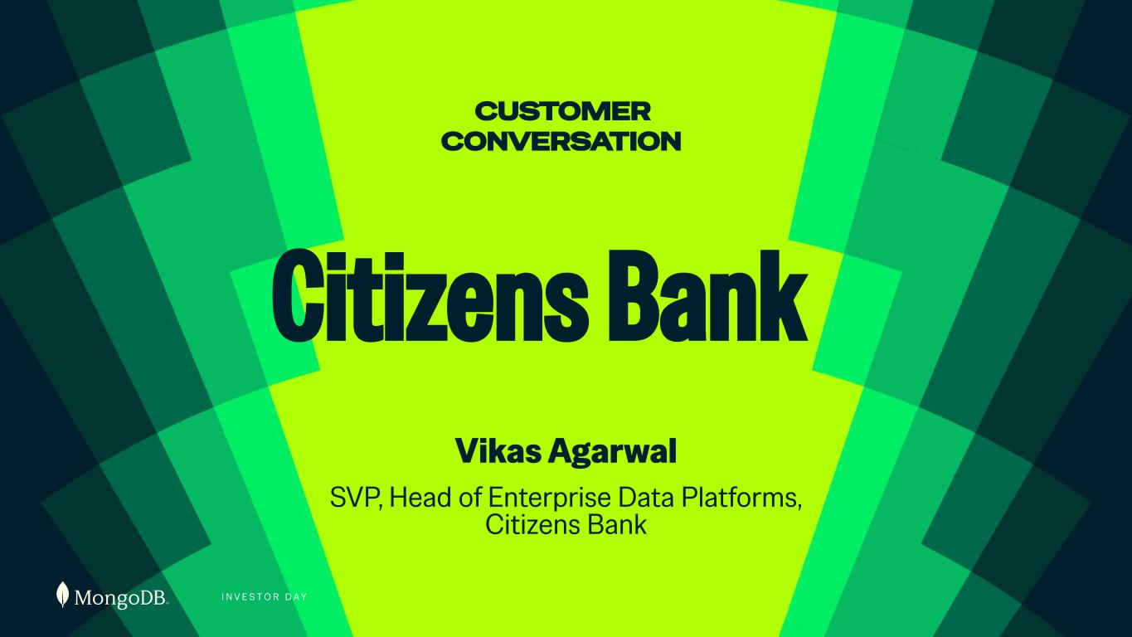
I N V E S T O R D A Y Citizens Bank Vikas Agarwal SVP, Head of Enterprise Data Platforms, Citizens Bank CUSTOMER CONVERSATION

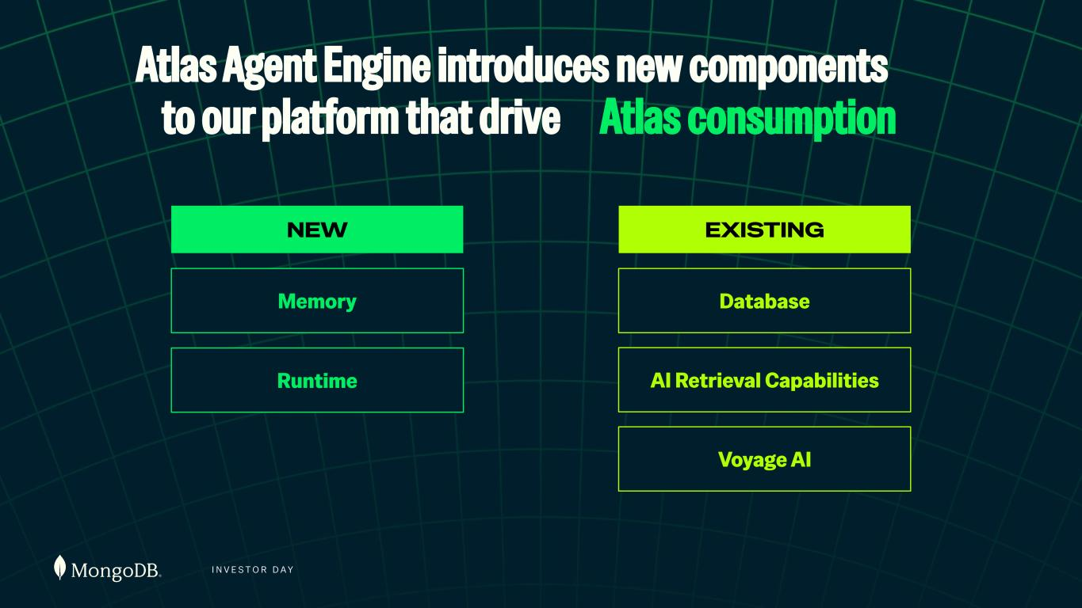
I N V E S T O R D A Y NEW EXISTING Memory Database Runtime AI Retrieval Capabilities Voyage AI Atlas Agent Engine introduces new components to our platform that drive Atlas consumption

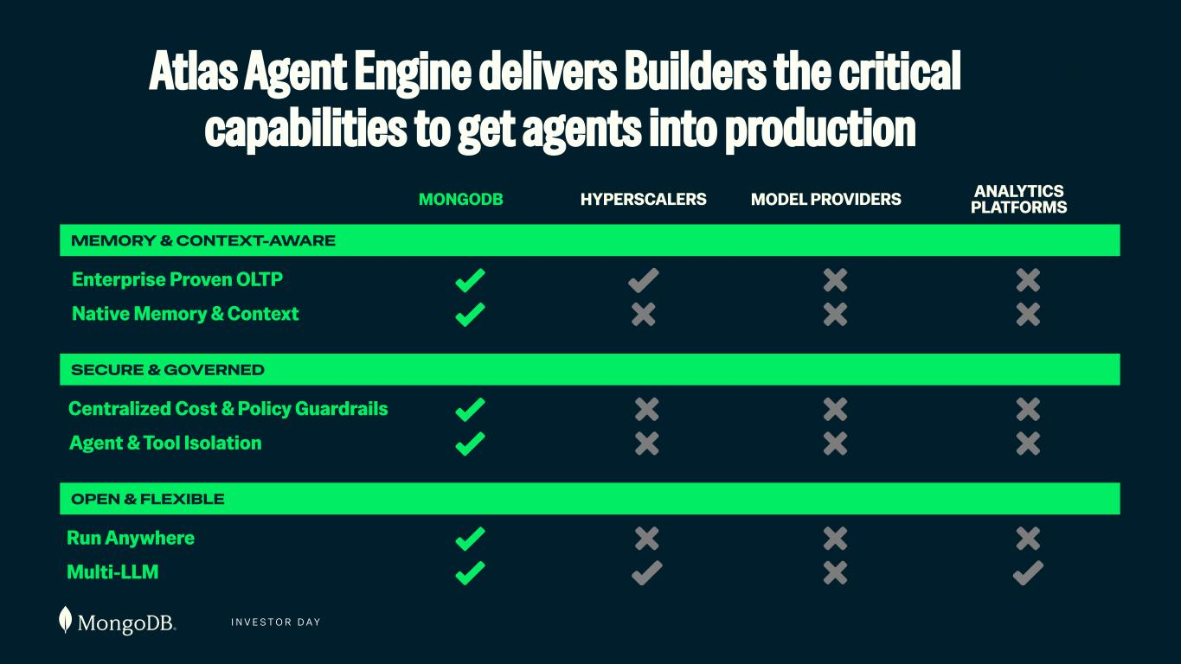
I N V E S T O R D A Y Atlas Agent Engine delivers Builders the critical capabilities to get agents into production MONGODB HYPERSCALERS MODEL PROVIDERS ANALYTICS PLATFORMS Multi-LLM Native Memory & Context Run Anywhere Agent & Tool Isolation Centralized Cost & Policy Guardrails MEMORY & CONTEXT-AWARE SECURE & GOVERNED OPEN & FLEXIBLE Enterprise Proven OLTP

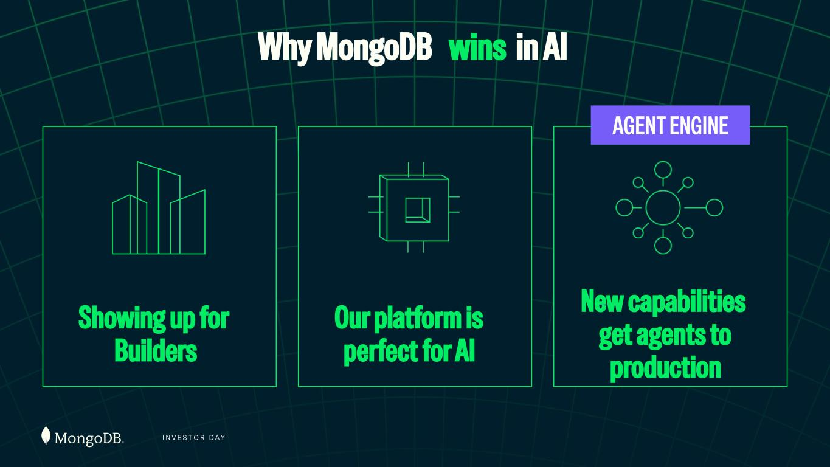
I N V E S T O R D A Y Showing up for Builders Our platform is perfect for AI New capabilities get agents to production AGENT ENGINE Why MongoDB wins in AI

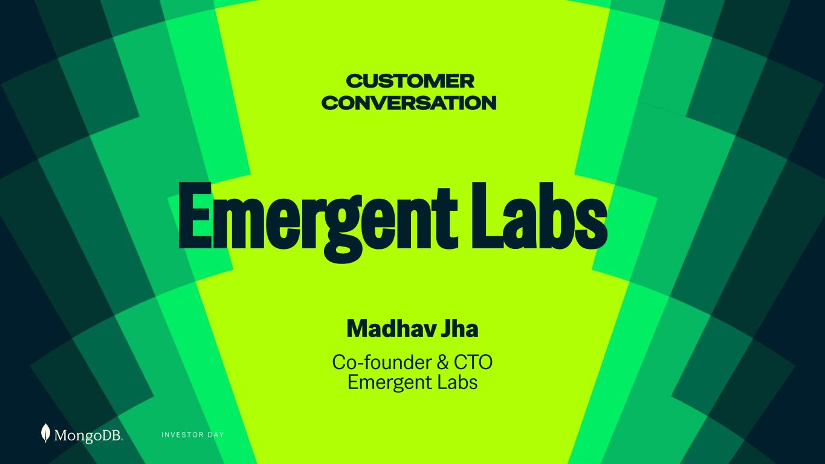
I N V E S T O R D A Y Emergent Labs Madhav Jha Co-founder & CTO Emergent Labs CUSTOMER CONVERSATION


I N V E S T O R D A Y GO-TO-MARKET & PARTNERSHIPS Ryan Mac Ban Chief Revenue Officer

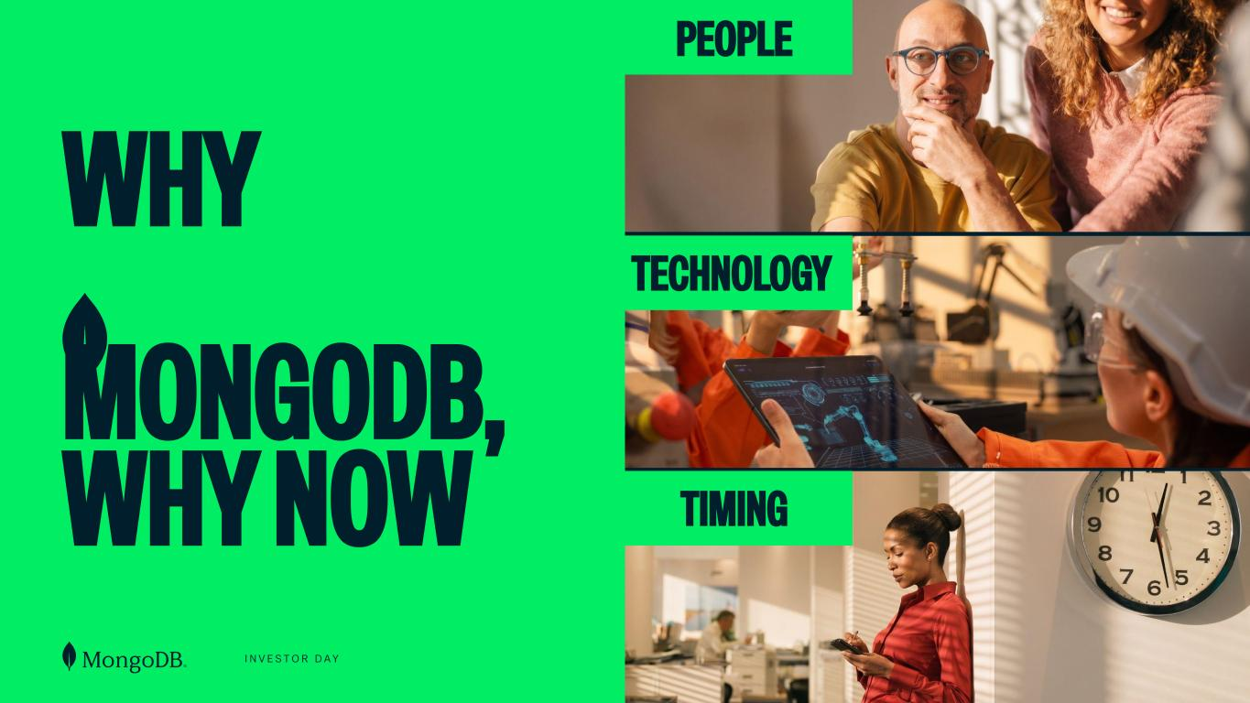
I N V E S T O R D A Y WHY MONGODB, WHY NOW PEOPLE TECHNOLOGY TIMING

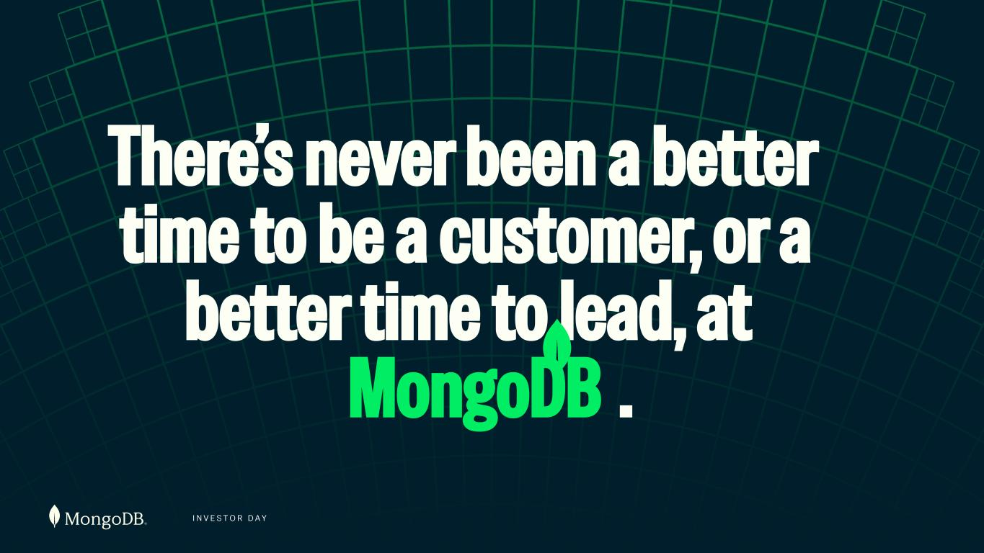
I N V E S T O R D A Y There’s never been a better time to be a customer, or a better time to lead, at MongoDB .

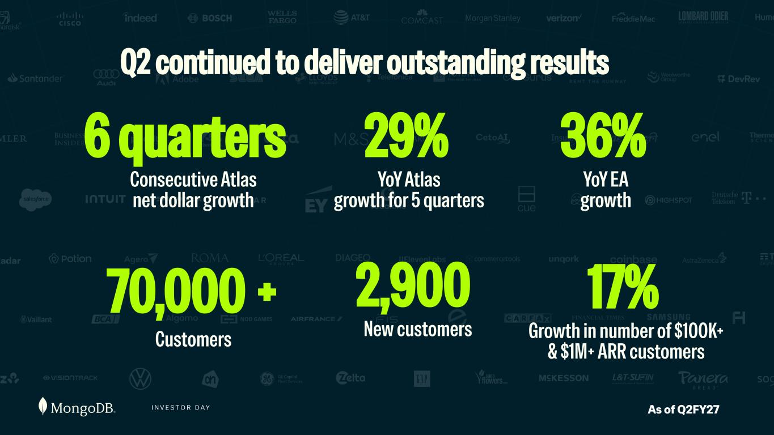
I N V E S T O R D A Y 6 quarters Consecutive Atlas net dollar growth 29% YoY Atlas growth for 5 quarters 36% YoY EA growth 70,000 + Customers 2,900 New customers 17% Growth in number of $100K+ & $1M+ ARR customers As of Q2FY27 Q2 continued to deliver outstanding results

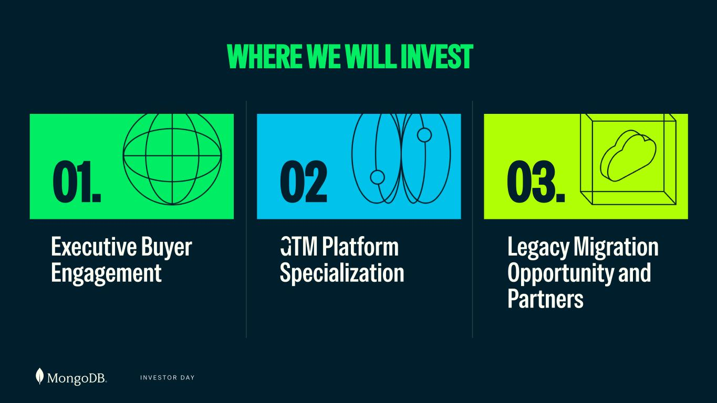
I N V E S T O R D A Y Executive Buyer Engagement GTM Platform Specialization Legacy Migration Opportunity and Partners WHERE WE WILL INVEST 01. 02 . 03.

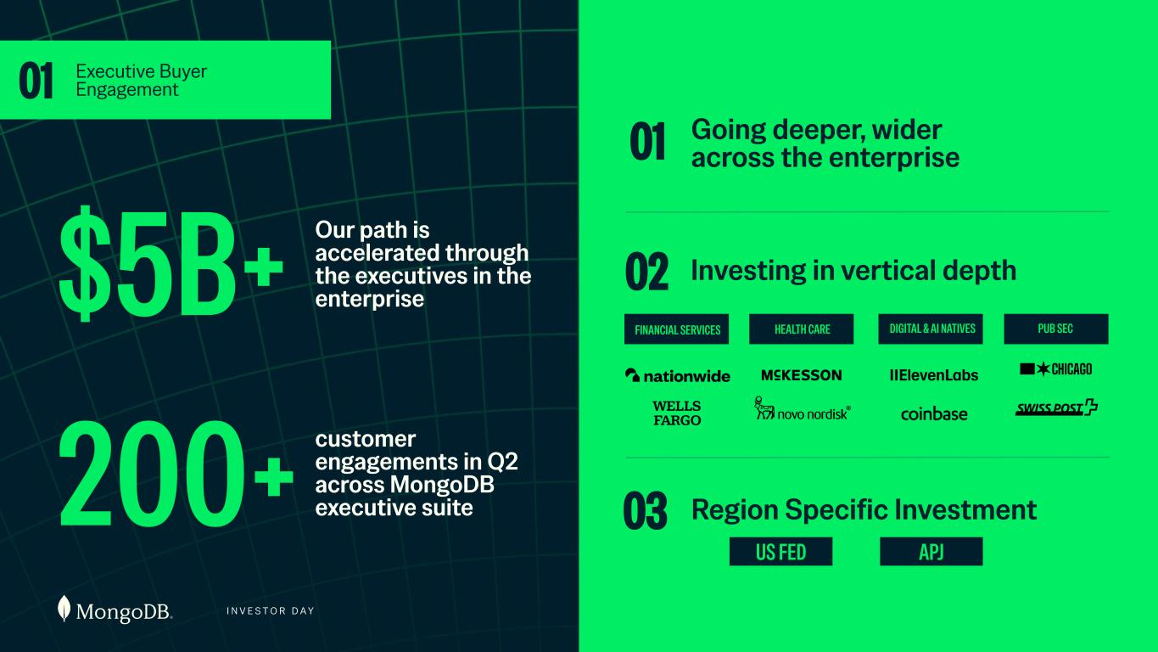
Our path is accelerated through the executives in the enterprise$5B+ 200+ 01 Executive Buyer Engagement customer engagements in Q2 across MongoDB executive suite I N V E S T O R D A Y Going deeper, wider across the enterprise Investing in vertical depth 01 Region Specific Investment 02 03 FINANCIAL SERVICES HEALTH CARE DIGITAL & AI NATIVES PUB SEC APJUS FED

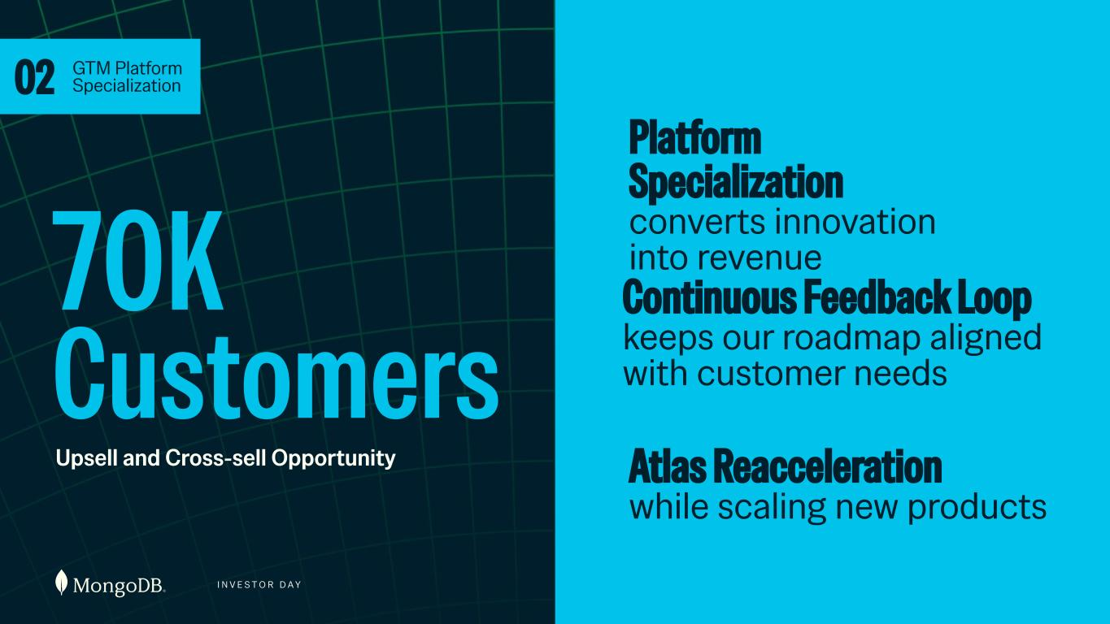
I N V E S T O R D A Y 70K Customers Upsell and Cross-sell Opportunity 02 GTM Platform Specialization Platform Specialization converts innovation into revenue Continuous Feedback Loop keeps our roadmap aligned with customer needs Atlas Reacceleration while scaling new products

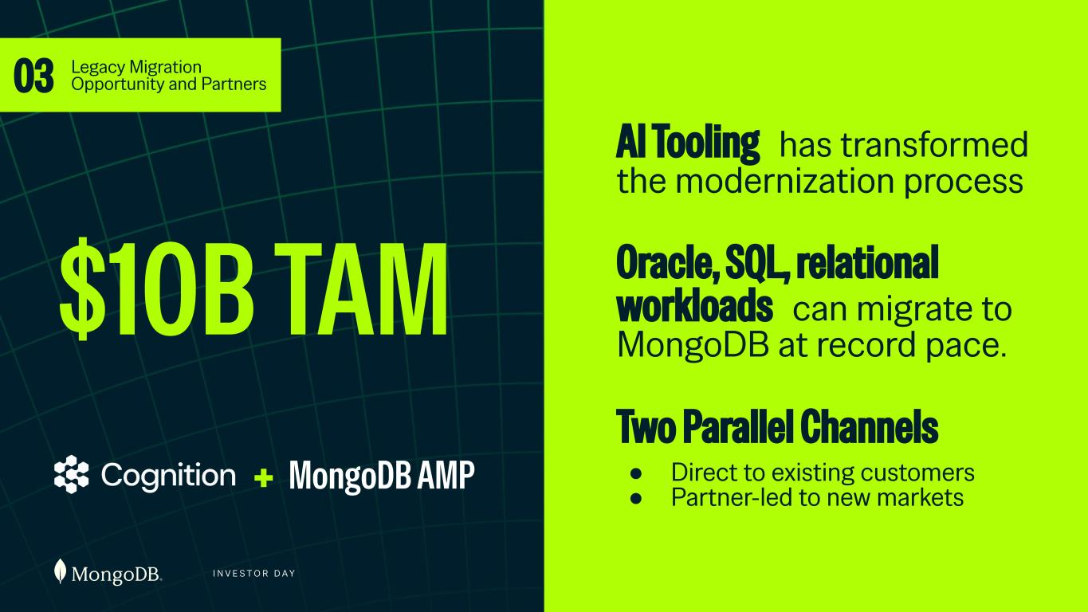
I N V E S T O R D A Y $10B TAM 03 Legacy Migration Opportunity and Partners AI Tooling has transformed the modernization process Oracle, SQL, relational workloads can migrate to MongoDB at record pace. Two Parallel Channels ● Direct to existing customers ● Partner-led to new markets+ MongoDB AMP

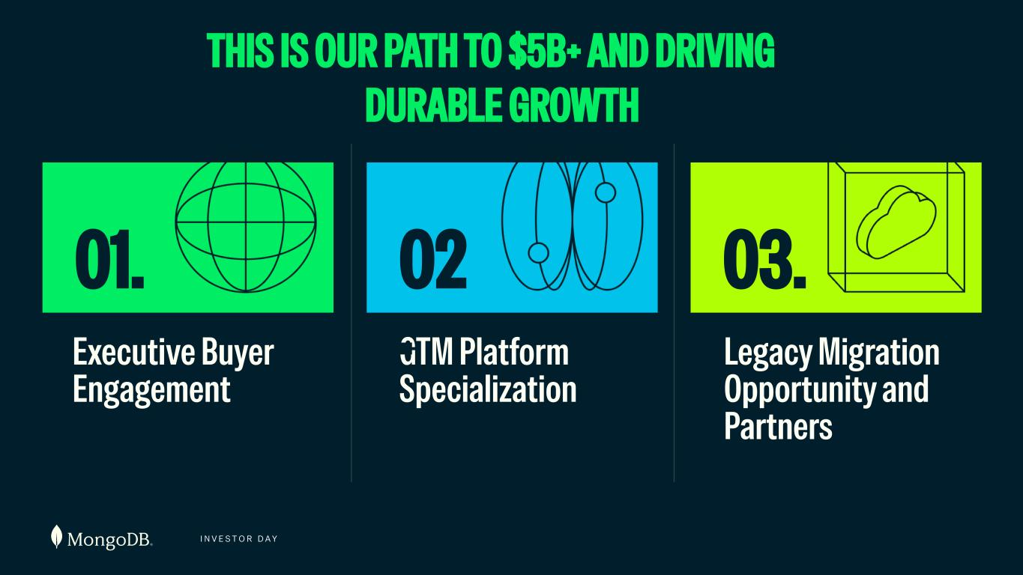
I N V E S T O R D A Y THIS IS OUR PATH TO $5B+ AND DRIVING DURABLE GROWTH Executive Buyer Engagement GTM Platform Specialization Legacy Migration Opportunity and Partners 01. 02 . 03.


I N V E S T O R D A Y Erica Volini Chief Customer Officer GO-TO-MARKET & PARTNERSHIPS

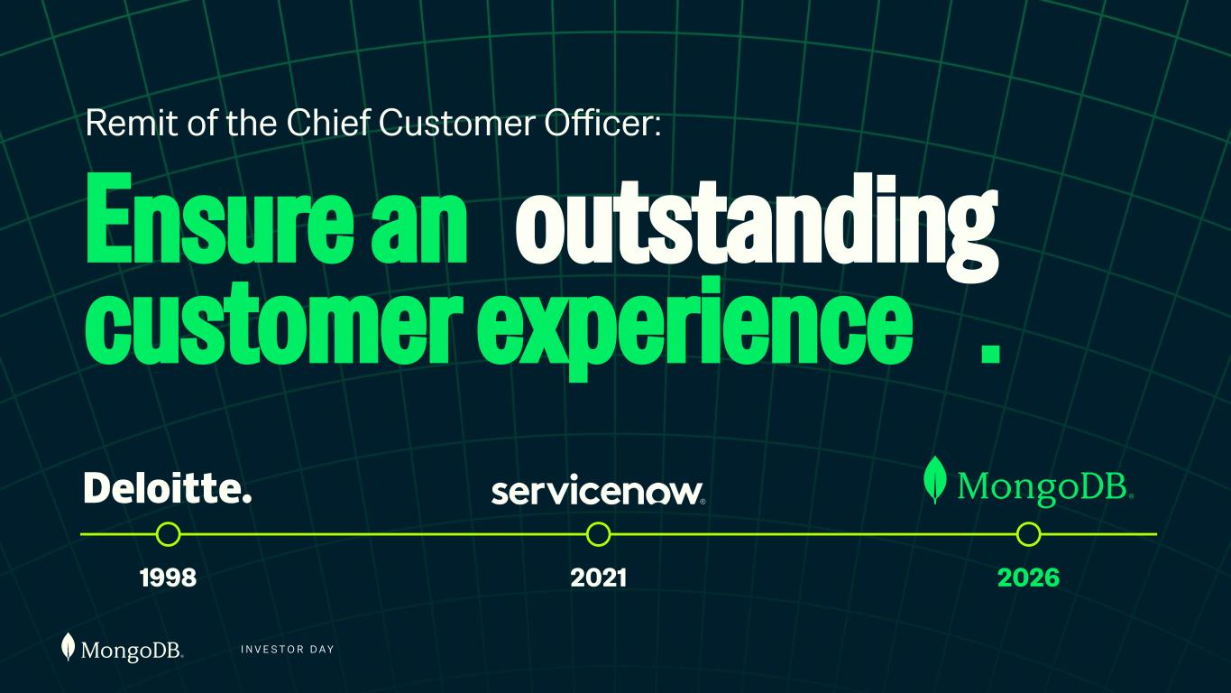
I N V E S T O R D A Y 1998 2021 2026 Ensure an outstanding customer experience . Remit of the Chief Customer Officer:

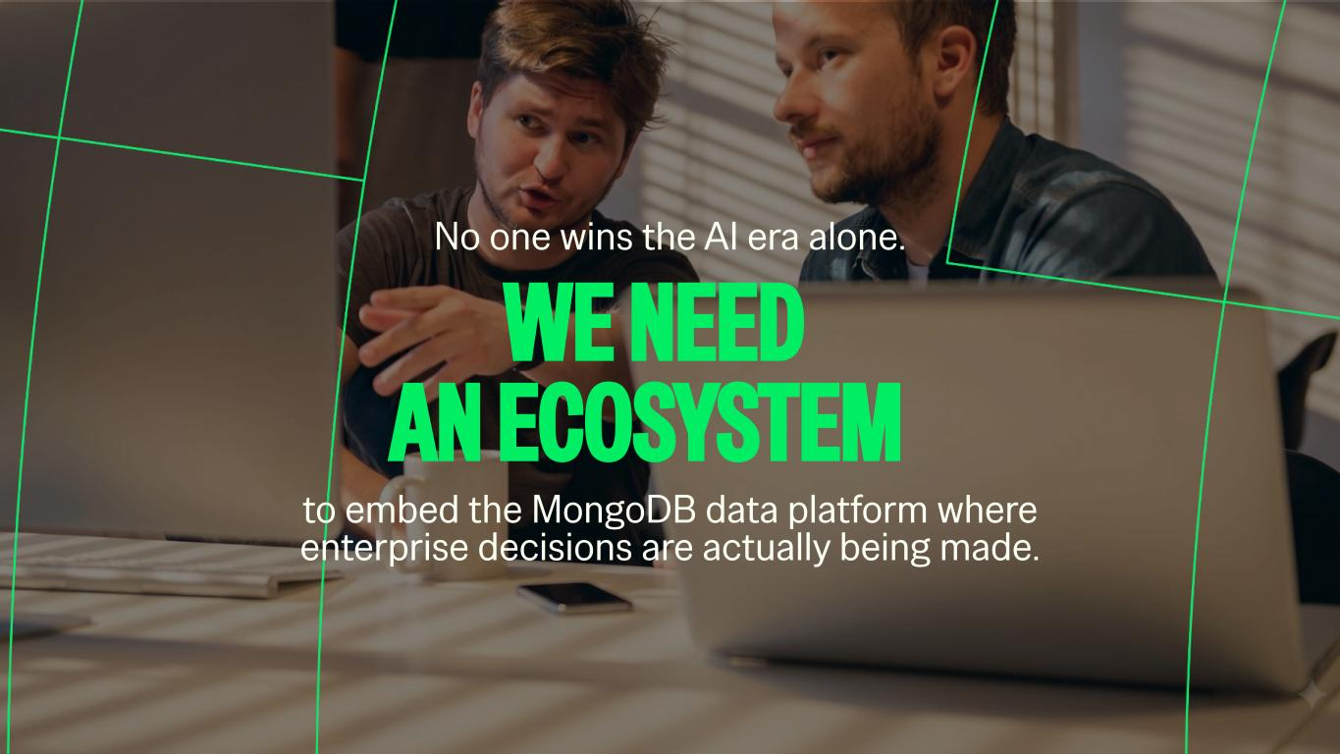
WE NEED AN ECOSYSTEM No one wins the AI era alone. to embed the MongoDB data platform where enterprise decisions are actually being made.

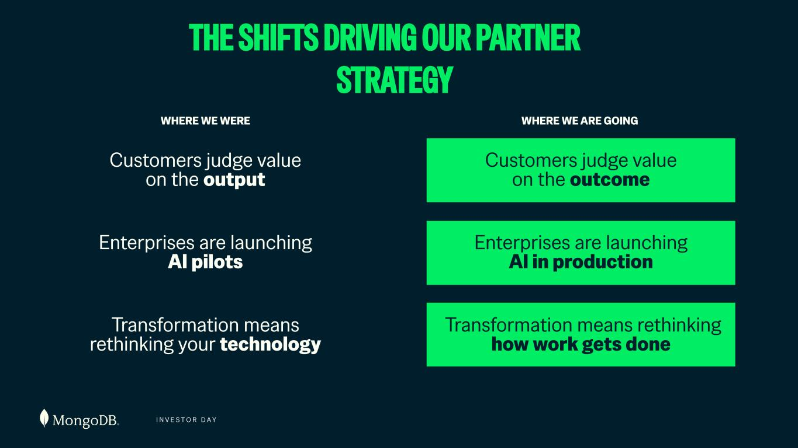
I N V E S T O R D A Y Customers judge value on the output Enterprises are launching AI pilots Transformation means rethinking your technology Customers judge value on the outcome Enterprises are launching AI in production Transformation means rethinking how work gets done WHERE WE WERE WHERE WE ARE GOING THE SHIFTS DRIVING OUR PARTNER STRATEGY


I N V E S T O R D A Y Partners will be our scale engine to surpass $5B+

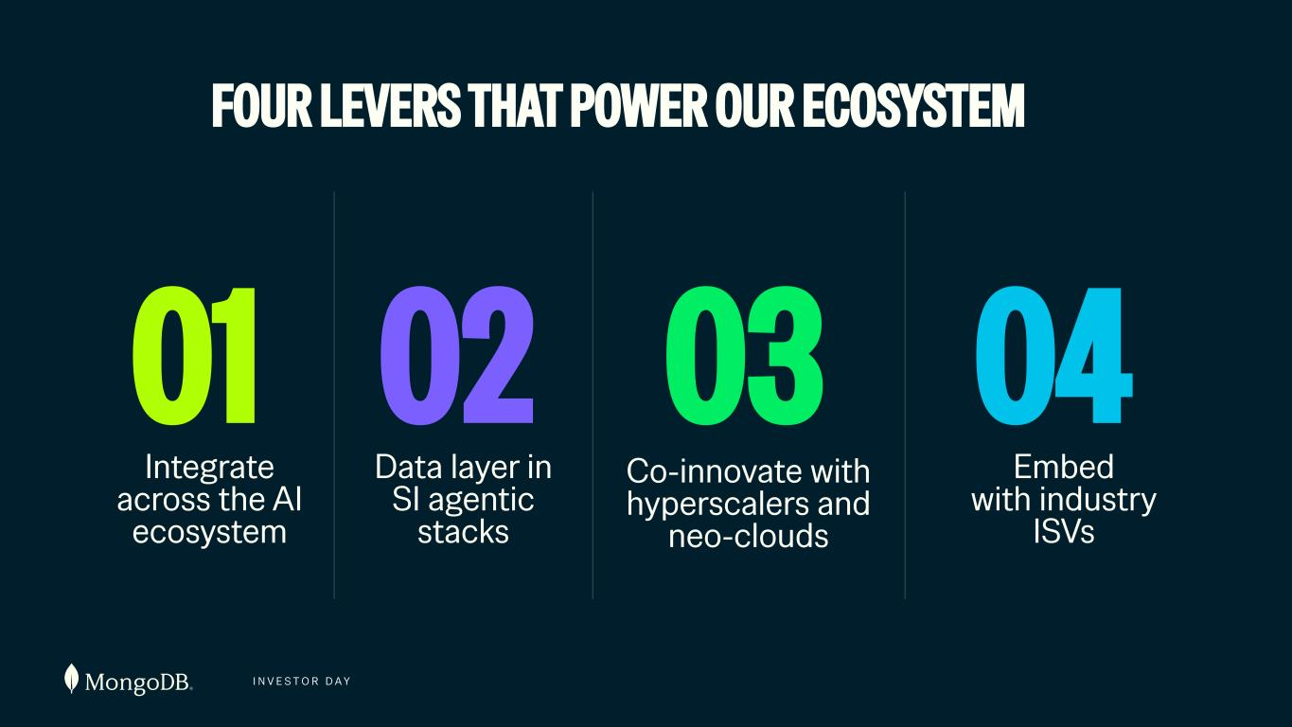
I N V E S T O R D A Y FOUR LEVERS THAT POWER OUR ECOSYSTEM Data layer in SI agentic stacks 01 Co-innovate with hyperscalers and neo-clouds 02 Integrate across the AI ecosystem 03 04 Embed with industry ISVs

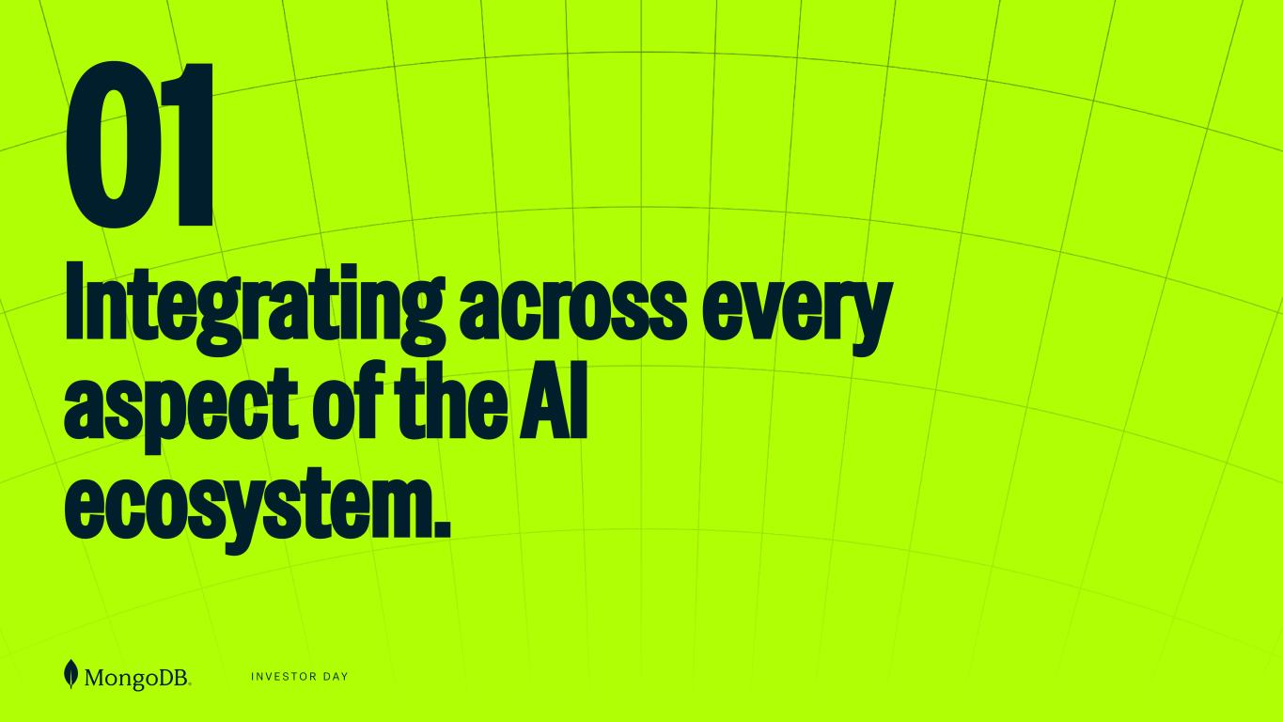
I N V E S T O R D A Y 01 Integrating across every aspect of the AI ecosystem.

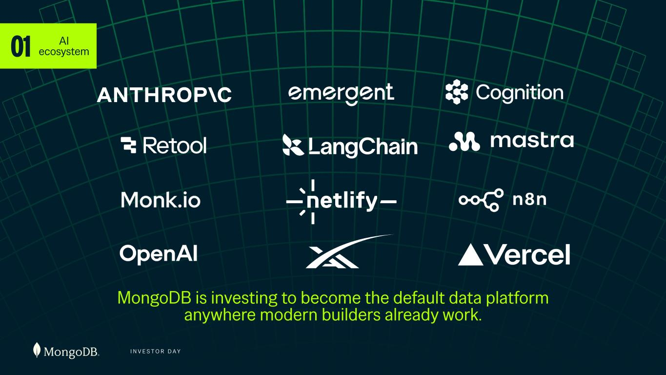
I N V E S T O R D A Y 01 AI ecosystem FRAMEWORKS API BUILDER PLATFORMS MongoDB is investing to become the default data platform anywhere modern builders already work. FRONTIER LABS

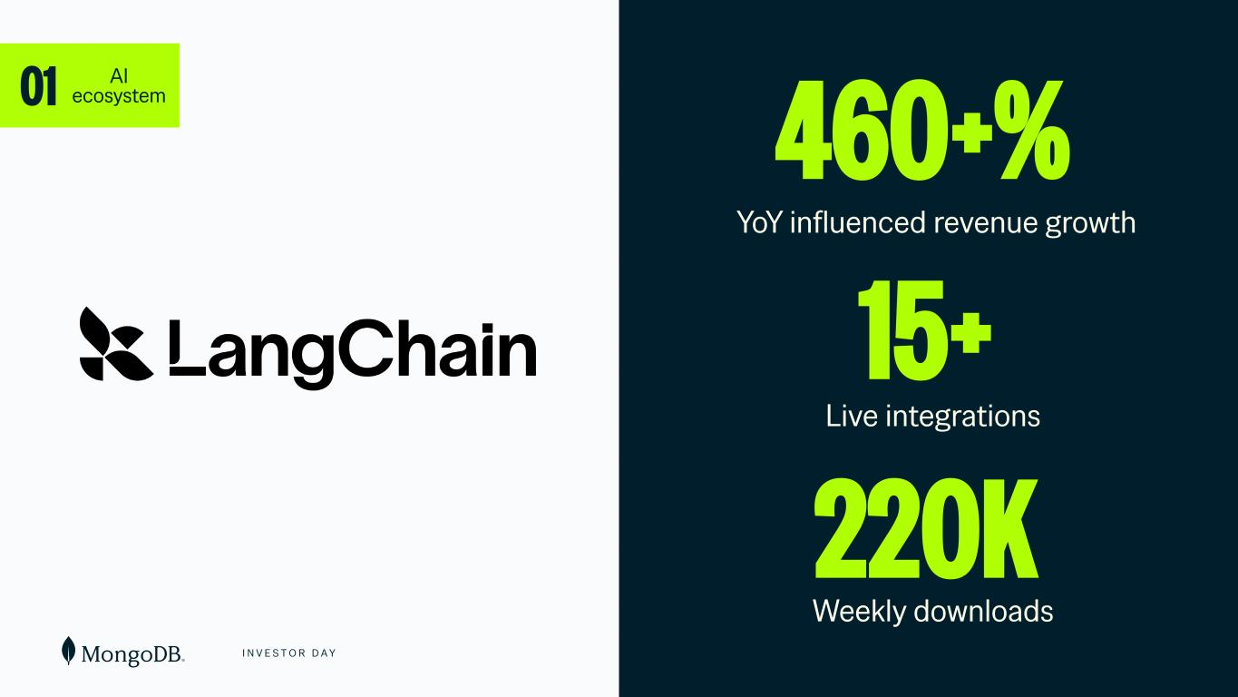
I N V E S T O R D A Y 01 AI ecosystem 460+% YoY influenced revenue growth 15+ Live integrations 220K Weekly downloads

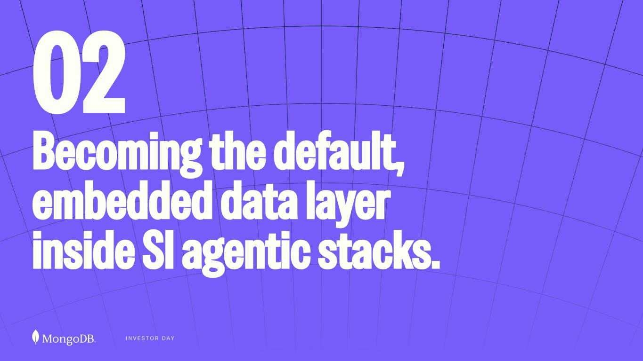
I N V E S T O R D A Y 02 Becoming the default, embedded data layer inside SI agentic stacks.

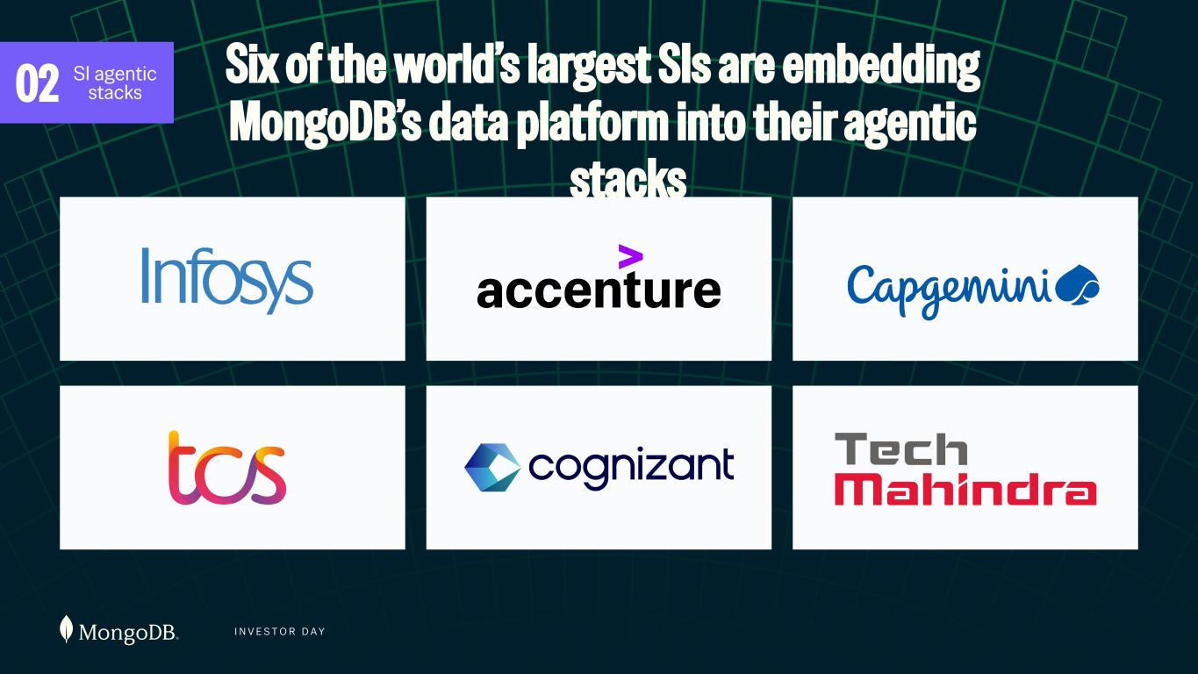
I N V E S T O R D A Y Six of the world’s largest SIs are embedding MongoDB’s data platform into their agentic stacks 02 SI agentic stacks

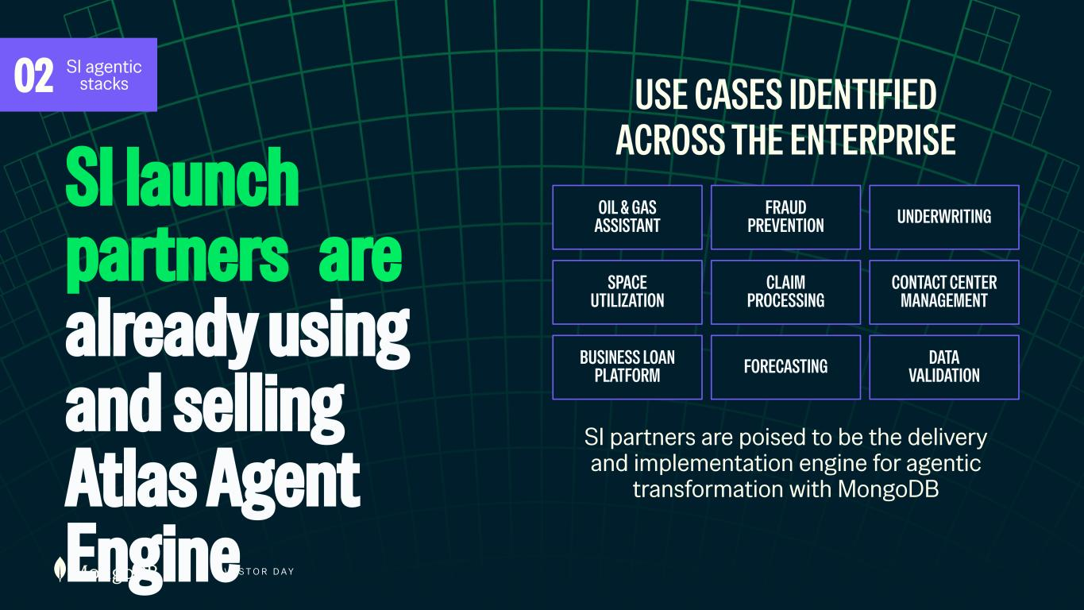
I N V E S T O R D A Y SI launch partners are already using and selling Atlas Agent Engine USE CASES IDENTIFIED ACROSS THE ENTERPRISE SI partners are poised to be the delivery and implementation engine for agentic transformation with MongoDB OIL & GAS ASSISTANT CONTACT CENTER MANAGEMENT BUSINESS LOAN PLATFORM FORECASTING SPACE UTILIZATION FRAUD PREVENTION UNDERWRITING CLAIM PROCESSING DATA VALIDATION OIL & GAS ASSISTANT FRAUD PREVENTION UNDERWRITING SPACE UTILIZATION CLAIM PROCESSING CONTACT CENTER MANAGEMENT BUSINESS LOAN PLATFORM FORECASTING DATA VALIDATION 02 SI agentic stacks

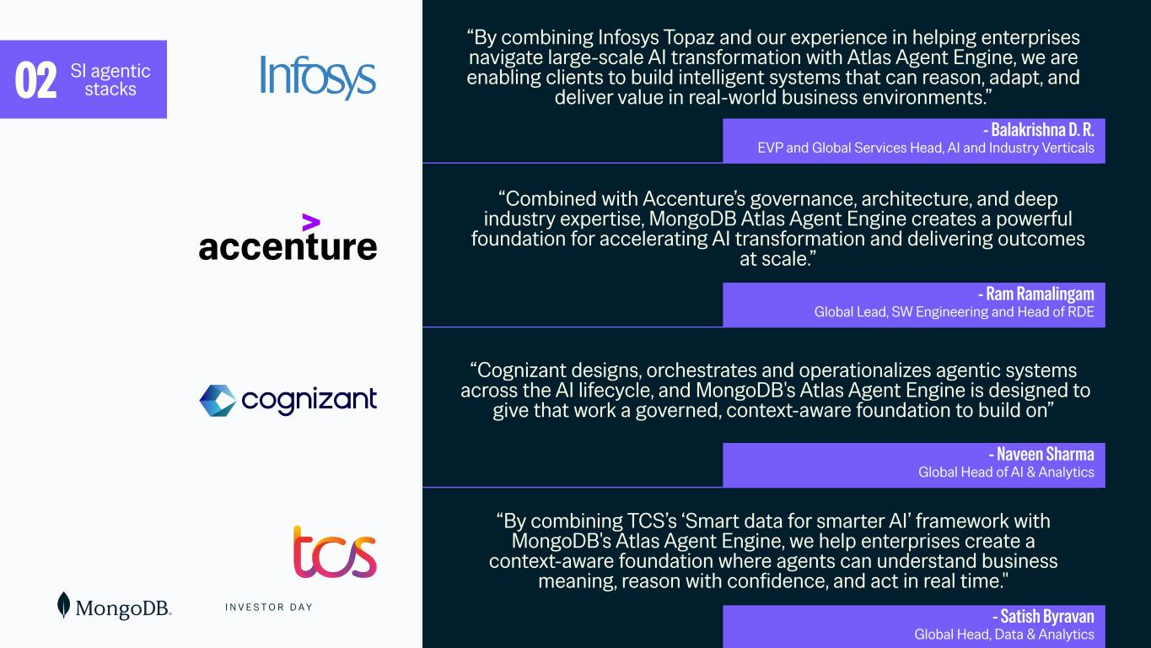
I N V E S T O R D A Y 99 “Combined with Accenture’s governance, architecture, and deep industry expertise, MongoDB Atlas Agent Engine creates a powerful foundation for accelerating AI transformation and delivering outcomes at scale.” “Cognizant designs, orchestrates and operationalizes agentic systems across the AI lifecycle, and MongoDB's Atlas Agent Engine is designed to give that work a governed, context-aware foundation to build on” “By combining TCS’s ‘Smart data for smarter AI’ framework with MongoDB's Atlas Agent Engine, we help enterprises create a context-aware foundation where agents can understand business meaning, reason with confidence, and act in real time." “By combining Infosys Topaz and our experience in helping enterprises navigate large-scale AI transformation with Atlas Agent Engine, we are enabling clients to build intelligent systems that can reason, adapt, and deliver value in real-world business environments.”02 SI agentic stacks - Ram Ramalingam Global Lead, SW Engineering and Head of RDE - Balakrishna D. R. EVP and Global Services Head, AI and Industry Verticals - Naveen Sharma Global Head of AI & Analytics - Satish Byravan Global Head, Data & Analytics

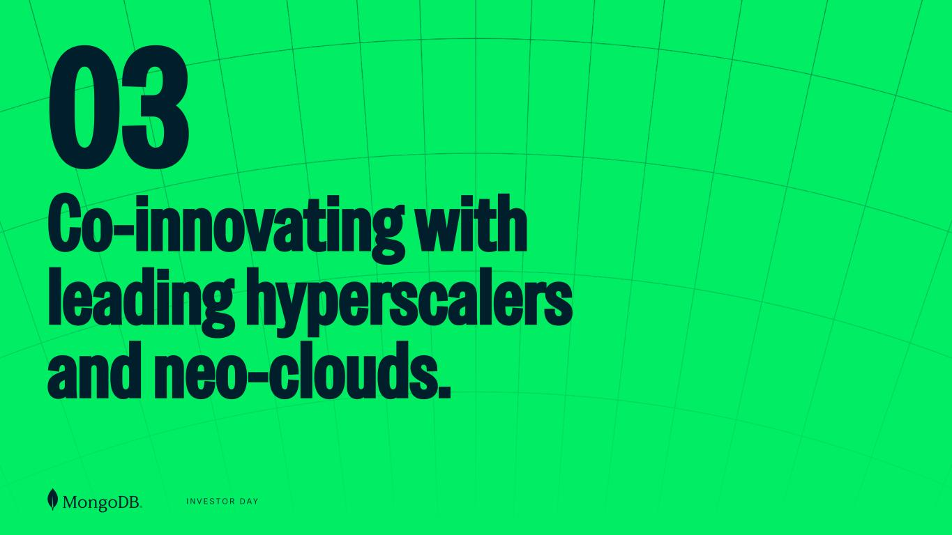
I N V E S T O R D A Y 03 Co-innovating with leading hyperscalers and neo-clouds.

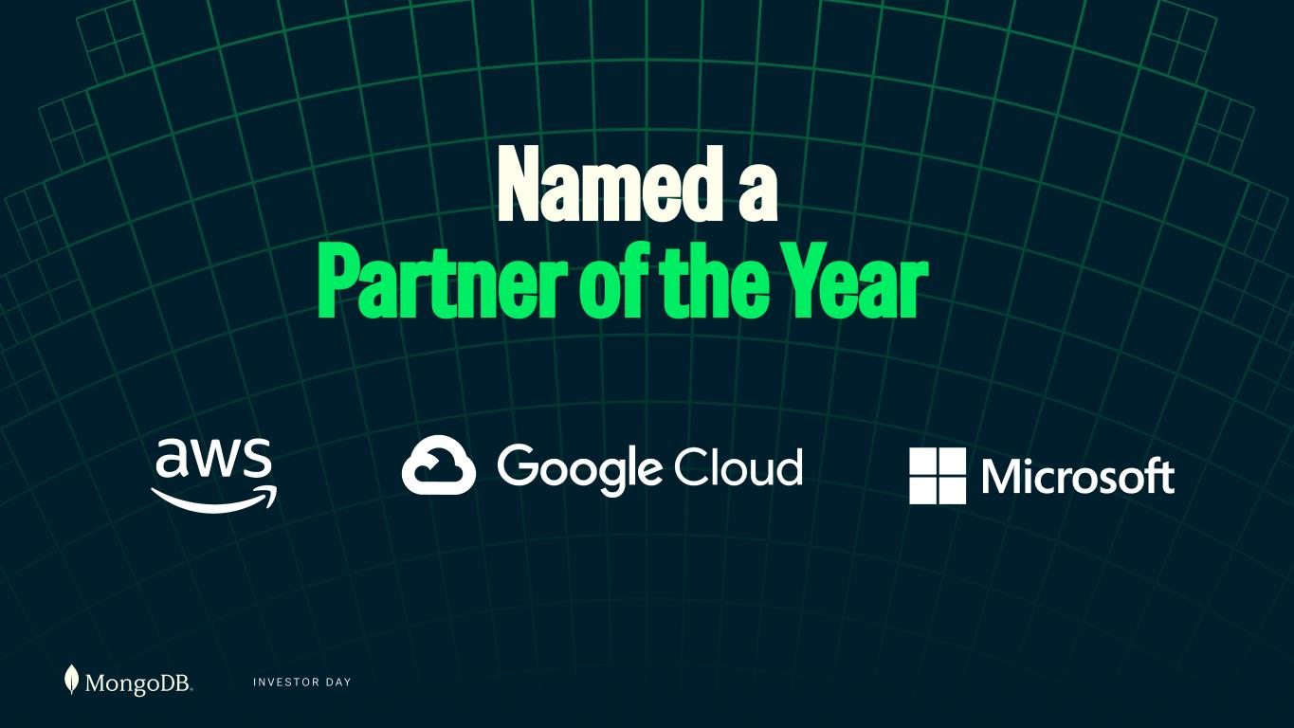
I N V E S T O R D A Y Named a Partner of the Year

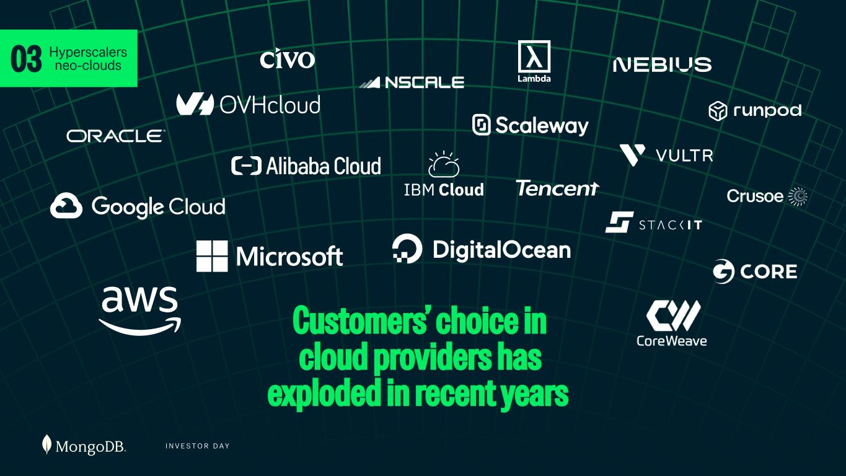
I N V E S T O R D A Y 03 Hyperscalers neo-clouds Customers’ choice in cloud providers has exploded in recent years

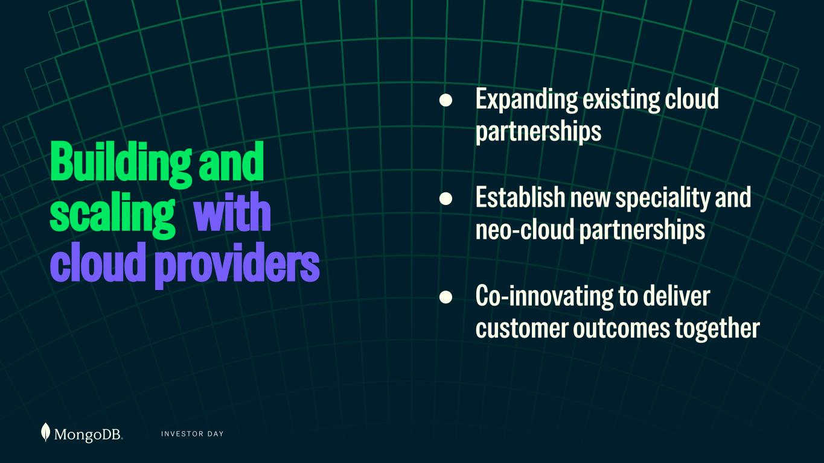
I N V E S T O R D A Y Building and scaling with cloud providers ● Expanding existing cloud partnerships ● Establish new speciality and neo-cloud partnerships ● Co-innovating to deliver customer outcomes together

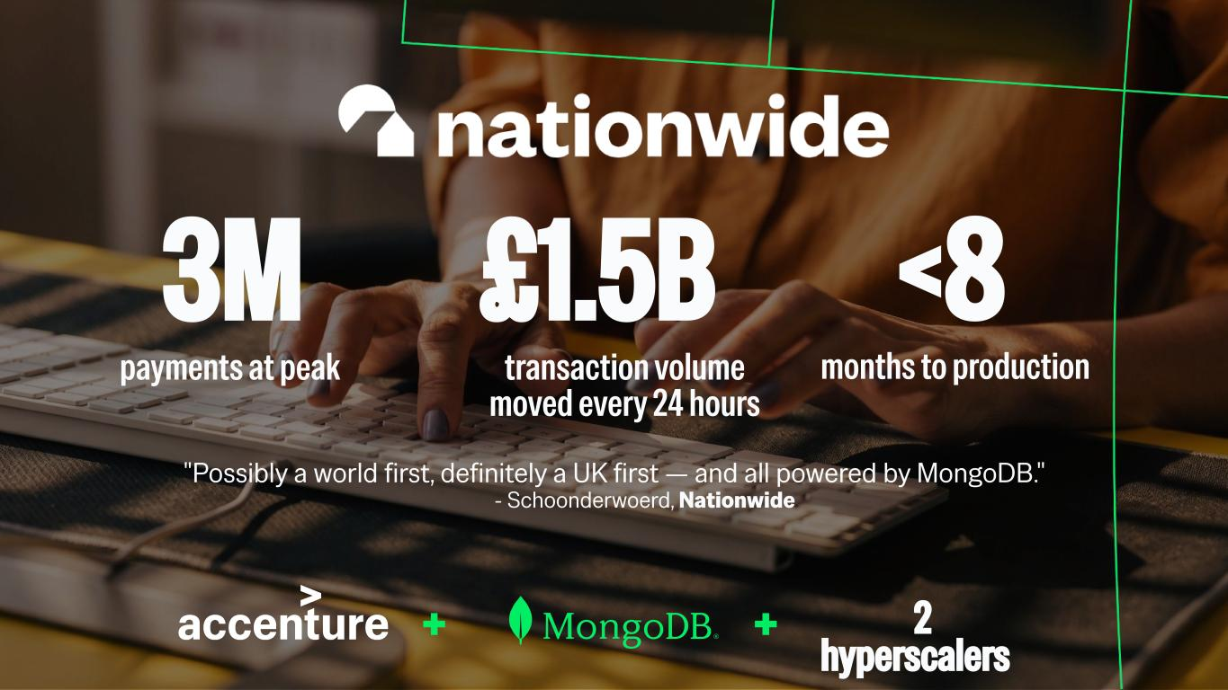
transaction volume moved every 24 hours payments at peak months to production £1.5B3M <8 "Possibly a world first, definitely a UK first — and all powered by MongoDB." - Schoonderwoerd, Nationwide + 2 hyperscalers+

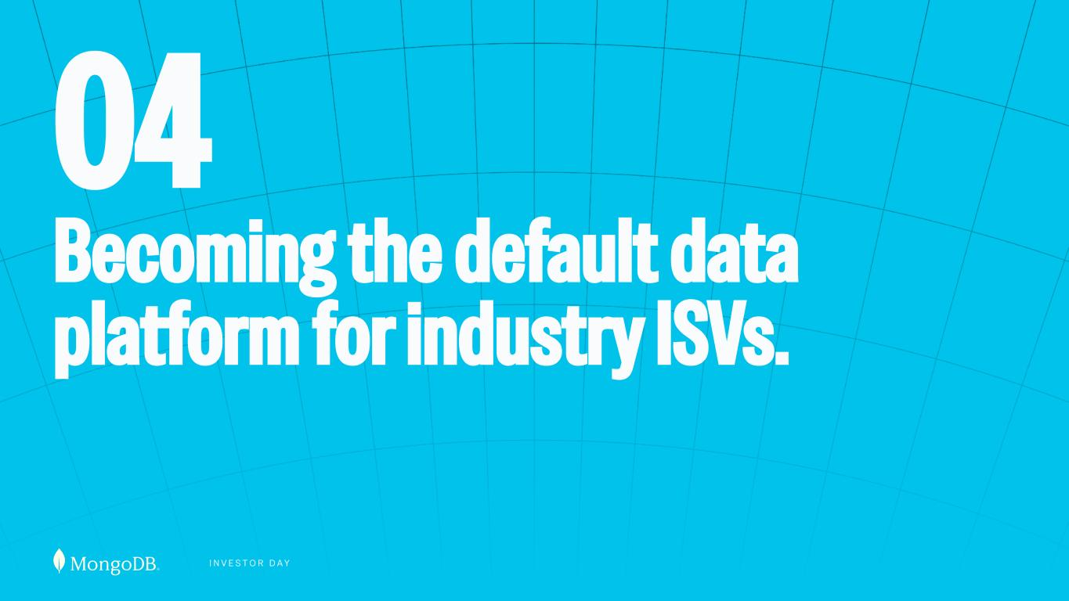
I N V E S T O R D A Y 04 Becoming the default data platform for industry ISVs.

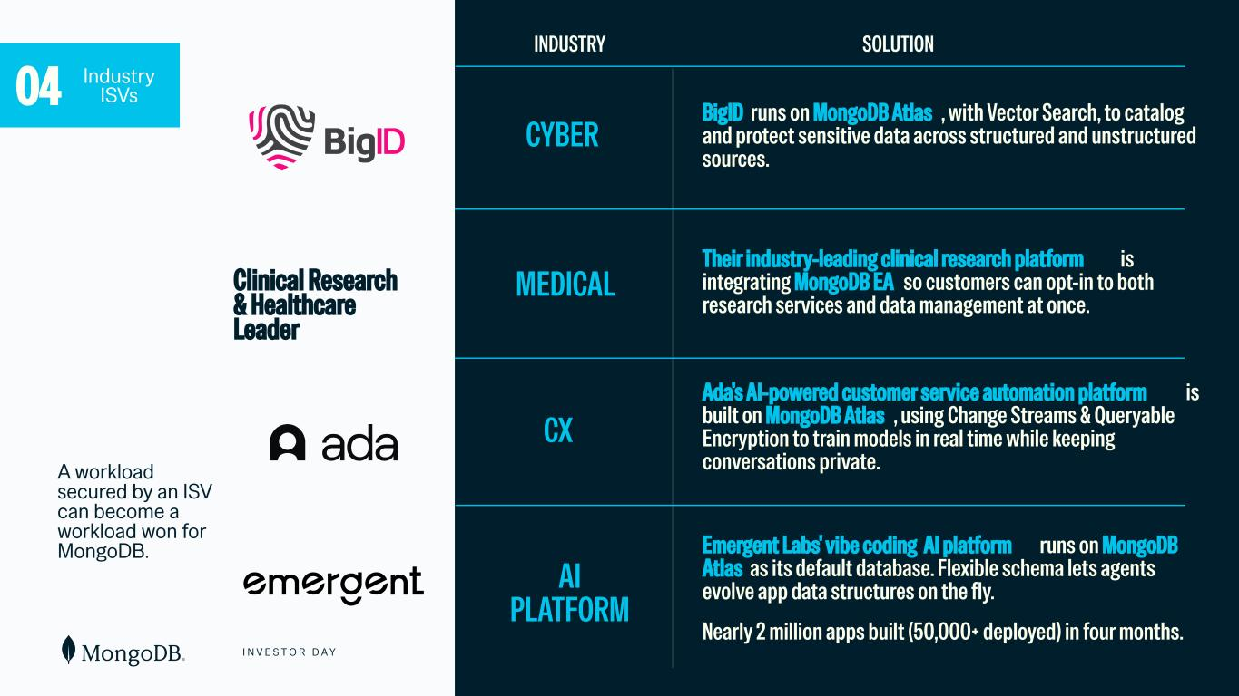
I N V E S T O R D A Y 106 Ada's AI-powered customer service automation platform is built on MongoDB Atlas , using Change Streams & Queryable Encryption to train models in real time while keeping conversations private. 04 Industry ISVs Their industry-leading clinical research platform is integrating MongoDB EA so customers can opt-in to both research services and data management at once. BigID runs on MongoDB Atlas , with Vector Search, to catalog and protect sensitive data across structured and unstructured sources. INDUSTRY SOLUTION Emergent Labs' vibe coding AI platform runs on MongoDB Atlas as its default database. Flexible schema lets agents evolve app data structures on the fly. Nearly 2 million apps built (50,000+ deployed) in four months. CYBER CX AI PLATFORM MEDICAL A workload secured by an ISV can become a workload won for MongoDB. Clinical Research & Healthcare Leader

I N V E S T O R D A Y FOUR LEVERS THAT POWER OUR ECOSYSTEM Data layer in SI agentic stacks 01 Co-innovate with hyperscalers and neo-clouds 02 Integrate across the AI ecosystem 03 04 Embed with industry ISVs


THE REACH IS THEIRS. WHAT POWERS IT IS OURS.

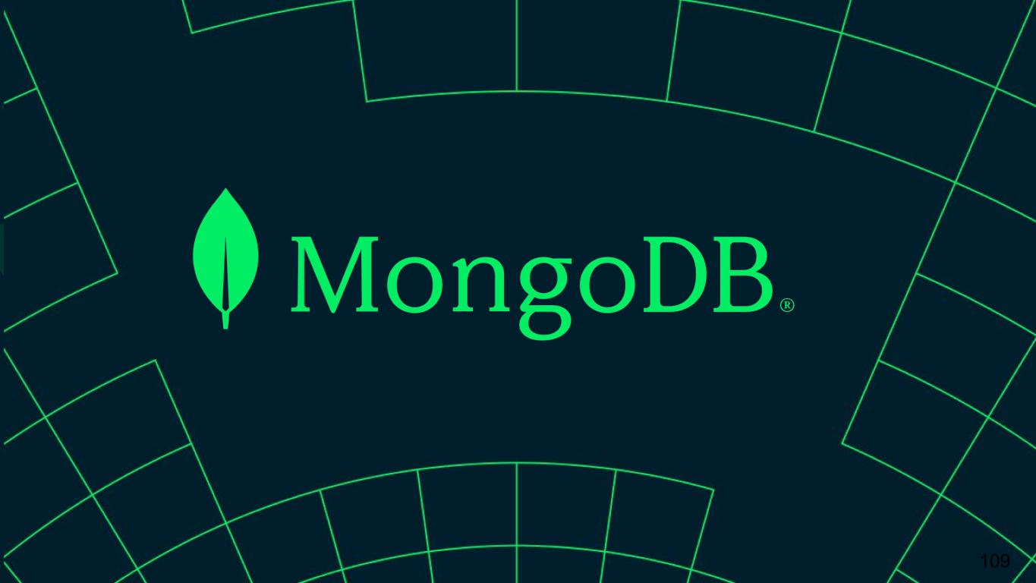
109


I N V E S T O R D A Y Safe Harbor This presentation and the accompanying oral presentation have been prepared by MongoDB, Inc. (“MongoDB” or the “company”) for informational purposes only and not for any other purpose. Nothing contained in this presentation is, or should be construed as, a recommendation, promise or representation by the presenter or MongoDB or any officer, director, employee, agent or advisor of MongoDB. This presentation does not purport to be all-inclusive or to contain all of the information you may desire. Information provided in this presentation speaks only as of the date hereof, unless otherwise indicated. This presentation contains “forward-looking statements” within the meaning of Section 27A of the Securities Act of 1933, as amended, and Section 21E of the Securities Exchange Act of 1934, as amended, including but not limited to statements regarding our financial outlook, financial guidance for fiscal 2027 and beyond, long-term financial targets, product development, business strategy and plans, market trends and market size and opportunities, our ability to continue to increase revenue from our Atlas platform, and the expected financial impact of AI adoption and new product innovations. These forward-looking statements include, but are not limited to, plans, objectives, expectations and intentions and other statements contained in this presentation that are not historical facts and statements, and may be identified by words such as “anticipate,” “believe,” “continue,” “could,” “estimate,” “expect,” “intend,” “may,” “plan,” “project,” “will,” “would” or the negative or plural of these words or similar expressions or variations. These forward-looking statements reflect our current views about our plans, intentions, expectations, strategies and prospects, which are based on the information currently available to us and on assumptions we have made. Although we believe that our plans, intentions, expectations, strategies and prospects as reflected in or suggested by those forward-looking statements are reasonable, we can give no assurance that the plans, intentions, expectations or strategies will be attained or achieved. In particular, the development, release, and timing of any features or functionality described for MongoDB products remains at MongoDB's sole discretion. Product roadmaps do not represent a commitment, promise or legal obligation to deliver any material, code, or functionality and you should not rely on them to make your purchase decisions. Furthermore, actual results may differ materially from those described in the forward-looking statements and are subject to a variety of assumptions, uncertainties, risks and factors that are beyond our control including, without limitation: the effects of ongoing geopolitical instability, including the conflict in Iran, the unrest in Mexico, the conflicts between Russia and Ukraine, Israel and Hamas and recent events in Venezuela, on our business and future operating results; economic downturns and/or the effects of, changes in trade policies, rising interest rates, inflation and volatility in the global economy and financial markets on our business and future operating results; our potential failure to meet publicly announced guidance or other expectations about our business and future operating results; reputational harm or other adverse consequences resulting from use of AI and ML in our product offerings and internal operations if they do not produce the desired benefits; our limited operating history; our history of losses; failure of our platform to satisfy customer demands; the effects of increased competition; our investments in new products and our ability to introduce new features, services or enhancements, including AI and ML, for both traditional and emerging use cases; social, ethical, regulatory and security issues relating to the use of new and evolving technologies, such as artificial intelligence, in our offerings or partnerships; our ability to effectively expand our sales and marketing organization; our ability to continue to build and maintain credibility with the developer community; our ability to add new customers or increase sales to our existing customers; our ability to maintain, protect, enforce and enhance our intellectual property; our ability to continue to increase revenue from our Atlas platform; the effects of social, ethical and regulatory issues relating to the use of new and evolving technologies, such as AI and ML, in our offerings or partnerships; the growth and expansion of the market for database products and our ability to penetrate that market; our ability to integrate acquired businesses and technologies successfully or achieve the expected benefits of such acquisitions; our ability to work with our strategic partners effectively; our ability to maintain the security of our software and adequately address privacy concerns; our ability to manage our growth effectively and successfully recruit and retain additional highly-qualified personnel; and the price volatility of our common stock. These and other risks and uncertainties are more fully described in our filings with the Securities and Exchange Commission (“SEC”), including under the section entitled “Risk Factors” in our Annual Report on Form 10-K for the fiscal year ended January 31, 2026 and our Quarterly Report on Form 10-Q for the quarter ended July 31, 2026 and in other filings and reports we may file from time to time with the SEC. This presentation includes market and industry data and forecasts that the company has derived from independent consultant reports, publicly available information, various industry publications, other published industry sources, and its internal data and estimates. Independent consultant reports, industry publications and other published industry sources generally indicate that the information contained therein was obtained from sources believed to be reliable. Although the company believes that these third-party sources are reliable, it does not guarantee the accuracy or completeness of this information, and the company has not independently verified this information. The company's internal data and estimates are based upon information obtained from trade and business organizations and other contacts in the markets in which the company operates and management's understanding of industry conditions. Although the company believes that such information is reliable, it has not had this information verified by any independent sources. In addition, the information contained in this presentation is as of the date hereof (except where otherwise indicated), and the company has no obligation to update such information, including in the event that such information becomes inaccurate or if estimates change. Subsequent materials may be provided by or on behalf of the company in its discretion and such information may supplement, modify or supersede the information in these materials. Neither the company, nor any of its respective affiliates, advisors or representatives shall have any liability whatsoever (in negligence or otherwise) for any loss or damage howsoever arising from any use of these materials or their contents or otherwise arising in connection with these materials. This presentation includes the following financial measures defined as non-GAAP financial measures by the SEC: non-GAAP income from operations, non-GAAP operating margin, free cash flow and free cash flow conversion. Non-GAAP income from operations and non-GAAP operating margin exclude expenses associated with stock-based compensation including employer payroll taxes upon the vesting and exercising of stock-based awards and expenses related to stock appreciation rights previously issued to our employees in China, amortization of intangible assets for the acquired technology and acquired customer relationships associated with prior acquisitions, certain acquisition-related costs and other, including due diligence costs, professional fees in connection with an acquisition and certain integration-related expenses, legal costs and settlement fees incurred in connection with non-ordinary course litigation, particularly ongoing securities litigation, and restructuring costs associated with a formal restructuring plan that are primarily related to workforce reductions. The Company excludes these expenses because they are not reflective of ordinary course ongoing business and operating results. Free cash flow represents net cash from/used in operating activities, less capital expenditures, principal payments of finance lease liabilities and capitalized software development costs, if any. MongoDB uses free cash flow to understand and evaluate its liquidity and to generate future operating plans. The exclusion of capital expenditures, principal payments of finance lease liabilities and amounts capitalized for software development facilitates comparisons of MongoDB's liquidity on a period-to-period basis and excludes items that it does not consider to be indicative of its liquidity. MongoDB believes that free cash flow is a measure of liquidity that provides useful information to investors in understanding and evaluating the strength of its liquidity and future ability to generate cash that can be used for strategic opportunities or investing in its business in the same manner as MongoDB's management and board of directors. MongoDB uses these non-GAAP financial measures internally in analyzing its financial results and believes they are useful to investors, as a supplement to GAAP measures, in evaluating MongoDB's ongoing operational performance. MongoDB believes that the use of these non-GAAP financial measures provides an additional tool for investors to use in evaluating ongoing operating results and trends and in comparing its financial results with other companies in MongoDB's industry, many of which may present similar non-GAAP financial measures to investors. Non-GAAP financial measures have limitations as an analytical tool and should not be considered in isolation from, or as a substitute for, financial information prepared in accordance with GAAP. In particular, other companies may report non-GAAP income from operations, non-GAAP operating margin, free cash flow and free cash flow conversion or similarly titled measures but calculate them differently, which reduces their usefulness as comparative measures. Investors are encouraged to review the reconciliation of these non-GAAP financial measures to their most directly comparable GAAP financial measures, as presented below. This presentation and any future presentations containing such non-GAAP reconciliations can also be found on the Investor Relations page of MongoDB's website at https://investors.mongodb.com. With respect to our forward-looking non-GAAP financial measures, we have not provided a reconciliation of (i) non-GAAP free cash flow conversion to the most directly comparable GAAP measure for FY 2027 guidance or (ii) all forward-looking non-GAAP financial measures included in this presentation to the most directly comparable GAAP measures for long-term future guidance beyond FY 2027, because certain items are out of our control or cannot be reasonably predicted without unreasonable efforts due to the high variability, complexity and low visibility with respect to the charges excluded from these non-GAAP measures, in particular stock-based compensation expense. Except as required by law, we undertake no obligation to update any forward-looking statements included in this presentation as a result of new information, future events, changes in expectations or otherwise. Nothing in this presentation is, and should not be construed as, an offer to sell or a solicitation of an offer to buy, any securities.


I N V E S T O R D A Y FINANCIAL UPDATE Mike Berry Chief Financial Officer

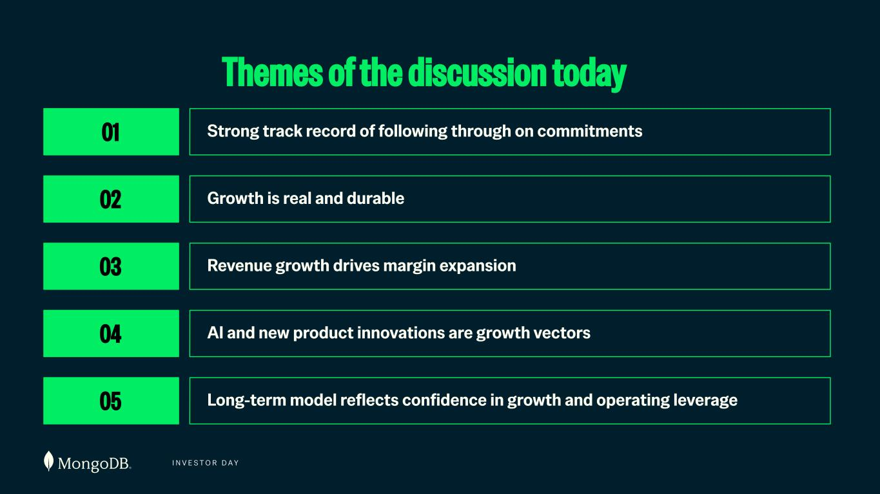
I N V E S T O R D A Y 112 Themes of the discussion today 01 Strong track record of following through on commitments Strong track record of following through on commitments 02 Growth is real and durable The growth is real and durable Revenue growth drives margin expansion03 AI and new product innovations are growth vectors04 Long-term model reflects confidence in growth and operating leverage05


I N V E S T O R D A Y 01 HITTING OUR COMMITMENTS

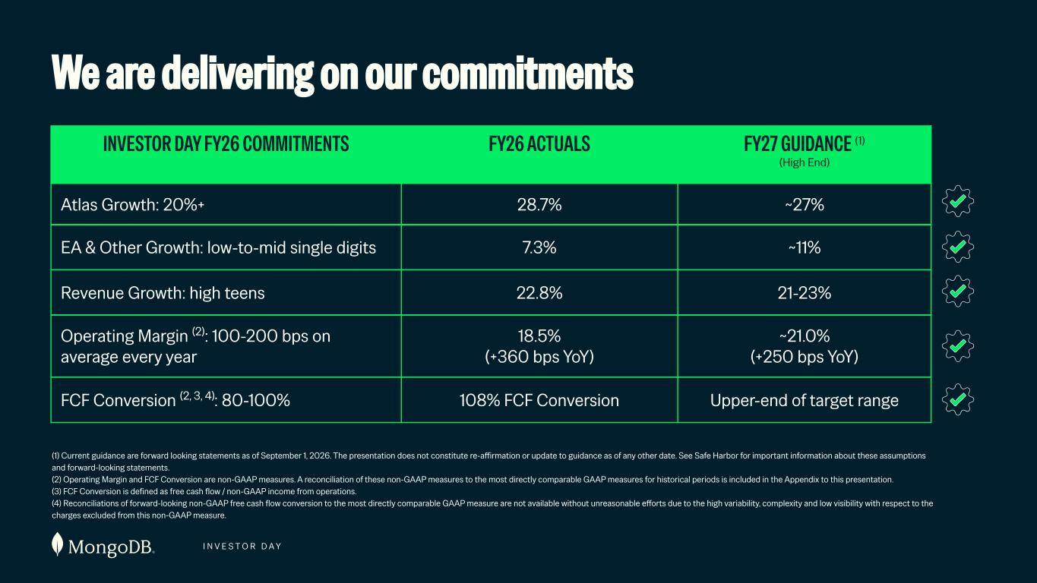
I N V E S T O R D A Y 114 We are delivering on our commitments Atlas Growth: 20%+ 28.7% ~27% (1) Current guidance are forward looking statements as of September 1, 2026. The presentation does not constitute re-affirmation or update to guidance as of any other date. See Safe Harbor for important information about these assumptions and forward-looking statements. (2) Operating Margin and FCF Conversion are non-GAAP measures. A reconciliation of these non-GAAP measures to the most directly comparable GAAP measures for historical periods is included in the Appendix to this presentation. (3) FCF Conversion is defined as free cash flow / non-GAAP income from operations. (4) Reconciliations of forward-looking non-GAAP free cash flow conversion to the most directly comparable GAAP measure are not available without unreasonable efforts due to the high variability, complexity and low visibility with respect to the charges excluded from this non-GAAP measure. EA & Other Growth: low-to-mid single digits 7.3% ~11% Revenue Growth: high teens 22.8% 21-23% Operating Margin (2): 100-200 bps on average every year 18.5% (+360 bps YoY) ~21.0% (+250 bps YoY) FCF Conversion (2, 3, 4): 80-100% 108% FCF Conversion Upper-end of target range INVESTOR DAY FY26 COMMITMENTS FY26 ACTUALS FY27 GUIDANCE (1) (High End)

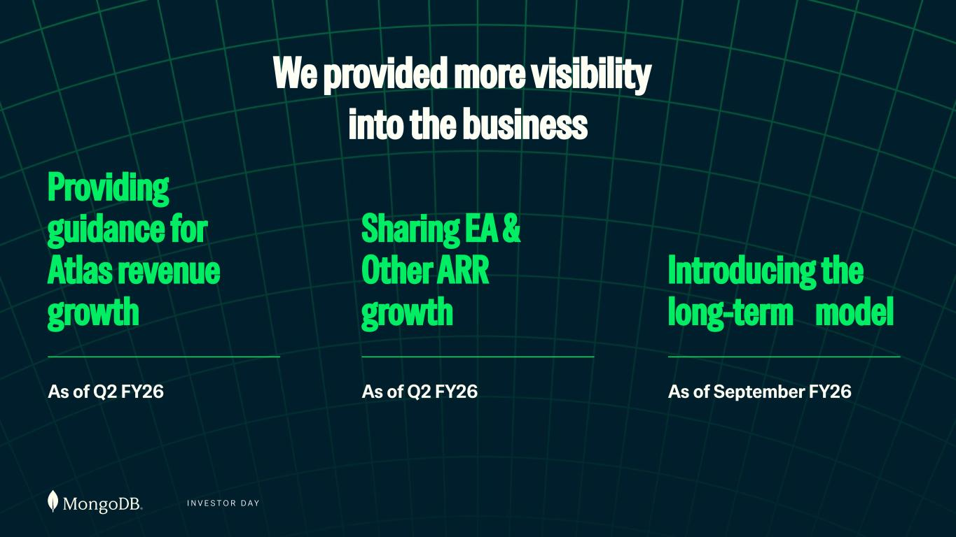
I N V E S T O R D A Y We provided more visibility into the business Providing guidance for Atlas revenue growth As of Q2 FY26 Sharing EA & Other ARR growth As of Q2 FY26 Introducing the long-term model As of September FY26


I N V E S T O R D A Y 02 GROWTH IS REAL & DURABLE

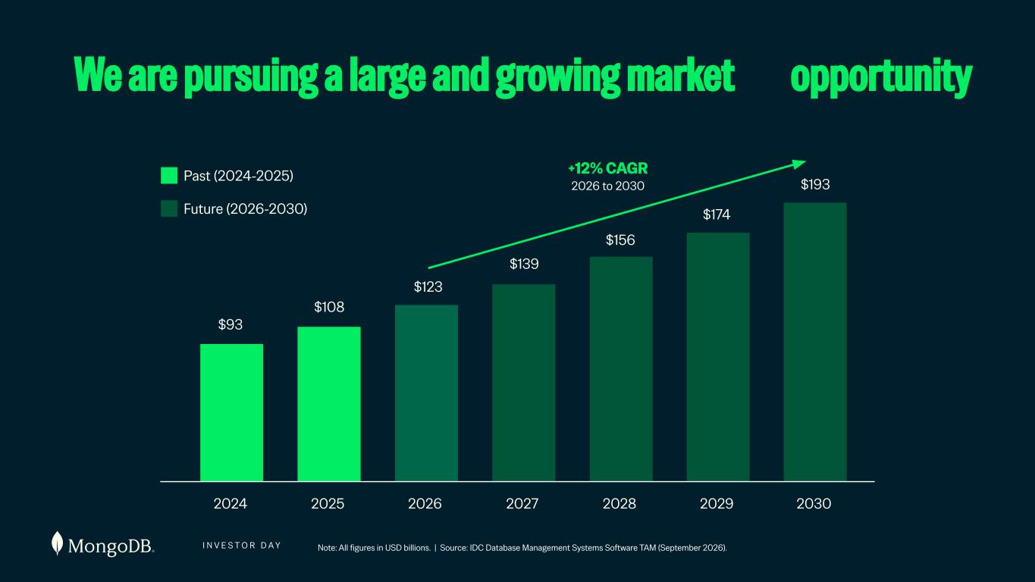
I N V E S T O R D A Y +12% CAGR 2026 to 2030 We are pursuing a large and growing market opportunity 117 Past (2024-2025) Future (2026-2030) Note: All figures in USD billions. | Source: IDC Database Management Systems Software TAM (September 2026). 2024 2025 2026 2027 2028 2029 2030 $93 $108 $123 $139 $156 $174 $193

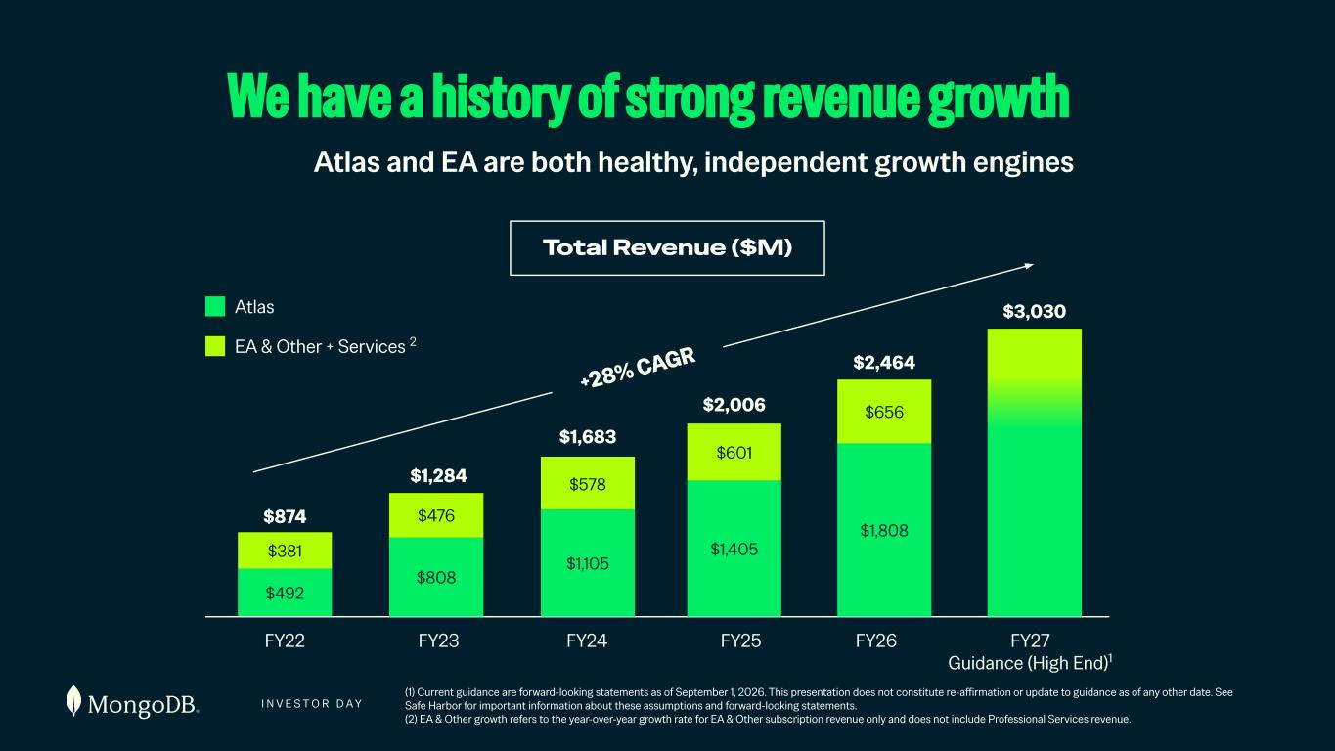
I N V E S T O R D A Y 118 Atlas and EA are both healthy, independent growth engines (1) Current guidance are forward-looking statements as of September 1, 2026. This presentation does not constitute re-affirmation or update to guidance as of any other date. See Safe Harbor for important information about these assumptions and forward-looking statements. (2) EA & Other growth refers to the year-over-year growth rate for EA & Other subscription revenue only and does not include Professional Services revenue. We have a history of strong revenue growth Total Revenue ($M) $381 $492 FY22 $874 $476 $808 $578 $1,105 $601 $1,405 $656 $1,808 FY23 FY24 FY25 FY26 FY27 Guidance (High End)1 $1,284 $1,683 $2,006 $2,464 $3,030 +28% CAGR Atlas EA & Other + Services 2

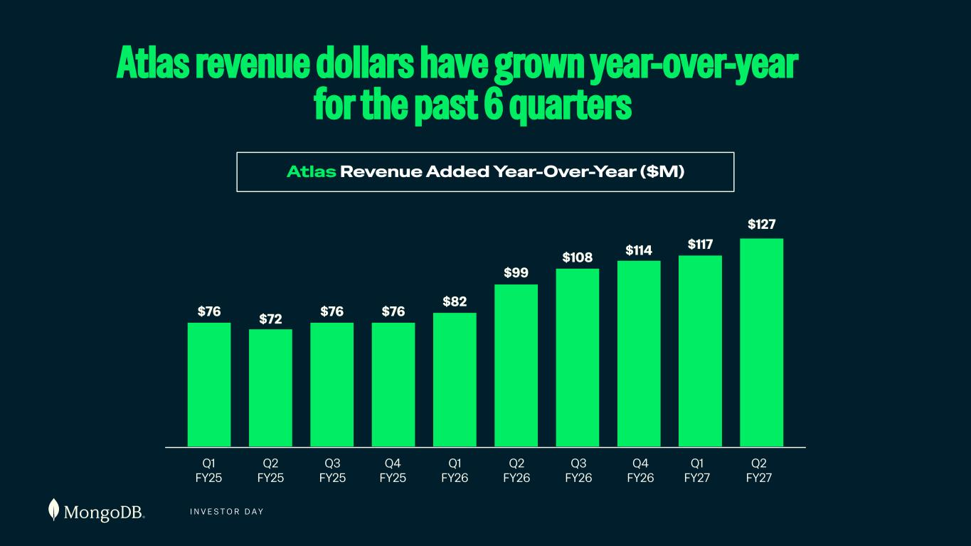
I N V E S T O R D A Y 119 Net Atlas Revenue Added Year-Over-Year ($M) Atlas revenue dollars have grown year-over-year for the past 6 quarters Atlas Revenue Added Year-Over-Year ($M) Q1 FY25 $76 FY26 FY27 Guidance (High End)1 $72 $76 $76 $82 $99 $108 $114 $117 $127 Q2 FY25 Q3 FY25 Q4 FY25 Q1 FY26 Q2 FY26 Q3 FY26 Q4 FY26 Q1 FY27 Q2 FY27

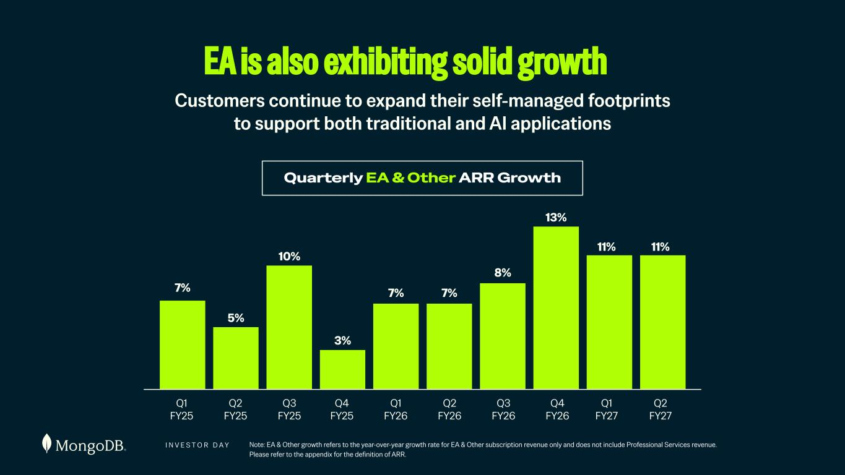
I N V E S T O R D A Y Note: EA & Other growth refers to the year-over-year growth rate for EA & Other subscription revenue only and does not include Professional Services revenue. Please refer to the appendix for the definition of ARR. EA is also exhibiting solid growth Quarterly EA & Other ARR Growth Customers continue to expand their self-managed footprints to support both traditional and AI applications 7% 5% 10% 3% 7% 7% 8% 13% 11% 11% Q1 FY25 Q2 FY25 Q3 FY25 Q4 FY25 Q1 FY26 Q2 FY26 Q3 FY26 Q4 FY26 Q1 FY27 Q2 FY27

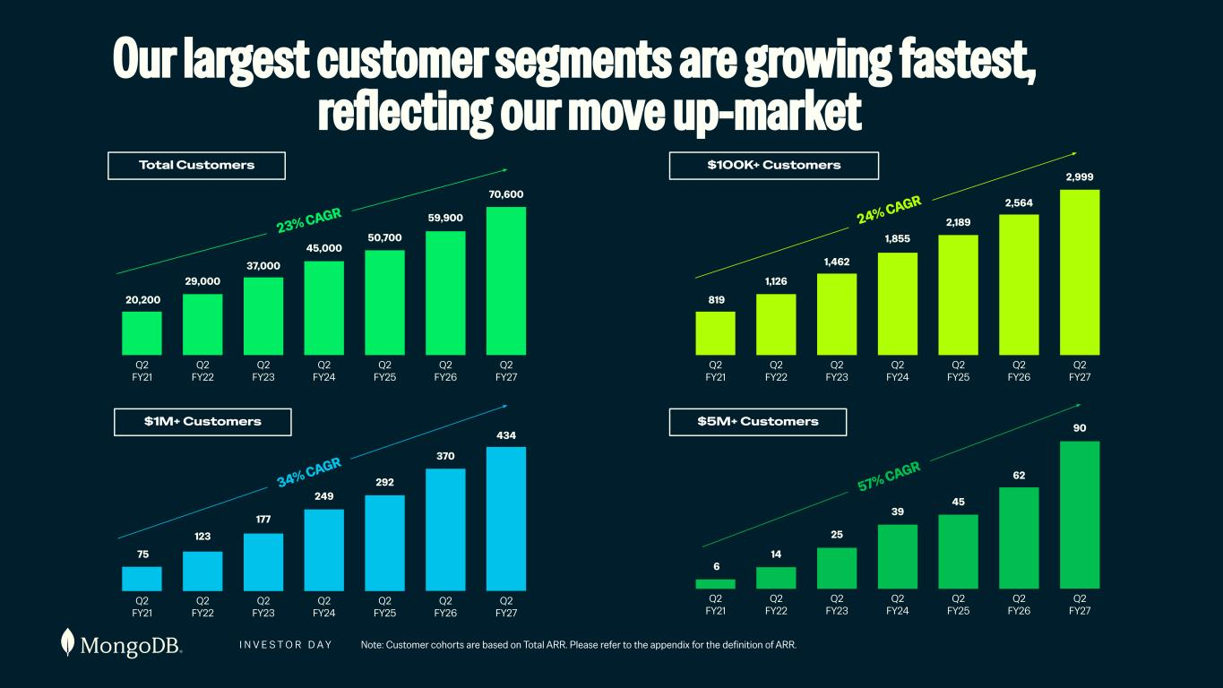
I N V E S T O R D A Y 20,200 Q2 FY21 Q2 FY22 Q2 FY23 Q2 FY24 Q2 FY25 Q2 FY26 Q2 FY27 29,000 37,000 45,000 50,700 59,900 70,600 23% CAGR Total Customers 819 Q2 FY21 Q2 FY22 Q2 FY23 Q2 FY24 Q2 FY25 Q2 FY26 Q2 FY27 1,126 1,462 1,855 2,189 2,564 2,999 24% CAGR $100K+ Customers 75 Q2 FY21 Q2 FY22 Q2 FY23 Q2 FY24 Q2 FY25 Q2 FY26 Q2 FY27 123 177 249 292 370 434 34% CAGR $1M+ Customers $5M+ Customers 6 Q2 FY21 Q2 FY22 Q2 FY23 Q2 FY24 Q2 FY25 Q2 FY26 Q2 FY27 14 25 39 45 62 57% CAGR 90 Our largest customer segments are growing fastest, reflecting our move up-market Note: Customer cohorts are based on Total ARR. Please refer to the appendix for the definition of ARR.

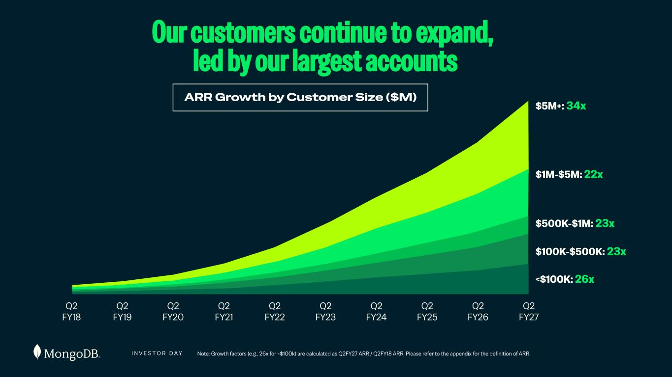
I N V E S T O R D A Y Note: Growth factors (e.g., 26x for <$100k) are calculated as Q2FY27 ARR / Q2FY18 ARR. Please refer to the appendix for the definition of ARR. 122 Our customers continue to expand, led by our largest accounts Q2 FY18 Q2 FY19 Q2 FY20 Q2 FY21 Q2 FY22 Q2 FY23 Q2 FY24 Q2 FY25 Q2 FY26 Q2 FY27 $5M+: 34x $1M-$5M: 22x $500K-$1M: 23x $100K-$500K: 23x <$100K: 26x ARR Growth by Customer Size ($M)

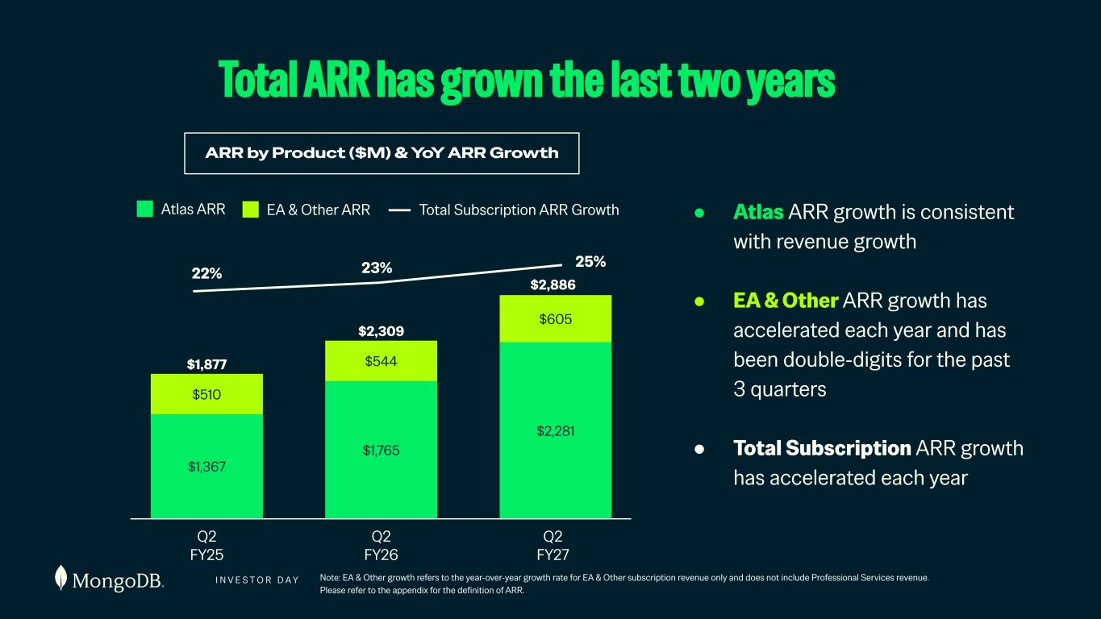
I N V E S T O R D A Y Note: EA & Other growth refers to the year-over-year growth rate for EA & Other subscription revenue only and does not include Professional Services revenue. Please refer to the appendix for the definition of ARR. 123 ● Atlas ARR growth is consistent with revenue growth ● EA & Other ARR growth has accelerated each year and has been double-digits for the past 3 quarters ● Total Subscription ARR growth has accelerated each year Total ARR has grown the last two years ARR by Product ($M) & YoY ARR Growth Q2 FY25 $1,877 $1,367 $510 $2,309 $1,765 $544 $2,281 $605 $2,886 22% 25%23% Q2 FY26 Q2 FY27 Atlas ARR EA & Other ARR Total Subscription ARR Growth

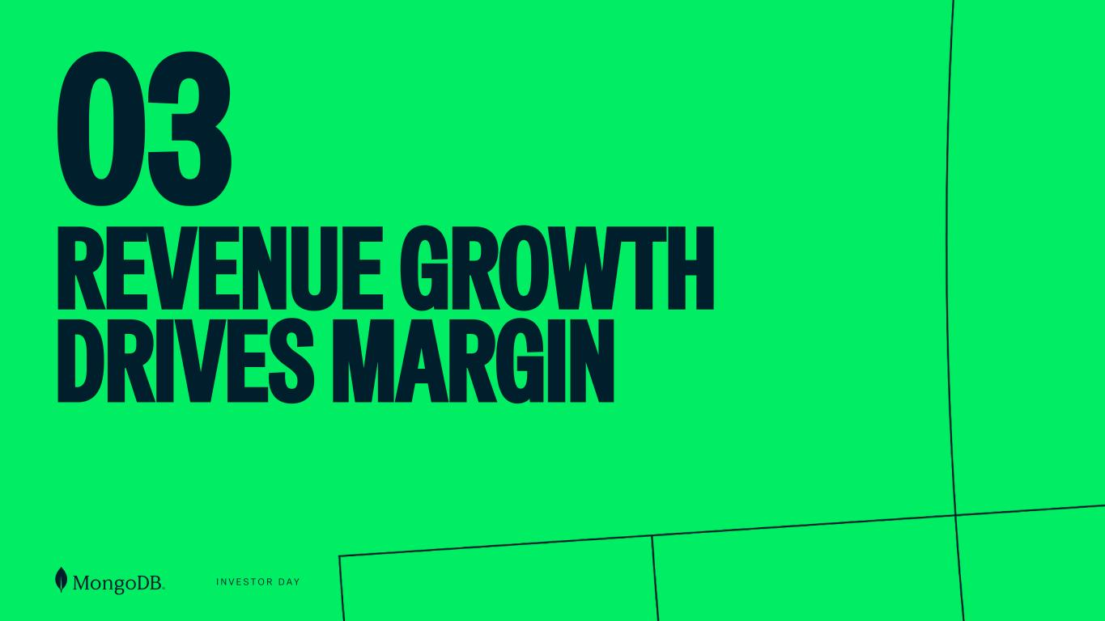
I N V E S T O R D A Y 03 REVENUE GROWTH DRIVES MARGIN

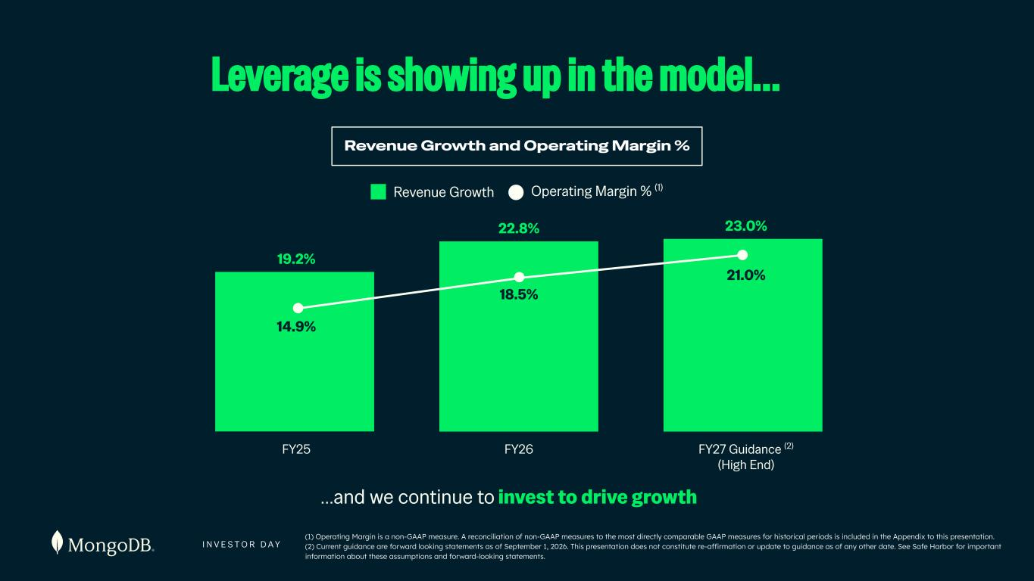
I N V E S T O R D A Y 125 …and we continue to invest to drive growth Revenue Growth and Operating Margin % Revenue Growth Operating Margin % (1) FY25 19.2% FY26 FY27 Guidance (2) (High End) 14.9% 18.5% 21.0% 22.8% 23.0% Leverage is showing up in the model… (1) Operating Margin is a non-GAAP measure. A reconciliation of non-GAAP measures to the most directly comparable GAAP measures for historical periods is included in the Appendix to this presentation. (2) Current guidance are forward looking statements as of September 1, 2026. This presentation does not constitute re-affirmation or update to guidance as of any other date. See Safe Harbor for important information about these assumptions and forward-looking statements.

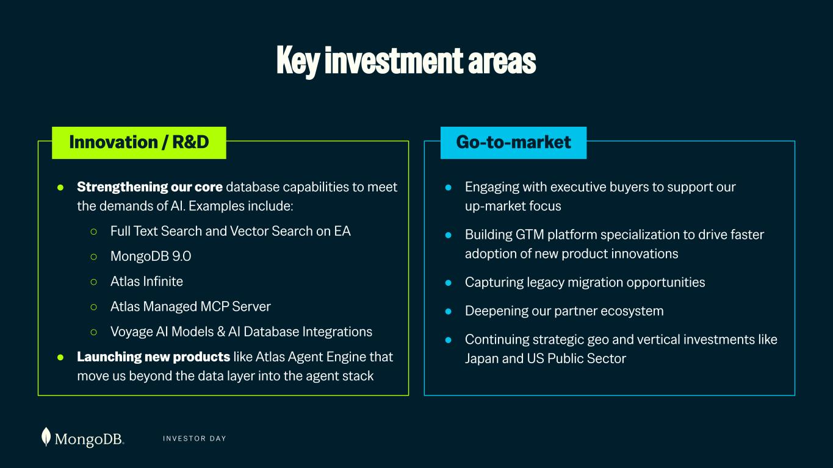
I N V E S T O R D A Y Key investment areas ● Strengthening our core database capabilities to meet the demands of AI. Examples include: ○ Full Text Search and Vector Search on EA ○ MongoDB 9.0 ○ Atlas Infinite ○ Atlas Managed MCP Server ○ Voyage AI Models & AI Database Integrations ● Launching new products like Atlas Agent Engine that move us beyond the data layer into the agent stack ● Engaging with executive buyers to support our up-market focus ● Building GTM platform specialization to drive faster adoption of new product innovations ● Capturing legacy migration opportunities ● Deepening our partner ecosystem ● Continuing strategic geo and vertical investments like Japan and US Public Sector Innovation / R&D Go-to-market

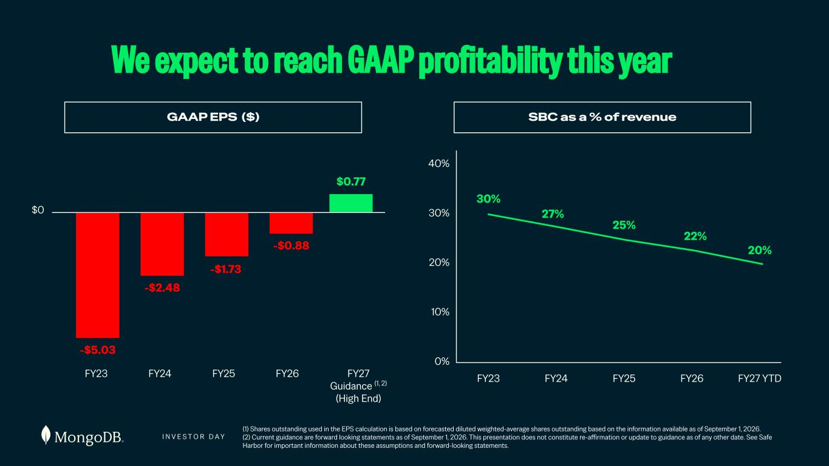
I N V E S T O R D A Y (1) Shares outstanding used in the EPS calculation is based on forecasted diluted weighted-average shares outstanding based on the information available as of September 1, 2026. (2) Current guidance are forward looking statements as of September 1, 2026. This presentation does not constitute re-affirmation or update to guidance as of any other date. See Safe Harbor for important information about these assumptions and forward-looking statements. We expect to reach GAAP profitability this year SBC as a % of revenue FY23 FY24 FY25 FY26 FY27 YTD 0% 10% 20% 30% 40% 30% 27% 25% 22% 20% GAAP EPS ($) $0 FY23 FY24 FY25 FY26 FY27 Guidance (1, 2) (High End) -$5.03 -$2.48 -$1.73 -$0.88 $0.77

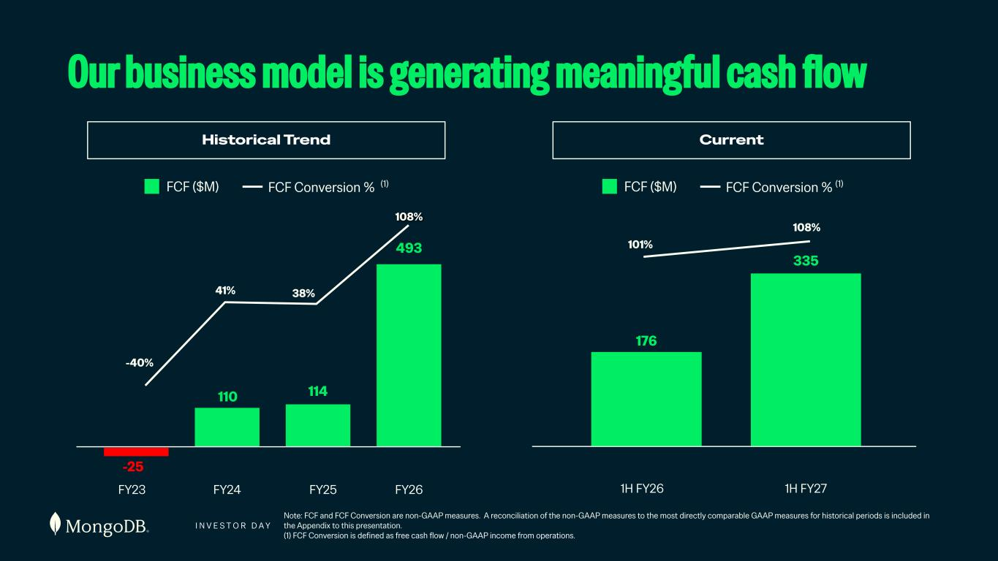
I N V E S T O R D A Y 128 w Note: FCF and FCF Conversion are non-GAAP measures. A reconciliation of the non-GAAP measures to the most directly comparable GAAP measures for historical periods is included in the Appendix to this presentation. (1) FCF Conversion is defined as free cash flow / non-GAAP income from operations. Our business model is generating meaningful cash flow Historical Trend Current FY23 FY24 FY25 FY26 110 114 335 -25 41% 38% 108% -40% FCF ($M) FCF Conversion % (1) 1H FY26 1H FY27 176 108% 101% FCF ($M) FCF Conversion % (1) 493

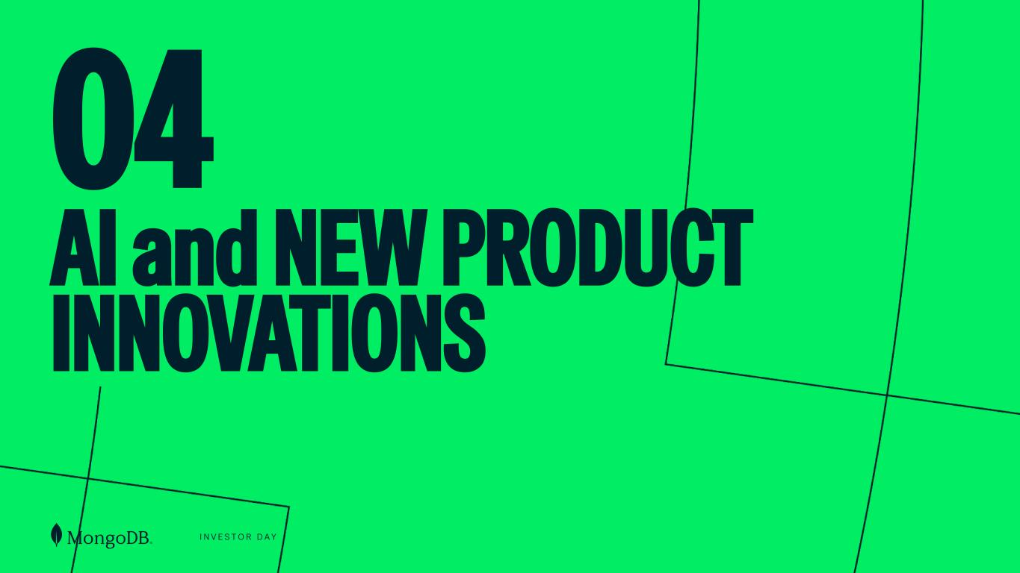
I N V E S T O R D A Y 04 AI and NEW PRODUCT INNOVATIONS

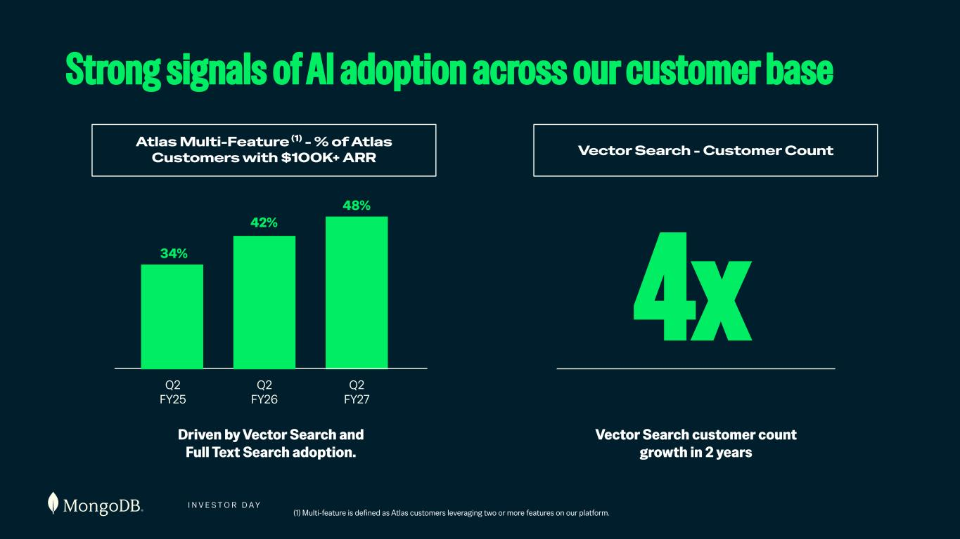
I N V E S T O R D A Y Vector Search customer count growth in 2 years Strong signals of AI adoption across our customer base Vector Search - Customer Count Atlas Multi-Feature (1) - % of Atlas Customers with $100K+ ARR (1) Multi-feature is defined as Atlas customers leveraging two or more features on our platform. Q2 FY25 Q2 FY26 Q2 FY27 Driven by Vector Search and Full Text Search adoption. Q2 FY25 Q2 FY26 Q2 FY27 ~3x in 2 years 34% 42% 48% 4x

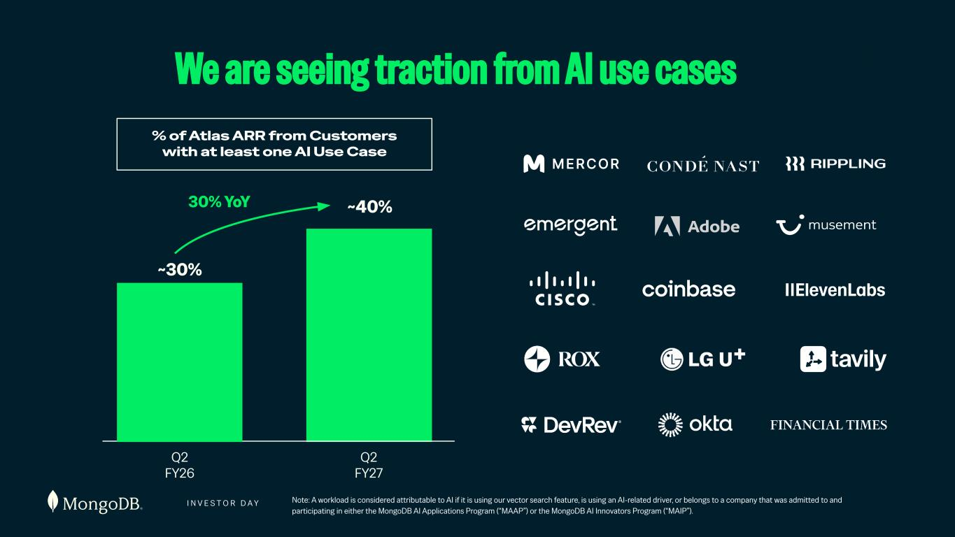
I N V E S T O R D A Y Q2 FY27 Note: A workload is considered attributable to AI if it is using our vector search feature, is using an AI-related driver, or belongs to a company that was admitted to and participating in either the MongoDB AI Applications Program (“MAAP”) or the MongoDB AI Innovators Program (“MAIP”). ~30% 30% YoY We are seeing traction from AI use cases % of Atlas ARR from Customers with at least one AI Use Case Q2 FY26 ~40%

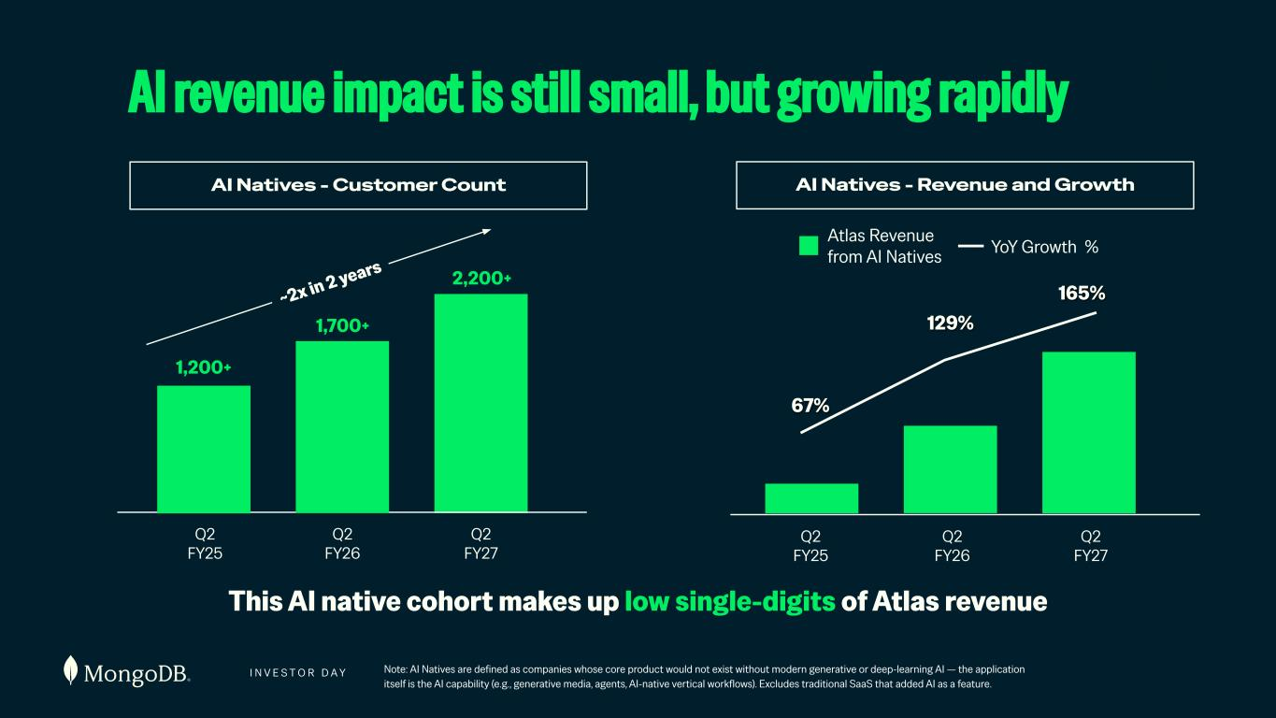
I N V E S T O R D A Y Note: AI Natives are defined as companies whose core product would not exist without modern generative or deep-learning AI — the application itself is the AI capability (e.g., generative media, agents, AI-native vertical workflows). Excludes traditional SaaS that added AI as a feature. This AI native cohort makes up low single-digits of Atlas revenue 1,200+ 1,700+ 2,200+ AI revenue impact is still small, but growing rapidly AI Natives - Customer Count AI Natives - Revenue and Growth Q2 FY25 Q2 FY26 Q2 FY27 ~2x in 2 years Q2 FY25 Q2 FY26 Q2 FY27 67% 129% 165% Atlas Revenue from AI Natives YoY Growth %

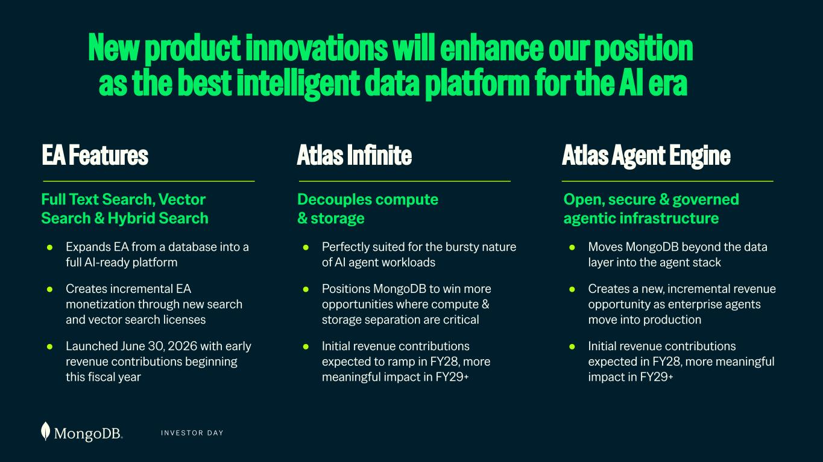
I N V E S T O R D A Y Decouples compute & storage ● Perfectly suited for the bursty nature of AI agent workloads ● Positions MongoDB to win more opportunities where compute & storage separation are critical ● Initial revenue contributions expected to ramp in FY28, more meaningful impact in FY29+ Open, secure & governed agentic infrastructure ● Moves MongoDB beyond the data layer into the agent stack ● Creates a new, incremental revenue opportunity as enterprise agents move into production ● Initial revenue contributions expected in FY28, more meaningful impact in FY29+ New product innovations will enhance our position as the best intelligent data platform for the AI era Atlas Infinite Atlas Agent Engine Full Text Search, Vector Search & Hybrid Search ● Expands EA from a database into a full AI-ready platform ● Creates incremental EA monetization through new search and vector search licenses ● Launched June 30, 2026 with early revenue contributions beginning this fiscal year EA Features


I N V E S T O R D A Y 05 FINANCIAL TARGETS

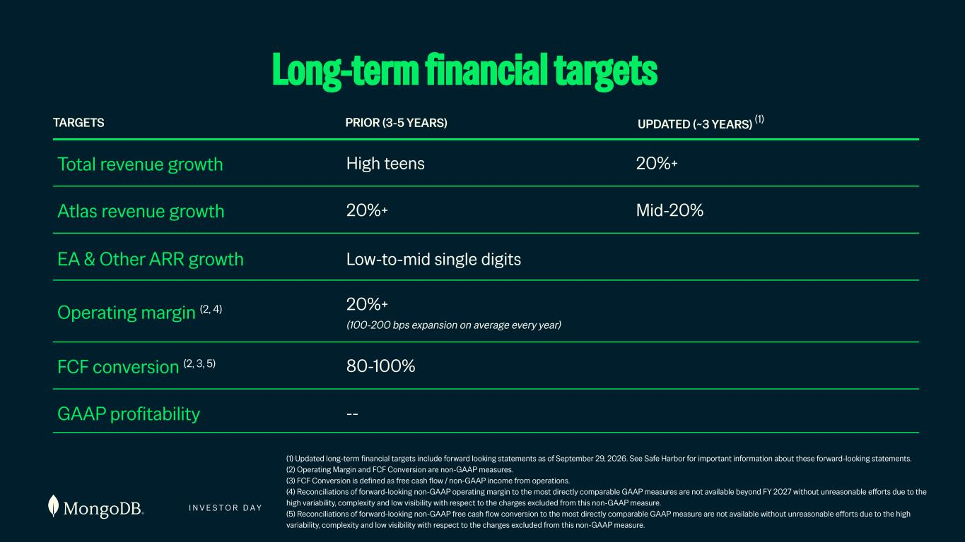
I N V E S T O R D A Y 135 Long-term financial targets (1) Updated long-term financial targets include forward looking statements as of September 29, 2026. See Safe Harbor for important information about these forward-looking statements. (2) Operating Margin and FCF Conversion are non-GAAP measures. (3) FCF Conversion is defined as free cash flow / non-GAAP income from operations. (4) Reconciliations of forward-looking non-GAAP operating margin to the most directly comparable GAAP measures are not available beyond FY 2027 without unreasonable efforts due to the high variability, complexity and low visibility with respect to the charges excluded from this non-GAAP measure. (5) Reconciliations of forward-looking non-GAAP free cash flow conversion to the most directly comparable GAAP measure are not available without unreasonable efforts due to the high variability, complexity and low visibility with respect to the charges excluded from this non-GAAP measure. TARGETS PRIOR (3-5 YEARS) UPDATED (~3 YEARS) (1) Total revenue growth High teens 20%+ Atlas revenue growth 20%+ Mid-20% 20%+ (100-200 bps expansion on average every year) Operating margin (2, 4) FCF conversion (2, 3, 5) 80-100% GAAP profitability -- EA & Other ARR growth Low-to-mid single digits

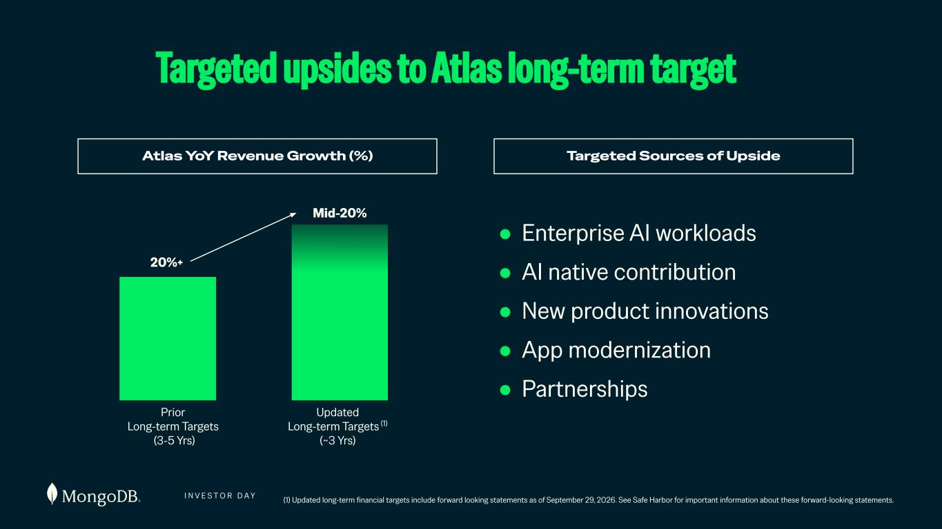
I N V E S T O R D A Y (1) Updated long-term financial targets include forward looking statements as of September 29, 2026. See Safe Harbor for important information about these forward-looking statements. Targeted upsides to Atlas long-term target Atlas YoY Revenue Growth (%) ● Enterprise AI workloads ● AI native contribution ● New product innovations ● App modernization ● Partnerships Targeted Sources of Upside Updated Long-term Targets (1) (~3 Yrs) Prior Long-term Targets (3-5 Yrs) Updated Long-term Targets (1) (~3 Yrs) Prior Long-term Targets (3-5 Yrs) 20%+ Mid-20% Mid-20%

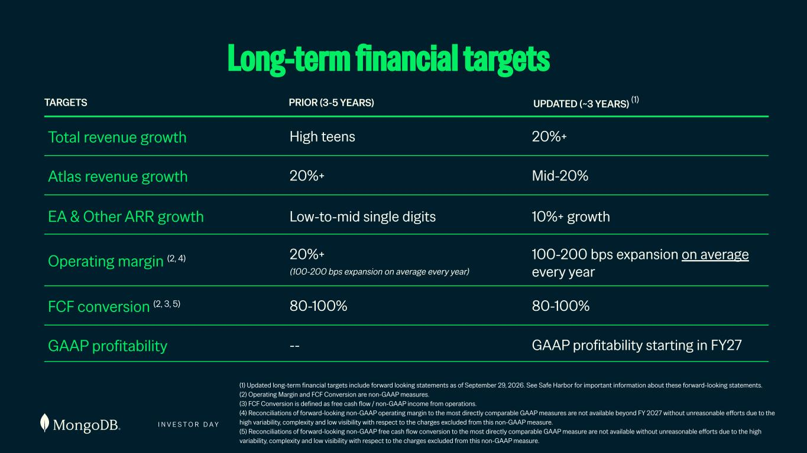
I N V E S T O R D A Y 137 Long-term financial targets (1) Updated long-term financial targets include forward looking statements as of September 29, 2026. See Safe Harbor for important information about these forward-looking statements. (2) Operating Margin and FCF Conversion are non-GAAP measures. (3) FCF Conversion is defined as free cash flow / non-GAAP income from operations. (4) Reconciliations of forward-looking non-GAAP operating margin to the most directly comparable GAAP measures are not available beyond FY 2027 without unreasonable efforts due to the high variability, complexity and low visibility with respect to the charges excluded from this non-GAAP measure. (5) Reconciliations of forward-looking non-GAAP free cash flow conversion to the most directly comparable GAAP measure are not available without unreasonable efforts due to the high variability, complexity and low visibility with respect to the charges excluded from this non-GAAP measure. TARGETS PRIOR (3-5 YEARS) UPDATED (~3 YEARS) (1) Total revenue growth High teens 20%+ Atlas revenue growth 20%+ Mid-20% 20%+ (100-200 bps expansion on average every year) Operating margin (2, 4) FCF conversion (2, 3, 5) 80-100% GAAP profitability -- EA & Other ARR growth Low-to-mid single digits 100-200 bps expansion on average every year 80-100% GAAP profitability starting in FY27 10%+ growth

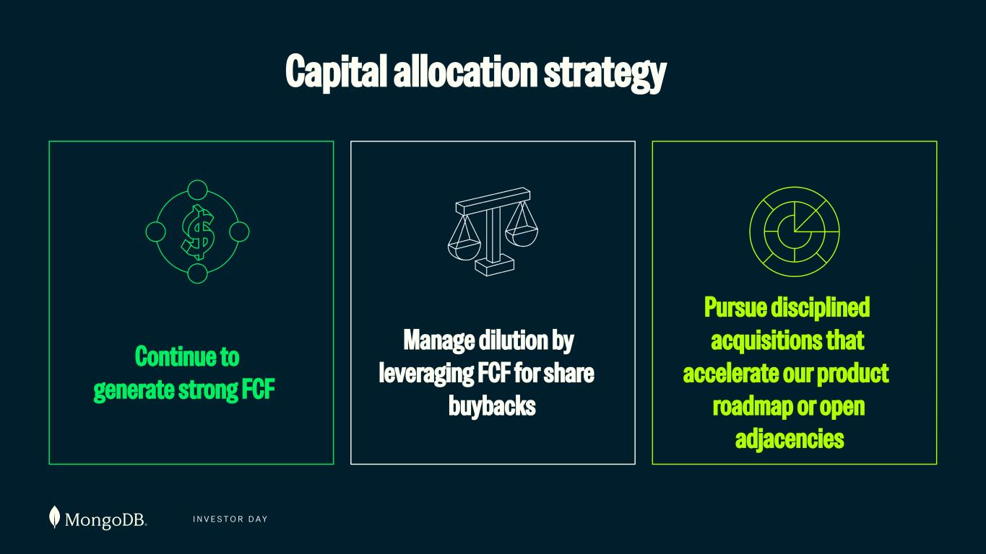
I N V E S T O R D A Y 138 Continue to generate strong FCF Manage dilution by leveraging FCF for share buybacks Pursue disciplined acquisitions that accelerate our product roadmap or open adjacencies Capital allocation strategy

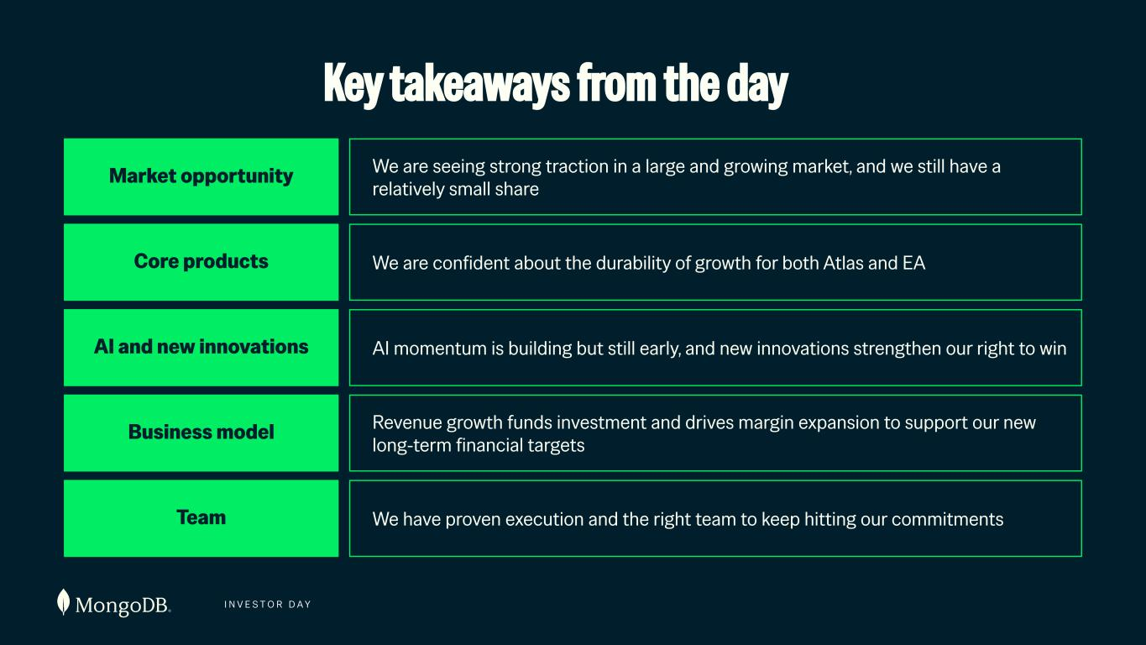
I N V E S T O R D A Y 139 Key takeaways from the day Core products We are confident about the durability of growth for both Atlas and EA Business model Revenue growth funds investment and drives margin expansion to support our new long-term financial targets Team We have proven execution and the right team to keep hitting our commitments AI and new innovations AI momentum is building but still early, and new innovations strengthen our right to win Market opportunity We are seeing strong traction in a large and growing market, and we still have a relatively small share

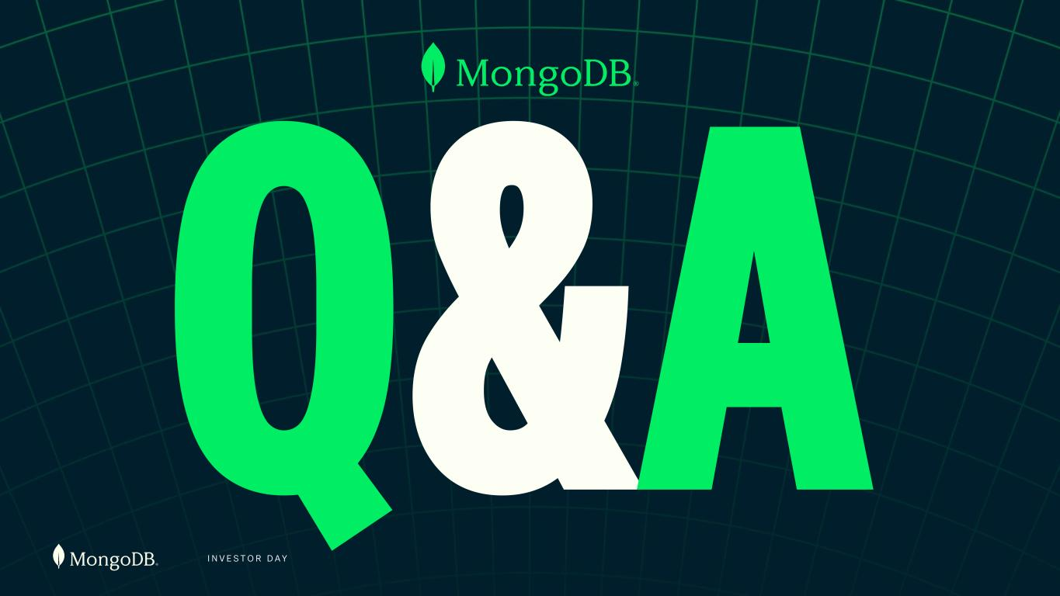
I N V E S T O R D A Y 140 Q&A

INVESTOR DAY 2026 September 29, 2026

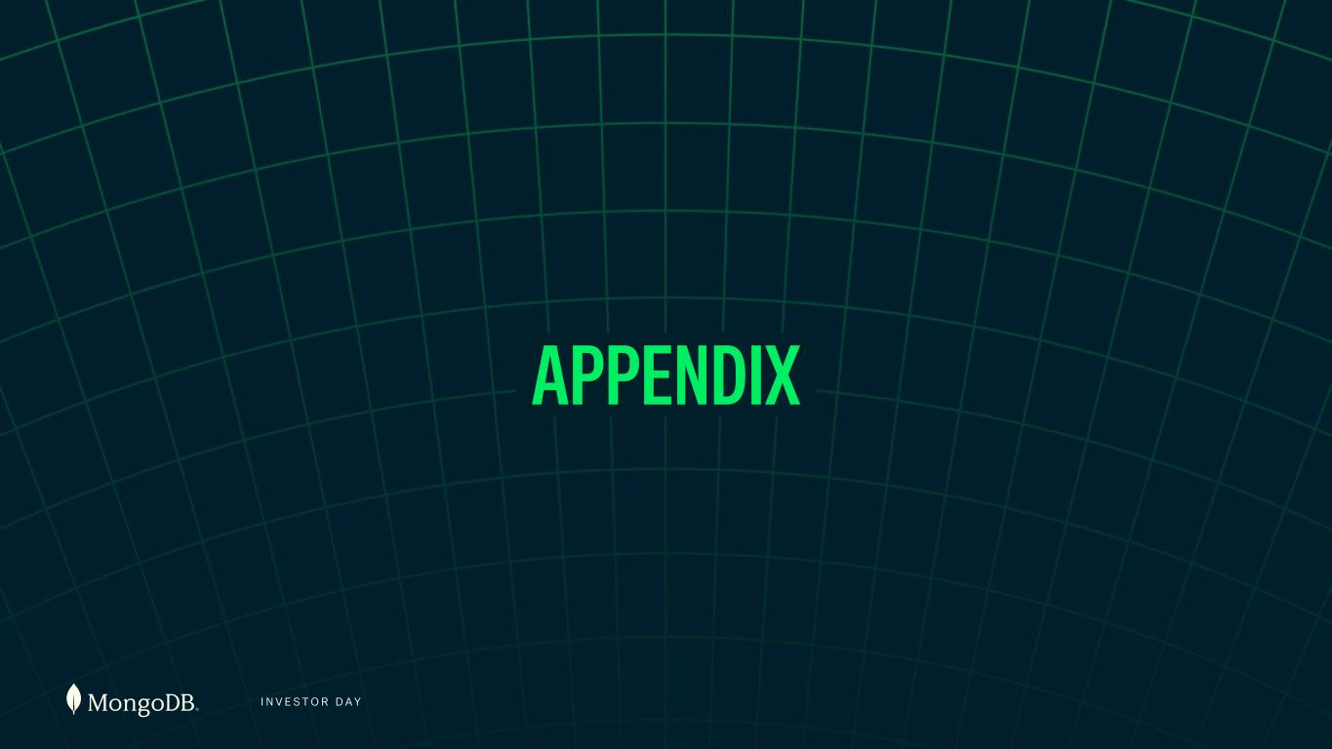
I N V E S T O R D A Y 142 APPENDIX

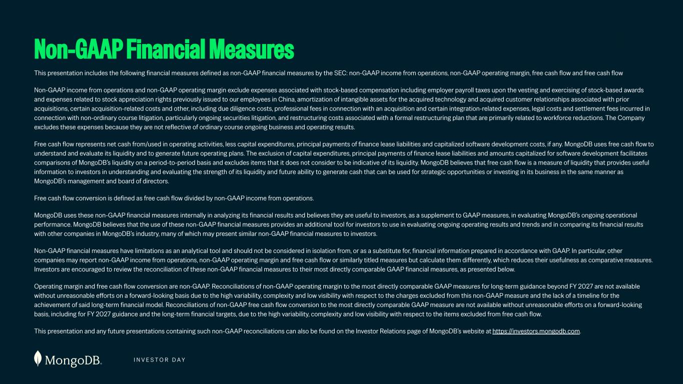
I N V E S T O R D A Y This presentation includes the following financial measures defined as non-GAAP financial measures by the SEC: non-GAAP income from operations, non-GAAP operating margin, free cash flow and free cash flow Non-GAAP income from operations and non-GAAP operating margin exclude expenses associated with stock-based compensation including employer payroll taxes upon the vesting and exercising of stock-based awards and expenses related to stock appreciation rights previously issued to our employees in China, amortization of intangible assets for the acquired technology and acquired customer relationships associated with prior acquisitions, certain acquisition-related costs and other, including due diligence costs, professional fees in connection with an acquisition and certain integration-related expenses, legal costs and settlement fees incurred in connection with non-ordinary course litigation, particularly ongoing securities litigation, and restructuring costs associated with a formal restructuring plan that are primarily related to workforce reductions. The Company excludes these expenses because they are not reflective of ordinary course ongoing business and operating results. Free cash flow represents net cash from/used in operating activities, less capital expenditures, principal payments of finance lease liabilities and capitalized software development costs, if any. MongoDB uses free cash flow to understand and evaluate its liquidity and to generate future operating plans. The exclusion of capital expenditures, principal payments of finance lease liabilities and amounts capitalized for software development facilitates comparisons of MongoDB’s liquidity on a period-to-period basis and excludes items that it does not consider to be indicative of its liquidity. MongoDB believes that free cash flow is a measure of liquidity that provides useful information to investors in understanding and evaluating the strength of its liquidity and future ability to generate cash that can be used for strategic opportunities or investing in its business in the same manner as MongoDB’s management and board of directors. Free cash flow conversion is defined as free cash flow divided by non-GAAP income from operations. MongoDB uses these non-GAAP financial measures internally in analyzing its financial results and believes they are useful to investors, as a supplement to GAAP measures, in evaluating MongoDB’s ongoing operational performance. MongoDB believes that the use of these non-GAAP financial measures provides an additional tool for investors to use in evaluating ongoing operating results and trends and in comparing its financial results with other companies in MongoDB’s industry, many of which may present similar non-GAAP financial measures to investors. Non-GAAP financial measures have limitations as an analytical tool and should not be considered in isolation from, or as a substitute for, financial information prepared in accordance with GAAP. In particular, other companies may report non-GAAP income from operations, non-GAAP operating margin and free cash flow or similarly titled measures but calculate them differently, which reduces their usefulness as comparative measures. Investors are encouraged to review the reconciliation of these non-GAAP financial measures to their most directly comparable GAAP financial measures, as presented below. Operating margin and free cash flow conversion are non-GAAP. Reconciliations of non-GAAP operating margin to the most directly comparable GAAP measures for long-term guidance beyond FY 2027 are not available without unreasonable efforts on a forward-looking basis due to the high variability, complexity and low visibility with respect to the charges excluded from this non-GAAP measure and the lack of a timeline for the achievement of said long-term financial model. Reconciliations of non-GAAP free cash flow conversion to the most directly comparable GAAP measure are not available without unreasonable efforts on a forward-looking basis, including for FY 2027 guidance and the long-term financial targets, due to the high variability, complexity and low visibility with respect to the items excluded from free cash flow. This presentation and any future presentations containing such non-GAAP reconciliations can also be found on the Investor Relations page of MongoDB’s website at https://investors.mongodb.com. Non-GAAP Financial Measures

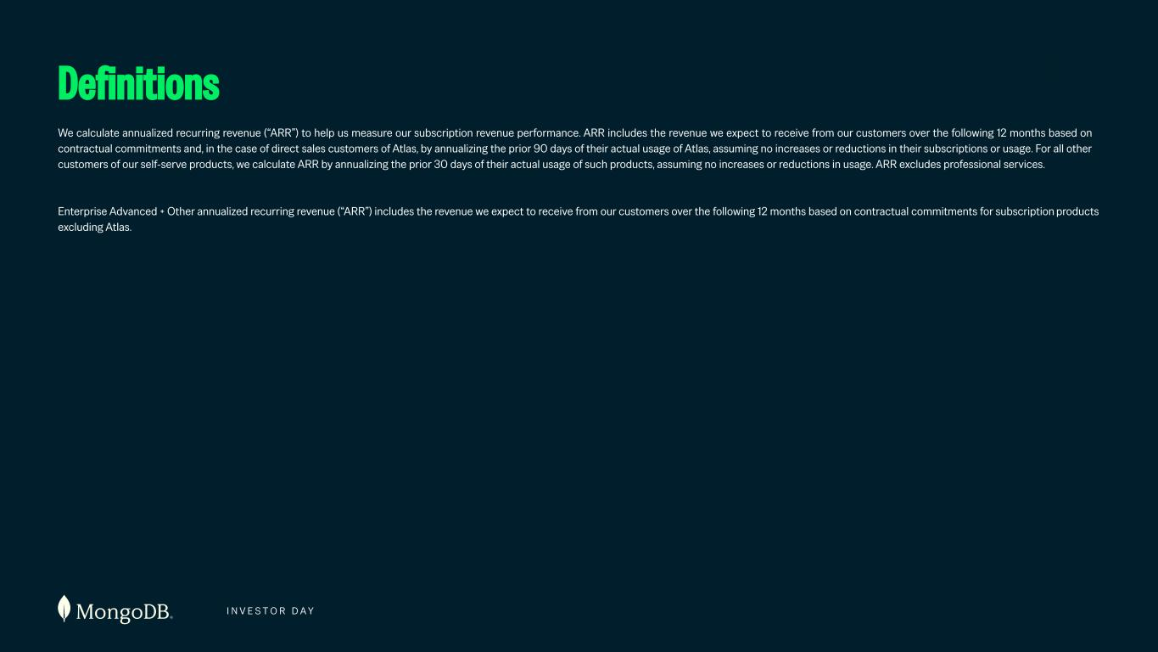
I N V E S T O R D A Y We calculate annualized recurring revenue (“ARR”) to help us measure our subscription revenue performance. ARR includes the revenue we expect to receive from our customers over the following 12 months based on contractual commitments and, in the case of direct sales customers of Atlas, by annualizing the prior 90 days of their actual usage of Atlas, assuming no increases or reductions in their subscriptions or usage. For all other customers of our self-serve products, we calculate ARR by annualizing the prior 30 days of their actual usage of such products, assuming no increases or reductions in usage. ARR excludes professional services. Enterprise Advanced + Other annualized recurring revenue (“ARR”) includes the revenue we expect to receive from our customers over the following 12 months based on contractual commitments for subscription products excluding Atlas. Definitions

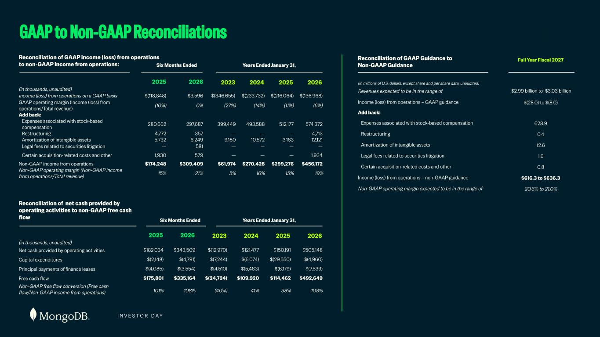
I N V E S T O R D A Y GAAP to Non-GAAP Reconciliations Reconciliation of GAAP income (loss) from operations to non-GAAP income from operations: Six Months Ended (in thousands, unaudited) 2025 2026 2023 2024 2025 2026 Income (loss) from operations on a GAAP basis $(118,848) $3,596 $(346,655) $(233,732) $(216,064) $(136,968) GAAP operating margin (Income (loss) from operations/Total revenue) (10%) 0% (27%) (14%) (11%) (6%) Add back: Expenses associated with stock-based compensation 280,662 297,687 399,449 493,588 512,177 574,372 Restructuring 4,772 357 — — — 4,713 Amortization of intangible assets 5,732 6,249 9,180 10,572 3,163 12,121 Legal fees related to securities litigation — 581 — — — — Certain acquisition-related costs and other 1,930 579 — — — 1,934 Non-GAAP income from operations $174,248 $309,409 $61,974 $270,428 $299,276 $456,172 Non-GAAP operating margin (Non-GAAP income from operations/Total revenue) 15% 21% 5% 16% 15% 19% 2023 2024 2025 2026 -$346,655 -$233,732 -$216,064 -$136,968 -27% -14% -11% -6% 399,449 493,588 512,177 574,372 — — — 4,713 9,180 10,572 3,163 12,121 — — — — — — — 1,934 $61,974 $270,428 $299,276 $456,172 5% 16% 15% 19% Years Ended January 31, (in millions of U.S. dollars, except share and per share data, unaudited) Full Year Fiscal 2027 Revenues expected to be in the range of $2.99 billion to $3.03 billion Income (loss) from operations – GAAP guidance $(28.0) to $(8.0) Add back: Expenses associated with stock-based compensation 628.9 Restructuring 0.4 Amortization of intangible assets 12.6 Legal fees related to securities litigation 1.6 Certain acquisition-related costs and other 0.8 Income (loss) from operations – non-GAAP guidance $616.3 to $636.3 Non-GAAP operating margin expected to be in the range of 20.6% to 21.0% (in thousands, unaudited) 2025 2026 2023 2024 2025 2026 Net cash provided by operating activities $182,034 $343,509 $(12,970) $121,477 $150,191 $505,148 Capital expenditures $(2,148) $(4,791) $(7,244) $(6,074) $(29,550) $(4,960) Principal payments of finance leases $(4,085) $(3,554) $(4,510) $(5,483) $(6,179) $(7,539) Free cash flow $175,801 $335,164 $(24,724) $109,920 $114,462 $492,649 Non-GAAP free flow conversion (Free cash flow/Non-GAAP income from operations) 101% 108% (40%) 41% 38% 108% Reconciliation of net cash provided by operating activities to non-GAAP free cash flow Six Months Ended Years Ended January 31, Reconciliation of GAAP Guidance to Non-GAAP Guidance

